Executive Summary
This report highlights (Microsoft,2023) Microsoft's growth as a leading multinational technology company, focusing on artificial intelligence, cloud computing, gaming, and strategic collaboration. The company has revolutionized its product offerings, such as Office 365 and Cortana, to enhance user experience and productivity. The company's financial position has shown significant success, with substantial growth and profitability. Microsoft's vision and mission focus empower individuals and organizations through technology, and under Satya Nadella's leadership, the company has undergone significant transformations to achieve better culture and innovation. Analyzing PESTLE, SWOT, 5 Forces, and BCG Matrix provides valuable insights into Microsoft's strategic decisions, market dynamics, and diverse product portfolio.
In summary, Microsoft’s Financial success, and market dominance in office productivity software position it well in the industry. Therefore, to maintain its competitive edge. Microsoft should focus on expanding its market reach, enhancing cloud services, fostering a robust developer ecosystem, embracing open-source collaboration, improving integration, accelerating AI adoption, prioritising accessibility, and enhancing data privacy and security. These actions will drive growth, innovation, and customer satisfaction, ensuring Microsoft’s continued success in the dynamic industry.


Strategic Management at Microsoft

Natalie Jayne Sahi 1915519 – 07/07/2023

Executive Summary
Content Page
- Introduction
- Main Findings
2.1 Historical Development of Microsoft’s Organisation
2.1.1 Strategic Development (2019/2023)
2.1.2 Microsoft Revenue (2021/2022)
2.1.3 Microsoft Market Share
2.1.4 Microsoft Stakeholders
2.1.5 Vision and Mission Statement
2.2 Pestle Analysis
2.2.1 SWOT Analysis
2.2.2 Porter 5 Forces Analysis
2.2.3 BCG
2.2.4 Porters Generic
2.2.5 Stakeholders Analysis
2.2.6.1 Stakeholder Mapping
2.2.6.2 Microsoft strategic position & Development
2.2.6.3 Microsoft Strategic Direction
2.2.6.4 Microsoft’s Long Term 5- year Plans
2.2.6.5 Schools on strategic management
2.7 Microsoft’s Current Strategy – Advantages and Disadvantages
3.0 Conclusion
Appendices 6
References 50

1.0 Introduction
This report, requested by Satya Nadella, CEO of Microsoft, analyzes the company's strategic initiatives and their impact on performance. It covers critical areas like growth, cloud services, cybersecurity, industry presence, partnerships, and artificial intelligence integration. The analysis uses frameworks like PESTLE, SWOT, Five Forces, BCG Matrix, Porters Generic, and stakeholder analysis to assess the competitive landscape and understand the company's strategic environment. The report emphasises Microsoft's ability to adapt to market trends and technology advances for sustained success in the evolving technology industry. Microsoft prides itself on high customer and partner satisfaction and aims to expand its market scope through various product and service offerings.

2.0 Mian Findings

2.1 Historical Development of Microsoft’s Organisation
According to the research (Mcfadden, 2020), Microsoft is one of the world's leading technology firms. Bill Gates and Paul Allen founded the company in Albuquerque, New Mexico 1975. Microsoft is a prominent international corporation with an established innovation and customer satisfaction track record. Campbell (2001) clarified how Microsoft began the company by developing software for personal computers, which led to the creation of the widely used operating system, Windows, in 1985, which formed a foundation of the company's success. Since then, Microsoft has continued developing and growing into a technological giant.
2.1.1 Strategic Development (2019/2023)
According to (Reuters. 2021), In 2019, Microsoft expanded its cloud services by releasing additional data analytics, artificial intelligence, and open-source programs. With the purchase of firms such as Hexadite and Blue Talon, the corporation also invests in cybersecurity. Over the previous five years, Microsoft's strategy development has concentrated on growing its cloud computing and artificial intelligence capabilities.
Microsoft embraced GitHub in 2020 to boost developer and source collaboration, speeding Amazon Web Services. Xbox Series X and Series S upgraded consoles and strategic partnerships for Microsoft's gaming sector. Service continuity required firm expansion. Microsoft has a five-year plan with Walmart to boost cloud computing to advance AI technology (Cio.com, 2018). Microsoft's cloud computing and cooperation for gaming, AI integration, and strategic alliances were evident in these strategic advances.
According to (Microsoft, 2022), AI integrations enhance Office 365, Azure, and Cortana to better goods and services. Microsoft and LSEG began a 10-year partnership in 2021 to boost capital markets. The collaboration will capitalise on Microsoft Azure's open and secure cloud platform to accelerate the digital transformation of trading, risk management, and other financial and operational processes. LSEG's data platform and other vital technology infrastructure will be migrated to Microsoft Azure, enhancing its cloud migration strategy.
Features for Office 365 have insights that can provide relevant information from the websites that are interacted like Excel and PowerPoint. AI-powered security is another feature with advanced threat protection and Office 365 Cloud App security.
Cortana integration with Microsoft Teams has allowed users to make calls, join meetings, and send messages and personalised briefings, and this is another way AI has been able to perform tasks such as the daily summary of relevant information, such as news and calendar events.

2.1.2 Microsoft’s Revenue (2021/2022)
According to (Microsoft.com, 2022), they earned $18.8 billion in profit in the final three months of 2021. Microsoft announced a profit of $61.3 billion2 for the fiscal year 2021, a 38% increase over 2020. Revenue for 2021 was $168.1 billion, a 17.5% increase over the previous year, and the company's gross profit for the fiscal year 2022 was $135.62 billion. The growth in Microsoft's cloud computing, gaming, and personal computer areas has increased its net income, driven by its good performance.

2.1.3 Microsoft Market Share
(Theverge. 2021) Confirmed that Microsoft is the second most valuable company behind Apple; Microsoft Office has a share of almost 50% of the office productivity software market. Windows and Android are the two major operating systems, and Microsoft and Google own these. (Companies market cap, 2023) Confirmed as of May 2023, it estimated that Microsoft was the most valuable company in the world, with a respected market capitalisation of over $2. Trillion. Microsoft is a large and diversified company with a significant presence in many markets, which can vary depending on the specific product and market segment.

2.1.4 Microsoft Stakeholders
Franek (2023) Confirmed that Microsoft Corporation's primary stakeholders are groups with a stake in its financial success. Microsoft has many important financial stakeholders. (Microsoft, 2019) corporate social responsibility approach states that stakeholders like customers, employees, communities, investors, and governments are crucial to an organisation's success. Addressing their demands helps companies create relationships, maintain reputation, attract investments, and operate sustainably. Customers generate income, staff operate, communities build reputation, investors provide revenue, and governments regulate the business environment. Prioritising these stakeholder groups boosts loyalty, productivity, reputation, investor trust, and compliance. Microsoft's CSR programmes underline stakeholders' importance. Innovative computer hardware and software products and responsive feedback systems satisfy stakeholder's interests, including customers. This example shows how key stakeholders, organisations that advocate, industry experts, and CSR-focused investors can offer valuable feedback to inform the company's business decisions by sharing its learning and practises. Microsoft fosters CSR, industry interaction, and open discussion. Microsoft improves their CSR approach to address stakeholder concerns and promote ethical business practices.

2.1.5 Vision & Mission Statement
According to (Microsoft, 2023), Microsoft's strategic management process develops its vision and mission statement, which empowers every person and organisation worldwide to achieve more. This shows the company's dedication to using technology to benefit lives. Microsoft's mission statement says that technology helps people and businesses succeed. Thus, the corporation prioritises creating productivity-boosting goods and services. Microsoft aims to redefine productivity, corporate operations, and personal computing.
(Newyorker, 2013) Microsoft's goal under Steve Ballmer was to help businesses worldwide, but Satya Nadella revised it in 2014. Nadella changed its strategy and focus, encouraging growth and innovation. Refauter (2018) verified Nadella's three primary goals, rethinking productivity and business processes, creating an intelligent cloud platform, and personalising computers. Microsoft's openness and collaboration have made its rivals partners. A more robust cloud computing approach allows the corporation to offer more internet-based computing services. These reforms made Microsoft more innovative, agile, and customer-centric, improving its financial performance and market value.
Darbi (2012) Confirmed that a vision and mission statement is significant in strategic planning and can be applied as a communication tool for internal and external stakeholders. The mission of an organisation might inspire a more strategic direction. A vision statement also defines purpose and values that support long-term goals. It informs stakeholders that the company is ready to adjust to succeed.

2.2 PESTLE analysis Appendix 1.
According to Johnson (2020), PESTLE analysis reveals Microsoft's organisational traits to improve strategy development. Understanding the external environment improves strategic decision-making. Microsoft recognised market chances to expand. Therefore, assessing these factors creates new trends and desires.
(Althoff, 2021) Examining the PESTLE can help the company improve its digital transformation marketing tactics. The analysis explores legal, environmental, and technological variables to help the company assess risks and dangers. Microsoft uses these elements to evaluate strategy development. As a result, a risk assessment helps the company identify and address legal issues.
(Bajj,2023) Further research confirmed insights into social characteristics that allow Microsoft to adjust its marketing efforts to the target population to understand consumer preferences and behaviours. The company can then present a more appealing message that boosts client engagement. The PESTLE analysis also helps Microsoft innovate. The company may also stay ahead by incorporating new technologies and trends into its marketing and product offerings.
(Microsoft, 2022a) PESTLE analysis identifies Microsoft's 2030 sustainability commitments which offer potential for expansion, government regulations, Azure demand, AI, IoT advances, emerging areas, and collaborations to enhance products and competitive position.However, (Beard, 2020) noted limitations. Microsoft faces market challenges due to fierce competition from Google, Apple, and Amazon, requiring rapid technological changes and addressing data privacy and security issues. Addressing these challenges can help Microsoft capitalise on market conditions, prepare people for informed decisions, and stay ahead in the dynamic technology industry.
(Frue, 2018) Confirmed that PESTLE analysis helps comprehend the external environment and inform strategic decisions. Its limits identify PESTLE factors that change quickly, making business predictions problematic. PESTLE analysis simplifies complicated and interrelated aspects, which could obscure the overall picture. The PESTLE evaluation should include internal elements, connections, the dynamic environment, and other strategic instruments. This could improve strategic decision-making by providing a holistic view of the organisation and its environment.

2.2.1 SWOT Analysis Appendix 2.
A SWOT analysis revealed Microsoft's internal and external strengths and weaknesses. Microsoft's strategic marketing success has shown the key causes behind the company's market position and growth. The SWOT analysis revealed the company's strengths and possibilities. Microsoft's strategic marketing has been effective thanks to SWOT analysis, which discovered motivating elements. (Goh,2020) The analysis reveals that Microsoft's strengths and opportunities have led to a devoted client base and increased revenue. The company's Windows operating system, Office suite, Azure cloud platform, and Xbox gaming device have enabled it to service more clients, setting industry standards and enjoying economies of scale. Research and development, particularly in artificial intelligence and the Internet of Things, have contributed to the company's growth, with Office 365 and Microsoft 365 increasing income by 32%.

2.2.3 Porter’s 5 Forces Analysis Appendix 3.
(Staff, 2022) Microsoft's strategic marketing decisions highlighted the 5 Forces analysis. It highlighted how competitive dynamics and market conditions have affected the company's marketing and consumer involvement. The research includes investment in research and development and brand loyalty. Microsoft also invests in research and development to stay ahead of entrants. Therefore, strategic marketing efforts have concentrated on showing technology developments that can strengthen brand loyalty through customer involvement.
(Mondragon, 2022) Further research revealed Microsoft's strong market position in markets allows them to focus on value, pricing control, and customer satisfaction. Strategic marketing tactics highlight Microsft's benefits, fostering client loyalty and exploiting market supremacy. The company's excellent financial position helps cut production costs and invest in product development and marketing.
According to (Goyal, 2020), The five forces model is a comprehensive framework for analysing competitive forces within an industry. However, it focuses on external factors and overlooks internal capabilities and technological improvements—the model changes. Therefore, comparing and prioritising components requires quantitative measurements of forces and their effects. The model must also account for complementary opposite forces essential in many sectors. In interconnected economies, industry boundaries can be challenging to define. The Five Forces approach assists strategic decision-making by conceptualising industry dynamics.

2.2.3 BCG Matrix Model Appendix 4.
According to Chiu (2020), a BCG Matrix provides a framework for an in-depth review of Microsoft's product portfolio that corresponds with strategic aims. The Model divided products into Stars, Question Marks, Cash Cows, and Dogs. Therefore, the company invests, divests, and keeps focus. The research shows where Microsoft may need to spend on growth and where it may use its market dominance to make strategic decisions to boost profitability. BCGs provide insights into market trends, consumer expectations, and competitive dynamics to support effective decision-making and long-term success in an ever-changing technology ecosystem.
Stars
(Chapple, 2022) Clarified Microsoft's enormous investment in Auzue Cloud Services, which are dominant cloud platforms. Azure's scalability and security highlight the integration in its strategic marketing. They have been able to market it as a complete company solution. With Microsoft 365, Microsoft highlighted the benefits of cloud-based productivity tools and collaborative features. Their marketing strategy focuses on device integration and subscription-based access flexibility. Microsoft also highlighted that the latest version of Windows increased security and user experience by integrating emerging technology. Therefore, their marketing efforts promoted upgrading to the latest Windows versions.
Question Marks
(Blog, 2022) Microsoft increased its surface line's marketing efforts, targeting professionals and creative users. The marketing strategy mainly focused on professionals and creative users. Their marketing strategy aimed to position Surface 9 pro devices as cutting-edge, high-quality products that offer a unique blend of laptop and tablet functionality. Microsoft also highlighted the innovative features and versatility of Surface devices, showcasing their ability to meet the specific needs of professionals and creative individuals. The marketing efforts to differentiate Surface devices from competitors aim to attract a niche market segment that values portability and performance. Identifying the premium build quality, intuitive design, and integration with Microsoft software enabled them to aim toward a distinct brand image for Surface devices and increase their market share.
Cash Cows
According to (Kumar, 2022) Microsoft Windows Server and SQL Server are reliable, secure enterprise solutions, focusing on consistency, functionality, customer experience, and customer support for enterprise-wide reliability, security, and satisfaction.
(Bonthys, 2022) Microsoft's Xbox cloud gaming marketing emphasizes unique games, compatibility, and online services, promoting immersive gaming and enhanced graphics. It also promotes enterprise solutions like Windows servers and SQL Server, ensuring stability, security, and customer satisfaction.
Dogs
(Tung,2019) Confirms Microsoft's mobile device strategy shift by discontinuing Windows phone initiatives. The IOS-dominated smartphone industry drove this decision. Microsoft realised the problems and invested in cross-platform software and services. Instead of Windows Phone, they promoted Windows apps, Office apps, and cloud-based solutions for Android and iOS. This was to offer software on more platforms. Microsoft also tried to get more people to use different gadgets. Microsoft identified their issues, diversified its strategic strategy in productivity tools like Microsoft Office, and expanded beyond the Windows Phone environment. Their cross-platform apps and services allow users to switch devices while using Microsoft's productivity tools.
Furthermore, Microsoft invests in cloud-based solutions like Microsoft Azure to meet increased demand for cloud services across devices and ad platforms. To conclude, Microsoft's decision to discontinue Windows Phone and focus on software and services for many platforms showed that they recognised their challenges and could develop and promote alternative systems, strengthening their innovation devices. They capitalised on their market presence and adapted to market trends, and client needs to stay competitive.
Kasi (2017) States that Microsoft aligns its strategic aims with its products. The BCG Matrix helps the organisation examine its product portfolio and make marketing positioning, target customer segment, and value proposition decisions. Microsoft can identify growth possibilities, manage resources, and handle market changes to increase profitability.
Palvlina (2014) states BCG Matrix helps companies examine their product portfolio and make strategic decisions. The Model's pros and disadvantages include simplicity, clarity, expense, and neglecting other factors. Implementing the BCG Matrix requires realistic product market growth rates and shares—costly and time-consuming data collecting. Data quality might be difficult to get in some businesses and markets, affecting analysis accuracy.

2.2.4 Porters Generic Model Appendix 5
A company's cost leadership strategy is to become its industry's lowest-cost producer or service. Results from the five forces Microsoft improved its operations to attain economies of scale to control expenses and offer competitive pricing for its products and services, according to Model. Their extensive resources, infrastructure, and worldwide reach can minimise costs throughout their supply chain and production process. According to (Martinekuan, 2023), Microsoft's cost leadership strategy has allowed them to recruit price-sensitive clients, compete fiercely on price, win market share, and maintain a solid competitive position. It has also given them better financial resources to invest in research, development, innovation, and future growth. This strategic objective emphasises the importance of tangible and intangible product attributes to maintain Microsft's competitive advantages, and by focusing on cost leadership, Microsoft balanced affordability and profitability while driving innovation and growth in the highly competitive technology industry.
Cost focus, or focused low-cost strategy, targets a niche market with unique client needs. The company provides low-cost products and services that fulfil market requirements. Understanding a targeted consumer group and providing cost-effective solutions can give the organisation a competitive edge. Microsoft does not focus on pricing since they have a diverse consumer base and offer several products and services. They focus on cost in specific market sectors and industries where client needs must be met efficiently. Microsoft offers low-cost solutions to educational institutions' specialised needs and budget constraints. This gives them a market edge while keeping their corporate approach.
(Gregory, 2023) States differentiation strategy entails generating unique and distinctive products and services that customers believe as superior or more valued. Microsoft has focused on features, functionality, quality, design, and customer service to differentiate its products. Therefore, businesses can charge a premium price and attract customers who value distinctive features by presenting themselves as high-value companies. Microsoft differentiates by constantly improving its software, devices, and cloud services' quality and user experience. This also provides clients differentiated products that fit their needs and give a better value proposition.
Differentiation Focus, or focused differentiation strategy, targets a niche market with particular wants and preferences. According to (Downie,2022), Microsoft employs demographic and behavioural segmentation to divide the large population into small segments and office systems and promote products. The company builds client loyalty by charging premium rates for highly unique items or services that meet target market needs. Microsoft uses a differentiation emphasis strategy in market areas where consumer demands match its differentiated solutions, even though it is not specifically part of its business model. Hence, Microsoft seeks to reduce costs, offer competitive rates, and distinguish its products and services to offer customers more excellent value Furthermore, Microsoft needs to pursue the cost and differentiation focus to employ strategies in specific market segments further to enhance its competitive position.
Kim (2004) Noted that cost leadership and differentiation demand different resources and skills. Porter believed combining them would adversely impact performance. Some firms have blended both tactics. Cost leadership needs standardised products with minimal unique features or services to reduce costs. However, the difference needs investment in R&D, marketing, and other areas to generate unique products or services that stand out from the competitors. Both tactics require different organisational structures, cultures, and management styles.

2.2.5 Stakeholder’s Analysis Appendix 6.
According to the report, shareholders and investors fund the company's growth and profitability. Microsoft's tactics and product innovations, notably marketing techniques, focus on customer feedback to maintain satisfaction and loyalty. Microsoft employee's operational efficiency and strategic planning skills are vital. Business partners and suppliers have also helped Microsoft increase its product lineup. Government and regularity agencies build the business environment to ensure compliance and positive interactions, according to Hall, Schmitz, and Dedmon (2019). Microsoft learns from industry associations and competitors by analysing industry trends. NGOs and advocacy groups organise Microsoft's social, sustainable, and responsible strategies. Local communities participate in community development programs to improve connections and wellbeing. Therefore, stakeholder involvement shows customer-centric, innovative, and sustainable strategic improvements that match social expectations.

2.2.6.1 Stakeholder Mapping
According to the research (Communications, 2021), stakeholder mapping for Microsoft highlights the importance of analysing stakeholder perspectives and interests. For example, the Microsoft partnership with Adobe and the collaboration with hardware manufacturers illustrate the company's strategic developments. It is crucial to consider the dynamic nature of the stakeholder relationships and the impact of emerging groups like ethical advocacy organisations. Microsoft's focus on cloud computing and AI, also reflected in initiatives like Azure and AI partnerships, influences its overall business strategy interdependencies between stakeholders, such as hardware partnerships and developer engagement strategies, as to the complexity. Microsoft can thrive in the rapidly evolving technology landscapes by effectively managing stakeholders and strategic developments.
The stakeholders mapping for Microsoft provides a valuable point to understand the various stakeholders involved in the company's operations. However, a critical analysis identifies several key factors that examined limitations. One aspect to consider is the potential oversimplify stakeholder viewpoints and interests. Understanding and acknowledging stakeholder objectives and concerns is essential. This knowledge can guide targeted strategies to improve stakeholder interactions. Stakeholder interactions are dynamic. Market conditions, legislative changes, and social trends can change stakeholders' interests and impact. Microsoft can monitor these trends and adjust its engagement techniques to manage stakeholders effectively.
According to (APM, 2013), it is essential to anticipate the emergence of new stakeholders who may impact Microsoft's strategic decisions. By proactively identifying and engaging with these groups, such as activist investors or emerging technology communities, the company can stay tuned to the evolving industry trends and leverage new opportunities. The mapping must expand to contain the interdependencies and interconnectedness between stakeholder groups. Stakeholders can influence and interact with one another, and their collective actions may shape Microsoft's strategic choices. So by recognising these interdependencies is critical for comprehensive stakeholder management.
Moreover, lastly, the mapping would also benefit from a deeper exploration of stakeholder engagement; building stronger relationships with stakeholders will require them to tailor different approaches that facilitate open dialogue, incorporate stakeholder feedback, and demonstrate a commitment to transparency and responsiveness. By implementing these effective engagement strategies, Microsoft can enhance stakeholder satisfaction and foster mutually beneficial relationships. Therefore, this identifies that by addressing these considerations, Microsoft can refine its stakeholder management approach, gain a comprehensive understanding of stakeholder dynamics, and bolster its ability to effectively meet their needs and expectations.
(ffrench-constant, 2015) The stakeholder mapping analysis is a helpful tool for identifying and understanding stakeholders, but it has limitations. Some disadvantages include difficulty finding stakeholders for research with no apparent benefits, the need for continuous stakeholder mapping, and the risk of overlooking critical stakeholder groups. Despite these limitations, stakeholder mapping analysis can provide valuable insights and help organisations make informed decisions about stakeholder engagement.

2.2.6.2 Microsoft Strategic Position & Developments
Microsoft's strategy is dynamic and complex, driven by CEO Satya Nadella's leadership. As identified throughout the report, their primary focus is expanding their cloud computing and artificial intelligence capabilities. The strategic developments have also included investments in data analytics, AI, open-source programs, and cybersecurity acquisitions. Microsoft has also integrated GitHub and expanded its presence in the gaming industry with Xbox Series X and Series S. The company has been able to form strategic partnerships and alliances with organisations like Walmart and LSEG as they aim to accelerate cloud computing and AI technology. Integrating AI into various products and services demonstrates their ability to adapt to emerging technologies, market trends, and customer demands. This dynamic approach has helped them stay competitive as they aim to cater to the evolving needs of their customers in the technology industry.

2.2.6.3 Microsoft strategic direction
(Scannell, 2019) Identified how Microsoft prioritises growth. Acquisitions and partnerships are helping them grow. Microsoft has added new technologies and users through acquisitions like GitHub and Linkedin. Microsoft uses strategic agreements with Adobe, sap, and Oracle to offer customers complete solutions. Microsoft may sell non-core businesses, but its overall strategy is acquisition and strategic relationships. These methods have helped Microsoft enter new industries and compete in the changing technology landscape.
Microsoft's Strategy Scope.
According to (Abbas, 2020), Microsoft has a company-wide strategy. Microsoft's approach extends beyond one product or SBU. They strategically offer hardware, software, and cloud services. Microsoft combines its business groups and product lines. This has allowed them to address diverse customer needs and target numerous market niches to earn their loyalty. Microsoft's strategy involves ethical expansion and alliance acquisitions. Microsoft achieves its goal by creating innovative products and having a strong market presence. Market developments are monitored by the following services.
- Microsoft employs product differentiation by offering a wide range of products and services tailored to meet the specific needs of different market segments.
- Microsoft conducts market research and analysis to understand customer preferences and behaviour.
- They customise and personalise their offerings to address the unique demands of various customer groups.
- Microsoft conducts thorough market research and analysis to understand customer preferences and behaviours, enabling them to align their products and marketing strategies with specific market segments.
- Strategic partnerships and alliances are formed to expand their reach and target specific segments, collaborating with hardware manufacturers and software developers.
- Marketing and promotion efforts are tailored to effectively reach and engage different market segments through segmented advertising campaigns and various channels.

2.2.6.4 Microsoft’s Long term 5-year plans
(Patel et al., 2017) stated that Microsoft’s strategy involves both long-term planning and short-term execution. The organisation pursues long-term strategic goals in a dynamic industry that requires flexibility and agility. They prepare for several years, but market conditions, new technologies, and client needs may change their strategy. To stay competitive and adapt, Microsoft's leadership regularly reviews its strategy. They value agility and adaptability over long-term goals.
Market conditions and stakeholder input are strongly influenced by Microsoft's strategy. They analyse market trends and adjust their strategy to take advantage of new possibilities and avoid challenges. Microsoft collaborates with stakeholders, including customers, workers, partners, investors, and the community, to ensure its plan meets their requirements and expectations. Microsoft seeks long-term value and sustainable growth by evaluating market conditions and stakeholder involvement.

2.2.6.5 Microsoft’s Schools on strategic management
Mintzberg (1990) identifies Microsoft's strategy as influenced by multiple schools of strategic thinking. They use a structured approach to strategy formulation but also adapt to emerging opportunities and market dynamics. They have focused on being market leaders and forming partnerships and alliances. Under CEO Satya Nadella, Microsoft exhibits entrepreneurial characteristics but also considers market conditions and stakeholder input. They continuously evaluate and refine their strategy based on market conditions, emerging technologies, and customer demands. Microsoft's organisational culture influences its strategic decisions, while external factors influence its strategy. They leverage their product lines, business units, and ecosystem to create a cohesive offering. Microsoft's strategy combines formal planning with adaptability, incorporating market dynamics and stakeholder input. Therefore, this emphasises learning and innovation and justifies the internal resources and capabilities to achieve a competitive advantage. Microsoft maintains an outward focus on marketing and strategic business units. They strive to expand their market presence and target customer segments, fostering collaboration with partners and developers. By doing so, they effectively engage diverse groups of customers and promote their products and services. The company proposes their primary focus to stay committed to meeting customers' evolving needs and trends in the ever-changing technology industry.

2.7 Microsoft Current Strategy – Advantages and Disadvantages
Microsoft's corporate reputation ranks seventh among the top 100 companies. However, current approaches have pros and cons. Microsoft's strategy benefits from diversification. Therefore, supplying various products and services across multiple markets lessens Microsoft's market potential. Diversification allows the organisation to explore new prospects and maintain stable growth despite industry setbacks. Microsoft's Azure platform dominates cloud computing. Cloud services have helped the organisation develop revenue and market share. This strategic focus has helped Microsoft to capitalise on the growing demand for cloud-based solutions. Microsoft's strong brand presence, vast client base, and high-quality products and services give it a competitive edge. Microsoft's brand familiarity and customer base allowed it to acquire and retain customers across its product lines.
Furthermore, Microsoft must constantly innovate and anticipate market trends. Customer needs to maintain its market position in the face of intense competition from tech giants like Amazon, Google, and Apple. Microsoft still significantly relies on legacy such as Windows and Office, which can cause issues in a fast-changing technology context, according to Saxena (2020). Avoiding setbacks requires managing old dependencies. Microsoft's cloud services capture more user data, raising privacy and security concerns. Data breaches or failures could damage the company's brand and lose customers. Microsoft's current approach benefits from diversification, cloud computing dominance, and brand visibility. The company faces competition, historical dependencies, and privacy issues. Microsoft can prosper in the ever-changing digital market by exploiting its strengths and proactively addressing these issues.

3.0 Conclusion
In conclusion, Microsoft has experienced significant financial success, with significant revenue growth and profitability. Its market share in office productivity software enables it to deliver value to stakeholders. Analysing models like pestle swot, 5 Forces, BCG Matrix, Porter's Generic Model, and stakeholder analysis helps identify strategic marketing decisions and market opportunities. These insights help Microsoft tailor marketing strategies and capitalize on market position, ensuring continued innovation and growth.Microsoft's strong product portfolio, research and development, subscription-based models, and strategic partnerships have enabled the company to adapt to market trends and challenges. Despite competition, technology changes, and regulatory changes, Microsoft remains customer-centric and differentiates itself. Effective stakeholder management and engagement with stakeholders, including shareholders, customers, employees, partners, government authorities, industry associations, and NGOs, have contributed to the company's strategic development. Innovation, customer centricity, differentiation, and stakeholder management are crucial for maintaining a competitive advantage in the dynamic technology industry.

Appendix 1.
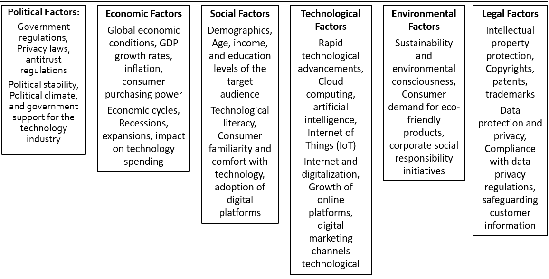

Appendix 2. 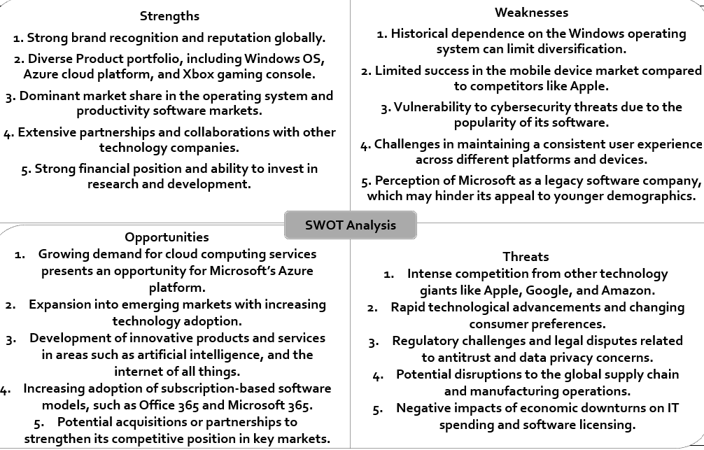

Appendix 3.
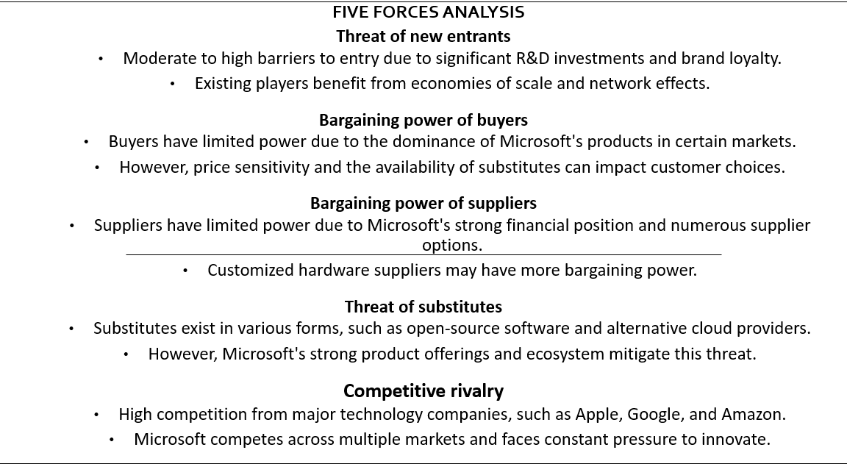

Appendix 4.
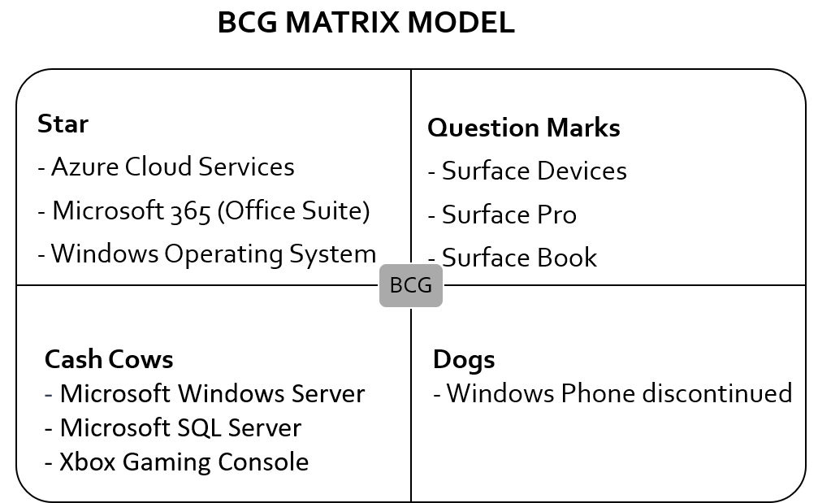

Appendix 5.
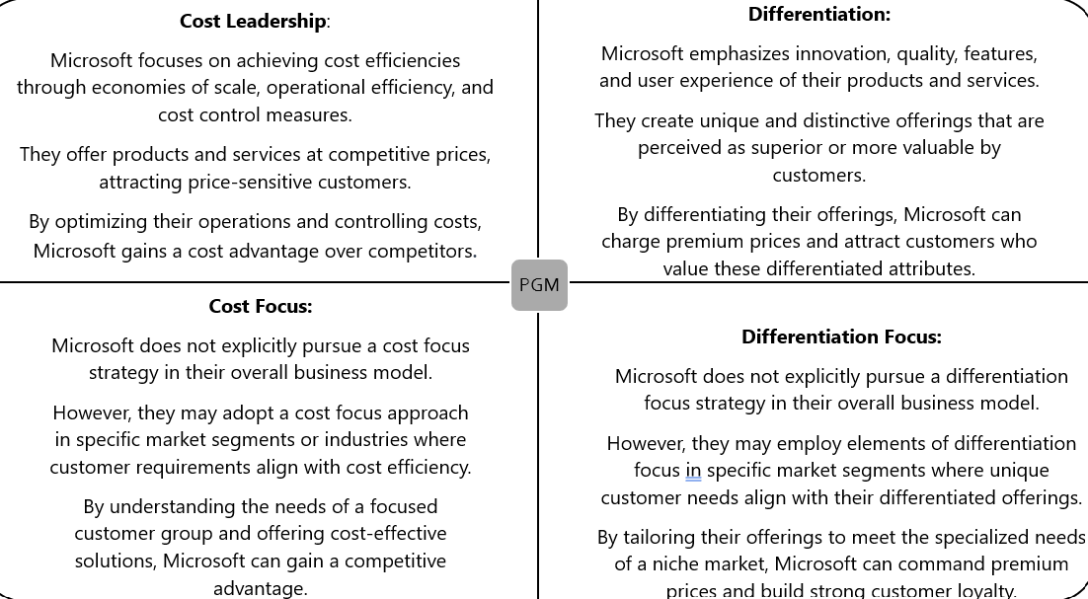

Stakeholder Analysis 6.
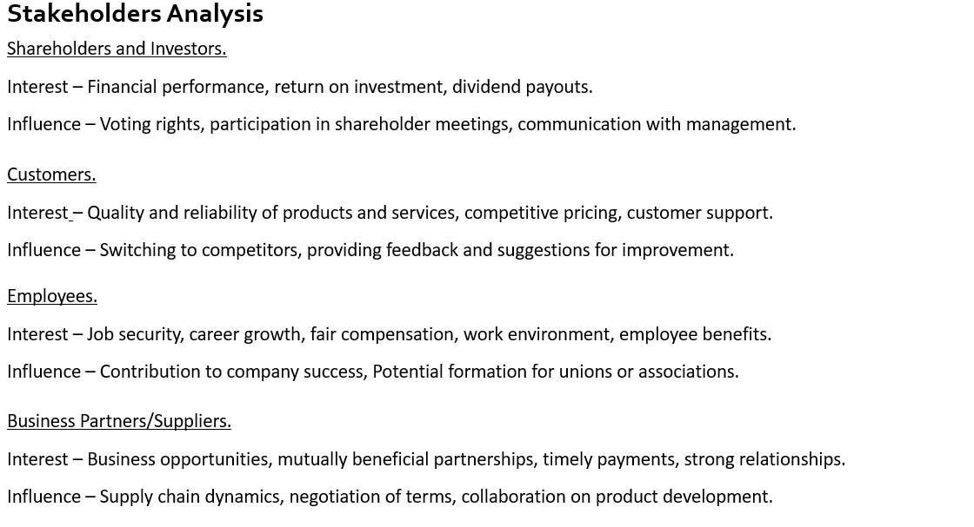

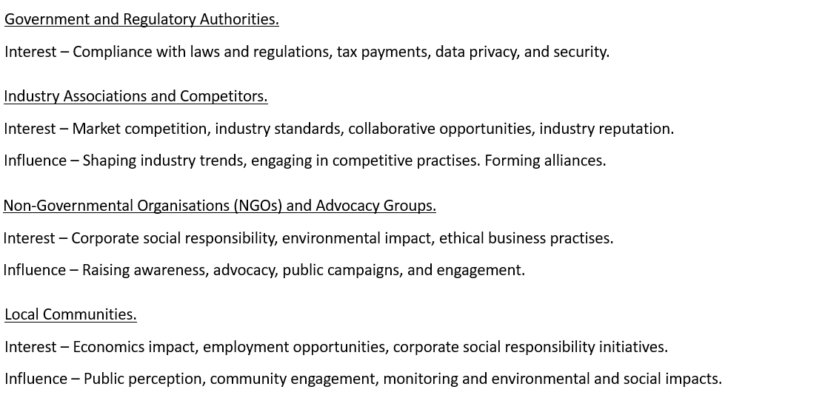

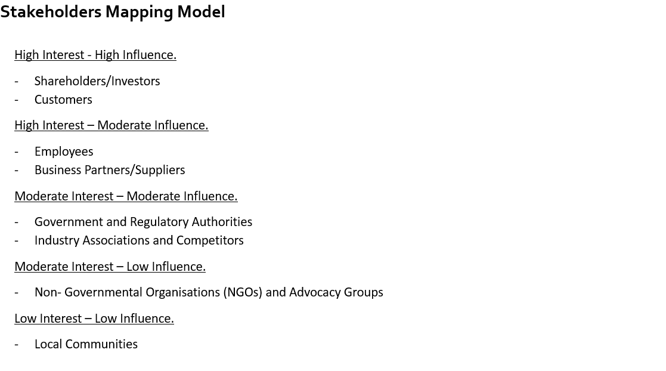

Reference
Abbas, Z. (2020a). (PDF) Competitive Analysis of Microsoft in Market Settings. [online] ResearchGate. Available at:https://www.researchgate.net/publication/341072093_Competitive_Analysis_of_Microsoft_in_Market_Settings.
Althoff,J. (2021). Embracing continuous innovation how Microsoft is helping customers overcome challenges to transform business and industries. (online) The Offical Microsoft Blog. Available at: https://blogs.microsoft.com/blog/2021/10/25/embracing-continuous-innovation-how-microsoft-is-helping-customers-overcome-challenges-to-transform-business-and-industries.
Bajj, A. (2023). Microsoft’s marketing strategies: How they conquered the Tech World (online) startup Talky. Available at: https://startuptaky.com/microsoft-marketing-strategies.
Beard, A. (2022). Can Big Tech Be Disrupted? [online] Harvard Business Review. Available at: https://hbr.org/2022/01/can-big-tech-be-disrupted.
Blog, M.D. (2022). Introducing new Surface devices that take the Windows PC into the next era of computing. [online] Microsoft Devices Blog. Available at: https://blogs.windows.com/devices/2022/10/12/introducing-new-surface-devices-that-take-the-windows-pc-into-the-next-era-of-computing/.
Bonthuys, D. (2022). Some Future Activision Blizzard Games Will Be Xbox-Exclusive, Microsoft Confirms. [online] GameSpot. Available at: https://www.gamespot.com/articles/some-future-activision-blizzard-games-will-be-xbox-exclusive-microsoft-confirms/1100-6504322/.
Campbell-Kelly. M. (2001). Not Only Microsoft: The Maturing of the Personal Computer Software Industry, 1982-1995. Business History Review. 75(1), 103-145. Doi: 10.2307/3115558.
Chapple, E. (2022). Cloud trends show customers increasing investments in hybrid and multicloud. [online] The Official Microsoft Blog. Available at: https://blogs.microsoft.com/blog/2022/01/27/cloud-trends-show-customers-increasing-investments-in-hybrid-and-multicloud/.
Chiu, C.C. and Lin, K.S., 2020. Rule-based BCG matrix for product portfolio analysis. Software Engineering, Artificial Intelligence, Networking and Parallel/Distributed Computing, pp.17-32.
Communications, A. (2021). Adobe and Microsoft Partner to Transform the Future of Work | Adobe. [online] Adobe Blog. Available at: https://blog.adobe.com/en/publish/2021/12/09/adobe-and-microsoft-partner-to-transform-the-future-of-work.
Darbi, W.P.K., 2012. Of mission and vision statements and their potential impact on employee behaviour and attitudes: The case of a public but profit-oriented tertiary institution. International Journal of Business and Social Science, 3(14).
Downie, R. (2021). Microsoft’s Competitive Advantage: An Inside Look. [online] Investopedia. Available at: https://www.investopedia.com/articles/insights/072516/microsofts-competitive-advantage-inside-look.asp.
Downie, R. (2022). Differentiation at Microsoft – Global Business, Demystified. [online] globestrategy.net. Available at: http://globestrategy.net/differentiation-at-microsoft/.
Franek, Kamil. “Who Owns Microsoft: The Largest Shareholders Overview.” Kamil Franek, 2 Mar. 2023, https://Kamilfranek.com/who-owns-microsoft-largest-shareholders/.
Frue, K. (2018). 6 frustrating disadvantages of PESTLE analysis. [online] PESTLE Analysis. Available at: https://pestleanalysis.com/disadvantages-of-pestle-analysis/.
ffrench-constant , L. (2015). Problems encountered Mapping Stakeholders…. and some suggested solutions. [online] Research to Action. Available at: https://www.researchtoaction.org/2015/09/problems-encountered-mapping-stakeholders-and-some-suggested-solutions/.
Gregory, L. (2023). Microsoft Corporation’s Generic & Intensive Growth Strategies. (online) PanmoreInstitute. Available at: https://panmore.com/microsoft-corporation-generic-strategy-intensive-growth-strategies.
Goh, D. (2020). Microsoft’s business model: How Microsoft make money (online) The Fifth person. Available at: https://fifthperson.com/microsoft-business-model/.
Goyal, A. (2020). A Critical Analysis of Porter’s 5 Forces Model of Competitive Advantage. [online] papers.ssrn.com. Available at: https://papers.ssrn.com/sol3/papers.cfm?abstract_id=3765758.
Hall, N., Schmitz, H.P. and Dedmon, J.M. (2019). Transnational Advocacy and NGOs in the Digital Era: New Forms of Networked Power. International Studies Quarterly, 64(1). doi:https://doi.org/10.1093/isq/sqz052.
Johnson, G., Whittington, R., Regner, P., Angwin, D. and Scholes, K., 2020. Exploring strategy. Pearson UK.
Kasi, K. (2017a). BCG Matrix of Microsoft Corporation. [online] BCG Matrix Analysis. Available at: https://bcgmatrixanalysis.com/bcg-matrix-of-microsoft-corporation/.
Kim, E., Nam, D.I. and Stimpert, J.L., 2004. The applicability of Porter’s generic strategies in the digital age: assumptions, conjectures, and suggestions. Journal of management, 30(5), pp.569-589.
Kumar, R. (2022). SQL Server 2022 is now generally available. [online] Microsoft SQL Server Blog. Available at: https://cloudblogs.microsoft.com/sqlserver/2022/11/16/sql-server-2022-is-now-generally-available/.
martinekuan (2023). Cost Management discipline overview - Cloud Adoption Framework. [online] learn.microsoft.com. Available at: https://learn.microsoft.com/en-us/azure/cloud-adoption-framework/govern/cost-management/?ssp=en-GB&safesearch=moderate.
Mondragon, G. (2022). How to leverage the Microsoft ecosystem for meaningful growth | Partner Success Guide. [online] US Partner Community Blog. Available at: https://www.microsoft.com/en-us/us-partner-blog/2022/01/12/how-to-leverage-the-microsoft-ecosystem-for-meaningful-growth-partner-success-guide/.
Microsoft (2019). Corporate Social Responsibility Governance – Microsoft CSR. [online] Microsoft.com. Available at: https://www.microsoft.com/en-us/corporate-responsibility/reporting-governance.
Microsoft (2022). Microsoft 2022 Annual Report. (online) Microsoft. Available at: https://www.microsoft.com/investors/reports /ar22/index.html.
Microsoft (2022a). An update on Microsoft’s sustainability commitments: Building a foundation for 2030. [online] The Official Microsoft Blog. Available at: https://blogs.microsoft.com/blog/2022/03/10/an-update-on-microsofts-sustainability-commitments-building-a-foundation-for-2030/.
Microsoft (2022). Microsoft 2022 Annual Report. [online] Microsoft. Available at: https://www.microsoft.com/investor/reports/ar22/index.html.
Mintzberg, H. (1990). The design school: reconsidering the basic premises of strategic managememt. Strategic management journal, 11(3), 171-195.
Patel, S., Jasso, S., Cardullo, R., Hays, H. and Chair (2017). MICROSOFT’S PARADIGM SHIFT: STRATEGICALLY REINVENTING THE BRAND, SUPPORTING ITS VISION FOR GROWTH, AND STRENGTHENING ITS COMPETITIVE POSITION. [online] Available at: https://escholarship.org/content/qt6vk8d6nz/qt6vk8d6nz_noSplash_043c7c4dd7d809cfbcbdb920a9ddb2d9.pdf?t=p0nijm.
Palvlína Haltofová, Petra Stepankova, An Application of the Boston Matrix within Financial Analysis of NGOs, Procedia - Social and Behavioral Sciences, Volume 147, 2014, Pages 56-63, ISSN 1877-0428, https://doi.org/10.1016/j.sbspro.2014.07.103.
Refauter, C., 2018. Microsoft’s renewal: the affect a new CEO can have on strategic change and firm performance (Doctoral dissertation)
Saxena, N., Hayes, E., Bertino, E., Ojo, P., Choo, K.K.R. and Burnap, P., 2020. Impact and key challenges of insider threats on organizations and critical businesses. Electronics, 9(9), p.1460.
Scannell, E. (2019). Microsoft’s history and future strategy beyond 2020. [online] SearchWindowsServer. Available at: https://www.techtarget.com/searchwindowsserver/feature/Microsofts-history-and-future-strategy-beyond-2020.
staff, I.T. (2022). Understanding Microsoft’s digital transformation. [online] Inside Track Blog. Available at: https://www.microsoft.com/insidetrack/blog/inside-the-transformation-of-it-and-operations-at-microsoft/.
Tabrizi, B. (2023). How Microsoft became Innovative again. 9ONLINE) Havard Business Review. Available at: https://hbr.org/2023/02/how-microsoft-became-innovative-again
Tung, L. (2019). Here are the real reasons Windows Phone failed, reveals ex-Nokia engineer. [online] ZDNet. Available at: https://www.zdnet.com/article/here-are-the-real-reasons-windows-phone-failed-reveals-ex-nokia-engineer/.
https://companiesmarketcap.com/Microsoft/marketcap/
https://cio.com/article/221997/how-the-walmart-microsoft-partnership-builds-on-the-four-strategic-themes-for-digitl-transformation.html
https://interestingengineering.com/innovation/history-of-microsft-and-its-major-milestones
https://www.reuters.com/technology/microsoft-rolls-out-new-tech-connect-its-cloud-rivals-2021-11-02/
https://www.zdnet.com/article/microsoft-github-acquisition-its-all-about-developer-relationships-influence/
https://www.newyorker.com/tech/annuals-of-technology/a-lack-of-vision
https://news.xbox.com/en-us/2020/09/09/xbox-series-x-and-xbox-series-s-launching-noveeber-10/.
https://microsoft.com/investor/reports/ar22/
https://www.microsoft.com/inside-the-transformation-of-it-and-operations-at-micosoft/
https://news.microsoft.com/2022/12/11/lseg-and-microsoft-launch-10-year-strategic-partnership-for-next-generation-data-and-analytics-and-cloud-infrastructure-solutions-microsoft-to-make-equity-investent-in-lseg-through-acquisition=of-sh/
https://www.theverge.com/2021/10/29/22753251/microsoft/apple.market-cap-business-valuable-company

