Name: Ryan Alderson
Title: Database Analysis and Design
Module: Introduction to Web and Database Concepts

Table of Contents
Entity Relationship Diagram 3
Report output 4
Forms 5
User Guide 8
Conclusion 9

Entity Relationship Diagram

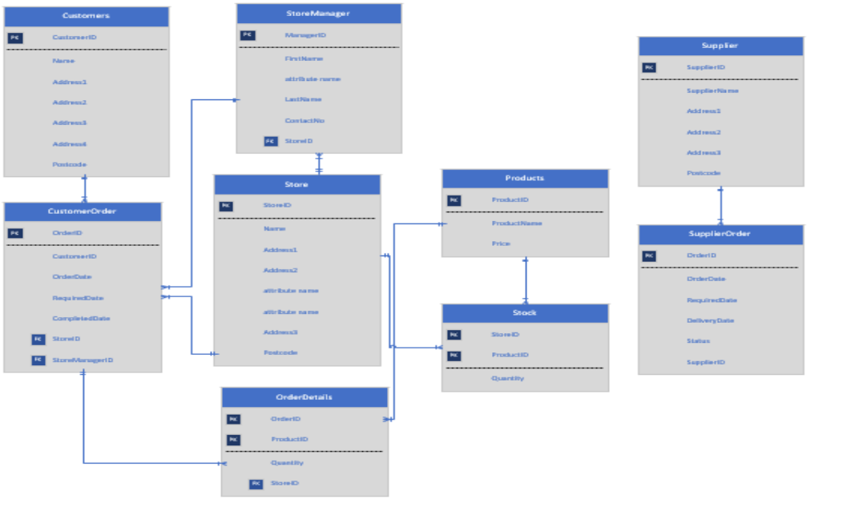

Report output

In order to produce this report, a parameter screen pops up asking the user to enter the order id which then shows the full cost report for that order.
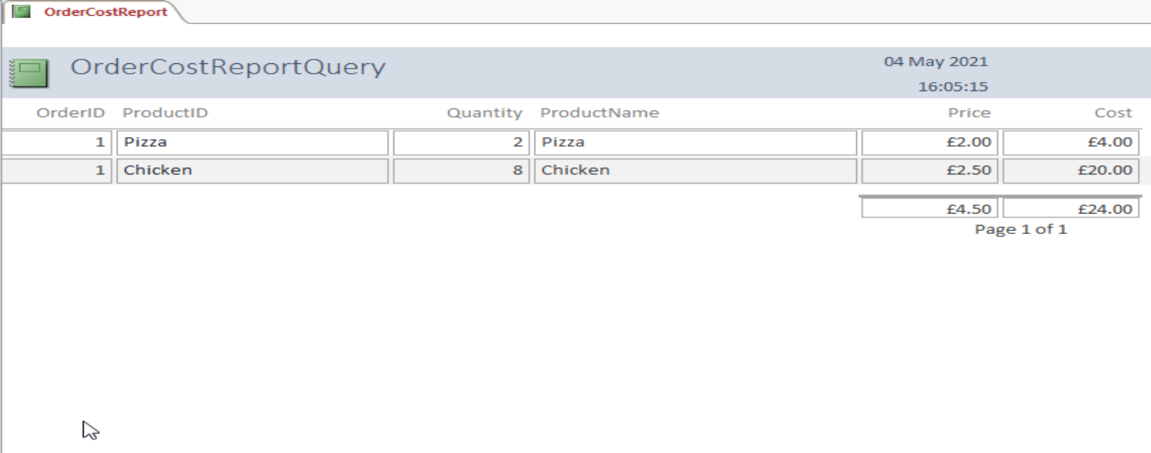

Due to time constraints with work commitments this is the only report I produced but I made sure I added a calculated field and I used a report that I thought the users would want to see.

Forms

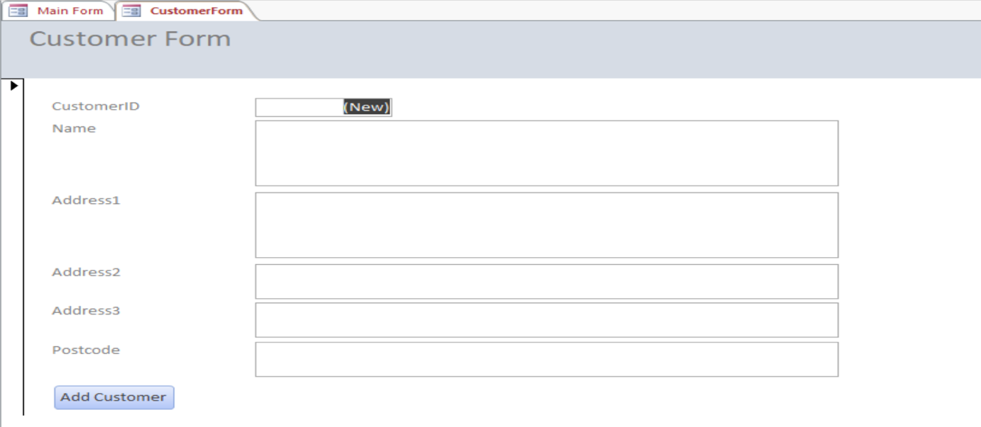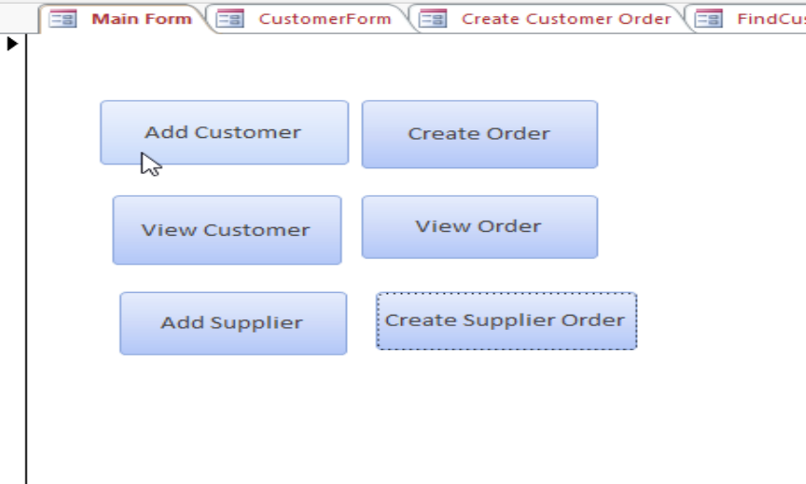
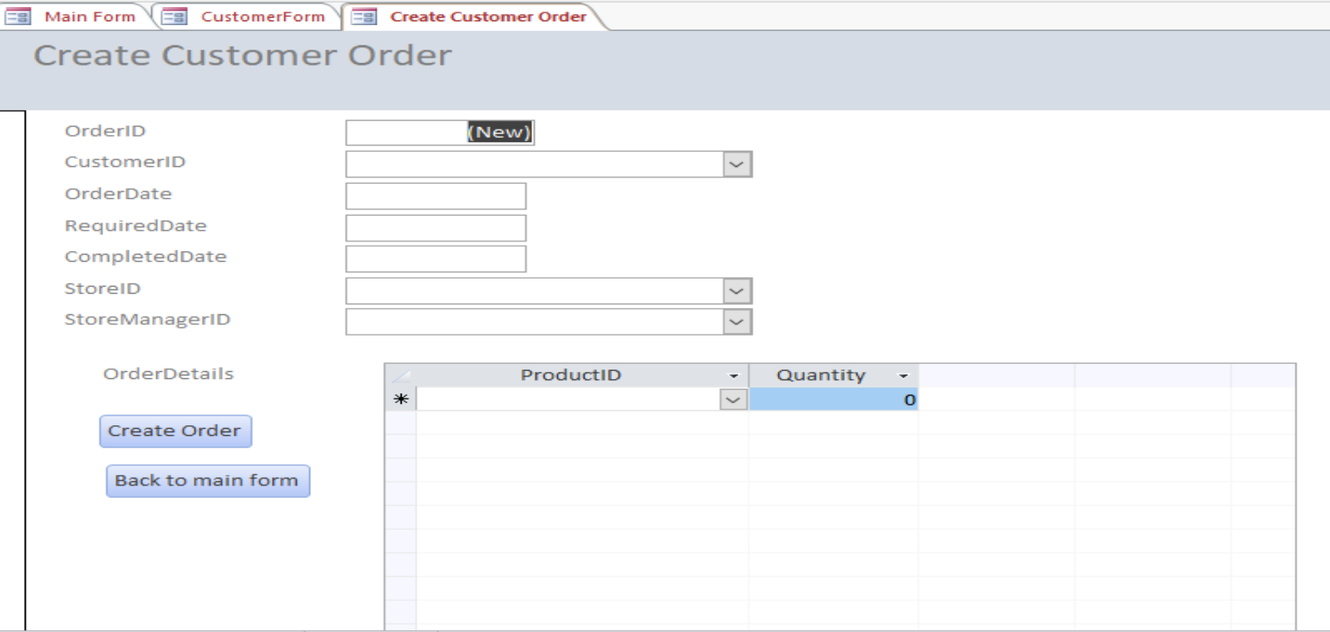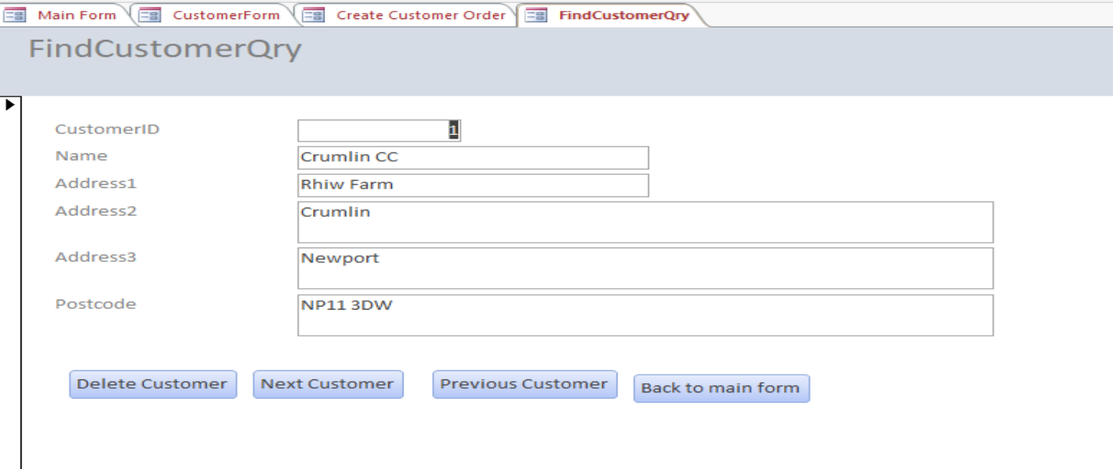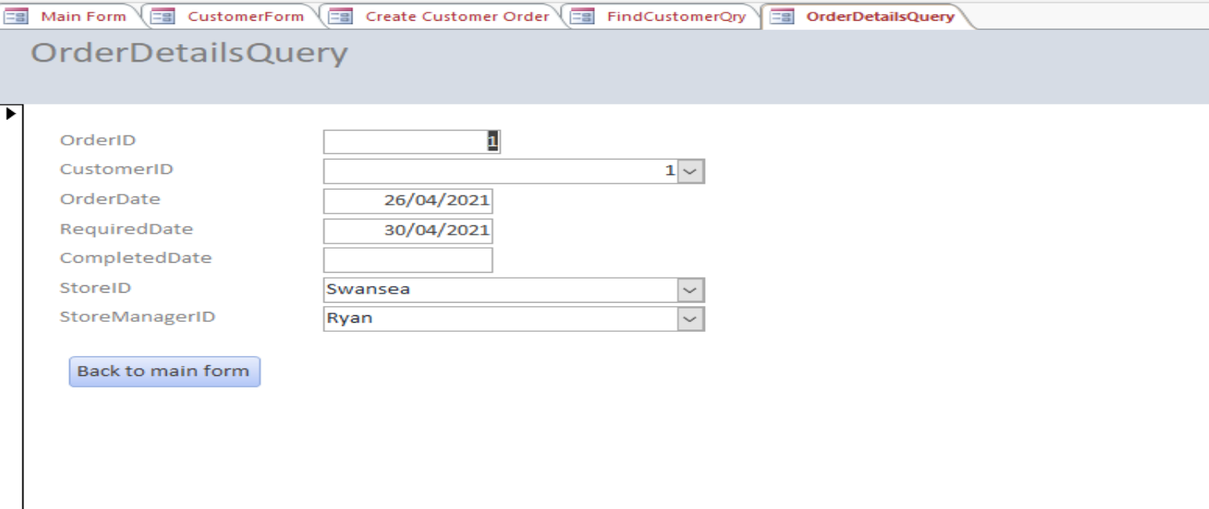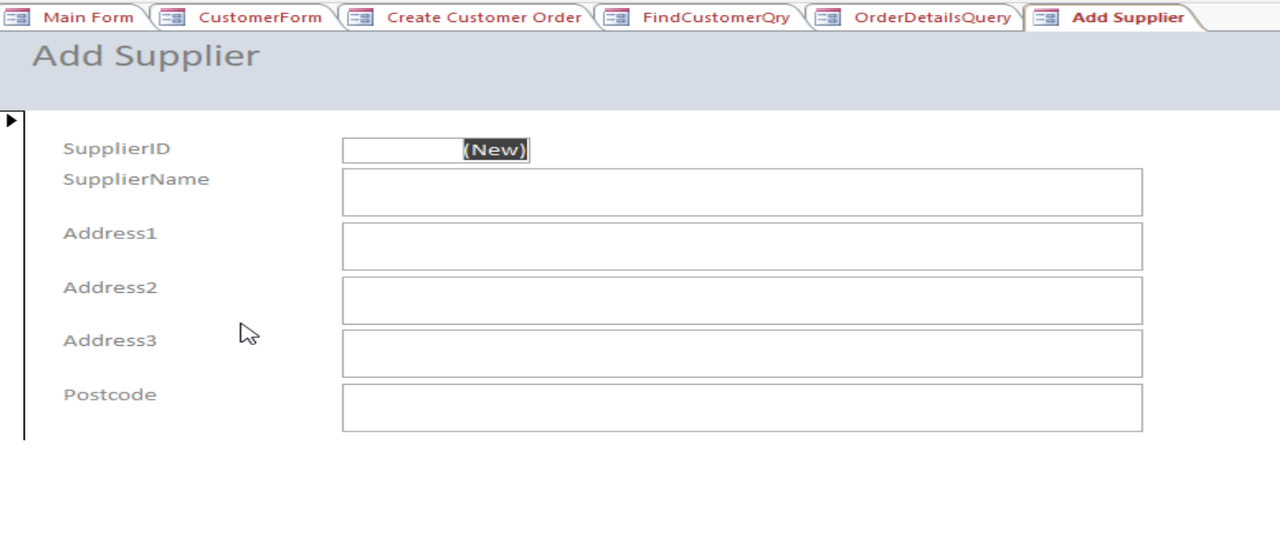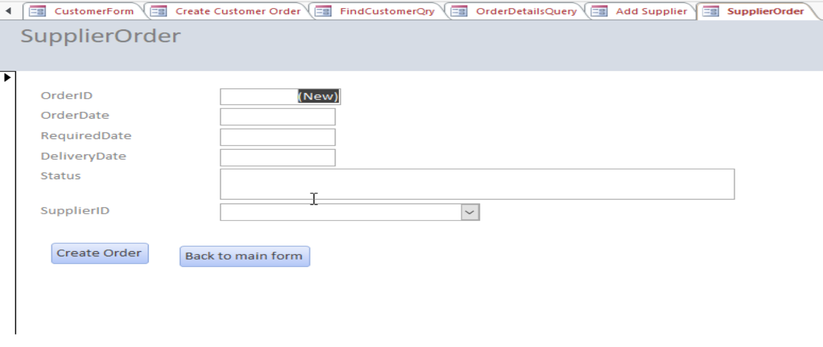

User Guide

Main Form: is the starting point of the system and opens when you open the database. This includes buttons to all the other forms on the system and all of these forms contain a button to allow you to navigate back to the main screen.

Customer form: Allows the user to enter details about a customer and then save to the details to the Database once clicking the ‘Add Customer’ button.

Create Customer Order Form: Allows the user to use the drop down lists to retrieve information about the Customer, Store and Store Manager before adding items to the order on the Order Details subform and then clicking the ‘Create Order’ button to save the order to the database.

FindCustomerQry Form: Allows the user to search for details on a Customer using their ID that is entered one opening the form. You can also navigate between to Next and Previous Customers using the buttons, as well as being able to delete a customer record (assuming there’s no orders attached due to the reference to this table).

OrderDetailsQuery Form: Allows the user to look up details on a customer’s order using the OrderID, which is input when opening the form.

AddSupplier Form: Allows the user to add a new supplier and their details to the Database.

SupplierOrder Form: Allows the user to create a new supplier order. They can select an existing Supplier to associate this with using the Supplier ID drop down/lookup list.

OrderCostReportQuery Report: This gives the user details on a specific order (using the OrderID), which needs to be input on opening the form. This also give the total cost for the order and the items that were order altogether.

Conclusion

If I had more time to complete this and was to do it again, I would make a few improvements to the database. For example, I didn’t have much time to enter much test data into the database. I also created a quantity column on the Stock Table which I would like to have updated when orders were made but also didn’t get a chance to do this. Although I added some input masks to some columns (postcodes for example), I would like to have added some Validation rules to data input and then give the user a meaningful message when they have input some incorrect data.

However, I hope I have demonstrated my understanding of relational databases and how they work as I felt this was the most important part. I have many years experience of working with databases (SQL Server, Postgres, Ingres, DynamoDB) so feel very comfortable working with them and the quirks of MS Access is something I felt I spent more time working around in this assessment.

For Reference:

Online articles used in helping me create my application:
- Microsoft [1]
- Microsoft Access Tutorial [2]

Videos:
- YouTube Video [3]
Books:
- Introductory Relational Database Design for Business, with Microsoft Access [4]
References
[1] Anonymous (). Create a diagram with crow's foot database notation. Available: https://support.microsoft.com/en-us/office/create-a-diagram-with-crow-s-foot-database-notation-1ec22af9-3bd3-4354-b2b5-ed5752af6769 [Accessed May 5, 2021].
[2] Anonymous (). Access video training. Available: https://support.microsoft.com/en-us/office/access-video-training-a5ffb1ef-4cc4-4d79-a862-e2dda6ef38e6 [Accessed May 5, 2021].
[3] Anonymous "How to Create a Stock Management Database in MS Access (NO MUSIC VERSION) - with Free Download," 2016. Available: https://www.youtube.com/watch?v=049IlFNcrl0.
[4] J. Eckstein and B. R. Schultz, Introductory Relational Database Design for Business, with Microsoft Access, Newark, UNITED KINGDOM: John Wiley & Sons, Incorporated, 2018Available: http://ebookcentral.proquest.com/lib/trinity/detail.action?docID=5131970.

