
INNOVATION CONSULTANCY
Lead Consultant

Contact
Phone 01234 567899
Email doesntexist@live.co.uk

Neath Port Talbot County Council
The Quays,
Brunel Way,
Neath,
SA11 2GG

Dear Client,
As you are aware, the current project for the infant school in Port Talbot falls under the sustainable communities for learning programme and thus is required to meet the Building Information Modelling (BIM) maturity levels.
BIM is not just the use of software to create scaled 3D models, it is a process to collaborate and managing an asset throughout its lifecycle, from strategic definition to design, construction and eventually operation.
There are 4 BIM maturity levels that range from low collaboration (no BIM) to full integration (iBIM). Traditionally, many copies (and copies of copies) were sent and shared with various contractors, subcontractors, and specialists, creating an endless cycle of professionals sending and receiving out of date information. BIM fosters and exchange of data and skills in real-time context. All parties involved in this project will have consistent access to the same data via a Common Data Environment (CDE), a collaborative platform on which information is available through shared, regulated conditions. The CDE, specific for this project, will contain information that has been collated from different sources and will contain contract details, reports, and models for the design, among other data.
The first step is for all parties to agree on the platform used and a set of standards. This project will be cloud-based and follow the international standards (BS EN ISO 19650-1:2018, BS EN ISO 19650-2:2018, etc).

This project will be a fully integrated (level 3) BIM project, with simultaneous shared model space online, allowing real-time capture and exchange, across all aspects of the construction process. At this level, information from the building is used to plan for future maintenance, upgrades, expansions, or energy efficiency improvements. Level 3 BIM allows for the opportunity to connect the entire supply chain with the integration of sustainability (6D) and facility management (7D) data, focusing on the building’s entire lifecycle.
The elements of the CDE will be in outlined the BIM execution plan, which is a resource that highlights how a project team will use BIM workflows, techniques, and tools to reach the desired project outcome. It also includes the roles and responsibilities of those involved, project timeline, and deliverables.
A BIM Execution Plan (BEP) is an important part of the BIM process as it helps to set clear goals and coordinate all aspects of the project. It provides the answer to all the critical questions that are no doubt going to be asked. For example, what software is to be used. A BEP can contain a lot of crucial information including a brief introduction to the project, roles and responsibilities, key performance indicators, response to the EIR, project implementation plan, project milestones, software and hardware to be used, standards to be followed, training requirements, risks and rewards and BIM quality management processes to be used.
Each BEP for each project is different and can include more or less data. Again, just setting out a checklist or word document is not a BEP. It still needs to be a collaborative aspect of the project. The new ISO 19650 standard uses an approval process that has the following statuses: work in progress, Shared, published, and archived.

A BEP is used to demonstrate to the client (yourself) that the delivery team has the ability to handle project data. It is also used to offer a delivery tool that the delivery team will use to produce, manage, and exchange information on the project. In short, it contains the who, what, when, and where in a BIM project (McParkland, 2017).
For you, the client, BIM will be implemented into the operational phase by way of asset procurement, monitoring maintenance, and space management. This is not an exhaustive list of all possible BIM applications, but they are the ones that are most useful in this project for this phase of the building’s lifecycle.
Additionally, the use of a computer aided facilities management system (CAFM) will help streamline the management of the facilities, infrastructure and assets, allowing full visibility of costs, risks and assets, enabling better time management. The BIM model will provide data for the integration to CAFM software. Autodesk Revit and BIM 360 are CAFM software choices that integrate with he BIM model. The use of a CAFM system shows real-time condition of assets allowing facility managers to plan repairs and maintenance effectively. It reduces costs by a reduction of manual labour due to minimising human error. Connecting BIM with CAFM is critically important in order for the building to be running efficiently in the operational phase.
The school’s facility management team will be trained and have full access to the BIM and CAFM systems/software allowing for seamless handover and operation of the building.
I hope the information provided highlights my teams understanding and implementation of BIM for your project.
Sincerely,
Eleanor Black
The level of information need provides methods for describing information to be exchanged according to exchange information requirements (EIR). The EIR specifies the wanted information exchange and the result of this process is an information delivery. Level of information need was introduced in BS EN ISO 19650:2018 and sets out the level of information need as the quality, quantity and granularity of information. Depending on each project or phase, the information can be documentation (reports, manuals, sketches), alphanumerical data and geometrical information.
It's relevance to BIM is so that the correct information reaches the right people with precision and in an efficient manner. It is crucial to have a framework set out to determine the quality of information, to minimise the occurrence of insufficient, wasteful and incorrect project information (Catenda, n.d).
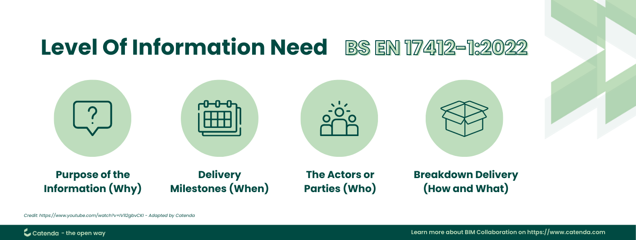
In short, information is required to fulfil a purpose. Different purposes may require different information deliverables. Therefore, different purposes require different level of information need. The purpose is the why, the delivery milestone is the when (RIBA stages), the actor is the who (eg. Cost consultant), and the object is the what (eg. Beam, column, render, etc). Level of information need is not the same as level of detail. The pre-requisites must be identified before defining the level of information need.
To apply the level of information need, firstly, the purpose of the information needs to be identified. It is paramount to specify needed information in correlation with the purpose to carry out a task or make a decision. Next is setting out delivery milestones, anticipating the level of information and actual use of it over different stages and milestones throughout the lifecycle of the project. Identifying actors and patries involved over the various stages of the project, allows for precision of producing and sharing information and determining who will receive and process it. Lastly, determining the type of information suitable for each stage and requirement. The types of information are Geometrical, documentation, and alphanumerical. The ISO standards also sets out the importance of integration between technology and people. The level of information need should be coherent enough for people to read and to be processed and verified automatically. This allows for human error to be minimised and to speed the process up, making things run more efficiently.
The level of detail for Building Information Modelling (BIM) project increases as the project proceeds, starting as existing information to then developing to a concept design through to a detailed 3D construction model to eventually, an as-constructed asset information model (AIM). Different aspects of the model will progress at different rates, with different members of a project team, and will be passed amongst different parties before eventually, being handed back to the client.
It is imperative that the employer defines the level of detail needed at each stage of development. This ensures that the design is being developed in sufficient detail, that the information needed to make informed decisions about the project development can be made and that efficient operation of the completed project is provided.
The employer defines the level of detail required in the Employer’s information requirements (EIR). The EIR is normally appended to the BIM protocol and contracted by way of the “modelling enabling amendment”, making delivery of required information a contractual obligation. A summary of level of detail requirements and responsibilities may be found in the mpdel production and delivery table.
BS EN ISO 19650 specifies two components of the level of definition: the level of detail, which is the graphical content of models, and the level of information, which is the non-graphical content of models. These two categories are closely aligned, often developing alongside each other.
The levels of model detail and information are defined for key stages of the project where information exchanges take place, enabling the employer to verify that project information given meets the employer requirements and allowing them to decide to proceed to the next stage. There is currently no standardised time-frame for information exchanges or for levels of detail and levels of information, except that they should be aligned to employer decision points and should be consistent. This is due to the difference in nature of each project.
LOD is required at every stage of development. At stage 2, the concept design, the requirement is for visual information to provide general principles of the design to meet the client’s brief. The general principles would provide information such as colour, context, scope and materiality. The purpose is to provide a visual aid of proposals at a concept design level to show general spatial coordination, access and maintenance zones.
At stage 3, the spatial coordination stage, the requirements are for more developed and detailed visual principles. The development should show coordination for general size and relationships between different elements. At this stage a brief can be created for the specialist to create the technical design, including critical dimensions, performance requirements and level of finish. The purpose of this is to provide a viusual representation of the proposal at at greater level of spatial development, so that the brief can be completed at the technical design stage.
What is required at the technical design stage? This stage also works off the previous stage, with visual information providing fixed principles to support procurement. All professions need developed spatial coordination and visual depiction showing coordination for size and relationships between different elements of the construction. The graphical representation needs to be dimensionally accurate. The purpose of the technical design is to provide visual representation of proposals at a technical design level, supporting full spatial coordination.
For construction, it is much the same at the technical design stage with finer detail of visual representation provided to aid construction. Final coordination for size and relationship between different elements is given at this stage. Dimensionally accurate graphical representation with sufficient information provided to support installation. The purpose is to provide sufficient information to aid in the construction and installation of required works/products and to be updated during the construction phase with final decisions made.
Originally, LOD framework was understood as level of detail as established by The American Institute of Architects, however, this soon changed to level of development due to the fact that as an element or model becomes more developed, there is more detail that is subsequently available. The LOD is the depth of thinking involved and the reliability of a model. There are six stages of LOD ranging from LOD 100 to LOD 500.
LOD 100 is concept design giving viewers a basic representation of existence but no information about size, orientation or shape. LOD 200, or schematic design, is a more defined version giving viewers some idea about size, location without too much precision. LOD 300 (design-specified) refers to exact geometric size and dimensions along with orientation and location. LOD 350 is the roughly the same as LOD 300 except that it shows how the model will be connected to nearby components, which is a minimum requirement of construction companies. LOD 400 (added components) is where sufficient information is added in order to fabricate the component, suitable for fabricators and assembly purposes. The last stage is LOD 500 which is the final design in a fully developed and functional model including verified information about individual, installed components. This reflects real-world conditions for maintenance and facility management.
BIM forms the basis for LOD integration, allowing digitisation for creation, management and sharing of detailed representations of a projects components. LOD provides a framework that specifies the accuracy required in BIM models at various stages. LOD is tracked through the LOD matrix, found in the BIM execution plan, where project teams can outline LOD requirements for specific components or systems throughout a project at different stages. The LOD matrix serves as a reference, assuring the BIM models created meet the LOD requirements and is continuously monitored throughout for compliance (Autodesk.com, 2023).

Reference list
Autodesk.com. (2023). Levels of Development (LOD) in BIM | Autodesk. [online] Available at: https://www.autodesk.com/solutions/bim-levels-of-development#:~:text=Levels%20of%20Development%20offer%20a%20range%20of%20benefits [Accessed 16 Jan. 2024].

Catenda. (n.d.). Level Of Information Need. [online] Available at: https://catenda.com/glossary/level-of-information-need/ [Accessed 15 Jan. 2024].

McPartland, R. (2017). What is a BIM Execution Plan (BEP)? [online] NBS. Available at: https://www.thenbs.com/knowledge/what-is-a-bim-execution-plan-bep.

NBS. (n.d.). Level of detail LOD and digital plans of work. [online] Available at: https://www.thenbs.com/knowledge/level-of-detail-lod-and-digital-plans-of-work#:~:text=LOD%20%3D%20 [Accessed 15 Jan. 2024].

Samuel, E. (2023). The Pros and Cons of Computer Aided Facilities Management. [online] Elogs | Powering better buildings. Available at: https://www.elogs.co.uk/the-pros-and-cons-of-cafm-in-facilities-management.
‌
www.designingbuildings.co.uk. (n.d.). Level of Development LOD. [online] Available at: https://www.designingbuildings.co.uk/wiki/Level_of_Development_LOD [Accessed 16 Jan. 2024].
‌

https://www.designingbuildings.co.uk/wiki/Level_of_Development_LOD


