Professional Career Development

Student’s Name: Petal Charmaine Jones
Student’s #: 1812740
Module #: BMSK 4005
Module Title: Professional Career Development
Lecturer’s Name: Mr. Anupam Mazumdar
Term 3

Introduction
The purpose of this assignment is to reflect on myself and understand where I am at the moment. In addition to this I will reflect on several different learning styles and what skills and knowledge are require of me in order to secure employment. These skills are: Communication, Time Management, Problem Solving and Decision Making, Computer skills, Teamworking, Leadership, Management and Transferable skills. In every work organisation, Professional Career Development is very important to the organisation and for those seeking employment within the organisation. With these skills one can gain knowledge and be more employable.
A life experienced diagram (see figure 1 below) can be used to show where I have been and where I am presently.
Positive

Employment
Education
Hospitality Assistant
New job
First Child
Education

Age 10 Age 53
Surgery
Mom died
Made redundant
Negative

Figure 1: Personal Life journey

From age 10 until now this is where I am now. Now that I am in Education, I will require some skills and knowledge to move forward. These skills and knowledge will make me more employable. The skills that were listed above will now be expounded on.
Communication Skills- Communication is when information is passed beginning with one individual then onto the following. This is the most critical capacity to any viable presentation or business. This bent is significant to me as an understudy and a future boss since it will help in dismissing misguided judgments among workers and various pioneers. For instance, Morley et al. (2002, p. 69) addressed how: "Affiliations that make reasonable correspondence procedures are bound to both have positive workplaces and be continuously persuading in accomplishing their goals".
Thusly, communication adds to widened occupation satisfaction for operators and better basic concern benefits for the affiliation. In like way, Zwijze-Koning and de Jong (2005, p. 429) joined that, "The significance of correspondence for the feasibility of affiliations and the accomplishment and motivation of delegates is undisputed". In like way, study has indicated how vain or ruinous power correspondence can be heartbreaking for affiliations (Schyns and Schilling, 2013; Tourish, 2013).
As indicated by Baczor (2019) "great worker communication will help individuals to comprehend their association's motivation and methodology. She further expresses that laborers are bound to contribute more and feel submitted if there is a culture of pen communication."
Communication skills are one of the key skills that employers are looking for in employees. However, to communicate effective you must have good interpersonal skills. According to McConnell (2004) interpersonal skills engaged with managing and identifying with others, generally on a coordinated premise.

Convincing communication is the establishment of any productive business, and to be a nice communicator, you need social capacities. They are significant for the establishment of associations among yourself and your accomplices, which prompts a mutual exchange of contemplations, information and capacities (Phillpott,2020)Moreover, you set up shared regard and thought for each other's assessments and info. Correspondence directed as such empowers a progressively liquid presentation of obligations, better administration of undertakings and the auspicious fruition of assignments (Phillpott, 2020). Along these lines, relational aptitudes are urgent.
According to Phillpott (2020) with great interpersonal skills, your associates and chiefs are unmistakably bound to see you as an agreeable individual. Accordingly, associates will be progressively open to connecting with you and all the more ready to look for your help and exhortation. You will likewise find that individuals become simpler to work with, enabling you to draw in with them all the more seriously and in this way increment efficiency levels no matter how you look at it.
Also, interpersonal skills make a powerful pioneer. This is on the grounds that the capacity to encourage relational connections, build up trust and impart obviously are for the most part significant aptitudes for a viable pioneer. A pioneer without the capacity to associate with their group will unavoidably bomb in the long haul, while important colleagues will probably escape temporarily. In any case, it will bring about lost efficiency, and it will trouble the rest of the representatives with extra work.
Another important skill that employers are looking for is Time Management.
Time management is significant with regards to finishing various errands, for example, task or introductions for work. Creating time the executives needs practice and a great deal of direction en route. The objective is to help gotten mindful or educated on the most proficient method to utilize one's time adequately.
As per Mann (2008) time management is the procedure associated with arranging and overseeing the measure of time spent on specific exercises so as to improve proficiency, viability and efficiency. He proceeded to state that in practicing the demonstration, scope of aptitudes, number of instruments and accessibility of procedures will be expected to achieve explicit assignment, destinations and objectives. Organizing and sorting out our time is significant particularly when we need to comply with a time constraint.
As indicated by the Essay UK (2018) Managing one's time includes organizing the errands ones needs to perform. It is critical to organize exercises arranged before you all together not to wind up accomplishing a point that doesn't convey reward and disregarding an action that when finished includes esteem. The capacity to rapidly process and investigations data and form it enthusiastically is one of the most new aptitudes of the expert present reality. They proceeded to state one must arrange their remaining task at hand arranged by significance and direness.
One method you can use to prioritize your time is the Eisenhower method. According to Oppong (2017) this is a technique used to sort out obligations and undertakings so as to make sense of needs. It's a helpful time the executives instrument for completing things. It's a prioritization system. It centers around radical or extraordinary prioritization. This straightforward model encourages move your deduction to long haul key arranging and efficiency. A great deal of things that take up mental vitality, sit around, and seldom push you toward your objectives can without much of a stretch be wiped out on the off chance that you apply the Eisenhower Principle. It's a straightforward basic leadership apparatus you can utilize at the present time. It's intended to assist you with addressing whether an activity is vital (Oppong, 2017)
Of course, organizing is the first and most beast utmost of the administrators as a method that takes every single other cut out (Sikavica et.al, 2008). Getting filtered through is an indispensable technique for making coordination and correspondence among the various bits of a coalition. Different businesses and positions are interrelated by fundamental relationship. It shows the channel and framework for correspondence among different people.
Organizing is a huge and the essential mechanical party to accomplish attempt objectives. A sound structure helps the relationship from various perspectives. It depicts different exercises and their ability relationship in the undeniable structure. It can avoid perplexity and deferrals moreover as duplication of work and covering of exertion. It is the structure by which the board arranges, controls, and animates the different exercises in the undertakings (Managementstudyguide.com., 2019).Problem Solving and Decision Making are another key skill that employers look on before they hire you. Problem Solving is the capacity to comprehend an issue by separating it into littler parts, and recognizing the key issues, suggestions and distinguishing arrangements. To apply your insight from a wide range of territories to settling an undertaking and thinking of an appropriate choice.

Making good decisions are commonly huge in light of the fact that as a future director or a pioneer there will be times when I should choose decision about how I need the business to push ahead. Without fundamental initiative contrasting administrative utmost, for example, planning, filtering through, arranging, controlling, staffing can't be driven. Continuously end, when a master does, she or he makes every central walk through fundamental power work. In this manner, we can say that essential initiative is an enormous fragment to finish as far as possible.
Affiliations suffer or evaporate essentially in perspective on the probability of the specialists that leads them. Basic organization isn't the focal, yet the crucial farthest reaches of the board that contributes most to the accomplishment or disillusionment of the affiliation. The director is the individual who picks decisions and significant authority is the epitome of masterminding.
Listening skill is one of the many skills that employers seek from their employees.
Listening skill is a very important skill that requires paying close attention to what the speaker is saying and understand their point of view. According to McKay, Davis, and Fanning (1995, cited in Maund, Schriek and Tinkler, 2017) listening requires a lot of effort and discipline if one does not do this they will end up being distracted which I agree with, if someone is trying to pass on a message and you do not listen and understand what they are saying if you do not listen to understand this can cause a problem. In addition to this distractions and noise, or maybe because of noise, you may fail to focus on the message being sent. As a result, you are not listening effectively (Freya, 2009, cited in Maund, Schriek and Tinkler, 2017). According to Branson (cited in Covey, 2004) listening is one of the main factors behind the success of virgin as a listener attention to detail is very vital.
In today’s society we all need to be computer literate. Technology is advancing rapidly, and you have to keep up to date. All the organisations are involved in some form of technology. Pens and papers are not effective anymore in the workplace or overall. When employers are hiring you, they ensure to check you are computer literate. Computing skill is another key skill that employers’ value in their employees.
According to Indeed.com (2020) computer skills include the capacity to learn and work different innovation. Equipment abilities enable you to physically work a PC and can be as straightforward as realizing how to turn gadgets on and off. Programming abilities help you to productively utilize PC projects and applications. There are some product abilities that businesses may consider as requirements to work, such as utilizing spreadsheets or knowing a specific coding language.
Related PC abilities include:
• Typing/Word handling
• Fluency in coding dialects
• Systems organization
• Spreadsheets

One other important employability skills that we must all have is Teamwork Skills. Groups are made out of people who have a few unique qualities. Collaboration is a helpful procedure that enables standard individuals to accomplish remarkable outcomes (Scarnati, 2001). Cooperation is synonymous to working cooperatively in gatherings.
Right when individuals working helpfully in social events, they (1) have a common total character, (2) have shared targets, (3) are connected similar to their assigned endeavours or results, (4) incorporate specific employments inside the gathering, and (5) are a bit of a greater various levelled setting that effects their work and that they, in this way, can affect (Kozlowski and Ilgen, 2006).
Facilitated exertion answers upon people taking an interest in a satisfying condition to accomplish regular social occasion objectives through sharing information and limits. The creating constantly incorporates that one of the key pieces of a social occasion is its concentration toward a typical objective and a reasonable clarification. Profitable composed exertion depends on synergism existing between all accomplices making a situation where they are regularly arranged to contribute and partake so as to advance and reinforce a positive, persuading gathering condition.
Associates must be sufficiently versatile to change in accordance with pleasant working environments where destinations are practiced through composed exertion and respect with another partner. Coordinated effort incorporates building associations and working with others using different critical aptitudes and penchants, for instance, working pleasingly; adding to bundles with considerations, recommendations, and effort; an attention to other's desires; a sound respect for different suppositions; and ability to participate in aggregate decision making. Participation is a key need in numerous occupations and an essential bit of workplace accomplishment.
Businesses are trying to enlist people who give due consideration to relations with companions and bosses. Understudies and managers noticed the capacity to work with others successfully is a significant work-availability expertise (Crawford, 2011). Business administrators need to enlist representatives who will increase the value of the working environment with a composite of delicate aptitudes and who will grasp cooperation (Griffin and Annulis, 2013). Collaboration abilities that add to gainful working connections and results.
Collaboration aptitudes are a lot of abilities that people use to cultivate the accomplishment of gatherings or groups from differing foundations. Cooperation abilities bunches comprise of various features: (a) gainful as a colleague, (b) positive and empowering frame of mind, (c) prompt and fulfills time constraint, (d) keeps up responsibility to the group, (e) work with numerous methodologies, (f) mindful and delicate to decent variety, and (g) share thoughts to different crowds (Crawford, 2011).
Transferable Skills is also a very important employability skill to possessed in today’s society. The Organisation for Economic Co-operation and Development (OECD) defines transferable skills as 'the heap of information, properties and limits that can be scholarly and that empower people to effectively and reliably play out a movement or task and can be based upon and reached out through learning'. The significance of transferable abilities is progressively underscored as of late. The weight of worldwide challenge implies that graduates need to offer a business more than scholarly abilities customarily spoke to by the subject and degree class. Transferable aptitudes are the establishment whereupon you will fabricate extra, increasingly complex abilities as your vocation unfurls.
Career Ambitions and Aspirations
With all of the skills that I currently have in business, I aspire to learn more about managing a business. I also aspire to educate myself more by going back to school and complete a bachelors degree in Business Management. I aspire to become an expert in the business field also. On the other hand, my career goal is to develop my computing skills in the next year and manage my own business in the next five years.
Smart Objectives
- My objective is to achieve at least 90% for each course in 2020
- My objective is to complete my Bachelor’s degree December 2021.

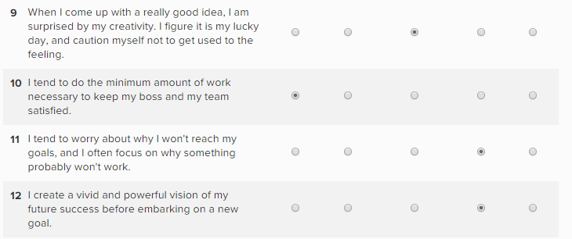
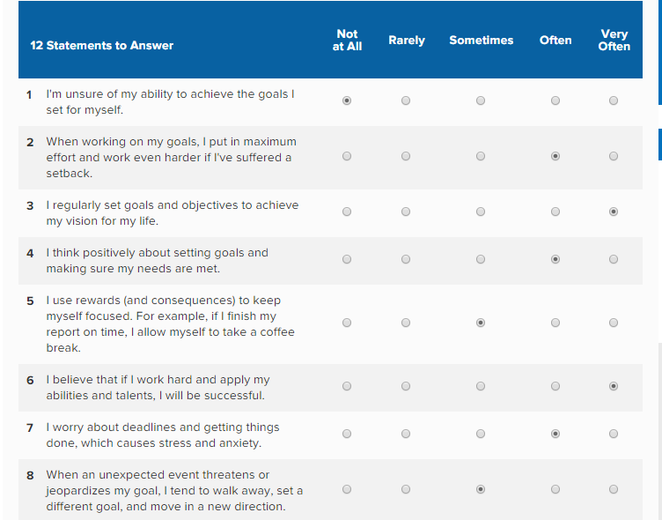
Self- Motivation Quiz (see results below)
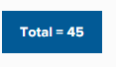
Self- Motivating Review
Based on the self-motivation quiz I am doing awesome I complete things, and I do not give anything stand access my direction. I put forth a cognizant attempt to remain self-propelled, and I invest noteworthy energy and exertion on defining objectives and acting to accomplish those objectives. I pull in and rouse others with my prosperity. These characteristics must be cherished as I am exceptionally mindful that not every person is as self-persuaded as I am.
Learning Styles
Kolb’s Learning Styles
McLeod (2017, cite in Kolb 1984) stated that there are four different learning styles: diverging (feeling and watching), assimilating (watching and thinking), converging (doing and thinking) and accommodating (doing and feeling).
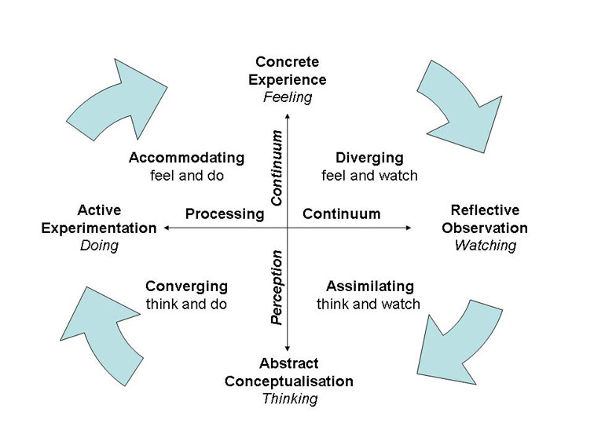
Below is a diagram of Kolb (1984) learning cycle/ style.

Figure 2: Kolb learning cycle

Assimilating (watching and thinking - AC/RO)
The Assimilating learning preference is very important because it allows you to prepare yourself for a task beforehand. By doing this you will gather all the relevant information needed. This learning style involves a concise, logical approach. Ideas and concepts are more important than people (McLeod, 2017 cited in Kolb 1984).
Converging (doing and thinking - AC/AE)
According to McLeod (2017, cited in Kolb 1984) people with a converging learning style have a way of thinking how to do things. This gives them the opportunity to view it from different angles then figure out how it should be done. If they are required to do challenging task with little or no experience, then they would be required to spend time researching on the given topic and figure out how it supposed to be.
Accommodating (doing and feeling - CE/AE)
With the Accommodating learning style as an individual you sometimes have task to do and not experienced enough in doing so. In order to complete this task, you have to ask question from someone who has the experience then from their idea you can go ahead and complete what is to be done (McLeod, 2017 cited in Kolb 1984).

Diverging (feeling and watching - CE/RO)
According to McLeod (2017, cited in Kolb 1984) these individuals can take a gander at things from alternate points of view. They are delicate. They want to observe as opposed to do, tending to accumulate data and use creative mind to take care of issues. They are best at review solid circumstances from a few distinct perspectives.
Kolb called this style 'diverging' in light of the fact that these individuals perform better in circumstances that require thoughts age, for instance, conceptualizing. Individuals with a wandering learning style have expansive social premiums and like to accumulate data.
They are excited about people, will all in all be imaginative and eager, and will as a rule be strong in human articulations. People with the isolating style need to work in social affairs, to tune in with a responsive standpoint and to get singular info.
The VAK Learning Style
This style of learning was created with three different teaching methods they are Visual, Auditory and Kinaesthetic, with these three styles one will be able to determine how to handle a situation the first phase of this method is Visual where you observe something by looking at it in more details. the Auditory is where you listen and hear what has been said then you have the option to talk about it the Kinaesthetic learning method is the physical experience where you will be able to talk about your feelings.

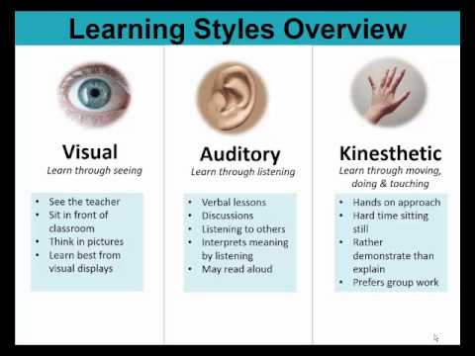

Figure 3: This photo is VAK learning style (McMillan, 2017)

Honey and Mumford Learning Style
This learning style was created by Peter Honey and Alan Mumford, similar to Kolb where both acknowledge the four different learning styles and are putting them into practice, which are as follows Activist, Theorist, Pragmatist and Reflector These are the learning stages that a person should take into consideration and follow in order to identify what type of learner they are.

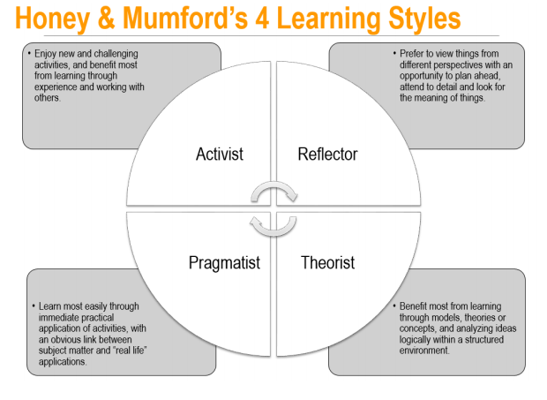
Figure 4: Honey and Mumford Learning style
From considering these learning styles, I understood that I fall into Kolb's converging style. I have the joining learning style. When there are any troubles, I would be the first my collaborators or cohorts would come to. I would urge them on what to do and how to do it. I appreciate doing this without question.

SWOT Analysis
Strength  - Good Communicator  - Creative  Commitment | Weakness  Computer skills  Time management
Opportunities  Seminars to develop my computer  Skills  People management courses | Threats  The advancement of technology

Personal Development Plan based on SWOT Analysis
Target | How? | Support/ Resources | Date
Computing skills. | Further training and development in technology. | Online training courses and training institution | February 2020
Time management skills | Reading and research prioritizing | Teaching myself how to prioritize my time effectively further reading | February 2020

Johari Window
Known to Self Not Known to Self
Arena  Working for Baxter Storey catering at Chartered Institute of Personnel and Development (CIPD) | Blind Spot  Clever  Has many abilities  Motivational leader  Open minded
Façade  Studying business management  Very outspoken  Taking driving lessons | Unknown  Getting married

Known
to Others

Not
Known
to Others

Action Plan
In the future I will attend seminars, workshops and training about computing and time management skills. I will talk to experts in this field to increase my knowledge. I will also enrol myself into an online course about computer skills so that I can be more computer literate to survive in today’s technological world and to make myself more employable.
Conclusion
In today’s society employability skills are vital to both the employer and the employees. The most vital employability skills are communication, time management and team working. With these skills you will be able to gain employment in the world of employment in today’s society. Without these skills is very hard to secure a job. In general, most bosses need representatives who will be successful in the present evolving economy. They want to enlist individuals who can oversee change and flourish with it, adaptable and versatile laborers who rush to learn. Additionally, it is very significant to set goals and work towards them. Your goals must be specific, measurable, attainable, realistic and timely so they can be achieved.

References
Covey, S. R. (2004). The seven habits of highly effective people. London, Simon & Schuster.
Crawford, P., Lang, S., Fink, W., Dalton, R., & Fielitz, L. (2011). Comparative Analysis of Soft Skills: What is Importance for New Graduates? Washington DC: Association of Public and Land-grant Universities.
Indeed.com. (2020). 10 Best Skills to Include on a Resume (with Examples) | Indeed.com. [online] Available at: https://www.indeed.com/career-advice/resumes-cover-letters/best-resume-skills [Accessed 11 Jan. 2020].
Griffin, M., & Annulis, H. (2013). Employability skills in practice: The case of manufacturing education in Mississippi. International Journal of Training and Development, 17(3): 221-232
Kolb, D. A. (1984). Experiential learning: Experience as the source of learning and development (Vol. 1). Englewood Cliffs, NJ: Prentice-Hall.
Kozlowski, S., & Ilgen, D. R. (2006). Enhancing the Effectiveness of
Work Groups and Teams. Psychological Science, 7:77–124.
Managementstudyguide.com. (2019). Management Study Guide - Library. [online] Available at: http://www.managementstudyguide.com/all-subjects.htm#management_functions [Accessed 25 Aug. 2019].
Maund, A. Schriek, M. and Tinkler, P. (2017). Certificate in Higher Education: Skills for the Workplace Student Yearbook. Sage Publications
McConnell, C.R., (2004). Interpersonal skills. What they are, how to improve them, and how to apply them. Health Care Management (Frederick). 23(2): pp. 177-87
Morley, D., Shockley-Zalabak, P. and Cesaria, R. (2002). Organisational influence processes:
perceptions of values, communication and effectiveness, Studies in Communication Sciences,
2, pp.69–104.
Phillpott, S. (2020). The Importance of Interpersonal Skills in the Workplace. [online] Careeraddict.com. Available at: https://www.careeraddict.com/the-importance-of-interpersonal-skills-in-the-workplace [Accessed 06 Jan. 2020].
Scarnati, J. T. (2001). On becoming a team player. Team Performance
Management: An International Journal, 7(1/2): 5-10.
Schyns, B. and Schilling, J. (2013). How bad are the effects of bad leaders? A meta-analysis of destructive leadership and its outcomes. The Leadership Quarterly, 24(1), pp.138-158.
Tourish, D. (2013). The Dark Side of Transformational Leadership: A Critical Perspective. Development and Learning in Organisations: An International Journal, 28(1).
Sikavica, P., Bahtijarević-Šiber, F., and Pološki Vokić N. (2008). Foundations of Management, School Book, ISBN: 978-953-0-30346-1, Zagreb
Zwijze-Koning, K. and de Jong, M. (2005) Auditing information structures in organisations:
A review of data collection techniques for network analysis, Organisational Research
Methods, 8, pp. 429-453.

