
Kwadwo Adjei Brempong
[2334944]
[IMODULE CODE]: LCHS4003
[MODULE NAME] : INTRODUCTION TO HEALTH AND SOCIAL CARE
[LECTURER’S NAME]: DR RAHEELA SHEIKH
[THE ROLE OF PHARMACY SERVICES IN UK HEALTHCARE]: POSTER + ESSAY

20/10/2025

1. Explanation of the Pharmacy Services
Pharmaceutical services are vital within the UK healthcare system to enable patients to access medicines safely, effectively and conveniently. Pharmaceutical services encompass providing dispensed medications as prescribed, clinical signposting, and supporting patients with self-care for minor illness. These services serve to maximise health outcomes, reduce admissions to hospital, and enhance patient safety (NHS England, 2023). Pharmacy users may include patients with long-term health conditions (e.g., diabetes, asthma), older patients and members of the public seeking advice for minor illness or requesting over-the-counter medicines (OTC). Pharmaceutical services are delivered by regulated and trained pharmacists and pharmacy technicians, with support from pharmacy assistants and pharmacy support staff. They may be delivered from community pharmacies, in hospital, internet pharmacies (Royal Pharmaceutical Society, 2022). Pharmacy services are crucial to the wider health system as they provide accessible frontline care, improve medicine adherence, and reduce pressure on general practitioners and hospitals (Anderson et al., 2021).

THE ROLE OF PHARMACY SERVICES IN UK HEALTHCARE
2. Brief History of Pharmacy Services
Pharmacy practice has evolved over the centuries in the UK from apothecaries who provided herbal therapies to today's profession which has developed the specialty of clinical pharmacy. The Pharmacy Act 1868 was the first piece of legislation to regulate the profession and define the role of the pharmacist and acknowledgment of their expertise in medicines (NHS England, 2023). The National Health Service Act 1946 further integrated pharmacy into the NHS, ensuring free prescriptions initially and equitable access (Rutter, 2020). By the 1990s, community pharmacies became more patient-focused, offering medicine-use reviews and public health services. The NHS (Pharmaceutical Services) Regulations 2005 formalised community pharmacy contracts, expanding their clinical responsibilities. In recent years, digitalisation and the Community Pharmacist Consultation Service (CPCS) launched in 2019 have transformed service delivery, linking pharmacies directly with NHS 111 and GP referrals (NHS England, 2023).
3. Current Functioning of the Service
In the United Kingdom, pharmacy services are situated in both an NHS-funded context and a private context and form a central part of their healthcare service. Community pharmacies, numbering over 11,500, provide necessary, advanced and enhanced services to the community and are a front-door to accessible healthcare services (General Pharmaceutical Council, 2023). The NHS England provides oversight for service delivery, while the GPhC provides the regulatory framework for professional standards and practice (NHS England, 2023). Funding is mainly through the CPCF (Community Pharmacy Contractual Framework) stating that service specifications are agreed terms nationally. Pharmacies also work within Integrated Care Systems (ICSs) to improve collaboration across local healthcare providers (Department of Health and Social Care, 2023). Beyond dispensing medicines, pharmacy services play a growing role in preventive health, chronic disease management, vaccinations, and health promotion. Their accessibility and professional expertise make community pharmacies integral to supporting the NHS’s long-term goal of delivering person-centred, preventive primary care (Rutter, 2020).

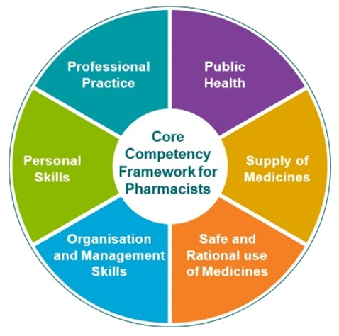


F
4.2 Challenge 2: Financial Sustainability
The pharmacies are under pressure because of stagnant NHS funding and increase in operational costs. The CPCF five-year contract (2019-2024) ensured the amount of funding stayed at £2.592 billion a year, which is not sufficient, according to many, with the effects of inflation and the growing demands of services (PSNC, 2023).
Evidence
The Pharmaceutical Services Negotiating Committee (PSNC, 2023) reports that the number of community pharmacies that have been closed in England since 2016 is over 400, and that these unfunded and pressured closures are not spread equally: in deprived areas, financial reform is urgently required in the sector.

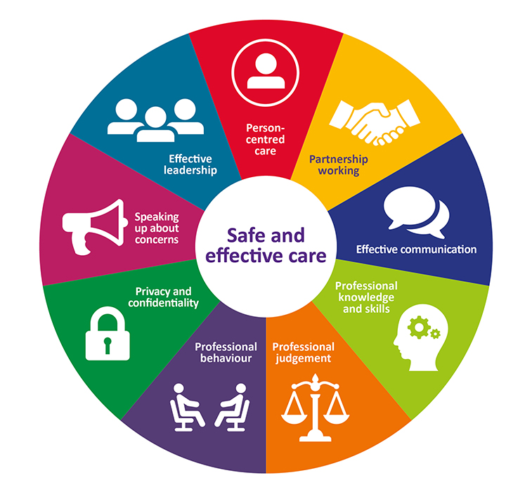
Fig 1: Standard for Pharmacy
(Source: ScienceDirect, 2024)

Fig 2: Pharmacy in UK
(Source: Self- Generated)

Fig 3: New Pharmacy Model
(Source: pharmacymentor, 2024)

3.1 Key functions include
Dispensing medicines safely and accurately from NHS prescriptions (NHS England, 2023).Providing clinical advice on medication use and side effects.Conducting health checks (e.g., blood pressure, cholesterol, smoking cessation). Delivering vaccination services such as flu and COVID-19 jabs.
4. Two Key Challenges Facing Pharmacy Services
4.1 Challenge 1: Workforce Shortages and Workload Pressure
The pharmacy sector in the UK is currently experiencing workforce challenges that severely threaten service delivery and patient safety. There are significant workforce issues with shortages of pharmacists, long hours, and increasing burnout (Pharmaceutical Services Negotiating Committee (PSNC), 2023). Recruitment and retention of personnel for community pharmacies appear to be even more challenging (NHS England, 2023). Many pharmacists have shifted away from community pharmacies to work in primary care networks (PCNs), and general practice. While the transition of pharmacists to the new integrated care models is positive for the models themselves, the pharmacist shift has negative implications for staffing community pharmacies. There is high and increasing accumulation of remaining staff workload which results in long shifts, stress, decreases job satisfaction, and job productivity (Savickas et al., 2021).As a result, there will be fewer opportunities to access services for patients, including prescription filling, clinical counseling, and medical consultations. The shortage of available professionals has been reported by numerous pharmacies, which have either been closed temporarily or reduced the number of opening hours. The scenario also limits innovation and extension of services, since the pharmacies are not in a position to undertake new roles without the capacity of workforce (Rutter, 2020). To meet this challenge, strategic workforce planning, better funding models, and investment in training and retention programs can be implemented to stabilize the sustainability of the community-pharmacy services in the long-term (Royal Pharmaceutical Society (RPS), 2024)
Evidence
Royal Pharmaceutical Society (2022) reported that 80 percent of those pharmacists cited workload pressure as a significant post-COVID-19 issue, and 60 percent of those pharmacists were considering leaving the profession as a result of work pressures and exhaustion- which is a critical workforce sustainability concern across UK community pharmacies.

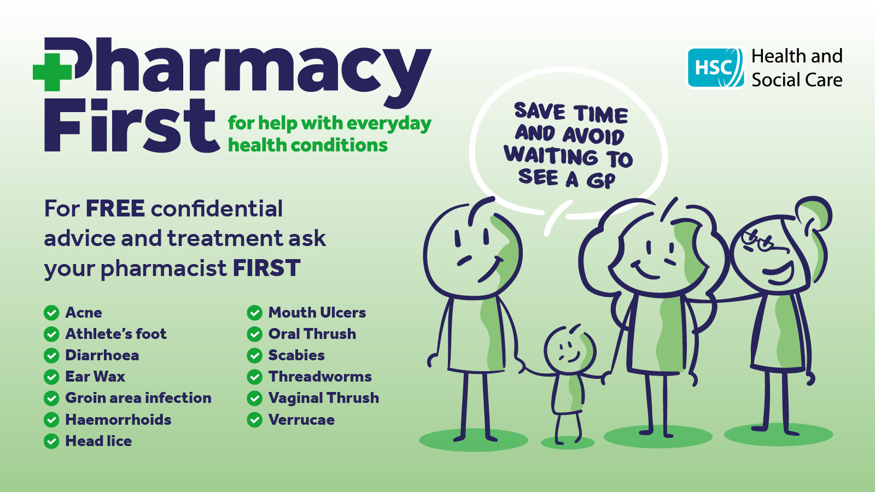
Fig 5: Pharmacy consultancy in UK
(Source: pharmacymentor, 2024)


Fig 4: Pharmacy consultancy in UK
(Source: Self-Generated)

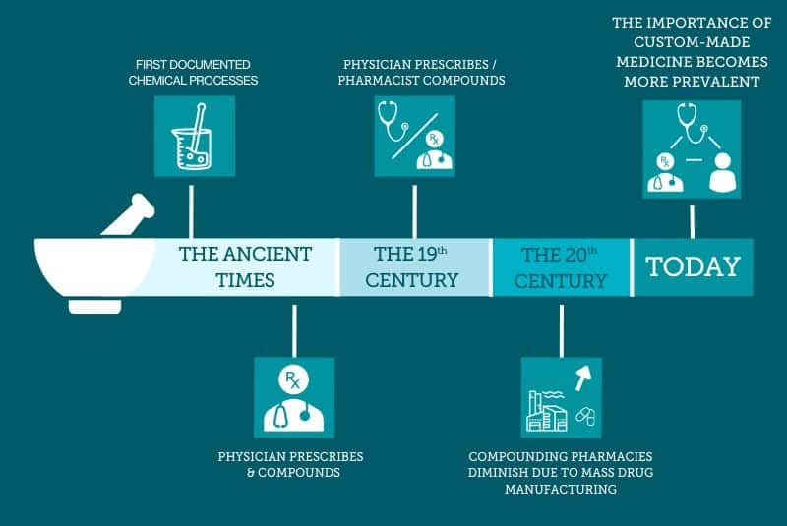

Conclusion
Pharmacy services in the UK are the foundation of healthcare services in the country, as they guarantee safe medication administration and easy front-line consultation. Although they have become patient-centred and technology-based care providers, issues like the shortage of workforce and financial strains still affect sustainability. Continued integration in the NHS and further investment are necessary to maintain these important community health resources.

Fig 6: Pharmacy Evolution
(Source: raconteur, 2024)

Reference list
Department of Health and Social Care, (2023) Community Pharmacy Contractual Framework: 2019–2024. Available at: https://www.gov.uk/ (Accessed: 12 October 2025).
General Pharmaceutical Council, (2024) Annual Report 2024. Available at: https://www.pharmacyregulation.org/ (Accessed: 12 October 2025).
NHS England, (2023) Community Pharmacist Consultation Service. Available at: https://www.england.nhs.uk/ (Accessed: 12 October 2025).
Pharmaceutical Services Negotiating Committee (PSNC) (2023) Pharmacy Pressures Survey. Available at: https://psnc.org.uk/ (Accessed: 12 October 2025).
Pharmacymentor, (2024) The New Pharmacy Model, [Online]. Available at: https://www.pharmacymentor.com/new-pharmacy-model/ (Accessed: 14/10/2025)
Royal Pharmaceutical Society (2022) Workforce Wellbeing Survey. Available at: https://www.rpharms.com/ (Accessed: 12 October 2025).
Rutter, P. (2020) Community pharmacy: symptoms, diagnosis and treatment. 4th ed. Edinburgh: Elsevier.
Savickas, V., Foreman, E., Ladva, A., Bhamra, S.K., Sharma, R. and Corlett, S.A. (2021). Pharmacy services and role development in UK general practice: a cross-sectional survey. International Journal of Pharmacy Practice, 29(1), pp.37-44.
The King’s Fund (2023) NHS performance tracker 2023. Available at: https://www.kingsfund.org.uk/ (Accessed: 12 October 2025).
Raconteur, (2024) Pharmacy Evolution. [Online]. Available at: https://www.raconteur.net/infographics/pharmacy-evolution (Accessed: 12 October 2025)
ScienceDirect, (2024) Role of the pharmacist in research. [Online]. Available at: https://www.sciencedirect.com/science/article/abs/pii/B978012820007000043X (Accessed: 12 October 2025)

Task 2: Essay – Origins and Current Structure of the NHS

1.0 Introduction
The National Health Service (NHS) is one of the largest social reforms in the history of British. It was founded in 1948 with a mission of delivering comprehensive and free medical services to each citizen. This essay will cover the history of the NHS and the principles upon which it was established and then offer a critical discussion of the present structure and operation of the NHS.

2.0 Main Body
Origins and Historical Context
The NHS has its origins in the social reform after the World War II. The destruction of the war led to the realization of the necessity of a combined health system that is available to everyone regardless of income. Prior to 1948, healthcare was dispersed, with voluntary hospitals, individual doctors, and services offered by local authorities having an uneven distribution of accessibility (NHS England, 2023). The Beveridge Report (1942) suggested taking care of the five giants of Want, Disease, Ignorance, Squelor, and Idleness. This structure affected the National Health Service Act (1946), led by the Health Minister Aneurin Bevan. Bevan had a vision of good healthcare made available to all, but funded by taxation and not direct payment.
Key Principles of the NHS
The National Health Service (NHS) was developed on three principles that it was based on; these are the principles of universality (for all), equity (care according to need not ability to pay) and comprehensiveness (care that is needed, all care). These principles are still contained in health policy today and the NHS continues to be a symbol of fairness, equality and social responsibility (Astbury et al., 2024).
Current Structure and Functioning
The NHS operates in England, Scotland, Wales, and Northern Ireland, which are each run separately. In England, NHS England is responsible for overseeing the strategic delivery of NHS services in general through Integrated Care Systems (ICSs) launched in 2022 to promote better collaboration between hospitals, primary care, and community services (NHS England, 2024). Most of the NHS funding comes from general taxation, with total annual budgets greater than £180 billion (Office for National Statistics, 2024). Services are delivered through a mixed economy of primary care (GPs, dentists, and pharmacists), secondary care (hospitals), and tertiary specialty services. The NHS is involved in digital developments including electronic patient records and virtual consultations. However, the NHS still has issues with workforce shortages, increasing demand, and inadequate funding of NHS services (The King’s Fund. 2023).
Critical Examination
The NHS maintains its core principles; however, some - especially critics on the left - see austerity, the prospect of privatization, and a growing population as worrying developments that challenge the future of the NHS (Calnan, 2020). The introduction of the private provider as initiated by the Health and Social Care Act (Department of Health and Social Care, 2023), heightens concerns of NHS stakeholders potentially fragmenting the NHS.

3.0 Conclusion
On the concluding notes national health services departure of many forms and structures of service delivery, we still achieve world class health care. In efforts to construct a sustainable future, we can grapple with the systemic puzzles of early intervention and prevention, reform of long term care, (re)investing in workforce strategies, and the management and efficiency questions by embracing innovative known as innovation.

Reference List
Astbury, J.L., Jacobs, S., McDermott, I., Willis, S.C., Moss, A., Stearns, S., Fenton, C., Hindi, A.M., Seston, E.M. and Schafheutle, E.I. (2024). Workforce development in community pharmacies in England: Opportunities and tensions for a private sector provider of NHS services. PloS one, 19(11), p.e0310332.
Calnan, M. (2020). 23. Health policy: in sickness and in health. Handbook on Society and Social Policy, p.306.
Department of Health and Social Care, (2023) Community Pharmacy Contractual Framework: 2019–2024. Available at: https://www.gov.uk/ (Accessed: 12 October 2025).
General Pharmaceutical Council, (2024) Annual Report 2024. Available at: https://www.pharmacyregulation.org/ (Accessed: 12 October 2025).
NHS England, (2023) Community Pharmacist Consultation Service. Available at: https://www.england.nhs.uk/ (Accessed: 12 October 2025).
NHS England (2024) Integrated Care Systems Overview. Available at: https://www.england.nhs.uk/ (Accessed: 12 October 2025).
Office for National Statistics, (2024) UK Healthcare Expenditure 2024. Available at: https://www.ons.gov.uk/ (Accessed: 12 October 2025).
The King’s Fund. (2023) NHS performance tracker 2023. Available at: https://www.kingsfund.org.uk/ (Accessed: 12 October 2025).

