EFECTIVE TEAM WORKING AND COMMUNICATION (A1) RESIT
Student nr - 1812784
Mihai ARDELEAN
MODULE - BMSK4002

Introduction
The influence of communication at the workplace is very important as the ideas -feelings, emotions can have an influence in to the development of the team and ensures that all the objectives are accomplished.

Table of content

Introduction................................................................1
Effective Communication..............................................2
Team Development.......................................................3
Effective Communication skills……………………………………4
Conclusion......................................................................5
Reference........................................................................6

1.Effective-Communication
Effectice communication promote the healthy relationships among the employers wich avoid to have eny conflicts at the workplace. Miscommunication can lead to issues among employees and can have a major impact of the organization.
Effective communication between the members and team leaders we'd to be clear, easy to understand. The message must be complete, short to facilitate the next step. An effective communication team members are feeling confident and important brings people together from different backgrounds and different cultures.
Effective Communication is one of the most important ways to make sure the team members they make the others to understand what are the espectation from them. When communication do not work can have a major impact on the team members creating confusion, frustration and lack of trust. Improving communication arround the team members will have a good impact on the team members communicate openly with each other creating an environment where people feel more confident to express their ideas.
Is-the-team-effective--or-not?

Effective-Team..
They are different indicators that show a team working effectively together, a successful team will include :
Clear Communication between the members
All the members participating on the project
They solve the problems together
Positive attitude and supportive working relationships between the members
Team-doesn't-work-effectively.
The team members not being able to communicate with each other resulting lack of support and communication
No clear roles between the members
They working alone not being able to share the information with the others
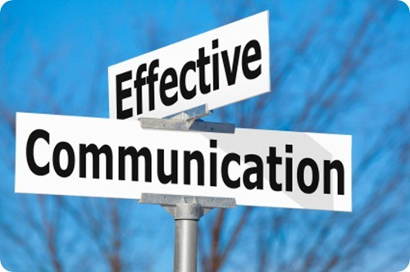 Figure 1; Efective communication(success signatuure.co.ke,picture)
Team-Development-Motivation-Training
Training :the team members are not aware of the work procedures. The team leaders have to provide training that enable the team members understand the job role and the work procedures. (Kaba, et al 2016).
Motivation :Scope of work place motivation can be understood by identifying internal and external issues and motive of the team members. Internal motives involves needs, whereas external motives concern with emotions and cognition. The scope of having well - motivated workplace is that the team will be able to ensure better performance to achieve the target.
Communication in the workplace is very important for the organisation to grow up and create relationships between employees and a better understanding and communication with the team delivering suitable services to the pacients (Health and Social Care ).The problems in communication mainly arise due to workplace hostility and deliberate hierarchical barriers to it(Norouzinia,et al.,).The staff members should be polite with the staff and efforts must be made to remove psychological barriers between the two. This can be achieved by having more friendly interactions with one other. The senior administration can also implement the( open-door policy)to ensure that the lower level employees face no obstacle for communicating and mental health can be looked after.The most affective mesure that can be implemented to make communication easier is using the the tactic of anonymous feedback.
Effective-Communication-Skills :observance, listening and understanding, emotional intelligence, non verbal communication, providing feedback.
OBSERVANCE:the leader must possess sharp observations skills to acumulate more knowledge.
LISTENNING AND UNDERSTANDING :must be a good listener and being able to understand the message well.
EMOTIONAL AND INTELLIGENCE :must be aware and have the ability to influence the team members.
NON VERBAL COMMUNICATION :means communication including also the gesture,eye contact and the body language.
PROVIDE FEEDBACK : positive feedback is a powerful tool to support Behavioral changes or introducing positive behaviour in the workplace.
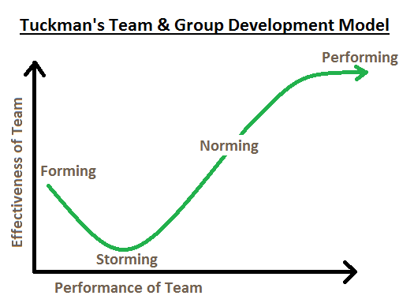
MindTools.com Tukman Team group development model
FORMING
The team will be organised and orientation what is the team and what are the tasks in order to create a good team they need to trust each other and more importantly to trust the team leader.

STORMING
In this stage the conflicts and the power have different perspectives when team or working together for a while. The team members are becoming more close to each other and gain each other trust. The team leaders need to encourage the team and to be open minded is essential that the team members to resolve the issues raised between them.

NORMING:
Is when people start to resolve the difference they appreciate each other and respect each other. They know what are the espectation and work together towards to achieve the goal and objectives.

PERFORMING
The team reach the stage wheere they perform to achieve the goal.

ADJOURING
The final stage of Development involves the evaluation of the roles of the team members in their job, the step determine and shows the specific skills which ca be helpful in the futureThe team members also may experience stress, pey attention and planning something that will be beneficial for the team.
Teams move through a series of stages beginning when they are formed and ending when they are disbanded. Bruce Tukman identified 4 distinct phases of Team Development each have a primary purpose and a common set of interpersonal dynamics among team members. Tukman's model is significant also recognise the fact that the teams grow through clearly defined stages from their creation, task focused team.
In conclusion Tuckman Stages explain how the teams working together, how the team develope and recognizes that teams grow through the Stages.
Tuckman model is significant and explain how the group starts functioning not being formed from the beginning. Tuckman Team Work Theory is based on the link between groups relationships and the tasks. Tuckman ideas indicates that is taking time to achieve the Performing~stage and is a normal fact that the teams to go through up and down developing relationships and observe how the team interact with each other in different situations.According to HACKMAN 'FIVE FACTOR MODEL' are:Factor being a real team, Compelling Direction, Enabling Structure, Supportive Context, Expert Coaching.
Factors being a good team: being a good team leads to other factors, good teams are Adaptable to each other being flexible with one another and focus on their goal.
Compelling Direction : The team members need to know what is the tasks and define the goals, the obstacle that will prevent the team members from achieving their goals.
Enabling Structure : Being meny different types of structures that the team members can adopt is very essential.
Supportive Context : Being essential for the team and organisation being able to be part OK f a larger organisation.
Expert Coaching : started by having a good couch being a team leader means you are a couch what is your job description and the task you need to complete.

Team-Development
The development of the team depends on the leadership, being the leaders they have to play an influence role in maintaining the quality of the role. By using Tukman Model the team members have the capability to a better understanding of their strengths which leads to more effective communication. The teams together they can understand and improved having a positive impact at the workplace. The leaders have to provide guidance and training constantly to the team members, the leaders of the organisation play a major role in development of the workforce (Sundberg et. Al 2016).As a member of the team every action we do affects the decisions of other members we become more responsible and understand what responsibility means,to adapt in all kind of situations wich forces to make unaspected decisions to carry out the task to the end.Each member of the team is important having different tasks to complete.Is very important for the team to try to discover themselves as individuals and not only as employees of the Company.
The team leaders have to play an important role and require several skills that enhance the quality of the work. The entire development of the team members relies on the team leaders and they can avail organisation with quality service.
Effective Communication-Skills
Team work suggested that people work together building support and trust between them that lead the team to achieve the target. A good team working skills will have the opportunity to look forward in the future. Team working skills are very valuable create a better understanding and an excellent opportunity for everyone.
Team-working-skills
Listening to other members of the team, sharing the information and responsibilities to achieve the target in an effective way. Feedback skills are essential in any situation, being able to give a clear positive feedback to others is important to keep the team together and stick to the plan and to be able to recive feedback as well. People understand that if they are achieve the target or not and what needs to be done in order to improve the service.
Conclusion
In Conclusion a team is made from two or more people working together to achieve the goals. An effective team can increase employee motivation, being part a Team the members not only share the information but also share responsibility for the team. Having efficient team work can have a major impact on the organisation, can improve the service and productivity, helping the other members.By working together people are able to develop new skills and working alongside other members to achieve the tas, TEAM Work is one of the most important key of a successful team and has a detailed abbreviation of the influence of the communication and the team dynamics.
Reference
Richard Hackman - Five Factors Mode, http://w.w.w.freemanagement-books.com-03-.htm, Richard Hackman 'FIVE FACTOR MODEL' Leading Team(2002),Bruce Tuckman, TEAM Development Model 1965,Bard Robin-Case study 2015,http:// Mind Tools.com, http://Skillsyouneed.com Management Team-why they succed or fail , Secan edition, 2003 The Five Stages. Com, Belbin. M. (1981)Managment Team B. Rosemary. K, (1996)Rushmer, British Psychological London Testing Centre, BPS PTC 2019-07-09 ,Mintberg Team Management Roles, Management London Centre http://Lmcuk..Com, - http://Lmcuk..Com, 2014-03-10.

