Assignment
Introduction to WEB – HTML & CSS
Jon Morgan (2218940)
2023
Table of Contents
Abstract 3
Requirements 3
Implementation 4
Screenshots 4
Home page - Desktop 4
Home page - Mobile 5
Collect page - Desktop 6
Collect page - Mobile 7
Build page - Desktop 8
Build page - Mobile 9
Paint page - Desktop 10
Paint page - Mobile 11
Play page - Desktop 12
Play page - Mobile 13
Read page - Desktop 14
Read page - Mobile 15
Validation 16
HTML Home Page 16
CSS File 16
Evaluation 17
Website Usability 17
Website Accessibility 17
Website Search Engine Optimisation (SEO) 17
Self-Evaluation 18
Website Usability 18
Website Accessibility 19
Search Engine Optimisation 21
References 22
Appendix – Code 23
Styles.css 23
Index.html 31
Collect.html 35
Build.html 39
Paint.html 43
Play.html 48
Read.html 55

Abstract
A brief report written in response to the assignment, which was given as:
“Design and hand-code a responsive website that is made up a reasonable number of relevant and related pages using web standards. (a minimum of 5 pages).
You can code it in raw HTML/CSS from scratch, or you can base it around a framework such as CSS Grid or Bootstrap etc. However, you must demonstrate your own design and customisation. You must not use a design package such as Dreamweaver that generates the code for you.
Possible examples of websites include a site:
- for an organisation of your choice (which may or may not be fictitious in nature)
- to promote a personal interest or hobby, a favourite band, a town/city, etc.

You are also required to produce a specification report containing relevant documentation describing your research and web development work.”

Requirements
To meet the given task, a responsive website has been created on the topic of “The 40K Hobby”. The site’s purpose is primarily to introduce people who are not already familiar to the hobby and the expansive universe of Warhammer 40,000, to explain the various aspects of the hobby, with the hopeful goal of it being something of interest that they may decide to learn more about or even try involving themselves in further, by visiting a store or trying out a demonstration game etc.
The site consists of 6 HTML files/pages, a CSS file and various supporting image files. The ‘media queries’ functionality of CSS has been used to support basic re-formatting of the page and hiding elements, to better suit smaller screened (viewport) devices such as mobile phones and tablets when they are used to view the site.

Implementation

Screenshots

Home page - Desktop
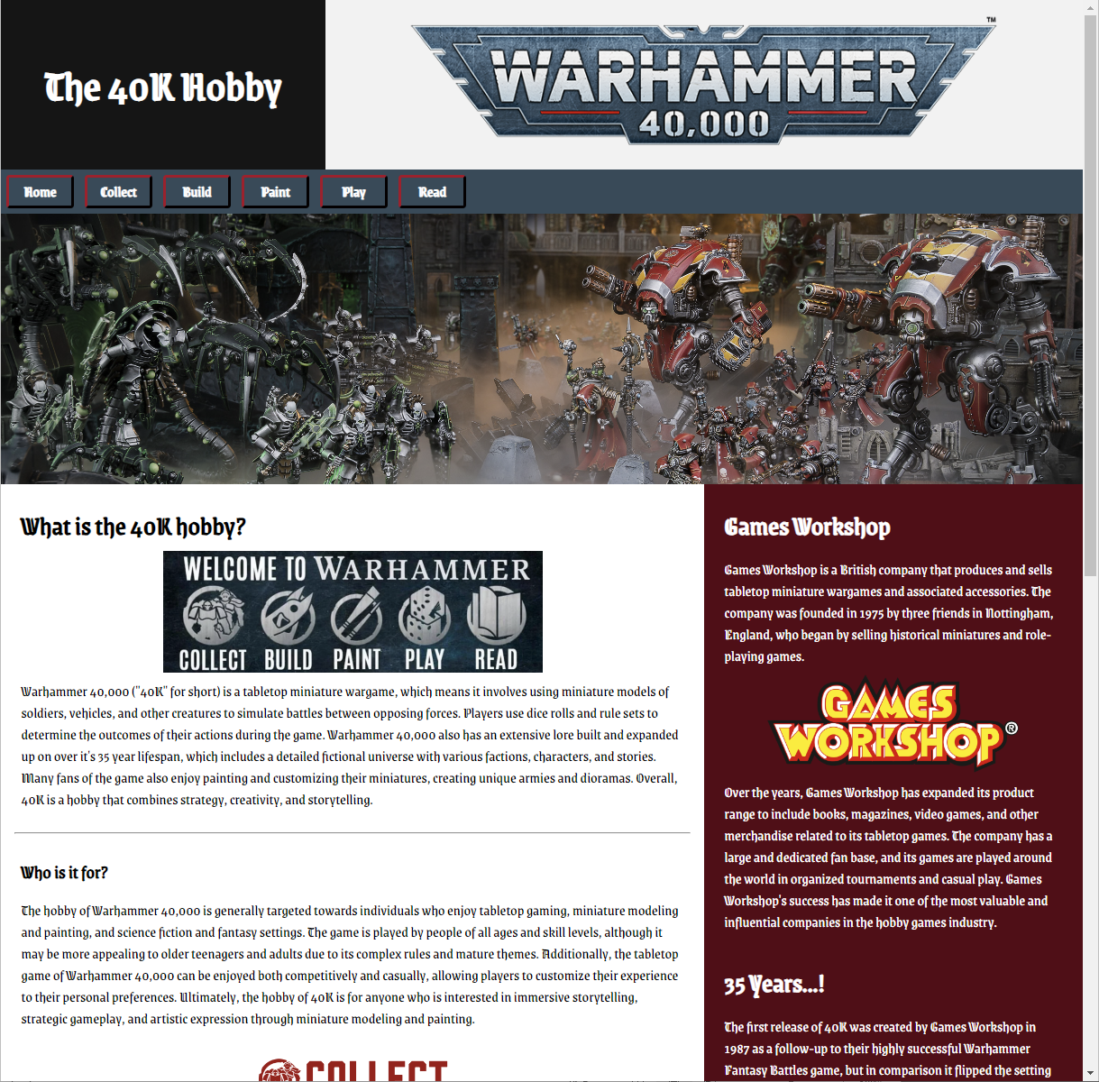

Home page - Mobile
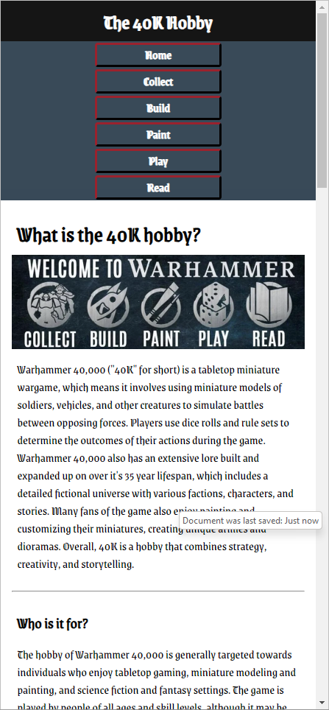

Collect page - Desktop
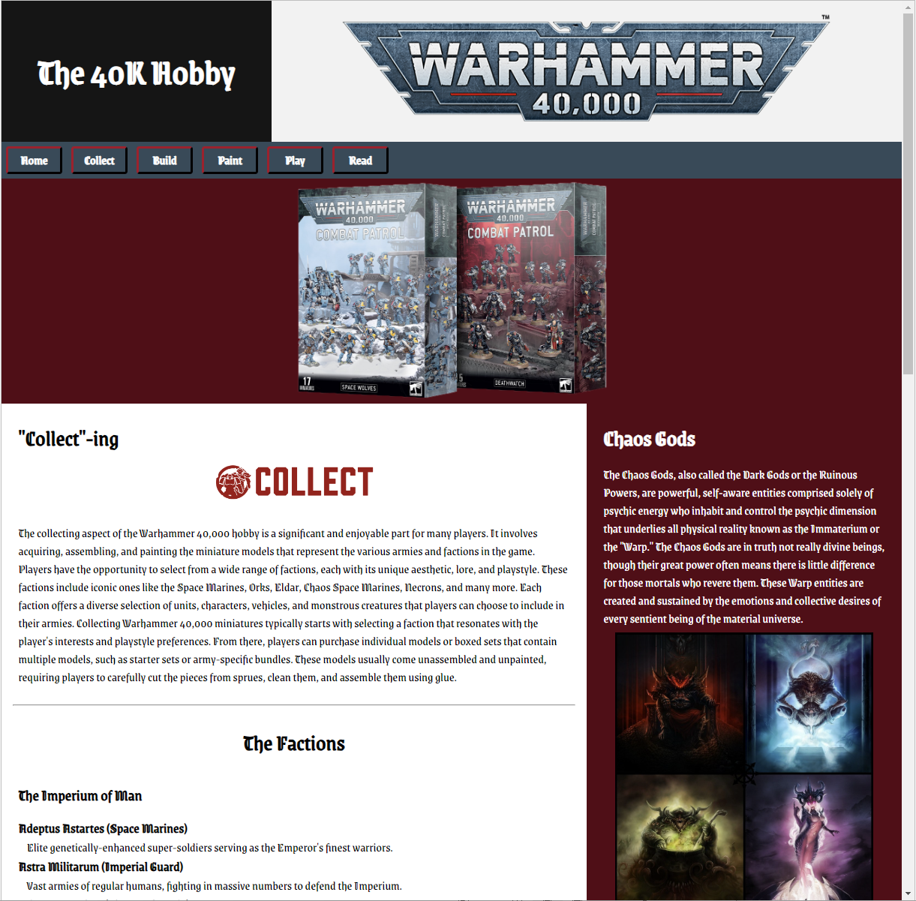

Collect page - Mobile
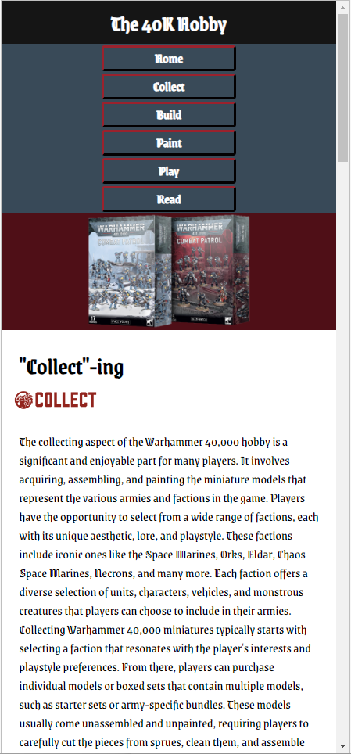

Build page - Desktop
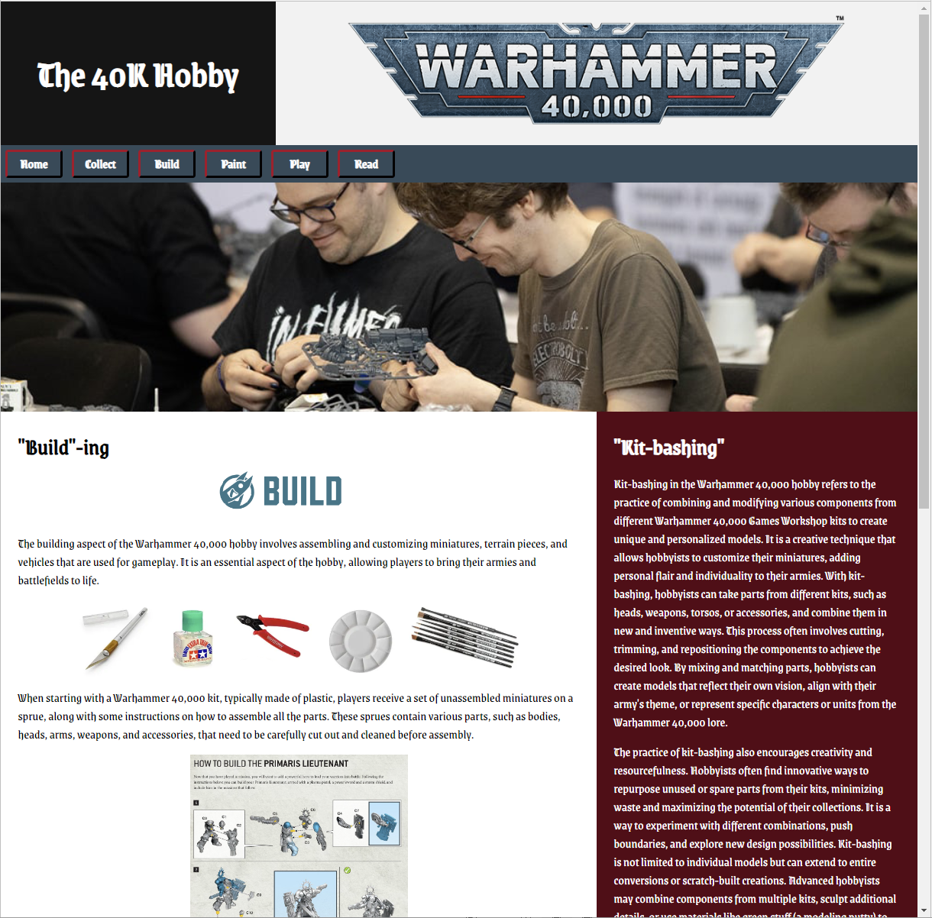

Build page - Mobile
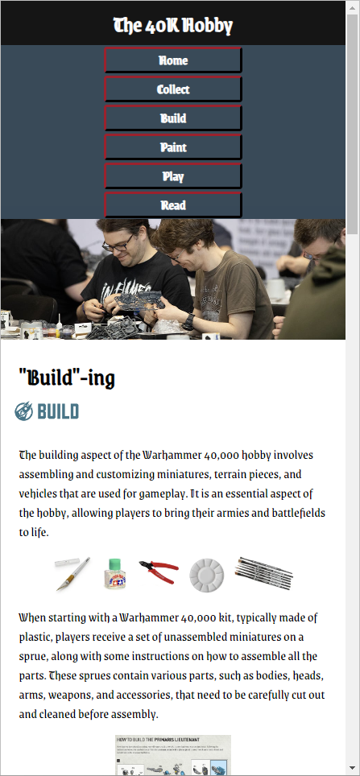

Paint page - Desktop
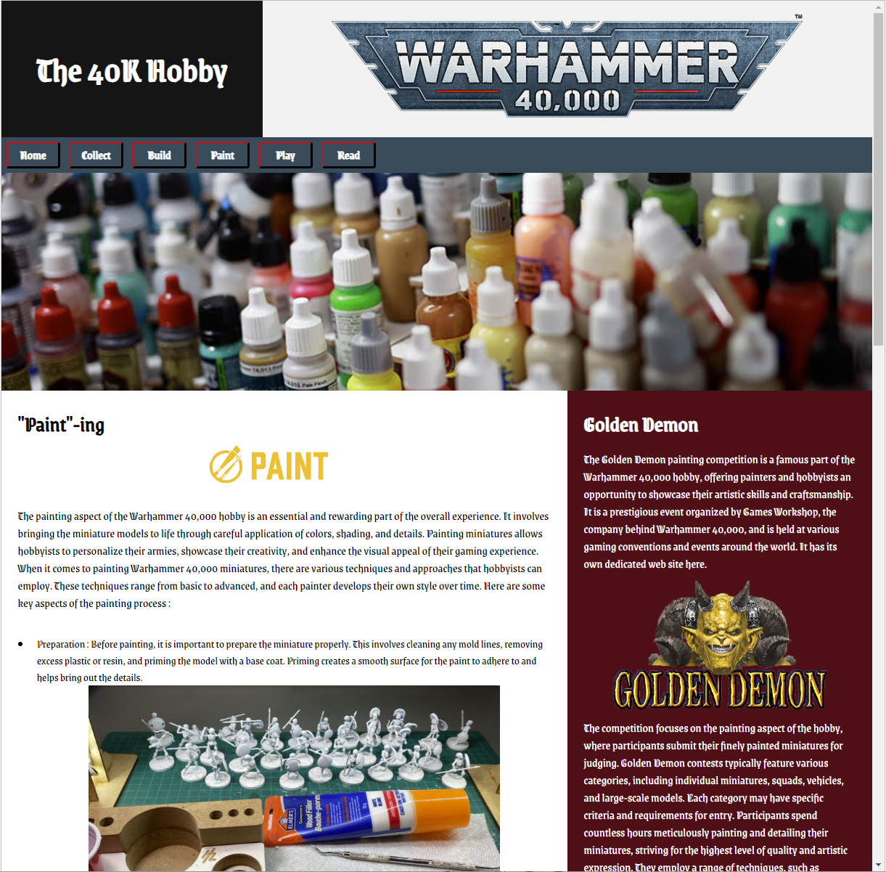

Paint page - Mobile
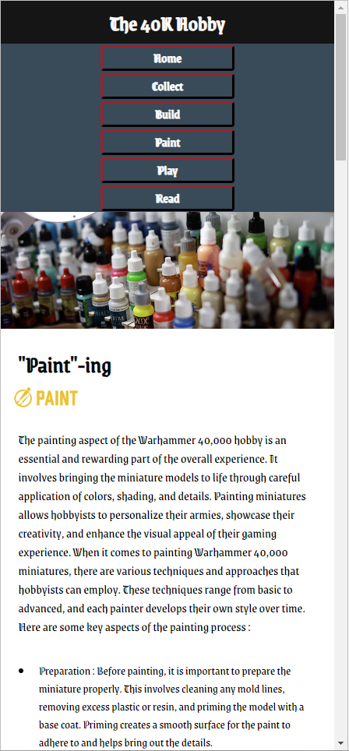

Play page - Desktop
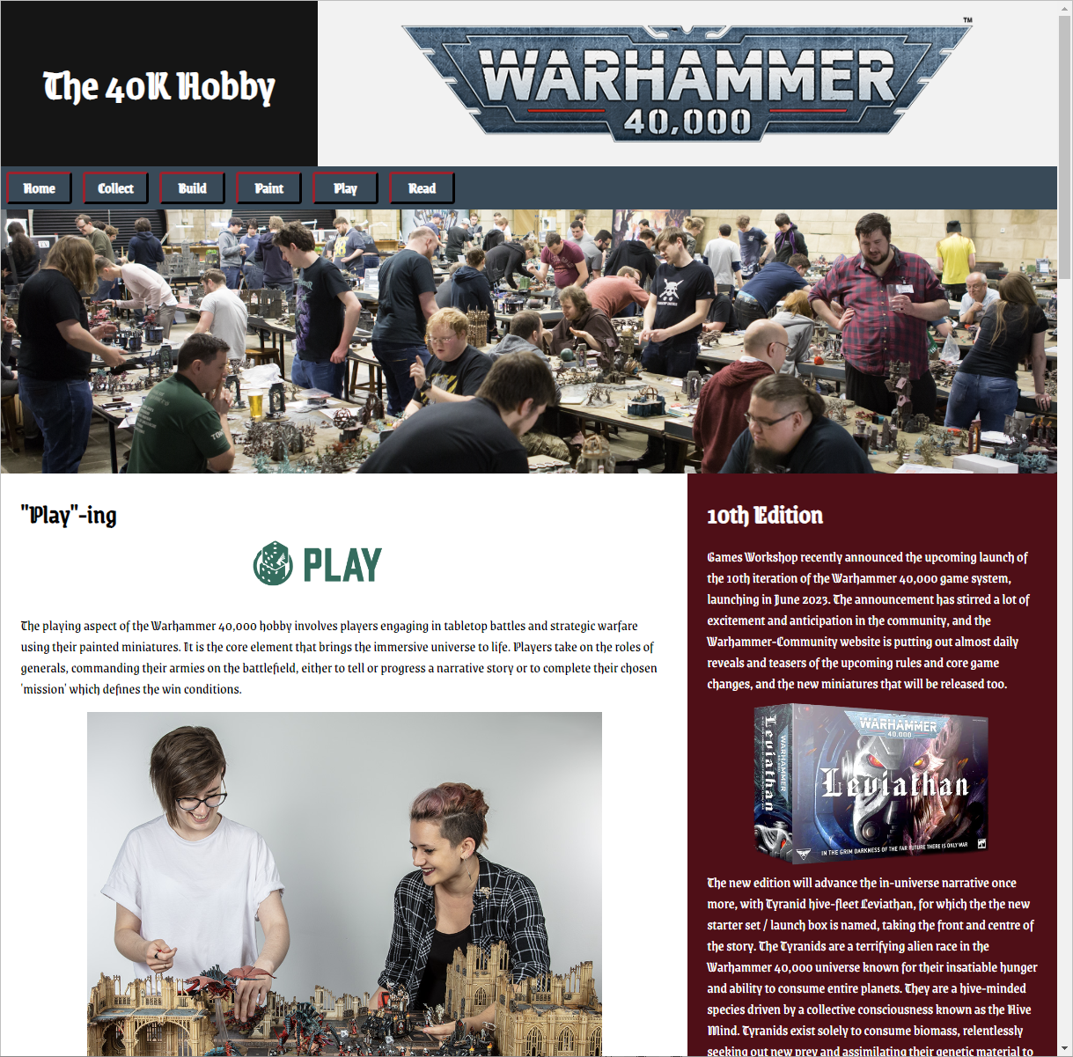

Play page - Mobile
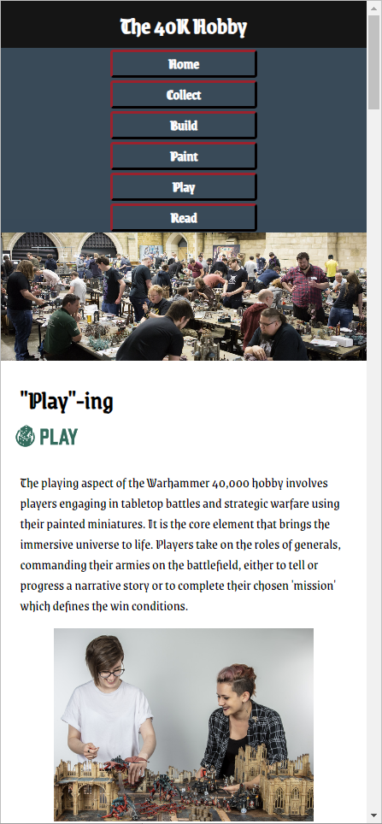

Read page - Desktop
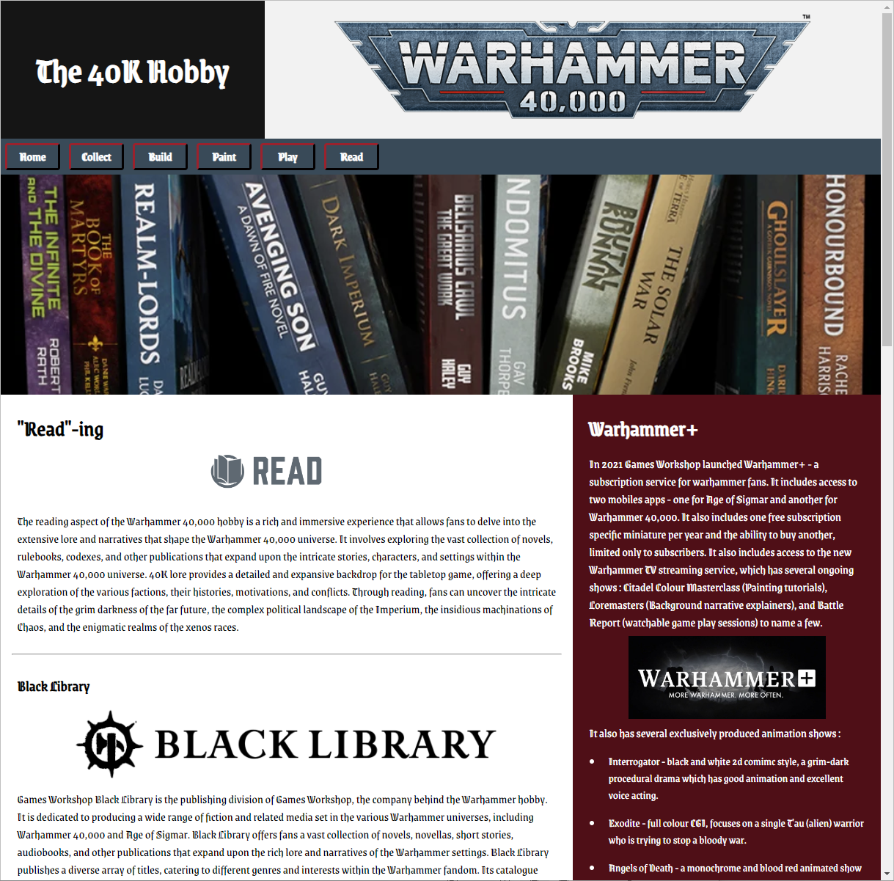

Read page - Mobile
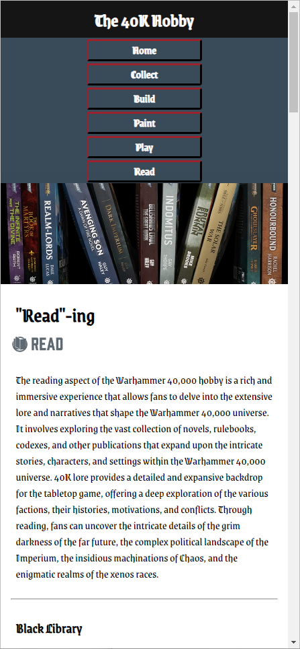

Validation

HTML Home Page

Upon first attempting to validate the HTML file for the home page (index.html), only a single error was noted, as shown in the following figure:

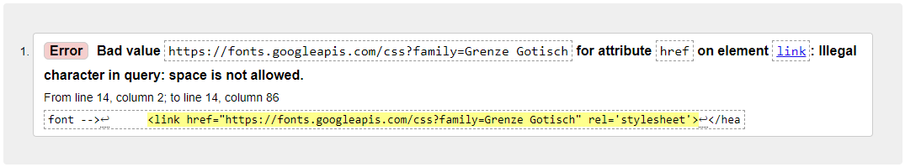

This link value was taken from the W3Schools page titled “How To – Google Fonts”. Initial attempts to correct this error by adding additional ‘quotes’ to surround the font family name in the href attribute value URL were not successful – the site loses the ability to render the requested font. It was then discovered that the space could be substituted with a “+” character – the site still renders in the correct Google font and successfully passes the validator.

CSS File

Upon first attempting to validate the CSS file for the site (Styles.css), the following clean result was displayed:

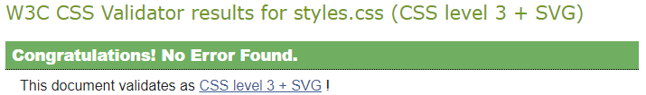

This result confirms a well-structured CSS file that fully conforms to validation standards.

Evaluation

Website Usability

As defined by the W3C (the international standards organisation for the World Wide Web), website usability “is about designing products to be effective, efficient, and satisfying. Usability includes user experience design.” [1] Broadly, website usability refers to the ease with which users can navigate, interact, and accomplish their goals on a website, encompassing various aspects such as the clarity of information, intuitive navigation, responsive design, effective use of multimedia, and overall user satisfaction.

Website Accessibility

As defined by the W3C, website accessibility “addresses discriminatory aspects related to equivalent user experience for people with disabilities. Web accessibility means that people with disabilities can equally perceive, understand, navigate, and interact with websites and tools. It also means that they can contribute equally without barriers.” [1]
The article “Progress on Website Accessibility?” [2] delves into how the modern web is now a requirement for full participation in society, and how people living with disabilities face being potentially disadvantaged. It goes on to look at how well both ‘Top-sites’ (Amazon, Yahoo, Microsoft, Facebook etc) and Government sites adhere to following the 4 principles outlined in the W3c WCAG 2.1 guidelines, both currently and historically over the course of just over a decade (where data was available). The article concludes that generally overall conformance to Web Accessibility standards is low but improving slowly, that government sites are the ones to improve the most and that most improvements are mere side-effects to the desire to place well in search engine results.

Website Search Engine Optimisation (SEO)

Techniques and strategies to improve a given websites rankings in search engine results. There are 2 broad types – on-page and off-page. Off page is less under your direct control and refers to all the activities you might engage in not directly related to your website to persuade search engines that your site is trustworthy and authoritative.
The best-known example of this is probably Google’s ‘Page Rank’ – where links from other sites to your site are effectively ‘votes’ for your site’s trustworthiness. Additionally, if those sites linking back to yours (providing ‘back links’) are themselves already highly ‘ranked / voted’ for with their own back links, then their votes for your site are ‘worth’ more in Google’s eyes too. That’s a very generalist explanation of Page Rank, and Google are constantly tweaking and evolving their search products and algorithms too to remain competitive, so some details either will or already have changed.
Considering this, any way in which you can get other sites to back link to your site, would be one form of off-page SEO. There are also other steps you could take, such as a content marketing campaign, or enlisting reviews of your site too.

Self-Evaluation

Website Usability

The site functionality is basic, primarily acting as a reading and information resource. The content is organised logically and according to the subject matters own marketing and branding efforts. Navigation between all the pages is consistent with a static navigation bar element near the top of every page. Images are used to reinforce the written content, with some being ‘clickable’ to larger versions where needed or appropriate. There are some links to other websites too, pointing users at other resources that they could use to learn more.
Future improvements that could be made to the site could include things such as:
- Adding ‘Back to Top’ links to the various main sections to allow users to return to the top of any page more easily, where the main navigation bar resides can then be accessed – this would be particularly useful for users using a smaller screened device where the site has re-formatted itself into a very long column of content.
- Adjusting the CSS further to reduce various heading and font sizes when accessed using smaller screened devices, allowing more content to be displayed.
- Adjusting the Navigation bar so that when viewed on a smaller screened device it condenses into 2 side by side columns of 3 buttons instead of the current 1 column of 6 buttons, which is quite tall and takes up a more vertical page space than it might otherwise.
- Highlighting with text where an image is a clickable link.
- The site overall is too text heavy - look to add more image content, showcasing more miniatures being built or painted, some entries from the Golden Demon competition too, maybe with some interactive CSS image gallery components for presenting them.

Website Accessibility

The site has been built using semantic HTML tags to better describe the various sections and content, to aid users using screen readers or other similar assistive technologies. The colours used are contrasting, and font sizes have been enlarged hoping to make them easier to decipher and read.
Here is some output from the WAVE (Web Accessibility Evaluation Tool) extension after using it to scan the home page:
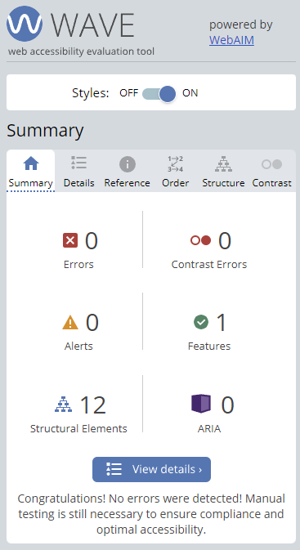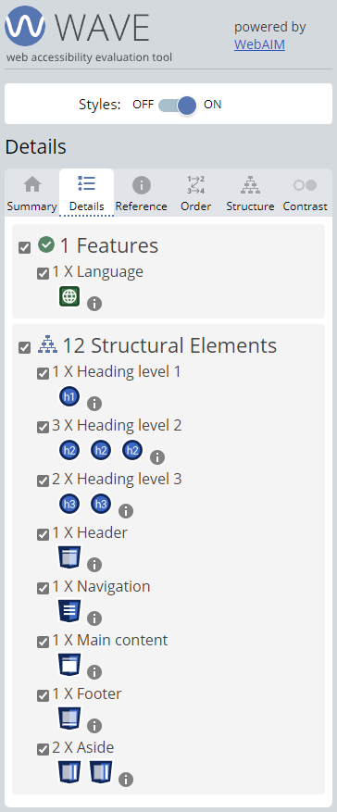

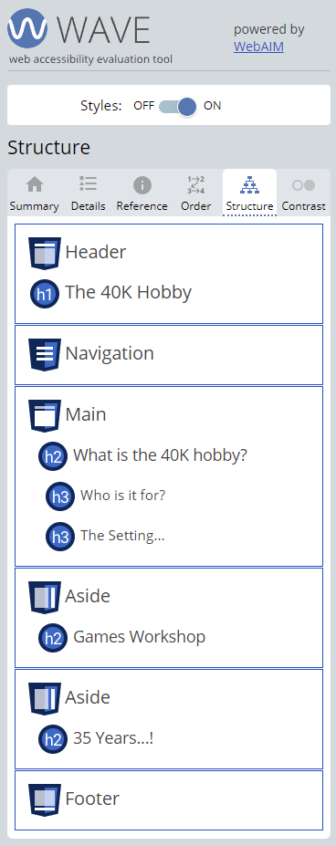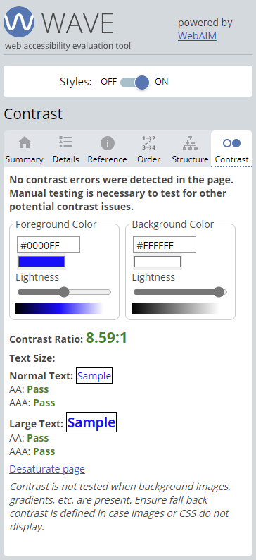
This tool seems to confirm good overall page / site structure and an adequate contrast ratio, both of which align well with the WCAG 2.1 [3] (Web Content Accessibility Guidelines) principle of content being ‘Perceivable’. Use of appropriate TITLE tags in the HTML on each page aligns well with the ‘Operable’ principle of the WCAG 2.1 guidelines. The confirmation of the ‘Language Feature’ in the WAVE tool output above also aligns well with the WCAG 2.1 principle of content being ‘Understandable’.
Future improvements that could be made to the site could include things such as:
- Adding a ‘High Contrast’ button, which would use CSS to adjust most site colours towards black and white for users with visual impairments.
- Adding a ‘Clean font’ button or feature, to on-the-fly adjust the site font being used to one that is easier to read for people with visual impairments.
- Work out how to add ‘alt text’ for images placed via the background-image attribute of a DIV tag, or redesign the page to use standard IMG tag based images instead.

Search Engine Optimisation

Some of the on-page SEO techniques [4] used on the site include:
- Specifying the appropriate ‘Lang’ in the HTML tag.
- Using the TITLE tag with an appropriate value for each page.
- Using the META tag for Keywords for each page.
- Using the META tag for an appropriate page description of each page.
- SEO Writing – using headings and sub-headings appropriately and making good use of lists, as confirmed in the WAVE tool output above in the Website Accessibility self-evaluation section.
- Using a responsive design - being more suitable to serve mobile devices searching for content.

References
[1] W. W. A. I. (WAI). (). Accessibility, Usability, and Inclusion. Available: https://www.w3.org/WAI/fundamentals/accessibility-usability-inclusion/ [Accessed May 14, 2023].
[2] V. L. Hanson and J. T. Richards, "Progress on Website Accessibility?" ACM Transactions on the Web, vol. 7, (1), pp. 1-30, 2013. . DOI: 10.1145/2435215.2435217.
[3] Anonymous (). Understanding WCAG 2.1 - Service Manual - GOV.UK. Available: https://www.gov.uk/service-manual/helping-people-to-use-your-service/understanding-wcag [Accessed May 15, 2023].
[4] 1. M. Read, 1. 0. Shares and 2. Reads. (). 12 Essential On-Page SEO Factors You Need To Know. Available: https://www.searchenginejournal.com/on-page-seo/essential-factors/ [Accessed May 15, 2023].

Appendix – Code

Styles.css
/* Colour codes */

/* Deep Red = 590716 */
/* Dark Grey = 324A59 */
/* Crimson Red = A60F0F */
/* White Grey = F2F2F2 */
/* Near Black = 151515 */

/* Start with broadest applicable styles first, then get more specific as you go down */

/* GLOBAL Styling */

* {
box-sizing: border-box;
margin: 0;
font-family: "Grenze Gotisch", Georgia, serif;
}

h1 {
font-size: 400%;
padding: 10px;
}

h2 {
font-size: 250%;
padding: 10px;
}

h3 {
font-size: 175%;
padding: 10px;
}

p {
font-size: 140%; /*1.25em; /* Use a relative font soze for accessibility - user can resize if needed */
padding: 10px;
}

img {
max-width: 80%;
display: block;
margin-left: auto;
margin-right: auto;
height: auto;
padding: 10px;
}

dl {
font-size: 140%; /*1.25em; /* Use a relative font soze for accessibility - user can resize if needed */
padding: 10px;
}

dl dt {
font-size: 110%;
font-weight: bold;
}

dl dd {
padding-left:15px;
}

ul {
font-size: 130%; /*1.25em; /* Use a relative font soze for accessibility - user can resize if needed */
padding-left: 35px;
}

ul li {
padding: 10px;
}

ul img {
width: 100%;
height: auto;
padding: 0px;
}

a {
text-decoration: none;
color: white;
}

/* CLASS styling */

/* Header Area Column container */
.headerrow {
display: flex;
flex-direction: row;
}

/* Create two unequal columns that sit next to each other */
/* 1st column in row, main content (sitting to the left) */
.headerleft {
display: flex;
flex: 30%;
justify-content: center;
align-items: center;
background: #151515;
color: white;
height: 250px;
}

/* 2nd column in the row, sidebar content (sitting to the right) */
.headerright {
flex: 70%;
background-color: #F2F2F2;
padding: 0px;
margin: 0px;
background-image: url("images/40k-logo-small.png");
background-size: contain;
background-repeat: no-repeat;
opacity: 1.0;
background-position: center center;
width: 100%;
}
/* Navbar class */

.navbar {
display: flex;
background-color: #324A59;
}

/* Style the navigation bar links */
.navbar a {
color: white;
margin:8px;
min-width: 100px;
padding: 5px 0px;
border-style: outset;
border-color: #590716;
border-radius: 5px;
text-decoration: none;
text-align: center;
font-weight: bold;
font-size: 140%;
}

/* Change color on hover */
.navbar a:hover {
background-color: #A60F0F;
border-style: inset;
}

.showcase {
background-image: url("images/showcase-battle-scene.jpg");
background-size: cover;
opacity: 1.0;
background-position: center center;
min-height: 400px;
width: 100%;
}

/* Column container */
.mainrow {
display: flex;
flex-direction: row;
}

/* Create two unequal columns that sits next to each other */

/* 1st column in row, main content (sitting to the left) */
.main {
flex: 65%;
background-color: white;
padding: 20px;
}

.fivepartlogo {
background-size: contain;
background-repeat: no-repeat;
opacity: 1.0;
background-position: center;
height: 80px;
margin: auto;
}

/* 2nd column in the row, sidebar content (sitting to the right) */
.side {
flex: 35%;
background-color: #590716;
color: white;
padding: 20px;
}

/* Footer */
.footer {
padding: 20px;
text-align: center;
background: #324A59;
color: white;
}

/* ID (Invidually named) Styling */

#fortyklogosmall {
float: right;
max-width: 80%;
max-height: 180px;
}

#welcomebanner {
background-image: url("images/welcome-banner.png");
background-size: contain;
background-repeat: no-repeat;
opacity: 1.0;
background-position: center top;
height: 180px;
}

#GWLogo {
background-image: url("images/GW-logo.png");
background-size: contain;
background-repeat: no-repeat;
opacity: 1.0;
background-position: center;
height: 150px;
margin: auto;
}

#RTLogo {
background-image: url("images/rogue-trader-logo.png");
background-size: contain;
background-repeat: no-repeat;
opacity: 1.0;
background-position: center;
height: 200px;
margin: auto;
}

#ChaosGods {
background-image: url("images/Chaos-Gods.jpg");
background-size: contain;
background-repeat: no-repeat;
opacity: 1.0;
background-position: center;
height: 500px;
margin: auto;
padding: 0px;
}

#collectlogo {
background-image: url("images/collect.png");
}

#collectbanner {
background-image: url("images/combat-patrol.png");
background-size: contain;
background-repeat: no-repeat;
background-color: #590716;
opacity: 1.0;
background-position: center center;
min-height: 400px;
width: 100%;
}

#buildlogo {
background-image: url("images/build.png");
}

#BuildBanner {
background-image: url("images/buildbanner.png");
background-size: cover;
background-repeat: no-repeat;
background-color: #590716;
opacity: 1.0;
background-position: center center;
min-height: 400px;
width: 100%;
}

#Instructions {
width: 40%;
}

#ResinPrinter {
background-image: url("images/3dprinter.png");
background-size: contain;
background-repeat: no-repeat;
opacity: 1.0;
background-position: center;
height: 350px;
margin: auto;
}

#paintlogo {
background-image: url("images/paint.png");
}

#PaintBanner {
background-image: url("images/paintbanner2.png");
background-size: cover;
background-repeat: no-repeat;
background-color: #590716;
opacity: 1.0;
background-position: center center;
min-height: 400px;
width: 100%;
}

#GoldenDemonLogo {
background-image: url("images/GoldenDemonlogo.png");
background-size: contain;
background-repeat: no-repeat;
opacity: 1.0;
background-position: center;
height: 250px;
margin: auto;
}

#playlogo {
background-image:url("images/play.png");
}

#playbanner {
background-image: url("images/playing-scene.jpg");
background-size: cover;
background-repeat: no-repeat;
background-color: #590716;
opacity: 1.0;
background-position: center center;
min-height: 400px;
width: 100%;
}

#LeviathanBox {
background-image: url("images/LeviathanBox.png");
background-size: contain;
background-repeat: no-repeat;
opacity: 1.0;
background-position: center;
height: 250px;
margin: auto;
}

#TournamentLogo {
background-image: url("images/TournamentLogo.png");
background-size: contain;
background-repeat: no-repeat;
opacity: 1.0;
background-position: center;
height: 200px;
margin: auto;
}

#ITCLogo {
background-image: url("images/ITCLogo.png");
background-size: contain;
background-repeat: no-repeat;
opacity: 1.0;
background-position: center;
height: 200px;
margin: auto;
}

#ITCCallout {
font-weight: bold;
}

#readlogo {
background-image: url("images/read.png");
}

#ReadBanner {
background-image: url("images/bookshelf.png");
background-size: cover;
background-repeat: no-repeat;
background-color: #590716;
opacity: 1.0;
background-position: center center;
min-height: 400px;
width: 100%;
}

#WhiteDwarf {
background-image: url("images/WhiteDwarf.jpg");
background-size: contain;
background-repeat: no-repeat;
opacity: 1.0;
background-position: center;
height: 375px;
margin: auto;
}

#WarhammerPlusLogo {
background-image: url("images/warhammer-plus-logo.png");
background-size: contain;
background-repeat: no-repeat;
opacity: 1.0;
background-position: center;
height: 150px;
margin: auto;
}

#factionsheader {
text-align: center;
}

#ThreeWaysHeader {
text-align: center;
}

/* Responsive layout - when screen is less than 700px wide, change flex mode from row to column to stack the content, and adjust other elements as needed */

@media screen and (max-width: 700px) {

h1 {
font-size: 225%;
}

.mainrow, .navbar, .headerrow {
flex-direction: column;
}

.headerleft {
flex: 100%;
height: auto;
}

.headerright {
display: none;
}

.navbar a {
margin: 2px auto;
padding: 2px 0px;
width: 40%;
}

.showcase {
display: none;
min-height: 150px;
}

#collectlogo {
background-position: left;
height: 40px;
}

#collectbanner {
min-height: 200px;
width: 100%;
}

#buildlogo {
background-position: left;
height: 40px;
}

#BuildBanner {
min-height: 200px;
}

#paintlogo {
background-position: left;
height: 40px;
}

#PaintBanner {
min-height: 200px;
}

#playlogo {
background-position: left;
height: 40px;
}

#playbanner {
min-height: 200px;
width: 100%;
}

#readlogo {
background-position: left;
height: 40px;
}

#ReadBanner {
min-height: 200px;
width: 100%;
}

}

Index.html
<!DOCTYPE html>
<html lang="en"> <!-- Lang attribute for WCAG2.1, SEO and Browser optimisation -->
<head>
<title>The 40K Hobby - a primer about the whole hobby - Collecting,
Building, Painting, Playing and Reading. Grim dark fun!</title>
<meta charset="UTF-8">
<!-- Keywords and a description for SEO -->
<meta name="keywords" content="Warhammer, Hobby, Miniatures, Sci-fi, 40K, Warhammer 40000, tabletop, wargaming, wargame">
<meta name="description" content="Introduction page to the 'Hobby' website, about the tabletop miniature wargame Warhammer 40,000.">
<!-- Set the initial viewport scale -->
<meta name="viewport" content="width=device-width, initial-scale=1.0">
<!-- Link the custom external stylesheet file -->
<link rel="stylesheet" type="text/css" href="styles.css">
<!-- Link the Google Fonts external stylesheet file to make use of the "Grenze Gotisch" font -->
<link href="https://fonts.googleapis.com/css?family=Grenze+Gotisch" rel='stylesheet'>
</head>

<body>

<!-- Header -->
<!-- Using CSS flex to allow collapsibility for smaller screens -->
<!-- Semantic HEADER tag for accessibility -->
<header>
<div class="headerrow">
<div class="headerleft">
<h1>The 40K Hobby</h1>
</div>
<div class="headerright"></div>
</div>
</header>

<!-- Flex Navigation Bar -->
<!-- Semantic NAV tag for accessibility -->
<nav>
<div class="navbar">
<a href="index.html">Home</a>
<a href="collect.html">Collect</a>
<a href="build.html">Build</a>
<a href="paint.html">Paint</a>
<a href="play.html">Play</a>
<a href="read.html">Read</a>
</div>
</nav>

<!-- Large Showcase Image Banner -->

<div class="showcase"></div>

<!-- Using CSS flex to allow collapsibility for smaller screens -->
<div class="mainrow">
<div class="main">
<!-- Semantic MAIN tag for accessibility -->
<main>
<!-- Semantic SECTION tags for accessibility -->
<section>
<h2>What is the 40K hobby?</h2>
<div id="welcomebanner"></div>
<p>
Warhammer 40,000 ("40K" for short) is a tabletop miniature wargame, which means it involves
using miniature models of soldiers, vehicles, and other creatures to simulate
battles between opposing forces. Players use dice rolls and rule sets to
determine the outcomes of their actions during the game. Warhammer 40,000 also
has an extensive lore built and expanded up on over it's 35 year lifespan, which
includes a detailed fictional universe with various factions, characters, and stories.
Many fans of the game also enjoy painting and customizing their miniatures, creating
unique armies and dioramas. Overall, 40K is a hobby that combines strategy,
creativity, and storytelling.
</p>
</section>
<br>
<hr>
<br>
<section>
<h3>Who is it for?</h3>
<p>
The hobby of Warhammer 40,000 is generally targeted towards individuals who enjoy
tabletop gaming, miniature modeling and painting, and science fiction and fantasy
settings. The game is played by people of all ages and skill levels, although
it may be more appealing to older teenagers and adults due to its complex rules
and mature themes. Additionally, the tabletop game of Warhammer 40,000 can be enjoyed both
competitively and casually, allowing players to customize their experience to
their personal preferences. Ultimately, the hobby of 40K is for
anyone who is interested in immersive storytelling, strategic gameplay, and
artistic expression through miniature modeling and painting.
</p>
<br>
<div class="fivepartlogo" id="collectlogo"></div><br>
<div class="fivepartlogo" id="buildlogo"></div><br>
<div class="fivepartlogo" id="paintlogo"></div><br>
<div class="fivepartlogo" id="playlogo"></div><br>
<div class="fivepartlogo" id="readlogo"></div>
</section>
<br>
<hr>
<br>
<section>
<h3>The Setting...</h3>
<p>
The Warhammer 40,000 universe is a dystopian and gothic science fiction setting that
is marked by constant warfare, corruption, and betrayal. The lore of the universe is
rich and expansive, with countless stories and characters that span across thousands
of years and light years of space.
</p>
<p>
The human-centric core of the universe is the Imperium of Man, a human empire that
spans across millions of worlds and is ruled by Roboute Gulliman, the Lord Commander
of the Imperium, in the name of his father the God-Emperor of Mankind, a powerful psychic
being who has been kept alive for over 10,000 years on the life-supporting Golden Throne.
The Imperium is constantly threatened by numerous enemies, including alien races such as
the Orks, Eldar, and Tyranids, as well as traitorous factions of humanity itself, such
as the Heretic Astartes and the chaos cultists that worship the same gods.
</p>
<p>
In addition to these threats, the universe is also plagued by warp storms, which are
turbulent currents of psychic energy that make interstellar warp-based travel hazardous and
unpredictable. The warp or 'immaterium' is an alternate dimension of purely psychic energy
that echoes and underlies the familiar four dimensions of the material universe. Within the
warp are the Chaos Gods, malevolent entities that embody various
aspects of destruction and corruption, who seek to manipulate mortals to their
own ends. Technology in the 40K universe is highly advanced, but also often arcane and
unpredictable, with machines and weapons that can be as dangerous to their users as
to their enemies. Genetic engineering, cybernetic implants, and psychic powers are
all common elements of the setting, with many characters and factions possessing
unique abilities and traits.
</p>
<p>
Overall, the Warhammer 40,000 universe is a grim and brutal place, with a sense of
despair and inevitability permeating throughout. Yet, despite the darkness and
hopelessness, the characters of the universe struggle on, fighting for survival and
striving to achieve their goals, no matter how impossible they may seem.
</p>
</section>
</main>
</div>

<div class="side">
<!-- Semantic ASIDE tags for accessibility -->
<aside>
<h2>Games Workshop</h2>
<p>
Games Workshop is a British company that produces and sells tabletop miniature
wargames and associated accessories. The company was founded in 1975 by three
friends in Nottingham, England, who began by selling historical miniatures and
role-playing games.
</p>
<div id="GWLogo"></div>
<p>
Over the years, Games Workshop has expanded its product range to include books,
magazines, video games, and other merchandise related to its tabletop games.
The company has a large and dedicated fan base, and its games are played around
the world in organized tournaments and casual play. Games Workshop's success has
made it one of the most valuable and influential companies in the hobby games
industry.
</p>
</aside>
<br>
<aside>
<h2>35 Years...!</h2>
<p>
The first release of 40K was created by Games Workshop in 1987 as a follow-up
to their highly successful Warhammer Fantasy Battles game, but in comparison it flipped
the setting for an extremely futuristic one and called it - "Warhammer 40,000 Rogue Trader".
This first version of the game was heavily oriented toward role-playing rather than strict wargaming.
Subsequent editions of the game dropped the 'Rogue Trader' subtitle and the gameplay
focussed more on the now more familiar wargaming aspects.
</p>
<div id="RTLogo"></div>
<p>
Over its' 35 years, Warhammer 40,000 has grown to become one of the most popular tabletop
wargames in the world, with a dedicated fan base and numerous expansions, rulebooks,
and supplements released by Games Workshop. The game has inspired video games, novels,
and other media, and has even been used as a tool for military training and education.
Today, Warhammer 40,000 remains a cornerstone of the hobby games industry, with new
players and veterans alike enjoying its rich lore and addictive gameplay.
</p>
</aside>
</div>
</div>

<!-- Footer area -->
<!-- Semantic FOOTER tag for accessibility -->
<footer>
<div class="footer">
<p>
Website created by 2218940 in reposnse to L4 Intro to HTML/CSS Assignment. All registered trademarks,
intellectual property and copyrights belong to their respective owners, used here only under 'fair use'
for academic purposes only.
</p>
</div>
</footer>

</body>
</html>

Collect.html
<!DOCTYPE html>
<html lang="en"> <!-- Lang attribute for WCAG2.1, SEO and Browser optimisation -->
<head>
<title>The 40K Hobby - "Collect" - All about how to begin collecting Warhammer 40,000, and brief
descriptions of the various factions available to choose from.</title>
<meta charset="UTF-8">
<!-- Keywords and a description for SEO -->
<meta name="keywords" content="Warhammer, Hobby, Miniatures, Sci-fi, 40K, Warhammer 40000, tabletop, wargaming, wargame,
Collect, Collecting, Space Marines, Chaos marines, Orks, Necrons, Tyranids, Aeldari, Xenos, Factions, Army, Armies">
<meta name="description" content="All about how to begin Collecting in the hobby Warhammer 40,000, and the various
factions that are part of the universe.">
<!-- Set the initial viewport scale -->
<meta name="viewport" content="width=device-width, initial-scale=1.0">
<!-- Link the custom external stylesheet file -->
<link rel="stylesheet" type="text/css" href="styles.css">
<!-- Link the Google Fonts external stylesheet file to make use of the "Grenze Gotisch" font -->
<link href="https://fonts.googleapis.com/css?family=Grenze Gotisch" rel='stylesheet'>
</head>

<body>

<!-- Header -->
<!-- Using CSS flex to allow collapsibility for smaller screens -->
<!-- Semantic HEADER tag for accessibility -->
<header>
<div class="headerrow">
<div class="headerleft">
<h1>The 40K Hobby</h1>
</div>
<div class="headerright"></div>
</div>
</header>

<!-- Flex Navigation Bar -->
<!-- Semantic NAV tag for accessibility -->
<nav>
<div class="navbar">
<a href="index.html">Home</a>
<a href="collect.html">Collect</a>
<a href="build.html">Build</a>
<a href="paint.html">Paint</a>
<a href="play.html">Play</a>
<a href="read.html">Read</a>
</div>
</nav>

<!-- Large Showcase Image Banner -->

<div id="collectbanner"></div>

<!-- Using CSS flex to allow collapsibility for smaller screens -->
<div class="mainrow">
<div class="main">
<!-- Semantic MAIN tag for accessibility -->
<main>
<!-- Semantic SECTION tags for accessibility -->
<section>
<h2>"Collect"-ing</h2>
<div class="fivepartlogo" id="collectlogo"></div><br>
<p>
The collecting aspect of the Warhammer 40,000 hobby is a significant and enjoyable part for many players.
It involves acquiring, assembling, and painting the miniature models that represent the various armies and
factions in the game. Players have the opportunity to select from a wide range of factions, each with its
unique aesthetic, lore, and playstyle. These factions include iconic ones like the Space Marines, Orks,
Eldar, Chaos Space Marines, Necrons, and many more. Each faction offers a diverse selection of units,
characters, vehicles, and monstrous creatures that players can choose to include in their armies.
Collecting Warhammer 40,000 miniatures typically starts with selecting a faction that resonates with
the player's interests and playstyle preferences. From there, players can purchase individual models or
boxed sets that contain multiple models, such as starter sets or army-specific bundles. These models
usually come unassembled and unpainted, requiring players to carefully cut the pieces from sprues, clean
them, and assemble them using glue.
</p>
</section>
<br>
<hr>
<br>
<section>
<h2 id="factionsheader">The Factions</h2>
<br>
<h3>The Imperium of Man</h3>
<dl>
<dt>Adeptus Astartes (Space Marines)</dt>
<dd>Elite genetically-enhanced super-soldiers serving as the Emperor's finest warriors.</dd>
<dt>Astra Militarum (Imperial Guard)</dt>
<dd>Vast armies of regular humans, fighting in massive numbers to defend the Imperium.</dd>
<dt>Adepta Sororitas (Sisters of Battle)</dt>
<dd>Zealous and heavily armed warrior-nuns devoted to the worship of the Emperor.</dd>
<dt>Adeptus Mechanicus (Tech-Priests)</dt>
<dd>Machine-worshipping technologists and engineers, guardians of ancient technology.</dd>
<dt>Adeptus Custodes</dt>
<dd>Elite bodyguards of the Emperor, clad in golden armor and wielding powerful weaponry.</dd>
<dt>Imperial Knights</dt>
<dd>Noble pilots of towering war machines called Knights, representing powerful knightly houses.</dd>
<dt>Deathwatch</dt>
<dd>Specialized Space Marine force tasked with combating xenos threats and hunting down alien infiltrators.</dd>
<dt>Grey Knights</dt>
<dd>Elite Space Marines dedicated to battling daemons and protecting the Imperium from supernatural threats.</dd>
<dt>Inquisition</dt>
<dd>Secretive organization rooting out heresy, corruption, and alien influence within the Imperium.</dd>
<dt>Officio Assassinorum</dt>
<dd>Masters of assassination, utilizing deadly operatives to eliminate high-value targets.</dd>
</dl>
</section>
<br>
<hr>
<br>
<section>
<h3>Agents of Chaos</h3>
<dl>
<dt>Heretic Astartes (Chaos Space Marines)</dt>
<dd>Renegade Space Marines who have turned against the Imperium and serve the Chaos Gods in their quest for power.</dd>
<dt>Chaos Daemons</dt>
<dd>Manifestations of the Warp, twisted entities representing the dark aspects of the Chaos Gods.</dd>
<dt>Chaos Knights</dt>
<dd>Giant war machines corrupted by Chaos, towering over the battlefield with destructive power.</dd>
<dt>Renegade Imperial Guard</dt>
<dd>Imperial Guard forces that have fallen to Chaos and now fight alongside the forces of Chaos.</dd>
<dt>Chaos Cultists</dt>
<dd>Fanatical worshippers of Chaos, willing to commit atrocities to further their dark gods' goals.</dd>
<dt>World Eaters</dt>
<dd>One of the original Astartes legions (12th) who turned traitor, dedicated to the Chaos God Khorne.</dd>
<dt>Death Guard</dt>
<dd>One of the original Astartes legions (14th) who turned traitor, dedicated to the Chaos God Nurgle.</dd>
<dt>Thousand Sons</dt>
<dd>One of the original Astartes legions (15th) who turned traitor, dedicated to the Chaos God Tzeentch.</dd>
<dt>Emperor's Children</dt>
<dd>One of the original Astartes legions (3rd) who turned traitor, dedicated to the Chaos God Slaanesh.</dd>
</dl>
</section>
<br>
<hr>
<br>
<section>
<h3>Galactic Xenos</h3>
<dl>
<dt>Orks</dt>
<dd>Savage and warlike green-skinned aliens, driven by an innate desire for battle and conquest.</dd>
<dt>Aeldari Craftworlders (Eldar)</dt>
<dd>Highly advanced and psychic aliens, striving to prevent the doom of their dwindling race.</dd>
<dt>Drukhari (Dark Eldar)</dt>
<dd>Sadistic and piratical Eldar who revel in inflicting pain and suffering on others.</dd>
<dt>Aeldari Harlequins</dt>
<dd>Mysterious and agile Eldar performers, adept at both combat and manipulation.</dd>
<dt>Ynnari</dt>
<dd>Aeldari who follow the god of the dead 'Ynnead', seeking to unite their race and defy the Chaos threat.</dd>
<dt>Tyranids</dt>
<dd>Swarming and self bio-engineered alien organisms consuming everything in their path in an endless hunger.</dd>
<dt>Genestealer Cults</dt>
<dd>Human cults infiltrated by insidious Tyranid Genestealers, paving the way for Tyranid invasion and harvesting.</dd>
<dt>T'au Empire</dt>
<dd>Advanced alien civilization focused on the Greater Good philosophy, expanding their influence.</dd>
<dt>Leagues of Votann</dt>
<dd>Descendant 'abhuman' clones, highly advanced starfaring race who live among and mine extreme environments of worlds in the galactic core.</dd>
<dt>Necrons</dt>
<dd>Ancient robotic race re-awakening from eons-long slumber, seeking to reclaim their lost empire.</dd>
</dl>
</section>
</main>
</div>

<div class="side">
<!-- Semantic ASIDE tags for accessibility -->
<aside>
<h2>Chaos Gods</h2>
<p>
The Chaos Gods, also called the Dark Gods or the Ruinous Powers, are powerful, self-aware entities comprised
solely of psychic energy who inhabit and control the psychic dimension that underlies all physical reality
known as the Immaterium or the "Warp." The Chaos Gods are in truth not really divine beings, though their
great power often means there is little difference for those mortals who revere them. These Warp entities are
created and sustained by the emotions and collective desires of every sentient being of the material universe.
</p>
<div id="ChaosGods"></div>
<p>
The most powerful and most malevolent of these have become the Gods of Chaos. Although they are god-like beings,
the Dark Gods are by their nature monomaniacal and completely single-minded since they are formed entirely of a
single emotion or concept. The Chaos Gods are dependent upon the emotions of mortal creatures, especially the
hordes of Humanity, for their power and continued existence. As a result, the Chaos Gods strive to convert all
mortals to their worship and service so that they may ultimately dominate the universe. However, if they were to
win such a dark victory, it would likely destroy all of reality when the dimensional separation between realspace
and the Immaterium broke down in its wake.
</p>
</aside>
</div>
</div>

<!-- Footer area -->
<!-- Semantic FOOTER tag for accessibility -->
<footer>
<div class="footer">
<p>
Website created by 2218940 in reposnse to L4 Intro to HTML/CSS Assignment. All registered trademarks,
intellectual property and copyrights belong to their respective owners, used here only under 'fair use'
for academic purposes only.
</p>
</div>
</footer>

</body>
</html>

Build.html
<!DOCTYPE html>
<html lang="en"> <!-- Lang attribute for WCAG2.1, SEO and Browser optimisation -->
<head>
<title>The 40K Hobby - "Build" - All about the building and modelling aspects of Warhammer 40,000, building miniatures,
creating battlefield and terrain, and an introduction to kit-bashing and the customisation possibilities.</title>
<meta charset="UTF-8">
<!-- Keywords and a description for SEO -->
<meta name="keywords" content="Warhammer, Hobby, Miniatures, Sci-fi, 40K, Warhammer 40000, tabletop, wargaming, wargame,
modelling, customising, basing, battlefield, terrain, immersive">
<meta name="description" content="All about the building aspect of the hobby of Warhammer 40,000, miniatures, battlefields,
terrain and kit-bashing and customisation.">
<!-- Set the initial viewport scale -->
<meta name="viewport" content="width=device-width, initial-scale=1.0">
<!-- Link the custom external stylesheet file -->
<link rel="stylesheet" type="text/css" href="styles.css">
<!-- Link the Google Fonts external stylesheet file to make use of the "Grenze Gotisch" font -->
<link href="https://fonts.googleapis.com/css?family=Grenze Gotisch" rel='stylesheet'>
</head>

<body>

<!-- Header -->
<!-- Using CSS flex to allow collapsibility for smaller screens -->
<!-- Semantic HEADER tag for accessibility -->
<header>
<div class="headerrow">
<div class="headerleft">
<h1>The 40K Hobby</h1>
</div>
<div class="headerright"></div>
</div>
</header>

<!-- Flex Navigation Bar -->
<!-- Semantic NAV tag for accessibility -->
<nav>
<div class="navbar">
<a href="index.html">Home</a>
<a href="collect.html">Collect</a>
<a href="build.html">Build</a>
<a href="paint.html">Paint</a>
<a href="play.html">Play</a>
<a href="read.html">Read</a>
</div>
</nav>

<!-- Large Showcase Image Banner -->

<div id="BuildBanner"></div>

<!-- Using CSS flex to allow collapsibility for smaller screens -->
<div class="mainrow">
<div class="main">
<!-- Semantic MAIN tag for accessibility -->
<main>
<!-- Semantic SECTION tags for accessibility -->
<section>
<h2>"Build"-ing</h2>
<div class="fivepartlogo" id="buildlogo"></div><br>
<p>
The building aspect of the Warhammer 40,000 hobby involves assembling and customizing miniatures,
terrain pieces, and vehicles that are used for gameplay. It is an essential aspect of the hobby,
allowing players to bring their armies and battlefields to life.
</p>
<img src="images/beginnertools.png" alt="A picture of a selection of basic tools needed for wargaming miniatire assembly.
Copyright TheGamer.com">
<p>
When starting with a Warhammer 40,000 kit, typically made of plastic, players receive a set of
unassembled miniatures on a sprue, along with some instructions on how to assemble all the parts.
These sprues contain various parts, such as bodies, heads, arms,
weapons, and accessories, that need to be carefully cut out and cleaned before assembly.
</p>
<a href="images/instructions.jpg" target="_blank">
<img id="Instructions" src="images/instructions.jpg" alt="A set of instructions on how to assemble a specific miniature kit.
Copyright Warhammer-Community.com / Games Workshop">
</a>
<p>
The parts are designed to fit together, often with the help of glue or plastic cement, to create the desired
miniature. The building process requires precision and attention to detail. Players carefully remove the parts from the sprues,
ensuring they don't accidentally damage or break any pieces. They may use tools like clippers,
files, and hobby knives to remove excess plastic and mold lines, ensuring a clean and smooth surface.
Additionally, they may use techniques like dry-fitting (fitting parts together without glue) to test
the positioning and make adjustments before final assembly.
</p>

</section>
<br>
<hr>
<br>
<section>
<h3>Battlefields and Terrain</h3>
<p>
In addition to assembling miniatures, players can also build and paint terrain pieces and vehicles to enhance the
battlefield. This involves constructing structures, landscapes, or vehicles using plastic kits or
scratch-building techniques. The process often includes cutting, gluing, and painting the components
to create a visually appealing and immersive gaming environment. The building phase of the Warhammer
40,000 hobby allows players to exercise their creativity and craftsmanship. It offers an opportunity
to bring their vision of the Warhammer 40,000 universe to life, personalizing their armies and creating
unique gaming experiences.
</p>
<a href="images/massivetabletop.png" target="_blank">
<img src="images/massivetabletop.png" alt="A picture of a very large wargaming table setup, covered in thematic,
realistic terrain features, buildings and equipment. Copyright TheCommGuild.com / DakkaDakka Forums">
</a>
</section>
<br>
<hr>
<br>
</main>
</div>

<div class="side">
<!-- Semantic ASIDE tags for accessibility -->
<aside>
<h2>"Kit-bashing"</h2>
<p>
Kit-bashing in the Warhammer 40,000 hobby refers to the practice of combining and modifying
various components from different Warhammer 40,000 Games Workshop kits to create unique and personalized
models. It is a creative technique that allows hobbyists to customize their miniatures,
adding personal flair and individuality to their armies. With kit-bashing, hobbyists can
take parts from different kits, such as heads, weapons, torsos, or accessories, and combine
them in new and inventive ways. This process often involves cutting, trimming, and
repositioning the components to achieve the desired look. By mixing and matching parts,
hobbyists can create models that reflect their own vision, align with their army's theme,
or represent specific characters or units from the Warhammer 40,000 lore.
</p>
<p>
The practice of kit-bashing also encourages creativity and resourcefulness. Hobbyists often find innovative ways to
repurpose unused or spare parts from their kits, minimizing waste and maximizing the
potential of their collections. It is a way to experiment with different combinations,
push boundaries, and explore new design possibilities. Kit-bashing is not limited to
individual models but can extend to entire conversions or scratch-built creations.
Advanced hobbyists may combine components from multiple kits, sculpt additional
details, or use materials like green stuff (a modeling putty) to create entirely
unique models or dioramas that capture their imagination. Even 3D printers are purposed
to further the ends of creative individuals looking to create something unique.
</p>
<div id="ResinPrinter"></div>
<p>
Overall, kit-bashing is an
exciting aspect of the Warhammer 40,000 hobby that allows hobbyists to unleash their
creativity and customize their armies. It adds a personal touch to the miniatures,
enhances the hobby experience, and showcases the artistic talent and ingenuity of
the miniature wargaming community.
</p>

</aside>
<br>
</div>
</div>

<!-- Footer area -->
<!-- Semantic FOOTER tag for accessibility -->
<footer>
<div class="footer">
<p>
Website created by 2218940 in reposnse to L4 Intro to HTML/CSS Assignment. All registered trademarks,
intellectual property and copyrights belong to their respective owners, used here only under 'fair use'
for academic purposes only.
</p>
</div>
</footer>

</body>
</html>

Paint.html
<!DOCTYPE html>
<html lang="en"> <!-- Lang attribute for WCAG2.1, SEO and Browser optimisation -->
<head>
<title>The 40K Hobby - "Paint" - All about the painting and creative aspects of Warhammer 40,000,
the basics of painting and basing, and an intro to the famous Golden Demon competition.</title>
<meta charset="UTF-8">
<!-- Keywords and a description for SEO -->
<meta name="keywords" content="Warhammer, Hobby, Miniatures, Sci-fi, 40K, Warhammer 40000, tabletop, wargaming, wargame,
preparation, priming, layering, blending, drybrushing, highlighting, edge highlighting, NMM, competition, basing, decoration">
<meta name="description" content="All about the painting aspect of the Warhammer 40,000 hobby, the basic stages, a bit more
about miniature basing and information about the famous Golden Demon painting competition..">
<!-- Set the initial viewport scale -->
<meta name="viewport" content="width=device-width, initial-scale=1.0">
<!-- Link the custom external stylesheet file -->
<link rel="stylesheet" type="text/css" href="styles.css">
<!-- Link the Google Fonts external stylesheet file to make use of the "Grenze Gotisch" font -->
<link href="https://fonts.googleapis.com/css?family=Grenze Gotisch" rel='stylesheet'>
</head>

<body>

<!-- Header -->
<!-- Using CSS flex to allow collapsibility for smaller screens -->
<!-- Semantic HEADER tag for accessibility -->
<header>
<div class="headerrow">
<div class="headerleft">
<h1>The 40K Hobby</h1>
</div>
<div class="headerright"></div>
</div>
</header>

<!-- Flex Navigation Bar -->
<!-- Semantic NAV tag for accessibility -->
<nav>
<div class="navbar">
<a href="index.html">Home</a>
<a href="collect.html">Collect</a>
<a href="build.html">Build</a>
<a href="paint.html">Paint</a>
<a href="play.html">Play</a>
<a href="read.html">Read</a>
</div>
</nav>

<!-- Large Showcase Image Banner -->

<div id="PaintBanner"></div>

<!-- Using CSS flex to allow collapsibility for smaller screens -->
<div class="mainrow">
<div class="main">
<!-- Semantic MAIN tag for accessibility -->
<main>
<!-- Semantic SECTION tags for accessibility -->
<section>
<h2>"Paint"-ing</h2>
<div class="fivepartlogo" id="paintlogo"></div><br>
<p>
The painting aspect of the Warhammer 40,000 hobby is an essential and rewarding part of the overall
experience. It involves bringing the miniature models to life through careful application of colors,
shading, and details. Painting miniatures allows hobbyists to personalize their armies, showcase
their creativity, and enhance the visual appeal of their gaming experience. When it comes to
painting Warhammer 40,000 miniatures, there are various techniques and approaches that hobbyists
can employ. These techniques range from basic to advanced, and each painter develops their own
style over time. Here are some key aspects of the painting process :
</p>
<br>
<ul>
<li>
Preparation : Before painting, it is important to prepare the miniature properly. This involves
cleaning any mold lines, removing excess plastic or resin, and priming the model with a base coat.
Priming creates a smooth surface for the paint to adhere to and helps bring out the details.
<img src="images/prep.jpg" alt="A picture of a hobbyists desk with miniatures being prepared for painting.
Copyright MustContainMinis.com">
</li>
<li>
Color Scheme : Choosing a color scheme is an important decision that sets the visual tone for the
army or individual miniatures. It could be based on established lore, personal preference, or
thematic considerations. Many painters create a cohesive look across their entire army by using
consistent color schemes.
</li>
<li>
Base Coating : The base coat involves applying the primary colors to the miniature using a brush
or an airbrush. This step establishes the overall color scheme and provides a foundation for
subsequent layers of paint.
</li>
<li>
Layering and Blending : Layering involves applying multiple layers of paint to build up depth and
highlights. This technique helps create realistic shading and adds dimension to the model.
Blending, on the other hand, involves smoothly transitioning between different colors to achieve
a seamless and natural look.
<img src="images/painting.png" alt="A picture of a hobbyist painting a miniature.
Copyright franciscojavier / stock.adobe.com">
</li>
<li>
Detailing : Detailing brings the miniature to life by painting intricate elements such as facial
features, weapons, armor, and accessories. This step requires precision and a steady hand to add
fine lines, highlights, and other small details that enhance the overall appearance.
</li>
<li>
Weathering and Effects : Some hobbyists choose to weather their miniatures to give them a
battle-worn and realistic appearance. This can involve techniques such as dry brushing, washes,
chipping, or adding rust and dirt effects. Special effects like object source lighting (OSL) or
glowing effects can also be used to create dramatic visual elements.
</li>
<li>
Basing : Completing the painting process often involves creating a suitable base for the miniature.
This could include adding texture, painting it to represent terrain or adding additional scenic
elements like grass, rocks, or debris.
</li>
</ul>
<br>
<p>
The painting aspect of the Warhammer 40,000 hobby allows hobbyists to express their creativity and
craftsmanship. It offers a sense of satisfaction and achievement as the miniature transforms from a
plain model to a visually stunning piece of art. Additionally, painting provides an opportunity for
hobbyists to continually improve their skills, learn new techniques, and share their work with the
vibrant Warhammer community. Whether it's painting individual characters, squads, vehicles, or
large-scale models, the process of bringing Warhammer 40,000 miniatures to life through painting
adds depth, personality, and immersion to the gaming experience.
</p>
</section>
<br>
<hr>
<br>
<section>
<h3>Basing</h3>
<p>
Basing miniatures is almost a 'mini-hobby' all to itself, with many hobbyists finding it to be one of their
favourite aspects of the building and painting process and dedicating a lot of time and effort to it.
Basing is an opportunity for hobbyists to showcase their creativity and attention to detail. It
allows for customization and personalization, ensuring that each miniature has its unique presence
on the tabletop. Well-executed bases contribute to the overall aesthetic appeal of the army and help
to create an immersive gaming experience.
</p>
<img src="images/base.png" alt="A picture of an intricately modelled and detailed base of a miniature.
Only the miniatures lower legs are visible. Copyright SpikeyBits.com">
<p>
Additionally, basing provides an opportunity for narrative
storytelling. The choice of terrain and the way it is depicted can convey information about the
miniature's background, the environment they are in, or the battles they have fought. It adds depth
and character to the models, making them more than just pieces on the gaming board. Overall, the
basing process in the Warhammer 40,000 hobby is an important and creative aspect that complements
the painted miniatures. It adds a finishing touch, enhances the visual appeal, and helps create a
cohesive and immersive battlefield.
</p>
</section>
<br>
<hr>
<br>
</main>
</div>

<div class="side">
<!-- Semantic ASIDE tags for accessibility -->
<aside>
<h2>Golden Demon</h2>
<p>
The Golden Demon painting competition is a famous part of the Warhammer 40,000 hobby,
offering painters and hobbyists an opportunity to showcase their artistic skills and
craftsmanship. It is a prestigious event organized by Games Workshop, the company behind
Warhammer 40,000, and is held at various gaming conventions and events around the world.
It has its own dedicated web site <a href="https://golden-demon.com/" target="_blank">here.</a>
</p>
<div id="GoldenDemonLogo"></div>
<p>
The competition focuses on the painting aspect of the hobby, where participants submit
their finely painted miniatures for judging. Golden Demon contests typically feature
various categories, including individual miniatures, squads, vehicles, and large-scale
models. Each category may have specific criteria and requirements for entry. Participants
spend countless hours meticulously painting and detailing their miniatures, striving for
the highest level of quality and artistic expression. They employ a range of techniques,
such as layering, blending, highlighting, and weathering, to bring out the intricate
details of the models. Additionally, they may use advanced techniques like freehand
painting, object source lighting (OSL), and special effects to create stunning visual
effects and storytelling elements.
</p>
<p>
The Golden Demon competition is known for its high standards, with judges consisting of
renowned painters and artists from across the Warhammer
community all o ver the globe. They assess the entries based on criteria like technical skill, creativity,
color scheme, composition, and overall impact. Winning a Golden Demon award is considered
a significant accomplishment and a testament to the skill and dedication of the participant.
Participating in the Golden Demon competition offers several benefits to hobbyists serving as a
platform for artists to gain recognition and exposure within the wider Warhammer
community and allowing them to connect further with fellow painters and enthusiasts.
</p>
<p>
The competition also serves as a source of inspiration and motivation for everyday hobbyists to push their boundaries,
learn new techniques, and improve their painting skills. Beyond the competitive aspect,
the Golden Demon painting competition fosters a sense of camaraderie and community among
miniature painting hobbyists. It brings together individuals who share a passion for the hobby,
allowing them to appreciate and celebrate the artistry and creativity within the Warhammer
universe. Overall, the Golden Demon painting competition is an exciting and prestigious
event that enriches the entire miniature painting hobby - encouraging painters to strive for
excellence, showcase their talent and dedication, and contributes to the vibrant and
thriving painting community within the miniature painting and wargaming hobby.
</p>
</aside>
<br>
</div>
</div>

<!-- Footer area -->
<!-- Semantic FOOTER tag for accessibility -->
<footer>
<div class="footer">
<p>
Website created by 2218940 in reposnse to L4 Intro to HTML/CSS Assignment. All registered trademarks,
intellectual property and copyrights belong to their respective owners, used here only under 'fair use'
for academic purposes only.
</p>
</div>
</footer>

</body>
</html>

Play.html
<!DOCTYPE html>
<html lang="en"> <!-- Lang attribute for WCAG2.1, SEO and Browser optimisation -->
<head>
<title>The 40K Hobby - "Play" - All about playing Warhammer 40,000, the game styles and how competitive play works.</title>
<meta charset="UTF-8">
<!-- Keywords and a description for SEO -->
<meta name="keywords" content="Warhammer, Hobby, Miniatures, Sci-fi, 40K, Warhammer 40000, tabletop, wargaming, wargame,
rules, missions, win, winning, casual, narrative, crusade, competition, competitive, tournament, itc">
<meta name="description" content="All about playing games of Warhammer 40,000, the various game modes, some info on
competition level play and a snippet about the new edition launching soo.">
<!-- Set the initial viewport scale -->
<meta name="viewport" content="width=device-width, initial-scale=1.0">
<!-- Link the custom external stylesheet file -->
<link rel="stylesheet" type="text/css" href="styles.css">
<!-- Link the Google Fonts external stylesheet file to make use of the "Grenze Gotisch" font -->
<link href="https://fonts.googleapis.com/css?family=Grenze Gotisch" rel='stylesheet'>
</head>

<body>

<!-- Header -->
<!-- Using CSS flex to allow collapsibility for smaller screens -->
<!-- Semantic HEADER tag for accessibility -->
<header>
<div class="headerrow">
<div class="headerleft">
<h1>The 40K Hobby</h1>
</div>
<div class="headerright"></div>
</div>
</header>

<!-- Flex Navigation Bar -->
<!-- Semantic NAV tag for accessibility -->
<nav>
<div class="navbar">
<a href="index.html">Home</a>
<a href="collect.html">Collect</a>
<a href="build.html">Build</a>
<a href="paint.html">Paint</a>
<a href="play.html">Play</a>
<a href="read.html">Read</a>
</div>
</nav>

<!-- Large Showcase Image Banner -->

<div id="playbanner"></div>

<!-- Using CSS flex to allow collapsibility for smaller screens -->
<div class="mainrow">
<div class="main">
<!-- Semantic MAIN tag for accessibility -->
<main>
<!-- Semantic SECTION tags for accessibility -->
<section>
<h2>"Play"-ing</h2>
<div class="fivepartlogo" id="playlogo"></div><br>
<p>
The playing aspect of the Warhammer 40,000 hobby involves players engaging in tabletop battles
and strategic warfare using their painted miniatures. It is the core element that brings the
immersive universe to life. Players take on the roles of generals, commanding their
armies on the battlefield, either to tell or progress a narrative story or to complete their
chosen 'mission' which defines the win conditions.
</p>
<img src="images/twoplayersplaying.png" alt="A picture of two people playing a game of warhammer 40,00,
with the tabletop space just in front of them. Copyright Warhammer-Community.com">
<p>
When participating in Warhammer 40,000 games, players create
their armies by selecting units and models from various factions. They strategically
choose their forces based on strengths, weaknesses, synergy, and overall strategy. The
game follows a comprehensive rule system that governs movement, shooting, close combat,
morale, and special abilities of units. During gameplay, players make tactical
decisions to outmaneuver and defeat their opponents. They position their units
strategically, assess strengths and weaknesses, and plan actions such as assaults,
defenses, or surprise maneuvers.
</p>
<p>
Chance and randomness play a role as players use dice to determine the success of certain
actions, adding an element of unpredictability to battles.
Warhammer 40,000 games often involve specific objectives and missions, such as capturing
strategic points or eliminating targets. These objectives add depth to the gameplay and
force players to think strategically. The game encourages narrative and storytelling,
allowing players to create their own stories, campaigns, and scenarios within the rich
lore of the universe.
</p>
<img src="images/dice-image.png" alt="A picture of some stacked dice, the type typically used during games of Warhammer 40,000.
Copyright TabletopTactics.tv">
<p>
The hobby fosters social interaction, camaraderie, and provides a platform for connecting
with fellow hobbyists who share a passion for tabletop wargaming and the 40K
universe. Overall, the playing aspect of the 40K hobby offers an immersive and
dynamic experience where players showcase their strategic thinking, adaptability, and
sportsmanship. It combines the thrill of tactical decision making, chance, and storytelling,
creating memorable battles and forging connections within the community.
</p>
</section>
<br>
<hr>
<br>
<section>
<h2 id="ThreeWaysHeader">The 3 Ways to play...</h2>
<h3>Open Play</h3>
<p>
Open Play in Warhammer 40,000 is a game type that offers a flexible and casual approach to
tabletop battles. It encourages creativity, customization, and the freedom to create unique
and enjoyable gaming experiences. Unlike Matched Play, Open Play does not impose strict
restrictions or formalized rules, allowing players to explore their imaginations and have
fun. In Open Play, players have the flexibility to build their armies in any way they choose,
without the point restrictions or limitations of Matched Play. This means they can field
large armies, mix factions, or include unconventional unit combinations to create exciting
and diverse battles.
</p>
<img src="images/openplay.jpg" alt="A picture of 4 players smiling and enjoying a game of Warhammer 40,000 inside a Warhammer store.
Copyright Warhammer-Community.com">
<p>
One of the key aspects of Open Play is scenario creation. Players can
design their own scenarios or use existing ones to add variety and excitement to their games.
These scenarios can include specific objectives, unique victory conditions, or special rules
that reflect the narrative or theme of the battle. This allows players to customize the game
and create engaging stories on the tabletop. Open Play also encourages the use of house rules
and modifications. Players can introduce their own rules or adjustments to enhance gameplay
or address specific aspects they want to emphasize. This flexibility allows for experimentation
and customization, giving players the opportunity to tailor the game to their preferences
and playstyles.
</p>
<p>
The focus of Open Play is on the enjoyment of the game and the shared
experience between players. It offers a relaxed and casual environment where players can
engage in battles, unleash their creativity, and forge memorable moments. Open Play is
particularly suitable for players who value freedom, flexibility, and the opportunity to
create their own narratives within the Warhammer 40,000 universe.
</p>
</section>
<br>
<hr>
<br>
<section>
<h3>Narrative or Crusade Play</h3>
<p>
Narrative Play, also known as Crusade, is a captivating game type within Warhammer 40,000 that
revolves around storytelling, campaign progression, and the evolution of armies and characters.
It offers players the opportunity to delve into immersive narratives and shape their own legends
within the vast and grim universe of Warhammer 40,000. Unlike other game types, Narrative Play
moves beyond isolated battles and introduces a connected series of games forming a campaign or
crusade. Each battle played contributes to an overarching storyline, allowing players to craft
a compelling narrative that unfolds over multiple engagements.
</p>
<p>
The heart of Narrative Play lies
in the development and growth of armies and characters. Rather than focusing solely on winning
individual battles, players aim to see their forces evolve, gain experience, and acquire new
abilities or equipment throughout the campaign. This progression creates a sense of investment
and attachment to the armies being played, as they become more formidable over time. Campaigns
in Narrative Play often feature unique objectives and challenges specific to the story being
told. Players have the freedom to create their own scenarios, missions, and narrative twists,
ensuring that each battle holds significance and contributes to the unfolding drama. This
aspect allows for customization and personalization, tailoring the campaign to the preferences
and creativity of the players involved. Furthermore, Narrative Play encourages players to
develop their characters and forge their legends. Heroes and commanders within the armies can
gain experience, level up, and earn special abilities or artifacts as the campaign progresses.
This adds a role-playing element to the game, where characters become more distinct and
influential, further enriching the storytelling experience.
</p>
<p>
The focus in Narrative Play is not
solely on winning or losing, but rather on creating engaging narratives, memorable moments,
and immersive experiences. It encourages players to embrace the spirit of storytelling and
immerse themselves in the grim darkness of the Warhammer 40,000 universe. Whether through epic
battles, unforeseen plot twists, or the growth of their armies and characters, Narrative Play
allows players to craft their own tales within the expansive and captivating lore of Warhammer
40,000.
</p>
</section>
<section>
<h3>Matched or Tournament Play</h3>
<p>
Matched Play is a game type within Warhammer 40,000 that focuses on balanced and competitive
gameplay. It provides a structured and standardized approach to battles, ensuring fair play and
allowing players to test their strategic skills against opponents on an equal footing. In Matched
Play, the emphasis is on creating balanced armies and engaging in tactical warfare. Players
construct their armies using specific points values assigned to each unit and follow the
army-building rules outlined in the game's official publications. This ensures that both players
have a similar number of points invested in their forces, promoting a level playing field. The
rules and restrictions in Matched Play are designed to maintain game balance and encourage fair
competition. Players adhere to guidelines regarding army composition, unit sizes, and limitations
on certain powerful abilities or combinations. These regulations prevent any single aspect from
becoming overly dominant and ensure that battles are challenging and engaging for both sides.
</p>
<p>
Matched Play games often feature specific missions or objectives that both players strive to
accomplish. These missions add variety and strategic depth to the gameplay, encouraging players
to make tactical decisions and prioritize their actions based on the objectives at hand. Victory
in Matched Play is typically determined by fulfilling these mission objectives, rather than simply
wiping out the opponent's army. In the competitive atmosphere of Matched Play, sportsmanship and
fairness are highly valued. Players follow the established rules and guidelines, and discussions
are encouraged to resolve any ambiguous situations. This creates an environment where both players
can focus on strategic decision-making and enjoy a challenging and balanced game.
</p>
<img src="images/TournamentTables.jpg" alt="A picture of rows and rows of tables, set up and ready for a vast organised tournament.
Copyright Warhammer-Community.com">
<p>
Matched Play appeals to players who seek a competitive gaming experience and enjoy the intricacies of army
building, tactical maneuvering, and strategic decision-making. It offers a structured and
standardized format that allows players to test their skills against opponents of similar ability,
making it a popular choice for organized tournaments and events. Overall, Matched Play provides
a framework for fair and balanced battles in the Warhammer 40,000 hobby. It ensures a level playing
field, promotes competitive gameplay, and allows players to engage in challenging and tactical
warfare within the rich and immersive universe of Warhammer 40,000.
</p>
</section>
</main>
</div>

<div class="side">
<!-- Semantic ASIDE tags for accessibility -->
<aside>
<h2>10th Edition</h2>
<p>
Games Workshop recently announced the upcoming launch of the 10th iteration of the Warhammer 40,000 game system,
launching in June 2023. The announcement has stirred a lot of excitement and anticipation in the community,
and the <a href="https://www.warhammer-community.com/2023/03/30/warhammer-40000-new-edition-everything-you-need-to-know/">Warhammer-Community</a>
website is putting out almost daily reveals and teasers of the upcoming rules and core game changes, and the new
miniatures that will be released too.
</p>
<a href="https://www.warhammer-community.com/2023/04/29/warhammer-40000-leviathan-whats-in-the-box/" target="_blank">
<div id="LeviathanBox"></div>
</a>
<p>
The new edition will advance the in-universe narrative once more, with Tyranid hive-fleet Leviathan, for which the
the new starter set / launch box is named, taking the front and centre of the story. The Tyranids are a terrifying
alien race in the Warhammer 40,000 universe known for their insatiable hunger and ability to consume entire planets.
They are a hive-minded species driven by a collective consciousness known as the Hive Mind. Tyranids exist solely
to consume biomass, relentlessly seeking out new prey and assimilating their genetic material to evolve and adapt.
</p>
</aside>
<br>
<aside>
<h2>Grand Tournaments</h2>
<p>
Grand Tournaments in the Warhammer 40,000 hobby are large-scale competitive events that bring together
skilled players from around the world. These tournaments offer a platform for players to showcase their
strategic prowess and engage in intense battles on the tabletop. At Grand Tournaments, the atmosphere
is highly competitive, with participants seeking to prove their skills and rise to the top. These events
provide an opportunity for players to challenge themselves against formidable opponents and test their
abilities in a demanding environment. In 2022, the Warhammer events team at Games Workshop has formed an official
partnership with the International Tournament Circuit (ITC**) to further support and champion
Warhammer gaming across the world.
</p>
<div id="TournamentLogo"></div>
<p>
Organizers of Grand Tournaments establish specific rules and
regulations to ensure fair play and maintain a consistent standard across the event. These rules govern
army composition, gameplay mechanics, and scoring systems. By adhering to these guidelines, the
tournaments create a level playing field and ensure that all participants compete under the same
conditions. Grand Tournaments often feature a structured format, such as multiple rounds of Swiss
pairing followed by elimination rounds. This format allows players to face opponents with similar
win-loss records, ensuring challenging matches throughout the tournament. As the event progresses,
players accumulate points or rankings based on their performance, with the ultimate goal of claiming
the tournament's top honors.
</p>
<p>
Participating in Grand Tournaments requires thorough knowledge of the game
rules, familiarity with the current edition's mechanics, and a deep understanding of one's chosen army.
Players spend significant time preparing their armies, refining strategies, and practicing their
gameplay to maximize their chances of success. The competitive nature of Grand Tournaments extends
beyond the gameplay itself. Players often engage in friendly rivalries, share insights, and exchange
ideas, fostering a sense of camaraderie and community among participants. These events serve as a
gathering point for dedicated hobbyists, allowing them to connect with like-minded enthusiasts and
forge lasting friendships. Ultimately, Grand Tournaments provide a thrilling and challenging
experience for Warhammer 40,000 players who seek to push their skills to the limit. These events
showcase the strategic depth of the game, celebrate the dedication of the community, and offer a
platform for players to demonstrate their mastery of the tabletop battlefield.
</p>
<a id="ITCLink" href="https://frontlinegaming.org/community/frontline-gamings-independent-tournament-circuit/" target="_blank">
<div id="ITCLogo"></div>
</a>
<p id="ITCCallout">
**The ITC?
</p>
<p>
The ITC has been around for over a decade. Helmed by Reece Robbins and Frankie Giampapa – the
industrious fellows behind the Las Vegas Open, the Bay Area Open, and many, many more Warhammer
events – the ITC offers a network of support for tournament organisers and players around the world.
Over the years the ITC’s passionate team of volunteers and event organisers have helped introduce
people to Warhammer, have grown garage gaming groups into full-fledged conventions and given the entire community
more opportunities to get together and roll dice in the name of fun.
</p>
</aside>
</div>
</div>

<!-- Footer area -->
<!-- Semantic FOOTER tag for accessibility -->
<footer>
<div class="footer">
<p>
Website created by 2218940 in reposnse to L4 Intro to HTML/CSS Assignment. All registered trademarks,
intellectual property and copyrights belong to their respective owners, used here only under 'fair use'
for academic purposes only.
</p>
</div>
</footer>

</body>
</html>

Read.html
<!DOCTYPE html>
<html lang="en"> <!-- Lang attribute for WCAG2.1, SEO and Browser optimisation -->
<head>
<title>The 40K Hobby - "Read" - All about the reading and narrative aspects of Warhammer 40,000</title>
<meta charset="UTF-8">
<!-- Keywords and a description for SEO -->
<meta name="keywords" content="Warhammer, Hobby, Miniatures, Sci-fi, 40K, Warhammer 40000, tabletop, wargaming, wargame,
books, stories, crime, drama, horror, political, black library, warhammer tv, tv, plus, shows, battle reports, tutorials">
<meta name="description" content="All about the reading and narrative aspects of the Warhammer 40,000 hobby, introducting
the Black Libraryand going on to briefly introduce the Warhammer TV animations and shows..">
<!-- Set the initial viewport scale -->
<meta name="viewport" content="width=device-width, initial-scale=1.0">
<!-- Link the custom external stylesheet file -->
<link rel="stylesheet" type="text/css" href="styles.css">
<!-- Link the Google Fonts external stylesheet file to make use of the "Grenze Gotisch" font -->
<link href="https://fonts.googleapis.com/css?family=Grenze Gotisch" rel='stylesheet'>
</head>

<body>

<!-- Header -->
<!-- Using CSS flex to allow collapsibility for smaller screens -->
<!-- Semantic HEADER tag for accessibility -->
<header>
<div class="headerrow">
<div class="headerleft">
<h1>The 40K Hobby</h1>
</div>
<div class="headerright"></div>
</div>
</header>

<!-- Flex Navigation Bar -->
<!-- Semantic NAV tag for accessibility -->
<nav>
<div class="navbar">
<a href="index.html">Home</a>
<a href="collect.html">Collect</a>
<a href="build.html">Build</a>
<a href="paint.html">Paint</a>
<a href="play.html">Play</a>
<a href="read.html">Read</a>
</div>
</nav>

<!-- Large Showcase Image Banner -->

<div id="ReadBanner"></div>

<!-- Using CSS flex to allow collapsibility for smaller screens -->
<div class="mainrow">
<div class="main">
<!-- Semantic MAIN tag for accessibility -->
<main>
<!-- Semantic SECTION tags for accessibility -->
<section>
<h2>"Read"-ing</h2>
<div class="fivepartlogo" id="readlogo"></div><br>
<p>
The reading aspect of the Warhammer 40,000 hobby is a rich and immersive experience
that allows fans to delve into the extensive lore and narratives that shape the Warhammer
40,000 universe. It involves exploring the vast collection of novels, rulebooks, codexes,
and other publications that expand upon the intricate stories, characters, and settings
within the Warhammer 40,000 universe. 40K lore provides a detailed and expansive
backdrop for the tabletop game, offering a deep exploration of the various factions, their
histories, motivations, and conflicts. Through reading, fans can uncover the intricate
details of the grim darkness of the far future, the complex political landscape of the
Imperium, the insidious machinations of Chaos, and the enigmatic realms of the xenos races.
</p>
</section>
<br>
<hr>
<br>
<section>
<h3>Black Library</h3>
<a href="https://www.blacklibrary.com/" target="_blank">
<img src="images/BlackLibraryLogo.png" alt="The Games Workshop Black Library logo. Copyright Warhammer-Community.com">
</a>
<p>
Games Workshop Black Library is the publishing division of Games Workshop, the company behind the
Warhammer hobby. It is dedicated to producing a wide range of fiction and related media set in the
various Warhammer universes, including Warhammer 40,000 and Age of Sigmar. Black Library offers
fans a vast collection of novels, novellas, short stories, audiobooks, and other publications that
expand upon the rich lore and narratives of the Warhammer settings. Black Library publishes a
diverse array of titles, catering to different genres and interests within the Warhammer fandom.
Its catalogue includes military science fiction, epic fantasy, horror, crime, and more, all set
within the dark, grim, and fantastical worlds of Warhammer.
</p>
<img src="images/book1.png" alt="A picture of the cover of Attack of the Necron. Copyright Games Workshop">
<p>
The novels and stories published by
Black Library provide readers with in-depth explorations of the factions, characters, and events
that shape the Warhammer universes. These stories often focus on iconic heroes, legendary battles,
and dramatic conflicts, offering a deeper understanding of the intricate narratives and motivations
behind the factions' struggles. Black Library works with a talented roster of established and
up-and-coming authors, who bring their unique styles and perspectives to the Warhammer fiction.
These authors have a deep knowledge and understanding of the Warhammer settings, and their
storytelling skills transport readers into the visceral and atmospheric realms of Warhammer.In
addition to the physical books, Black Library also offers a range of audiobooks, bringing the
stories to life through dramatic performances, sound effects, and music. These audio productions
further enhance the immersive experience for fans, allowing them to immerse themselves in the rich
soundscapes and vibrant characters of the Warhammer universes. Black Library's publications are
not only a source of entertainment and immersion but also serve as inspiration for hobbyists. The
detailed descriptions of characters, factions, and battles found in the novels often ignite the
imagination of readers, influencing their army choices, painting schemes, and narrative creations
in the tabletop game.
</p>
<img src="images/book3.png" alt="A picture of the cover of Anarch. Copyright Games Workshop">
<p>
Black Library plays a vital role in expanding the Warhammer universe,
offering fans an extensive library of fiction that adds depth, complexity, and excitement to the
hobby. It provides a gateway for fans to further explore the lore, immerse themselves in captivating
stories, and connect with the vast community of Warhammer enthusiasts who share a passion for the
fictional worlds brought to life by Black Library's publications.
</p>
</section>
<br>
<hr>
<br>
<section>
<h3>Codexes and Campaign Books</h3>
<p>
Codexes and campaign books play a significant role in expanding the lore of Warhammer 40,000. They
provide detailed information about factions, characters, events, and settings, enriching the narrative
aspects of the game. Codexes delve into the history, culture, and beliefs of each faction, offering
a deeper understanding of their place in the universe. They introduce new units, heroes, and villains,
accompanied by rich descriptions and artwork. Campaign books present narrative-driven storylines,
introducing major events, conflicts, and developments that shape the ongoing narrative of the universe.
They provide players with scenarios and missions that reflect these storylines, allowing them to engage
in immersive gameplay experiences. These publications not only serve as rulebooks but also expand the
lore by introducing new factions, expanding on existing ones, and showcasing the epic battles and
stories that unfold in the grim darkness of the Warhammer 40,000 universe.
</p>
<img src="images/CodexSpaceMarines.jpg" alt="A picture of the cover of Codex Space Marines. Copyright Games Workshop">
</section>
</main>
</div>

<div class="side">
<!-- Semantic ASIDE tags for accessibility -->
<aside>
<h2>Warhammer+</h2>
<p>
In 2021 Games Workshop launched Warhammer+ - a subscription service for warhammer fans. It includes
access to two mobiles apps - one for Age of Sigmar and another for Warhammer 40,000. It also
includes one free subscription specific miniature per year and the ability to buy another,
limited only to subscribers. It also includes access to the new Warhammer TV streaming service, which
has several ongoing shows : Citadel Colour Masterclass (Painting tutorials),
Loremasters (Background narrative explainers), and Battle Report (watchable game play sessions) to name a few.
</p>
<a href="https://warhammertv.com/" target="_blank">
<div id="WarhammerPlusLogo"></div>
</a>
<p>
It also has several exclusively produced animation shows :
</p>
<ul>
<li>
Interrogator - black and white 2d comimc style, a grim-dark procedural drama which has good animation and excellent voice acting.
</li>
<li>
Exodite - full colour CGI, focuses on a single T'au (alien) warrior who is trying to stop a bloody war.
</li>
<li>
Angels of Death - a monochrome and blood red animated show which looks beautiful, is appropriately grim for the
Warhammer 40,000 setting, is strongly acted and captures the artistic style of the franchise incredibly well.
</li>
<li>
Hammer and Bolter - an anthology series, presented in a stylised 2D, cel-style animation, about 15 minutes long
that tell one story each, covering lots of different factions.
</li>
</ul>
<p>
Over the years, Games Workshop has expanded its product range to include books,
magazines, video games, and other merchandise related to its tabletop games.
The company has a large and dedicated fan base, and its games are played around
the world in organized tournaments and casual play. Games Workshop's success has
made it one of the most valuable and influential companies in the hobby games
industry.
</p>
</aside>
<br>
<aside>
<h2>White Dwarf</h2>
<p>
White Dwarf is a monthly magazine published by Games Workshop that focuses on various aspects of the Warhammer
hobby. The magazine serves as a source of news, updates, and inspiration for Warhammer 40,000, Age of Sigmar,
and other Games Workshop games. White Dwarf magazine has a long and storied history, dating back to its first
publication in 1977. Initially, it primarily focused on role-playing games, including Dungeons & Dragons.
However, with the rise of Games Workshop's own tabletop games, such as Warhammer Fantasy Battle and Warhammer
40,000, White Dwarf shifted its focus to cover these games extensively. Over the years, White Dwarf has
evolved to cater to the changing needs and interests of the Warhammer community. It has undergone format
changes, including transitioning from a weekly to a monthly publication. The magazine has featured numerous
articles, editorials, and features that explore the lore, painting techniques, and strategies associated with
the various games and factions.
</p>
<div id="WhiteDwarf"></div>
<p>
White Dwarf magazine aims to provide a comprehensive and engaging resource for Warhammer enthusiasts. It covers
a wide range of content, including hobby guides, painting tips, battle reports, rules updates, interviews with
game developers, showcases of new releases, and behind-the-scenes features. The magazine acts as a hub for the
Warhammer community, offering hobbyists a platform to share their work, discuss strategies, and stay up-to-date
with the latest developments in the Warhammer universes. White Dwarf has become an iconic and highly anticipated
publication within the Warhammer community, providing a mix of informative and entertaining content. It continues
to be a valuable resource for hobbyists, offering insights, inspiration, and a platform for showcasing the
passion and creativity of the Warhammer community.
</p>
<p>
In summary, White Dwarf magazine serves as a monthly source of news, updates, and inspiration for Warhammer
enthusiasts. It has a rich history and remains a vital publication within the Warhammer hobby, providing a
platform for the community to engage with the games, share their work, and stay connected with the latest
developments in the Warhammer universes.
</p>
</aside>
</div>
</div>

<!-- Footer area -->
<!-- Semantic FOOTER tag for accessibility -->
<footer>
<div class="footer">
<p>
Website created by 2218940 in reposnse to L4 Intro to HTML/CSS Assignment. All registered trademarks,
intellectual property and copyrights belong to their respective owners, used here only under 'fair use'
for academic purposes only.
</p>
</div>
</footer>

</body>
</html>

