Emergent Leadership Skills in the Workplace
BMSW 6101
Lecturer – Eric Osei
Student – Rume Meah
Student ID -1813924

Contents

Part 1 -

- Introduction…………………………………………………………...……………..3
- Leadership and Management……………………………………………………..4
  - What is Leadership?..................................................................................4
  - What is Management?...............................................................................4
  - The differences between Leadership and Management…………………..5
- Leadership Styles…………………………………………………………………..7
  - Transformational Leadership…………………………………….….………..7
  - Democratic……………………………………………………………………..8
  - Laissez Faire……………………………………………………………..…….9
  - Autocratic………………………………………………………………………10
  - Tesco’s Leadership Style………………………………………..…………..10
- Transformational Leadership Style in uncertain times…………..……………13
- Conclusion…………………………………………………………..……………..14

Part 2 –
- Reflective Essay using GIBBS cycle………………………………….………..15
  - Learning………………………………………………….……………………15
  - Feelings………………………………………………………….……………15
  - Evaluation……………………………………………………..………………16
  - Analysis……………………………………………………..…………………16
  - Conclusion…………………………………………………….….………….. 17
  - Action Plan…………………………………………………………………….17

Part 3
3.1 References…………………………………………………………………….………18
3.2 Appendices………………………………………………………………..…………..20

Part 1

- Introduction

Emergent Leadership is a management structure that self identifies leaders who naturally arise from within the organization, through their achievements over time. Emergent leadership is based on one’s natural desire to expand, teach and gain knowledge through communication with peers. They naturally progress to become leader by gaining their colleagues trust and respect by shifting perspective, through innovation and acceptance of ideas from their teams.

Tesco’s is a multinational retailer, with more than 360,000 staff members. They hold 30% of the markets share of the grocery market. Leadership style has become an important part of the organizational structure due to the changing social, customer needs. Life as we know it, is more demanding, customer requirements have changed due to social climate, global reach. To meet customer demands Tesco’s must adapt their leadership style to get the best out of their employees.

This paper will focus on the impact of leadership styles used in various organizations, why there are differing leadership and why certain types of leadership work better in one area than another.

- Leadership and Management

  - What is Leadership?

“Leadership is a process of social influence which maximizes the efforts of others towards the achievement of a goal”. (Kruse, 2013). When a group of people come together to accomplish an outcome, individuals (leader) must step up and guide the group (followers) to the goal, through indirect and direct forms of influence to maintain the compliancy and obediency, they rely on collective input to reach goals (Forsyth, 2014).

Effective Leaders are facilitators, they share their power, involving everyone to help motivate and commit. They maximize subordinate’s potential by removing barriers, through support, feedback, and training. They are collaborators, they create collaborative environment for the teams to be able to communicate effectively to all stakeholders. They use their influence to keep lines of communication open. They promote diversity, attracting human talents, the more diverse an organization is, the bigger pool of talent is acquired. Organizational who have broad mindset, thrive better in a multinational world. To be a good leader you have to think of the greater good than one’s selfish needs, Sir Terry Leahy was a prime example, he led Tesco’s through promoting Tesco’s and its employees first (Daft, 2014).

Leaders lead from the heart, (fig 1) they heavily rely on interpersonal skills to maneuver and encourage through the medium of one’s personality – inspiring, knowledge, innovation.

  - What is Management?

Management is key administrative function in organizations, if you do not have managers in place to oversee company tasks then it will be chaos. Management is a systematic functional framework, it is a process where you plan, organize, direct and control. Planning requires deciding on goals, how this will be attained, through which strategies. Organizing requires assigning responsibility for task accomplishment, this allows workers to operate together to reach common goal. Directing requires using your influence to motivate people, persuade and inspire. Controlling is overseeing activities and establishing standards, helps make decisions through measuring, comparing.

Managers lead from the head using constructive methods that work, they are tactical thinkers (fig 1), they need structure to accomplish goals. Management is associated with group work, they establish environments where people can achieve their goal with available resources, predefined goals is a measurement of the accomplishment through successful management, it is a continuous exercise. Management cannot be seen or felt, you can only monitor management achievements through comparing a well-managed organization with one that has been badly managed.

The success of an organization is based on the methodical process of management by effectively and efficiently, using resources available to complete task.

  - The differences between Leadership and Management

Leadership and Management are very similar in relation to an organization, both want to succeed and reach goals, both have different directives and use different avenues to reach this. Leadership is a trait, which is embodied through characteristic and or a distinguishing quality of a person, whereas Management is a function which is goal oriented through planning, organizing, leading, and controlling. Leadership influences and can create a mission and vision based on their goals, whereas Management have been specifically recruited to plan, implement, and supervise work to reach goals and targets (Derman, 2019).

The main difference between Leadership and Management is that is that both have different ways of maintaining relationships. Both share common traits such as interpersonal skills (Chinta, 2021). Leaders and Management are both are responsible for task accountability, stability, and planning, however, Management is more functional and utilizes interpersonal skills by focusing on how to do the task then sharing the vision, whereas Leadership are more thought provoking, utilizing interpersonal skills through assessing their teams’ capabilities, providing a creative environment where their employees are better motivated.

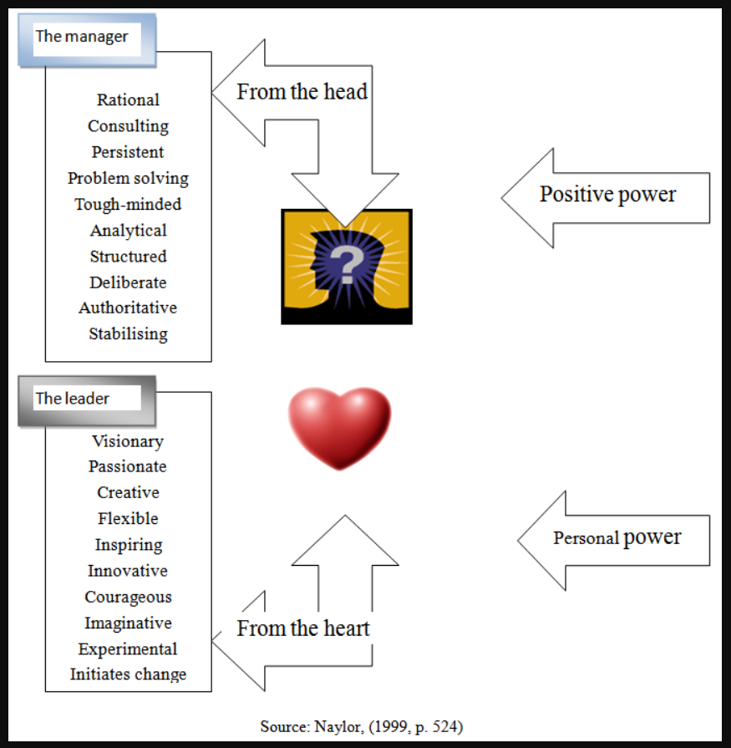

Fig 1

- Leadership Styles

I will be looking at 4 Leadership Styles (fig 1)

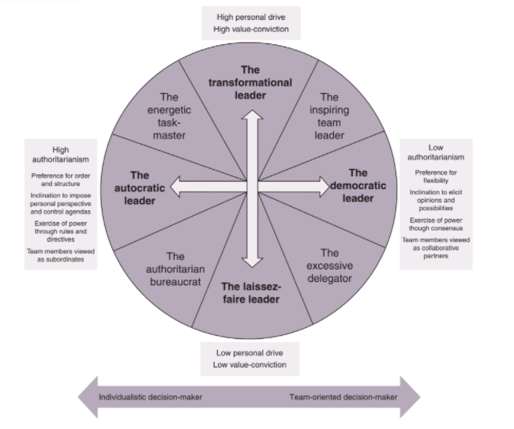

Fig 2 The Leadership Orientation Paradigm (Source: Hunt (2017). (Hunt and Fitgerald, 2018)

3.1 Transformational
This theory allows leaders to influence subordinates to understand the importance of the task through motivation,
AMAZON – Jeff Bezos
Entrepreneur Jeff Bezos, founder of ecommerce Amazon is a classic case of Transformational Leadership. His story is inspirational, that anybody can do whatever they put their mind to, but you must possess the qualities (fig 1).
Amazon was initially an online bookshop, with innovative ideas Amazon has grown to be global. They excelled in the COVD pandemic because they had the business infrastructure in place to easily accommodate online sales, with recruiting more staff to manage demand.
Amazon in COVID
Amazon recruited an additional 175,000 staff to meet demands. Trying to utilize 175,000 staff with social distancing in effect is an astronomical task. Workers were not able to able to social distance themselves adequately to keep themselves safe (Paul, 2020). Even with forward planning, effectively coordinating this within a timeline would be difficult. Here Amazon’s bigger picture was “Covid Pandemic – sales will increase we need more staff” but the smaller details of how to place additional 175,000 staff safely was not thought through enough, leading to unhappy employees, can this leader be linked to narcistic personality disorder?
Transformational Leaders characteristics have been linked to narcistic personality disorder. Which are self-confident, entitled, grandiose, manipulative, hostile, and risk takers (Appendix 1). On the face of it, grandiose narcissist can appear as Transformational leaders. As these characteristics overlap, it can be difficult to distinguish, but it will heavily rely on the whether they have a healthy amount of self-confidence. (O’Reilly and Chatman, 2020). However, organizations will not be able to identify this, as it is dependent on, if the narcissistic traits are used in a positive and healthy way.
3.2 Democratic
A democratic leaders behavior influences people in a manner consistent with principles such as self-determination, inclusiveness, equal participation, and deliberation (Gastil, 1994). A democratic leader characteristic consists of intelligence, fairness, honesty, creativity, and competence. They make decisions based on morals and values, the followers tend to feel inspired, and make contributions and act.

VIRGIN GROUP - Richard Branson
Branson believes that "Our view at Virgin is that collective responsibility bonds teams and having pride in your work is a far better driver than a hierarchical culture where the boss calls the shots." His employs likeminded people however he values individuality, as they provide new ideas and diversity.
He holds lunches as opposed to structured meetings in boardrooms, this helps participants to communicate in a more relaxed atmosphere. He guides his followers by outlining the factors to work from with the necessary tools to carry out the task. He provides innovative outlets schemes where his staff can submit innovative ideas. (Crush, 2010)
However, Leaders may procrastinate, as they delegate. They need to regulate their goals, as they will be unable to make decisions when required. This can be overcome, through understanding purpose and goal, prioritizing, staying away from distractions, and try and develop a sense of urgency. You can also use Multi Factor Leadership Questionnaires available that help identify individual strengths and weaknesses, and provide support where required (Avolio and Bass, 2020).

3.3 Laissez faire
This leadership is based on implicit trust, freedom, and resources. Leaders take a step back and staff make decisions and set their own targets as long it is aligned with companies’ vision and mission. However, this can only be performed with experienced staff.
Laissez faire leadership tend to do better, when subordinates have a high level of passion and intrinsic motivation, and in being knowledgeable in their respective field than the leader. It encourages personal growth through being hands on and provides an atmosphere that accelerates growth and development.
Laissez faire works better in a creative Industries, such as technology, arts, and entertainment areas. This is because subordinates are given free reign, within constraints to do as they want.
Apple – Steve Jobs
Steve Jobs had a vision that helped revolutionize Apple products, recruiting skilled experts. He is not 24/7 hands on, but likes to visit his Industrial Design Lab, to provide his opinions and guidance on the project (Murphy, 2018).
He managed talent requisition. If he recruited most talented people for the top 50 positions, then this will naturally cascade down the line. He managed his work life, essentially through computers, he had access to all the information/ real time data he needed.
However, as Laissez faire heavily relies on the skills of the group, recruiting experts in the fields will minimize the negative effect.

3.4 Autocratic Leadership
The leader has absolute control, rules are clearly defined, communicated with no movement for maneuver for subordinates. This is beneficial when you require a strong directive, with a clear chain of command and allows for quick decision making in stressful environments on the other hand it is very one sided and restrictive, it can desensitize the subordinates in the organization. This a very narrow directive, subordinates are only allowed to complete task in the boundaries that the leaders set. It has been known to restrict communication and workplace socialization, effecting subordinates’ output. (Al Khajeh, 2018).
However, as negative as this leadership may seem, it is beneficial in scenarios that are predominantly task motivated for example, Tesco’s checkout staff, will have daily targets to hit. There is no personal contribution as an employee, check out staff have a structured task. But you must consider the mental and physical wellbeing of the staff.

Tesla - Elon Musk
Elon Musk is an advocate of innovative technology and pushes boundaries. His personality is of an aggressive nature; this can be considered passionate. As the CEO of Tesla, he has designed the first ever electric car. His leadership is considered transformational, with his emphasis on innovation and upskilling his workers. However due to the nature of his business, he is authoritarian in getting his needs met but relies on transactional leadership to hit his short-term goals. (Hamed, 2021).

3.5 TESCO’S Leadership style
Tesco is a large global retail company with a flat hierarchy organizational structure. They have over 4673 branches worldwide.
Steven - Democratic Style
Steven has extensive hands-on knowledge of how consumer requirements have changed and how Tesco’s has adapted. Divisional managers have been recruited for their skills and experience in the relevant department.
Stephen adopts the Democratic style because he is accountable for 300 staff (indirectly/ directly). It is physically impossible to oversee by himself, he has recruited experienced managers to delegate work. As top management he must make sure all the divisional tasks are hitting targets through regular meetings, feedback from managers. However, there are scenarios that democratic does not work, i.e., he may need to interject with a disgruntled employee, rather than let this fester and cause animosity within the team, leaders will need to change the leadership to situational and minimize negativity in the workforce.
Tesco’s Stores require high emphasis on people and task, primarily because they are additionally dealing with the public, therefore the democratic approach works better generally (fig 3).

Martin - Democratic Style
Departmental goals are to provide business critical training and skills, to upskill staff. This requires collecting data, planning, creating, delivering, and evaluating. These are all task related variables; he can delegate task to the relevant skilled staff.
Education and Skills, can be task oriented, i.e., deliver training through planning, organize time and place, attendees etc. - autocratic leadership works better in this scenario, however overall democratic leadership is required to manage.

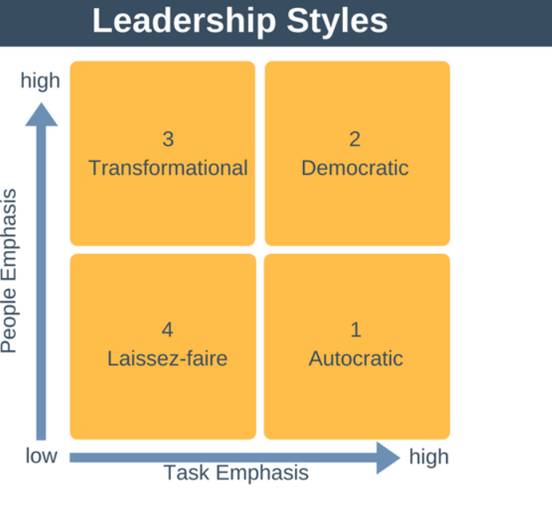
Fig 3

Both departments require a distinct set of task related goals, Tesco’s store (selling and buying) and Education and Skills (upskilling employees) department. They have different set of variables that require a leadership method that works well for that goal, which involves overlapping different styles for the desired outcome.

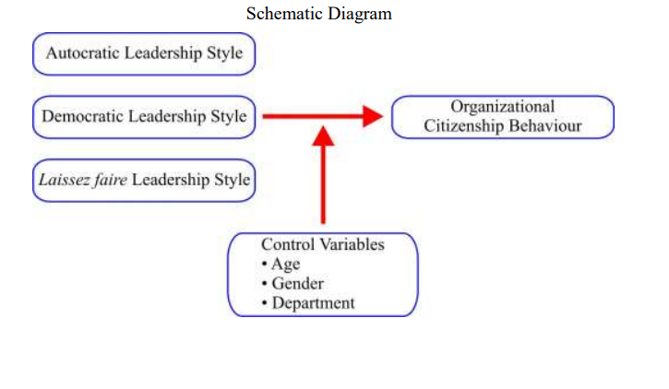
Fig 4

Figure 3 illustrates some of the main variables that contribute to Organizational Citizen behavior. Studies have provided strong evidence, suggesting Democratic Leadership encourages more organizational citizen behavior (Malik et al. 2016).

- Transformational leadership styles in uncertain times

What is Uncertainty? It is an unawareness of knowing the possibility of future state of events. Not having clear directives results to misrepresented conceptions and leads to risky and incorrect decisions. Decision makers are hugely impacted by uncertainty because it limits control over an outcome. Organizations can only cope and reduce uncertainty with managing areas within their control (Sniazhko, 2019).
One aspect of the changing work climate is The Digital Era. The 21st Century has seen a significant change in the workplace (Holland and Bardoel, 2016). The use and control of IT provides an opportunity to be innovative in where we work and the way we work in a global economy. Information Technology has been around in the workplace since 1980’s, however not all industries utilized this due to increased expenditure, Thomas Cook was one of them.
Thomas Cook - The impact of Information Technology since 1980
Their business structure was old and the expense running a high street shop meant that they had limitations. The rise of on-line companies such as Expedia, and search engines like Google Flights meant consumers had easy to access information. Thomas Cook sales declined due to not investing in Information Technology.
In 2011, Thomas Cook faced financial decline, (Ganea and Giosan, 2018) they rehauled their organizational structure by changing the structure of the board, which consisted of nationalities from Belgium, Turkey, Netherlands, U.S., and UK becoming an international company with 1/3 of the members being female. They hired a new CEO – Harriet Green (Transitional Leader), specially brought in to tackle a corporate challenge, whose purpose was to take Thomas Cook out of decline.

They recruited the right leadership mindset and skills to lead the company through fresh external perspective. Harriet Green made radical changes; her goal was to get the company into the best possible financial shape using resources that she had. Harriet maneuvered shop sales to online sales, increasing efficiency, reducing cost, this involved job cuts of 2,500, reducing 199 shops outlets. Harriet leadership style included emailing 35,000 staff for their input, this provides employee inclusiveness in decisions. Harriet stayed as a CEO for 2 years, in which she pulled Thomas Cook out of decline, Thomas Cook went onto hire Peter Fankhauser, who’s focus was digital transformation. Thomas Cook employed the right leaders and the right time for the company however they did not plan well to stay in business in the commercial climate of that time. Harriet proved that leadership with determination, clear, concise, and empathetic, established a positive outlook.

During BREXIT, UK Treasury made assumptions that people will not be spending as much and that the Bank of England will not do anything. However, both assumptions were incorrect, people were still buying, and the Bank of England cut interest rates, and helped banks (Tetlow and Stojanovic, 2018). Tesco’s have managed to plan and put in measures that made sure they were not to affected by this and still were able to be ‘very modest’ in their pricing (BBCNews, 2020).
BREXIT was a planned, time constraint narrative, businesses had time to implement this into their forward planning, for minimal impact. Whereas Covid-19, even though we were aware, the impact of dimensions was astronomical, effecting the way of life in the economy, you can only plan within your remit.

- Conclusion
All organization may have one main Leadership styles they align themselves to in regards company Mission/ Vision, however one style does not work with all situations all Leaders need to adapt/ overlay styles to effectively hit goals. Each leadership changes when there are different variables in task, global reach – acquiring masses of diversity, work culture.
To manage Leadership challenges in uncertain times requires leaders to alter their outlook in business to include innovation due to the fast-paced environment we are now living in. Organizations need to be able to adapt and change continuously to innovative ideas to succeed.

Part 2
- Reflective Essay using Gibbs Reflective Cycle

1.1 Learning
Our lecturer assigned class activities as summarizing articles. I am not good at on-the-spot activities. I received feedback as excellent, I was surprised, so I looked at my summary to see how well I had written to make a contrast to my less well written summaries and figure out why I did better. The article literature itself was understandable, I understood the lecturer’s directive and applied this to summarize. The difference was that I was more confident in this one because I understood it better.

When I did my video presentation, I was able to identify some traits of emergent leadership in myself. I take on board additional tasks naturally as I know it will help reach our goals collectively. I always stay behind if something is needed, I am passionate about the little menial root tasks as I know if I do this right then the rest of the task should come together.

I did a quick email poll to see if my peers would be happy to be led by me, out of 14, 6 people replied to say they would be where happy to be led, (Appendix 3). This is down to the fact, I have always been interactive with my peers, they often approach me, when they need assistance To seek validation of my leadership skills I completed a Multifactor Leadership Questionnaire Form 6S (Appendix 2), the outcome was that I was high in areas of Idealized Influence (I have the trust of at least 6 of my peers), Intellectual Stimulation (always ask leading questions) and Individual Consideration (I always think first of the other person).

I welcome debates as it reflects different ideas, there is no right or wrong! I like to understand different viewpoints as it helps change my understanding if I am missing something, I have ended up changing my opinion based on debates, not often though.

1.2 Feelings
I did not realize how diverse leadership is, each leadership style has key components that is required to make it work, managing people is an art! I feel all leadership traits and style are linked to all aspect of life, everyone is a leader in their own personal circumstances i.e., Family of 5, autocratic - leader needs to manage school runs, lunches, coordinate food shopping. If you are deciding on what games to play – democratic etc. You adapt your style in align to task requirement and people skill.

At work, I identified myself as a democratic leader however when we recruited 2 undergraduates for compliance, which is task related, I showed them how to do the task and provided manuals. I assumed that it is common sense what to do. However, 1 individual was not able to complete task properly, it was primarily down to confidence. I had initially used this directive because that was how I was shown (I forget – I had experience). However, I realized I used laissez faire approach due to time constraints. I changed this by adapting their training. Here I assumed something, I learnt never assume someone knows how to apply a skill set.

1.3 Evaluation
I feel that this module has been very enlightening for me. By making the video, I have identified where my own strengths and weakness lies, tasks are my strengths, self-confidence is my weakness. However, once I understand something, I run with it! When we did written tests on the day, I did groan but I also acknowledge the bigger picture, that this is outside my comfort zone, positive learning outweighed being comfortable but I saw this as an opportunity. I found that I enjoyed these little tests, even when I did not do well, I could compare as to why and learn from it.

I feel that we should be given challenges every week/ other week, so it is fresh in our minds, online learning now interaction is limited. In the context of learning this module, being a natural overthinker, I found when I try and decipher something I lose focus on where I am going. I found this really challenging trying to stop my thought process to not go into overdrive.

1.4 Analysis
I always identified myself in as a follower. I did not realize that I have some emergent leadership qualities as I am a people person, when I speak, I naturally ask leading questions, so I have their input. I have always been naturally creative but never honed this skill, I always like to think out of the box. When I work, I like structure but like to streamline processes to be effective as possible. The one thing I do not possess is the self confidence in myself to believe I can be a leader; however, I believe this can be overcome.

I think it is necessary to expand thinking and knowledge as I have noticed throughout my degree, words that I read in everyday life have more meaning in the context that it is written i.e., Sustainability – That word pops up in bank, solar panel adverts etc., if I read that word before, I didn’t acknowledge the significance. I am now more aware of what is happening around me because my knowledge is expanding, I am thoroughly enjoying increasing my knowledge.

I feel we are all leaders in our own way, we have used leadership traits in everyday life. We as individuals have a memory vault full of lifetime experiences. How we emerge from these experiences defines our progress!

1.5 Conclusion
I learnt that I can be a leader, but I need to upskill myself, the areas I need to concentrate is my self-confidence as a leader. I am not authoritative in nature; I need to find a healthy balance of what works for me to want people to want me as a leader. As I am a visual, kinesthetic learner, I would have liked practical/ theoretical activities outside university. Team building exercises where each person has taken turns in leading, how well we communicated etc., providing feedback.

1.6 Action Plan
I need to concentrate in developing my self-confidence and manage my overthinking. As I am a visual and kinesthetic learner, I will find learning avenues that are aligned to this. There are many online YouTube tutorials, TED Talk videos that help with this, I can do this now however I also need practical experience, attending workshops, volunteering, will help, it would mean putting myself out of my comfort zone.

Part 3 -
3.1 References

- Hughes, R., Ginnett, R.C. and Curphy, G.J., 1996. Leadership. Chicago, Irwin.

- Al Khajeh, E.H., (2018). Impact of leadership styles on organizational performance. Journal of Human Resources Management Research, 2018, pp.1-10.
- Avolio, B.J. and Bass, B.M., (2004). Multifactor leadership questionnaire (TM). Mind Garden, Inc. Menlo Park, CA.
- BBCNews (2020). ‘Tesco: Brexit impact on food prices ‘very modest’. Available at: https://www.bbc.co.uk/news/uk-55460948 (Accessed: 1 August 2021).
- Chinta, B.K.R., The Comparison of Leadership and Management in the Businesses and Organizations.
- Crush, P. (2010) ‘Exclusive Sir Richard Branson talks to HR magazine about Leadership’, HR Magazine. Available at: https://www.hrmagazine.co.uk/content/features/exclusive-sir-richard-branson-talks-to-hr-magazine-about-leadership (Accessed: 28 July 2021).
- Daft, R.L., 2014. The leadership experience. Cengage Learning.
- Derman, G.S., (2019). The Main Differences Between Leadership and Management “Atatürk’s Leadership”. International Journal of Social and Economic Sciences, 9(1), pp.12-16.
- Forsyth, D.R., (2014). How do leaders lead? Through social influence. In Conceptions of Leadership (pp. 185-200). Palgrave Macmillan, New York.
- Ganea, M., Giosan, A. (2018) ‘The Developing Manager – Case Study on Thomas Cook Tour Operator’, ARTECO Journal. Socio-Economic Researches and Studies, 1(1), pp 36-39.
- Gastil, J., (1994). A definition and illustration of democratic leadership. Human relations, 47(8), pp.953-975.
- Hamed, M, (2021) ‘LEADERSHIP STYLES Elon Musk Tesla fonder and CEO of SpaceX’, Researchgate. Available at: https://www.researchgate.net/publication/349098187_LEADERSHIP_STYLES_Elon_Musk_Tesla_founder_and_CEO_of_SpaceX?channel=doi&linkId=601fabfca6fdcc37a80b88f4&showFulltext=true (Accessed: 1 July 2021).
- Holland, P. and Bardoel, A., (2016). The impact of technology on work in the twenty-first century: Exploring the smart and dark side.
- Hunt, J. and Fitzgerald, M., (2018). Styles of leadership. Leadership: Global and regional perspectives, pp.62-98.
- Kruse, K (2013) ‘What is Leadership’ Forbes. Available at: https://www.forbes.com/sites/kevinkruse/2013/04/09/what-is-leadership/?sh=72876c4b5b90 (Accessed: 31 July 2021).
- Malik, S., Saleem, M. and Naeem, R (2016) ‘Effects of Leadership Styles on Organizational Citizenship Behavior on Employees Of Telecom Sector In Pakistan’ Pakistan Economic and Social Review, 54(2), pp.385-406. Available at: https://www-jstor-org.ezproxy.uwtsd.ac.uk/stable/pdf/26616714.pdf?refreqid=excelsior%3Aaca7c91048acd1aa06c148f7b179fc71 (Accessed: 31 July 2021).
- O’Reilly, C. and Chatman, J., (2020). Transformational Leader or Narcissist? How Grandiose Narcissists Can Create and Destroy Organizations and Institutions. California Management Review, [online) 62(3), pp.5-27. Available at: https://journals.sagepub.com/doi/pdf/10.1177/0008125620914989 (Accessed 1 August 2021).
- Paul, K. (2020) ‘California investigates Amazon’s treatment of workers during pandemic’, The Guardian. Available at: https://www.theguardian.com/technology/2020/jul/27/california-investigations-amazon-workers-coronavirus (Accessed: 28 July 2020).
- Murphy, M (2018) ‘The Leadership Model used by Steve Jobs, Henry Ford and Thomas Edison’, Forbes. Available at: https://www.forbes.com/sites/markmurphy/2018/01/14/the-leadership-model-used-by-steve-jobs-henry-ford-and-thomas-edison/ ?sh=5964e49c23f6 (Accessed: 31 July 2021).
- Sniazhko, S., (2019). Uncertainty in decision-making: A review of the international business literature. Cogent Business & Management, 6(1), p.1650692.
- Tetlow, G., Stojanovic, A (2018) ‘Understanding the economic of BREXIT’, Institute for Government. Available at: https://www.instituteforgovernment.org.uk/sites/default/files/publications/2018%20IfG%20%20Brexit%20impact%20%5Bfinal%20for%20web%5D.pdf (Accessed: 1 August 2021)

3.2 Appendix

Appendix 1

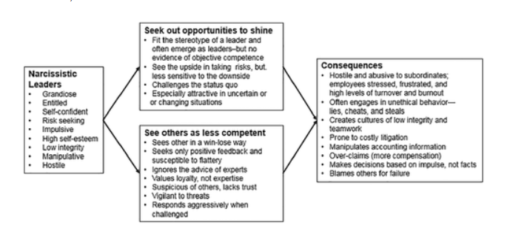

The organizations effects of narcissistic leaders.

Appendix 2
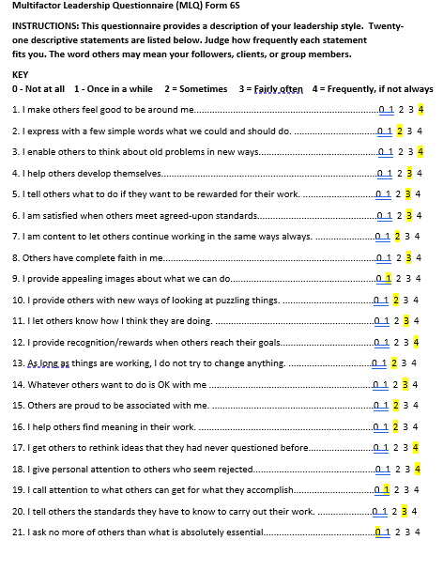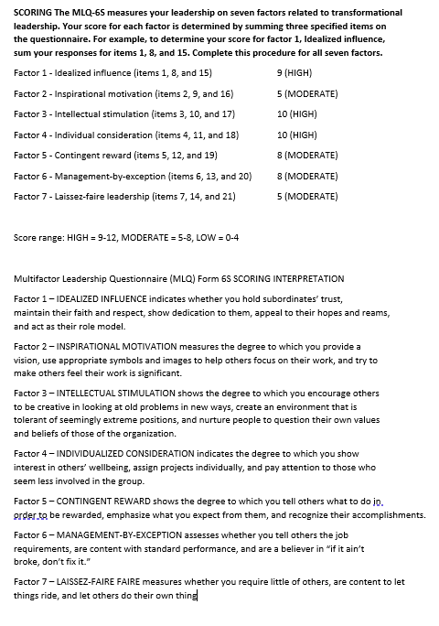
Addendix 3

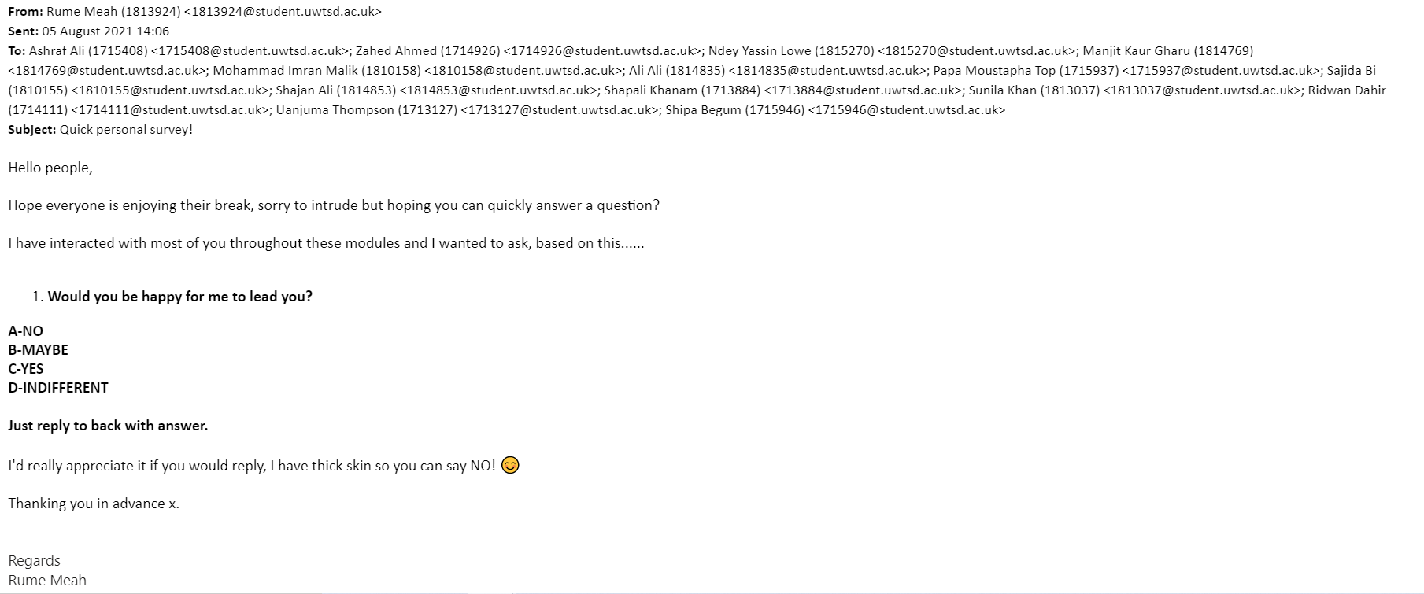

Appendix 3 (cont)

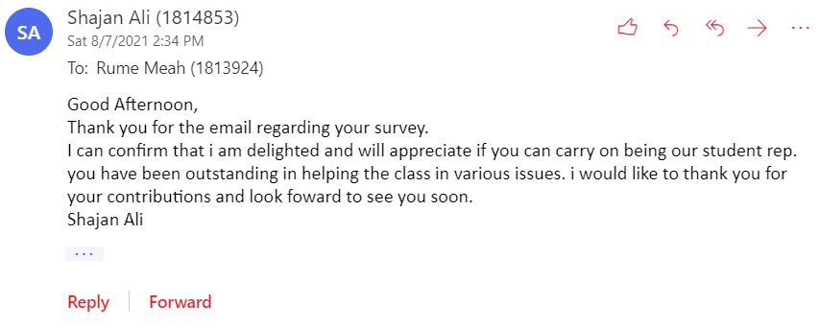
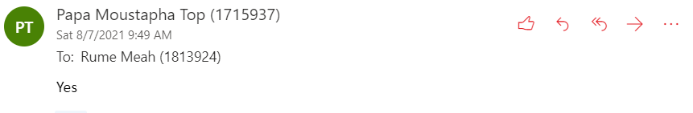

Appendix 3 (cont)

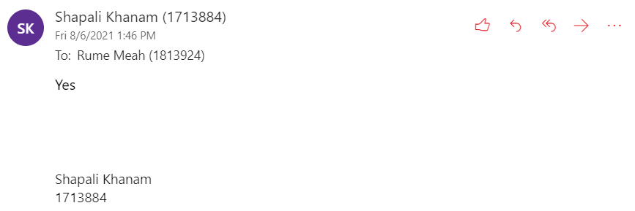
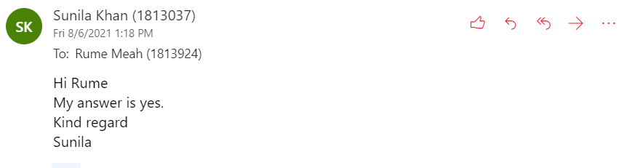

Appendix 3 (cont)



