

BA (Hons) Leadership and Management Skills for the Workplace

Organizational Culture



Student Name: Chaudhry Badar Munir Mehar
Student ID: 2334056
Module Title: Organizational Culture
Module Code: LCLM 5005
Module Leader: DR Ramees Manalang

Table of Contents
Introduction 3
Organisational Culture of Tesco 4
How the Organizational Culture Helps Shape the Company’s Structure and Decision-making 6
Relevant Frameworks, Models, or Theories to Tesco 8
Organisational Culture and Adaptation to the External Environment at Tesco 11
Organisational Culture and Effective Functioning of Tesco 13
Evaluation of the Impact of Organizational Culture on Organisational Performance at Tesco 15
Conclusion 17
Reference 18

Introduction
Tesco is a global supermarket shop that has several stores in most countries, such as the UK and Ireland, among others. Tesco was established in 1919 by Jack Cohen, and it began as a small grocery retailer and has, over time, expanded to be a multinational chain of supermarkets (Tesco, 2025). The company has a great variety of products, such as food, clothing, electronics, and financial services. Tesco is well known in terms of its keen interest in value-for-money, convenience, and quality services to its customers. This report is aimed at discussing the organizational culture at Tesco and how the organizational culture affects the company structure, decision-making, and performance. Through the values, beliefs, and practices of Tesco, it gets to know how its culture influences how it does business and relates with both employees and customers as well as the external environment. The report also explains the appropriate frameworks and models to examine the organizational culture of Tesco.

Organizational Culture of Tesco
Organizational culture can be described as a set of common values, beliefs, behaviors, and practices that determine how people in each organization associate themselves with each other and also the external stakeholders (Abawari et al., 2024). It is associated with the way workers will work, the process of decision-making, and customer experience.
Current Culture
The Tesco organizational culture has been based on customer commitment, teamwork, innovation, and responsibility (Awadari and Kanwal, 2019). The company's mission has been to serve customers a little better each day, which shows that the company is oriented towards improving customer satisfaction (Tesco PLC, 2026). Tesco culture has a history of customer-centricity, and workers are encouraged to give priority to the needs of the customers. The company believes in quality service, value for money delivery, and providing the customer with an enjoyable shopping experience. Teamwork and cooperation are also an ethos at Tesco, and its workers pull together their joint efforts to achieve common goals (Costa, 2025). The company practices diversity and inclusion in which all employees feel respected and valued regardless of their origin. The other aspect of Tesco culture that has come to be of paramount importance is Tesco's commitment to the development of employees.
Cultural Elements
The leadership approach of Tesco is empowerment and cooperation oriented. Tesco leaders are also trying to be inspirational and give leadership to their teams rather than a top-down approach (Chalmers and Brannan, 2025). This type of style enables building a trusting atmosphere and encourages employees to be active and propose their ideas. The organizational culture of the company can often be described as a friendly team that is open to feedback, and that has led to a culture of mutual respect between the individuals and the authority (Iskamto, 2023). In relation to communication, Tesco has an open and transparent communication culture. Constant updates and feedback are stimulated between the employees and management in the firm through various channels, such as meetings, surveys, and internal messages.
Impact on Work Environment
The work environment and employees in Tesco have a huge impact on the organizational culture (Costa, 2025). This encourages customer satisfaction, and this will have a positive effect on encouraging the employees to provide quality service that leads to a nice customer experience. This cooperative spirit of working contributes to a favorable working climate in which the workers collaborate to solve the problems and organizational goals (Abawari et al., 2024). This alliance assists in enhancing employee morale and job satisfaction since the individuals in the relationship will feel that they belong to a workforce where they have shared interests. It is also the culture that allows professional growth and development to occur at Tesco, resulting in appropriate motivation and engagement of the employees. The company provides its staff with numerous chances to learn and develop new skills and achieve career advancement.

How Organizational Culture Helps Shape the Company’s Structure and Decision-making
Link Between Culture and Structure:
Organizational culture plays a key role in determining the business structure in terms of how the business will set itself and how it will behave externally. The chain of command and information flow exist in Tesco as its culture presupposes cooperation and free communication (Chalmers and Brannan, 2025). The company has quite a flat structure, which helps in making decisions, and the communication process is fast. The openness and teamwork Tesco possesses are reflected by such a structure. The employees are all motivated to be vocal and contribute to the success of the company. Tesco has levels that are hierarchical and made approachable, and this assists in supporting the culture of transparency (Iskamto, 2023). The front-line employees are in contact with the top executives and managers to provide feedback and their ideas. Tesco is more adaptable and receptive as communication cuts across both upward and downward, with employees being encouraged.

Decision-making Processes:
The decision-making processes are also influenced by the Tesco organizational culture. The company is oriented towards empowerment and is prone to decentralization of decision-making (Tesco PLC, 2026). This means that the top executives involve themselves in making numerous decisions either at the local or departmental level rather than individually. This plan enables the managers and the employees to make decisions that are more suited to the respective areas that they are expected to serve (Akter et al., 2023). This allows Tesco to be responsive to both the customers’ needs and changes in the market, as it makes decisions at the lower levels. In addition, Tesco promotes the culture of team decisions (Abawari et al., 2024). The company is not a strong top-down organization but encourages managers to cooperate, share information, and make decisions together. The given consultation strategy will ensure that all the views will be taken into consideration in the process of decision-making.

Examples:
The way Tesco's brick-and-mortar operations are managed in its stores can be an example of how Tesco culture dictates decision-making processes (Costa, 2025).
- Tesco managers in local store groups are permitted to make local decisions based on the needs of the local customers, such as the product mix or store formats (Zhang et al., 2023).
- Such decentralization of decision making allows the firm to be more open to local markets but implies keeping its values and customer service attractive.
- The other case is how cross-functional teams at Tesco work together with strategy initiatives (Putra and Nasution, 2024).
These teams are crack teams that are composed of the employees of various departments, such as marketing, operations, and finance, and are convinced to work together to make critical decisions. The collaborative decision-making process allows Tesco to make well-informed decisions by incorporating all the implicated areas, therefore ensuring that the decision made is in the best interest of the firm.

Relevant Frameworks, Models, or Theories to Tesco
Schein’s Model of Organizational Culture
It establishes three levels of organizational culture: artefacts, espoused values, and underlying assumptions, which are fundamental (Chalmers and Brannan, 2025). Some of the artefacts within Tesco are the open-office arrangement, the store designs that seem to be friendly towards the customer, and the employee engagement initiatives. The mentioned observable aspects imply the emphasis of Tesco on the significance of its cooperation, openness, and customer contentment (Iskamto, 2023). This makes its philosophy of continual improvement, customer focus, and employee empowerment. Another corporate value reflected in the company is inclusivity, which is also enshrined in the diversity programmers, and the company also trusts its employees to make decisions.
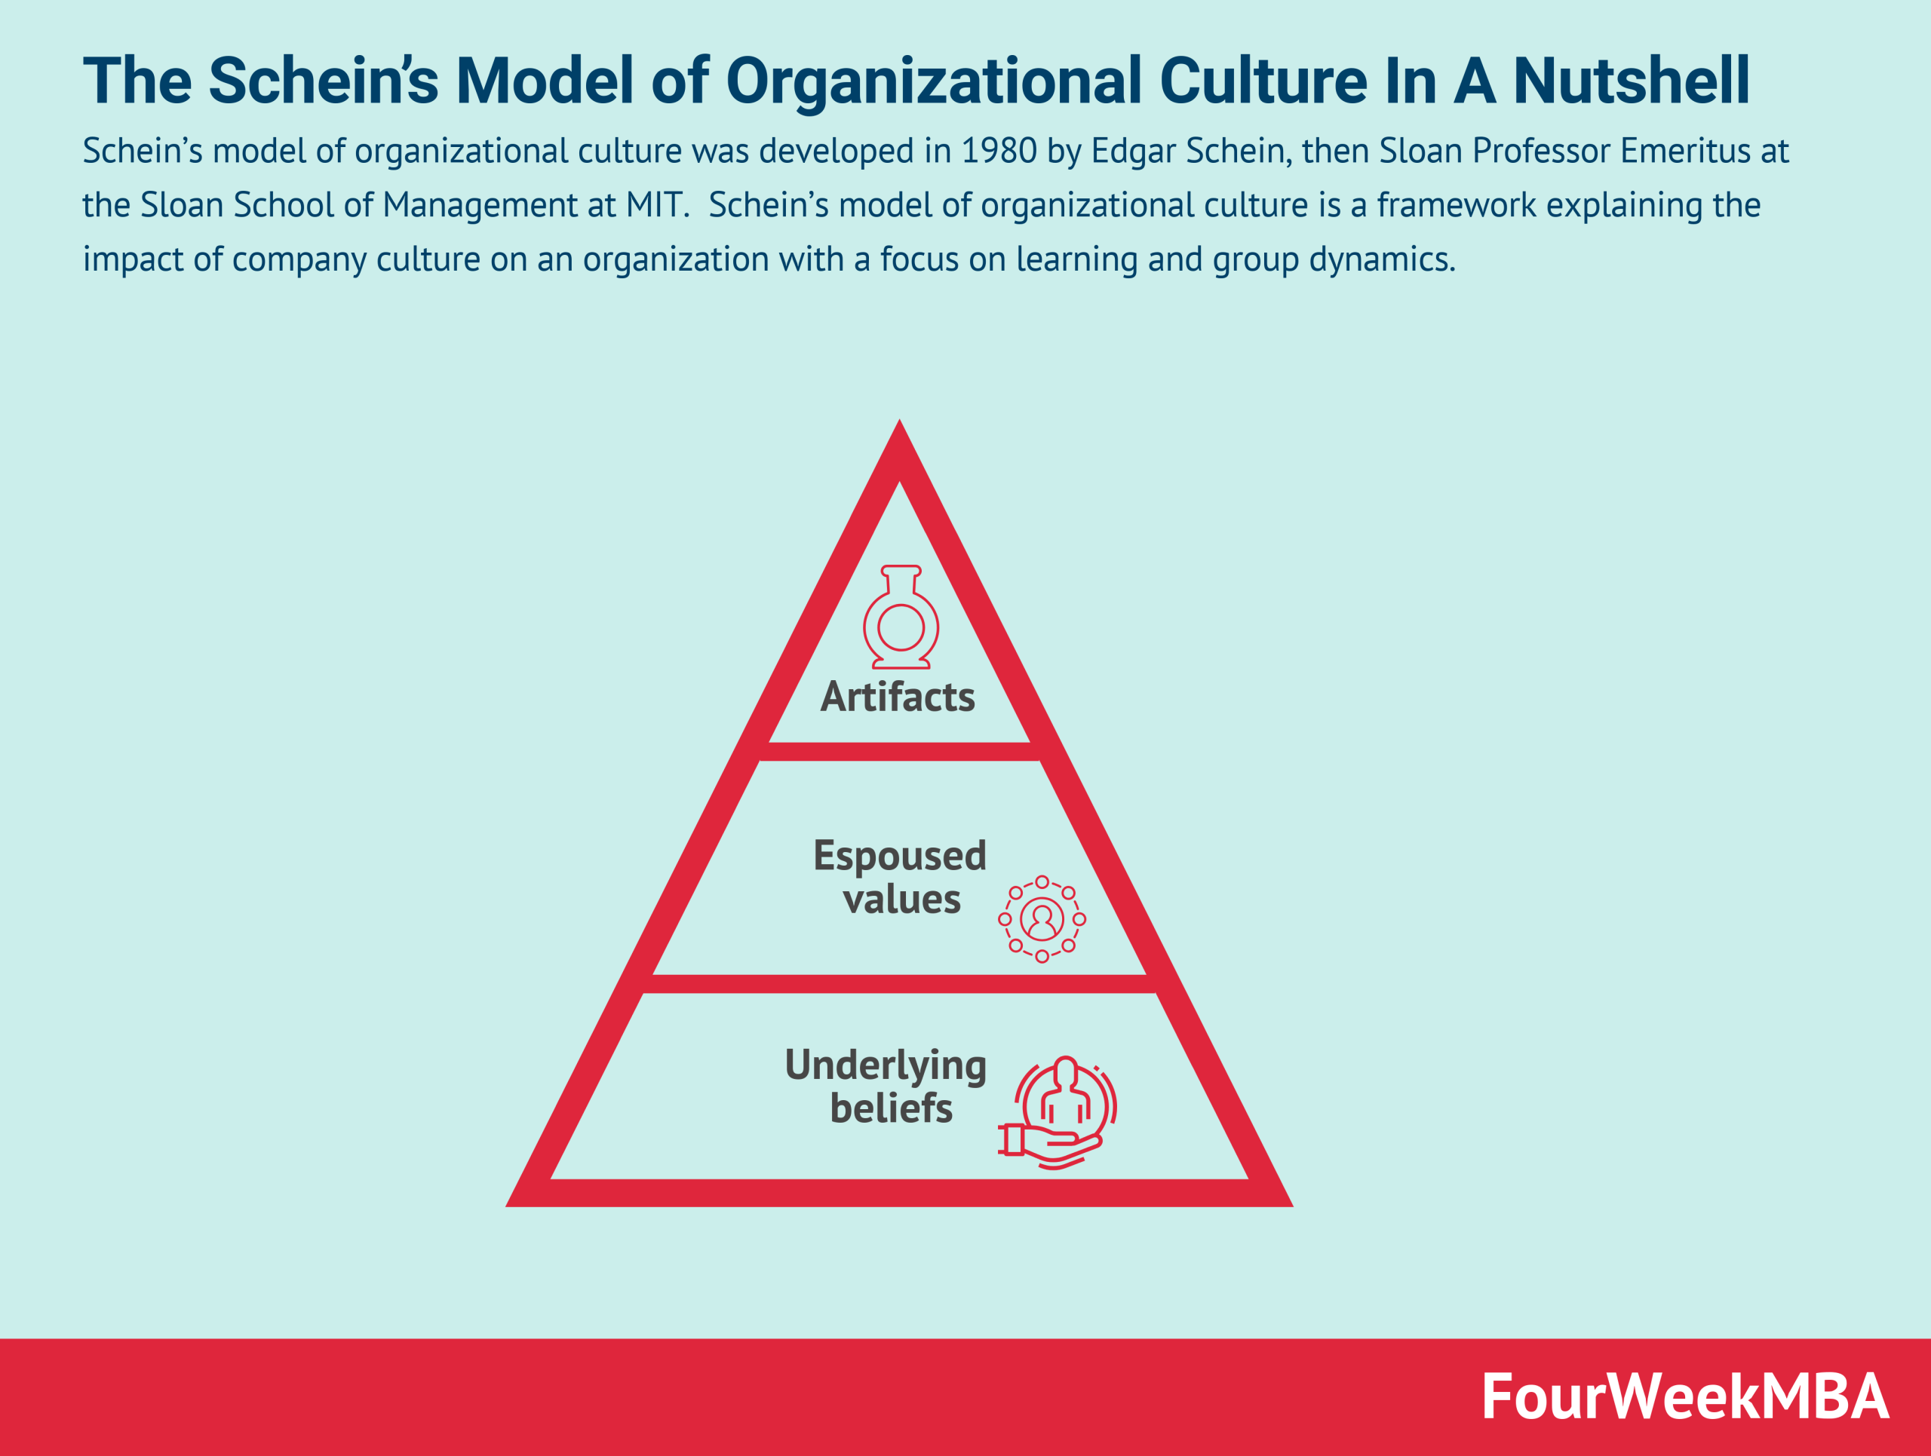
Figure 1 Schein’s Model (Cuofano, 2021)

Hofstede’s Cultural Dimensions
It aids in the frameworks of analysis of organizational culture when the national value is put into consideration (Piotrowska and Piotrowski, 2023). Tesco is characterized by low Power distance, meaning that there is reduced hierarchy and equality among the employees and the management. Tesco has an open communication style where the leaders listen to ideas and the employees are provided with a chance to voice their ideas (Nikčević et al., 2025). The issue of individualism and collectivism is an issue; Tesco is inclined towards collectivism because it focuses on teamwork and shared goals (Abawari et al., 2024). This type of group influences the decision-making processes in the workplace and how the teams interact in the various departments. Tesco culture that promotes coordination and employee orientation, as the Hofstede cultural dimensions, demonstrates the company's culture.
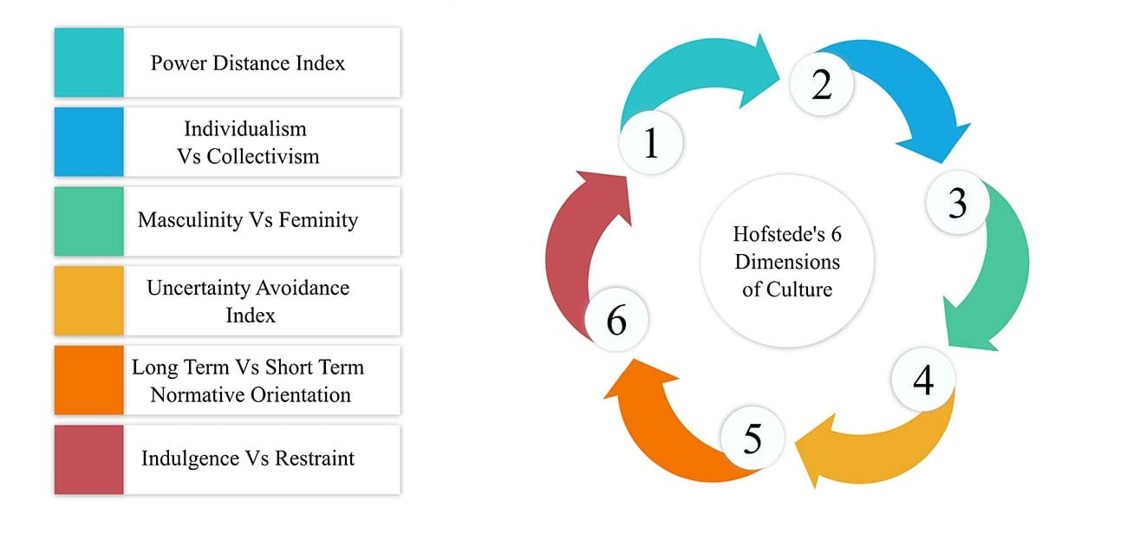
Figure 2 Hofstede’s Cultural Dimensions (Piotrowska and Piotrowski, 2023).

Strengths of applying this model
The Schein model provides an elaborate understanding of the relationship between Tesco in the cultural context (Akpa et al., 2021). It further explains how the tenets of the business, such as the one on customer commitment and the team effort, can be traced in real-life practice (Putra and Nasution, 2024). Knowledge of these layers will see Tesco implement its culture at every organizational level. The model that was developed by Hofstede helps explain the organizational culture of Tesco with regard to the national aspects (Piotrowska and Piotrowski, 2023). Through the model, it is possible to explain the reasons why Tesco is interested in collaborative efforts and equality within the company.

Weaknesses of applying these models
One of the weaknesses of the model advanced by Schein is that the organizational culture usually moves, especially in the fast-evolving market (Pietersen, 2017). External forces can transform Tesco culture, and they may intrude into the operation of the company due to the competition in the market or technological advancements. One of the facts that makes the Hofstede model weak is the fact that it assumes that organizational culture is strongly influenced by national cultures (Nickerson, 2025). The national culture is also applicable, yet in this sense, this model is a bit limited since the internal culture of Tesco.

Organizational Culture and Adaptation to the External Environment at Tesco
External Influences
The organizational culture within Tesco is shaped by a number of external influences, which include competition, economic, technological, and changes that occur within society (José et al., 2025). Retail business is highly competitive, and all the firms are perpetually striving to please their customers and increase their productivity. There are changes in the economy, such as inflation or adjustment of consumer spending, that influence Tesco's business operations and culture (Awadari and Kanwal, 2019). The rise of e-commerce and digitalization also helped develop the change in how Tesco has been functioning in terms of social needs, in terms of sustainability, and the duty of a business force Tesco to adopt more sustainable ways of doing business. Consumer expectations are also dynamic in influencing the Tesco culture (Nikčević et al., 2025).

Cultural Adaptation
The Tesco organization culture is quite accommodating to outside pressures, particularly in adapting to change in the market dynamics and customer preferences (Tesco, 2023). Tesco can be used as an example, where environmental responsibility has been an effort by the company to alter its culture since its customers are increasingly demanding sustainable products (Sulej, 2021). This has been applied by cutting the level of carbon emitted into the environment, given its commitment to the use of more recyclable products, and a wider range of green products (Alam and Raut-Roy, 2019). Tesco has embraced the digital transformation in its business culture around technology adaptation. By not occupying its activities with the traditional in-store shopping to offering online shopping and home delivery services, particularly during the COVID-19 pandemic, the company transformed the nature of its activities (Tshifhiwa and Morukhu, 2025).

Examples
One of the real-life examples where Tesco made cultural changes is the sustainability efforts undertaken by Tesco. Tesco has responded to international challenges of climate change and, as such, has undertaken a lot in its supply chain to reduce food wastage and emissions of carbon (Awadari and Kanwal, 2019). The culture of the company has been accommodating green practices by setting such aspirations as reducing the amount of waste materials and ensuring that all the packages can be recycled by 2025. The other example is the reaction of Tesco to COVID-19. The culture of customer-centricity and flexibility of Tesco enabled it to create online delivery services as fast as possible, as online shopping has become more popular, and customers must engage in contactless shopping (Sulej, 2021). The organizational culture empowered the workers through a conducive environment, offering the workers a chance to work away and select the working hours, which made the employees feel secure and supported in difficult times (Alam and Raut-Roy, 2019). The culture of the Tesco organization has been very accommodating to the external environment.

Organizational Culture and Effective Functioning of Tesco
Culture as a Barrier/Enabler
Tesco's organizational culture is an enabler of its operations and performance in general (José et al., 2025). The company boasts of a culture that increases customer-centricity, teamwork, and innovation, which have brought it success in a competitive retail environment. The focus on the idea of teamwork and inclusiveness allows Tesco to make the right decisions on time, swiftly obtain a solution to the issue, and employees feel their ownership (Zhang et al., 2023). This culture encourages employees who come up with ideas, and this has led to improved levels of operation and enhanced customer service. However, the culture of the company may also act as a hindrance in certain cases (Tshifhiwa and Morukhu, 2025). Indicatively, owing to the strong consideration given to the culture of having a team, Tesco may occasionally experience problems in making decisions in a situation where greater individuality or expedience in decision-making is required.

Efficiency and Innovation
The Tesco corporate culture also embraces high efficiency and innovation, which have been among the key factors that have made the company remain effective (Tesco, 2023). The company embraces the culture of continuous improvement, and to this end, employees in all the branches of the company are encouraged to come up with ideas on how best processes can be optimized, costs minimized, and customer experience optimized. The culture will come in handy when organizing the processes of Tesco and realizing emerging opportunities to increase productivity (Bogale and Debela, 2024). One of the areas where the Tesco innovations culture has been effective is in supply chain management (Pham et al., 2024). The firm has also embraced technology in its operations, as it has made use of specialized technologies to facilitate its operations, through which it has used advanced systems to maintain its inventory and even predict its demand.

Examples
One such example is the Tesco Clubcard loyalty scheme, which has enabled the firm to be operationally effective due to its culture (Sulej, 2021). The programme allows Tesco to gather not only useful information about the preferences and purchasing behavior of customers (Pham et al., 2024). This information will help the company in making a more informed choice in how to handle stocks, as well as the promotion and sale of products. Customer focus culture at Tesco has seen the organization make changes in the program over the years to add new functions, including Clubcard Plus, and offer them in digital form (Tacon, 2020). The other source is the COVID-19 reaction of Tesco. The culture at Tesco encourages agility and innovation, which allowed the company to develop its online platform quickly in response to the increasing number of people in need of services on online shopping and home delivery. Tesco has also deployed online ordering and delivery services and introduced new safety measures within its stores.

Evaluation of the Impact of Organizational Culture on Organizational Performance at Tesco
Impact on Performance:
Organizational culture has a significant bearing on the performance in terms of success, profitability, and growth of Tesco (Zhang et al., 2023). Such a mindset of customer first, innovation, and teamwork within the company has assisted the alcohol industry in dominating the market. Tesco culture is the driving force that motivates the employees to offer quality services and customer value. The focus helps the company to remain at the same level with its competitors, cope with the changing business environment, and maintain customer loyalty (Tesco, 2023). Tesco spreads the culture of empowerment and inclusivity, and consequently, the employees are motivated and engaged.
Positive Impact:
Customer-centric culture at Tesco has made the firm enjoy high satisfaction and customer loyalty (Bogale and Debela, 2024). The Clubcard loyalty program and the frequent focus given to the formation of customer relationships with the company have been instrumental in establishing customer relationships with the company. The income stream of Tesco will be supported by such loyalty, and the company will raise its market share. The Tesco inclusive culture also impacts employee satisfaction positively (Ogbeibu et al., 2018). The company has been able to achieve high employee engagement due to development programmers, flexible working time, and a working environment. Engaged employees become more productive, and this eventually results in the overall success and growth of the company.
Negative Impact:
Although teamwork, being a major part of the Tesco culture, is mostly a positive thing, in the scenario of fast-paced competition, it may be a rather inhibiting factor in the decision-making process (Sulej, 2021). This teamwork spirit of the company has the capacity to postpone the decision-making processes, particularly where speed is required in decision-making and not in teams. This can be a demerit in case they enjoy a competitive market. The Tesco corporate culture may sometimes contrast with the local market requirements (John and Kavatekar, 2025). Otherwise, in some places, Tesco has had some difficulties in trying to adapt its culture to the local needs of the population, as is the case in the withdrawals of some of its international markets, including the United States (Bogale and Debela, 2024). Although this may be because Tesco is too homogenous in its culture and inflexible to fit the local tastes, it may also be that Tesco was too rigid to adhere to the local culture.

The strong cultural ground of Tesco can be considered the positive financial performance and customer satisfaction scores (Vasumathi et al., 2025). The surveys done on the involvement of employees also show that the figures are very high, with most employees articulating that they are important and feel supported by the company. The defeat in some of its markets, however, as seen in the exit of the US market, states that Tesco must balance cultural conformity and adjust to the needs of the local market.

Conclusion
The organizational culture in Tesco has significantly assisted the company in attaining its success, profitability, and growth. The customer focus culture, collaboration and employee engagement have resulted in high customer loyalty, operational efficiency and a sustained innovation process in the company. Culture has enabled Tesco to maintain its competitive edge, particularly in the tumultuous environment of the retail industry, such as the case of online shopping coming into the picture. Although Tesco culture has been more facilitating in its success, there are some incidents where it has faced challenges, such as slowness in the decision-making process and a need to be more adaptable in the international markets. Overall, Tesco's organizational culture remains one of the largest contributors to Tesco performance since it allows the organization to resist external force and sustain growth in the long term.

Reference
Abawari, A.M., Debela, K.L. and Abegaz, M.B. (2024). The effects of organizational culture on change management in Oromia public sectors: the mediating role of leadership styles. Cogent business & management, [online] 11(1). doi:https://doi.org/10.1080/23311975.2024.2375623.
Akpa, V.O., Asikhia, O.U. and Nneji, N.E. (2021). Organizational Culture and Organizational Performance: a Review of Literature. Organizational Culture and Organizational Performance: a Review of Literature, [online] 3(1). Available at: https://www.publications.calebuniversity.edu.ng/caleb_uploads/2024/04/Organizational-Culture-and-Organizational-Performance-A-Review-of-Literature.pdf.
Akter, R., Rathnayaka, S. and Ahmadi, Z. (2023). The Effect of Leadership and Organisational Culture on Organisational Innovation. International Journal of Services Technology and Management, 28(5/6), pp.360–388. doi:https://doi.org/10.1504/ijstm.2023.135084.
Alam, S. and Raut-Roy, U. (2019). Evaluating the Effectiveness of Reward Strategy at Tesco: Evidence from Selected Stores in UK. Indian Journal of Industrial Relations, [online] 55(1), pp.105–120. Available at: https://www.jstor.org/stable/27124702.
Awadari, A.C. and Kanwal, S. (2019). Employee participation in organizational change: A case of Tesco PLC. International Journal of Financial, Accounting, and Management, 1(2). doi:https://doi.org/10.35912/ijfam.v1i2.93.
Bogale, A.T. and Debela, K.L. (2024). Organizational culture: a Systematic Review. Cogent Business & Management, 11(1), pp.1–23. doi:https://doi.org/10.1080/23311975.2024.2340129.
Chalmers, R. and Brannan, G.D. (2025). Organizational Culture. [online] PubMed. Available at: https://www.ncbi.nlm.nih.gov/books/NBK560543/ [Accessed 8 Mar. 2026].
Costa, Dr.R. (2025). Building a Strong Organizational Culture: Key Drivers and Best Practices. OTS Canadian Journal, [online] 4(6), pp.1–15. doi:https://doi.org/10.58840/dyqem182.
Cuofano, G. (2021). What is Schein’s Model of Organizational Culture? The Schein’s Model of Organizational Culture In A Nutshell. [online] FourWeekMBA. Available at: https://fourweekmba.com/scheins-model-of-organizational/ [Accessed 9 Mar. 2026].
Iskamto, D. (2023). Organizational Culture and Its Impact on Employee Performance. International Journal of Management and Digital Business, 2(1), pp.47–55. doi:https://doi.org/10.54099/ijmdb.v2i1.584.
John, S.M. and Kavatekar, S. (2025). Impact of organizational culture traits on employee intention to stay in the IT services sector: An empirical analysis. Problems and Perspectives in Management, 23(4), pp.585–601. doi:https://doi.org/10.21511/ppm.23(4).2025.40.
José, D., Palma-Moreira, A. and Au-Yong-Oliveira, M. (2025). Organizational Culture and Perceived Performance: Mediation of Perceived Organizational Support and Moderation of Motivation. Administrative Sciences, [online] 15(8), p.307. doi:https://doi.org/10.3390/admsci15080307.
Nickerson, C. (2025). Hofstede’s Cultural Dimensions Theory & Examples. [online] Simply Psychology. Available at: https://www.simplypsychology.org/hofstedes-cultural-dimensions-theory.html [Accessed 8 Mar. 2026].
Nikčević, G., Pavićević, D. and Abramovic, N. (2025). ORGANIZATIONAL CULTURE AS THE FOUNDATION OF TRANSPARENCY AND ACCOUNTABILITY IN THE BUSINESS ENVIRONMENT. AGORA INTERNATIONAL JOURNAL OF ECONOMICAL SCIENCES, [online] 19(2), pp.328–336. doi:https://doi.org/10.15837/aijes.v19i2.7334.
Ogbeibu, S., Senadjki, A. and Luen Peng, T. (2018). An organisational culture and trustworthiness multidimensional model to engender employee creativity. American Journal of Business, 33(4), pp.179–202. doi:https://doi.org/10.1108/ajb-12-2017-0043.
Pham, V.K., Nhu, T., Thanh Tu Phan and Ngoc Anh Nguyen (2024). The Impact of Organizational Culture on Employee Performance: A Case Study at Foreign-Invested Logistics Service Enterprises Approaching Sustainability Development. Sustainability, 16(15), pp.6366–6366. doi:https://doi.org/10.3390/su16156366.
Pietersen, C. (2017). Organizational culture: a foundational perspective. African Journal of Economic and Management Studies, 8(3), pp.262–273. doi:https://doi.org/10.1108/ajems-06-2016-0085.
Piotrowska, M.Z. and Piotrowski, J. (2023). Hofstede’s Cultural Dimensions Theory. Encyclopedia of Sexual Psychology and Behavior, [online] 1(1), pp.1–4. doi:https://doi.org/10.1007/978-3-031-08956-5_1124-1.
Putra, D.M. and Nasution, N. (2024). The Role of Organizational Culture on Employee Performance through Job Satisfaction and Work Motivation. Journal of Entrepreneur & Business, 5(1), pp.55–68. doi:https://doi.org/10.24123/jeb.v5i1.6099.
Sulej, K.P. (2021). Organizational Culture and Project Management methodology: Research in the Financial Industry. International Journal of Managing Projects in Business, [online] 14(6), pp.1270–1289. Available at: https://www.emerald.com/insight/content/doi/10.1108/IJMPB-08-2020-0252/full/html [Accessed 8 Mar. 2026].
Tacon, C. (2020). Groceries Code Adjudicator Investigation into Tesco plc. [online] Available at: https://www.eurofresh-distribution.com/wp-content/uploads/2016/01/GCA_Tesco_plc_final_report_26012016_-_version_for_download.pdf [Accessed 8 Mar. 2026].
Tesco (2023). Why work here. [online] Tesco Careers. Available at: https://www.tesco.com/careers/en-GB/our-culture/why-work-here?srsltid=AfmBOor4lA_S8FYtEdKmhMjr5aGMe9omnjiJtfgcFR3nCPXIy21pE9iA [Accessed 8 Mar. 2026].
Tesco (2025). About Us. [online] Tesco PLC. Available at: https://www.tescoplc.com/about [Accessed 8 Mar. 2026].
Tesco PLC (2026). Core Purpose and Values. [online] Tesco PLC. Available at: https://www.tescoplc.com/about/how-we-do-business/core-purpose-and-values [Accessed 8 Mar. 2026].
Tshifhiwa, M. and Morukhu, D. (2025). The Impact of Organisational Culture on Employee Engagement: A Case Study of the University of Venda. International Journal of Applied Research in Business and Management, 6(3). doi:https://doi.org/10.51137/wrp.ijarbm.407.
Vasumathi, A., Vasudevan, A., Razak, A. and Mohammad, S.I.S. (2025). An empirical study on the impact of organizational culture dimensions on employees’ performance through organizational support in the IT industry. Social Sciences & Humanities Open, [online] 12, p.102054. doi:https://doi.org/10.1016/j.ssaho.2025.102054.
Zhang, W., Zeng, X., Liang, H., Xue, Y. and Cao, X. (2023). Understanding how organizational culture affects innovation performance: A management context perspective. Sustainability, 15(8), pp.1–18. doi:https://doi.org/10.3390/su15086644.

