Introduction
In this report, I will examine the effects of additive manufacturing principles. As part of this process, I have been assigned two tasks to complete. First, I will apply Design for Additive Manufacturing (DfAM) principles to a component of my own choosing. To demonstrate DfAM principles/concepts and design tools effectively, I must carefully choose the component for my case study. To increase my chances of success, I should choose a component for which I have baseline familiarity. As part of my case study, I will identify an appropriate AM process and material selection, with a written report justifying my choices.
Task 1
BIKE CRANK- FUNCTIONALITY
Since I believe that there are several segments to the bicycle market throughout the world, I decided to use a bike crank as my component of choice. Consumers who purchase recreational products are primarily concerned with price and do not consider the weight of the components. Recreational cyclists, professional racers, and serious cyclists are more concerned with weight than price. Performance characteristics of components are also important to serious cyclists. It is important for a serious cyclist to have a crank that is relatively stiff so that the energy they generate can translate to forward motion with the least amount of energy being wasted on deflecting the material.
Failure of the paddle crank was identified as one of the most critical failure points of bicycles. Bottom bracket axles are connected to pedals by two cranks, both mounted 180° apart. There are many different types of bicycle cranks, which can be adjusted for different types of cyclists and cyclists of different sizes. In addition to the pedal spindle, the bottom bracket spindle or axle can also be measured for crank length. There are many types of loadings that paddle cranks undergo. Tensile, Torsional, Shear, and Compressive forces can be applied. This can result in cracks developing at various critical points on the crank.
Generally speaking, cracks or failures tend to occur near the crank mounting point and the spider arms. Material defects and abrupt geometric changes may occur as a result of loading in tension. As the crank undergoes dynamic cyclic loading, it is expected that it will initiate brittle cracks, which progress further to the point of failure.
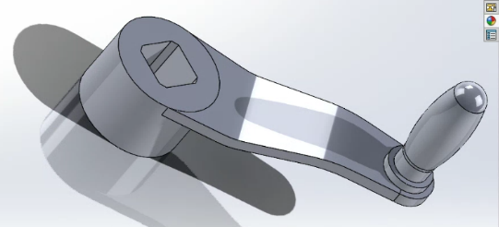

Figure1 – Design of bike crank with the use of SolidWorks.
MANUFACTURING PROCESS
An alloy is pressed into shape using a proprietary Mold in a typical bike crank manufacturing process. In cases where a brand is not interested in developing their own Mold for a component, they can opt for an open Mold. There is, of course, one drawback to this approach: the finished product does not have a unique identity. After refinement is complete, the crank arm itself is stripped of alloy to an accuracy of 0.01mm, as well as the spindle receptacles and spider arm-ends (chain ring seats and bolt holes).
Top, bottom, left side, right side of the crank arm are all processed simultaneously in order to increase efficiency. Before moving on to the next stage, every piece must go through four stages of processing. The crank arm's spindle receptacle, where the bottom bracket spindle connects to the crank arm, is shaped by a drill bit rotating at high speed. Later on in production, the spindles will be fused to the spider.
Afterwards, the softer alloy is removed with a carbide-tipped cutter. In order to begin anodizing, the surface needs to be perfectly clean. When it comes to achieving a surface that is almost completely uniform, sand blasting is the most efficient method.
Electrochemically altering the surface of the crank, anodizing is a step up from painting. An electrolytic solution, such as sulfuric acid, is used to immerse crank arms in electrically conductive liquids. Crank arms are coated with aluminium oxide after being charged positively through an aluminium component and negative through a solution.
As anodizing does not add to an alloy, it transforms it. This makes anodized surfaces more resistant to wear and tear.

DFAM – Design for Additive Manufacturing
In order to begin task one, I will give a basic introduction to additive manufacturing (AM). Industrial sectors are using additive manufacturing (AM) processes to produce components. Traditional manufacturing methods cannot create complex geometries and intricate design features due to additive manufacturing.
A result of this increase in design freedom, many manufacturers are designing new components (and redesigning existing ones) to maximize the optimisation opportunities offered by these technologies, a practice referred to as Design for Additive Manufacturing (DfAM).
Comparatively to other manufacturing processes such as injection moulding and CNC machining (All3 dp 2023). AM processes have removed constraints on component design. As well as strengthening internal structures, part consolidation, complex geometric shapes, mass customization, and multi-material design, additively manufactured parts have unique characteristics.

PRINCPLES FOR DFAM
Design for additive manufacturing (DfAM) is a process that exploits the freedoms of additive manufacturing (AM) while adhering to the limitations of the process (ALTAIR, 2022). In order to maximize functionality and quality of my component, production time, cost, and risk of in-build failure should be minimized. Using four key principles of DfAM.
The understanding of these principles will enable me to create a new design that fully utilizes the benefits of AM and maximizes the chances of it being a commercial success.
- DfAM begins with designing for the correct AM process. Due to the wide variety of categories and processes associated with AM, this is important. Processes differ in their characteristics. Production scale, cost, and geometric complexity vary based on these factors.
Designing for an AM process needs to be closely matched to the geometry of the parts in order to determine which is the best process to use.

- In DfAM, the second principle is to design for minimal material consumption. It is common to believe that minimal material usage is only useful in industries that require lightweight components in additive manufacturing. Nevertheless, the cost and build time of the AM print are also correlated with material usage. The minimum amount of material required to successfully print a part designed for AM should be used when designing the part. this can be achieved by changing build orientation or splitting the components into several parts.

- As a third point, we ought to take advantage of all the opportunities that AM offers. DfAM's third principle, design for improved functionality, can help us accomplish this. It's important to understand what AM can do that other processes can't, in order to benefit from AM's benefits. A few ways to achieve this include customizing parts, adding fluid channels for cooling or heating, and texturing the parts' surfaces. All of these methods make AM the only method for producing parts.

- Consolidation of parts is the final principle. AM's main advantage is the ability to consolidate assemblies into fewer parts, even monolithic parts in some cases. Consolidating parts may reduce the number of fixings, reduce inventory requirements, reduce delivery risks and part obsolescence, and ultimately make assembly less time- and cost-intensive.

METHODALOGY
Selection of materials
Based on (Researchgate,2018) I have determined that high stiffness and specific strength are required to achieve high performance at low mass. Therefore, density, Young's modulus, and yield strength were identified as important factors. Ti64 Titanium and Maraging steel MS1 are the best materials for these applications.
AM manufacturing process
Using research in the field of additive manufacturing. A potential process for manufacturing bike cranks was identified as follows. The said process was evaluated.
Powder bed fusion
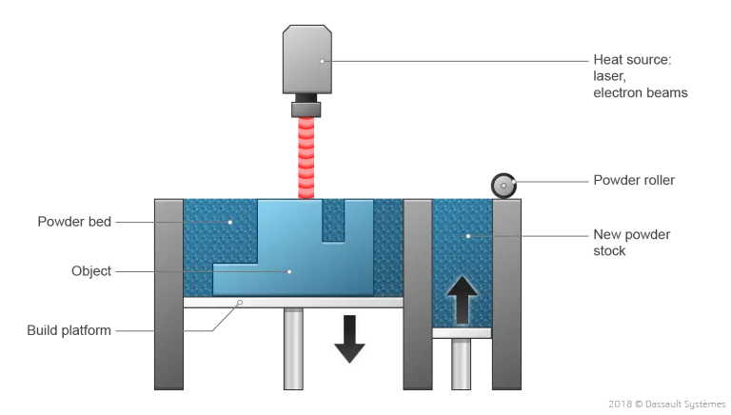
3D printing using Powder Bed Fusion (PBF) produces precise products demonstrated in figure 2. A laser or electron beam is used to fuse powder particles layer-by-layer, forming a solid part, as a 3D printing technique. This enables the manufacture of a vast array of geometrically complex products. Considering PBF presents a variety of materials and technologies, manufacturers can enjoy substantial design freedom. (3ds,2018)

Figure 2- Laser powder bed fusion (3DS,2018)

Different types of powder bed fusion are:
SLS (Selective Laser Sintering)
This process usually involves sintering nylon or polyetherketoneketone (PEKK), which are powdered polymers.
SLM (Selective Laser Melting)
In SLM, a laser provides heat, but instead of sintering the powder, the laser melts it fully. Stainless steel, titanium, and aluminium alloys are among the metal powders that are suitable for this process. Besides exotic metals (like tungsten), more application-based metals can also be processed. The build chamber contains an inert atmosphere (typically argon) that prevents the consolidated material from oxidizing or nitriding.
DMLS (Direct Metal Laser Sintering)
Similar to SLM, DMLS operates in a similar manner. While the term 'sintering' is used, the material melts completely.
EBM (Electron Beam Melting)
A laser is replaced by an electron gun in EBM, which is comparable to SLM. Vacuum is used instead of inert atmosphere for the build chamber, but small amounts of inert gas (typically helium) are used for better process control.

Post Processing
Metals and alloys may require post processing in order to function properly in their intended applications. There are several reasons why this might happen:
- By heat treating the material, you can improve its mechanical properties.

- Heat treatment can be used to reduce residual stress.

- Abrasive grit blasting, laser polishing, or chemical polishing can be used to improve surface finish.

The following are some of the advantages of powder bed fusion:
- Enhanced buy-to-fly ratio (reduced waste and costs)
- Reduced the time it takes to develop production.
- Production of low volume products and rapid prototyping
- Functionally graded parts can be built.
- Individually customised parts, eliminating fixed designs.
- Comparing additive manufacturing to other processes, this has good resolution.
- Unmelted powder can be recycled efficiently.
- A wide range of materials can be joined, including ceramics, glass, plastics, metals, and alloys.
- Machining fixtures are no longer required.
(Twi-Global,2023)

Among powder bed fusion's disadvantages are the following:
- Printing takes a long time.
- There may be a need for post-processing.
- It is possible for structural properties to be weak.
- As molten powder is quickly heated and cooled, residual stresses can form between layers below as the new layer is fused to the cooling solid layer of previously melted powder below.
(Renishaw,2023)

The process of designing and developing
To maximize the benefits of AM, the original design was analysed using FEA, topology, and generative design using SolidWorks. (Solidworks,2023)
This allowed for the identification of potential areas of improvement that could reduce weight and cost while optimizing the design. The optimized design was then 3D printed and tested for strength and performance. Finally, the AM process was optimized to ensure the best quality.

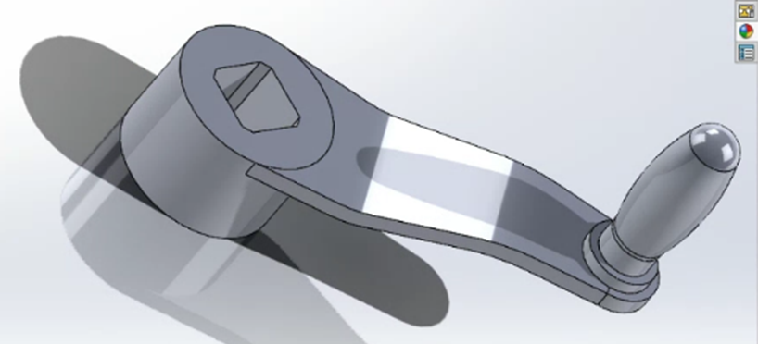
Figure 3– Design of bike crank with the use of SolidWorks. (Solidworks,2023)
Finite Element Analysis (FEA)
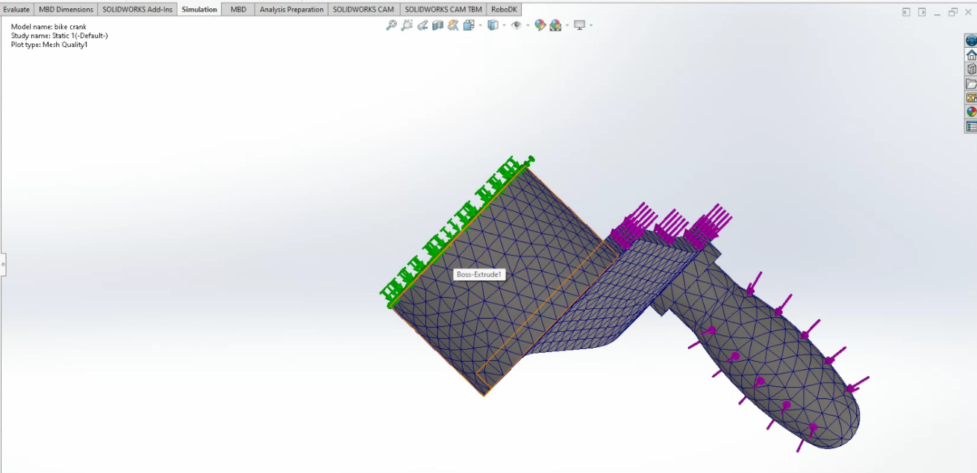
Static stress analysis or in other words (FEA) was performed on the bike crank using SolidWorks.

Figure 4- Generative Design 3D Model
As shown in figure 4, the 3D model of the crank has been fitted with a fine mesh, while also simulating forces acting on the design for a higher degree of accuracy in the FEA calculations. The material choice for the design as stated earlier was titanium.

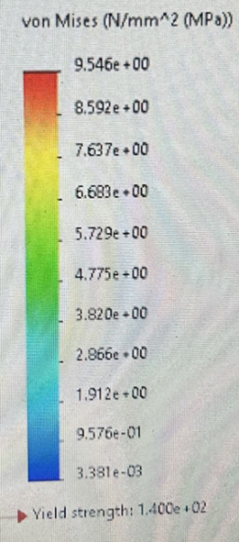
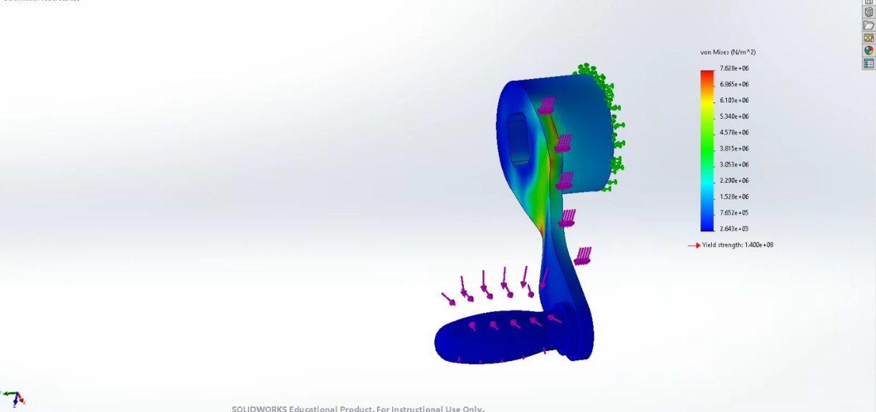
The results are as follows:

Figure 5- Stress

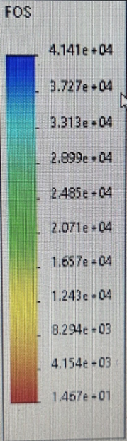
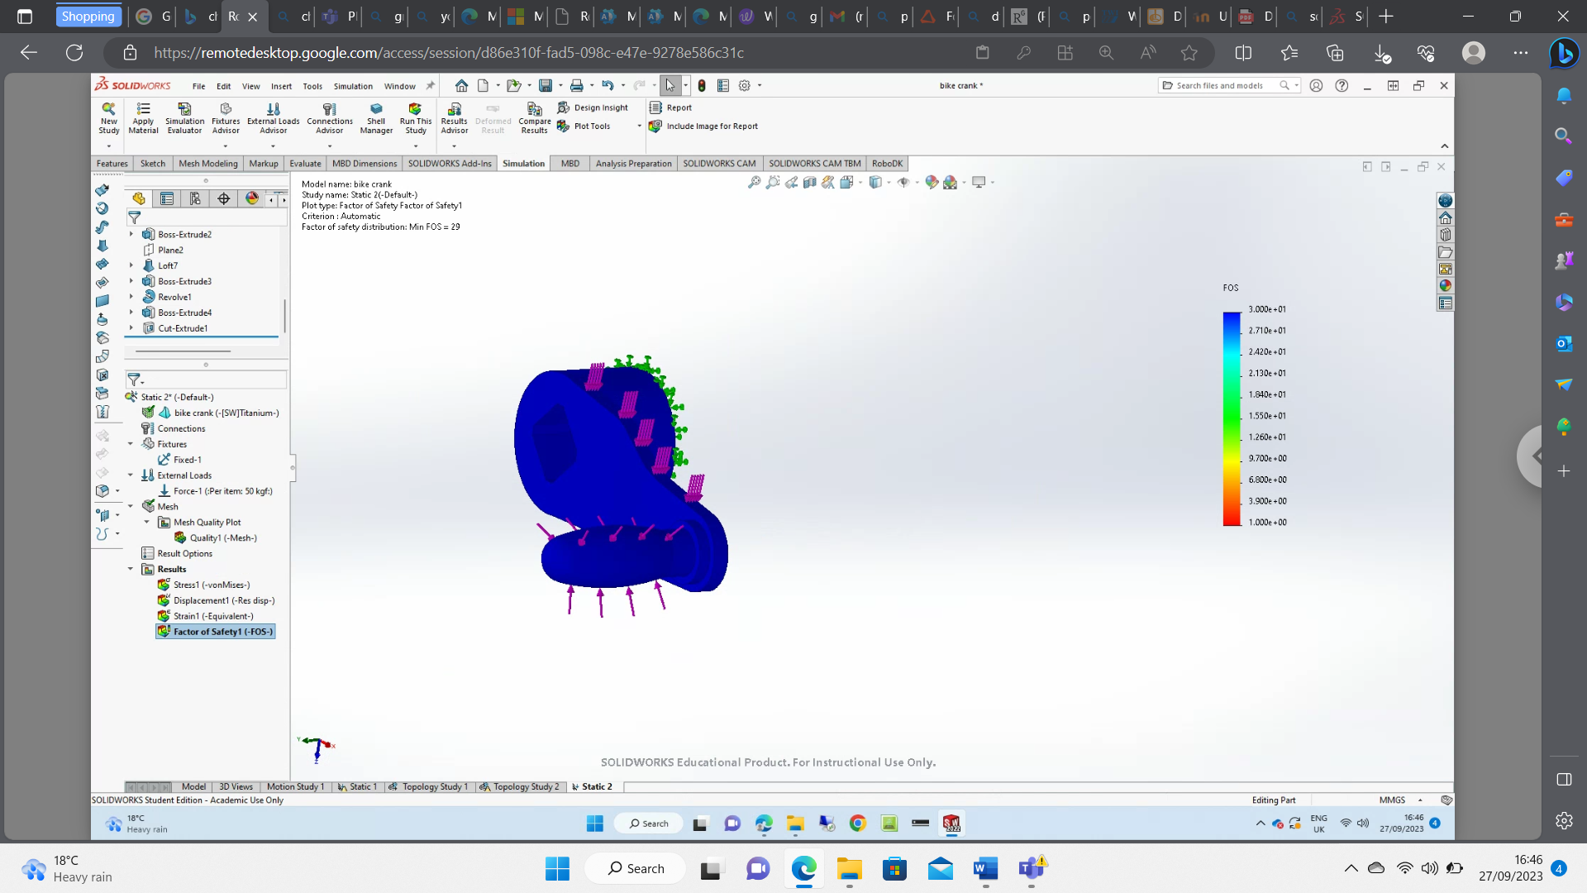

Figure 6 – Factor of safety is 15.

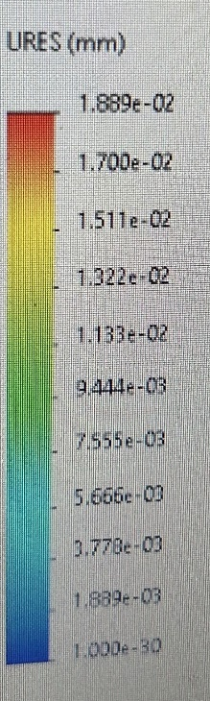
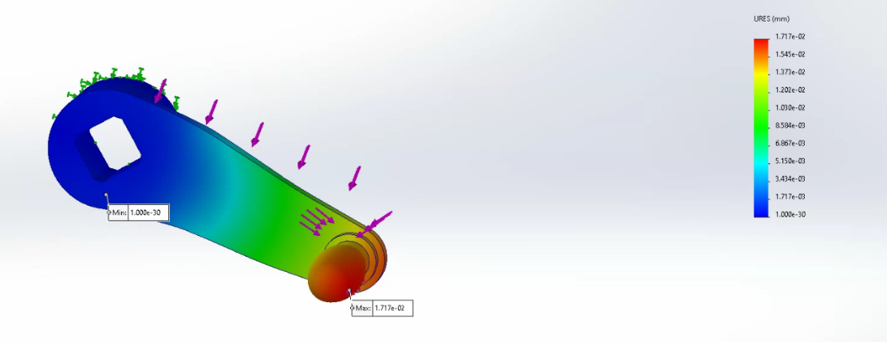
Figure 7- Displacement

Figure 7
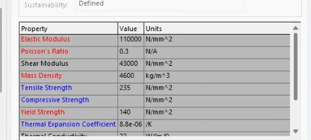

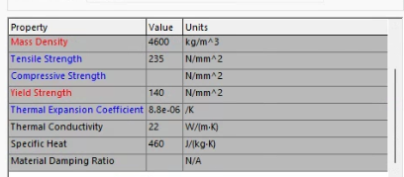

TOPOLOGY OPTIMISATION
In applying topology to the bike crank, areas of preservation for functionality requirements were determined in this example, the side faces, the pedal, and the part with a hole to attach to the bike. To simulate where the main forces will act on the crank, simulated loads were applied to the crank. As shown in the bottom figure, structural constraints were applied where the mounting bolt holes are located.
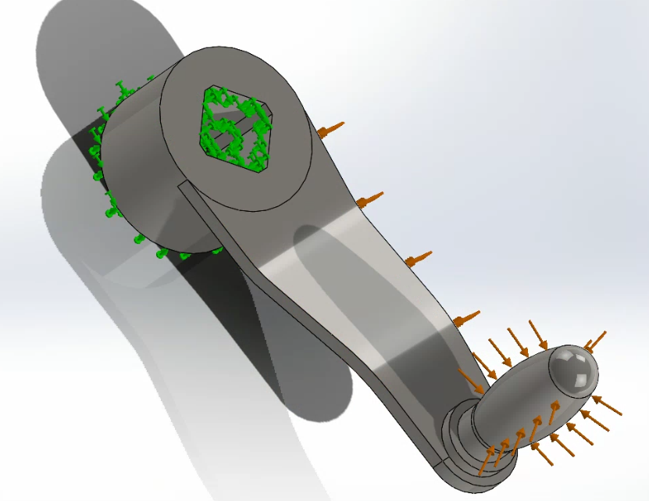

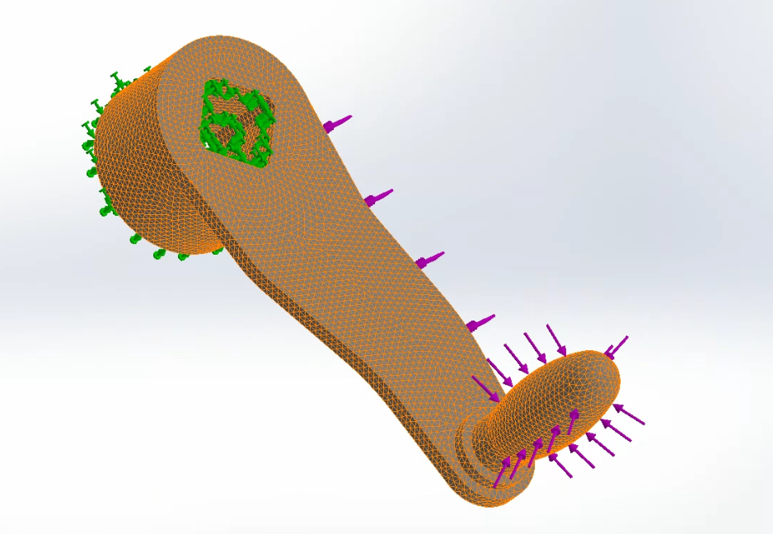

RESULTS
A topology optimization process reduced weight by 80% compared to the original design, leaving only the necessary structural material. The concept of topology is traditionally applied to conventional manufacturing processes and does not take into account factors that are critical to additive manufacturing. Generative design tools were applied to achieve a design that was more aligned with the AM process.
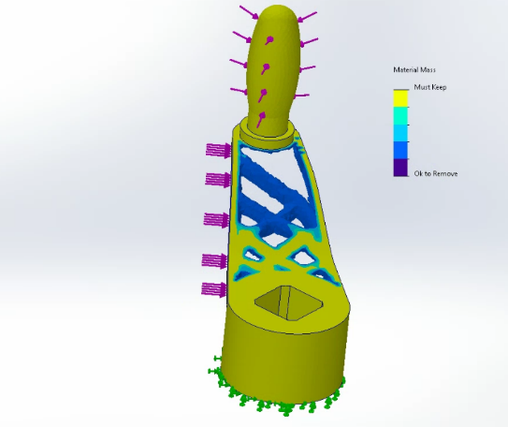

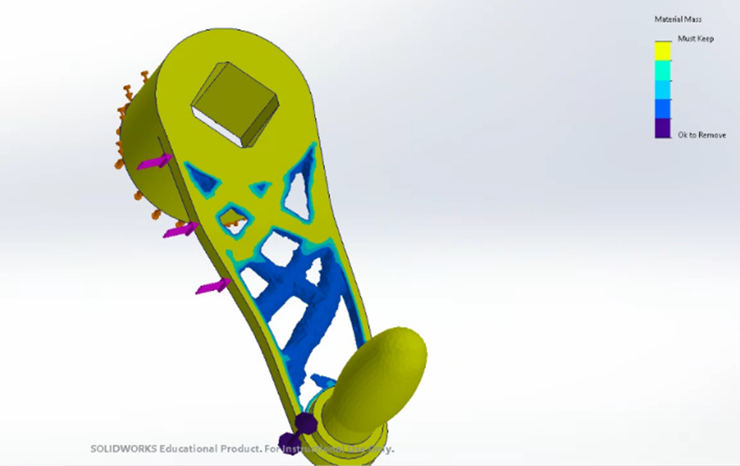

DMLS (Direct Metal Laser Sintering)
Despite the anisotropy factors of the layering process, I chose the DMLS process for my additive manufacturing selection process. Upon reviewing protolab's (2023) research, I have concluded that most of the cases result in homogeneous masses.

COST
The source (Layers (2021)) indicated that a 10-by-10-by-12-inch laser powder-bed fusion system could cost between $400,000 and $800,000. Human intervention is still required to operate metal 3D printers, so labour rates can be low or high. Additionally, parts can cost $15 each or $800 for larger models. Materials could be an ongoing expense for the entire operation depending on what you need. For most printers, this powder costs between $300 and $600; however, for DMLS printers, the cost can range between $2000 and $4000. Depending on the technique used, post processing prices will vary, for example:

- The cost of heat treatment per part ranges from $500 to $2000

- Depending on the part, support removal costs $100 to $200

- Depending on the part, surface treatment can cost between $200 and $500.

- Depending on the build, stress relief can cost $500 to $600.

- A CNC machine can machine a part for $500 to $2000.

Layers (2021) were used to source all of this.

CONCLUSION

A key factor to consider when considering alternative ways of producing this component is cost. This part is currently best manufactured using traditional methods, according to the cost analysis.

In this case, the proposed generative design has some structural reservations, and the chosen design looks visually vulnerable to any accidental impacts that could occur in an industrial setting. In addition, further design analysis, such as an analysis of structural buckling, would be prudent.

The traditional bicycle crank is robust and well suited for this purpose, as it experiences a lot of pressure from the bike it is connected to. It may be possible for generative designs in this case to be easily damaged, and their life cycles may differ from those of the original designs, resulting in safety concerns in some cases. As such, it is important to make sure that the generative designs can withstand the same pressure as the original designs. Additionally, any generative designs should be tested to ensure that the safety concerns are addressed. Furthermore, the generative designs should be designed to be easily repaired and maintained.

INTRODUCTION
My second task will be to review a prototype of a portable wind turbine as a manufacturing engineering consultant. I am currently being asked to consider redesigning the components/assemblies for mass production based on the fact that many of the components are designed to be 3D printed.
Concept designs have already been created. It is now necessary for me to undertake further development work to take into account and optimize the system's manufacturability. According to initial market research and opportunity specifications, production volumes will be between 1000 and 2000 units per week.

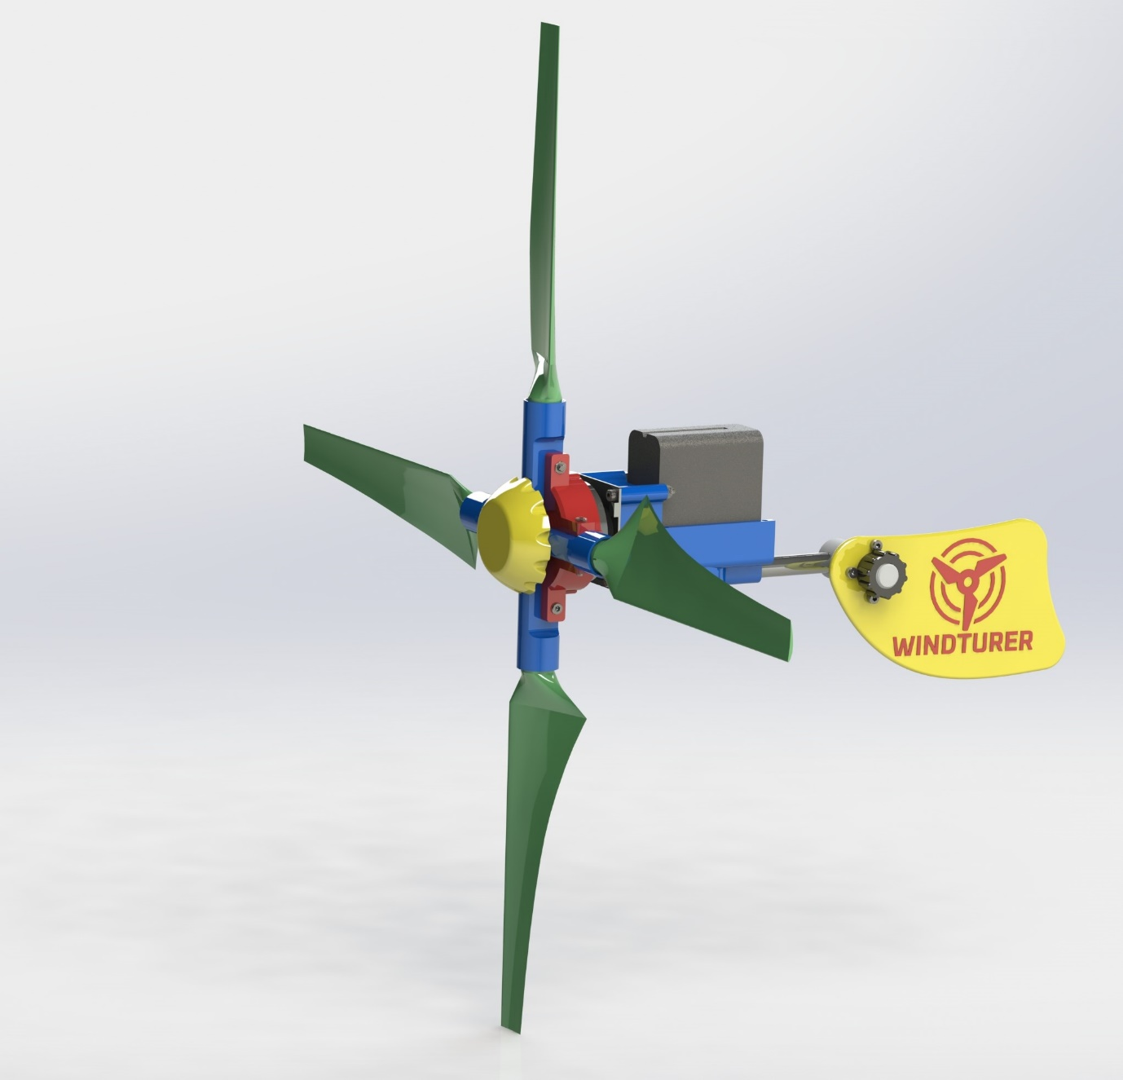
Figure 1 – Design Concept

ASSESSMENT OF THE CONCEPT DESIGN
Design evaluation was conducted to refine the design after 3D printed prototypes were produced. The Quality Function Deployment (QFD) method was used to identify and prioritize customer expectations and needs.
The design specification was developed as part of the QFD in order to outline the right product requirements. The QFD method was further used to guide the development of a prototype design.
Once the prototype was completed, it was tested and evaluated for performance and customer satisfaction. This allowed for any necessary design improvements to be made before the product was finalized.

(QFD) QUAILTY FUNCTION DEPLOYMENT
The QFD process focuses on fitting customer needs and values into the design, development, and implementation of new products. A wide range of top-notch organizations have used QFD successfully, including automobile manufacturers, ship builders, electronics, aerospace, utilities, leisure and entertainment, financial institutions, and software companies. (sciencedirect,2017)
As a structured method, Quality Function Deployment (QFD) identifies the customer's needs and translates them into specific plans for producing products that meet those needs. As indicated in the QFD, portability, durability, lightweight, affordability, and power are the main requirements for the design.
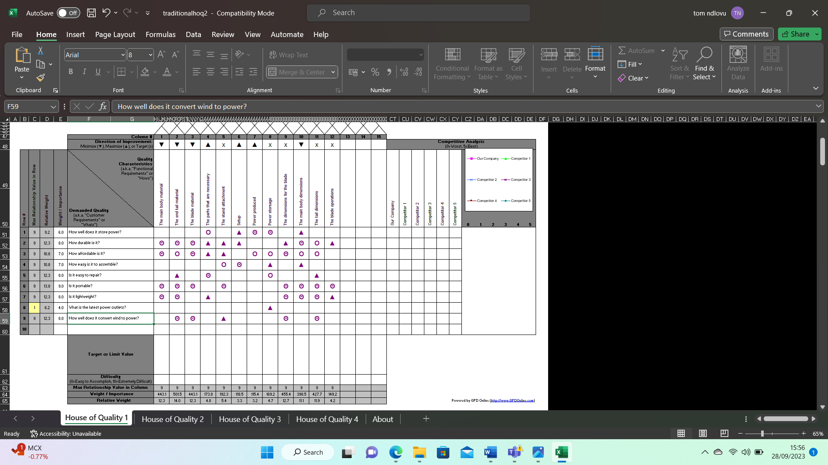
I was able to produce a QFD for the concept design look at figure 2:
Figure 2- QFD for the concept design
TECHNIQUAL DETAILS
To meet all requirements and objectives of the customer, a detailed technical design was developed. As a helpful guide throughout development, this document describes the product's requirements, such as its features and limitations. Here are some of the requirements highlighted in the turbine's design specification.
- The goal - generate and store off-grid power using wind energy to charge devices.

- Featuring- detachable or folding parts for ease of transport, and rotating blades that catch wind efficiently.

- Volume - High volume production of 1000-2000 units per week.

- Visuals- a seamless visual experience with uniform colour.

- Practicability - easy packability and one-handed holding after parts are folded away.

- User requirements- lightweight, portable, waterproof, and easy to pack.

- Composition - Strong, lightweight material.

- In terms of weight and size- Convenient for carrying in backpacks with other items.

- Price- keeping costs low without compromising quality or durability.

- Eco-friendliness- for components to last as long as possible, and for materials to be widely recyclable.

AN OUTLINE OF THE PROCESS
For determining the appropriate manufacturing process for the wind turbine, it was necessary to choose a material that met the specific criteria outlined in my bullet points.
As a result of lower raw material costs, durability, weight, recyclability, and manufacturing and design flexibility, plastic was determined to be a better choice over metal and alloy. (Plastics-concepts, 2017)
To manufacture high-volume turbines, Acrylonitrile Styrene Acrylate (ASA) injection moulding was determined to be the best method after researching plastic materials and manufacturing techniques.
In ASA, grafted acrylic ester elastomers are introduced into acrylonitrile and styrene copolymerization’s as a powder.
In addition, ASA lacks double bonds, making it stronger, more resistant to chemical reactions, weathering, and UV exposure. (Sybridge,2021)

The following are some of the mechanical properties of ASA:

- 4750 pounds per square inch tensile strength, yield

- At break, it has a tensile strength of 4630 pounds.

- Modulus of elasticity: 287 ksi

- Strength of the compressed yield: 10900 psi

- Modulus of compression: 297 ksi
Presented by (sybridge,2021)

Plastics made from ASA are tough and durable, and they are resistant to UV rays, wear, and impact. The material is also capable of withstand the extremes of temperature and several chemical agents, including saturated hydrocarbons, aqueous salt solutions, weak acids and alkalis, and a wide variety of oils. When exposed to outdoor environments, ASA parts retain their colour, gloss, and mechanical properties. It can be post-processed in a variety of ways, including sanding, painting, milling, drilling, gluing, or cutting. In addition, acetone is an effective way of smoothing layer lines on ASA parts. (Sybridge, 2021)
MATERIAL
For this product, injection moulding was chosen over CNC machining as the most suitable production process. Despite the significant investment involved in injection mold tooling, the durability and lifespan of the molds can significantly reduce production costs per unit.
It is important to consider the following factors when choosing between CNC machining and injection molding: the process of plastic injection molding involves heating pellets of thermoplastic resin, injecting the molten material into a hardened steel mold, ejecting the part after it has cooled, and repeating the process.
CNC machining, on the other hand, is a subtractive process that removes material from larger pieces using cutting tools and high-speed rotation. Each of these manufacturing methods has its own advantages and considerations because they take very different approaches to how the part is actually formed.
The size of the production run is one factor contributing to this. The process of injection molding is generally only economically feasible for high volume parts if there is a great deal of complexity in the design. When the molds are made of steel or aluminum, the process can be very expensive and time-consuming.

Once the tooling has been finalized, thousands to millions of plastic injection-molded parts can be produced rapidly due to the durability and lifespan of the mold. The cost of machined parts is relatively unaffected by increased production volume, so injection molding might be a good option if the volume of parts is expected to be high. Injection molding is much cheaper per unit than machining, but since mold tooling isn't needed, smaller quantities of parts can be created in shorter periods of time.
As each process works with different types of materials, the material of the part must also be considered. CNC machining can lose precision when machining softer materials, such as thermoplastics, thermosets, and rubbers and elastomers. In contrast, many hard, high-performance plastics are only machinable. (Sybridge 2021)
DESIGN
In order to optimize the assembly process and boost manufacturing efficiency, product designers use the Design for Assembly (DFA) method. Design for assembly can reduce costs, assembly time, and potential errors by simplifying and streamlining assembly.
In order to achieve these objectives, components are integrated, parts count is reduced, access is made easy, and ergonomics are taken into consideration. In this way, product designers can deliver high-quality, high-efficiency products that meet customers' needs.
Using the considerations, the first step was to categorize the components of the wind turbine based on their function into "A" and "B" parts. Fasteners and locators are non-essential components (B), while (A) perform a primary function. This methodology is also referred to as the Lucas methodology.
By using the Boothroyd & Dewhurst methodology, I will divide my parts into essential and non-essential, where 1 represents an essential part and 0 represents a non-essential part. Once the results are gathered, they will be plugged into an equation that calculates the design efficiency as a percentage by dividing the necessary parts by the total number of parts and multiplying that by 100.

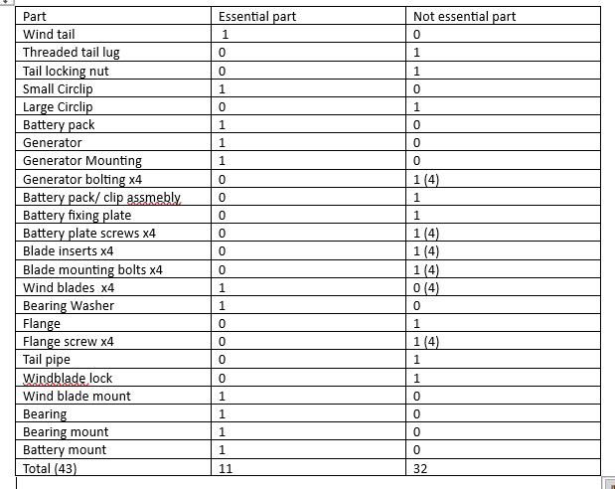

So, 11/43 x 100= 25.58
Design efficiency = 25.58%

After going through my results for the turbine I have concluded that out of the 43 parts only 11 have been essential making the design effciency to be 25.58%. my next aim will be to increase the design efficiency.

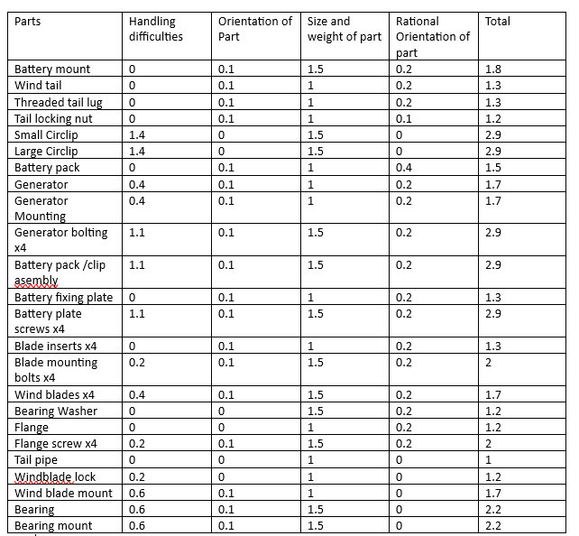

Handling index – 45.2
Handling ratio - 4.1

You can calculate the handling ratio by dividing the handling index by the number of essential parts. Based on Lucas/Hull's recommendation of 2.5 (UlIoa, et al., 2018), the turbine components failed the evaluation with a handling ratio of 4.1.

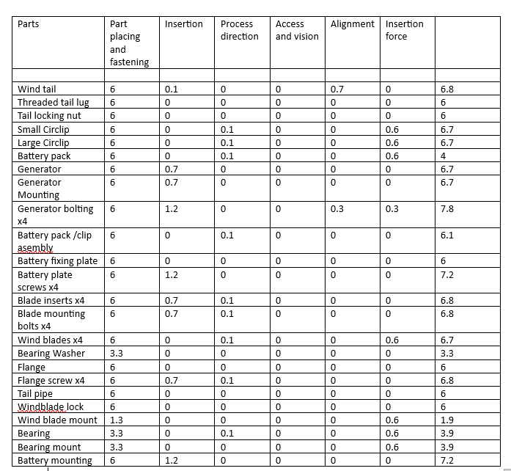

Fitting index – 144.8
Fitting ratio- 13.16

Using the fitting index and the number of essential parts, we can calculate the fitting ratio. Based on Lucas/Hull's target factor of 2.5 (UlIoa, et al., 2018), the turbine components do not pass the evaluation by a considerable margin.

QUALITY AND PERFOMANCE
Sales are directly influenced by the quality of a product. A product's quality is determined by eight key characteristics: performance, reliability, features, durability, conformance, aesthetics, perceived quality, and aesthetics. (Usmani, 2022)
An important component of a wind turbine's performance is how well its blades convert wind energy into rotational energy. A wind turbine typically incorporates three blades rather than four blades, in part because fewer blades result in lower drag, making power conversion more efficient, according to Velling (2021) and Usmani (2022). A turbine that has fewer than three blades may be unstable. By reducing the number of parts and reducing assembly time, this design modification reduced costs and assembly time.
Despite its portable nature and intended purpose, the prototype design lacked durability. When removed or replaced in a carrying device, the product was prone to breakage due to snagging areas. In re-designing the product, we considered fewer sharp edges and corners.
Durability was also dependent on the prototype design's weather resistance. A re-design with weather resistance as an essential feature was considered for the exposed electrical components that might fail in specific weather conditions.
An example of this is the exposed battery pack in figure 6:
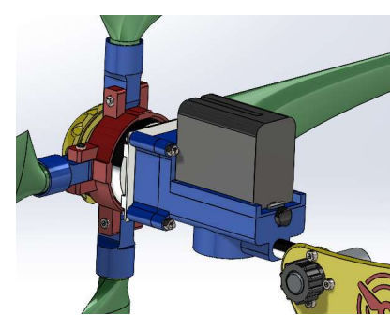

Figure 6 - Exposed generator

Prototypes featured exposed parts and visible fasteners, as well as sharp edges and corners. Another aspect that was highlighted for improvement or removal was these features. In addition to enhancing the assembly's weather resistance, a uniform colour and smoother, sleeker design encompassed major parts.

For easy maintenance, fast connections using clips were recommended to reduce parts and fasteners and increase serviceability.
The public's perception of a product can be impacted by sustainability during the design stage. A mechanical part recovery scheme will be implemented to recycle any precious metals for reuse during the redesign of the product to promote sustainability.
Packaging should also be made from 100% recyclable and biodegradable materials. Design considerations for interchangeable parts were incorporated into the product design, like the wind generator being removable from the main body and the turbine blade mount being easy to replace, in order to extend the product life cycle.
An analysis of failure modes and effects was conducted in order to assess the prototype's reliability. As a result of regular transportation of the product, it was anticipated that exposed parts would snag and possibly snap due to their design.
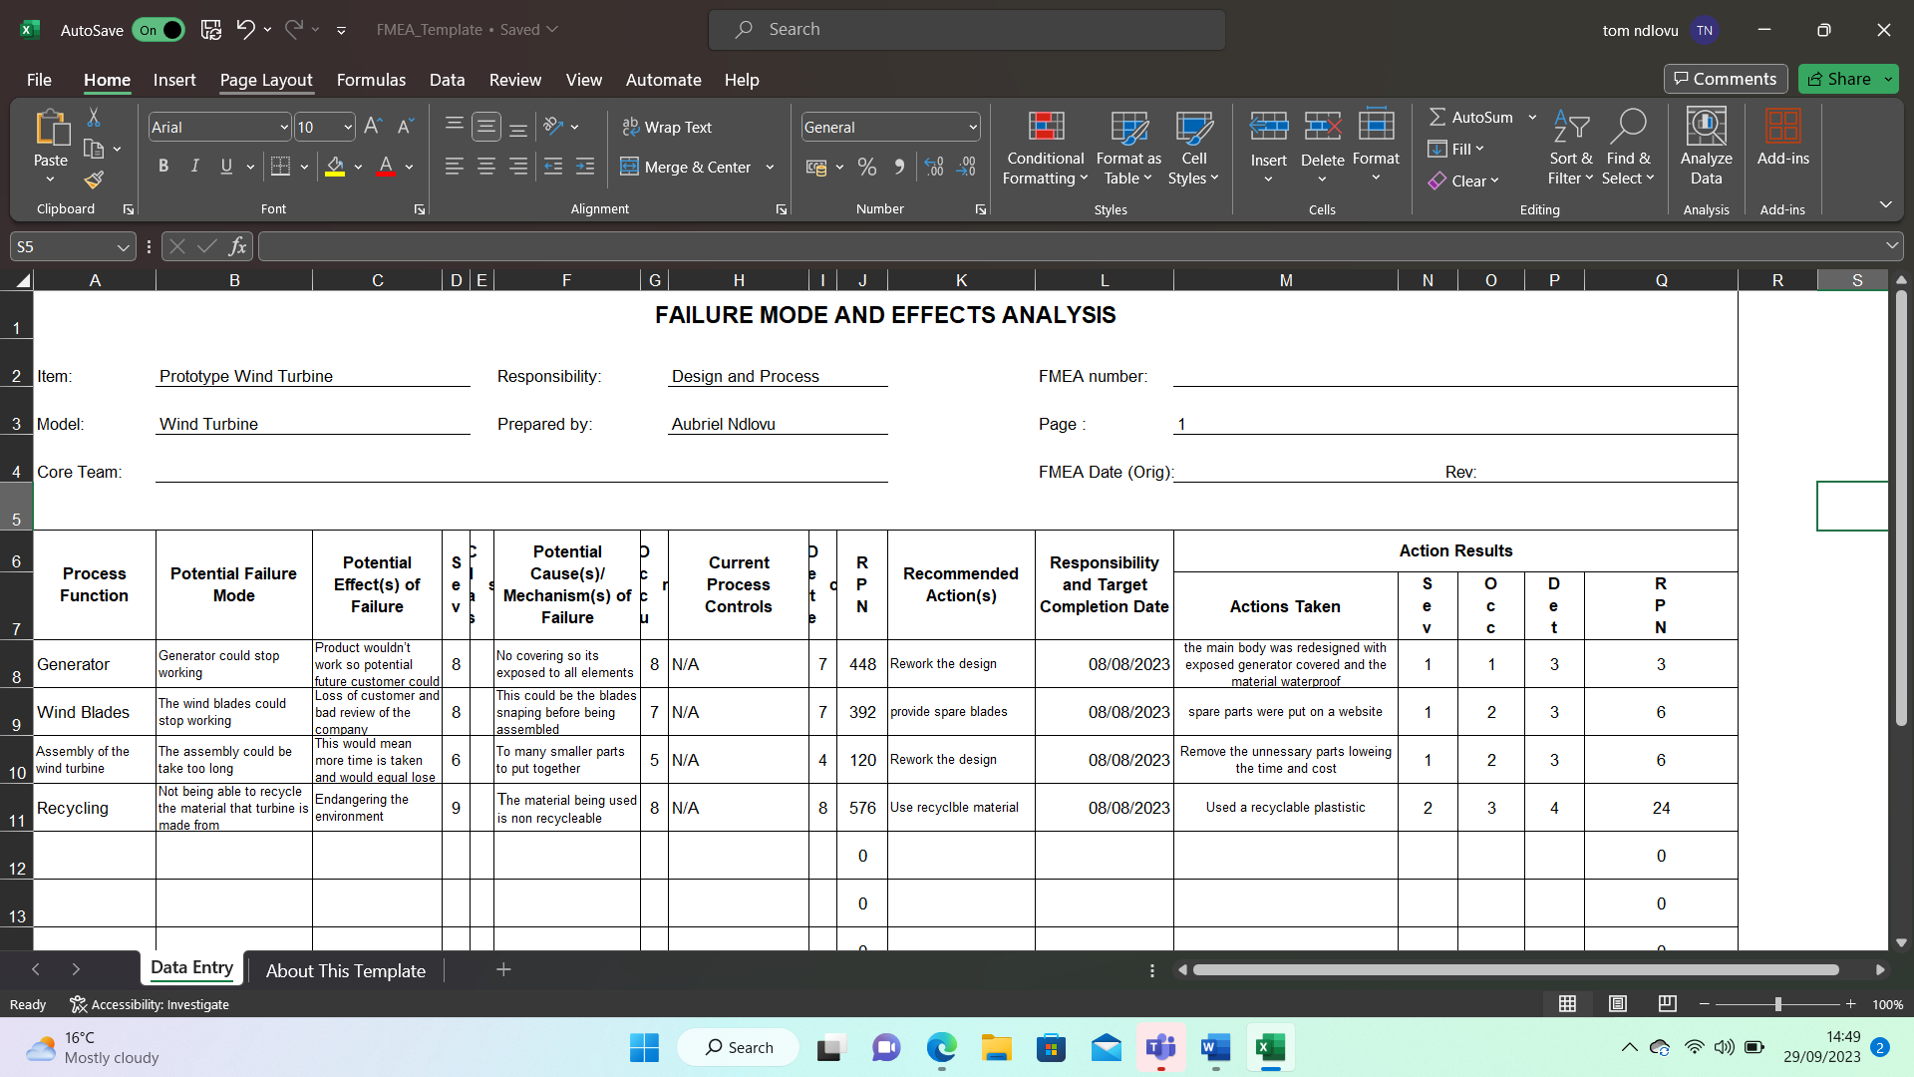
Prototype with exposed electrical components - Water intrusion is a potential problem when the prototype operates in undesirable weather conditions. Part failures - General failures of electrical and mechanical parts are extremely rare. It was then decided to re-design the product to address these issues, with warranties and spare parts covering out-of-warranty issues.
Figure7 – FMEA table for the wind turbine.

DESIGN AND DEVELOPMENT
During the development and design stages as well as at the design specification stage, all issues identified were addressed with a re-design.
We will use injection moulding to manufacture all materials (excluding mechanical and electrical components).
By redesigning the main body of the product, exposed parts were concealed, and the product's design was made smooth and sleek. Wind tails, batteries, and bearing assemblies are enclosed in a tubular shape during storage. Additionally, the mounting end of the generator was equipped with a waterproof channel.
Water flows around the generator when connected to the main body through the overlapping recess of the main body. This prevents any water damage to the generator.
The large circlip from the original prototype has been replaced with a push-fit bearing housing, so it will not be required.
In order to achieve the main body's cylindrical shape, the enclosure is a simple extension of the bearing housing.
Five screws hold the body enclosure to the main body, which also serves as a battery locking mechanism.
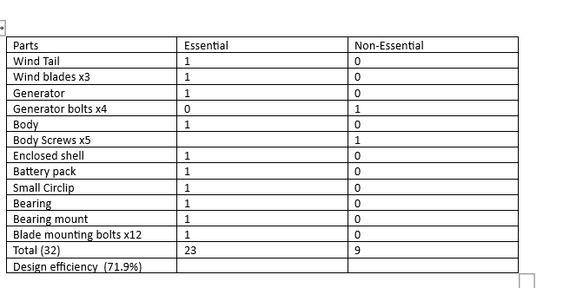
The prototype design was found to be less efficient when compared to a three-blade design, however, the blades have been vertically oriented, and each have two bar like attachments connected to the body. Arcadia (2017) claims that blade turbines are easier to install than other types of wind turbines, and can even operate in extreme weather conditions, with variable winds and mountainous terrain. It is referred to as a H-Rotor wind turbine.

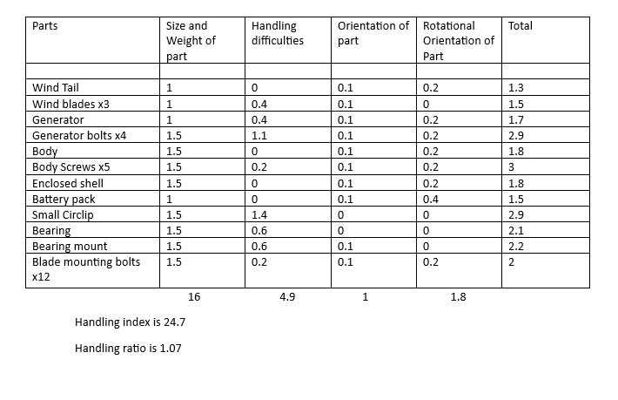

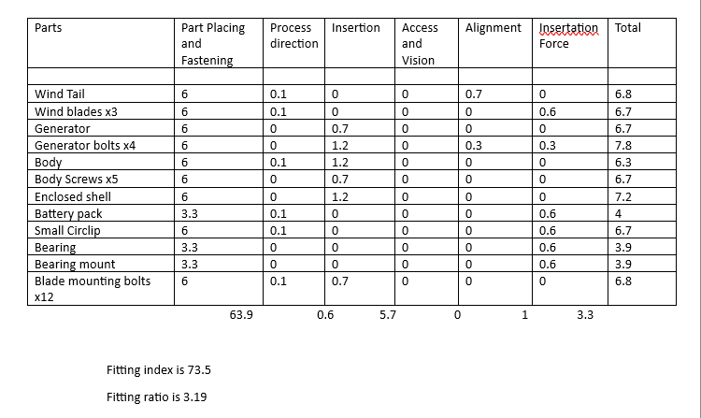

Design efficiency has more than doubled since the redesign, which has reduced the number of parts from 43 to 32. It is evident from the analysis that the redesign has significantly improved the design. As for the design efficiency, it has exceeded its target of 60%, while handling ratio has also exceeded its target of 2.5. Even though the fitting has not achieved the goal set, significant improvements have been seen.

CONCLUSION

Transitioning from a 3D printed prototype to a high volume conventionally manufactured product required the use of a variety of design tools. A thorough redesign was required after various analysis tools revealed that the original prototype was unsuitable for its purpose in several ways. We evaluated the prototype's weather resistance, using the failure mode and effect analysis to identify exposed mechanical and electrical parts as likely to fail due to this. We also incorporated this feature into the original design specification. The product life cycle would be greatly improved, and customer satisfaction would increase by creating a weather-resistant design. In addition, the Lucas method allowed a complete review of all parts during the Design for X stage.

According to the research, the product would be more efficient in capturing wind to produce energy if the fourth blade was removed after using the analysis tool. As a result, the product performed better and required fewer parts, resulting in cost and assembly time reductions. Aspects of the prototype's aesthetics were also discussed during the Design for X stage. Fasteners and edges were noted to be exposed too often. Despite its visual appeal and durability, the design fell short of demonstrating a useful and durable product. As a result of the design, mechanical and electrical parts are enclosed in an elliptical tube, creating a more attractive appearance.

By combining various techniques, such as QFD, design specification, and design for X (which includes the Lucas method and failure modes and effects analysis), the prototype's shortcomings were identified, and improvements were made. As a result, analysis tools play a crucial role in the design process. Analysis tools are essential for the successful completion of the design process. They provide valuable insight into the design, allowing designers to identify potential issues and make the necessary improvements. Ultimately, these tools help to ensure that the design is both efficient and effective.

REFERENCES

3D CAD Design Software | SOLIDWORKS. (n.d.-a). https://www.solidworks.com/
Arcadia, T. (2017a). Vertical axis wind Turbines Advantages & Disadvantages. blog.arcadia.com. https://blog.arcadia.com/vertical-axis-wind-turbines-advantages-disadvantages/#:~:text=More%20easily%20installed%20compared%20to,winds%20and%20even%20mountain%20conditions.
Design Tip: How DMLS can produce reliable metal parts. (n.d.-a).
https://www.protolabs.com/en-gb/resources/design-tips/designing-for-direct-metal-laser sintering/?utm-source=google&utm-medium=cpc&utm-campaign=uk-3d-printing-0619&utm-content=3dp-ag-dynamic-search-ads&gad=1&gclid=CjwKCAjw1YCkBhAOEiwA5aN4AStoQu_chr3YUqSWg
Four Key Principles of Design for Additive Manufacturing (DFAM). (2022a, November 22). Default. https://altair.com/newsroom/articles/four-key-principles-of-design-for-additive-manufacturing-dfam
Li, J. (2021a, March 5). Bike Crank Arm Ultimate Guide (Right Length, Design etc). First Components. https://www.firstcomponents.com/bike-crank-arm/
MacLean-Blevins, M. T. (2018a). Conceptual design—how do we begin the design process? In Conceptual Design. https://doi.org/10.1016/b978-0-323-44501-6.00005-2
Melissa. (2021a). Plastic vs. Metal – Which is best for your project? Plastic Concepts. https://www.plastic-concepts.com/plastic-vs-metal/
Plc, R. (n.d.-a). Error. https://www.renishaw.com/en/design-for-metal-am-a-beginners-guide--43333%20%20https://www.twi-global.com/technical-knowledge/faqs/what-is-powder-bed-fusion
Pmp, F. U. (2022a, September 2). Design for X or DfX: Definition, Meaning & Examples |. Fahad Usmani. https://pmstudycircle.com/design-for-x-dfx/
Polymer Resins. (2021a, November 17). PC/ASA resin | polycarbonate and ASA blend - by polymer resources. https://prlresins.com/products/pc-asa- resin/#: ~:text=The%20resins%20are%20structurally%20similar, resistance%20and%20better%20chemical%20resistance
Schwaar, C. (2022a). Design for Additive Manufacturing (DfAM) – The Ultimate Guide. All3DP Pro. https://all3dp.com/1/design-for-additive-manufacturing-dfam-simply-explained/
Systèmes, D. (2023a). Powder Bed Fusion. Dassault Systèmes. https://www.3ds.com/make/guide/process/powder-bed-fusion
Technologies, S. (2023a). CNC Machining vs. Injection Molding: Which Method is Right for Plastic Parts? SyBridge Technologies. https://sybridge.com/cnc-machining-vs-injection-molding-manufacturing-plastic-parts/
Technologies, S. (2023c). Know your materials: Acrylonitrile styrene acrylate (ASA). SyBridge Technologies. https://sybridge.com/acrylonitrile-styrene-acrylate-asa/
Velling, A. (2023a). Design for X (DFX) methods. Fractory. https://fractory.com/design-for-x-dfx/
McEwen, I., Cooper, D. E., Warnett, J., Kourra, N., Williams, M. A., & Gibbons, G. J. (2018). Design &
Manufacture of a High Performance Bicycle Crank by Additive Manufacturing. Design & Manufacture
of a High Performance Bicycle Crank by Additive Manufacturing.
https://doi.org/10.20944/preprints201807.0306.v

A. Nikhil Setty,"Stress Analysis and Optimization of a Bicycle Crank", IJSRD- International Journal for
Scientific Research & Development | Vol. 5, Issue 06, 2017

Ventzi G. Karaivanov, David A. Torick," Optimization of a Bicycle Crank and Spider Using finite element software."

PL. Vairakanna, M. Chandran, "Design and Material Study of Race Bike crank" IJESRT volume April, 2017

