

BSc. Health and Social Care Level 6 Term 1

Topic

The challenges of the ageing population on the Health and Social Care System

Student name:​ Elizabeth Owusu
Student ID: ​1917244
Module name: Living with Care: The Older Person
Module code: BMHP6009
Lecturer name: Diola Bijlhout ​
Date: 5/04/2022

1
Contents Page………....……………………………………………………………………….1
Introduction……………………………………………………………………………………………………………………….…………….2
Overview…………………………………………………………………………………………………………………………….…………2-3
Definition of Age………………………………………………………………………………………………………………………………3
Successful Ageing………………………………………………………………………………………………………………………………4
Discussions/ Analysis 1……………………………………………………………………………………………………………………5
  - UK population pyramid……………………………………………………………………………………………………………….5
  - The Ageing population……………………………………………………………………………………………………………….5
  - The challenges facing the-Health and Social care System……………………………………………………….5- 6
  - Current housing needs for the elderly…………………………………………………………………………………………6
Evaluation…………………………………………………………………………………………………………………………………………6
The impact of Covid-19………………………………………………………………………….…………………………………………6
Conclusion………………………………………………………………………….…………………………………………………………….7
Recommendation………………………………………………………………………………………………………………………………7
References…………………………………………………………………………………………………………………………………………A
Appendices………………………………………………………………………………………………………………………………………B

2
Introduction
The task offers an overview of the challenges that the Health and Social Care System faces as a result of the growing elderly population. The ramifications for the workforce and delivery systems. The financial load, as well as management in general.
Life expectancy has grown. (Better, 2020). Health disparities are expected to worsen due to the Covid-19 pandemic. (Ageing, 2021). (Santabárbara, 2021).
The public is aware of the strains that health and social care are under, but less so of the challenges that social care is facing. (McGilton, 2018).

Overview
The Health and Social Care System

Leadership/  Governance | Information System | Workforce |  | Finance | Resource | Service delivery
   |    |    |    |  |       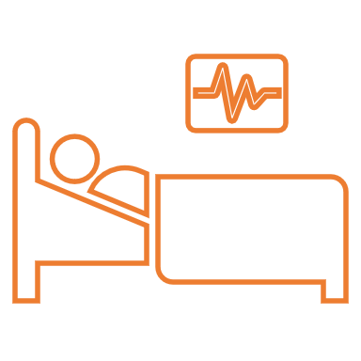  (Santabárbara, 2021). | Residential  Hospice  Nursing Care  Domiciliary Care  Assisted living    
Leadership and Governance
Resources
Workforce
Finance

Training

Training
Information and Communication
Service Delivery

3
Health Care Systems, according to the World Health Organization defines as any activities whose primary goal is to promote, restore or preserve the health of the population they serve by bringing together people, organizations, and resources by established policies. (Ghezzi, 2017).
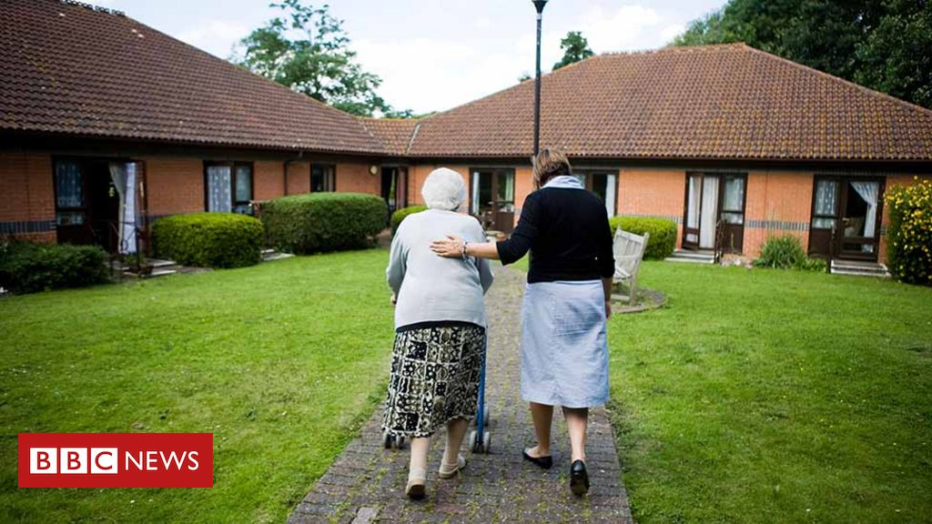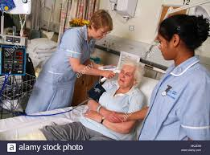
National health policies, strategies, and plans can all be used to define the health system. To construct health interventions, the Health Information System uses economic policy, social, and health data to analyze trends in illness prevalence and severity.
Resources are the facilities to be used, Equipment needed, Supplies, Transportation, and the Communication network. (Ghezzi, 2017).
The workforce includes everything from assistance with basic daily activities, ensuring policies and regulations are carried out, Person-centered care, and safeguarding. Care Act 2014.

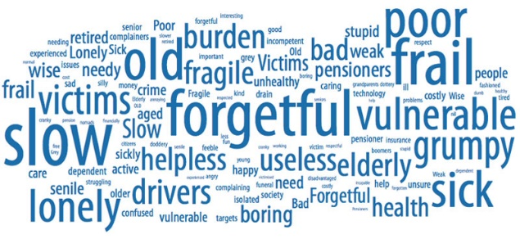
Definition of Ageing
This Photo by Unknown Author is licensed under CC BY
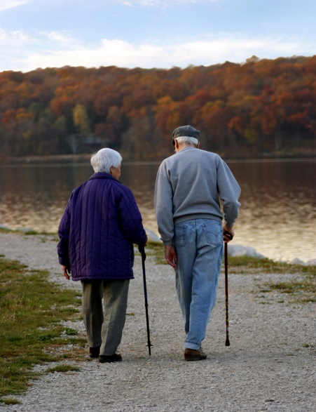
People become feeble as they age, which is linked to decreased function and social retreat, lowering their quality of life.
This Photo by Unknown Author is licensed under CC BY-SA-NC
Older adults, according to the Continuity theory, are more likely to keep much of their personality and way of life that they formed earlier in life, whereas the Activity theory states that poor health or impairment is the primary cause of morbidity, and fewer physical activities, and low cognitive activities. It is also vital to discourage society’s negative options about the Elderly, according to the reconstruction theory. (Ageing, 2021). Disengagement may be another fact when society’s stigma pops up.

4
Successful Ageing

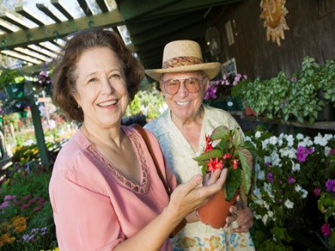
This Photo by Unknown Author is licensed under CC BY-SA
This Photo by Unknown Author is licensed under CC BY

Happiness, commitment, and life satisfaction and well-being

Life Expectancy
Personal development and gaining new skills.

Cognitive function, mental and psychological health
Work, support, involvement, and activity in the social sphere.
Successful Ageing

Physical and mental well-being as well as self-sufficiency
Perceived autonomy, control, independence, flexibility, coping, self-esteem, optimistic outlook, objectives, and sense of self are all psychosocial qualities and resources to consider.
Engagement, integration, and participation in social society.

5
Discussion
The rise of the aging population poses challenges to Health and Social Care systems. (Santabárbara, 2021). Increased demand for elderly-focused health services. Many complicated disorders, quality of life expectations, and health-care utilization. (Howdon, 2017).
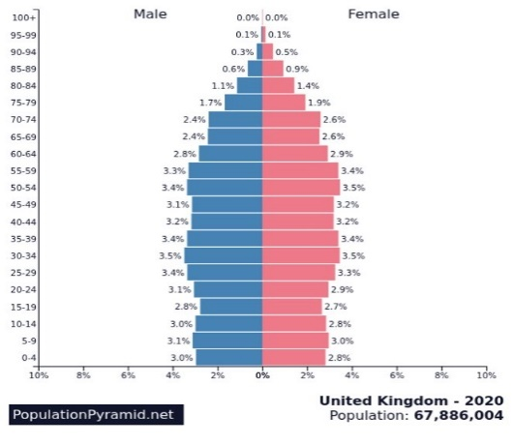
UK population pyramid
There are about 12 million people in the UK aged 65 and up, with 3.2 million aged 80 and up, which poses a global concern for future end-of-life care. (Bone, 2018), making it a burden on Social Insurance Program. (Brazier, 2022).

The Ageing population
Ageism can be discriminatory, prejudiced, and stereotypical. Ageing, both structural and institutional, can take various forms. It might be portrayed as a period of weakness and decline.
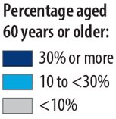
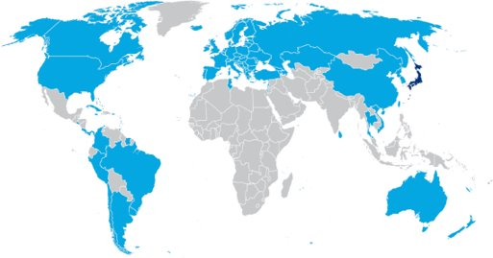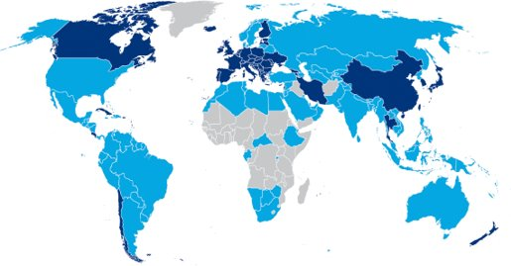

2015 2050
According to Age UK,15% of the population lives in Care Homes in the UK. Chronic diseases have become a challenge in the health and social care system. Insufficiently trained staff for the different delivery. (Santabárbara, 2021). Risk of unqualified care assistants fulfilling duties of traditional nurses. (CQC, 2018).
The challenges facing the health and social care system
According to NICE, poor transitions, delays in transfers of care, re-admissions, NHS care, or home care packages to be finalized are delayed. According to the King’s Fund, an 18 billion funding gap will open in the UK by 2030/31. Multimorbidity has been linked to increased healthcare utilization and expenses. (Howdon, 2017).
Nearly two-thirds of persons admitted to hospital are over 65, and hospital treatment has increased by 65% with the care that needs to be predicted to increase by 61% by 2030. According to CQC data, there were 4.3 million older adults who visited emergency rooms between September 2016 and September 2017, an increase of 11.3% over two years. The number of older adults admitted to the hospital in an emergency room climbed by 4.8%.
6
NHS hospitals are overburdened. The percentage of acute hospital beds occupied is higher than it has ever been. According to NICE analysis, just 16 of England’s 152 local systems had bed occupancy rates below the recommended 85 % level in April 2018.
Financial pressure has harmed joint working, making funding flows a difficulty across systems. Funding for health and social care services is minimal. (Watkins J, 2017).
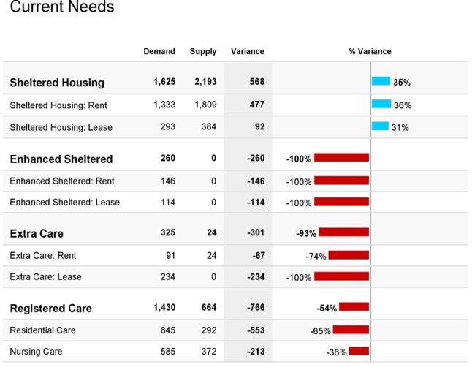
Current housing needs for the elderly
1.5 million people claim to have a medical condition or handicap that necessitates special accommodation. By 2030, the demand for dementia care will range from 164,000 to 240 persons.

Evaluation
Increase in long-term care as people live longer. (Better, 2020). 65 % of elder carers, aged 60 – 94, suffer from long-term health issues or disabilities themselves. 68% reported of increase in mental health due to caregiving responsibilities, and sometimes forego treatment to fulfill their commitments
There is an increase in communicable diseases and decreased fertility, but there are fewer caregivers for fragile older persons. (Watkins J, 2017). The correct culture, capability, and capacity are required for an effective system that assists older persons’ movements. (CQC, 2018).
The challenges of the aging population are caused by a combination of diminishing fertility and increasing longevity. The UK fertility rate has remained below the replacement threshold of 2.1 children per woman for nearly 40 years.

The impact of Covid-19
As of 2020, according to Careers, UK, 13.6 million people cared through the pandemic. (Nguyen, 2020). Challenges of staff working overtime during lockdown, strain, and stress, (Santabárbara, 2021), an increase of 18.6% increase in workload. Front-line health workers were at risk of reporting a positive Covid-19 test during the pandemic. (Santabárbara, 2021).

7
Conclusion
The need for long-term funding security. (CQC, 2018). Demographic age shift modifications must be implemented. Housing, health, communities, and workplace. (Briggs, 2018).
The ability to strengthen community services, make current medical technologies and interventions more accessible to older people, and develop multidisciplinary community-based geriatric facilities can all be prioritized. (Dwolatzky, 2017).

Recommendation
Political action and appropriate funding settlement are to be made to ease the tension on the Service delivery according to NHS. Building standards should be updated as soon as possible by the government, according to Age UK,

.

References

Appendix

The last 7-9 years of life will be spent with a disability, with an estimated 1.5 million people who are unable to recognize someone across the street. 7million people are unable to walk up the stairs, and 4million have severe hearing loss. Up to 7million people suffer from urine incontinence, and 1.5 million are depressed.

In Europe, there are approximately 5.5 million individuals living with dementia, with 4% of persons over 65 expected to increase in the next 50 years.
Alzheimer’s disease prevalence goes from 2% among those aged 65-69 to 22% among those aged 89. Over the next 30 years, the number of people with cognitive impairment is predicted to increase by more than 60%

