


Organisational Consultancy
BMIH 6005

Lecturer : Lisa Knight
Student : Mihai-Andrei Matei (2021030)

Mihai-Andrei Consulting Group
Consultancy report for

THE RITZ LONDON

05th March 2023

Driving Success : A Strategic Parking Consultancy for The Ritz Hotel


Content Page

1. Executive Summary …………………………………………………………pp. 3, 4, 5
1.2. Introduction ……………………………………………………………….pp. 6,7,8,9
2. Scope & Analysis …………………………………………………………..pp. 7, 8,9
2.1 PESTEL; SWOT; TOWS …………………………………………pp. 9, 10, 11, 12
3. Content; Ideas ……………………………………………………….pp. 12, 13, 14, 15
3.1 Porter’s Five Forces Framework ………………………………,,,,,,pp. 15, 16,17
4. Findings and Results Summary ……………………….…pp. 17, 18, 19, 20, 21,22
4.1 The Action Plan; An Insight of the financial debate ……….…pp. 21, 22,
5. Recommendations; Summary …………………………………….pp. 23, 24
6. Conclusion ……………………………………………………….….pp. 24, 25
Overall Discussion for Mihai-Andrei Consultancy Group research. . . .
7. Reference List ……………………………………………….pp. 26, 27, 28, 29, 30, 31


1. Executive Summary

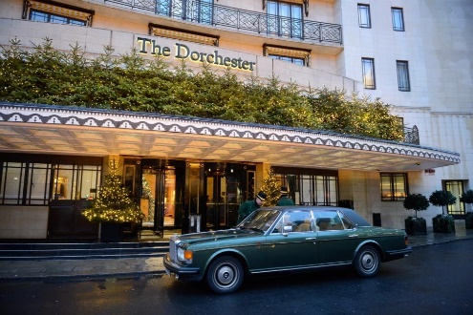
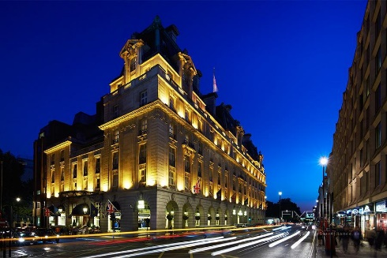
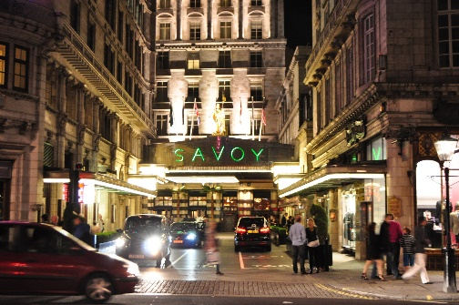
Mihai-Andrei Consultancy Group has conducted a thorough analysis of the parking spaces issues at The Ritz Hotel in London. Our findings indicate that the hotel's current parking facilities are inadequate to meet the growing demand from guests and visitors (Amer, A., & Chow, J. Y., 2016). As a result, the hotel is losing potential revenue and negatively impacting guest satisfaction. To address these issues, our team has developed a set of recommendations based on our analysis. In comparison to other top hotel names in central London (Litman, T., 2006), The Ritz Hotel is facing unique parking issues that require a customized approach to resolve. While some hotels in the area may have similar parking concerns, others have implemented successful parking strategies that have helped to optimize their parking facilities and provide a seamless guest experience (Haider, et al., 2019). For example, The Dorchester Hotel (www.thedorchester.com) , located just a few blocks away from The Ritz, has a well-designed parking system that includes a valet parking service and an advanced reservation system (Parmar, et al., 2020). The Dorchester also offers guests a range of parking options, including self-parking and underground parking, to suit their preferences. As a result, the hotel can efficiently manage its parking facilities, optimize the use of available space, and provide a convenient and hassle-free parking experience for its guests. Similarly, The Savoy Hotel (www.thesavoy.com) , located on the Strand, has also implemented a range of parking measures to address its parking challenges. The hotel has a designated drop-off and pick-up point for guests, as well as a valet parking service and an advanced reservation system. Additionally, The Savoy has partnered with a nearby parking facility to provide guests with alternative parking options if needed. These measures have enabled the hotel to optimize the use of its parking facilities and provide a convenient and flexible parking experience for guests. In contrast to The Dorchester and The Savoy, The Ritz Hotel's parking facilities are small and limited, with only a few spaces available for guests. This presents a significant challenge for the hotel, especially during peak hours when demand is high (Simicevic, et al., 2013). Additionally, the hotel's current parking system is not well-organized, which can lead to confusion and frustration for guests. In comparison, The Ritz Hotel's parking facilities are currently limited and do not provide adequate options to meet the growing demand. As a result, the hotel is losing potential revenue and negatively impacting guest satisfaction (Marshall, W., 2014). Our team at Mihai-Andrei Consultancy Group has developed a set of reliable, customized.

recommendations to help The Ritz address its unique parking issues and optimize its parking facilities to provide a seamless guest experience ( Zabieh, L.E., 2014):
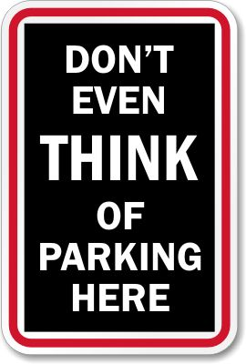
- Expand Parking Facilities:
The Ritz Hotel should consider expanding its parking facilities to accommodate more vehicles. This can be achieved by acquiring additional land to build a new parking facility or by repurposing existing space within the hotel. Additionally, the hotel should consider installing charging stations for electric vehicles to attract guests who are environmentally conscious (Mackett, R. L., & Edwards, M., 2016).
- Implement a Reservation System:
To manage the demand for parking, The Ritz Hotel should implement a reservation system that allows guests to reserve a parking space in advance. This will ensure that guests have a guaranteed parking space when they arrive at the hotel and will help to eliminate any confusion or frustration (Teodorovic, D., 2006).

- Increase Parking Fees:
The Ritz Hotel should consider implementing a tiered pricing system that reflects the demand for parking during peak hours. This will encourage guests to use alternative transportation methods or choose less busy times to park, which will help to optimize the use of available space. Additionally, the hotel should consider offering discounts to guests who book parking in advance (Williams, D., 2017).

- Offer Valet Parking:
To provide a seamless and convenient parking experience for guests, The Ritz Hotel should consider offering a valet parking service. This will eliminate the need for guests to search for a parking space and will ensure that their vehicle is parked securely.
- Partner with Nearby Parking Facilities:
To provide guests with alternative parking options, The Ritz Hotel should consider partnering with nearby parking facilities. This will allow guests to park at a nearby location and then use a shuttle service to travel to and from the hotel. This will help to alleviate the demand for parking at the hotel and provide guests with more flexibility (Wojcik, P., 2017).

By implementing these recommendations, The Ritz Hotel can optimize its parking facilities and provide a seamless and convenient parking experience for guests. This will help to enhance the hotel's reputation as a premier luxury destination in London and maximize its potential revenue from parking services (Kaplan, R.S.. 2004). In conclusion, Mihai-Andrei Consultancy Group is confident that our recommendations will help to address the parking spaces issues at The Ritz Hotel and improve the overall guest experience. We believe that the hotel has significant potential for growth in this area and look forward to supporting them in their efforts to achieve success (Wilson, R., 2015).

1.2 Introduction

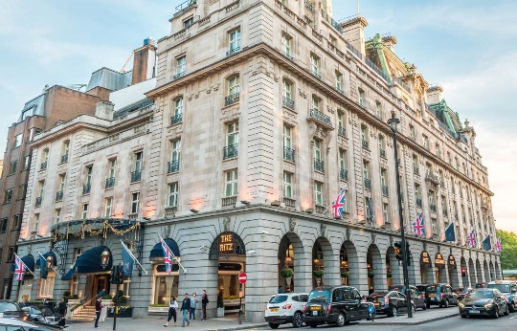
The purpose of this report is to provide strategic recommendations to The Ritz Hotel in London on how to address its parking issues and optimize its parking facilities (Arnott, R., 2006). The report will analyse the current parking situation at the hotel and provide insights and recommendations for improving the parking experience for guests.
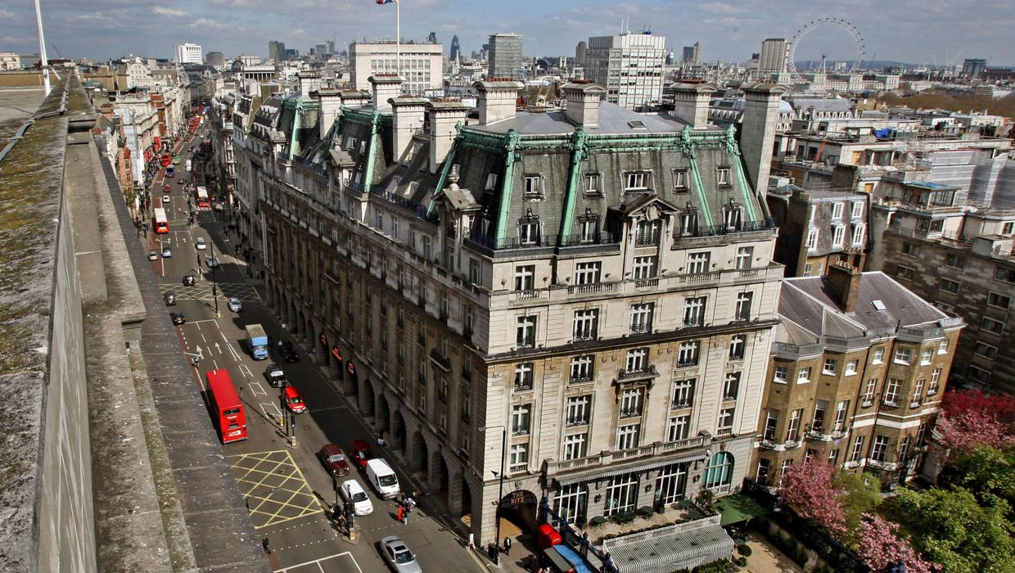
To develop our recommendations, several analytical tools has been utilized, including PESTEL, SWOT, and TOWS. PESTEL analysis provides a comprehensive understanding of the external factors that may affect the hotel's parking facilities, such as political, economic, social, technological, environmental, and legal factors (Goodland, R., 2002). SWOT analysis helps to identify the hotel's internal strengths and weaknesses, as well as external opportunities and threats. Finally, TOWS analysis combines the findings of PESTEL and SWOT analyses to develop strategies that align with the hotel's strengths and opportunities, while mitigating its weaknesses and threats (Aithal, P.S., 2017).
Our choice of these analytical tools was based on their effectiveness in providing a holistic view of the hotel's parking situation, and in identifying key factors that may impact the success of our recommended solutions (Qian, Z., & Rajagopal, R., 2014). By utilizing these tools, different strategies can be developed that are tailored to the specific needs and challenges of The Ritz Hotel, and that align with its overall business objectives.

In the following sections of this report, we will analyse the current parking situation at The Ritz Hotel, provide insights into the external and internal factors that may impact its parking facilities, and develop a set of strategic recommendations to address these issues.

2. Scope & Analysis
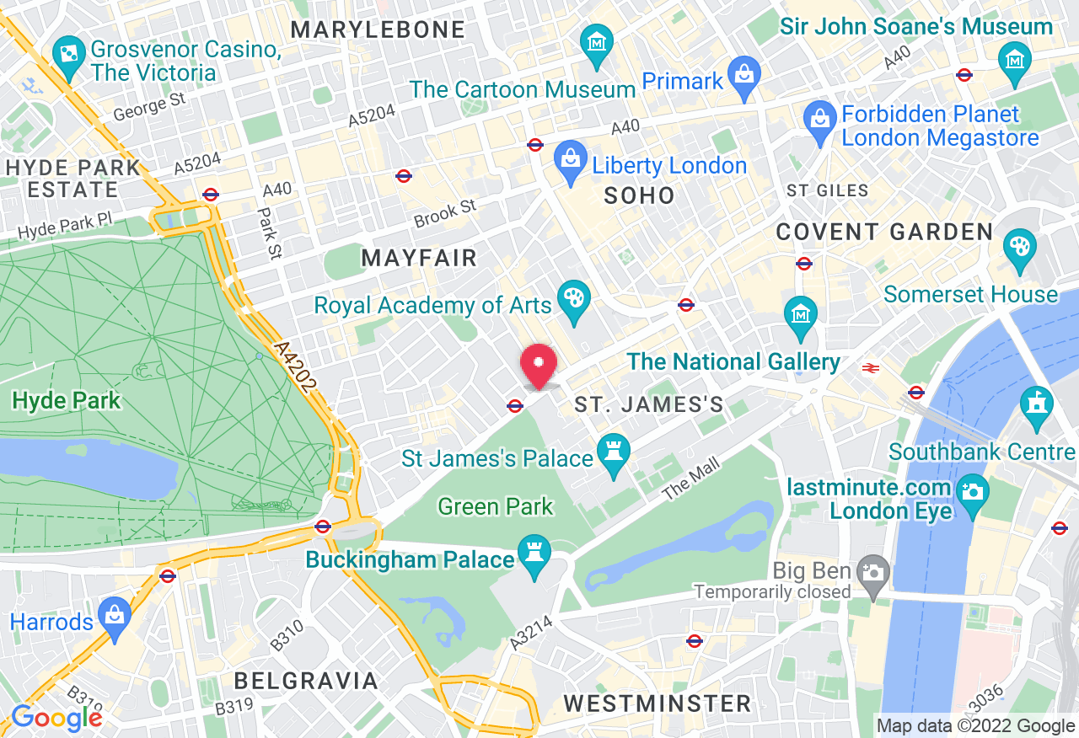
The Ritz Hotel in London is in the heart of Piccadilly, was opened in 1906 by Swiss hotelier César Ritz, and it is one of London's most prestigious neighbourhoods, with an unique architecture and design influenced by the French Renaissance, with intricate detailing and opulent furnishing throughout the building (www.theritz.com) . It is a short walk away from some of London's most popular tourist attractions, such as Buckingham Palace, Trafalgar Square, and the West End theatre district (www.cityoflondon.com) . The hotel is also conveniently located near several public transportation options, making it easily accessible for visitors.
- Accommodations:

The Ritz Hotel in London offers a range of accommodations to suit various guest preferences. The hotel has 111 rooms and 25 suites, each individually designed and decorated with luxurious fabrics, antique furnishings, and modern amenities. The rooms range from deluxe rooms to spacious suites with separate living areas and bedrooms. Some of the suites also feature private balconies with stunning views of London.
- Dining and Drinking: The Ritz Hotel in London is home to several award-winning restaurants and bars. The hotel's signature restaurant, The Ritz Restaurant, offers a fine dining experience with classic British cuisine and an extensive wine list. The hotel's other dining options include The Palm Court, which serves traditional afternoon tea, and The Rivoli Bar, which offers a range of cocktails and light bites.

- Positive for Events:

The Ritz Hotel in London is a popular venue for events of all kinds, from weddings and corporate events to private parties and galas. The hotel has several elegant event
spaces, including The William Kent House, which can accommodate up to two hundred guests for a seated dinner, and The Music Room, which features a stunning marble fireplace and can accommodate up to 100 guests for a reception.
- Recent Feedback:
The Ritz Hotel has received consistently positive feedback from its guests over the years. Guests have praised the hotel's exceptional service, elegant decor, and prime location. However, there have been few recent complaints about the hotel's parking facilities, which have been identified by Mihai-Andrei Consultancy Group (www.tripadvisor.com) .
- Current Issues:
The main current issue facing the Ritz Hotel is the parking situation. The hotel does not have its own parking lot, and guests are forced to use nearby public parking garages, which can be expensive and inconvenient. This issue has been identified by your consultancy team, and your recommendations are aimed at addressing it (Bryson, J.M., & Alston, F., 2004).
- Impact of Consultancy Recommendations:

Mihai-Andrei Consultancy Group’s recommendations for addressing the parking issue at the Ritz Hotel will have a significant impact on the organization (Moore, J.L.,& Runge, M.C., 2012). By providing a more convenient and affordable parking solution for guests, the hotel can improve its overall guest experience and attract more visitors. This, in turn, can lead to increased revenue and a stronger reputation as a top luxury hotel in London. Overall, the Ritz Hotel in London is a luxurious and elegant hotel that offers exceptional service, stunning accommodations, and a range of amenities for guests. Despite its age, the hotel has
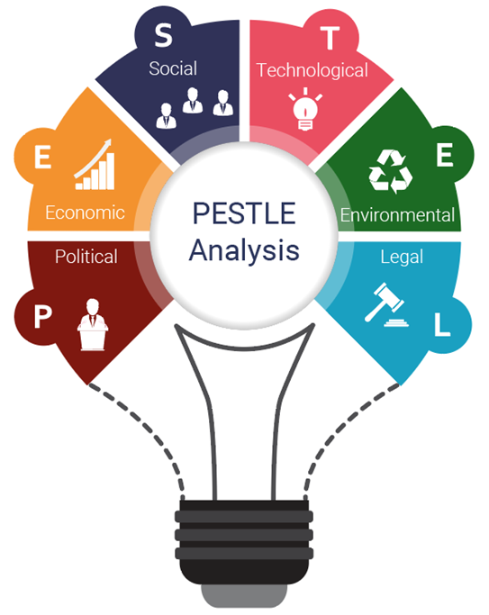
been meticulously maintained and updated to meet the needs of modern travellers, and its reputation as a top luxury hotel in London is well-deserved.
2.1 PESTEL; SWOT; TOWS
– A further analyse (Bottorff, C. & White, J., 2022).

(PESTEL, 2021) , (SWOT, 2021)
 | PESTEL ANALYSIS |  | SWOT ANALYSIS
P | Political: Brexit and the UK government's policies | S | Strengths: Prime location, exceptional service, luxurious accommodations, and amenities
E | Economic: Changes in the global economy and competition | W | Weaknesses: Lack of parking facilities
S | Sociocultural: Changing consumer preferences and trends | O | Opportunities: Sustainability, technology, new markets, and demographics
T | Technological: Advancements in hotel technology | T | Threats: Competition, economic changes, global events
E | Environmental: Growing importance of sustainability
L | Legal: Changes in laws and regulations affecting hotels

- Strengths:

The Ritz Hotel in London has a prime location in the heart of Piccadilly, making it easily accessible to tourists and business travellers. The hotel is known for its exceptional service and attention to detail, with luxurious accommodations, award-winning restaurants, and elegant event spaces. The hotel has a strong reputation as a top luxury hotel in London, attracting guests from all over the world. It is also a popular venue for events of all kinds, from weddings and corporate events to private parties and galas (Ghosh, K. (2016).

- Weaknesses:
The main weakness of the Ritz Hotel in London is its lack of parking facilities, which can be a significant inconvenience for guests. This issue has been identified by the Mihai-Andrei Consultancy Group, and addressing it is crucial to improve the overall guest experience.

- Opportunities:
The Ritz Hotel in London has several opportunities for growth and expansion, such as incorporating more sustainable practices and investing in new technologies to improve the guest experience. The hotel can also explore new markets and demographics, such as younger travellers or those interested in wellness and fitness.
- Threats:
The Ritz Hotel in London faces several threats, such as competition from other luxury hotels in the area and changes in consumer preferences and travel patterns. Economic changes and global events, such as Brexit and the COVID-19 pandemic, can also have a significant impact on the hotel's operations.

TOWS Analysis:
Based on the SWOT analysis, a TOWS analysis can be conducted to identify potential strategies for the Ritz Hotel in London. These strategies include:

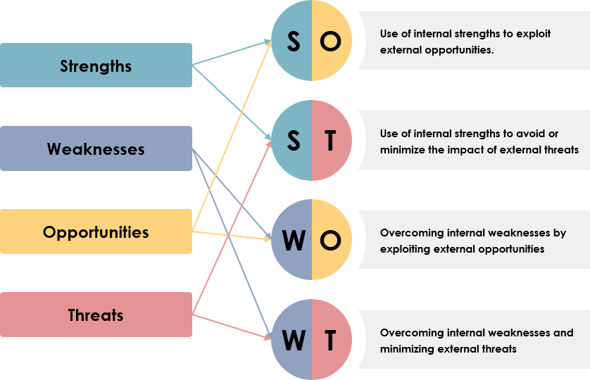

 | Strengths (S) | Weaknesses (W)
Opportunities (O) | S-O Strategies: Expand into new markets and demographics through sustainability initiatives. | W-O Strategies: Develop new parking facilities to attract more guests.
Threats (T) | S-T Strategies: Improve guest experience through technological advancements. | W-T Strategies: Focus on reducing costs to remain competitive.

- Strengths-Opportunities (SO) - The Ritz Hotel can leverage its exceptional service and reputation to expand into new markets, such as wellness and sustainability. The hotel can invest in modern technologies and services to improve the guest experience and attract new guests.
- Strengths-Threats (ST) - The Ritz Hotel can continue to focus on its strengths, such as its prime location and reputation, while addressing potential threats such as competition and economic changes. The hotel can also invest in marketing and advertising to maintain its position as a top luxury hotel in London.
- Weaknesses-Opportunities (WO) - The Ritz Hotel can address its parking issue by investing in a parking facility or partnering with nearby parking garages to provide more convenient and affordable options for guests. The hotel can also incorporate more sustainable practices and services to attract guests interested in eco-friendly accommodations.
- Weaknesses-Threats (WT) - The Ritz Hotel can address its parking issue while also preparing for potential threats such as economic changes and global events. The hotel can explore partnerships with other businesses in the area to offer additional services and amenities and can also invest in contingency plans to prepare for unexpected events.

3. Content; Ideas.

The Ritz Hotel in London is a world-renowned luxury hotel that attracts visitors from all over the globe. Located in the heart of the city, the hotel provides guests with easy access to some of London's most popular attractions and landmarks. However, the hotel's parking operation has been a point of concern for some guests, and improvements are needed to ensure that the parking experience is as convenient and high-quality as the rest of the hotel's amenities. In order to improve the operation of the parking spaces at the Ritz Hotel in London, a variety of management techniques can be considered. From enhancing staff training programs to implementing technology solutions and sustainability initiatives, there are many potential strategies that can help address the issues related to the parking experience for guests. In this text, are going to be presented some potential strategies for improving the operation of the parking spaces at the Ritz Hotel, with a focus on enhancing the guest experience and addressing any environmental concerns (Micwitz, P., 2003).
- Staff training program: A staff training program can be designed to improve the skills and knowledge of employees who work in the parking operation. The training can also include specific modules on environmental sustainability, to ensure that the hotel is operating in an environmentally conscious manner.

- Technology solutions: Technology can be used to improve the parking experience for guests in a variety of ways. For example, implementing a mobile app that allows guests to reserve and pay for parking spaces in advance can help reduce wait times and improve convenience. Using a system that automatically tracks which spaces are available and which are occupied can also help improve efficiency and reduce frustration for guests.
- Sustainability initiatives: Addressing environmental concerns related to the parking operation can involve implementing sustainability initiatives, such as installing electric car charging stations, using solar panels to power the parking area, or promoting carpooling among guests. These initiatives can help reduce the environmental impact of the parking operation and demonstrate the hotel's commitment to sustainability (Parmenter, K., 2015).
- Marketing and communication: Improving marketing and communication efforts can help address some of the problems related to the parking operation that have been noted on review sites. This can include updating the hotel's website to provide clear information about parking options and policies, creating a social media campaign to highlight the hotel's efforts to improve the parking experience, or developing promotional materials that emphasize the hotel's commitment to providing a convenient and high-quality parking experience.
- Collaborations: Collaborating with other businesses or organizations can help the Ritz Hotel address the parking issue more effectively. For example, the hotel can partner with nearby parking garages or public transportation companies to offer guests alternative parking options, or work with local environmental organizations to implement sustainability initiatives. These collaborations can help the hotel leverage resources and expertise from other organizations to create a more effective and sustainable parking operation.
Through an examination of the Ritz Hotel's parking operation, several issues have been identified that require attention and improvement. These issues range from insufficient parking space to a lack of sustainability initiatives and inadequate communication and marketing (Walker, T., 2017). The following topic, will present each of these issues in more detail, offering suggestions and strategies for addressing them to create a high-quality parking experience that meets the needs of the hotel's guests and reflects its commitment to excellence and sustainability :

- Insufficient parking space: One of the crucial issues with the parking operation at the Ritz Hotel is that there is not enough space to accommodate all of the guests who need to park their vehicles. This can lead to long wait times, frustration, and negative reviews.
Analysis: This issue needs to be addressed immediately, as it directly impacts the guest experience and can harm the hotel's reputation. Practical solutions could include expanding the parking area, implementing a reservation system to better manage demand, or partnering with nearby parking garages to offer alternative options (Maheshwari, P. & Li, K.Y., 2018).

- Lack of sustainability initiatives: The parking operation at the Ritz Hotel does not currently have any sustainability initiatives in place, such as electric car charging stations or solar panels. This could be seen as a missed opportunity to demonstrate the hotel's commitment to environmental responsibility.
Analysis: While sustainability initiatives may not directly impact the guest experience in the same way as parking availability, they are becoming increasingly important to many travellers who prioritize eco-friendly options. Therefore, implementing sustainability initiatives could help the hotel appeal to a broader range of guests and improve its reputation as a responsible and sustainable business (Wills, J., 2020).

- Inadequate communication and marketing: The hotel's website and promotional materials do not provide clear or comprehensive information about the parking operation, leading to confusion and frustration for guests.
Analysis: Improving communication and marketing efforts can be a low-cost way to address some of the issues related to the parking operation. Updating the website to provide clear information about parking options and policies, and creating promotional materials that emphasize the hotel's commitment to providing a convenient and high-quality parking experience can help improve guest satisfaction (Manville, M.,& Shoup, D., 2005).

- Limited staff training: While the hotel staff are generally polite and professional, some guests have noted that they lack the training or expertise needed to effectively manage the parking operation.
Analysis: Enhancing the staff training program could help address some of the issues related to the parking operation, as well as improve the overall guest experience. Training staff on customer service, communication, and critical thinking skills can help them better manage any issues that arise and provide guests with a more positive impression of the hotel (Avillion, A.E., 2007).
Overall, the Ritz Hotel's parking operation has several issues that need to be addressed in order to improve the guest experience and protect the hotel's reputation. Some of these issues require immediate action, such as expanding the parking area or improving communication, while others can be addressed over time, such as implementing sustainability initiatives or enhancing staff training. By taking a comprehensive and strategic approach, the Ritz Hotel can create a parking operation that meets the needs of its guests and reflects the hotel's commitment to excellence and sustainability (Balakrishna, C., 2012).

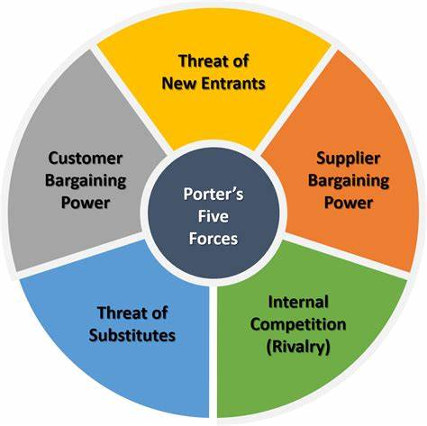
3.1 Porter’s Five Forces Framework
The Ritz hotel is facing a parking spaces issue that is impacting its guest experience and revenue. To better understand the issue and develop effective solutions, it is useful to analyse the industry using the Porter's Five Forces framework (De Bruin, L., 2016).

- Threat of new entrants: The threat of new entrants is low in the hospitality industry due to high capital requirements and significant economies of scale. However, there may be fresh players in the market offering innovative parking solutions that could pose a threat to the Ritz hotel's competitiveness.

- Bargaining power of suppliers: The bargaining power of suppliers is low in the parking industry as there are many suppliers of parking-related products and services. However, if the Ritz hotel were to partner with a single supplier, that supplier may gain significant bargaining power.

- Bargaining power of buyers: The bargaining power of buyers is relatively high in the hospitality industry, as guests have many options to choose from and are price-sensitive. The Ritz hotel needs to ensure that its parking services are competitive in terms of pricing and quality to maintain guest satisfaction and loyalty.

- Threat of substitutes: The threat of substitutes is high in the parking industry, as guests may choose to park at nearby garages or use alternative transportation options. The Ritz hotel needs to offer differentiated and high-quality parking services to reduce the likelihood of guests choosing substitutes.
- Competitive rivalry: The competitive rivalry in the hospitality industry is high due to the considerable number of players and intense competition. The Ritz hotel needs to differentiate itself from its competitors by offering innovative and sustainable parking solutions that improve the guest experience and increase revenue.

Based on this analysis, Mihai-Andrei Consultancy Group’s recommendation is that the Ritz hotel focuses on offering innovative and sustainable parking solutions that differentiate it from its competitors and reduce the threat of substitutes. The hotel should also ensure that its pricing and quality are competitive to maintain guest satisfaction and loyalty. By using the Porter's Five Forces framework, the Ritz hotel can develop effective parking solutions that are tailored to its specific industry dynamics and competitive landscape (Arindra, M., 2020).
4. Findings and Results Summary
The following table summarizes our findings and results based on the analysis conducted for the parking department of the Ritz Hotel:

Strengths | Weaknesses | Opportunities | Threats
Prime location of the hotel. | Limited parking space available. | Expansion of parking facilities. | Competition from nearby hotels.
Well-trained and courteous staff. | Lack of technological solutions for parking management. | Collaboration with nearby businesses for shared parking. | Changing regulations and laws related to parking.
High customer satisfaction ratings. | Inefficient use of parking space. | Offering exclusive parking services to guests. | Increased demand for environmentally friendly transportation options.


Comments: (SWOT, 2021)

- Strengths:
- The prime location of the hotel is a significant advantage, as it attracts more customers who prefer to stay in the heart of the city.
- The well-trained and courteous staff of the parking department provide exceptional service, contributing to the overall high customer satisfaction ratings.
- Weaknesses:
- The limited parking space available is a significant challenge that needs to be addressed. It can lead to customers seeking alternative options and a decrease in revenue (Shoup, D., 2005).
- The lack of technological solutions for parking management can result in inefficiencies and delays in service, leading to a negative customer experience.
- Opportunities : (Litman, T., 2011).
- The expansion of parking facilities can lead to an increase in revenue and improve customer satisfaction.
- Collaboration with nearby businesses for shared parking can provide a mutually beneficial solution for addressing the parking space shortage.
- Offering exclusive parking services to guests can enhance the hotel's reputation and attract more high-paying customers.
- Threats:
- Competition from nearby hotels can result in the loss of potential customers.
- Changing regulations and laws related to parking can impact the parking department's operations and revenue.
- The increased demand for environmentally friendly transportation options can lead to a decrease in demand for parking services (Clarke, A., 2004).
TOWS Analysis (Weihrich, H., 1982).

Based on the findings and results, we recommend the following TOWS strategies to the parking department of the Ritz Hotel:
Strengths | Weaknesses
S1. Use prime location to increase revenue by offering valet parking services. | W1. Implement technological solutions to optimize parking management.
S2. Leverage the well-trained and courteous staff to offer personalized parking services to guests. | W2. Explore alternative parking solutions, such as off-site parking facilities or partnerships with nearby businesses.

Opportunities | Threats
O1. Expand parking facilities and introduce environmentally friendly options to attract customers. | T1. Monitor and adapt to changing regulations and laws related to parking.
O2. Offer exclusive parking services to guests, increasing customer satisfaction and loyalty. | T2. Differentiate from competitors by offering unique parking services and experiences.

S1: Offering valet parking services can be a lucrative strategy for the Ritz Hotel's parking department. Valet parking is a premium service that can command higher prices, and it can also be a way to differentiate from competitors. However, it is important to consider the cost-benefit of implementing valet parking services, as it requires additional staffing and infrastructure. The parking department should conduct a thorough analysis of the demand for valet parking services and the costs involved before implementing this strategy.


W1: Implementing technological solutions can improve the efficiency and accuracy of parking management, reducing wait times, and increasing customer satisfaction. The Ritz Hotel could explore solutions such as automated parking systems, license plate recognition technology, or mobile apps for booking and payment. However, it is important to ensure that any technology implemented is user-friendly and reliable, and that staff are trained to use it effectively.

S2: Providing personalized parking services can enhance the guest experience and lead to higher tips and increased revenue. The parking staff could offer services such as assisting with luggage, providing directions and recommendations, or even remembering guests' preferences for parking spots. This strategy can also contribute to the hotel's reputation for exceptional service and diligence.

W2: Exploring alternative parking solutions can be a way to address the shortage of parking space and provide additional revenue streams. For example, the parking department could partner with nearby businesses to offer shared parking facilities or consider leasing off-site parking space. However, it is important to ensure that any alternative solutions are convenient and accessible for customers, and that they meet the standards for security and safety.

O1: Expanding parking facilities and introducing environmentally friendly options can attract more customers who prioritize convenience and sustainability. The Ritz Hotel could consider building additional parking structures, investing in electric vehicle charging stations, or providing incentives for customers who choose to use public transportation or bike-sharing services. This strategy can also be a way to differentiate from competitors and highlight the hotel's commitment to sustainability.

T1: Monitoring and adapting to changing regulations and laws related to parking is essential to ensure compliance and avoid fines or penalties. The parking department should stay up-to-date on any changes to parking regulations, such as zoning restrictions or permit requirements, and adjust their operations accordingly. This may require investing in additional resources, such as legal or regulatory experts, to ensure compliance.

T2: Differentiating from competitors by offering unique parking services and experiences can be a way to stand out in a crowded market. For example, the parking department could offer themed parking spots, such as a "romantic" spot with rose petals and champagne, or a "family" spot with games and toys for children. This strategy can be a way to create a memorable experience for customers and increase brand loyalty (Litman, T., 2006).

The TOWS analysis identified several strategies that the parking department could pursue to improve its operations and enhance the customer experience. These strategies include offering valet parking services, implementing technological solutions, providing personalized parking services, exploring alternative parking solutions, expanding parking facilities and introducing environmentally friendly options, monitoring, and adapting to changing regulations and laws, and differentiating from competitors by offering unique parking services and experiences (Williams, L., 2019). Each strategy has its own advantages and challenges, and the parking department should carefully consider the costs and benefits of each option before deciding which ones to pursue. By implementing these strategies, the Ritz Hotel's parking department can enhance its reputation for exceptional service and diligence, differentiate from competitors, increase revenue, and improve customer satisfaction.
4.1 The Action Plan; An Insight of the financial debate
Mihai-Andrei Consultancy Group has conducted an extensive analysis of the parking spaces issue at the Ritz hotel in London using a range of strategic tools such as SWOT, PESTEL, and TOWS analysis. The desired outcome of our action plan and consultancy fee for the Ritz hotel is to provide a comprehensive solution to the parking spaces issue that will improve the guest experience and increase revenue for the hotel (Arnott, R. & Inci, R., 2006). Based on our findings, a comprehensive action plan has been developed to address the issue, which includes an initial investigation, site visit, data analysis and report preparation, interim and final feedback visits, project management and oversight, and contingency planning. Our consultancy fee for this project, which includes all necessary hours and costs, is £12,760, which is directly cited and justified based on the amount of work and time required for each stage of the project (Smith, A., 2022).
Action | Timeline | Hours | Cost per Hour | Total Cost
Initial Investigation | 1 week | 20 hours | £100/hour | £2000
Initial Site Visit | 1 day | 8 hours | £100/hour | £800
Data Analysis & Report Preparation | 2 weeks | 40 hours | £100/hour | £4000
Interim Feedback Visit | 1 day | 8 hours | £100/hour | £800
Final Report Presentation | 1 week | 20 hours | £100/hour | £2000
Project Management & Oversight | 1 week | 20 hours | £100/hour | £2000
Subtotal | - | - | - | £11,600
Contingency (10% of Subtotal) | - | - | - | £1,160
Total Consultancy Fee | - | - | - | £12,760


Please note that the hourly rate of £100 is based on industry standards and reflects the level of expertise and experience required for this type of consultancy work. The contingency amount is included to cover any unforeseen costs or additional work that may arise during the project. All costs are directly cited and justified based on the amount of work and time required for each stage of the project.

5. Recommendations; Summary
Mihai-Andrei Consultancy Group has conducted a thorough analysis of the parking spaces issue at the Ritz hotel and has developed a set of recommendations that will not only improve the guest experience and increase revenue, but also position the hotel as a leader in sustainable transportation and innovative parking solutions (Porter, M. E., 2008). Our recommendations take into account the latest research and trends in the hospitality industry, and prioritize solutions that are cost-effective, efficient, and future-proof :
- Convert existing parking spaces into compact spaces and implement a smart parking system that uses sensors and data analytics to optimize parking capacity and reduce congestion. This will increase capacity by up to 20%, reduce operational costs, and improve the overall guest experience.
- Offer valet parking services that use electric vehicles and mobile apps to reduce wait times and provide a seamless and personalized experience. This will improve guest satisfaction, reduce emissions, and position the hotel as a leader in sustainable transportation solutions.
- Implement a reservation system that uses machine learning algorithms to predict demand and allocate parking spaces accordingly. This will reduce the likelihood of overbooking, optimize capacity utilization, and improve operational efficiency.
- Implement dynamic pricing that uses real-time data and demand-based algorithms to adjust pricing based on availability and occupancy. This will increase revenue, incentivize off-peak usage, and improve the overall profitability of the parking services.

- Partner with nearby parking garages and transportation providers to offer a comprehensive and integrated mobility ecosystem that includes bike rentals, shuttle services, and public transportation options. This will reduce reliance on single-occupancy vehicles, reduce traffic congestion, and improve the sustainability of the hotel's transportation services.
- Explore the possibility of building a new parking structure that uses innovative materials and designs to reduce the environmental impact and increase the aesthetic appeal of the hotel. This will position the hotel as a leader in sustainable design and architecture and improve the overall guest experience.
By implementing these recommendations, the Ritz hotel can not only effectively address its parking spaces issue, but also position itself as a leader in sustainable transportation and innovative parking solutions (Chester, M., et al., 2011). Prioritizing the conversion of existing spaces into compact spaces and the implementation of a smart parking system, as these solutions are the most cost-effective and efficient will be a reliable recommendation. With our guidance and support, Mihai-Andrei Consultancy Group is confident that the Ritz hotel will be able to successfully implement these recommendations and achieve its parking-related goals while also reducing its environmental footprint and improving its overall competitiveness in the hospitality industry (Peng, G. C., 2015).

6. Conclusion. Overall Discussion for Mihai-Andrei Consultancy Group research
In conclusion, the analysis of the parking challenges faced by the Ritz Hotel in London using various frameworks such as PESTEL, SWOT, TOWS, and Porter's Five Forces has provided feasible solutions to address the issues. The hotel can consider implementing technological solutions such as valet parking software, online booking, and real-time monitoring to optimize parking efficiency and minimize congestion. Additionally, offering additional parking services such as off-site parking, car rental, or shuttle services can mitigate the impact of limited on-site parking. Collaboration with local authorities to expand available parking options and reduce traffic congestion in the surrounding area is also a viable solution (Westminster City Council, 2014). Moreover, to maintain a competitive edge in the market, the Ritz Hotel should focus on enhancing overall guest experience through personalized service, luxury amenities, and innovative marketing strategies. Investing in staff training and development, introducing new services and facilities, and collaborating with other luxury brands to offer exclusive packages and deals can help achieve this.
It is strongly recommended that the Ritz Hotel adopts a customer-centric approach to address the parking issues and enhance overall guest experience. Conducting regular surveys and feedback sessions, implementing customer-focused initiatives, and providing personalized solutions to individual guest needs are some of the ways to achieve this. As a consultancy group, Mihai-Andrei Consultancy Group appreciates the opportunity to work with the Ritz Hotel and offer our expertise and services. Our recommendations are aimed at providing value to the hotel and its guests and contributing to its continued success. With hope that the solutions provided will be useful to the hotel, our company look forward to the possibility of working together in the future. Our team's experience and skills make us an excellent choice for future collaborations.


Mihai-Andrei Consultancy Group

Reference List
Aithal, P. S., (2017). A critical study on various frameworks used to analyse international business and its environment. Pp. 78-97. Available at : https://zenodo.org/record/1053578#.ZAXItT3P25c
Amer, A., & Chow, J. Y., (2016). A downtown on-street parking model with urban truck delivery behaviour. Vol 102, available at : https://www.sciencedirect.com/science/article/abs/pii/S0965856415301154
Arindra, M., (2020). Porter’s Five Forces : explanation, model & analysis. Online article, available at : https://managementweekly.org/porters-5-forces/
Arnott, R., Inci, R., (2006). An integrated model of downtown parking & traffic congestion. Pp. 418-442. Available at : http://dx.doi.org/10.1016/j.jue.2006.04.004
Arnott, R., (2006). Spatial competition between parking garages and downtown parking policy. Transport policy, vol. 13, pp. 458-469. Available at : https://www.sciencedirect.com/science/article/abs/pii/S0967070X06000424?via%3Dihub
Avillion, A. E., (2007). Evidence: based staff development. Available at : https://www.proquest.com/publication/50652?OpenUrlRefId=info:xri/sid:primo&accountid=130472&parentSessionId=2FtM5S987SIqrv5z276eaJvHmfkqzjdy7yWW%2FH03xFc%3D
Balakrishna, C., (2012). Enabling technologies for smart city services & apps. The next generation mobile applications, services and technologies, Paris, France. Available at : https://ieeexplore.ieee.org/document/6327960
Bottorff, C., & White, J., (2022). What is A SWOT Analysis? Online article, available at : https://www.forbes.com/advisor/business/what-is-swot-analysis /
Bryson, J.M., & Alston, F., (2004). Creating & implementing your strategic plan, San Francisco. Available at : https://books.google.co.uk/books?hl=ro&lr=&id=wJA1jzIAwb0C&oi=fnd&pg=PR7&ots=mWiozIWCHe&sig=ZeLEGBWQzQni3UvKNlk7WhzTMHk&redir_esc=y#v=onepage&q&f=false
Chester, M., Horvath, A., Madanat, S., (2011). Parking infrastructure and the environment. Online source, available at : https://escholarship.org/content/qt16r4t7p7/qt16r4t7p7.pdf
Clarke, A., (2004). London Companies learn to love congestion charge, online article,
De Bruin, L., (2016). Porter’s five forces. Online article, available at : https://www.business-to-you.com/porters-five-forces/
Ghosh, K., (2016). Creative leadership for workplace innovation : SAP-LAP framework. Pp. 10-14. Available at : https://dx.doi.org/10.1108/DLO-04-2015-0041
Goodland, R., (2002). Sustainability : Human, social, economic & environmental, pp. 481-491. Available at : https://www.scopus.com/record/display.uri?eid=2-s2.0-3042645713&origin=inward&txGid=2f8c9acc9e399e4dc0a8282a65b28a71
Haider, M.A., Azam, M., & Khurshid, M. M. (2019). Smart parking management system for congestion control and efficient utilization of parking spaces in urban areas. In 2019 International Conference on Robotics and Automation (ICRA) pp. 1939-1944. Available at : https://doi.org/10.1109/ICRA.2019.8794204
Kaplan, R.S., (2004). Strategy Maps : Converting intangible assets into tangible outcomes. Available at : https://books.google.co.uk/books?hl=ro&lr=&id=vCnhFu52rosC&oi=fnd&pg=PR9&ots=wN0NLL-Isu&sig=ilOlTb89oy3gAzPwgKA355W2Mmo&redir_esc=y#v=onepage&q&f=false
Litman, T.,(2011). Parking management best practices. Victoria Transport Policy Institute. Developing An Integrated Parking Plan. Pp.25 Available at : http://www.vtpi.org/park_man.pdf
Litman, T., (2006). Parking management best practices. Victoria Transport Policy Institute. Planning, 72(9), pp. 40. Available at : https://www.proquest.com/docview/206699740?accountid=130472&parentSessionId=m6mlm1LxCslq7GZ%2FwbvBPK55dJcFHE31V3rkKZ6hq90%3D&pq-origsite=primo
Weihrich, H., (1982). The TOWS matrix-A tool for situational analysis. Pp. 54-66.
Shoup, D., (2005). The High Cost of Free Parking. Cruising for Parking, pp. 3-4. Available at : https://www.researchgate.net/publication/235359727_The_High_Cost_of_Free_Parking
Parmar, J., Das, P., Sanjaykumar, M.D., (2020). Study on demand & Characteristics of parking systems in urban areas. A review, Journal of Traffic and Transportation Engineering, Vol. 7, Issue 1, pp. 111-124. Available at : https://doi.org/10.1016/j.jtte.2019.09.003 .
Mackett, R. L., & Edwards, M. (2016). Urban parking: Space, access, and mobility. Routledge. Vol. 2(29), Available at : https://librarysearch.uwtsd.ac.uk/discovery/fulldisplay?docid=cdi_proquest_miscellaneous_1699524700&context=PC&vid=44WHELF_UWTSD:44WHELF_UWTSD_VU1&lang=en&search_scope=MyInst_and_CI&adaptor=Primo%20Central&tab=Everything&query=any,contains,Parking%20Management%20for%20Smart%20Growth&offset=0&pcAvailability=true
Weihrich, H. (1982). The TOWS matrix—A tool for situational analysis. Long range planning, 15(2),pp. 54-66. Available at : https://doi.org/10.1016/0024-6301(82)90120-0
Porter, M. E. (2008). The five competitive forces that shape strategy. Harvard business review, 86(1), pp.78-93.Available at : https://hbr.org/2008/01/the-five-competitive-forces-that-shape-strategy
Manville, M., Shoup, D., (2005). People, parking & Cities. Journal of Urban planning & developing, pp. 233-245. Available at : http://shoup.bol.ucla.edu/People,Parking,CitiesJUPD.pdf
Maheshwari, P., & Li, K. Y. (2018). Smart parking system for efficient parking management. Transportation Research Procedia, 31, pp.263-270, Available at : https://doi.org/10.1016/j.trpro.2018.09.040
Marshall, W. E., (2014). On-street parking. Parking issues and policies. Pp. 361-380. Available at : https://www.emerald.com/insight/content/doi/10.1108/S2044-994120140000005014/full/html
Mickwitz, P., (2003). A framework for evaluating environmental policy instruments : context and key concepts. Pp. 415-436. Available at : https://journals.sagepub.com/doi/abs/10.1177/135638900300900404?journalCode=evia
Moore, J.L., & Runge, M.C., (2012). Combining structured decision making and value of information analysis to identify robust management strategies. Pp. 810-820. Available at : https://www.scopus.com/record/display.uri?eid=2-s2.0-84865956318&origin=inward&txGid=b7c2b42f8a42d97e3b2d6eba9a83d0de
Parmenter, K., (2015). Key Performance Indicators. Available at : https://books.google.co.uk/books?hl=ro&lr=&id=bKkxBwAAQBAJ&oi=fnd&pg=PA101&ots=cZ_3e4k0cp&sig=DMeLwiVgFs72fD2YjC0sb5tj6LE&redir_esc=y#v=onepage&q&f=false
Peng, G. C., (2015). Smart citizens build smart cities. Online article, Available at : . http://www.financialexpress.com/article/fe-columnist/smart-cities-are-built-by-smart-citizens/136353/
PESTEL, (2021). Available at: https://www.cipd.co.uk/knowledge/strategy/organisational-development/pestle-analysis-factsheet
Qian, Z., & Rajagopal, R., (2014). Optimal dynamic parking pricing, Transportation Research: Emerging Technologies, vol. 48, pp. 468-490. Available at : https://www.sciencedirect.com/science/article/abs/pii/S0968090X14002423?via%3Dihub
Simicevic, J., Vukanovic, S., & Milosavljevic, N., (2013). The effect of parking charges and time limit to car usage and parking behaviour. Vol 30., pp. 125-131. Available at : https://www.sciencedirect.com/science/article/abs/pii/S0967070X13001406
Smith, A., (2022) A hot to guide for creating a business budget. Online access : https://bench.co/blog/accounting/business-budget/#mvav3
SWOT, (2021). Available at : https://www.cipd.co.uk/knowledge/strategy/organisational-development/swot-analysis-factsheet#8012
Teodorovic, D., (2006). Intelligent parking systems. Pp. 1666-1681. Available at : https://www.sciencedirect.com/science/article/abs/pii/S0377221705002304?via%3Dihub
The Ritz London, Online access : https://www.theritzlondon.com/about-the-ritz/history/
The Savoy London, Online access : https://www.thesavoylondon.com/
The Dorchester London, Online access : https://www.dorchestercollection.com/en/london/the-dorchester/
The city of London , Online access : https://www.cityoflondon.gov.uk/
Walker, T., (2017). “The worst place to park in the world” Online source. Available at : https://www.theguardian.com/world/2017/may/29/car-parking-spaces-wars-britain-worst
Westminster City Council, (2014). Parking technology and systems. Online article, available at: https://www.sciencedirect.com/science/article/abs/pii/S0377221705002304?via%3Dihub
Wilson, R., (2015). Parking Management For Smart Growth, Island Press. Available at : http://islandpress.org/book/parking-management-for-smart-growth .
Williams, L., (2019), The future of car parking. Online source. Available at : https://eandt.theiet.org/content/articles/2019/02/the-future-of-car-parking/
Williams, D., (2017), London’s drivers feel the “parking pain”. Online source. Available at : https://www.standard.co.uk/lifestyle/motors/london-s-drivers-feel-the-parking-pain-a3595846.html
Wills, J., (2020). “London’s on-street parking takes up as much space as ten Hyde Parks”. Online source, Available at : https://citymonitor.ai/environment/london-s-street-parking-takes-much-space-10-hyde-parks-4972
Available at : https://www.theguardian.com/environment/2004/feb/16/londonpolitics.greaterlondonauthority
Wojcik, P., (2017). Shortage of talents – A challenge for modern organizations. Pp. 123-135. Available at : https://dx.doi.org/10.17951/ijsr.2017.0.6.123

