Margarita Mandulova
Student ID 2119899
Marketing analysis and evaluation of Coca-Cola
Module code LCBB4004
Lecturer Mr. Afzal Munna

Contents

- Introduction…………………………………………………………………………………………………………………p. 2
- Coca-Cola life cycle………………………………………………………………………………………………………p. 3
- SWAT analysis………………………………………………………………………………………………………………p. 3
- Porter’s five forces……………………………………………………………………………………………………….p. 7
- Ansoff Matrix……………………………………………………………………………………………………………….p. 9
- PESTLE analysis…………………………………………………………………………………………………………….p. 11
- Segmentation, targeting and positioning…………………………………………………………………… p. 14
- Marketing Mix……………………………………………………………………………………………………………..p. 15
- Conclusion……………………………………………………………………………………………………………………p. 16
- Reference list …………………………………………………………………………………………………………… ..p. 17

Analysis and evaluation of Coca-Cola Company

- Introduction

Marketing is managing profitable customer relationships. The twofold goal of marketing is to attract new customers by promising superior value and to keep and grow current customers by delivering satisfaction. ( Kotler, Armstrong, 2012)
By analysing and evaluating the current market and implementing marketing strategies a company can only benefit and grow. Different tools can be used for the comprehensive and accurate evaluation of both internal and external factors. Therefore, this report will use SWAT analysis, Pestel, Porter’s Five Forces, as well as Marketing Mix and STP to determine the chosen company's position, strength, and profitability.
Coca-Cola is the most famous brand around the world, present in over 200 countries with over 500 brands in its portfolio. Moreover, statistic shows that the company is the 4th most valuable company in the world, hence if there is a formula for success it must be invented by Coca-Cola as the company is the perfect example of continuous growth, profitability, and popularity.
One of the most diverse and thorough strategies to this day is that of Coca-Cola, proving that keeping its traditions and at the same time being innovative is the right way to determine longevity in the market. The company’s revenue continuously soar year after year, making it one of the most successful brands in history.

2. Coca-Cola life cycle

At the beginning of this report, the life cycle or the stages that the company already went through and is now currently at will be discussed. This will help give a clear view to the rest of the analysis provided as this affect the performance and the place of the company in the market. There are five stages and a short description will be provided for each of them.
Introduction stage- Coca-Cola was founded in 1886 and was first sold from a soda fountain in a pharmacy.
Growth stage- started when the product was first bottled, advertised and distributed to more locations. This stage ended in 1990 when the company went into the stage of maturity.
Maturity stage – when the product is well recognised, sales are soaring, and the demand is high. Coca-Cola is still in this stage due to its strong global existence, wide distribution and manufacturing network, massive advertisement and social networks presence and loyalty to its customers.
Decline stage- although the company is not there yet, recent years shifted the customer’s perspective to a more health-aware lifestyle and there has been a decline in certain products that the company offers. Due to its rich portfolio, the company has a variety of products satisfying different needs, thus managing to balance any losses.
Withdraw stage- when the demand decreases and the company can’t keep up with relevant products.

3. SWOT Analysis

SWOT Analysis is a way to evaluate the internal factors to help companies increase their revenue and secure a position in the market. Divided into four sections this tool determines what are the Strengths, Weaknesses, Threats, and Opportunities of a company. Asking simple questions such as “what do you do better than your competitors?” to identify the strengths and “where do you need improvement?” to establish the weaknesses, as well as “what innovations and trends can boost the sales?” and “what are the strengths of your competitors?” to establish the possible threats and opportunities. Every company set for victory must also evaluate its opponents not only to achieve a successful position but also to be aware of the current situation in the market.

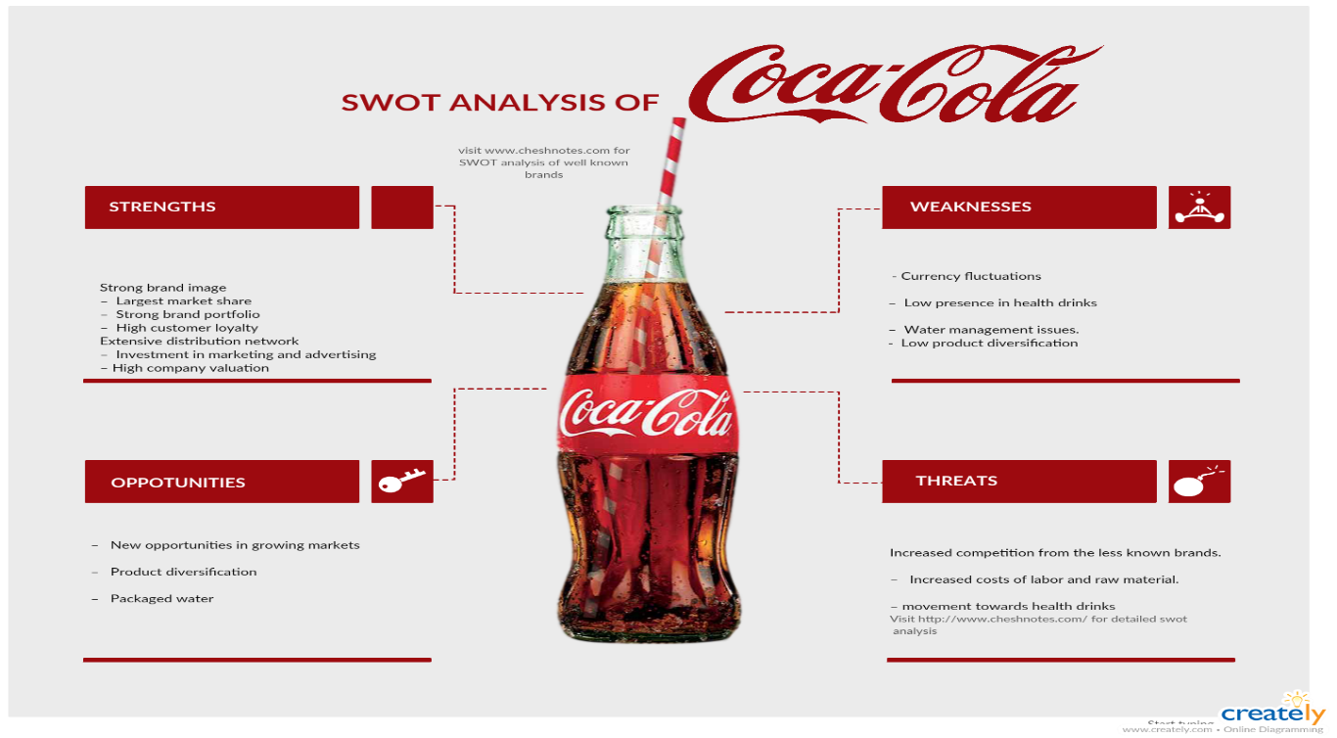
Figure 1

3.1 Coca-Cola Strength Analysis

136 years of continuous and successful presence in the market.
The brand is worth over 87.6 billion dollars and it is valued that high because of its vast presence and authentic brand identity.
Coca-Cola dominates the market share in the beverage industry with over 500 products.
The company has strong connections with the bottling companies thus creating one of the most extensive distribution networks.
Coca-Cola has the biggest advertisement budget compared to its rival companies in the industry.
Partnership with McDonald’s- another huge worldwide present company.

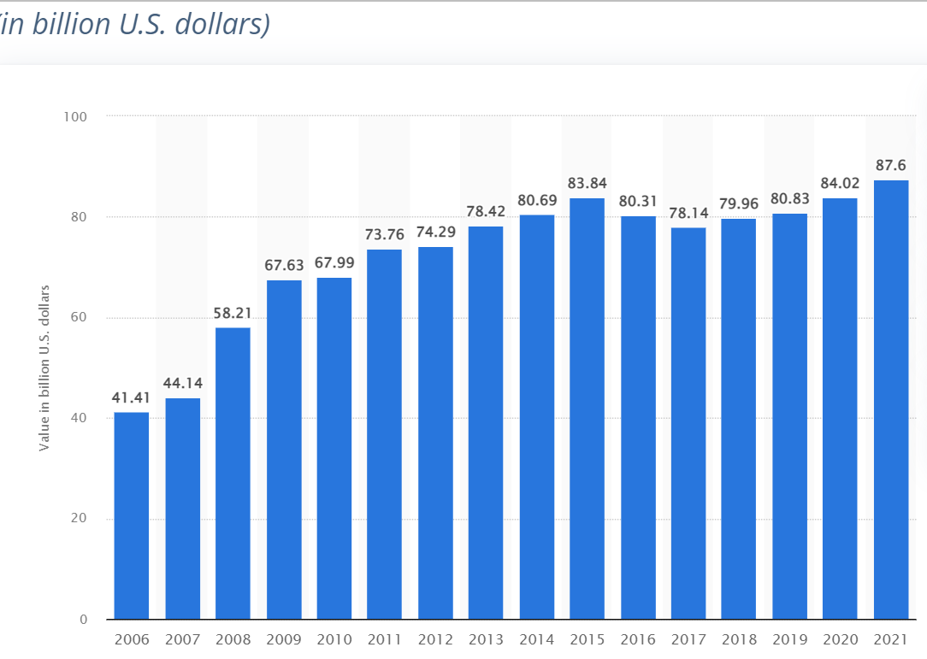
.

Figure 2

3.2 Coca-Cola Weaknesses Analysis
As the largest non-alcoholic beverage company Coca-Cola holds the focus of attention for some of its business practices.
Nowadays people are much more conscious about what they consume, hence sugary and carbonated drinks are in serious decline. The company relies on the diet and sugar-free versions of their most selling products and on the many more products they have in their portfolio - low calories beverages such as water, tea, and coffee.
One problem of huge significance is the high volume of water consumption - in its chase for water supplies to feed its plants, which has resulted in the drying up of farmers' wells and the destruction of local agriculture.
Competition with Pepsi is another big issue for the company. According to Euromonitor International, Pepsi got a share in the snacks market, out of $22 billion brands that Pepsi Co owns, $7 billion comes from the savoury snacks brands. Coca-Cola still has no presence there and that is seen as a weakness. It is expected in the next few years the savoury snacks segment to be a very successful one and companies like Coca-Cola only can benefit further if enter the market.
Last but not least, any fluctuation in the USD currency can negatively affect the company.

3.3 Coca-Cola Opportunities Analysis

According to The Beverage Marketing Report in 2017, RTD (ready-to-drink) coffees were the fastest growing segment.
The figure shows 6 times faster growth for RTD drinks 12.3% compared to only 2.1% for the whole US beverage industry.
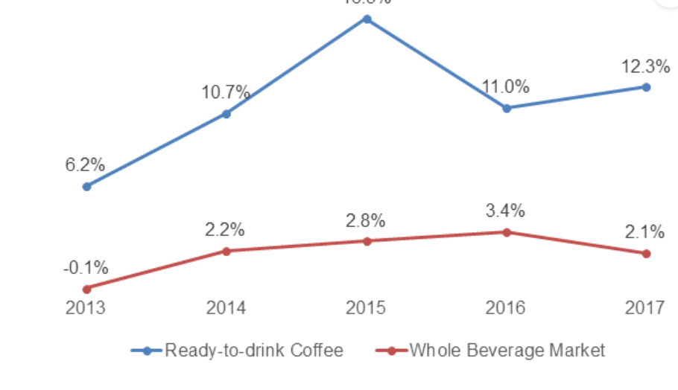

Figure 3

In the last couple of years, the negative effect of the pandemic and the demand for fresh, bottled water opened another big opportunity for Coca-Cola. Already in the business with their brand Kinly, it is an easy opportunity for them to expand the market.
Another fast-growing segment is the demand for Coconut water. It is expected by 2023 to grow to a staggering US$8.3 billion globally. ( Arizton , 2018)
They already have the distribution channels, the bottling plants the funds and the brand name to promote and sell successfully these products.
Yet again will be mentioned the segment of savoury snacks, another fast-growing segment, in which Coca-Cola has not taken part so far. This is revenue that can be persuaded to secure more diversity in their portfolio and profits, moreover, their biggest rival Pepsi has already been in the market and had success with their products.

3.4 Coca-Cola Threats Analysis

The leading place should belong to the fast-growing concern of obesity and its related diseases such as diabetes, thus affecting the biggest provider of sweet, carbonated drinks. There is a steady decline in the consumption of such beverages which will lead to reduced sales for the company.
The sugar tax has been introduced in a few cities across the US, the UK, and other countries around the world (Bird.B , 2018). It is a tax, that aims to reduce the consumption of all sugar-containing beverages. According to the American Journal of Public Health, ( 2018), this increased water consumption and decreased the sales of carbonated drinks. Since then, more cities across the US are joining the initiative and very soon is to be believed it will spread nationwide. This is a real threat for Coca-Cola as its biggest and most profitable segment will be affected enormously.
Water scarcity is a major problem for the company as they rely solely on water supply for their products. Climate change, overpopulation, increased demands for agricultural produce, and bad wastewater management is just some of the problems that are creating a huge demand for fresh water. This easily can reduce the profits for Coca-Cola by increasing the cost of clean and cheap water supply.

4. Porter’s Five forces Analysis

This model was published first By Michal Porter in 1979 and at its core, aims to explain why different sectors may maintain different levels of profitability.
This model is used to analyse a market or an industry – to understand the strength of buyers and suppliers and the threat of substitutes or new players in the market.
The model is built on five variables which are: Bargaining power of buyers, the Bargaining powers of suppliers, the Threat of new entrants, the Threat of substitutes, and Competitive rivalry.

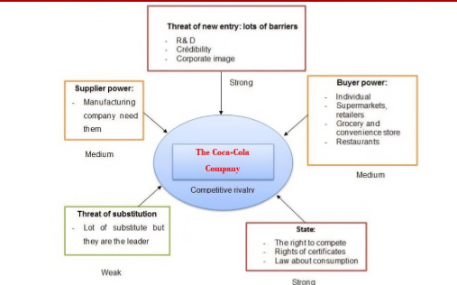
Figure 4

4.1. The threat of New Entrants
Coca-Cola has been on the market for over a century and it is the biggest player in the field with a presence in over 200 countries, hence why threats of new entrants are insignificant. Moreover, the company has over 500 brands under its belt and one of the best production and distribution systems. Even with the presence of new players, this can benefit companies such as Coca-Cola using the dynamics to expand their portfolio. (TrefisTeam. 2016)

4.2. Threats of Substitutes
There is a wide range of beverages in the market that consumers can choose from, therefore this holds medium risk for Coca-Cola, although customers who prefer the products of the company are not very likely to switch to another brand.
Nevertheless, according to Wahlen et.al.,( 2014), the presence of other brands apart from Coca-Cola can change the industry dynamics as the consumers have other options available, leading to a potential effect on the profitability of Coca-Cola.
4.3. Bargaining Power of Buyers
The beverage industry consists of two types of buyers- corporate and individual. For the individual buyer, the bargaining power is low, on the other hand for the corporate buyers is moderate. Coca-Cola has established strong connections with leading fast food chains such as Mcdonald’s, also vending machines and convenience stores that widen the reach of the targeted market. (Thompson and Martin, 2010).

4.4. Bargaining Power of Suppliers
As the company relies on commodities such as water, sugar, caffeine etc, its suppliers have low bargaining power due to the large scale of business that this company brings. In favour of companies such as Coca-Cola is also the Agriculture Guiding Principles that the suppliers must abide by, implementing that suppliers have low bargaining power and that the manufacturer has greater powers when it comes to pricing and contracts. ( Journey Staff, 2017)

4.5. Competitive Rivalry
Competitive rivalry is moderate. The biggest competitor for Coca-Cola is Pepsi, the competition between them is also known as The Cola war. Smaller companies are low risk as they lack the popularity, distribution and advertisement that huge companies such as Coca-Cola have, therefore they have a much smaller market share. ( Lamb, Hair and McDaniel, 2011)

5. Ansoff Matrix

The Ansoff Matrix (product market expansion grid) is a tool used by management and analyst teams to formulate, plan and evaluate growth initiatives. In other words, the matrix provides a solution to the dilemma of whether to grow using existing products and markets or to develop new products and seek new markets .( Oakley, Tom, 2015)

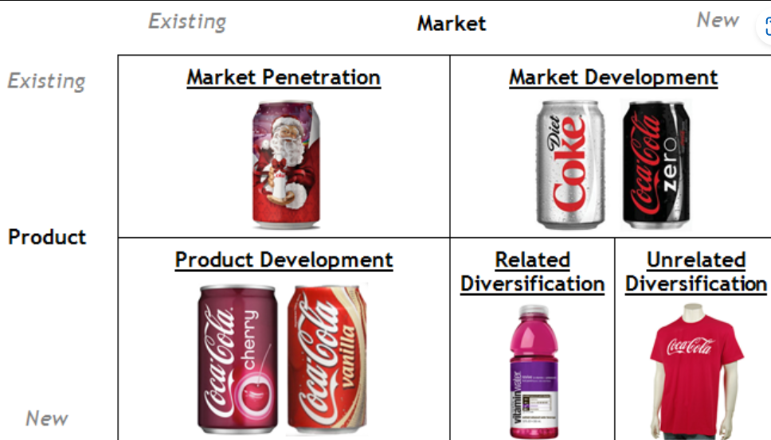
Figure 5

5.1. Market penetration
Existing product and existing market
This strategy is designed to achieve an increase in market share by finding new customers or selling more products. Usually, for a company such as Coca-Cola with a presence in the global market and over 500 brands in their portfolio, this is already established practice. What they did to achieve more sales during the winter season, when the sales of carbonated beverages normally go down was to implement the promotion element of the Marketing Mix. This was quite an advanced idea for 1931, when they decided to put the image of Santa Claus on their bottles and invest heavily in the advertisement and ever since then there probably is not a single person in the world who hasn’t seen it.
5.2. Product development
New product and existing market
Launched in 1985 Cherry Coke had a huge success once again with the help of mass advertisement. Since then, the company released a few more flavours such as lemon, lime and vanilla. Some of these products haven’t met the expectations and were not quite successful but Cherry Coke stayed in the market and is now recognised worldwide.
5.3. Market development
Existing products and new market
This strategy is used to attract new customers without changing the product. An example of that is Diet Coke, ever since its release in 1985, it has been associated as one of the most popular drinks among women. When Coke Zero was introduced, they designed the packaging with a more masculine appeal and now Coke Zero is the bestseller for the company.
5.4. Related diversification
New market and new product
Coca-Cola bought Glaceau in 2007 for $4.1 billion including Vitaminwater. The shift to healthy alternatives was inevitable if the company wanted to sustain its image and profits. With the steady decline in sales of carbonated drinks, this was a smart move for Coca-Cola to enter a new market with a new product.
5.5. Unrelated diversification
New market and new product
Coca-Cola seems to avoid entering new territories but what it does very successfully is to promote its brands. The unrelated products are all official merchandise such as glasses, pens, clothing, umbrellas and even fridges. This opens a possibility not only for bigger profits and acquiring new clients but for more advertisement too.

6. PESTEL Analysis

Pestel analysis is probably the most used method in the business when come to analysing the macro-environment. It is used to determine the Political, Economic, Social, Technological, Legal and Environmental factors that can affect the performance of a company or business. All these factors must be studied and analysis to be performed regularly so the business can be aware of any possible changes and be able to sustain and enhance its performance.

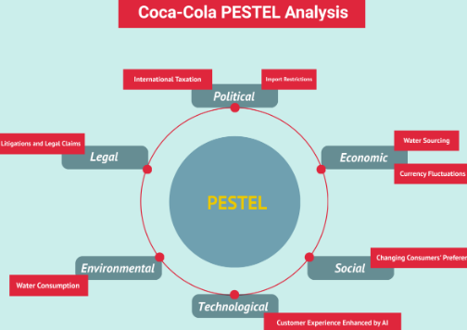
Figure 6

6.1. Political Factors
If a country’s political environment is unstable as well as any changes in legislation or taxation can affect directly the performance of a company. Trade relations between the US and other countries might also not be in favour of the company.
Especially in developing countries or ones that have been through civil conflicts and new governments have been formed the risk of changing laws, corruption or bureaucracy can put a strain on the company.
Political factors at home can also play a huge role in the sustainability of the company, hence Coca-Cola has been heavily involved in political lobbying. This is one way to ensure their voice will be heard and their interests will be considered. According to the company, political donations, advocacy and trade associations are just a few of the tactics they use. (Coca-Cola, 2017)
6.2. Economic Factors
This is one factor that the companies have non or very little control over, recent years proved that in case of a major global crisis the business suffers immensely. The business crisis from 2008-2009 showed how little control a company can have and in the last two years, the Pandemic brought once again massive disruption in the global market.
Currency fluctuations are another big issue and that has a severe impact on the company’s profits.
During the Covid-19 pandemic Coca-Cola has been performing well, the sales have been steady, but the problems came from supply chains, transportation and workforce restrictions. As the biggest non-alcoholic beverage company in the world, Coca-Cola has an excellent partnership with local bottling companies, distributors and suppliers, thus easing the process through these difficult times. According to the company’s report “Compared to 2019, global unit case volume sequentially improved each quarter in 2021, resulting in full-year unit case volume being ahead of 2019. This performance was driven by an ongoing, asynchronous recovery in many markets and the company’s ability to better adapt to successive waves of the pandemic”. (Coca-Cola reports, 2022)

6.3. Social Factors

The socio-cultural conditions greatly impact a company, and there are many factors to be considered.
Worldwide awareness of the negative health effect of sugary carbonated drinks is the biggest issue for companies such as Coca-Cola. They need to diversify their portfolio by introducing more products like Coke Zero for their health-conscious clientele. Also, the diversity of palates in each region is something to be considered, which they did for example in Japan - they introduced over 30 products with particular for the region’s tastes.
Coca-Cola is one of the best campaign initiators, they accentuate on few social conditions and the mastermind behind is that by creating social awareness they also bring the spotlight to their company and promote the brand.

6.4. Technological Factors

The most prominent side of the development of technologies is the use of the internet, more specifically social media, where every business can promote and market their products, helping their company grow.
Coca-Cola has a very active social media presence on all big platforms, such as Facebook, Twitter, Instagram and Pinterest. As of 2021, it is reported that 3.8 billion people have smartphones, and 4.66 billion have access to the internet which gives the company huge advance in promoting and selling their products online. (Statista, 2021)
Nevertheless, technologies are so advanced now that the development of a new product takes a few days instead of months compared to just a few years ago. The striving to conquer markets and increase sales in minimum time is impossible without the fast-developing technological field.

6.5. Environmental Factors

Environmental sustainability has grown to such importance, that governments around the world are issuing strict laws and regulations. Due to climate change, water scarcity is the issue in the leading position at the moment and Coca-Cola works hard to reduce the use of water drastically by investing in agricultural water-smart programs in Africa such as CARE and RAIN, where they teach local farmers more efficient methods of farming.
The use of virgin plastic is another big threat to the environment; therefore, the company has already begun reducing its use, striving to achieve the use of 100% recycled plastic for their packaging in near future.

6.6. Legal Factors

Legislation alongside Political factors is another area with the least control a company can have over. This can be observed abroad where the company doesn’t have strongly established lobbying practices, or in underdeveloped or torn from civil conflicts countries.
Coca-Cola falls under the authority of the Food and Drugs Administration where new requirements and standards are issued regularly. The company must abide by those regulations and every change can affect its performance.
Moreover, different counties have different laws, from employment, and taxation to consumer and intellectual property law. A vigilant and experienced team must follow every shift and change in these laws to shield and guide the company in the right direction.
Noncompliance can cost millions for companies and Coca-Cola had its fair share of problems with the law in different countries, varying from discrimination, water overuse, working conditions and so on. Most of these issues have been addressed and the company changed its practice accordingly. (Abhijeet, Pratap, 2021)

7. Segmentation, Targeting and Positioning

STP is a framework that divides the market into groups, such as demographics, age, interests and needs, thus targeting the right segments. Here the focus is shifted from the advertisement of the product to the customer.
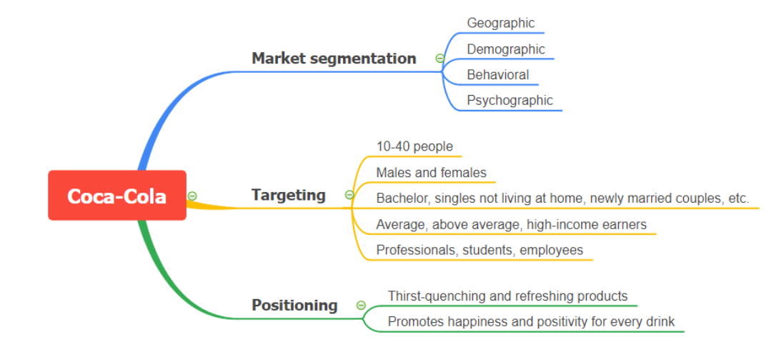
Figure 8

7.1. Segmentation
Geographic segmentation is one of the branches of market segmentation. Coca-Cola is globally distributed mostly focusing on urban and suburban areas but also available even in rural regions.
Demographic factors are such as age, sex, race, nationality, social class and occupation. Psychographics on the other hand are factors such as lifestyle, values and personality.
Behavioural is based on the customer’s awareness, knowledge or attitude towards their products.
As the biggest provider of soft drinks, Coca-Cola satisfies the needs of different segments by having in its arsenal more than 500 products to choose from.

7.2. Targeting
The targeted clientele is divided into two groups - 10 to 25 and 25 to 45 years old.
The first group is the biggest user of the original Coke drinks as well as Sprite and Fanta, and the second group is more health conscious that leans towards sugar-free products.

7.3. Positioning
In a saturated market making your brand stand out is a difficult act to perform but for Coca-Cola, the benefit of being in the market for over 130 years and having so many different brands under its umbrella makes it a bit easier to accomplish.
The company promotes its drinks s a thrust-quenching, a drink you enjoy with family and friends, all advertisements through the years carry the same reference. It is already stapled in people’s minds as a high-quality brand that caters to all its customers whatever their needs, preferences or tastes might be.

8. Coca-Cola Marketing Mix

The marketing mix consists of 7 elements - Product, Promotion, Place, Price, People, Process and Physical evidence. Also known as the 7P framework it helps businesses to evaluate and find out what the main issues are that can affect the marketing of products or services.

8.1. Product
Coca-Cola has a massive portfolio with over 500 brands and over 3900 still and sparkling drinks such as Coca-Cola, Diet |Coke, Coke Zero, Sprite, Fanta, Vitaminwater and many more. Having such a diversity of products creates a bigger share in the market and bigger revenue for the company.

8.2. Promotion
Due to the high competition in the sector, Coca-Cola spends over $4 billion every year on advertising. From TV, and outdoor ad campaigns the company has a huge presence on all online social platforms.
The pandemic boosted the company’s transformation to a new level of a digitalised firm where marketing, commercials, and distribution can be done both online and in a physical way.
Coca-Cola is investing also in SCR projects, as well as in developing sustainable supply chains and manufacturing and that has been very beneficial for the image of the company.

8.3. Place
Coca-Cola operates through numerous distribution and manufacturing channels. With its global presence, there is no other way to satisfy the needs of its customers in time. “ Our Company manufactures and sells concentrates, beverage bases and syrups to bottling operations owns the brands and is responsible for consumer brand marketing initiatives. Our bottling partners manufacture, package, merchandise and distribute the final branded beverages to our customers and vending partners, who then sell our products to consumers” Coca-Cola Company

8.4. Price
The biggest competitor on the market for Coca-Cola is Pepsi Co, they always price their products in the same range. If one goes up the customers might switch to the other, or if the price goes down that might leave the impression of a low-quality product. Moreover, due to the constantly decreasing demand for carbonated drinks, the rivalry between the two leaders in the market got even more intense.

8.5. People
Coca-Cola is a large international employer that proud itself with an advanced Human Resource strategy, allowing its employees to grow and develop different skills, as well as a recognition and reward system, that ensures job satisfaction.

8.6. Process
Over 225 bottling companies are included in the Coca-Cola system, as this supports the international manufacturing and distribution process. The company sells to its partners the ready concentrates and syrups and the bottling company produce the final product and distributes it to the customers.

8.7. Physical Evidence
The physical evidence of Coca-Cola is spread globally, from offices and headquarters around the globe to products that can be found in every shop and company merchandise and promotional material as well.

Conclusion

The analysis shows that Coca-Cola is a very versatile and flexible organization that rules over the market of the soft drinks industry. Several factors are in play here to ensure the constant growth and popularity of the brand such as taking advantage of new trends and technologies, extensive advertisement and well-structured global supply, manufacturing and distribution chains.
As mentioned above, the company’s marketing strategy, brand positioning, loyalty to its customers, and product innovation bring recognition from its customers and partners.
Moreover, dominating the market for so long provides vast experience and knowledge that the brand uses to its benefit.

Reference list

- American Public Health Association (2016). Impact of the Berkeley Excise Tax on Sugar-Sweetened Beverage Consumption. Available at: http://ajph.aphapublications.org/doi/abs/10.2105/AJPH.2016.303362
- Bird, B. (2018). What Is the Soda Tax and Which Cities Have One? Available at: https://www.thebalance.com/soda-tax-and-which-cities-have-one-4151209
- Journey Staff ( 2017 ) Supplier requirements. The Coca-Cola Company. ttps://www.coca-colacompany.com/policies-and-practices/supplier-guiding-principles Philip Kotler, Gary Armstrong, 2012, Principles of Marketing, Pearson Education, Inc
- Lamb, CW., Hair, J.F., and McDaniel. 2011 Essentials of Marketing. USA: South-Western Cengage Learning
- Packaged Coconut Water Market in Europe - Industry Outlook and Forecast 2018-2023 Coconut Water Market in Europe 2018-2023 | Market Research Report | Size | Share | Trends | Forecast | Arizton
- Pratap, Abhijeet. 2021 Coca Cola PEST Analysis (notesmatic.com)
- Strategic Management Insight (2018). PepsiCo SWOT Analysis. Available at: https://www.strategicmanagementinsight.com/swot-analyses/pepsico-swot-analysis.html
- Trefis Team., 2016. How Coca-Cola is Counting its Portfolio Diversification Strategy. Forbes How Coca Cola Is Continuing Its Portfolio Diversification Strategy (forbes.com)
- Wahlen, J., Baginski, S. and Bradshaw, M. 2014 Financial reporting, financial statement analysis and valuation. USA South-Western Cengage Learning

APENDIX

Fig1 Published by Statista Research Department, Jul 27, 2022

