
Applied Leadership and Management in the Workplace
Module Assignment Submission
Student Name: | Nicola Powell
Student Number: | 2433701
Module No: | BMSK4013
Module Title: | Management Communication

Statement of Confirmation of Authenticity
By the act of making this submission, the student declares that this is the work of the student named above. The work has not, in whole or in part, been knowingly presented elsewhere for assessment, or where assessment has been built on a previous assessment, this has been identified. Where materials have been used from other sources it has been properly acknowledged. If this statement is untrue, the student acknowledges that an assessment offence has been committed.
Attention is drawn to the plagiarism and unfair practice policies of both the University and of ILM.

Index Page
- Introduction 3
- The Communication Cycle and its Relevance in Management 4
- Communication Models in the Workplace 5
  - 3a Shannon and Weaver Model 5
  - 3b Berlo's SMCR Model 5-6
  - 3c Comparison of Models 6-7
- The Importance of Tone, Language, and Formality in Management Communication 8
  - 4a Formality in Communication 8
  - 4b Language and Audience 8
  - 4c Structure, Content, and Tone 8
  - 4d Modes of Communication 8
- Assessing Verbal and Written Communication in the Air and Water Hygiene Sector 9
  - 5a Verbal Communication: Methods, Advantages, and Disadvantages 9
  - 5b Written Communication: Methods, Advantages, and Disadvantages 9
- Motivation in the Workplace 10
  - 6a Definition of Motivation 10
  - 6b Intrinsic vs Extrinsic Motivation 10
  - 6c Theories of Motivation: Maslow, Herzberg, McGregor 11
  - 6d Application of Motivation Theory in the Workplace 12
- Evaluating Communication Effectiveness 13
  - 7a Criteria for Good Communication 13
  - 7b Communication Survey: Design and Implementation 14
  - 7c Survey Results and Analysis 15-16
  - 7d Personal Development Plan (PDP) References 16
  - 7e Self-Reflection: Strengths and Areas for Improvement 17-18
- Conclusion 19
- Reflection 20
- Referencing 21

1. Introduction
Effective communication and motivation are the key element of a productive and engaged workforce. In a company such as aa Air and water hygiene, where operations are critical to public health, environmental standards, and regulatory compliance, the importance of these factors is even more significant. Employees must understand complex procedures, adhere to safety protocols, and collaborate across various departments to deliver services such as air duct cleaning, water treatment, and environmental risk assessments. Without clear communication and motivated teams, there is a risk of misinterpretation, errors, and reduced service quality, all of which can have serious consequences.
This report aims to explore the vital role that communication and motivation play in the success of a national air and water hygiene company. It will examine the communication cycle as a tool for effective management, comparing key communication models to highlight their applicability in the workplace. The report will also evaluate the importance of selecting appropriate tone, language, formality, and communication methods to suit different audiences, ensuring messages are not only transmitted but fully understood.
Furthermore, the report will analyse the effectiveness of current communication practices, both verbal and written within the organisation, identifying strengths, weaknesses, and areas for improvement. It will assess the role of motivation in driving employee performance, comparing theories such as Maslow’s Hierarchy of Needs, Herzberg’s Two-Factor Theory, and McGregor’s Theory X and Y, to evaluate their relevance and effectiveness in this specific workplace context. Understanding what motivates employees, whether it is financial incentives, recognition, or a sense of purpose.
The report will also reflect on my own communication skills as a manager, based on feedback from colleagues, and will develop a Personal Development Plan (PDP) to address areas for growth. This includes the design of a communication effectiveness questionnaire and an analysis of the results, providing an evidence-based approach to continuous improvement.
Ultimately, this report aims to provide practical recommendations for enhancing communication and motivation within a national air and water hygiene company, ensuring that teams are aligned, engaged, and empowered to deliver safe, compliant, and high-quality services.

2. The Communication Cycle and its Relevance in Management
The communication cycle ensures that messages are encoded, transmitted, received, and understood (Shannon & Weaver, 1949). In the workplace, using this cycle improves clarity, reduces errors, and is essential in regulated industries like air and water hygiene (Hargie, 2016).
For instance, a team leader in an air and water hygiene company might use the cycle when explaining a new safety procedure:
- Encoding - formulating the message clearly.
- Transmitting - sharing via email or in a meeting.
- Receiving and Decoding - team reads or listens.
- Feedback - questions or clarifications.
The cycle ensures two-way communication which is vital in a safety critical industry where procedures must be understood and followed precisely.

3. Communication Models in the Workplace
In the air and water hygiene industry, clear communication is vital in safety critical industries (Robbins & Judge, 2019). Shannon and Weaver’s linear model explains communication as a process of encoding, sending, and decoding a message, with potential barriers like noise (Shannon & Weaver, 1949). Berlo’s SMCR model builds on this by focusing on human factors like the sender’s and receiver’s skills, knowledge, and attitudes (Berlo, 1960). These models highlight the importance of using the right channels and tailoring communication for different audiences (Goleman, 1995).

3a Shannon and Weaver Model (1949)
The Shannon and Weaver Model is a linear, step-by-step model that shows how messages are sent and received. It includes:
- Sender: The person who creates the message = a manager writing an email.
- Encoder: Converts the message into a format = typed words.
- Channel: How the message travels = email, phone, face-to-face.
- Decoder: Interprets the message = the reader understanding the email.
- Receiver: The person who gets the message = a technician.
- Noise: Anything that interferes = IT problems, distractions, language barriers.
Example: A manager emails new Legionella procedures. If a technician doesn’t read it because their computer isn’t working (noise), the message fails this could lead to safety risks.
Strengths:
- Helps spot barriers like poor channels or technical issues.
- Useful for technical messages that need to be clear and precise.
Weaknesses:
- One-way process doesn’t include feedback.
- Ignores human factors like tone and body language.
- Assumes communication problems are mainly technical, not personal.

3b Berlo’s SMCR Model (1960)
Berlo’s model focuses more on the people involved in communication. It includes:
- Source: The sender’s communication skills, attitude, knowledge, social background.
- Message: What’s being said, how it’s structured, and the language used.
- Channel: The senses used (e.g. hearing, seeing, reading).
- Receiver: The audience’s skills, knowledge, and background.
Example: A site manager explaining a water safety procedure must consider:
- The apprentice’s technical understanding.
- Their attitude - keen to learn or anxious?
- The best channel - hands-on demo vs. written guide.
Strengths:
- Focuses on audience needs more human.
- Helps managers adjust communication to suit different people.
- Explains why messages might not be understood.
Weaknesses:
- Still one-way no clear feedback step.
- Can be hard to apply quickly in a busy work environment.
- Less focus on technical barriers (e.g. noise, IT issues)

3c Comparison of Models
Both the Shannon and Weaver Model and Berlo’s SMCR Model help explain communication in the workplace, but they focus on different aspects.
Aspect | Shannon & Weaver Model | Berlo’s SMCR Model
Focus | Technical flow of information (sender → receiver) | The people involved (skills, attitudes, background)
Human Factors | Minimal – assumes communication is purely technical | Central – highlights the sender’s and receiver’s knowledge, culture, etc.
Feedback | Not included – one-way communication | Implied, but not clearly defined
Barriers | Technical issues (noise, channel errors) | Misunderstanding due to skills, culture, or attitudes
Practical Example | Sending an urgent email about site shutdown procedures | Explaining Legionella control steps to a new apprentice
Strength in Hygiene Industry | Highlights importance of channels for critical updates | Helps tailor communication for diverse audiences
Weakness in Hygiene Industry | Doesn’t account for audience understanding | Doesn’t focus on technical issues like system failures

In an air and water hygiene company:
- Shannon and Weaver’s model is useful for identifying technical barriers for example, ensuring critical safety alerts reach the right people through the right channels.
- Berlo’s model helps managers adjust communication for different audiences such as simplifying procedures for apprentices or using technical terms for experienced engineers.
While both models provide valuable insights, they overlook the importance of a clear feedback process which is an essential element in communication, particularly for ensuring safety, compliance, and engagement. A more effective approach is to integrate the strengths of both models:

4. The Importance of Tone, Language, and Formality in Management Communication
In a national air and water hygiene company managers communicate with a wide range of people including technicians, clients, suppliers, regulators, and senior management. Each audience has different needs, levels of technical understanding and expectations of tone and formality. Selecting the right tone, language, and formality must match the audience. For example, using technical terms like "biocide concentration" with non-specialists can cause confusion (Hargie, 2016). Adjusting language for different audiences improves understanding (Goleman, 1995).
For example:
- A technical report for a client must be formal, clear, and structured.
- A toolbox talk for technicians can be more informal and conversational, using everyday language.
- An email to a regulator must use precise, formal language to demonstrate compliance.

4a. Personal Experience Example
As a manager I once sent an email to a team of field technicians explaining a new water testing procedure. I used very formal language, including technical terms. After the email, I noticed some technicians looked confused and later made mistakes in following the procedure.
When I followed up in a team meeting, I realised I had not considered the audience’s knowledge level or preferred communication style. Some team members felt the email was "too much like a textbook" and hard to understand. After this experience, I adjusted my approach by simplifying the language, I gave verbal briefings alongside written instructions, and I asked the team for feedback to make sure they understood. This improved communication outcomes, and the team reported feeling more confident with new procedures.

4b. Why Tone, Language, and Formality Matter
Factor | Key Consideration | Example in Practice
Tone | Should match the message’s importance and urgency | Firm tone in safety alerts, friendly tone in informal updates
Language | Must be clear, appropriate for the audience’s knowledge level | Simple terms for technicians, technical language for engineers
Formality | Depends on the audience and situation | Formal in reports/emails to clients, informal in team chats
Choosing the right tone, language, and formality helps build trust, avoid misunderstandings, and ensures the message is understood by all.

5. Assessing Verbal and Written Communication
Effective communication is essential for safety, compliance, and teamwork. This section reviews how verbal and written communication are used in the workplace, what works well, and what could improve.
5.a Verbal Communication
Verbal communication methods include:
- Team meetings for updates and problem solving.
- Toolbox talks for safety reminders and discussions.
- Phone calls for urgent or quick clarifications.
- One-to-one chats for feedback and mentoring.
What works well:
Verbal communication builds teamwork and allows for questions. Toolbox talks are effective for safety, and phone calls are useful for quick updates.
What could improve:
Meetings can be time consuming and sometimes unclear without a follow up. Important points in talks can be forgotten. Supporting key messages with a brief written summary would help.
Personal reflection:
I once led a safety briefing that went well, but a technician later told me they forgot part of the message. Since then, I follow up talks with a simple email summary to make sure key points are clear.

5b. Written Communication
Written communication methods include:
- Emails for instructions and updates.
- Reports for audits and compliance records.
- Safety bulletins for reminders and warnings.
- Procedures/manuals for step-by-step guidance.
What works well:
Written communication provides a clear record for compliance. Emails and reports are useful for sharing detailed information.
What could improve:
Some written materials are too long or technical for all readers. Using simpler language and clearer layout would help make messages easier to understand.
Personal reflection:
I realised some of my emails were too long and formal making it hard to spot key points. I now focus on clearer shorter emails with bullet points, which has improved understanding and response times.
6. Motivation in the Workplace
Motivation drives employee performance, engagement, and success. Motivated staff follow procedures, solve problems, and contribute to a positive team culture.
This section defines motivation, explains intrinsic and extrinsic motivation, and reviews key theories to assess how they apply in the workplace.
6a. What is Motivation?
Motivation is the drive that pushes people to take action and reach goals. In the workplace, it helps ensure:
- Compliance with safety standards (e.g., Legionella prevention)
- High-quality service (e.g. thorough site reports)
- Innovation (e.g. process improvements)
Without motivation, performance drops, errors increase, and customer satisfaction suffers.
6b. Intrinsic vs Extrinsic Motivation
Type | Definition | Example in the Workplace
Intrinsic | Internal satisfaction, personal fulfilment | Technician feels proud completing a complex job.
Extrinsic | External rewards: pay, bonuses, recognition | Team exceeds targets to earn a safety bonus.
Both types are important for performance and job satisfaction.

6c. Theories of Motivation
Maslow’s Hierarchy of Needs
Maslow said people have five levels of needs:
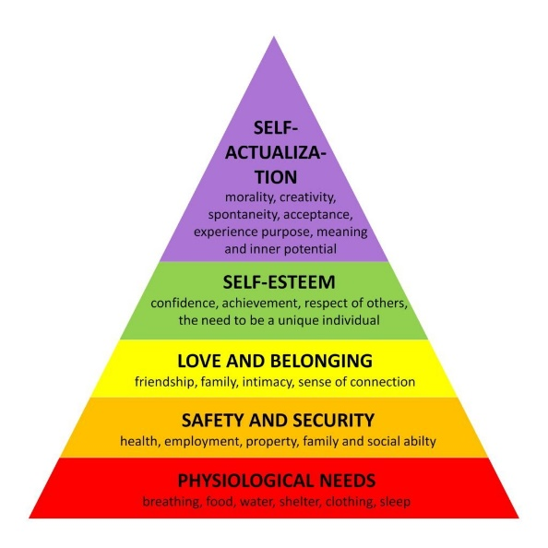
Review: Maslow’s strict hierarchy isn’t always accurate; some staff may prioritise esteem even if basic needs aren’t fully met.

Herzberg’s Two-Factor Theory
Herzberg divides motivation into:
- Motivators: Achievement, responsibility, growth.
- Hygiene factors: Pay, safety, policies.
Example: A technician may feel motivated leading a project (motivator) but dissatisfied if safety procedures are poor (hygiene factor).
Review: Hygiene factors alone won’t motivate, both motivators and hygiene must be addressed.

McGregor’s Theory X and Y
- Theory X: Staff need close supervision; they avoid responsibility.
- Theory Y: Staff are self-motivated, seek responsibility, and contribute ideas.
A hygiene company may use Theory X for safety-critical tasks but benefit from Theory Y to encourage ownership and innovation.

6d. Motivation in the Workplace
The company’s approach aligns mostly with Herzberg’s theory:
- Hygiene factors: Competitive pay, safety policies.
- Motivators: Awards, training, career progression.
Areas for improvement:
- More employee involvement in decisions.
- More day-to-day recognition (not just formal awards).
A combined approach adding Maslow’s self-actualisation and Theory Y’s autonomy could further boost motivation.
Example: A mentoring scheme where experienced engineers guide apprentices support both recognition for mentors and development for mentees.

7. Evaluating Communication Effectiveness
7a. Criteria for Good Communication
Effective communication requires clarity, active listening, and feedback (Hargie, 2016). Reviewing feedback from employees helps identify what works and what needs improvement (CIPD, 2021).
Effective communication in management is not just about transmitting information; it’s about ensuring the message is understood, acted upon, and results in positive outcomes. Based on best practices and workplace requirements, the following criteria were identified as essential for good communication in a national air and water hygiene company:
Criteria | Description
Clarity | Clear and unambiguous language, free from jargon (unless appropriate).
Conciseness | Avoiding unnecessary detail while conveying the full message.
Audience Awareness | Adjusting tone, language, and style for different audiences.
Active Listening | Demonstrating understanding through responses, summarising, and clarifying.
Feedback Integration | Encouraging and incorporating feedback into future communication.
Professionalism | Using appropriate tone, formality, and structure.
Timeliness | Communicating promptly, especially on safety-critical issues.
These criteria form the basis for the survey and self-evaluation.

7b. Communication Survey: Design and Implementation
A survey was developed to gather feedback from 15 employees across the company (technicians, managers, admin staff). The questions focused on the key communication criteria and used a 5-point Likert scale (1 = Strongly Disagree, 5 = Strongly Agree).
Here’s an example of the survey questions:
Communication Effectiveness Survey
1. My manager communicates clearly and avoids technical language.
2. Messages are concise and easy to follow.
3. Communication style is adapted depending on the audience.
4. My manager listens to feedback and acts on it.
5. I feel comfortable raising questions or concerns.
6. Communication is professional and respectful.
7. Communication is timely, especially regarding urgent matters.
8. Written communication is well-structured and easy to read.
9. Verbal communication (e.g., toolbox talks, meetings) is effective.
10. Overall, I am satisfied with the quality of communication in my team.

7c. Survey Results and Analysis
Summary Table of Responses
Question | Average Score (1-5)
1 | 4.2
2 | 4.0
3 | 3.6
4 | 3.8
5 | 4.1
6 | 4.3
7 | 3.9
8 | 4.0
9 | 4.2
10 | 4.1
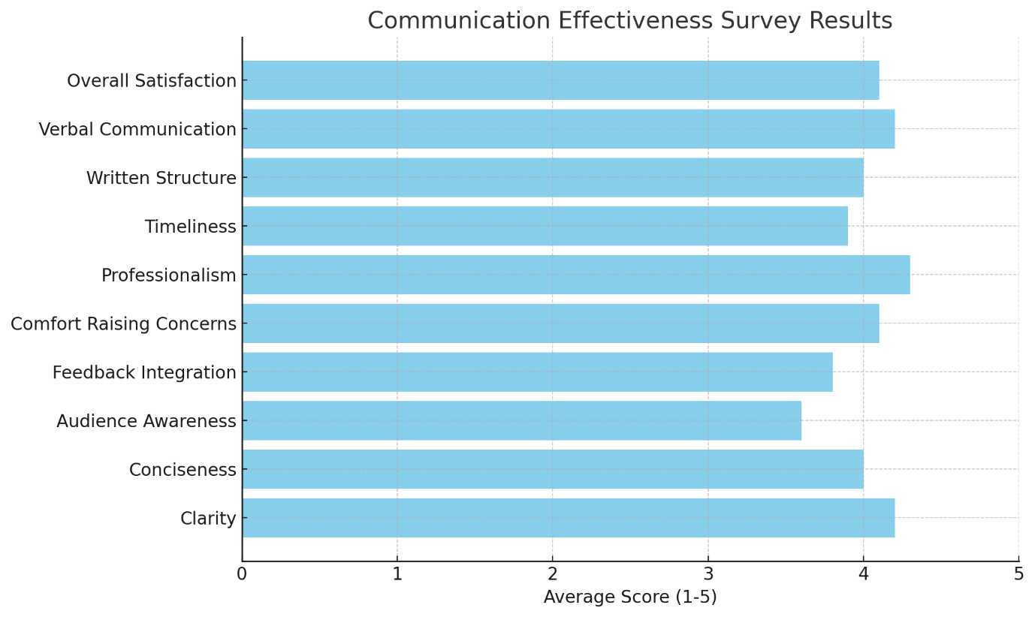

Key Findings and Insights
- Strengths: Clarity (4.2), professionalism (4.3), and verbal communication effectiveness (4.2) were rated highly, indicating that formal communications such as toolbox talks and meetings are generally effective.
- Areas for Improvement:
Audience Awareness (3.6) - Some employees noted that communication could be more tailored, for example by simplifying technical language for non-specialists. Feedback Integration (3.8) - While feedback is welcomed, there is room for improvement in closing the feedback loop and showing how employee suggestions are implemented.
Surprising Findings - Despite confidence in verbal communication, the score for communication timeliness (3.9) suggests delays occur, perhaps due to busy schedules or cascading communication in a multi-site environment.

7d. Personal Development Plan (PDP)
Development Objective | Action Plan | Resources Required | Timescale
Improve language for different audiences | Attend communication workshop, practise simplifying technical terms | Time for training; learning materials | 3 months
Deliver urgent updates more quickly | Use group messaging tools for critical alerts (e.g., WhatsApp/Teams) | Access to tools; create contact lists | 1 month
Follow up on team feedback | Create feedback tracker; provide updates in team meetings | Feedback log (Excel or form); team input | 3 months
Improve structure of written communications | Develop and use standard templates for reports and emails | Time for template design; peer review | 2 months

7e. Self-Reflection: Strengths and Areas for Improvement
Good communication is essential for any manager, especially in a technical and safety-focused industry like air and water hygiene. Based on feedback from the survey, my own observations, and examples from recent work, here are my key strengths and areas for improvement as a manager:
Strengths
- Clear Verbal Communication
I explain complex procedures in a way that team members understand, especially during toolbox talks and meetings. For example, when explaining Legionella risk assessments, I break it down into simple steps.
- Professional and Respectful Tone
Team members feel comfortable asking questions and sharing ideas because I maintain a respectful and approachable tone.
- Good Listening Skills
I listen carefully in meetings, ask clarifying questions, and make sure everyone feels heard.
- Encouraging Participation
I involve the team in discussions and ask for their ideas, which helps improve processes and keeps people engaged.

Areas for Improvement
- Adapting Language for Different Audiences
I sometimes use too much technical language when talking to non-technical staff or clients. For example, I used phrases like "biocide residuals" without explaining what that means, which caused confusion. I need to simplify my language for different audiences.
- Timeliness of Communication
Feedback shows that some urgent updates, like last-minute site changes or safety alerts, could be communicated more quickly.
- Following Up on Feedback
While I ask for feedback, I don’t always let people know how their ideas are being used or why some aren’t actioned. This can leave people feeling unheard.
- Written Communication Structure
Some reports and emails can be long and a bit unclear. I need to use simpler layouts and headings so that important information stands out.
Next Steps
I will focus on:
- Using clearer, simpler language for non-technical audiences.
- Sending urgent updates more quickly (e.g. using group messaging apps).
- Giving better feedback on ideas and suggestions from the team.
- Improving the layout and structure of written communications (using templates).
By working on these areas, I aim to communicate more effectively and support my team to do their best work safely and efficiently.
8. Conclusion
This report has explored the importance of effective communication and motivation within a national air and water hygiene company. By examining communication models, such as Shannon and Weaver’s and Berlo’s, we see how different approaches help identify barriers, adapt messages for audiences, and improve clarity. However, both models highlight the need for better feedback loops and two-way dialogue in practice.
The report also reviewed motivation theories, including Maslow’s Hierarchy of Needs, Herzberg’s Two-Factor Theory, and McGregor’s Theory X and Y. These models show that a balance of fair pay, safety, recognition, and development opportunities is key to maintaining an engaged and productive workforce. In the workplace, practices like safety talks, recognition schemes, and training already support motivation, but improvements like mentoring, clearer communication, and better feedback can make a meaningful difference.
Feedback from team members has shown where communication strengths lie such as clear verbal briefings and active listening and where improvements are needed, like simplifying language and following up on feedback. A personal development plan has been created to address these areas.
In conclusion, effective communication and motivation are central to safety, compliance, and performance in the air and water hygiene sector. By building on existing strengths and addressing gaps, the organisation can create a positive, engaged, and high-performing workforce.

9. Reflection
This report has helped me better understand the importance of clear communication and motivation in the workplace. I’ve realised that while I communicate well in technical situations, I need to adapt my tone, language, and approach for different audiences especially for non-technical staff. Receiving feedback from my team has been valuable, highlighting areas for improvement such as simplifying language, following up on feedback, and improving the structure of written communication.
I also recognise the importance of motivation in supporting a safe and engaged workforce. By applying theories like Herzberg’s Two-Factor Theory and McGregor’s Theory Y, I can help create a more positive environment that encourages growth and collaboration.
Overall, this report has shown me that good communication and motivation are essential for team performance and safety and that I must continue developing these skills to be an effective manager.

10. References
Berlo, D. K. (1960). The Process of Communication: An Introduction to Theory and Practice. Holt, Rinehart, and Winston.
CIPD. (2021). Employee motivation and engagement. Chartered Institute of Personnel and Development.
Goleman, D. (1995). Emotional intelligence: Why it can matter more than IQ. Bantam Books.
Hargie, O. (2016). Skilled interpersonal communication: Research, theory and practice. Routledge.
Herzberg, F. (1959). The motivation to work. Wiley.
Maslow, A. H. (1943). A theory of human motivation. Psychological Review, 50(4), 370–396. https://doi.org/10.1037/h0054346
McGregor, D. (1960). The human side of enterprise. McGraw-Hill.
Robbins, S. P., & Judge, T. A. (2019). Organizational behaviour (18th ed.). Pearson Education.
Shannon, C. E., & Weaver, W. (1949). The mathematical theory of communication. University of Illinois Press.
Wright, P. M., & McMahan, G. C. (1992). Theoretical perspectives for strategic human resource management. Journal of Management, 18(2), 295–320. https://doi.org/10.1177/014920639201800205

