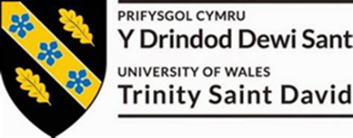

Component 1 Coursework: Written Report

Programme: BA BUSINESS MANAGEMENT
Module name: STRATEGIC MANAGEMENT AND
SUSTAINABILITY
Module code: LCBB6004
Student name: ALEXANDRA LENUTA CREANGA
Student ID: 2113195

Table of Contents
Introduction 3
Background of Unilever 3
Identifying Key Business and Corporate Strategies 3
Analysing Resources and Capabilities 7
Evaluating Strategy in Action 10
Evaluating Sustainability Efforts 11
Conclusion 13
Reference list 14
Appendices 16

Introduction
Since its founding in 1930, Unilever, a well-known British Plc traded on the London Stock Exchange, has made a name for itself as a world leader in consumer products. Unilever prioritizes innovation, sustainability, and market development in its strategic approach, which encompasses a diversified portfolio that includes food and drink, home care, and personal care products. To shed light on Unilever's competitive posture and potential, this research explores the firm's corporate and business strategies, examines how well they are being implemented, and appraises the sustainability initiatives the company has undertaken.

Background of Unilever
A global leader in consumer products, Unilever is a British Plc business that is traded on the London Stock Exchange. Established in 1930 because of the union of Dutch margarine manufacturer Margarine Unie and British soap manufacturer Lever Brothers, Unilever has expanded to become one of the world's biggest multinational corporations.
Unilever showed enhanced economic results in 2023, with the actual operating margin rising to 16.7%, volume growing by 0.2%, and sales growth of 7.0%. Notably, Unilever's 30 Power Brands had an 8.6% increase in sales growth (Unilever, 2024). Unilever serves billions of customers globally through operations in over 190 countries and territories, with headquarters located in Rotterdam, Netherlands, and London, United Kingdom. Food and drink, personal care, and home care items are among the company's wide range of offerings. These are sold under well-known names including Ben & Jerry's, Lipton, Dove, and Knorr. In terms of the industrial competitive landscape, Unilever faces significant changing patterns in the target consumers with the shifting in sustainability and ecological improvement.

Identifying Key Business and Corporate Strategies
Unilever's Key Business and Corporate Strategies
Unilever is widely recognized for its varied range of consumer goods, encompassing food and drink, home care, and personal care items. Unilever uses innovation and product diversity as two of its main business strategies. Its wide range of brands, which each target distinct market categories, including Dove, Lipton, Knorr, and Axe, is proof of this. Unilever operates in the consumer goods market with over 400 brands with its continuous commitment to diversification and innovation in the extensive ranges of products meeting the changing preferences of consumers.
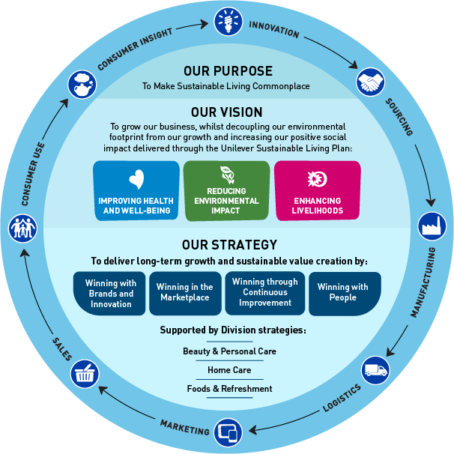
Figure 1: Key business strategy of Unilever
(Source: Unilever, 2024)
Another contextual business strategy of Unilever includes sustainability and CSR practices. Unilever intends all its goods to have net-zero emissions by 2039 (Mazikana, 2023). The firm is dedicated to making its brands have a good social impact. Reduced plastic waste is a goal Unilever actively pursues. By 2025, it promises to have all its plastic packaging entirely recyclable, biodegradable, or reused. The Unilever Sustainable Living Plan is one of the company's initiatives that demonstrates its commitment to reducing its environmental effects.
Porter's Generic Strategies and Unilever's Market Positioning
Porter’s generic strategic framework outlines the three main strategies as regards getting a competitive advantage which include cost leadership, differentiation, and focus. Considering the framework, Unilever mainly stresses the differentiation and sustainability approaches. Diverse aspects of Unilever's business processes demonstrate the company's strategic focus on distinction (Iglesias and Ind, 2020). A crucial element is the focus on product attributes and excellence, as demonstrated by companies such as Dove. Goods such as Dove Cream Bars set themselves apart from traditional, abrasive soaps with their moisturizing, mild qualities. Furthermore, Unilever uses its brand image to highlight social impact and sustainability, as seen by initiatives like Dove's "Real Beauty" campaign. Unilever distinguishes Dove from rivals by endorsing body acceptance and self-worth, securing its place as a frontrunner in unique products that connect with customers more deeply. The strategic acquisition of Dollar Shave Club by Unilever in 2016 was a step towards strengthening the company's differentiation strategy in the male grooming market. Dollar Shave Club is a leader in the direct-to-consumer market because of its creative strategy of providing premium grooming goods at reasonable costs to its 3.2 million members.
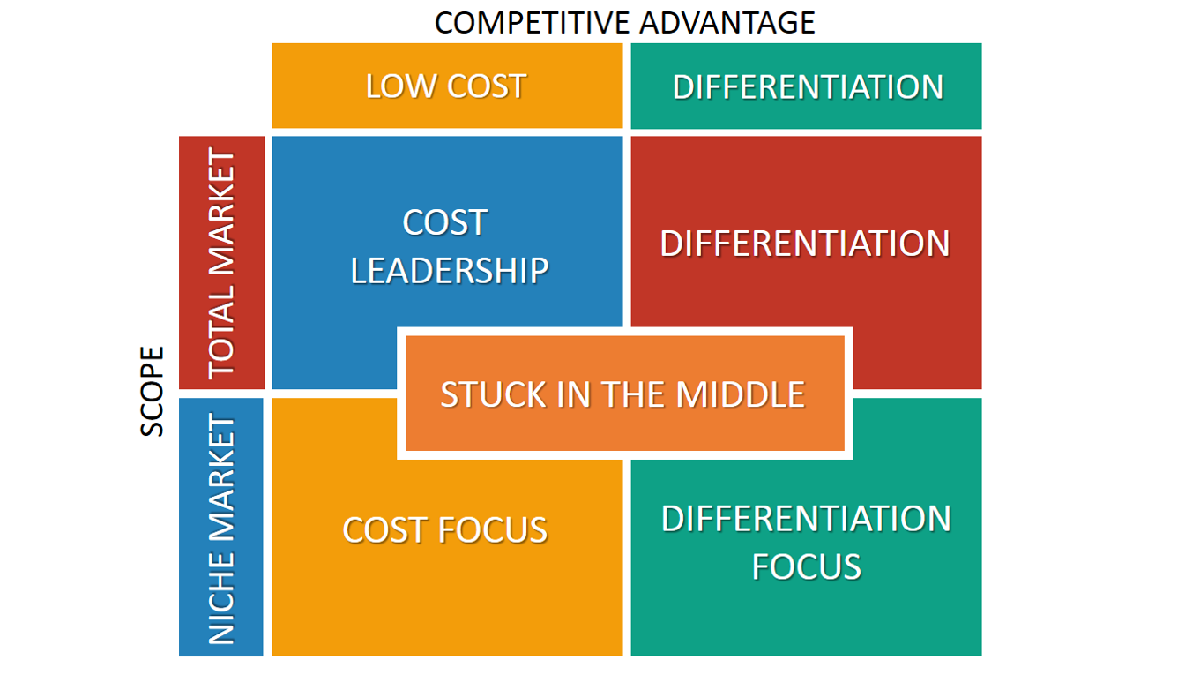
Figure 2: Porter’s generic strategy framework
(Source: Medium, 2024)
Ansoff Matrix and Unilever's Strategy Direction
The Ansoff Matrix provides the strategic framework as regards the identification of the growth strategies on the pursuing market expansion reaching the targeted consumers.
Market penetration
Unilever strategically focused on increasing sales of existing products with aggressive and effective marketing approaches. In 2023, Unilever's market penetration increased significantly due to strong underlying sales growth in several critical areas. Sales increased by 7.0% overall, with a modest 0.2% increase in volume and a noteworthy 60 basis point increase in the underlying operating margin to 16.7%. Key industries showed remarkable performance, with notable growth rates of 8.3%, 8.9%, 7.7%, and 5.9% for Beauty & Well-Being, Personal Care, Nutrition, and Home Care, respectively [Referred to Appendix 2].

Product development
The three pillars of Unilever's innovation approach are science, technology, and customer insights. The firm, which employs over 5,000 people globally and has eight global R&D centers, focuses on topics such as plant-based diets, functional nutrition, cleanliness, skincare, and luxury cosmetics. Breakthroughs like performance-boosting enzymes for home care products that reduce ingredients and plastic waste are the result of collaborations with partners like Arzeda. Innovations that highlight less plastic use and water saving, such as the Dilute at Home Refill, demonstrate Unilever's dedication to sustainability.
Market development
The corporation places a strong emphasis on its brands, with over €1 billion in revenue coming from these brands and being bolstered by sustainability initiatives. Despite difficulties in China because of COVID-19, there is clear evidence of accelerated development in strategic markets including the US and India (Czinkota et al. 2021). With a 23% growth in digital commerce and investments in eCommerce hubs and digital marketing to ensure seamless customer experiences, Unilever is leading the way in future channels.
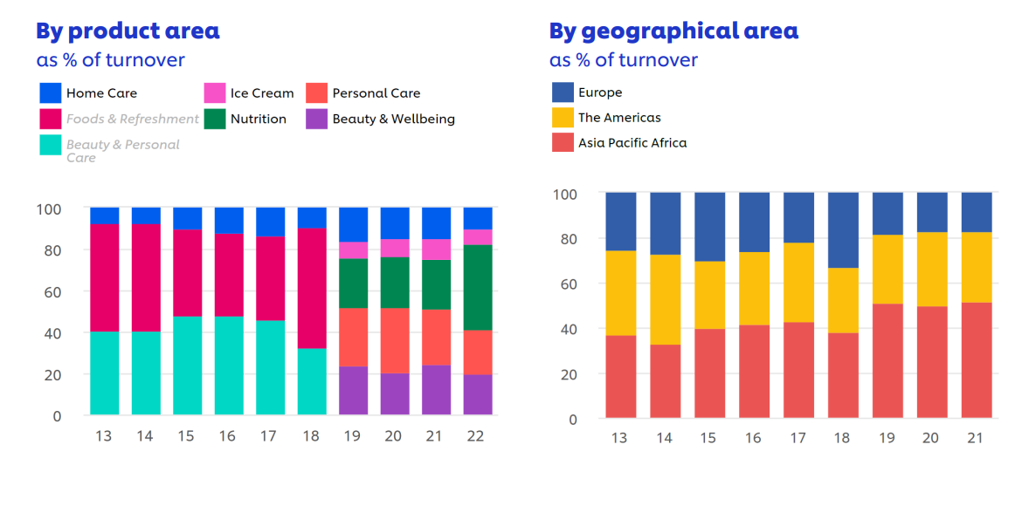
Figure 3: Operative profit of Unilever by product and area
(Source: Unilever, 2024)
Diversification
Unilever has strengthened its position in the organic and herbal tea markets through strategic acquisitions such as Pukka Herbs and Tazo Tea. Pukka's focus on ingredients supplied ethically and organically is in line with Unilever's sustainability objectives. Tazo Teas's wide selection appeals to health-conscious consumers, which goes well with Unilever's wellness-focused approach. These purchases strengthen Unilever's commitment to sustainable living while allowing for market expansion.
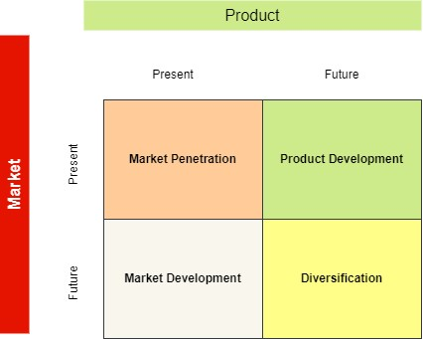

Figure 4: Ansoff Matrix analysis
(source: Self-created)

Analysing Resources and Capabilities
A strong portfolio of brands, like Dove and Lipton, is what drives Unilever's success and accounts for a sizable portion of its income. Robust production and distribution networks guarantee effective product delivery around the globe. Robust R&D capacities provide ongoing innovation, satisfying customer needs (binti Tsuraya et al. 2023). A sustainable culture combined with a staff that is engaged and varied fosters creativity. Effective marketing, as demonstrated by commercials such as Dove's "Real Beauty," improves sales and brand reputation. In general, Unilever's resources and competencies support its presence in international markets and steady expansion [Referred to Appendix 1].
Value chain and value system analysis
Primary Activities
Inbound Logistics: Unilever oversees a huge worldwide supplier network and spends a total of €43.2 billion in several categories. The organisation prioritizes adaptability and durability, maximizing the cost and asset base, and guaranteeing favorable effects on both people and the environment.
Operations: By using data and technology from the fourth industrial revolution, Unilever improves its operational efficiency through digital transformation efforts (Prado Perez, 2020). It gives partnerships and talent that are future-ready a priority to maintain a competitive edge.
Outbound Logistics: The seamless delivery of goods to consumers is guaranteed by Unilever's logistics and operations providers, who also uphold the company's dedication to providing excellent customer service and value.
Marketing and Sales: Through its Partner with Purpose (UPWP) program, Unilever engages in purpose-driven relationships with suppliers, promoting sustainability and driving innovations in the industry.
Support Activities
Procurement: Unilever works closely with its network of 54,000 suppliers to promote technological innovation, service resilience, and sustainability (Lanzolla and Markides, 2021). Unilever wants to raise industry standards and prioritize suppliers that share its commitment to sustainability, accountability, and respect through its Partner with Purpose program.
Technology Development: Across its whole business, Unilever places a high priority on innovation and technology, planning to invest €949 million in R&D by 2023. With more than 20,000 patents and 5,000 professionals worldwide, Unilever leads the way in innovation and environmentally friendly solutions. Their multidisciplinary experts use digital technology to get insights and accelerate product development to generate innovation for people and the environment. By embracing artificial intelligence (AI) and next-generation biology, Unilever works towards a Clean Future by utilizing sustainable methods and renewable resources. To implement AI throughout the company, Unilever opened its first AI Horizon3 Lab in Canada.
Human Resource Management: The goal of Unilever's human resource management is to adjust to the changing nature of the workforce, workplace, and work environment through initiatives. By 2030, they hope to reskill workers by 2025, provide flexible work opportunities, and provide 10 million young people with basic skills (Makina and Oundo, 2020). 'U-employment' and other flexible employment models, collaborations with UNICEF's Generation Unlimited, and technological training initiatives are among the initiatives. Unilever prioritizes the enhancement of skills, flexibility, and mobility to meet the demands of work environments of the decades to come.
Infrastructure: Unilever restructures its asset and cost base with an emphasis on resilience and agility to maintain competitiveness throughout its international operations.
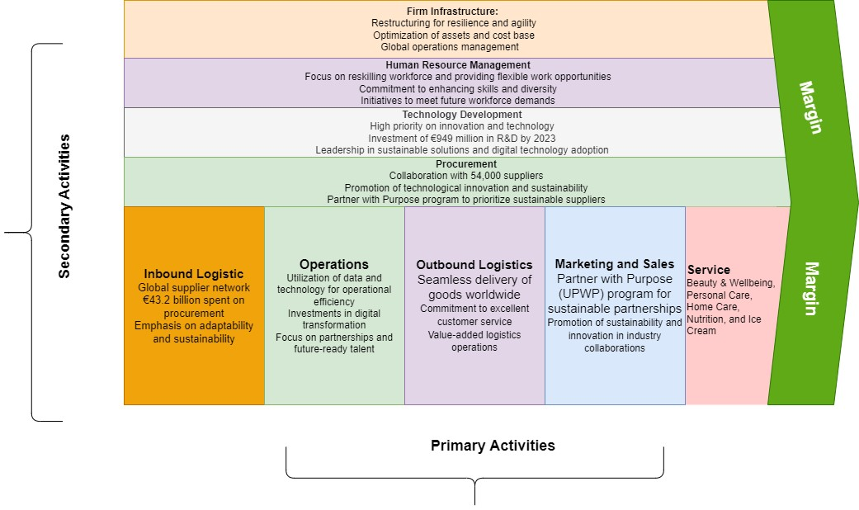

Figure 5: Value chain analysis of Unilever
(Source: Self-created)

VRIO analysis
Core Competencies | Valuable | Rare | Imitable | Organised | Implications
Strong Brand Portfolio | Yes | Yes | Partial | Yes | Provides Unilever with brand equity and consumer loyalty.
Extensive Distribution Network | Yes | Yes | Partial | Yes | Enables Unilever to reach a wide range of customers globally efficiently.
Commitment to Sustainability | Yes | Yes | Partial | Yes | Enhances Unilever's reputation and attracts socially-conscious consumers.
Organisational Culture | Yes | Yes | Partial | Yes | Fosters innovation, diversity, and employee engagement, contributing to Unilever's success.
Table 1: VRIO analysis of Unilever
(Source: Self-created)
Unilever's VRIO investigation identifies several significant advantages. Its robust portfolio of well-known brands, which includes Lipton and Dove, is valued and uncommon in the consumer goods sector and greatly boosts sales and market share. Because it takes a significant amount of money and experience to replicate, Unilever's wide distribution network is a valuable asset. The company's operations and corporate culture are infused with a dedication to sustainability that improves customer loyalty and brand reputation. Unilever has a competitive edge thanks to its organisational culture and human capital, which are centered on innovation and diversity and encourage employee engagement and performance.

Evaluating Strategy in Action
Unilever has strategically demonstrated its effective business and corporate strategies. One of the key strategies is innovation driving growth with the continuous development of products based on the chain requirements and preferences of target consumers (Hinterhuber et al. 2021). Further Unilever has successfully leveraged its differentiated product brand portfolio with the expansion in the potential emerging markets through its acquisition strategies.
In aligning with its differentiation strategy, Unilever efficiently aligns with its objectives and operational capabilities. Applying the SAF framework provides a more structured analysis and evaluation of the effectiveness of Unilever’s strategies.
Suitability: Unilever operates in the food, home care, and personal care sectors, their broad diversification approach makes sense given its wide range of product categories. Reducing risk by providing a variety of consumers with diverse experiences is what brands like Dove, Lipton, and Knorr do (Hinson et al. 2020). With 190 countries worldwide and a key skill in innovation, Unilever adjusts its products to various cultural settings to meet the needs of shifting customer tastes.
Acceptability: Unilever's approach to engaging stakeholders highlights its dedication to openness and ethical corporate conduct. Unilever guarantees alignment with its mission of sustainable living through a multi-stakeholder strategy that involves workers, consumers, shareholders, governments, non-governmental organisations, and peer firms. Elevated levels of involvement, worldwide market reach, and collaborations demonstrate its commitment to cultivating confidence and cooperation for sustainable growth.
Feasibility: The corporation can successfully implement its goals because of its investments in sales, distribution, and advancement of knowledge (Iglesias et al. 2023). Unilever's dedication to growth driven by innovation is demonstrated by significant expenditures in research and development (R&D), which are expected to reach €949 million by 2023. This financing supports innovative ideas and long-term fixes.

Evaluating Sustainability Efforts
Unilever has been at the forefront of sustainability efforts in the consumer goods market with its strategic commitment to responsible and social impact in its corporate strategy. Unilever makes a point of highlighting its environmental initiatives in both its corporate communications and yearly reports (Hosen, 2021). Launched in 2010, the company's Sustainable Living Plan sets high standards to boost livelihoods throughout its value chain, lessen environmental impact, and promote health and well-being. benefit. According to the 2024 annual report, for instance, greenhouse gas emissions increased by 1%, with Scope 3 emissions accounting for almost 98.8%.
Despite the hardships this presents, Unilever's commitment to cutting outflows is shown by various endeavors, including provider decarbonization plans and eco-plan programs. Sales of plant-based products and monetary help for minimized networks are substantial signs of Unilever's social manageability drives. Iglesias et al. (2023) express that Unilever has put forth an essential objective to achieve €1.5 billion in deals of plant-based products by 2050, exhibiting its obligation to ecological maintainability and general well-being. Moreover, Unilever expects to give €2 billion yearly to providers that have a place with underestimated networks by 2025, showing a pledge to social incorporation and prosperity. Sales of plant-based merchandise and monetary help for minimized networks are substantial signs of Unilever's social supportability drives. Iglesias et al. (2023) express that Unilever has put forth an essential objective to achieve €1.5 billion in deals with plant-based products by 2050, exhibiting its obligation to ecological supportability and general well-being. Even Unilever plans to give €2 billion every year to providers that have a place with minimized networks by 2025, showing a guarantee of social incorporation and flourishing.

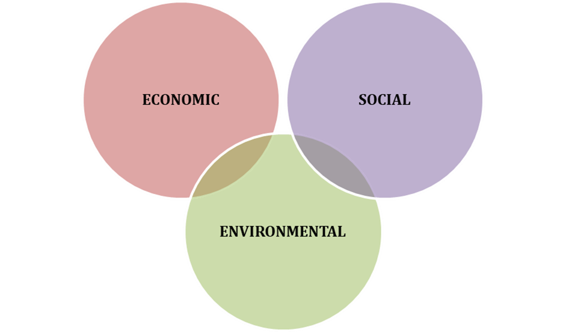
Figure 6: Three pillars of sustainability
(Source: Self-created)

Economic sustainability
The targets of Unilever's economic sustainability are firmly connected with its business methodology, which plans to boost natural impact while advancing productive development. Unilever displays its essential spotlight on finding some kind of harmony between financial success and ecological and social obligation by moving forward with interest in manageable items and genuinely promising to give decent pay to all suppliers by 2030.
Social sustainability
Unilever's business methodology of advancing comprehensive turn of events and cultural health is inseparably connected to its social maintainability targets (Mazikana, 2023). Unilever's devotion to social obligation and variety is found in drives like putting resources into underrepresented gatherings, joining forces with associations like UNICEF and Oxfam, and contacting one billion individuals yearly through sustenance and cleanliness programs
Environmental sustainability
Unilever's corporate strategy and its obligation to environmental sustainability are firmly adjusted. Unilever shows its obligation to address environmental change by laying out objectives to arrive at net-zero emanations by 2039 and lessen ozone-depleting substance discharges by 2030. The organisation's work on cutting plastic utilization and restoring normal cultivating is one more way that it exhibits its obligation to natural stewardship.

Conclusion
Unilever is dedicated to innovation, sustainability, and stakeholder involvement, as seen by its strategic methods of leadership. This paper describes Unilever's advantages in competing and developing market trends through a thorough review of its core strategy, distribution of resources, and sustainability activities. Unilever's strategy focus on distinctiveness, sustainability, and market growth prepares it for continuing success and leadership in the consumer products business as it navigates changing consumer demands and international difficulties.

Reference list
binti Tsuraya, H., Endayani, L., Zahda, F.M., Utami, I.S. and Jayadi, U., (2023). Unilever Company Work Model. International Journal of Economics, Management and Accounting (IJEMA), 1(1), pp.7-14.
Czinkota, M.R., Kotabe, M., Vrontis, D., Shams, S.R., Czinkota, M.R., Kotabe, M., Vrontis, D. and Shams, S.R., (2021). Product and service decisions. Marketing Management: Past, Present and Future, pp.341-397.
Hinson, R.E., Adeola, O., Amankwah-Amoah, J. and Adomako, S., (2020). Multinational enterprises' subsidiary initiative-taking: a model for implementing corporate social responsibility. International Journal of Multinational Corporation Strategy, 3(2), pp.153-170.
Hinterhuber, A., Vescovi, T. and Checchinato, F., (2021). Digital transformation: an overview. Managing Digital Transformation, pp.3-10.
Hosen, M.S., (2021). The Managemental Effects of Cultural Differences in Marketing Strategies.
Iglesias, O. and Ind, N., (2020). Towards a theory of conscientious corporate brand co-creation: The next key challenge in brand management. Journal of Brand Management, 27(6), pp.710-720.
Iglesias, O., Mingione, M., Ind, N. and Markovic, S., (2023). How to build a conscientious corporate brand together with business partners: A case study of Unilever. Industrial Marketing Management, 109, pp.1-13.
Lanzolla, G. and Markides, C., (2021). A business model view of strategy. Journal of Management Studies, 58(2), pp.540-553.
Makina, I. and Oundo, J.N., (2020). Effect of competitive strategies on organisation performance in relation to sugar industry in Kenya. Universal Journal of Management, 8(5), pp.220-230.
Mazikana, A.T., (2023). Significance of Social Factors in the Marketing of Fast-Moving Consumer Goods. A Case of Unilever. A Case of Unilever (March 7, 2023).
Medium, (2024). An overview of Porter’s generic competitive strategies. Medium.
Available at: https://medium.com/@kolbeuk/an-overview-of-porters-generic-competitive-strategies-453342d1a6ae [Available at: 27.03.2024]
Prado Perez, S., (2020). Sustainability Discourse in the Fast-Moving Consumer Goods Sector–A comparison between Procter & Gamble and Unilever.
Unilever, (2024) CSR issue of Unilever [online] Available at: https://www.unilever.co.uk/planet-and-society/ [Accessed on 27.03.2024]

Appendices
Appendix 1: SWOT analysis of Unilever

Aspect | Strengths | Weaknesses
Internal Factors | Global reach in 190 countries  Strong financial performance and strategy  Strong and popular brand portfolio  R&D focus and integrated supply chain  Strong advertising and marketing capabilities | Financial position: Unilever invests significantly in R&D, which can be costly.  Risk of high costs: Differentiation strategies often involve higher costs.  Market share challenges: Intense competition in consumer goods markets  Balancing costs: Ensuring consumer willingness to pay for differentiated products
External Factors | Opportunities: Growing demand for sustainable and healthier products  Expansion into emerging markets  Strategic acquisitions (e.g., Dollar Shave Club, Graze) | Threats: Increasing competition from rivals like Procter & Gamble, Nestlé, and Coca-Cola  Market share defense: Continuous monitoring and adaptation required

Appendix 2: PESTEL analysis of Unilever

Aspect | Factors
Political | Trade regulations and tariffs: Unilever operates in over 190 countries, so changes in trade policies (e.g., tariffs or trade barriers) can impact its supply chain and distribution strategies.
 | Government policies and regulations: Political stability and other political forces affecting the business environment.
Economic | Economic conditions and trends: Impact on Unilever’s operations, profitability, and growth.
Sociocultural | Social and cultural aspects: Influence consumer preferences, lifestyles, demographics, and market trends.
Technological | Developing and applying new technologies: Innovations and trends that impact the industry or organisation.
Environmental | Ecological and environmental concerns: Affecting Unilever’s operations and decision-making.
Legal | Laws and regulations: Governing businesses and industries.

