The Current Environmental Forces and Their Impact on the Morgan Stanley Company



December 2022

MODULE NAME: Strategic Management(BMMB7013)
STUDENT NAME: Zefeng Zhang
STUDENT NUMBER: 2217959

Outline

Abstract 3
1. Introduction 4
2. General Business Condition 4
2.1 The current condition of Morgan Stanley 4
2.2 Macro Market Environment 8
3. PESTEL Analysis 9
3.1 Political factors 9
3.2 Economic factors 11
3.3 Social factors 12
3.4 Technological factors 14
3.5 Legal factors 15
3.6 Environmental factors 19
4. Conclusion and Recommendations 19
Reference 22

Abstract
Morgan Stanley is a world famous investment bank, which plays an important role in the world economy. With the prevalence of COVID-19 and changes in the world situation, Morgan Stanley's economic index performance this year is not optimistic. This paper makes a simple analysis on the financial data of Morgan Stanley, and through the analysis of international and American economic policies, through the analysis of PESTEL model, this paper shows the readers the current domestic and foreign investment environment faced by the company. On this basis, the future development trend and strategy of the company are given.

- Introduction
Morgan Stanley is an international financial services company established in New York, USA. She provides a variety of financial services including securities, asset management, business merger Morgan Stanley was originally the investment department of JPMorgan Chase. The United States experienced the Great Depression in 1933, when Congress prohibited the company from providing commercial banking and investment banking services at the same time,
Morgan Stanley was established as an investment bank in New York on September 5, 1935. In 1941, Morgan Stanley cooperated with the New York Stock Exchange and became its partner. The company expanded rapidly in the 1970s, with its employees growing rapidly from more than 250 to more than 1700, and began to develop business worldwide. In 1986, Morgan Stanley was listed on the New York Stock Exchange. From 1990 to 2000, Morgan Stanley expanded rapidly. It has gradually developed into a comprehensive financial service company, providing one-stop diversified financial products and reorganization, credit card, etc.
- General Business Condition

2.1 The current condition of Morgan Stanley
According to the financial report released by Morgan Stanley, the company's investment banking department's revenue in the third quarter was 1.28 billion US dollars, down 55% year on year. Trading business revenue increased slightly, with fixed income business revenue soaring by 33%. Net interest income from wealth management increased to $2 billion.
When we open the financial statements, of course, the most important thing is the yield. Although net income is the most widely used parameter to measure the profitability and value of a company, it is the most unreliable. The reason is that the reported earnings can be easily manipulated by adjusting any number such as depreciation, depletion, non motorization and non recurring items. This is a common understanding among practitioners. However, MS still failed to provide a better set of data. From the first quarter of 2022 to now, MS's net interest rate has fallen steadily, down 13.6 percent compared with the same period last year.
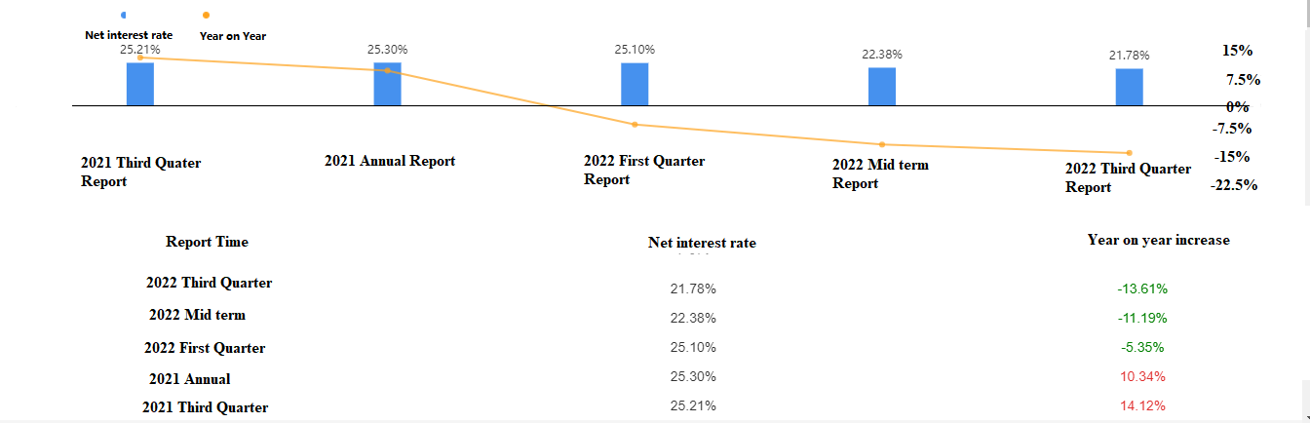

Through the analysis of the above figure, people may compare the data of 2020 with that of this year. After all, the data of the company in 2020 is worse than that of this year. But please do not forget that in February 2020, Morgan Stanley acquired E * TRADE, an online broker, with a transaction value of about $13 billion, which is equivalent to a share price premium of more than 30% to E * Trade. The purpose of the acquisition of this company is certainly to develop customer retail business and digital services. It is also to increase the scale and breadth of the company's wealth management franchise and become a pioneer in the wealth management industry in all channels and wealth fields. This is the largest M&A transaction on Wall Street since the financial crisis broke out in 2008. In October 2020, Morgan Stanley announced that it had signed a final agreement with Eaton Vance, and Morgan Stanley would acquire Eaton Vance in the form of 7 billion dollars in cash and shares.These two acquisitions reduced the market value of Morgan Stanley, while the market value of the acquired companies increased. That is to say, despite the pandemic in 2020, the year 2020 is a year of Morgan Stanley's capital output and full of confidence. Although the data are not so good looking, investors and brokers are full of expectations for the future, which are also reflected in the data of 2021. Therefore, 2020 is just a low point caused by both preparedness and emergencies, but 2022 is no longer so simple.The following table shows MS's net profit from 2019 to 2021.
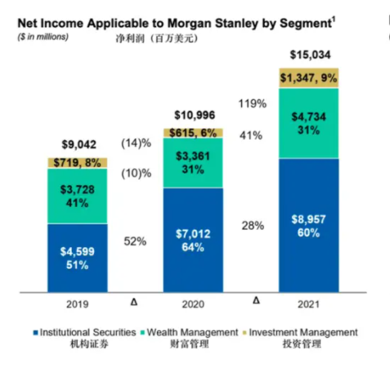
Many people like to see the net profit growth rate of enterprises, but in fact, the operating cash flow growth rate of enterprises is more real and reliable. Because net profit is sometimes false, and this operating cash flow can be used as a very good indicator to measure the gold content of net profit From the chart, we can see that the profit cash ratio once appeared negative and close to zero in 2020 and 2022, indicating that the company's ability to cash in assets is very unstable, which is related to the particularity of the industry where MS is located. However, this cannot be used as an excuse for the lack of liquidity of enterprise funds and poor profit quality. Although it can be judged that the company has been in a profitable state when analyzing the profitability indicators, it can be seen from the perspective of cashability that the company's ability to generate cash is not strong when analyzing the profitability quality. The rate of payment recovery is not stable. As we all know, cash flow is extremely important for enterprises. The large cash flow shows that the enterprise has a long capital turnover cycle, strong short-term and long-term repayment ability, and strong economic strength.
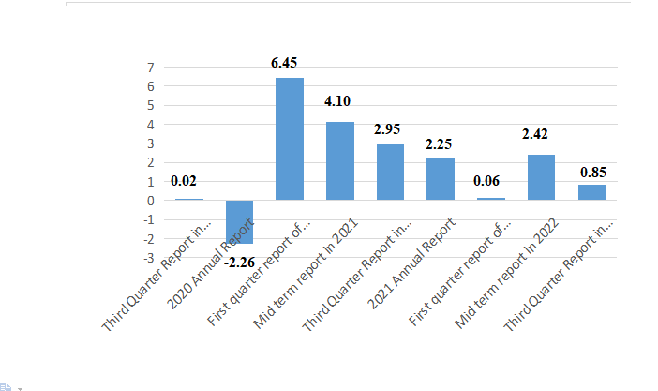
As for stock returns, Morgan Stanley's share price has dropped 19% this year. In addition, Morgan Stanley's stock underwriting revenue fell 78% to $218 million, and its bond underwriting revenue fell 35% to $366 million. At present, the number of shares of the Company has reached more than 175 million. 21.6% of the shares belong to Mitsubishi UFJ Financial Group. Net assets per share and net income per share decreased slowly from the first quarter of this year. However, the property right ratio shows an increasing trend.

2.2 Macro Market Environment
If you look at the market situation of the entire investment banking business, although the revenue of MS's investment management department and wealth management business unit also declined, the operating revenue of the trading business remained stable, of which the revenue of the fixed income business in the first half of 2022 surged by 49% year-on-year to $2.5 billion, and the revenue of securities trading was $2.96 billion better than the same period last year. MS's investment banking business revenue ranked the fourth in the world, after JPMorgan Chase, Goldman Sachs and Bank of America. That is, all banks are in the same position. Therefore, I don't think the crisis in 2022 can be solved by technical operation alone. At present, MS is doing the right thing, not only completing the US $2.7 billion stock repurchase in the first half of the year, but also planning a new US $20 billion repurchase plan. This large-scale repurchase sends a signal to the public that the value of MS is seriously undervalued, and will play an important role in stabilizing and even increasing the company's share price.
- PESTEL Analysis

3.1 Political factors
The United States has implemented a decade long monetary easing policy, resulting in an abnormal zero interest rate environment around the world. In terms of economic environment, there has been an economic shutdown caused by the COVID-19 epidemic. In terms of political factors, geopolitical risks are causing a huge impact on the global supply chain. These phenomena have not occurred in the past 70 years.
At present, from the perspective of the world pattern, there are worrying risks everywhere. And with the risk comes the worldwide inflation. Economists believe that the level of inflation this time is unprecedented in 40 years. As an investment bank, it can only keep an eye on the trend of the political situation in the United States and the world, understand the GDP and unemployment rates of various countries, and pay more attention to the trend of world energy prices The investment prospect is always full of uncertainty, which is more complicated in the current situation of intensified geopolitical crisis.When faced with such an environment, it is often beneficial for investment to list the main factors that affect asset prices, analyze which are determined and which are still difficult to determine, and thus price assets. If these problems can be handled properly, Morgan Stanley will be able to move forward smoothly.
In terms of the political environment, investors will have more diversified views on the economy, policies, profits and valuation in the coming year. As an investment bank, I am afraid that it needs more flexible management strategies than other enterprises.Morgan Stanley divided the forecast of US stocks for next year into bull market, benchmark market and bear market. It is estimated that the S&P 500 index will be 4200, 3900 and 3500 by the end of next year respectively. In addition, Morgan Stanley recommends investors to maintain investment stability from the perspective of industry and style. It is expected that the company will increase its holdings in necessities, healthcare, utilities and defensive energy enterprises.
When inflation spreads around the world, there is also an obvious economic recession in this cycle. Economists expect the Federal Reserve to suspend interest rate hikes. However, this is not the case. The Federal Reserve did not suspend raising interest rates. All economic indicators tell people that the economy has begun to decline. No one can save the economic cycle or the downward trend of the stock market. However, even in the case of weak income, the employment market remains strong for a longer time. More importantly, this situation may last until next year, providing more time for the Federal Reserve to raise interest rates. This is why we believe that the current market has seen a small growth.Optimists believe that this small increase can continue for some time. Because there will be no worse data in the next few months, if the CPI in October can remain stable, the Federal Reserve will probably not continue to study how to further increase interest rates. But this is at least Morgan Stanley's optimistic prediction. After all, the crisis of restricting Russia and Ukraine has not been resolved. The Russian Ukrainian crisis, like most geopolitical issues, belongs to an unknown category. Although many people have quite a lot of knowledge about such things, geopolitics is difficult to analyze, so it is difficult to price. People only know that such a crisis will increase the long-term risks associated with it. In an environment of rising valuation and rising profit risk, when the Federal Reserve begins to tighten monetary policy and the profit situation deteriorates, even if there is a tactical rebound in the stock market, it is very likely that the growth momentum will be lost in the short term.
It should be noted that the "suspension of interest rate increase" and "interest rate reduction" are different: although some investors may think that interest rate reduction is even better than the suspension of interest rate, the evidence does not prove this. When interest rate cuts and economic recession occur at the same time, it is unfavorable for stocks. Therefore, although the market dreams of raising interest rates and pausing, so that the stock market has the opportunity to keep rebounding before the end of the year, when the rate cut really comes, it indicates that the recession has begun.

3.2 Economic factors
In last year's stock market outlook, Morgan Stanley's Wilson put forward the concept of "fire and ice", which respectively represented overheating inflation and economic recession. Over time, the United States is shifting from inflation to recession. With the tide of economic recession surpassing inflation, people no longer believe that enterprises will make large profits and are no longer willing to invest in the stock market. People in good economic conditions will put their money into a more stable bond market. Such differences will bring new opportunities, and will also make investment banks perplex the future path. Opportunities often arise from contradictions.Economic recession will lead the country to rescue the market. The best way to rescue the market is to suspend interest rate hikes or even cut interest rates. This is the expectation of people after the typical cycle between the Federal Reserve raising interest rates and economic recession. Historically, this period is a period of stock profits and an opportunity for investors.
However, both enterprises and investors should pay attention that this is a tactic, not a strategy. Although in the short term, the market will be favorable in the future, but this is the technical prediction of those engaged in investment activities for many years, rather than the prediction of the overall economic environment. Our economic environment is still showing a downward trend.
With the recovery of commodity prices and the growth of export manufacturing in emerging countries, emerging markets are undergoing economic reform. At the same time, the wave of digital revolution rapidly swept over emerging markets and promoted development.These are the main reasons why investors have refocused on emerging markets.

3.3 Social factors
When we look at the whole social environment, we will find that the global population is decreasing and aging, the global economy is developing towards the direction of islanding, many countries have an anti globalization attitude, the global productivity is also declining, and what is more terrible is that global governments are generally experiencing soaring debt.
With the rise of inflation expectations, the trend of investors buying houses to fight inflation is obvious. Last year, property prices in almost all developed countries rose rather than fell. There is reason to believe that the rising trend of property prices will continue. In particular, affected by the epidemic blockade measures and the low interest rate environment in developed countries in Europe, many families have a demand for house replacement, and the shortage of houses may continue to push up the property price. This situation has also occurred in the United States, where interest rates are soaring. However, many people struggling on the poverty line are unable to pay the high house price and rent.
In terms of currency selection, when the consumer price index rebounds, if central banks tighten monetary policies, the world will experience psychological fears similar to that of the 2013 Fed. As a result of the large-scale economic stimulus measures of the United States in the past few years, countries around the world began to lose confidence in the ability to pay in dollars. The emergence of Bitcoin may shake the dominant position of the US dollar as a global currency, because it can not only serve as a value saving function of traditional currencies, but also serve as a transaction medium. Millennials are the major holders of cryptocurrencies, and they may even be able to decide on a currency to replace the US dollar in the future. If so, it will be a big era.
What is exciting is that 16 countries from emerging markets, including China, South Korea and Indonesia, are promoting digital reform and further promoting productivity.The reason is very simple. In the absence of physical infrastructure, consumers are difficult to access physical banks, retail stores and other service channels. Consumers in these markets are more likely to embrace digital services. The income from digitization has grown to double digits annually, much higher than that of developed countries. The rapid development of this new industry has greatly changed people's lifestyle and consumption habits. In addition to the development of the COVID-19, many people's life, work and entertainment activities have turned to the Internet, from offline to online new media tools for shopping and entertainment. Even if the epidemic is over, people have become accustomed to all kinds of new media and become the new normal, which will last for a long time.

3.4 Technological factors
Nevertheless, Morgan Stanley is still the leader of many stock funds. It all depends on the company's many best investment teams. They classify themselves as investors in the company rather than stock selection experts, and conduct transactions in a very prudent manner. The investment portfolio of each fund of the Company is relatively compact, and only the best investment opportunities in the market are selected, rather than following a certain index to build a portfolio. Take Morgan Stanley Institutional Growth Fund as an example. It holds fewer index components, such as Apple, Microsoft, Google and Tesla. On the contrary, it has its own unique stock selection strategy. The effective stock selection strategy makes the fund's return 115% in 2020, almost three times that of the index. However, investors also need to pay attention to risks. The fund as a whole tends to trend and fluctuate stocks, and pays less attention to value and financially stable companies. In other words, many of Morgan Stanley's funds have not taken the usual route. Another important point is that most of MS's investment teams hold the long-term investment concept. The following is the yield data of Morgan Stanley Institutional Growth Fund over the past decade. MS is still a reliable investment expert.
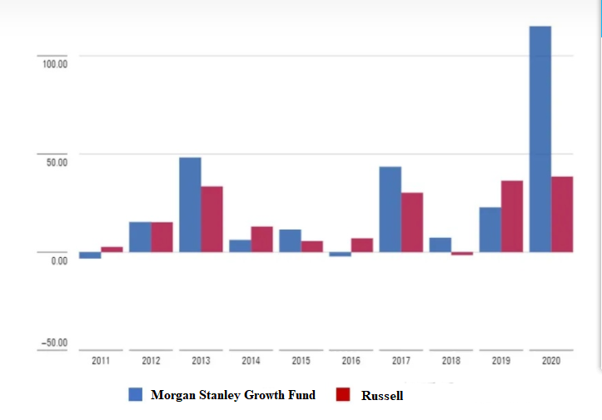

3.5 Legal factors
Recently, Morgan Stanley's Smith Barney LLC. was fined 35 million US dollars for failing to protect personal financial information. Morgan Stanley's Smith Barney LLC. is an international financial services company established in New York, USA, which provides financial services including securities, asset management, business merger and reorganization, credit card, etc. The U.S. Securities and Exchange Commission found that the company failed to properly protect the personal identity information of about 15 million financial customers, violating the protection and disposal rules under Regulation S-P: Privacy of Consumer Financial Information and Protection of Personal Information. According to the investigation of the Securities and Exchange Commission of the United States, since at least 2015, Morgan Stanley's Smith Barney LLC has failed to strictly comply with the laws and regulations, and has not established efficient and orderly internal procedures to properly handle the equipment that stores customers' personal identity information.
According to the investigation results of the Securities and Exchange Commission of the United States, on the one hand, the reason for this situation is that American Bond was negligent. When it eliminated the hard disks and servers storing millions of customer data, the moving and warehousing companies it hired had no data destruction related resources, no professional knowledge and no service experience. Morgan Stanley's Smith Barney LLC itself did not timely and prudently supervise the data destruction of the company. The investigation found that the moving company sold tens of thousands of electronic equipment of American Bond to a third party, including a large number of servers and hard disks of unencrypted and undeleted customer data. These devices were finally transferred to the Internet auction platform and resold as second-hand goods, resulting in serious personal information leakage. On the other hand, when managing servers in offices and branches, Morgan Stanley's Smith Barney LLC failed to strictly protect customers' personal information and credit report. According to the verification of investigation records, at least 42 servers storing unencrypted customer information and credit investigation reports were lost. The investigation also found that although the servers being decommissioned have been equipped with encryption functions, the corresponding encryption software has not been activated.
Morgan Stanley is a world-renowned financial institution and should follow very strict guidelines on how to deal with hardware obsolescence. As a subsidiary of Morgan Stanley's Smith Barney LLC, the mistake in this case has caused quite a stir in the industry. When consumers submit personal information to financial professionals, they trust that such information will be strictly protected as it should be. If such sensitive information falls into the hands of criminals, it will bring disastrous consequences to investors. This punishment sent a clear message to financial institutions that they must earnestly fulfill their obligations to protect data security.
Under the leadership of Jay Clayton, the former chairman, from May 2017 to December 2020, the Securities and Exchange Commission of the United States once adopted a relatively loose policy on network security. With the appointment of Gary Gensler, the new chairman of the Securities and Exchange Commission of the United States, the trend of strong supervision has gradually emerged. The above-mentioned high punishment on Morgan Stanley Smith Barney Co., Ltd. is a classic case that the SEC requires financial enterprises to strengthen the personal information protection system and implement the internal compliance procedures of enterprises. In addition to Smith Barney, since June 2021, the SEC has carried out a number of special law enforcement actions against network security and personal information protection.
On August 30, 2021, the SEC imposed a fine of 700000 dollars on eight investment advisers and brokers in three enforcement actions. The SEC accused the latter of serious mistakes in the company's internal network security rules and procedural safeguards, which led to unauthorized access to e-mail accounts and customer data leakage, violated Article 30 (a) of Regulation S-P, and violated the security, confidentiality and integrity requirements of customer records and information, Substantial harm or inconvenience to customers' rights and interests.
At present, the SEC not only punishes companies that leak information and data, but also holds companies that conceal data leaks accountable. On August 16, 2021, the Securities and Exchange Commission of the United States reached an administrative enforcement settlement with Pearson Group, and agreed that the latter should pay $1 million as a punishment for the latter's failure to disclose data leakage timely and accurately. According to the survey, as early as 2018, Pearson Group had a network intrusion involving more than 13000 schools and millions of student records (including birth date and email address) being stolen. In the semi annual report submitted in July 2019, Pearson called the data leakage event "hypothetical risk", which seriously misled consumers and investors. In addition, six months after learning about the network intrusion, Pearson claimed to have implemented strict protection measures for consumers' information without repairing key security vulnerabilities.
As a large investment bank with multiple branches, it should also be noted that if the company does not have a sound internal information disclosure reporting system, it will also be punished by the relevant departments. First American Financial Corporation, an American financial services company, provides property insurance and settlement services for the real estate and mortgage industries. Its core business includes property insurance and settlement services; Property rights and other real estate information records (including consumer personal information); Property and accident insurance; And banking, trust and investment advisory services. On June 14, 2021, the U.S. Securities and Exchange Commission accused First American Financial Corporation of incomplete disclosure of network security protection information and imposed a fine of nearly 490000 dollars. According to the investigation of the Securities and Exchange Commission of the United States, on the morning of May 24, 2019, a network security reporter informed First American Financial Corporation that its application for sharing file images had vulnerabilities, exposing more than 800 million images dating back to 2003, including images containing sensitive personal data such as social security numbers and financial information. The Company issued a public press statement on the evening of May 24, 2019, and provided a Form 8-K to the SEC on May 28, 2019. However, the investigation showed that First American Financial Corporation lacked executable internal information disclosure and procedures, which led to the company's information security personnel, although they found the security vulnerability several months ago, they did not repair the vulnerability on time, let alone report it to the company's senior management in a timely manner.
From the punishment of RMB 8.026 billion of Didi Chuxing to the fine of USD 35 million of Morgan Stanley, it shows that the law enforcement agencies of China and the United States are moving towards the trend of strong supervision and law enforcement, and will no longer be open to corporate networks that are slow to implement network security and data protection regulations. In short, constantly strengthening network security law enforcement and personal information protection has become the core proposition of how to maintain sustainable and steady development in data economies represented by China and the United States. Whether traditional financial enterprises or platform service enterprises, they must strictly abide by relevant laws and regulations, ensure the compliance and effectiveness of internal network data security assurance procedures, specify specific steps to identify and evaluate network security incidents and their impacts, timely submit potential major network security incidents to government regulators, and ensure that major network security incidents are disclosed to investors, Specify procedures and deadlines for remediation to establish best practice standards for network security protection. Avoid unnecessary financial losses.

3.6 Environmental factors
As long as there is no major climate change and disaster, the impact of environmental factors on the Group is negligible.

- Conclusion and Recommendations
Through the above analysis, the author believes that MS should not lose confidence in the process of economic recession,because the company still has a lot of room for development, for example, the company can implement the following measures:
- Absorb customer funds through deposit business, which is characterized by stability and low cost.With the development of the Internet, we now have online payment, online transfer, automatic cash deposit and withdrawal and other deposit taking channels, and also maintain the function of traditional bank savings accounts. These operations can absorb idle funds, attract more funds, and at the same time obtain a lot of potential customers and recommended service income.
- MS should widely develop loan products and improve the market share of loan products. It should not only provide loans for large enterprises, but also provide various mortgage loans for small and medium-sized enterprises and individuals. The company has more than 40 years of account management experience and ability, and has the top investment management consultants, financial advisers, relevant talents of portfolio strategies, proprietary databases, and top asset manager research teams. These valuable human resources cannot be wasted.
- Use the Internet platform to further expand their service channels. The service should not be limited to financial management and investment portfolio. These services are aimed at enterprises and the well funded classes, who are still in the minority after all. The company can consider providing more optimized services for ordinary people, such as further developing third-party payment platforms with its own abundant funds, or providing small loans with lower interest rates, or even petty cash loans.
- High quality products and services attract customer assets and improve the market penetration rate of charging assets. After 2008, although the average fee rate of paying customers' assets has decreased year by year, the scale of customers' assets, especially the scale of paying customers' assets, has increased, and the penetration rate of charging assets has continued to increase. The profit growth effect of these asset scales completely covers the reduced expenses. Therefore, when the economy is getting worse and worse, and people's assets are shrinking sharply or people's cash holdings are decreasing, service rates can be further reduced.Since the 2008 financial crisis, wealth management business has become one of the main drivers of MS business growth However, the business growth momentum of MS in the future may require the improvement of core investment technology and the dual concept of serving all people. It is not just to serve rich customers and high net worth customers.
- At present, the company is accelerating the repurchase of shares, which can stabilize the share price on the one hand, and release the signal of market recovery on the other hand. Although it is difficult to see the economic activity returning to the trend before the epidemic, as an investment company, the company should bravely carry out various daily investment activities. With the deepening of social aging and the decline of the working population in developed countries, human resources are a good investment option. Secondly, with the de-globalization and the return of manufacturing industry, as the US government continues to raise interest rates, inflation will not end in a short time, and there are tactical profit opportunities in the stock market. Third, with the aggravation of the situation in Ukraine, all kinds of energy and resource products are still investment highlights.
- The company should accelerate the establishment of an iconic brand that is directly oriented to consumers, and continue to reach young customers. Improve the company's technological content and brand marketing, improve the company's digital capabilities, and make the company more attractive to the next generation of wealth holders. Consolidate the Company's income from fixed income and financial derivatives. Organize a team of specialized talents to improve the service level of the company's digital banking field, and ultimately achieve a significant increase in the size and breadth of the company in all channels and subdivisions of the wealth management industry.
Due to the decrease in issuance and customer activities caused by macroeconomic conditions, Morgan Stanley's underwriting and consulting revenue decreased significantly compared with the previous year. The decline in the stock market led to a decline in asset levels, which led to a decrease in asset management related expenses over the same period of last year, and a decrease in income from investment management business. In the uncertain and difficult environment, the company's performance still maintains a certain elasticity and balance, and shows asset scale and stability when the asset value decreases. In any case, as a bystander, I have to admit that Morgan Stanley has many difficulties as an investment bank. Because investment banking and investment management business are almost completely market-oriented.
Andrew Sheets, chief cross asset strategist of Morgan Stanley, believes that we have passed the worst period of inflation and political influence. However, the analysis results of Morgan Stanley itself do not seem so optimistic.
Elliott Management, one of the largest and most influential hedge funds in the world, warned recently that the global economy is moving towards "hyperinflation", which may trigger the worst financial crisis since World War II.
Combined with economists' predictions and slightly poor economic development data, the author only warns investors and investment banks to reduce leverage and control financial risk within a safe range through this report.

Reference
- Melanie Klein, 2020, Implications of negative interest rates for the net interest margin and lending of euro area banks, BIS working Papers, 2020-3-18.

JH Burger，WD Hamman, 1999, The relationship between the accounting sustainable growth rate and the cash flow sustainable growth rate, South African Journal of Business Management. 1999-12:32-36.

- Morgan Stanley, 2022, Morgan Stanley's First Quarter Financial Statements of 2022.
- Morgan Stanley, 2020, Morgan Stanley's First Quarter Financial Statements of 2020.
- G Liu, 2009, Research on the Quality of Enterprise Sustainable Growth, 2009 International Conference on Growth of Firm and Management Innovation.
- Qianji Consultant, 2022, Morgan Consortium: The vicissitudes of American banking industry and the rise of modern financial industry, Ifeng News 2022-10-26.
https://ishare.ifeng.com/c/s/v002Q98EZvHvrf5DZp--v0--6RHuunirfZYhTs0GBWxfIuRl4__

- Morgan Stanley, 2020, Morgan Stanley's Third Quarter Financial Statements of 2020.
- Morgan Stanley, 2020, Morgan Stanley's Annual Financial Statements of 2020.
- Meryana，E Setiany, 2021, The Effect of Investment, Free Cash Flow, Earnings Management, and Interest Coverage Ratio on Financial Distress, Journal of Social Sciences , 2021:26-28.
- China Fund News, 2022, Morgan Stanley: Downward risks still exist in 2023, but there are no lack of tactical opportunities, 2022-11-18.
- Morgan Stanley, 2022, Morgan Stanley's Middle Financial Statements of 2022.
- Morgan Stanley, 2022, Morgan Stanley's Third Quarter Financial Statements of 2022.
- Morgan Stanley, 2021, Morgan Stanley's First Quarter Financial Statements of 2021.
- Morgan Stanley, 2021, Morgan Stanley's Middle Financial Statements of 2021.
- Morgan Stanley, 2021, Morgan Stanley's Third Quarter Financial Statements of 2021.
- Morgan Stanley, 2021, Morgan Stanley's Annual Financial Statements of 2021.
- Zhuxiaobin, 2013, Quantitative Investment: R as a Tool, China Power Press.
- Morgan Stanley, 2020, Morgan Stanley's Middle Financial Statements of 2020.
- Morgan Stanley, 2020, Evolution, not Revolution, IDEA, 2020-8-21.
- Morgan Stanley, 2022, Bank Stress Tests Underline US Financial Stability, Financial Service, 2022-7-6.
- Stanley, P. (2008). The new multi-ministry response to conduct problems: a swot analysis. Kairaranga.
- Worthington, A. , & Higgs, H. . (2006). Market risk in demutualized self-listed stock exchanges: an international analysis of selected time-varying betas. Global Economic Review, 35(3), 239-257.
- Wang, J. S., Meng, X. G. , & Liang, B. L. . (2006). Morgan stanley round table on private equity and its import for public companies. Journal of Applied Corporate Finance, 18(3), 8-37.
- Smith, C. , Ikenberry, D. , Nayar, A. , Anda, J., Mcvey, H. , & Stewart, B. (2020). Morgan stanley roundtable on capital structure and payout policy. Journal of Applied Corporate Finance, 32.
- Miguel, Arvelo, Ju-Lie, Bell, Christian, & Novak, et al. (2008). Morgan stanley's approach to assessing credit risks in the microfinance industry. Journal of Applied Corporate Finance.
- Jackson, S. E. , Joshi, A. , & Erhardt, N. L. . (2003). Recent research on team and organizational diversity: SWOT analysis and implications. Journal of Management, 29(6), 801-830.
- Mohamed, A. B. , Mai, M. , & Florentin, S. . (2018). An extension of neutrosophic ahp–SWOT analysis for strategic planning and decision-making. Symmetry, 10(4), 18.
- Marco, R. , & Pietro, R. . (2011). A multivariate and multicriterial approach for the SWOT analysis. Journal of Applied Sciences, 11(4), 719-724.
- Amin, S. H. , Razmi, J. , & Zhang, G. . (2011). Supplier selection and order allocation based on fuzzy SWOT analysis and fuzzy linear programming. Expert Systems with Applications, 38(1), 334-342.
- Sevkli, M. , Oztekin, A. , Uysal, O. , Torlak, G. , Turkyilmaz, A. , & Delen, D. . (2012). Development of a fuzzy anp based SWOT analysis for the airline industry in turkey. Expert Systems with Applications, 39(1), 14-24.
- Liu, Z. C. . (2009). The role of foreign investment banks in china's enterprises development--morgan stanley as an example. Journal of Shanxi Economic Management Institute.
- Financial, Decision, Makers', & Conference. (2005). Morgan stanley panel discussion on seeking growth in emerging markets: spotlight on china. Journal of Applied Corporate Finance, 17-18.
33. Gree Johnson, Richard Whittington,&Kevin (2013). Fundamentals of Strategic Management Electronic Industry Press.
34. Xu Jing, Liu Xiaoying, Wang Hening, Tang Yunqing (2020). Research on the development of commercial banks in the post epidemic era based on the PESTEL model Quality and Market, (021), P.66-68.
35. Cai Enze (2008) Morgan Stanley's footsteps in China Chain and franchise: management engineer (1) 21-25.
36. Frankfurt. Why morgan stanley's GM analysis matters. Automotive News.
37. Fan Zhiping,&Sun Yonghong (2002). Enterprise knowledge management strategy based on PESTEL analysis Nankai Management Review, 5 (4), 3-10.
38. Gong Xiaojun (2003). PESTEL analysis as a general analysis method of strategic research Journal of Xi'an University of Electronic Science and Technology: Social Science Edition, 13 (1-4).
39 Zhang Honglin (1993). PESTEL analysis method and its application in enterprise strategic management Foreign Economy and Management (2), 31-35.
- Zhang Qinyuan (2006). The application of PESTEL analysis in strategic management Enterprise Reform and Management, (002), 62-63.
- Xiao Zishi&Liang Wenchao (2002). PESTEL analysis and development strategy selection of small and medium-sized enterprises Science and Technology Progress and Countermeasures, 19 (3), 42-47.
- Shen Yu (2009). Application progress and prospect of PESTEL analysis method Knowledge Economy (8), 48-52.
- Cao Jinli (2003). Investment banking - Morgan Stanley entered China's financial industry in the form of a joint venture International Economic Cooperation (12),30-36.
- Su Dajun,&Jiang Zhimin (2007). Morgan Stanley, the "textbook" of finance Chinese and Foreign Corporate Culture (10), 29-36.
- Liu Wentao,&Zhang Rui (2007). Morgan Stanley: Running in turbulence Financial Management and Research: Journal of Hangzhou Institute of Finance (3), 54-59.
- University, L. M. . PESTEL analysis. Leeds Metropolitan University.
- Weyns, G. , Juan Perez, Hurewitz, B. , & Jenkins, V. (2011). Morgan stanley's risk‐reward views: unlocking the full potential of fundamental analysis. Journal of Applied Corporate Finance, 23(2), 59-68.
- Khalil S , Saleem, Oleimat I M . The Impact of the Coronavirus Pandemic on the Profit of Jordanian Banks Listed on the Amman Stock Exchange. 2021.
- Costa A M . The impact of the coronavirus on economic policy and the economy. 2021.
- Istianingsih, Trireksani T , Manurung D . The Impact of Corporate Social Responsibility Disclosure on the Future Earnings Response Coefficient (ASEAN Banking Analysis)[J]. Sustainability, 2020-12.
- Morgan, E. L. . (2010). Open source software and libraries: a current SWOT analysis.

Melanie Klein, 2020, Implications of negative interest rates for the net interest margin and lending of euro area banks, BIS working Papers, 2020-3-18.
JH Burger，WD Hamman, 1999, The relationship between the accounting sustainable growth rate and the cash flow sustainable growth rate, South African Journal of Business Management. 1999-12:32-36.
Morgan Stanley, 2022, Morgan Stanley's First Quarter Financial Statements of 2022.
Morgan Stanley, 2020, Morgan Stanley's First Quarter Financial Statements of 2020.
G Liu, 2009, Research on the Quality of Enterprise Sustainable Growth, 2009 International Conference on Growth of Firm and Management Innovation.
Qianji Consultant, 2022, Morgan Consortium: The vicissitudes of American banking industry and the rise of modern financial industry, Ifeng News 2022-10-26.
Morgan Stanley, 2020, Morgan Stanley's Third Quarter Financial Statements of 2020.
Morgan Stanley, 2020, Morgan Stanley's Annual Financial Statements of 2020.
China Fund News, 2022, Morgan Stanley: Downward risks still exist in 2023, but there are no lack of tactical opportunities, 2022-11-18.
JH Burger，WD Hamman, 1999, The relationship between the accounting sustainable growth rate and the cash flow sustainable growth rate, South African Journal of Business Management. 1999-12:32-36.
Morgan Stanley, 2022, Morgan Stanley's Middle Financial Statements of 2022.
Morgan Stanley, 2022, Morgan Stanley's Third Quarter Financial Statements of 2022.
Morgan Stanley, 2021, Morgan Stanley's First Quarter Financial Statements of 2021.
Morgan Stanley, 2021, Morgan Stanley's Middle Financial Statements of 2021.
Morgan Stanley, 2021, Morgan Stanley's Third Quarter Financial Statements of 2021.
Morgan Stanley, 2021, Morgan Stanley's Annual Financial Statements of 2021.
Zhuxiaobin, 2013, Quantitative Investment: R as a Tool, China Power Press.
Morgan Stanley, 2020, Evolution, not Revolution, IDEA, 2020-8-21.
Morgan Stanley, 2022, Bank Stress Tests Underline US Financial Stability, Financial Service, 2022-7-6.
Worthington, A. , & Higgs, H. . (2006). Market risk in demutualized self-listed stock exchanges: an international analysis of selected time-varying betas. Global Economic Review, 35(3), 239-257.
Wang, J. S., Meng, X. G. , & Liang, B. L. . (2006). Morgan stanley round table on private equity and its import for public companies. Journal of Applied Corporate Finance, 18(3), 8-37.
Miguel, Arvelo, Ju-Lie, Bell, Christian, & Novak, et al. (2008). Morgan stanley's approach to assessing credit risks in the microfinance industry. Journal of Applied Corporate Finance.
Marco, R. , & Pietro, R. . (2011). A multivariate and multicriterial approach for the SWOT analysis. Journal of Applied Sciences, 11(4), 719-724.
Liu, Z. C. . (2009). The role of foreign investment banks in china's enterprises development-morgan stanley as an example. Journal of Shanxi Economic Management Institute.
Liu, Z. C. . (2009). The role of foreign investment banks in china's enterprises development-morgan stanley as an example. Journal of Shanxi Economic Management Institute.
Financial, Decision, Makers', & Conference. (2005). Morgan stanley panel discussion on seeking growth in emerging markets: spotlight on china. Journal of Applied Corporate Finance, 17-18.
Frankfurt. Why morgan stanley's GM analysis matters. Automotive News.
Cao Jinli (2003). Investment banking - Morgan Stanley entered China's financial industry in the form of a joint venture International Economic Cooperation (12),30-36.
Weyns, G. , Juan Perez, Hurewitz, B. , & Jenkins, V. (2011). Morgan stanley's risk‐reward views: unlocking the full potential of fundamental analysis. Journal of Applied Corporate Finance, 23(2), 59-68.
Khalil S , Saleem, Oleimat I M . The Impact of the Coronavirus Pandemic on the Profit of Jordanian Banks Listed on the Amman Stock Exchange. 2021.
Meryana，E Setiany, 2021, The Effect of Investment, Free Cash Flow, Earnings Management, and Interest Coverage Ratio on Financial Distress, Journal of Social Sciences , 2021:26-28.
Costa A M . The impact of the coronavirus on economic policy and the economy. 2021.
China Fund News, 2022, Morgan Stanley: Downward risks still exist in 2023, but there are no lack of tactical opportunities, 2022-11-18.

