

Understanding the importance of Stakeholder Engagement in successful commencement and completion of project.

INDIVIDUAL REPORT

Student Name: ROSA PIMINCHUMO DE ZARCZYNSKI
Student ID: 2436125
Module Code: LCLM5001
Module: Understanding and Engaging Stakeholders
Lecturer: Eric Osei Nadeem Mirza

Table of Contents

1.0. Introduction to the Chosen Organization
2.0 Smart objectives
3.0 Identifying the list of Key internal and external stakeholders
- Identification of the stakeholders
- Benefits and challenges
4.0 Explanation of the roles and responsibilities of the key stakeholders
- Communication Plan
- RACI Matrix
5.0 Critical Explanation of the Stakeholder Engagement Process
Managing Conflicts Using Structured Approaches
Evaluation of the Impact of Sustainable Stakeholder Engagement on Tesco’s Business Performance
6.0 Recommendation
7.0 Conclusion
8.0 References

1.0 Introduction to the Chosen Organization
TESCO PLC, founded in 1919, is one of the world’s largest and most influential multinational retail and e-commerce organisations, headquartered in Welwyn Garden City, England. Founded in 1919 by Jack Cohen, the company originated as a modest group of market stalls and has progressively into one of the world’s largest retailers, operating across Europe and Asia with over 4,000 stores and a rapidly expanding online presence, Tesco has invested in digital innovation to enhance customer experience and operational efficiency. As part of its strategic transformation, Tesco is preparing to launch ConnectPlus, a new engagement platform to integrate personalized recommendations, mobile rewards, and advanced analytics.
ConnectPlus will enable Tesco to deepen customer relationships, improve retention, and strengthen brand differentiation in competitive markets. The platforms rollout across local and international markets within six months requires coordinated efforts from diverse stakeholders – including IT developers, marketing teams, store managers, data analysts, regulatory bodies, and technology partners.
Stakeholder engagement is therefore central to project success. According to Freeman’s (1984) stakeholder theory, organizations must manage relationships with all parties who can affect or be affected by their actions. For Tesco, this means engaging internal and external alignment, trust, and commitment. This report explores how stakeholder engagement contributes to successful project commencement and completion, identify key stakeholders, evaluating their roles and challenges, and proposing engagement strategies, grounded in academic theory and industry practice. It also assesses the impact of sustainable stakeholder engagement on business performance and provides recommendations for future improvement.
During project commencement, stakeholder involvement helps define clear objectives, allocate resources efficiently, and identify potential risks. Throughout project execution, continuous communication and feedback mechanisms enable Tesco to maintain alignment between project goals and stakeholder expectations, thereby enhancing accountability and performance. Understanding stakeholder engagement is therefore fundamental to ensuring that projects are initiated, managed, and completed successfully within the organization's strategic framework.

2.0 SMART Objectives for Tesco PLC
Tesco uses SMART objectives—Specific, Measurable, Achievable, Relevant, and Time-bound – provides a structured approach to setting goals that align with Tesco’s corporate vision and operational priorities.
Smart Element | SMART Objetives
Specific | Lauch the ConnectPlus platform across selected UK and international markets, integrating AI-driven recommendations, mobile rewards, and customer-insight features.
Measurable | Achieve a 20% increase in customer retention and a 15% rise in loyalty-programme participation within twelve months of deployment.
Achievable | Utilise Tesco’s existing technological infrastructure, data-analytics capabilities, and cross-functional expertise to deliver the platform within the planned timeframe.
Relevant | Support Tesco’s strategic goal of enhancing customer engagement and data-driven decision-making, contributing directly to long-term competitiveness.
Time - bound | Complete system development, staff training, and market rollout within six months, ensuring full operational readiness and compliance with GDPR regulations.

3.0 Identifying the list of Key internal and external stakeholders
The successful design, launch and adoption of Tesco’s ConnectPlus platform requires coordinated involvement from a diverse set of stakeholders across the organisation and its wider ecosystem. Stakeholder theory (Freeman, 1984) emphasises that organisations must identify all individuals and groups who can affect or be affected by a project. For Tesco, these stakeholders operate at strategic, operational, technical, regulatory, and customer-facing levels. To structure this identification, stakeholders are grouped into Internal and external categories, reflecting their proximity to Tesco’s operations and their influence on project outcomes.

Identification of the stakeholders

Analyze and categorize the stakeholders
With your team, freely brainstorm a list of your stakeholders. Open up your mind and just jot down all the people and organizations you can think of that may have some connection to your projects.
Once you’ve come up with as many as you can, gather the lists each team member has come up with. Now it’s time to categorize them into internal and external stakeholders.

Stakeholder Group | Type | Responsibilities
Executive  Leadership  (CEO, Board of Directors) | Internal | Provide strategic direction,  Approve  Resources, and Monitor project  Outcomes.
Project  Management  Team | Internal | Coordinate  Planning,  Execution, and  Stakeholder communication
IT and Digital  Development  Teams | Internal | Design, test, and  Implement the e-commerce  Platform.
Product Development Team | Internal | Designs features, integrates AI personalisation, ensures usability.
Marketing and Sales  Department | Internal | Promote  Platform  Adoption and  Manage customer  Engagement  Campaigns.
Customer  Services Teams | Internal | Handle  Customer  Inquiries and feedback  Post-launch
Logistics and Supply Chain Managers | Internal | Dellvery, coordination with suppliers
Suppliers and Technology  Partnes | External | Provide  Logistics,  Software Integration and technical  Support.
Customers  (Local and International) | External | End-users  Influencing  Design and adoption  Through feedback
Investors and Shareholders | External | Provide  Financial  Backing and expect  Transparency and returns.
Regulatory Authorities  (UK & International) | External | Ensure compliance  With trade, data  protection, and ethical standards.
Local Communities  And NGOs | External | Represent  Social and environmental  Interests affected by  Operations.
Explanation of the Diagram
- Internal Stakeholders
These are directly involved in project planning, execution, and delivery. They include Tesco’s executive leadership, project management office. IT and product development teams, marketing, sales customer service, and logistics & supplies departments. Their collaboration ensures the platform’s design and implementation align with Tesco’s strategic goals.
- External Stakeholders
These influence Tesco’s operations and success indirectly. They include customers, suppliers, technology partners, investors, regulators, local communities, NGOs, and competitors. Their engagement ensures compliance, trust, and market acceptance.
- Arrows of Influence
The arrows between internal and external stakeholders represent communication, collaboration, and feedback loops essential for project success.
Why these Stakeholders Matter
Each stakeholder group contributes unique expertise, resources, and perspectives essential for ConnectPlus’s success. Internal stakeholders ensure operational readiness, technical reliability, and strategic alignment, while external stakeholders provide regulatory oversight, technological support, and customer validation. Together, they form an interconnected ecosystem that determines whether ConnectPlus can be launched effectively, adopted widely, and sustained long-term across Tesco’s local and international markets.

Interest / Influence Matrix
Then, analyze and further categorize your stakeholders. Who has the most influence and the least? The biggest interest, the Medium, and the lowest? How about impact — positive or negative?
Grouping stakeholders by level of interest (or involvement) can help you understand and prioritize the stakeholders you’ll be working with most closely. These are the three levels of stakeholder involvement: High, Medium and Low.

Quadrant | Stakeholders | Engagement and  Strategy
High  Interest /  High  Influence  (Manage  Closely) | Executive  Leadership (CEO, CIO, CMO)  Project  Management Office (PMO)  IT & Digital Development  Teams  Legal & Compliance  Regulatory Bodies  (ICO, GDPR authorities) | Strategic, Direction,  Engagement  Governance, scheduling, risk management.  Through  Meetings,  Progress  Reports, and  Strategic  consultations
High  Interest /  Medium  Influence  (Keep  Informed) | Customers,  Service  Teams,  Marketing  Department | Regular  Updates,  Branding, communication, adoption  Surveys, and Feedback  Sessions to Maintain trust  And satisfaction.
Low  Interest /  High  Influence  (Keep  Satisfied) | Regulator,  Investor,  Technology  Partners | Compliance  Reporting,  Financial  Briefings, and  Transparent  Communication.
Low  Interest /  Low  Influence  (Monitor) | Logistic Partners

1. High Interest / High Influence
- Executive leadership
- Project management team
- IT and digital teams
These stakeholders must be engaged continuously through meetings, progress reports, and strategic consultations
2. High Interest / Low Influence
- Customers
- Customer service teams
These groups require regular communication, feedback loops, and user-testing sessions.
- Low Interest / High Influence
- Regulatory authorities
- Investors and shareholders
They must be kept satisfied through compliance reporting, financial updates, and transparent communication.
- Low Interest / High Influence
- Local communities
- Minor suppliers
Although their influence is limited, they should not be ignored due to reputational implications.

Stakeholder Mapping for TESCO

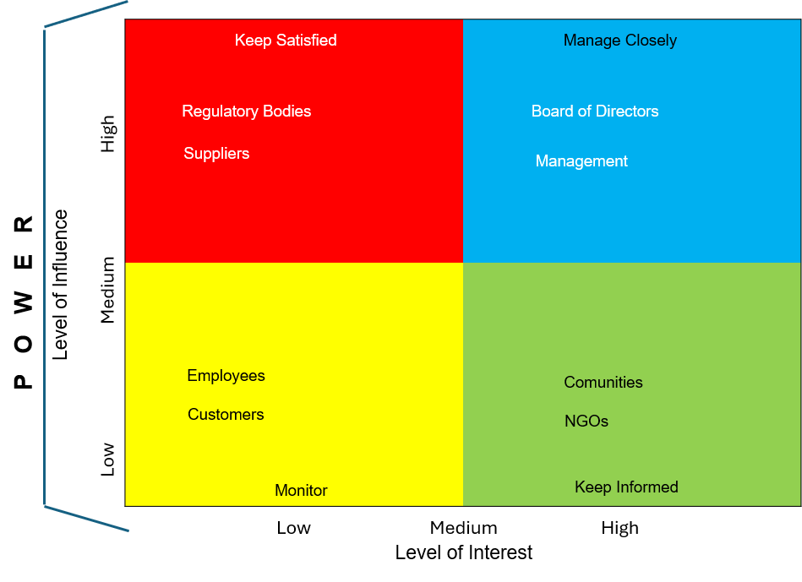

The stakeholders are put into 4 different groups, and the stakeholder mapping provides Tesco with a clear visual and analytical framework for managing relationships. We may understand who holds influence and interest. The Board of Directors have a direct impact on strategic decisions and ensure technical success; they keep High Power and big impact. High Influence and Low Interest include Regulators, investors, and technology partners. They ensure compliance, funding, and technical reliability. Medium Influence, High Interest for example Marketing, Sales and Customer service teams, because they promote the platform and manage customer engagement. Low Influence, High Interest stakeholders include customers, workers, local communities, and NGOs. These groups are important but do not have much influence.

4.0 Explanation of the roles and responsibilities of the key stakeholders

Internal Stakeholders
Internal stakeholders are team members or groups who are directly related to the organization or project, and are typically involved in its day-to-day operations or decision-making processes. Internal stakeholders have a vested interest in the success of the organization or project, and their involvement is crucial to its achievement and they are:
- Executive Leadership (CEO, Board of Directors)
Tesco’s executive leadership provides strategic oversight, approves budgets, and ensures the project aligns with corporate vision and digital transformation goals. They are responsible for authorizing resources, setting performance targets, and monitoring progress. Their leadership ensures accountability and long-term sustainability. Board of Directors’s attributes: Possess power, legitimacy, and urgency.
They hold decision-making authority and control funding.
- Project Management Team
The project manager oversees day-to-day operations, planning, scheduling, and budgeting.
Responsible for coordinating tasks, managing timelines, and ensuring stakeholder communication. Project managers act as the bridge between the project team and stakeholders, coordinating vendors, contractors, and internal teams.
- IT and Digital Development Teams
Design, develop, test, and maintain its platform. Their technical expertise ensures system reliability, cybersecurity, and integration with Tesco’s existing digital infrastructure.
- Product Development Team
Translate customer insights into platform features, ensuring it meets functional and commercial requirements. They collaborate closely with marketing and IT teams to deliver innovation.

- Marketing and Sales Department
Promote, manage customer engagement campaigns, and ensure consistent brand messaging across markets. Their role is vital in driving adoption and customer awareness.

- Customer Service Teams
Handle customer inquiries, feedback, and complaints post-launch. Their insights help refine the platform and improve user satisfaction.

External Stakeholders
External stakeholders, on the other hand, are individuals or groups who are not directly related to the organization or project, but are affected by its actions and decisions. External stakeholders have a varying degree of influence on the organization or project, and their involvement can have a significant impact on its success or failure and they are:
- Customers (Local and International)
End-users whose adoption determines the platform’s success. Their feedback shapes design decisions, usability improvements, and services enhancements.
- Suppliers and Technology Partners
Provide essential resources, software integration, and technical support. Their collaboration ensures the platform’s reliability and scalability.
- Investors and Shareholders
Expect transparency, financial returns, and evidence that Connect Plus strengthens Tesco’s competitive position.
- Regulatory Authorities
Ensure compliance with data protection laws (e.g., GDPR), consumer rights, and ethical AI standards. Their influence is high due to legal enforcement power.

- Local Communities and NGOs
Represent social and environmental interests affected by Tesco’s operations. Their engagement supports corporate social responsibility and ethical reputation.

Benefits and Challenges
Stakeholder Internal
Strategic Alignment and Leadership Support
Executive leadership provides clear strategic direction, ensuring that Connect Plus aligns with Tesco’s long term digital transformation goals. Their involvement secures funding, legitimizes decisions, and fosters organisational commitment. This top-level support enhances project credibility and accelerates decision-making.
Benefit: Strategic direction and resource allocation.
Challenge: Balancing short-term financial pressures with long-term innovation investment.

Project Management Team
This team coordinates planning, execution, and stakeholder communication. They manage timelines, budgets, and risk mitigation while ensuring cross-departmental collaboration.
Benefit: Efficient coordination and project control.
Challenge: Managing competing priorities and maintaining stakeholder alignment across departments.

IT and Digital Development Teams
Benefit: Technical innovation and operational efficiency
Challenge: Managing complex data systems and ensuring compliance with global standards.
Product Development Team
Benefit: Customer centric innovation
Challenge: Balancing creative design with technical feasibility and budget constraints.
Marketing and Sales Department
Benefit: Increased visibility and customer acquisition.
Challenge: Coordinating global campaigns across diverse cultural markets.
Customer Service Teams
Benefit: Direct customer insight and relationship management
Challenge: Adapting to new digital tools and managing increased service demand.

Logistics and Supply Chain Managers
Benefit: Operational reliability and customer trust.
Challenge: Coordinating international logistics and supplier performance.

External Stakeholders Benefits and Challenges

Customers (Local and International)
End-users whose adoption determines ConnectPlu’s success. Their feedback informs continuous improvement.
Benefit: Market validation and loyalty
Challenge: Diverse expectations and technological literacy across regions.

Suppliers and Technology Partners
Provide essential resources, software integration, and technical support.
Benefit: Innovation and scalability
Challenge: Managing contractual obligations and data-sharing risks.
Investors and Shareholders
Expect transparency, profitability, and evidence of strategic alignment.
Benefit: Financial stability and investment confidence.
Challenge: Balancing innovation costs with shareholder expectations.

Regulatory Authorities
Ensure compliance with data protection, consumer rights, and ethical AI standards.
Benefit: Legal compliance and public trust.
Challenge: Navigating complex international regulations.
Local Communities and NGOs
Represent social and environmental interests affected by Tesco’s operations.
Benefit: Enhanced corporate reputation and social responsibility.
Challenge: Maintaining consistent engagement across markets

5. Critical Explanation of the Stakeholder Engagement Process

Effective/ stakeholder engagement is essential for the successful design, launch, and adoption of Tesco’s ConnectPlus platform. As Project Manager, my role is to ensure that all stakeholders – Internal and External – are informed, aligned and committed throughout the project lifecycle. This requires a structured, strategic, and culturally sensitive engagement process supported by established frameworks and theories. The following section critically explains the engagement process and evaluates methods for managing conflicts that may arise during the global rollout of ConnectPlus.
Stakeholder engagement is a structured, iterative process designed to align expectations, reduce resistance, and ensure project success. Key steps include:
Stakeholder analysis is carried out to identify groups and individuals who have a stake in the work, the nature of their interest, expectations, and influence, so that these can be represented in planning and considered throughout the life cycle. A list of stakeholders forms the basis of the stakeholder's register.
Engaging stakeholders, effectively is one of the most critical responsibilities of a project manager, particularly in complex organisational environments where diverse interests, expectations, and power dynamic shape project outcomes. The process of stakeholder engagement is not linear; it requires continuous analysis, communication, negotiation, and conflict management. Stakeholder engagement and stakeholder management are arguably the most important ingredients for successful project delivery.

Prioritize Engagement
High-power/high-interest stakeholders require close, frequent engagement.
Low-power/low-interest stakeholders require minimal monitoring.

A stakeholder engagement plan is then developed as part of planning, defining how to engage stakeholders in a co-ordinated and appropriate way. The plan should be implemented, monitored, and updated to reflect newly emerging stakeholders and changes in the position of existing stakeholders as the work proceeds.
Engagement can be designed to:
- Consult, for example, to seek ideas and feedback, through face-to-face meetings, workshops, questionnaires, surveys or consultation exercises
- Inform, for example, to explain proposals, update on progress or public success, with channels ranging from email and social media, organisation websites, press releases and briefings, media interviews and publications.
- Direct, for example, to set direction or provide instructions, whether through briefing meetings or written communications
- Build relationships, for example, to build support or consensus, or help new delivery partners get to know each other, typically through launch events, awaydays or collaborative working activities.

Some stakeholders are also engaged directly in the work, for example in:
- Providing approval and funding.
- Verifying and validate the solution.
- Leading organizational and societal change as senior leaders, product owners and change advocates.
- Managing the future solution and realizing benefits following transition to business as usual.
Stakeholder attitudes should be assessed, updated, and validated throughout the work. The views of stakeholders should also be considered as part of learning from experience, post-programme and project evaluation, and benefits of realisation.

Who manages stakeholder engagement?
Stakeholder engagement can take many forms and so can involve a range of people across the team.
The portfolio, programme or project manager, as appropriate, is accountable for developing and managing the stakeholder engagement framework, register and plan, including ongoing monitoring, review and evaluation, as well as any specific stakeholder engagement activities allocated to them.
This matters even if team members are not directly involved in stakeholder engagement activities, to reduce potential for confusion and miscommunication.
In general, any person with a legitimate interest may identify a stakeholder. In practice stakeholders are normally identified in the early phases of the work by the sponsoring body or the team itself, including suppliers. For public works stakeholders may often identify themselves.
Depending on the scale of the work, there could be a dedicated stakeholder manager or team with responsibility for developing and maintaining the stakeholder register and engagement plan and managing engagement activities, either themselves. The stakeholder manager and engagement owners should work closely with the business analysis, business change, and communications teams. In some cases, the stakeholder manager may also act as the engagement owner for specific stakeholders.

Focusing stakeholder engagement activities
The approach to stakeholder engagement, monitoring, and evaluation should be tailored to suit the nature of the work and the phase of the life cycle. Large portfolios, programmes and projects, particularly those involving contentious proposals or extensive organisational or social change, require a more developed approach and more ongoing management than simpler ones.
Engagement activities should also be tailored to the particular position, interests and perspectives of different stakeholder groups, and should reflect their needs and preferences, for example in terms of how best, where and when to engage. Stakeholders have a choice whether or not to engage, so the approach needs careful consideration. For example, a stakeholder unfamiliar with the government can find it easier to explain their perspective in their own environment. Employees might prefer to use an existing meeting rather than add another one. When in doubt, ask for their preferences or provide options.

Managing Conflicts Using Structured Approaches
Conflict is inevitable when stakeholders have diverse interests, priorities, and levels of influence. Rather than viewing it as negative, As project manager, I would treat conflict as a source of constructive dialogue that can lead to better decisions. I would adopt structured conflict management approaches.
Identifying Sources of Conflict
Common sources include:
- Misaligned goals
- Competing priorities
- Resource constraints
- Power struggles
Early identification allows proactive intervention.
Applying the Thomas – Kilmann Conflicts Mode Instrument (TKI)
The TKI model identifies five conflict-handling styles:
Competing – useful in crises or when defending ethical standards.
Collaborating – ideal for complex issues requiring win-win solutions
Compromising – useful when time is limited
Avoiding – appropriate for minor issues
Accommodating – preserves relationships.
Critically, effective conflict management requires situational awareness. For example, collaborating may be ideal for scope disagreements, while competing may be necessary when regulatory compliance is at risk.
Interest-Based Relational Approach (IBR)
The IBR model emphasizes separating people from problems, focusing on interests rather than positions, and encouraging empathy and active listening. This approach is particularly effective for conflicts involving interpersonal tension or miscommunication.
Continuous Monitoring and Adaptation
Stakeholder engagement is dynamic. As project manager, I would continuously monitor stakeholder attitudes, emerging risks, and potential conflicts. Engagement strategies must be adapted as the project evolves. Regular reviews, feedback loops, and reflective practice ensure responsiveness and learning.
Mitchell, Agle & Wood Typology: highlights stakeholders with urgent or legitimate claims that could conflict with organisational priorities.
By mapping these relationships early, I can anticipate friction points – for example, between high-power sponsors demanding rapid delivery and operational teams concerned about workload.

Stakeholder Matrix (Power–Interest Grid)
Using the stakeholder matrix, I would map stakeholders according to their level of power and interest.
- High power, high interest stakeholders (e.g., senior executives, project sponsors) require close engagement and involvement in decision-making.
- High power, low interest stakeholders (e.g., regulators) must be kept satisfied through compliance and periodic updates.
- Low power, high interest stakeholders (e.g., frontline employees, customers) should be kept informed and consulted.
- Low power, low interest stakeholders require minimal monitoring.
This matrix helps prioritize engagement efforts and tailor communication strategies. For example, high-power stakeholders may need strategic briefings and decision-making involvement, while low-power groups may benefit newsletters of feedback sessions.
Critically, this matrix helps prioritise engagement efforts and prevents resource waste. It also highlights potential conflict zones — for example, high-power stakeholders with conflicting interests may require early negotiation to avoid escalation later.

Stakeholder Typology (Mitchell, Agle & Wood, 1997)
The stakeholder typology model categorizes stakeholders by power, legitimacy, and urgency:
Definitive stakeholders, possess all three attributes and demand immediate attention.
Dominant stakeholders have power and legitimacy buy may not be urgent.
Dependent stakeholders rely on others to advocate for their interests.
Critically, this model emphasizes ethical responsibility – ensuring that less powerful but legitimate stakeholders (e.g., community members) are not overlooked. It also supports dynamic reassessment as stakeholder influence evolves throughout the project lifecycle.
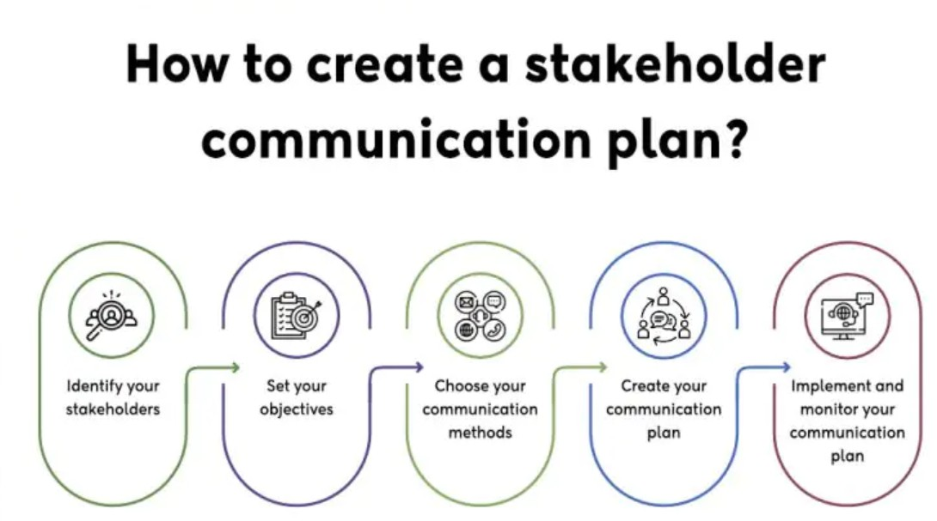

Communication Plan
Stakeholder | Meeting |  | Reports
 | Weekly meeting | Monthly meeting | Weekly project status | Monthly highlight report | Monthly newsletter | Exception reports
Internal Stakeholders
Employees | X F2F |  | X F2F
Management | X VC | X F2F | X F2F | X VC |  | X TC
Board of Directors |  | X F2F |  | X F2F VC | X E | X F2F
External Stakeholders
Shareholders |  |  |  | X VC TC F2F | X E
Customers |  |  |  |  | X E
Suppliers |  |  | X F2F E
Regulatory Bodies |  |  |  |  |  | X
NGOs |  |  |  |  | X E VC
Communities |  |  |  |  | X E TC VC

F2F – Face to Face
TC– Teleconference
VC- Video Conference
E – Email

The purpose of the communication plan is to ensure clear, timely, accurate, and culturally sensitive information sharing. Channels include Face to face, Teleconference, Video Conference, email updates, and dashboards. Clear communication reduces uncertainty and builds trust among stakeholders. The plan supports transparency, collaboration, and alignment across departments and international markets.
All stakeholders internal and external are kept updated and involved through regular and well-organised lines of communication.

Applying the 4Cs Model to Strengthen Engagement
The 4Cs model – Communication, Collaboration, Consultation, Commitment – provides a behavioural framwork for stakeholder engagement.
Communication, Clear, timely communication prevents misunderstandings and reduces conflict.
Consultation, Seeking stakeholder input demonstrates respect and reduces resistance. Consultation is especially important for dependent stakeholders who lack power.
Commitment, building long-term commitment ensures sustained support. This can be achieved through recognition, transparency, and involving stakeholders in key decisions.
Critically, the 4Cs model transforms engagement from transactional to relational, reducing the likelihood of conflict and increasing stakeholder satisfaction.

- RACI Matrix
^{Task/Activity} | ^{Employees} | ^{Management} | ^{Board of Directors} | ^{Share}  ^{holders} | ^{Customers} | ^{Suppliers} | ^{Regulatory Bodies} | ^{NGOs} | ^{Communities}
Develop Stakeholder Engagement Plan | ^{R} | ^{A} | ^{C} | ^{I} | ^{I} | ^{I} | ^{I} | ^{C} | ^{I}
Implement Sustainability Initiatives | ^{R} | ^{A} | ^{C} | ^{I} | ^{I} | ^{C} | ^{I} | ^{C} | ^{I}
^{Strategic Decision Making} | ^{I} | ^{R/A} | ^{C} | ^{C} | ^{I} | ^{I} | ^{I} | ^{I} | ^{I}
^{Financial Performance Review} | ^{I} | ^{R} | ^{A} | ^{C} | ^{I} | ^{I} | ^{I} | ^{I} | ^{I}
Product Development and Innovation | ^{R} | ^{A} | ^{I} | ^{I} | ^{C} | ^{C} | ^{I} | ^{I} | ^{I}
^{Supply Chain Management} | ^{I} | ^{R} | ^{I} | ^{I} | ^{I} | ^{R/A} | ^{I} | ^{I} | ^{I}
Compliance and Regulatory Reporting | ^{I} | ^{R} | ^{I} | ^{I} | ^{I} | ^{I} | ^{A} | ^{C} | ^{I}
^{CSR Activities} | ^{R} | ^{A} | ^{C} | ^{I} | ^{I} | ^{I} | ^{C} | ^{R} | ^{C}
^{Marketing and Branding} | ^{I} | ^{R} | ^{I} | ^{I} | ^{C} | ^{I} | ^{I} | ^{I} | ^{C}
^{Community Engagement} | ^{I} | ^{R} | ^{I} | ^{I} | ^{I} | ^{I} | ^{I} | ^{I} | ^{R/A}
^{Note} | ^{R = Responsible} |  | ^{A = Accountable} |  | ^{C = Consulted} |  |  | ^{I = Informed}

The RACI matrix clarifies project roles by assigning each task to one of four categories: Responsible, Accountable, Consulted, or Informed, ensuring clear ownership and communication.

Evaluation of the Impact of Sustainable Stakeholder Engagement on Tesco’s Business Performance
Evaluating its impact on business performance reveals significant benefits across customer loyalty, operational efficiency, innovation, regulatory compliance, employee engagement, brand reputation, and financial sustainability. For a company deploying ConnectPlus engagement is not merely supportive – it is foundational to achieving competitive advantage and long-term growth.
Firstly, sustainable engagement significantly enhances customer loyalty and retention, which are core objectives of ConnectPlus. Customers expect personalised experiences, ethical practices, and transparency in how their data is used. By engaging customers through feedback loops, pilot testing, and co-creation workshops, the organisation gains deep insight into customer preferences and behavioural patterns.
Secondly, sustainable stakeholder engagement improves operational efficiency and supply chain performance. ConnectPlus relies on accurate data flows, reliable technology infrastructure, and coordinates cross-departmental processes. Engaging internal stakeholders—such as IT teams, data analysts, marketing, and store operations—ensure alignment, reduce bottlenecks, and support agile development. External stakeholders, including suppliers and technology partners, benefit from collaborative planning and transparent communication.
Thirdly, sustainable engagement enhances employee motivation, capability, and performance. Employees are critical stakeholders in the adoption and promotion of ConnectPlus. Engaging them through training, consultation, and involvement in decision-making fosters ownership and commitment. When employees understand the purpose and benefits of the platform, they are more effective in supporting customers, promoting features, and providing feedback.
Regulators and government bodies require strict adherence to data protection laws, cybersecurity standards, and ethical AI practices. Engaging regulators early ensures compliance with GDPR, consumer protection regulations, and international data governance requirements. Sustainable engagement reduces the risk of fines, legal disputes, and reputational damage. It also supports ethical decision-making by ensuring transparency in data usage, algorithmic fairness, and responsible AI deployment.
Finally, sustainable stakeholder engagement generates social and environmental impact, which indirectly supports business performance. Tesco’s collaboration with charities, local communities, and environmental organisations enhances social wellbeing and reduces ecological footprint. These initiatives create goodwill, attract positive media attention, and align Tesco’s operations with global sustainability goals. The resulting social capital reinforces stakeholder trust and long-term brand sustainability.

6.0 Recommendation
To strengthen Tesco’s stakeholder engagement and ensure successful implementation of strategic initiatives such as ConnectPlus, several recommendations are proposed.

- Tesco should enhance cross-functional collaboration by establishing stakeholder working groups that include representatives from IT, marketing, data analytics, store operations, suppliers, and customer experience teams. This will reduce siloed decision-making and support shared ownership of digital transformation initiatives.

- Tesco should strengthen ethical governance, particularly around data privacy, AI transparency, and responsible innovation. Engaging regulators, customers, and community groups in ethical discussions will enhance compliance and protect Tesco’s reputation.
Finally, Tesco should implement continuous monitoring and evaluation mechanisms, such as stakeholder satisfaction surveys, engagement scorecards, and post-implementation reviews. This will ensure that engagement practices evolve with organisational needs and market conditions.

7.0 Conclusion
Effective stakeholder engagement is essential for Tesco’s long-term performance, especially when launching complex digital platforms such as ConnectPlus. Sustainable engagement enhances customer loyalty, operational efficiency, employee motivation, regulatory compliance, innovation, and brand reputation. It also strengthens Tesco’s resilience in competitive global markets by fostering trust, collaboration, and ethical decision-making. By adopting structured engagement frameworks, improving communication, and embedding ethical governance, Tesco can transform stakeholder relationships into strategic assets. Ultimately, sustainable stakeholder engagement not only supports successful project delivery but also drives long-term business growth, competitive advantage, and organisational sustainability.

8.0 References
Carroll, A.B. and Buchholtz, A.K. (2015) Business and Society: Ethics, Sustainability, and Stakeholder Management. Boston: Cengage Learning.
Eccles, R.G., Ioannou, I. and Serafeim, G. (2014) ‘The impact of corporate sustainability on organizational processes and performance’, Management Science, 60(11), pp. 2835–2857.
Elkington, J. (1997) Cannibals with Forks: The Triple Bottom Line of 21st Century Business. Oxford: Capstone Publishing.
Fombrun, C. and Shanley, M. (1990) ‘What’s in a name? Reputation building and corporate strategy’, Academy of Management Journal, 33(2), pp. 233–258.
Freeman, R.E. (1984) Strategic Management: A Stakeholder Approach. Boston: Pitman.
Macey, W.H. and Schneider, B. (2008) ‘The meaning of employee engagement’, Industrial and Organizational Psychology, 1(1), pp. 3–30.
Mitchell, R.K., Agle, B.R. and Wood, D.J. (1997) ‘Toward a theory of stakeholder identification and salience: defining the principle of who and what really counts’, Academy of Management Review, 22(4), pp. 853–886.
Porter, M.E. and Kramer, M.R. (2011) ‘Creating shared value’, Harvard Business Review, 89(1/2), pp. 62–77.

