Student Name: |  |  |  | Student Number:
Module Code: |  | ECCE4001 |  | Module Title: | Who Am I? – Exploring Professional Identity
Learning Outcome: |  |  | • begin to develop research, referencing and critical thinking skills;
Task No: | Activity |  |  |  |  | Prior to session | During session | After session
1 | Access the UWTSD Academic and Infoskills webpages at Academic and InfoSkills | Digital Services | University of Wales Trinity Saint David
2 | 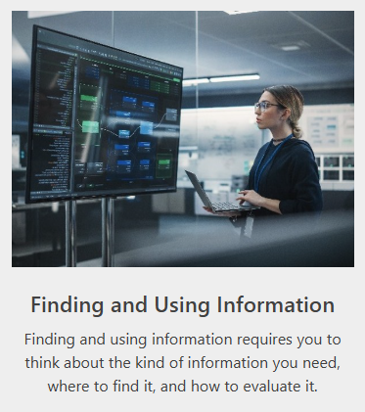  Click on the tile for Finding and Using Information which looks like this:
3. | Complete Unit 1: Identifying Information & Unit 2: Searching for Information

