Decisions in Python 3 (if… and/or…)

We have already seen the use of conditions with if statements. We can also have multiple conditions.

and

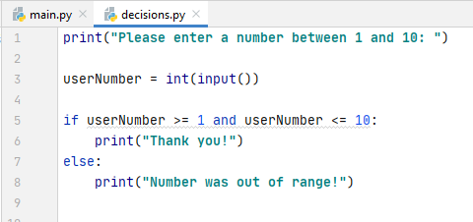

In this example, both conditions must be satisfied (and):

So for 4:
4 is greater than 1 4 is less than 10

Result - In range (if)
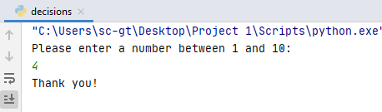 OK

Result - Out of range (else)
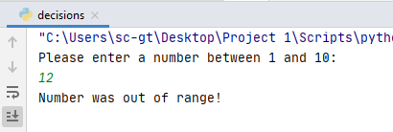 Out of range
Note: When programming, you should also test on the boundaries of conditions – in this case 1 and 10. This is because I might have "between 1 and 10" in my mind and forget that I meant to include both 1 and 10.

Natural languages such as English often need less precision, because we infer some the meaning of the sentence from everyday usage of language. eg When someone says "between 1 and 10" I infer that 1 and 10 are included. If there is any doubt, I might ask a further question to clarify (eg "Is that 1 and 10 inclusive?")

When programming, we need to be more precise.

If I write the following, only numbers 2-9 will meet the condition:

I should therefore test the program's boundaries (1 and 10) to make sure, and adjust my code if it doesn't behave as expected.
(1-10 inclusive)

and example 2

Let's do another and example:

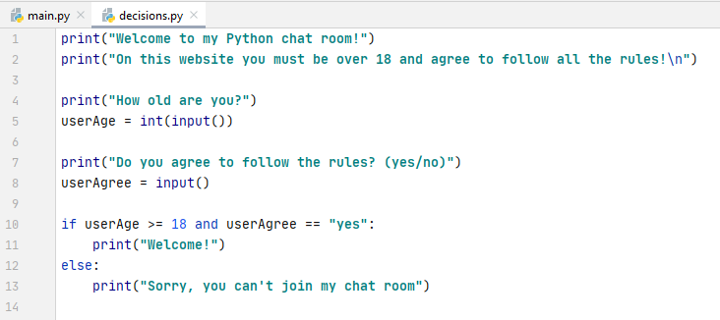

In this case, the user needs to be over 18 (ie "18 or over") and agree to the rules. If they fail to do meet one or both of these things they cannot join.

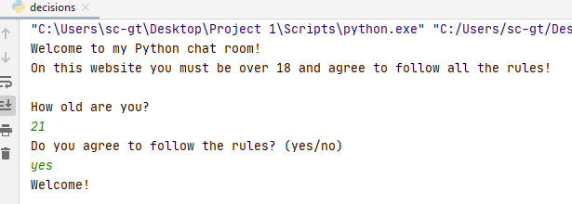 OK

or

In multiple conditions with or, only one of the conditions must be true (technically, it is OK for both to be true, but it must be at least one). If I take the previous example of checking for a number between 1-10, I can write the logic slightly differently:

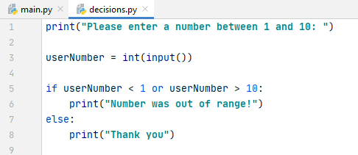

This time, I am checking to see whether the number is out of range:

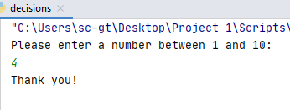 - goes to the else clause
4 is not less than 1 X 4 is not greater than 10 X

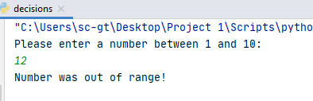

12 is not less than 1 X 12 is greater than 10

Remember, only one condition has to be true when or is used.
or example 2

This is a light-hearted example, but hopefully illustrates the use of or:

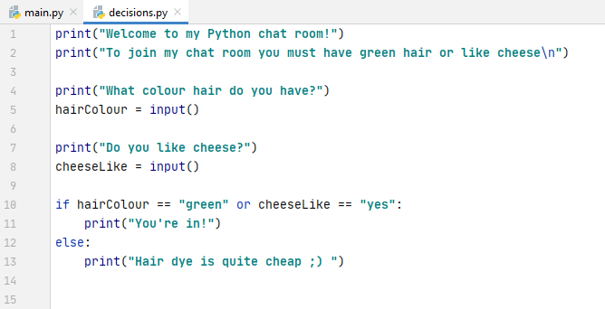

In this case you must answer "yes" to having green hair or liking cheese – or both. Or only requires one condition to be true (but it is fine if they both are).

Green hair/no cheese: (1 condition satisfied)
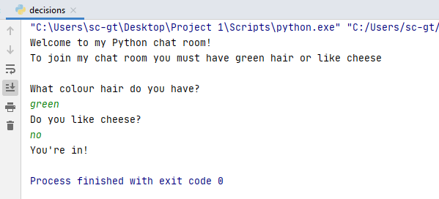

Non-green hair/yes cheese (1 condition satisfied)
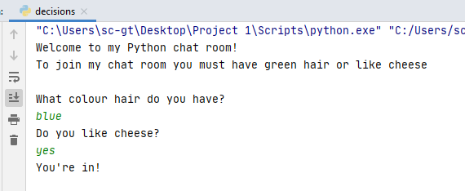

Green hair/yes cheese (both conditions satisfied – still OK for or)
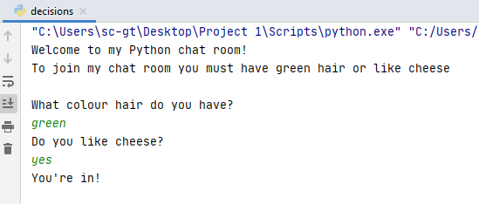

Neither condition satisfied, so Python goes to else:
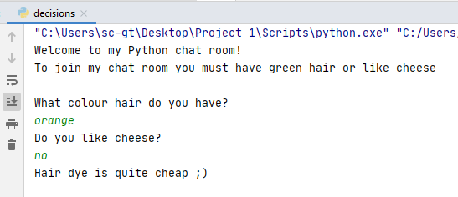

Note: I might extend my conditions to allow for people typing "y" or "n" instead of yes and no. I always need to anticipate what a user might do and account for it in my code

When conditions start getting long, use brackets to keep the logic on track

Either hairColor should be green or one of these should be true

