

Student name: EMMANUEL BABATUNDE OLUKOGA
Student ID: 2415104

Module name: INTRODUCTION TO PHYSIOLOGY

Module code: BMHP5023
Lecturer name: DR SOBAN SADIQ

Assessment: WRITTEN ASSIGNMENT (CASE STUDY REPORT)

Introduction
Diabetes mellitus is a long-term metabolic disorder in which the body is unable to control blood glucose levels properly. Normally, insulin and glucagon work together to keep blood sugar within a healthy range, but diabetes develops when this balance is disrupted. The condition is generally divided into two primary forms. Type 1 diabetes arises when the immune system attacks and destroys the pancreatic beta cells that produce insulin, leading to a complete lack of insulin. Type 2 diabetes, on the other hand, is most often linked to insulin resistance or reduced insulin production, meaning the body does not use or make insulin effectively (NHS, 2023; American Diabetes Association, 2024).
A range of modifiable lifestyle factors, including poor dietary habits, physical inactivity, obesity, smoking, and excessive alcohol intake, significantly increase the risk of developing type 2 diabetes. Non-modifiable factors such as age, family history, and ethnicity also play a crucial role. Individuals of South Asian, African Caribbean, and Middle Eastern heritage are disproportionately affected and often develop the condition at a younger age (NICE, 2026; Diabetes UK, 2024). Diabetes represents a major public health challenge in the UK, with more than five million people currently diagnosed and many more at heightened risk (Public Health England, 2020). This rising prevalence places increasing pressure on primary care services, where early identification, patient education, and long-term management are essential components of effective care.
To understand diabetes, you need to know how the endocrine system works. The pancreas is very important for keeping blood sugar levels stable. If you looked at a schematic of the pancreas, you would see the islets of Langerhans. These are groupings of cells that produce insulin and glucagon. Insulin lowers blood sugar by releasing glucose into cells. Glucagon raises blood sugar by signalling the liver to release stored glucose. Maintaining homeostasis requires this balance of hormones. When insulin production or action is impaired, as in Type 2 diabetes, blood glucose levels rise and remain persistently elevated, leading to chronic complications affecting the eyes, kidneys, nerves, and cardiovascular system (World Health Organisation, 2023).
This essay explains how the body maintains blood sugar, how cells use glucose and oxygen to produce energy, and why people with Type 2 diabetes need to keep an eye on their blood sugar levels. It also gives you research-based suggestions for changing your lifestyle and improving your health in ways that can help you better manage your illness. Diagrams can be utilised throughout the essay to illustrate key concepts such as the endocrine system, the negative feedback loop that regulates blood sugar levels, and the steps of cellular respiration.
Blood Sugar Regulation
Maintaining stable blood sugar levels is a primary function of the body, crucial for providing continuous energy. When you consume carbohydrates, your body converts them into glucose, which then enters your bloodstream. In response to elevated blood sugar, the pancreas releases insulin. Insulin acts like a key, facilitating the entry of glucose into cells, particularly those in fat and muscle, where it can be used for energy. Additionally, insulin signals the liver to convert excess glucose into glycogen for storage. As blood sugar levels decrease, insulin production subsequently reduces (Marieb and Hoehn, 2018).
Conversely, if blood sugar levels fall too low, for example, due to fasting or physical activity, the pancreas secretes glucagon. Glucagon instructs the liver to release stored glucose from glycogen reserves. This mechanism ensures a consistent supply of glucose for bodily functions. Essentially, high blood sugar triggers insulin to lower it, while low blood sugar prompts glucagon to raise it.
However, in individuals with Type 2 diabetes, this delicate system of blood sugar control malfunctions. The body's cells develop insulin resistance, meaning they no longer respond effectively to insulin. This impedance prevents glucose from entering the cells efficiently, causing it to accumulate in the bloodstream. Initially, the pancreas attempts to compensate by producing more insulin. Over time, however, it becomes unable to sustain this heightened production. Furthermore, even when blood sugar is already high, the liver may inappropriately produce excessive amounts of glucose. This combination of insulin resistance and insufficient insulin production results in persistently high blood sugar levels (DeFronzo, 2010; ADA, 2024).
Prolonged elevated blood sugar levels cause damage to blood vessels and nerves, significantly increasing the risk of serious complications such as heart disease, stroke, kidney failure, nerve damage, and vision loss. To mitigate these health risks, national guidelines underscore the importance of strict glucose management (NICE, 2026; NHS England, 2023). A clear understanding of blood sugar regulation empowers individuals to grasp the necessity of dietary modifications and medication in supporting their body's optimal functioning.
Cellular Metabolism
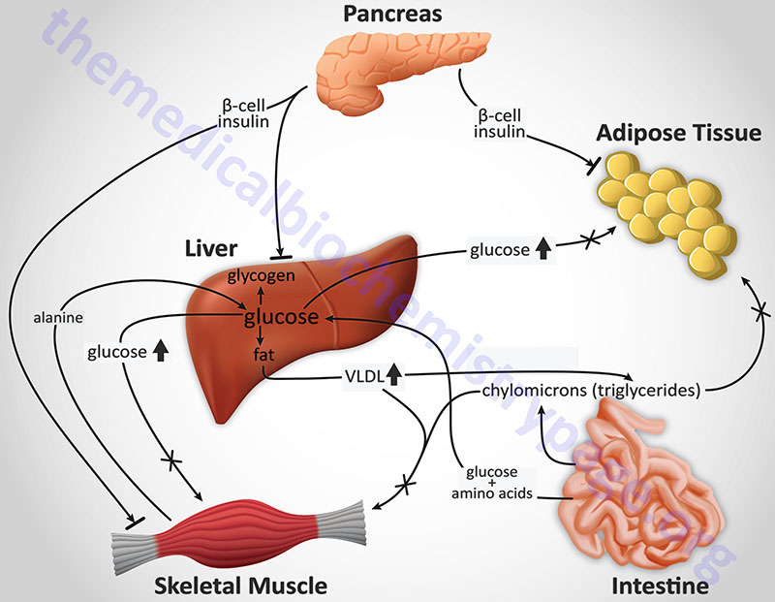
Figure 1 (The Medical Biochemistry Page, 2026).
Cells generate energy by breaking down glucose in the presence of oxygen through cellular respiration, a multi-stage process that occurs within different parts of the cell. The first stage, glycolysis, happens in the cytoplasm, where one glucose molecule is split into two molecules of pyruvate. This step also produces a small amount of ATP, which serves as the body’s primary energy currency (Marieb and Hoehn, 2018).
When oxygen is available, pyruvate moves into the mitochondria and is converted into acetyl-CoA, which then enters the Krebs cycle. During this cycle, high-energy electron carriers such as NADH and FADH₂ are produced. These molecules transfer their electrons to the electron transport chain, located in the inner mitochondrial membrane. Oxygen plays a crucial role here as the final electron acceptor. As electrons travel along the chain, energy is released and used to generate large amounts of ATP through oxidative phosphorylation. Thus, after glucose enters the cell and is transformed into pyruvate, both the Krebs cycle and the electron transport chain take place inside the mitochondria.
In Type 2 diabetes, insulin resistance prevents cells from efficiently absorbing glucose. As a result, even when blood glucose levels are high, cells may still lack the energy they need. When this happens, the body may begin breaking down fat for fuel, producing ketones. Although more common in Type 1 diabetes, elevated ketone levels can disturb metabolic balance and, in severe cases, lead to diabetic ketoacidosis (ADA, 2024). Poorly controlled diabetes can also impair mitochondrial activity and increase oxidative stress, further disrupting cellular metabolism and contributing to long-term complications (WHO, 2023).
Understanding how cellular metabolism works helps explain why maintaining stable blood glucose levels is essential for sustaining energy and preventing health problems
Recording and Tracking Blood Sugar Levels for Type 2 Diabetes
Maintaining and recording your blood sugar levels is one of the most important things you can do to manage Type 2 diabetes. Monitoring allows doctors to adjust a person's care based on how their daily choices affect their blood sugar levels. Blood sugar levels can be checked with finger-prick tests or continuous glucose monitors (CGMs). CGMs give people actual time information and notifications so they can act quickly when their blood sugar levels change (Diabetes UK, 202l).
Blood sugar monitoring is crucial for several reasons. It helps avoid hazardous highs and lows. Hyperglycemia, or elevated blood sugar, can result in chronic problems, fatigue, and thirst. Taking insulin or other glucose-lowering drugs without eating enough might result in hypoglycemia, or low blood sugar. Shaking, perspiration, lightheadedness, and disorientation are some of the symptoms. Hypoglycemia might cause unconsciousness if treatment is delayed (NHS, 2023).
Second, judgments about treatment are supported by routine monitoring. When determining whether to modify medication, suggest lifestyle modifications, or send patients to specialised services, healthcare providers use blood glucose readings and HbA1c findings to gauge how effectively diabetes is controlled (NICE, 2026; NHS England, 2023). It is challenging to determine whether high HbA1c is caused by food, inactivity, disease, or drug problems without accurate records.
If blood sugar levels aren't checked, high blood sugar may go untreated. This could lead to problems like heart disease, kidney damage, and nerve damage that last a long time. If low blood sugar isn't found quickly, the chances of fainting, getting confused, or having seizures may go up. People feel better about their health and in charge of their diabetes when they monitor their blood sugar regularly (Diabetes UK, 2024).

Recommendations
Managing Type 2 diabetes successfully involves a combination of lifestyle changes, professional medical guidance, and ongoing support. A nutritious diet is absolutely fundamental to diabetes management. Incorporating more whole grains, various vegetables, fruits, and other high-fibre foods into your daily meals will contribute significantly to maintaining steady blood sugar levels. Fibre slows down the absorption of glucose into the blood, which keeps blood sugar levels from rising too quickly (WHO, 2023; NHS, 2023). Cutting back on sugary drinks, candy, and processed foods can also help you control your blood sugar better. The Mediterranean diet, which focuses on whole foods and healthy fats, has been demonstrated to help regulate blood sugar and lower the risk of heart disease (Estruch et al., 2013).
For people with Type 2 diabetes, regular exercise is very important. Exercise helps the body use insulin more effectively, making it easier for glucose to enter cells. It also helps you lose weight, makes your heart healthier, and makes you feel better overall. The UK Chief Medical Officers (2019) recommend that individuals engage in at least 150 minutes of moderate-intensity exercise per week.
This could be brisk walking, biking, or swimming. Strength training is also crucial because it helps you build muscle mass. Even when you're not working out, muscle tissue utilises more glucose than fat tissue; thus, building up your muscles can help you control your blood sugar better (Colberg et al., 2016).
Another important part of diabetes care is keeping your weight in check. Having excess body fat, especially around the abdomen, worsens insulin resistance. Even a tiny amount of weight loss can make a big difference in how well your body uses insulin and controls your blood sugar (Public Health England, 2020; NICE, 2026). Support from dietitians, diabetes nurses, and structured weight-loss programmes can help individuals make sustainable changes.
It is very advised to stop smoking. Smoking makes inflammation worse, makes insulin less effective, and boosts the risk of problems like heart disease and stroke (Willi et al., 2007; WHO, 2023). Cutting back on alcohol is also crucial because it can change blood sugar levels in ways that are hard to predict.
Emotional wellbeing is another important aspect of diabetes care. Having a long-term illness can be stressful, and stress can make blood sugar levels go up. Healthcare professionals, family, friends, or support groups can help people cope better (RCN, 2022; DHSC, 2021).
Public awareness campaigns and community-based interventions are two examples of health promotion techniques that can help lower the number of people with Type 2 diabetes and improve the lives of those who already have it. The NHS Diabetes Prevention Program offers structured education and lifestyle support to individuals at heightened risk of Type 2 diabetes, aiming to avert or delay its onset through weight loss, better nutrition, and increased physical activity (GOV.UK, 2025; NHS England, 2023).

Conclusion
Type 2 diabetes is a long-term illness that needs to be managed all the time. People may take charge of their health by learning how the body balances blood sugar, how energy is made, and how lifestyle choices affect health. Monitoring blood sugar levels provides individuals and healthcare providers with essential information that facilitates safe and effective care. Making lifestyle adjustments, such as eating better, getting more exercise, quitting smoking, and keeping your weight in check, can have a big impact on your health. With the right help, people with Type 2 diabetes may take good care of themselves and minimise their risk of long-term issues.

References
American Diabetes Association (2024) Standards of Medical Care in Diabetes—2024. Diabetes Care, 47(Suppl. 1), pp. S1–S200.
Colberg, S.R. et al. (2016) ‘Exercise and Type 2 Diabetes’, Diabetes Care, 39(11), pp. 2065–2079.
Department of Health and Social Care (2021) Health matters: preventing Type 2 diabetes. London: DHSC.
DeFronzo, R.A. (2010) ‘Insulin resistance, lipotoxicity and Type 2 diabetes’, Diabetologia, 53(7), pp. 1270–1287.
Diabetes UK (2024) Diabetes statistics. London: Diabetes UK.
Estruch, R. et al. (2013) ‘Primary prevention of cardiovascular disease with a Mediterranean diet’, New England Journal of Medicine, 368(14), pp. 1279–1290.
GOV.UK (2025) Diabetes profile: statistical commentary. London: Public Health England.
Marieb, E.N. and Hoehn, K. (2018) Human Anatomy & Physiology. 11th edn. Harlow: Pearson.
NHS (2023) Type 2 diabetes – Overview. Available at: https://www.nhs.uk/conditions/type-2-diabetes/ (nhs.uk in Bing)
NHS England (2023) National Diabetes Audit 2021–22. London: NHS England.
National Institute for Health and Care Excellence (2026) Type 2 diabetes in adults: management (NG28). London: NICE.
Public Health England (2020) Diabetes prevalence model. London: PHE.
Royal College of Nursing (2022) Diabetes essentials: A pocket guide for nurses. London: RCN.
The Medical Biochemistry Page (2026) Diabetes: Type 1 and Type 2. Available at: https://themedicalbiochemistrypage.org/diabetes-type-1-and-type-2 (Accessed: 14 March 2026)
UK Chief Medical Officers (2019) Physical Activity Guidelines. London: DHSC.
Willi, C. et al. (2007) ‘Active smoking and the risk of Type 2 diabetes’, JAMA, 298(22), pp. 2654–2664.
World Health Organisation (2023) Diabetes fact sheet. Geneva: WHO.

