
APPENDIX GA36b

LEVEL 5 ASSESSMENT SPECIFICATION

Student name: | Graham Vaughan | Student ID number: | 1902830
Programme: | BSc (Hons) Sport Therapy
Module: | Rehabilitation
Module code: | SHSS5063 | Contribution to Overall Module Assessment (%): | 25
Lecturer: | Dr Kate Williams | Internal Verifier: | Charley Keen
Assignment Title: | Tissues and Issues | Word count (or equivalent): | 1500 words
Submission deadline: | 19 November 2020 | Return date of provisional marks & written feedback: | 19 December 2020
Submission method: | Please submit via Turnit In on your Module Moodle pages.  Late submission of the assessment will result in a late penalty mark.  Penalties for late submission: Up to one week late, maximum mark of 40%. Over one week late, 0%. Only the Extenuating Circumstances Panel may approve a change to submission dates.
Academic honesty / referencing: | Academic honesty is required. In the main body of your submission you must give credit to authors on whose research and ideas your work is based. Append to your submission a reference list that indicates the books, articles, etc. that you have used, cited or quoted in order to complete this assessment.

Module Learning Outcomes (from module syllabus)
- Devise, conduct and monitor appropriate sports specific rehabilitation plans for various stages in the healing process, for both groups and individuals
- Use a range of devices, technologies and environments to enhance rehabilitation and consider return to participation/ play criteria
- Critically consider evidence relating to minimising the psychological and nutritional impact of injury and strategies to enhance recovery

STUDENT FEEDBACK FORM

This section details the extent to which the assessment criteria are demonstrated by you, which in turn determines your mark. The marks available for each category of skill are shown. Lecturers will use the space provided to comment on the achievement of the task(s), including those areas in which you have performed well and areas that would benefit from development/improvement.

Generic Assessment Criteria | Marks  available | Marks  awarded
1. Engagement with Literature Skills
.
 | 30
2. Knowledge and Understanding Skills

 | 30
3. Cognitive and Intellectual Skills

 | 30
4. Practical Application Skills

 | 5
5. Transferable Skills for Life and Professional Practice

 | 5

Assessment Mark (Assessment marks are subject to ratification at the Exam Board. These comments and marks are to give feedback on module work and are for guidance only until they are confirmed. ) | Late Submission Penalties (tick if appropriate) |  | %
 | Up to 1 week late (40% Max) |  | %
 | Over 1 week late (0%) |  | %

Rehabilitation 5063
Graham Vaughan
St# 1902830
Anatomy, Structure, and Function of Ligamentous Tissue
Skeletal ligaments are dense bands of fibrous connective tissue that play a vital role in mechanical stability and normal function of musculoskeletal joints (Wan et al., 2014; Zitnay and Weiss, 2018; Nyland et al., 2020). This is achieved by spanning, or crossing, the joint and attaching to the bone at either side, providing stability during movement. Under tension, the ligament also provides stabilisation through normal range of motion by limiting excessive motion while transferring force and distributing the load applied to them (Hauser et al., 2013). Ligaments also form joint capsules that seal synovial joints and prevent loss of synovial fluid, the lubricant for articular surfaces (Shukunami et al., 2016).
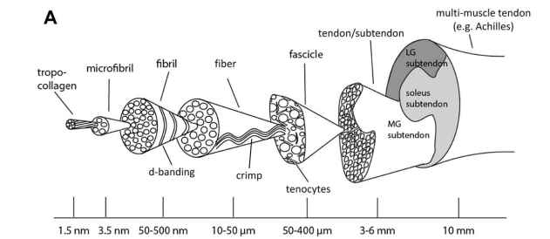
Figure 1. Anatomy of Tendons and Ligaments (Zitnay and Weiss, 2018).
Figure 1. shows the anatomy of ligaments (and tendons) which are made up of tropo-collagen, microfibrils, fibrils, fibres (with the crimp), and fascicles (containing ligamentocytes. Type I collagen is responsible for the high tensile strength of the ligament, due to the thick and densely pack fibrils, while the more flexible type III collagen allows for a higher extensibility, with its loosely packed fibrils (Stamenov et al., 2019; Wan et al., 2014). Under microscope, ligaments have bundles of collagen fibres composed of smaller fibrils aligned parallel with the long axis and assume a cross linked pattern that contributes to the tremendous tensile strength (Hauser et al., 2013; Frank, 2004). These bundles appear crimped along their length which is believed to be present in relation to the capacity of the ligament to tolerate load, predominantly tensile forces, and allow elongation without damage (Hauser et al., 2013; Frank, 2004).
Due to these proprioceptive and nociceptive afferents ligaments can help protect joints while under stress (Hauser et al., 2013; Zhang et al., 2018).
Ligaments Under Load
The ligament has an unloaded state, followed by a soft toe region under low strains and a stiff linear region and finally damage or disruption of the fibres, as seen in Figure 2. (Zitnay and Weiss, 2018). As the ligament fibres are aligned parallel to the long axis its primary function is to resist tensile forces. Though less able, ligaments are still able to resist transverse, shear, and compressive loads during normal function of the joint (Ristaniemi et al 2018; Zitnay and Weiss, 2018). This suggests that ligaments are more prone to injury when under forces other than tensile load. 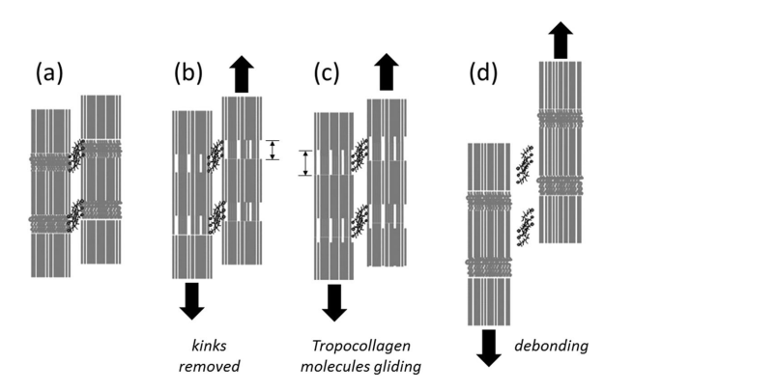
Figure 2. Karunaratne et al 2018
(Figure 2. proposes the deformation and failure (stress-strain curve) as a schematic. The Toe region (b) shows a slightly loaded state but not enough to straighten the ‘crimp’, or wavey formation, seen in collagen fibres. The Linear region (c) would be the point in loading we would see the crimp straighten out and stiffening of the collagen fibres and a display of elastic behaviour, and (d) is the disruption, or debonding, state which could escalate to plastic deformation and laxity of the collagen fibres (Karunaratne et al., 2018; Liao et al., 2015)).
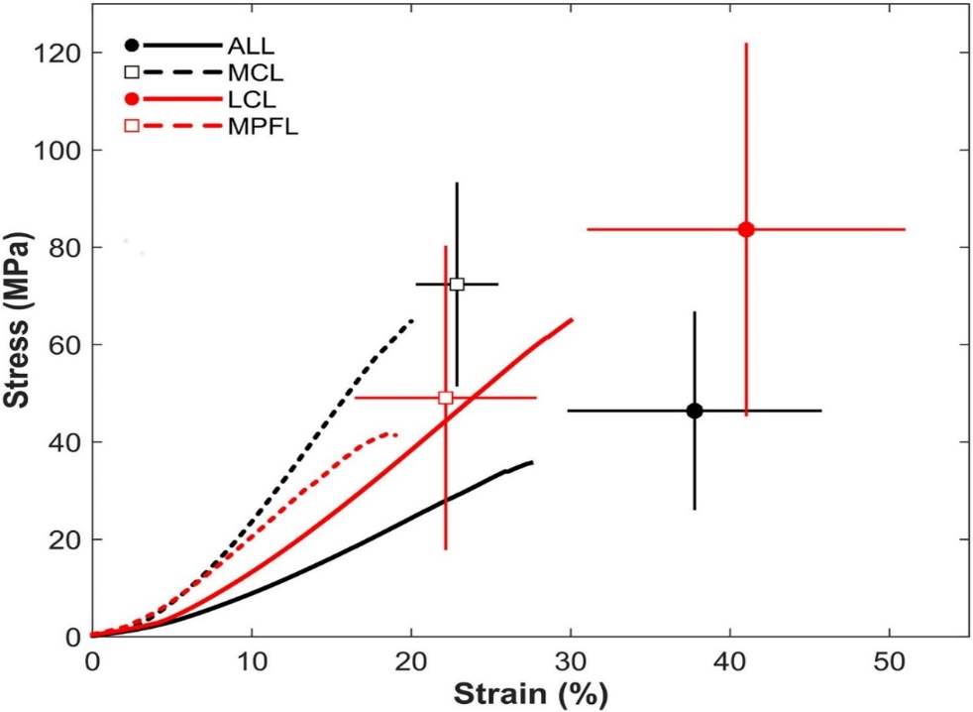
(Figure 3. Shows average stress–strain curves for the anterolateral (ALL), medial collateral (MCL), lateral collateral (LCL), and medial patellofemoral (MPFL) ligament specimens. The final points represent the average ultimate stress and ultimate strain, and the error bars indicate the standard deviation (Smeets et al., 2017).
Ligament Injuries
Ligament injuries can be classified intrinsic, improper motion of the joint, or extrinsic, being from external factors. Common mechanisms of injury include planting, pivoting, and blunt force trauma from a collision with another athlete that can overstretch the ligament to the point of tearing (Hauser et al., 2013). Zintay and Weiss (2018) describe mechanical damage to ligaments as unrecoverable change to the tissue or its constituents, and/or an inability to carry load. This can be within at least one level of the tissue structure, from the fascicle, fibre, fibril or the collagen itself.
There are three grades of ligamentous injury (Brukner and Khan, 2012; Houglum, 2010b). Grade I is a mild over stretching of the fibres with no visual disruption of the tissue. Grade II will include further stretching, macro-tearing and partial disruption. Grade III is a complete rupture, or disruption, and loss of integrity in the ligament, and possibly the joint.
Healing Ligaments
Ligaments have been demonstrated to be weaker while repairing because the rapidly generated type III collagen, laid down initially during healing, is more extensible and less stiff then type I collagen (Wan et al., 2014). The time frame can be a few months up to a year or two for some injuries to completely heal (Brukner and Khan, 2012; Houglum, 2010a). The acute inflammatory reaction begins from the onset of injury and continues over 48 to 72 hours (Hauser et al., 2013). Resting the injury site in this phase is paramount so as not to cause further damage and allow the healing process to begin. Once the rehabilitation begins it is suggested by Melick et al. (2016) that it is goal oriented as opposed time oriented. By this they mean to set goals to address what specific activities of daily living, or movement in sport, they have lost and are looking to recover through rehabilitation exercises. Over the next few weeks, during the proliferative phase, it would be advantageous to provide controlled kinetic movement, as mobilisation of these damaged tissues has been shown to improve healing and reduce adhesions, joint stiffness, and muscle atrophy around the joint (Morishita et al., 2018; Hauser et al., 2013). Open chain, isometric exercises under the limbs own weight can provide this control and isolate to a particular movement plane, reducing abnormal movements and loading that the ligament may not be ready to tolerate (Melick et al., 2016). Submaximal isometric exercise would provide appropriate loading to improve strength, endurance and maintain neuromuscular function without causing further disruption to the newly laid collagen fibres (Haff and Triplett, 2016).
The remodelling phase, where collage maturation takes place, can be up to 3 months and as long as one to three years from the initial injury (Hauser et al., 2013; Houglum, 2010a; Nyland et al., 2020). During this stage the load and demand put on the tissue can be increased by adding weight to the strengthening exercises and/or more complex proprioceptive/ neuromuscular exercises related to the activity or sport the patient would like to be able to perform again (Haff and Triplett, 2016). This increase in movement to the ligament tissue will help to strengthen it and improve collagen organisation. As Zhang et al. (2018) shows, collagen organisation in an injured ligament under stretch can modulate pain-related neuronal pathways. This suggests that rehabilitation to correctly heal a ligament can reduce pain signals in the tissue during future activities. Also, the lower integrity of the new ligament tissue and incomplete healing can predispose the joint to further injury (Hauser et al., 2013). By taking a gradual, goal-oriented approach through the proliferative and remodelling phases the patient can return to pre-injury activities or sport specific movements that are suited to that individual. For example, a patient who is unable to drive to work or cook due to a shoulder ligament injury will want the therapist to address these matters first, if they are not playing a sport. While an individual that plays professional sports will most likely want to get back to their chosen sport before anything else. Though it will still be necessary to start with basic movement first it must be tailored to the patient’s lifestyle goals. Using a time-based approach ignores the patient’s individual capacity for the body to repair itself and the effects of their lifestyle on healing and of the healing process on their lifestyle.
Inhibiting and Reinjury Factors
Detrimental effects can occur due to improper care and exercise after injury. Complete immobilisation of a joint after injury leads to decreased loading of the ligament tissue and can increase the risk of synovial adhesions, decrease in collagen synthesis, and increase collagen degradation (Hauser et al., 2013). These factors can lead to incorrect healing and reduced mass and strength of the ligament. Decreased loading of the ligament can also result in the subperiosteal osteoclasts to reabsorb much of the bony inserts at the fibro-osseus junction having a profound effect on tensile strength at the bone-ligament interface (Hauser et al., 2013). Reduction in strength of the ligament and bone-ligament interface due to incorrect healing while likely result in a higher chance of reinjury. A few non-mechanical factors that can inhibit healing, and lead to reinjury, are non-steroidal anti-inflammatory drugs and corticosteroids. NSAIDs block enzymes that play a significant role in ligament healing and the analgesic effects can reduce pain signals that protect the joint/ tissue form incurring more damage. While the latter inhibits fibroblast formation and in effect collage synthesis.
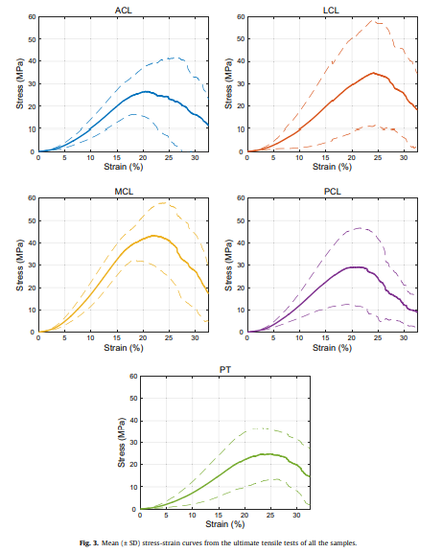
(Figure 4. Stress-strain curves from the ultimate tensile test of Bovine ligaments and patella tendon (Ristaniemi et al 2018)).
Conclusion
Ristaniemi et al. (2018) states that the study of musculoskeletal biomechanics, especially bovine, remain typical to humans. Taking this into account we can use the stress-strain curves in figure 3. and figure 4. that shows each ligament has its own significantly different tensile properties attributed, by Ristaniemi et al. (2018), to density, collagen fibre crimp angles and cross-sectional area, and these findings should be considered for treatment strategies for different ligaments (Smeets et al., 2017). We can conclude from this that too much loading of the ligament can damage healing tissue, while not enough loading can impair growth leading to incorrect organisation of the collagen matrix and weakness in the tissue. With these findings we can utilise appropriate timing and balanced use of mechanical loading on the healing ligament to optimise repair and remodelling of the tissue and improve patient outcomes (Nyland et al., 2020).

References
Frank, C.B. (2004), "Ligament structure, physiology and function", Journal of Musculoskeletal and Neuronal Interactions, Vol. 4, No. 2, pp. 199.
Hauser, R.A., Dolan, E.E., Phillips, H.J., Newlin, A.C., Moore, R.E. and Woldin, B.A. (2013), "Ligament injury and healing: a review of current clinical diagnostics and therapeutics", The Open Rehabilitation Journal, Vol. 6, No. 1.
Karunaratne, A., Li, S. and Bull, A.M.J. (2018), "Nano-scale mechanisms explain the stiffening and strengthening of ligament tissue with increasing strain rate", Scientific reports; Sci Rep, Vol. 8, No. 1, pp. 3707-9.
Morishita, Y., Kanemura, N., Kokubun, T., Murata, K. and Takayanagi, K. (2018a), "Microscopic observation of a rat spontaneous anterior cruciate ligament healing", Annals of Physical and Rehabilitation Medicine, Vol. 61, pp. e417.
Morishita, Y., Kanemura, N., Kokubun, T., Murata, K. and Takayanagi, K. (2018b), "Microscopic observation of a rat spontaneous anterior cruciate ligament healing", Annals of Physical and Rehabilitation Medicine, Vol. 61, pp. e417.
Nyland, J., Huffstutler, A., Faridi, J., Sachdeva, S., Nyland, M. and Caborn, D. (2020), "Cruciate ligament healing and injury prevention in the age of regenerative medicine and technostress: homeostasis revisited", Knee surgery, sports traumatology, arthroscopy : official journal of the ESSKA; Knee Surg Sports Traumatol Arthrosc, Vol. 28, No. 3, pp. 777.
Ristaniemi, A., Stenroth, L., Mikkonen, S. and Korhonen, R.K. (2018), "Comparison of elastic, viscoelastic and failure tensile material properties of knee ligaments and patellar tendon", Journal of Biomechanics; J Biomech, Vol. 79, pp. 31-38.
Shukunami, C., Yoshimoto, Y., Takimoto, A., Yamashita, H. and Hiraki, Y. (2016), "Molecular characterization and function of tenomodulin, a marker of tendons and ligaments that integrate musculoskeletal components", The Japanese dental science review; Jpn Dent Sci Rev, Vol. 52, No. 4, pp. 84-92.
Smeets, K., Slane, J., Scheys, L., Claes, S. and Bellemans, J. (2017), "Mechanical Analysis of Extra-Articular Knee Ligaments. Part One: Native knee ligaments", The knee; Knee, Vol. 24, No. 5, pp. 949-956.
Stamenov, N., Yordanova, P., Dimitrov, D., Telbiyska, M. and Stefanov, M. (2019), "The Epiligament: Structure, Postnatal Development and Role in Ligament Healing", Curēus (Palo Alto, CA); Cureus, Vol. 11, No. 6, pp. e4836.
van Melick, N., van Cingel, R.E., Brooijmans, F., Neeter, C., van Tienen, T., Hullegie, W. and Nijhuis-van der Sanden, Maria WG (2016), "Evidence-based clinical practice update: practice guidelines for anterior cruciate ligament rehabilitation based on a systematic review and multidisciplinary consensus", British journal of sports medicine, Vol. 50, No. 24, pp. 1506-1515.
Wan, C., Hao, Z., Wen, S. and Leng, H. (2014), "A quantitative study of the relationship between the distribution of different types of collagen and the mechanical behavior of rabbit medial collateral ligaments", PloS one; PLoS One, Vol. 9, No. 7, pp. e103363.
Zhang, S., Singh, S. and Winkelstein, B.A. (2018), "Collagen organization regulates stretch‐initiated pain‐related neuronal signals in vitro: Implications for structure–function relationships in innervated ligaments", Journal of orthopaedic research; J Orthop Res, Vol. 36, No. 2, pp. 770-777.
Zitnay, J.L. and Weiss, J.A. (2018), "Load transfer, damage, and failure in ligaments and tendons", Journal of orthopaedic research; J Orthop Res, Vol. 36, No. 12, pp. 3093-3104.

