

Programme: BA (Hons) Leadership and Management Skills for the Workplace
Module: Organisational Culture
Module code: LCLM 5005
Assignment Title: Component 1 Organisational Culture: Individual Report

Student Name: Ana Capatina
Student ID number: 2408124

Word Count: 3024

Table of contents
1.0 Introduction 3
2.0 Influence of organisational culture on structure and decision-making process 3
3.0 Application of theories and identification of organisational culture at BA 5
3.1 Schein’s Model of Organisational Culture 5
3.2 Handy’s Cultural Types 7
3.3 Hofstede’s Cultural Dimension 8
4.0 The ways an organisation leverages its culture to adapt to external environmental influences 9
5.0 Organisational culture acts as a barrier or an enabler 10
6.0 Impact of OC on organisational performance and recommendations for improvement 13
6.1 Impact of OC on organisational performance 13
6.2 Recommendations for improvement 13
7.0 Conclusion 15
References 16

1.0 Introduction
Organisational culture is a leading factor that influences the behaviour of employees as well as organisational performance. It also influences the long-term success of the company. Understanding culture allows companies to connect their structures, values, and management practices with strategic objectives (Vasumathi et al., 2025).

Figure 1: British Airways logo
(Source: British Airways, n.d.a)
The study aims to examine British Airways’ organisational culture using relevant theories and models. British Airways is a leading airline company of the UK that is bringing people, places as well as diverse cultures closer for over 100 years (British Airways, n.d.a). The study can find the dominant characteristics of culture within the company and examine the ways’ organisational structure, decision making and organisational effectiveness are influenced by culture.

2.0 Influence of organisational culture on structure and decision-making process
Culture in an organisation plays an important role in structuring both organisational structure as well as decision making process. According to Mullins and Christy (2016), culture has a direct influence on “how things are done around here”. Culture establishes shared values, beliefs, as well as behaviour that guide the actions of employees. In the context of British Airways (BA), organisational culture has a dramatic influence on its hybrid matrix and divisional organisational structure. It also influences the strategic decision-making practices of the organisation.
The concerned company has maintained a strong-performance-focused and consumer-centric organisational culture. This allows the company to become the world’s leading airline. Organisational culture (OC) of the company prioritises excellence, promotes care and open-mindedness (British Airways, 2024a). This culture helped in developing a formal organisational structure.
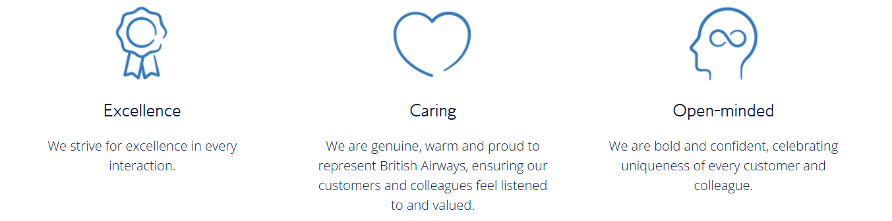
Figure 2: Cultural values of BA
(Source: British Airways, 2024)
The organisational structure (OS) of the company is characterised by clear lines of authority. The culture follows standardised procedures and defined responsibilities. Such a structure is important in the aviation industry. The aviation industry is characterised by regulatory compliance, safety and operational consistency (Lawrenson and Braithwaite, 2018). Alignment between structure and culture maximises coordination and effectiveness across departments. However, highly hierarchical structures might minimise flexibility and respond slowly to environmental changes. It sometimes disconnects employees from top-level management (Nibusinessinfo, 2020). Culture also impacts the decision-making process of the organisation. BA emphasises service quality, safety and operational excellence (Nath, 2025). This influences the decision-making of managers regarding employee training, standards of consumer services and investment into technology.
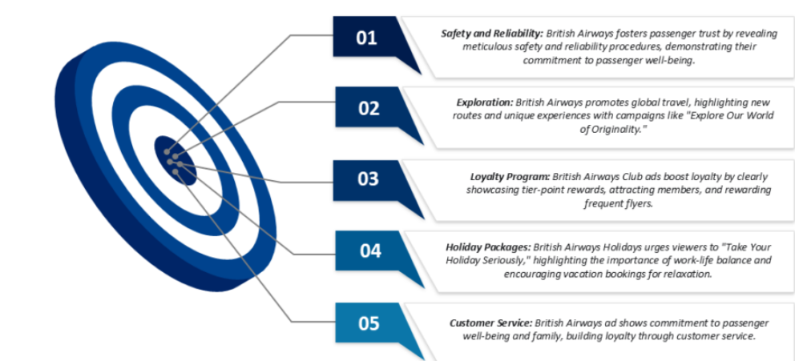
Figure 3: BA’s focus areas
(Source: Nath, 2025)
These managerial decisions are shaped by underlying assumptions, for example, professionalism, consumer satisfaction and reliability. Additionally, the research shows that BA emphasises diversity and inclusion besides prioritising the core values such as excellence, open-mindedness and caring (British Airways, 2025a; British Airways, n.d.). This practice reflects Mullins and Christy’s (2016) argument about the management of culturally different workforces in global organisations. Inclusive cultural values influence wider employee participation and support the development of informed decisions. However, organisational culture can constrain decision-making. Research shows that historically, BA has dealt with a tension between management and employee groups. For example, in 2010, BA was involved in a bitter dispute with Unite over plans to overhaul the contracts of cabin crew (Leggett, 2020). The issue lasted two years and involved 22 days of strikes. Such issues occasionally created resistance to organisational change. This reflects how norms of culture can hinder innovation as well as transformation. This represents the complexity of culture as both an enabler as well as a barrier to the effectiveness of the organisation. The analysis shows that OC significantly shapes OS and decision-making.

3.0 Application of theories and identification of organisational culture at BA
Mikušová et al. (2023) noted that organisational culture is a phenomenon that is composed of individual components. According to Schein’s model, the most common elements of organisational culture include norms, artefacts, values, attitudes, as well as beliefs that exist in the organisation. OC is an outcome of a learning process. Understanding OC is important because it structures the behaviour of employees, leadership, decision-making, as well as organisational performance. In the case of BA, OC can be assessed using different theories, models and frameworks discussed below.

3.1 Schein’s Model of Organisational Culture
According to Schein, many problems in an organisation arise when managers do not understand the different levels of culture. It arises because of managers' lack of understanding of how these levels influence the behaviour of employees and organisational practices (Makumbe and Washaya, 2022, Al Natour, 2019). These different levels include artefacts, espoused values and underlying assumptions.
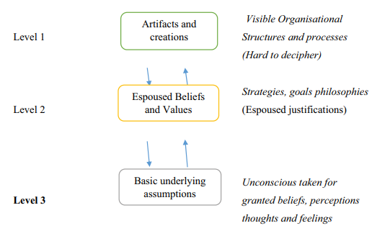
Figure 4: Schein’s Model
(Source: Makumbe and Washaya, 2022)
At the artefact level, a highly professional as well as customer-oriented environment is reflected by BA. This is reflected through the uniforms of employees, service protocols, safety processes, as well as corporate branding. These visible elements indicate the commitment of the company to operational excellence as well as customer service. In 2024, the company launched its onboarding safety video, titled “A British Original Period Drama” (Kadri, 2024). The video is a blend of literature of the UK, TV, and film, with necessary safety instructions.
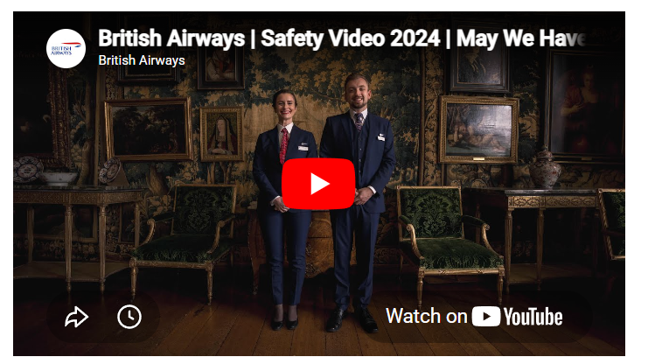
Figure 5: BA safety video
(Source: Kadri, 2024)
At the espoused values level, BA prioritises customer satisfaction, safety, diversity, teamwork, as well as sustainability. These values are established through business strategies, employee training, and organisational policies. At the deepest level, underlying assumptions include the belief that passengers’ trust is necessary for long-term success. It also assumes that the safety of passengers is non-negotiable and that employees need to collaborate effectively to deliver reliable services. These assumptions shape the behaviour of employees as well as the decision-making of managers across the organisation.

3.2 Handy’s Cultural Types
Nasaireh et al. (2019) and Obeidat (2019) noted that Handy (1996) finds four cultural types, including ‘Power Culture’, ‘Role Culture’, ‘Person Culture’, as well as ‘Task Culture’. In a power culture, employees are completely influenced by a leader. Role culture relates to the ways work should be structured to be followed to complete tasks. In task culture, an organisation is influenced by the level of expertise of a leader. In person culture, the organisation exists to help individuals.
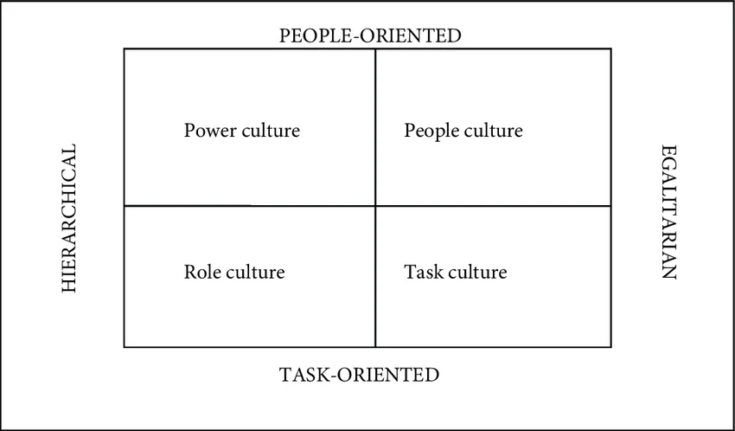
Figure 6: Handy’s Cultural Types
(Source: Janićijević et al., 2018)
BA typically follows a role culture. The role culture of BA is characterised by effectively defined liabilities and formal rules. It is also characterised by hierarchical authority, as well as standardised procedures. This can be exemplified through an airline’s structured organisational hierarchy as well as operational processes. As part of its role culture, the company introduced a £7bn transformation investment programme and established cutting-edge technologies to boost operational performance (British Airways, 2025b). However, components of task culture are also present in BA. This can be seen in project teams that are responsible for performing digital transformation, service innovation, as well as sustainability. According to task culture, teams focus on problem-solving as well as collaboration. This allows them to attain organisational objectives. This indicates that when role culture is dominant in BA, the company increasingly adopts task culture to maximise adaptability as well as competitiveness.

3.3 Hofstede’s Cultural Dimension
Hofstede’s Cultural Dimensions further offer insights into the managerial practices in an organisation. Vizmonte and Ligot (2024) noted that Hofstede’s Cultural Dimensions refer to differences between cultures in organisation and national culture. The cross-cultural differences can be understood through six dimensions, including power distance, individualism-collectivism, and avoidance of uncertainty. It also includes long-term vs short-term orientation, masculinity-femininity, and indulgence-restraint.
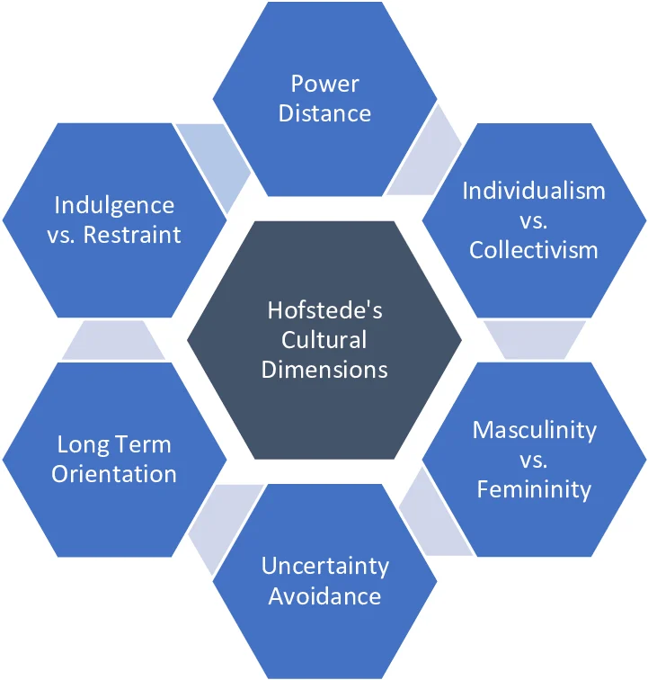
Figure 7: Hofstede’s Cultural Dimension
(Source: Vizmonte and Ligot, 2024)
BA operates across numerous countries, and therefore, the company needs to manage a culturally diverse workforce. Research shows that BA flies to around 200 destinations in over 75 nations (British Airways, 2024b). The company operates 280 aircraft. As mentioned above, the company emphasises inclusion as well as collaboration. These practices reflect the company’s efforts to accommodate different cultural expectations and minimise possible conflicts that arise from differences in power distance, individualism, as well as uncertainty avoidance.

4.0 The ways an organisation leverages its culture to adapt to external environmental influences
In contemporary business settings, it is important for organisations to consistently adapt to external influences, for example, the advancement of technology, changing expectations of consumers and global competition. OC plays a leading role in allowing firms to respond effectively to these changes. In the case of BA, organisational culture supports the adoption of these changes by emphasising consumers' demand, maintaining excellence in operations and ensuring safety, along with consistent improvements. The airline industry is highly competitive. External environmental factors have a dramatic influence on business operations. Yadav and Goriet (2022) noted that fluctuations in fuel price, aircraft maintenance, labour and aircraft operations costs are primary factors that significantly affect the airline’s budget. Uncertainty, such as a pandemic, impacted operational profit as well as the airline's agility.
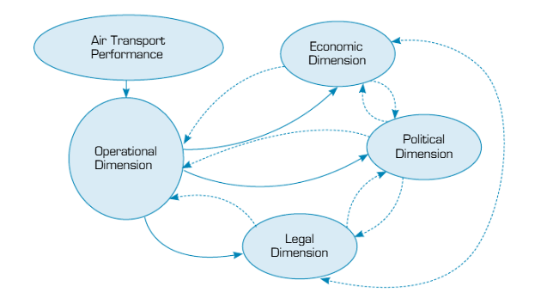
Figure 8: Performance dimension of the airline
(Source: Yadav and Goriet, 2022)
BA performs in a highly competitive and regulated aviation industry. Within the industry, external environmental factors have a direct influence on the operations of the business. BA has a strong safety culture that allows the company to comply with aviation regulations as well as maintain trust among consumers. Research shows that the parent company of BA, International Airlines Group (IAG), offered high-quality safety training to cabin crew through Yellow Academy (Iairgroup, 2025). By establishing safety as a core value in the workplace, BA ensures that employees follow industry standards as well as meet regulatory requirements. This allows the company to adapt effectively to changing compliance demands. The company further developed consumer focus culture to respond effectively to evolving expectations of consumers. Globally, consumers' demand for convenience, digital services and personalised experiences increases. This can be exemplified through the World Bank information that reflects the world gained 1.5 billion new internet users during 2018-2022 (World Bank, 2023). The number of internet users reached approximately 5.3 billion in 2022. In response to this demand, BA has invested in digital transformation initiatives. The company introduces online booking systems, mobile applications and self-service technologies to streamline operations.
Additionally, as mentioned earlier, diversity and inclusion are important cultural values in BA (British Airways, 2025a). This helps the company address the challenges of operating in a global environment. A culturally diverse workforce is capable of better understanding as well as serving consumers from diverse backgrounds and nations (Mouboua et al., 2024). Managing cultural diversity in international orientations is important for operational success. The sustainability demand is also increasing due to increased environmental concern regarding climate change. In response to climate concerns, BA introduced fuel-efficient aircraft as well as sustainable aviation fuel. The company developed a clear roadmap to attain net-zero carbon emissions by 2050 (British Airways, n.d.b). These actions reveal the ways BA’s values guide strategic responses to environmental pressures. The analysis represents that BA leverages its culture as a strategic resource to adapt to technological, regulatory, social and environmental changes. By fostering values of consumer focus, safety, sustainability and diversity, the company becomes more resilient and competitive in a complex global environmental setting.

5.0 Organisational culture acts as a barrier or an enabler
Organisational culture dramatically influences the functioning of the organisation by shaping the behaviour of employees, decision-making, performance and communication. However, there is confusion about whether culture acts as an enabler or a barrier to organisational effectiveness. In the case of BA, OC acts as both an enabler and a barrier. As a part of enablers, OC offers a shared system of values as well as assumptions. It guides employees' actions and supports the goals of organisations. As reflected, the culture of BA represents excellence and open-mindedness (British Airways, 2024a). It represents safety and professionalism. These values of culture allow employees to understand the behaviour expected from them and contribute to the consistent delivery of service. Leadership plays an important role in shaping as well as reinforcing organisational culture (Jerab and Mabrouk, 2023). It supports the effectiveness of the organisation rather than resisting change. The strong culture of the company promotes employee commitment as well as reinforces standards that support customer satisfaction.
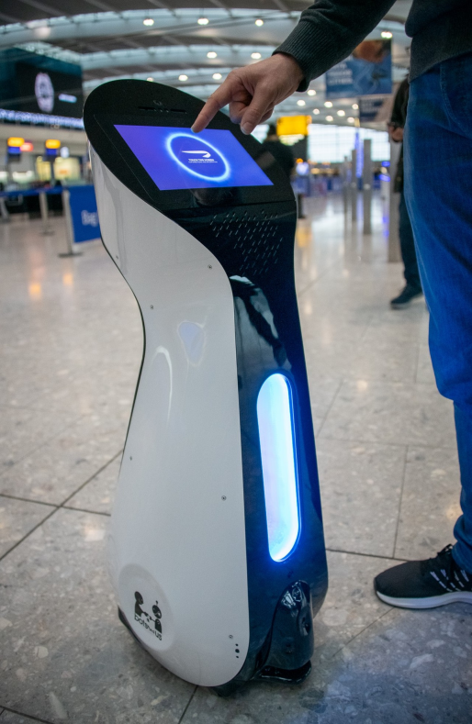
Figure 9: Autonomous robot of BA
(Source: British Airways, 2019)
Culture further facilitates the adaptability of the organisation. BA embraced adaptability through consistent innovation and responded to changing expectations of consumers. For example, in 2019, the company announced that it would start trials of fully autonomous robots in 2020 as a part of its innovation (British Airways, 2019). Additionally, the company explored AI, driverless baggage vehicles and 3D printing to further improve punctuality for customers.
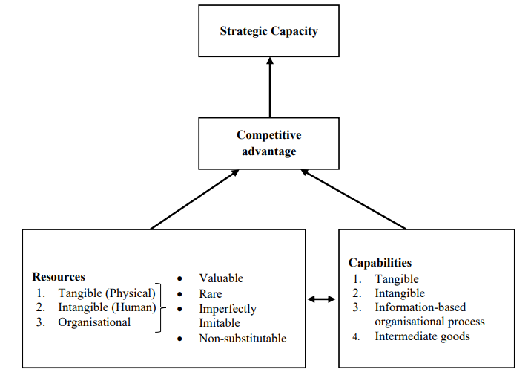
Figure 10: Resource-based view theory
(Source: Lubis, 2022)
According to resource-based view theory, a company’s internal resources as well as capabilities are primary drivers of competitive advantage as well as superior performance (Lubis, 2022). In alignment with the theory, a strong OC can be considered a valuable and inimitable resource that can contribute to a competitive advantage. The ability of the company to integrate employees from different backgrounds can maximise collaboration as well as service delivery across the world. However, OC can also act as a barrier. Strong cultures can cause employees’ resistance to change as they remain attached to established practices as well as routines.
British Airways has encountered major industrial disputes as well as tensions between management and employee groups, as mentioned above (Leggett, 2020). This represents the ways deeply embedded cultural norms can hinder organisational transformation. Additionally, a highly structured role culture can minimise flexibility and discourage participation of employees in decision-making. Based on the analysis, it can be interpreted that BA’s OC acts more as an enabler than a barrier. When cultural rigidity can occasionally hamper adaptation, the organisational values positively impact operational effectiveness. Thus, OC can maximise the function of the organisation when cultural values are actively managed by leaders, and both employees as well as leaders adopt these values to meet evolving environmental and corporate demands.

6.0 Impact of OC on organisational performance and recommendations for improvement

6.1 Impact of OC on organisational performance
OC has a significant impact on the performance of an organisation. It is because OC influences the behaviour of employees, motivation, productivity, as well as the attainment of strategic objectives. In BA, culture contributes to performance by promoting shared values related to consumer service, professionalism as well as operational excellence. These values guide the actions of employees and support a consistent quality of service. This further helps in strengthening the satisfaction of consumers and brand reputation. An effective OC can improve the commitment of employees as well as their involvement (Pathan, 2023). This is done by creating a sense of belonging as well as shared purpose. Cultural values allow employees to understand the expectations of companies. This further resulted in increased coordination as well as efficiency. Due to the cultural value, the company launched a multi-channel advertising campaign along with its Uncommon Creative Studio (British Airways, 2022). The aim of the campaign was to strengthen the brand identity of the airlines by celebrating the unique travel motivation. This campaign helps the company develop a deeper connection with consumers, understand their needs and improve services accordingly.
Additionally, the diversity and innovation approaches of the company help it respond effectively to changing market conditions and address the expectations of consumers. However, culture can negatively affect organisational performance. A rigid culture can contribute to employees ' resistance to change. It can minimise flexibility and slow responses of organisations to external challenges. Research shows that the company faced operational challenges, including Heathrow power outage (British Airways, 2026). Despite over 700 cancellations, the company ensures its success because of an effective organisational culture. Cultural values and resilience of colleagues across the operations ensure improved performance of the company. Thus, it can be interpreted that BA’s culture has a positive impact on organisational performance. It maximises effectiveness, satisfaction of consumers, engagement of employees and long-term success in the organisation.

6.2 Recommendations for improvement
- Strengthening a learning-focused culture: BA is recommended to develop a learning culture that influences continuous professional development, sharing of knowledge and organisational learning. According to Peter Senge’s Learning Organisation model, individuals consistently expand their capacity to develop desired results (Springmier et al., 2024). Regular training programmes in the workplace, especially on consumer service digital skills and sustainability, would maximise employees’ adaptability. It can support innovation in the rapidly changing aviation industry.
- Enhancement of employee participation as well as empowerment: In order to improve organisational culture and practices, BA is recommended to strengthen employees’ involvement in decision development. Mansor et al (2023) opined that employee engagement positively impacts organisational productivity. By establishing cross-functional teams, forums for employee consultation, as well as feedback mechanisms, BA would ensure the contribution of staff to idea development. It can support organisational change initiatives more effectively.
- Strengthening transformational leadership practices: Leadership plays an important role in shaping a positive as well as adaptive culture. According to transformational leadership theory, transformational leaders inspire employees through shared vision, innovation as well as empowerment (Iqbal et al., 2023). Managers are recommended to actively communicate the goals of the organisation, identify employee contributions, as well as influence collaboration across departments. This would strengthen the engagement of employees and also ensure successful change in culture.
- Fostering innovation as well as readiness for change: BA is recommended to establish a system that influences experimentation as well as innovation. BA is suggested to reward creative problem-solving and support initiatives of digital transformation. This would help the company respond effectively to changes in the external environment and also maintain excellence in operations along with long-term competitiveness.
- Promotion of agility in culture: Carvalho et al. (2023) noted that organisational agility has a positive impact on operational excellence. Thus, BA is recommended to maximise intercultural training along with inclusive leadership programmes to improve cultural agility. This suggestion would improve collaboration among diverse employees as well as support consumer service across the global market.

7.0 Conclusion
Thus, in conclusion, the culture of the organisation refers to a fundamental driver of organisational effectiveness at BA. The company’s role-oriented culture is supported by strong cultural values. These values include safety, consumer service, professionalism, as well as excellence of operations. When cultural rigidity occasionally limits organisational change, BA’s culture acts as an enabler of performance and adaptability, as well as allowing the company to attain advantages over competitors. The company can continue their investment in employee empowerment, learning, transformational leadership, as well as innovation. This will help the company strengthen operational resilience along with long-term success in a dynamic aviation industry.

References
Al Natour, W. (2019) ‘Organizational Culture Management: Reality or Myth’. Researchgate. Luettavissa: https://www. researchgate. net/publication/332569673_Organizational_Culture_manageme nt_Reality_or_Myth. Luettu, 20, p.2020.
British Airways (n.d.) Our Culture, careers.ba.com. Available at: https://careers.ba.com/our-culture (Accessed: 18 May 2026).
British Airways (2019) British Airways Trials Robots To Guide Customers Through The Airport, Available at: https://mediacentre.britishairways.com/news/19122019/british-airways-trials-robots-to-guide-customers-through-the-airport (Accessed: 27 May 2026)
British Airways (2022) British Airways launches its new brand positioning: A British Original, Available at: https://mediacentre.britishairways.com/pressrelease/details/14254 (Accessed: 28 May 2026)
British Airways (2024a) Our Culture, Available at: https://careers.ba.com/our-culture (Accessed: 22 May 2026)
British Airways (2024b) Reasons to book with British Airways, Available at: https://mediacentre.britishairways.com/factsheet/details/43 (Accessed: 26 May 2026)
British Airways (2025a) People | Inclusion, Diversity & Representation, Available at: https://www.britishairways.com/content/en/in/information/about-ba/ba-better-world/people (Accessed: 24 May 2026)
British Airways (2025b) British Airways improves on-time performance as world-leading technology boosts flight punctuality, Available at: https://mediacentre.britishairways.com/news/14052025/british-airways-improves-on-time-performance-as-world-leading-technology-boosts-flight-punctuality (Accessed: 26 May 2026)
British Airways (2026) A message from CEO Sean Doyle to colleagues following release of IAG annual results, Available at: https://mediacentre.britishairways.com/pressrelease/details/24855 (Accessed: 28 May 2026)
British Airways (n.d.a) About British Airways, Available at: https://www.britishairways.com/content/en/in/information/about-ba (Accessed: 22 May 2026)
British Airways (n.d.b) Planet | BA Sustainability, Carbon Reduction & Net Zero, Available at: https://www.britishairways.com/content/information/about-ba/ba-better-world/planet (Accessed: 27 May 2026)
Carvalho, A.M., Sampaio, P., Rebentisch, E., McManus, H., Carvalho, J.Á. and Saraiva, P. (2023) ‘Operational excellence, organizational culture, and agility: bridging the gap between quality and adaptability’ Total Quality Management & Business Excellence, 34(11-12), pp.1598-1628.
Iairgroup (2025) Annual Report, Available at: https://www.iairgroup.com/media/ktnlp1jx/iag-annual-report-and-accounts-2025.pdf (Accessed: 26 May 2026)
Iqbal, J., Ashraf, H.A., Islam, A. and Ahmad, M. (2023) ‘The empowerment bridge: Assessing the role of employee empowerment in transmitting the impact of servant and transformational leadership on creativity and team innovation’ Journal of Business and Management Research, 2(2), pp.1-18.
Janićijević, N., Nikčević, G. and Vasić, V. (2018) ‘The influence of organizational culture on job satisfaction’ Economic Annals, 63(219), pp.83-114.
Jerab, D. and Mabrouk, T. (2023) ‘The role of leadership in changing organizational culture’ Available at SSRN 4574324.
Kadri, S. (2024) British Airways Launches New Safety Video: “A British Original Period Drama”, Available at: https://www.businesstraveller.com/news/british-airways-safety-video-2024/ (Accessed: 25 May 2026)
Lawrenson, A.J. and Braithwaite, G.R. (2018) ‘Regulation or criminalisation: What determines legal standards of safety culture in commercial aviation?’ Safety science, 102, pp.251-262.
Leggett, T. (2020) British Airways: A breakdown in trust?, Available at: https://www.bbc.com/news/business-53023563 (Accessed: 25 May 2026)
Lubis, N.W. (2022) ‘Resource based view (RBV) in improving company strategic capacity’ Research Horizon, 2(6), pp.587-596.
Makumbe, W. and Washaya, Y.Y. (2022) ‘Organisational culture and innovation: testing the Schein Model at a private university in Zimbabwe’ Cogent Business & Management, 9(1), p.2150120.
Mansor, F.A., Jusoh, Y.H.M., Hashim, M.Z., Muhammad, N. and Omar, S.N.Z. (2023) ‘Employee engagement and organizational performance’ International Journal of Accounting, Finance and Business, 8(50), pp.69-80.
Mikušová, M., Klabusayová, N. and Meier, V. (2023) ‘Evaluation of organisational culture dimensions and their change due to the pandemic’ Evaluation and Program Planning, 97, p.102246.
Mouboua, P.D., Atobatele, F.A. and Akintayo, O.T. (2024) ‘Cross-cultural competence in global HRD: Strategies for developing an inclusive and diverse workforce’ International Journal of Science and Research Archive, 12(1), pp.103-113.
Mullins, L. and Christy, G. (2016). Management and Organisational Behaviour (11th ed.). Pearson Education Limited.
Nasaireh, M.A., Abdullah, A.H. and Obeidat, K.A. (2019) ‘The relationship between cultural types according to Handy’s model and organizational structure in Jordanian public universities’ International journal of academic research in business and social sciences, 9(1), pp.973-985.
Nath, K. (2025) British Airways’ diverse ad campaigns highlight safety, luxury, and service excellence: GlobalData, Available at: https://www.traveldailymedia.com/british-airways-diverse-ad-campaigns-highlight-safety-luxury-and-service-excellence-globaldata/ (Accessed: 24 May 2026)
Nibusinessinfo (2020) Hierarchical organisational structure, Available at: https://www.nibusinessinfo.co.uk/content/hierarchical-organisational-structure (Accessed: 22 May 2026)
Pathan, M.S.K. (2023) ‘Assessing the mediating role of job satisfaction in the relationship between organizational culture and employee commitment’ International Research Journal of Education and Innovation, 4(1), pp.1-11.
Springmier, K., Fonseca, C., Krier, L., Premo, R., Smith, H. and Wegmann, M. (2024) ‘A learning Organization in Action: applying Senge's five disciplines to a collections diversity audit’ portal: Libraries and the Academy, 24(2), pp.251-263.
Vasumathi, A., Vasudevan, A., Razak, A. and Mohammad, S.I.S. (2025) ‘An empirical study on the impact of organizational culture dimensions on employees’ performance through organizational support in the IT industry’, Social Sciences & Humanities Open, 12, p. 102054.
Vizmonte, E.J. and Ligot, D.V. (2024) ‘Analyzing the relationship between cultural dimensions and educational performance using Hofstede model and PISA data’ Available at SSRN 4686789.
Worldbank (2023) Digital Progress and Trends Report 2023, Available at: https://openknowledge.worldbank.org/server/api/core/bitstreams/95fe55e9-f110-4ba8-933f-e65572e05395/content (Accessed: 27 May 2026)
Yadav, D.K. and Goriet, M.O. (2022) ‘An illustrative evaluation of external factors that affect performance of an airline’ Journal of Aerospace Technology and Management, 14, p.e1122.

