Learning in the Digital Era
Video Presentation

Ellis Christie
2203571
Animation & VFX

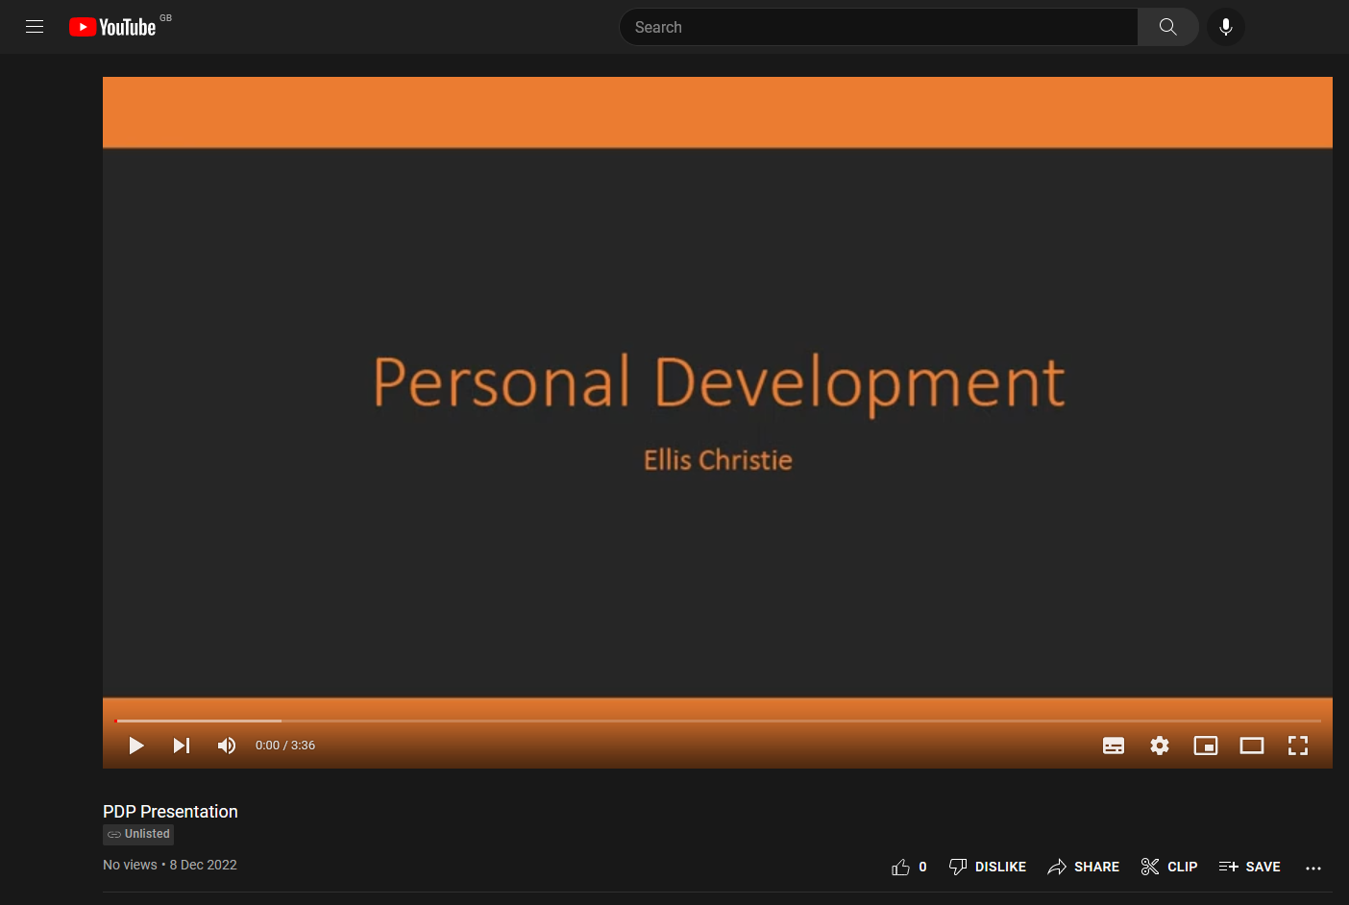

Video Link: https://www.youtube.com/watch?v=VWFRVZhhHe4
Presentation Link: Personal Development.pptx

