

STUDENT NAME: ANCUTA CHIRITA
STUDENT ID NUMBER: 1605755
COURSE CODE: BMSK4001
COURSE NAME: ACADEMIC AND EMPLOYABILITY SKILLS
LECTURER NAME: SYLVIA HOFFMAN
WORDS COUNT: 1994 WORDS

Table of Contents
INTRODUCTION 2
DESCRIPTION 2
FEELINGS 4
EVALUATION 5
ANALYSIS 5
CONCLUSION 7
ACTION PLAN 7
REFERENCES 7

INTRODUCTION

The purpose of these report, is to reflect, about how the learning in this module helped me to develop my academic and employability skills, and also, to reflect on any skills gap and suggest ways to might improve on these gaps.

DESCRIPTION

From the beginning, I thought that, at these time of my life, I know about employability skills. Also, I thought the same thing about the academic skills. But this course, proved me that I was not such an informed person, like I have been thinking, about it. Every class, showed me again and again, a fact that I knew from long time, meaning, as much as a person start to learn about something, always realise how little information have it. Things like interpersonal skills and intrapersonal skills, was totally unknow for me at that moment, even if, in every single day, there was present in my life. Everything looks like I have been hearing about, for the first time, or like I have been blind until then and I did not realize all of these. Basic notions like, simple, compound, complex, complex-compoud sentences start to came from deep deep inside of my mind.
In another class, I learned about strengths and wicknesses, about personal qualities, about the skills categories like basic skills and thinking skills, people skills and personal skills. I have never thinked before about that, even that I knew about all these skills to the people. Our lecturer from the first term, explained us about each one skill in depth way, about adaptability, flexibility, about being well educated, about good communication and effective communication, about good time management, reliability, punctuality, loyalty and confidentiality, about being organized and having a positive attitude, how important are each one of these skills, and what happen when a person doe not have this skills.
When we learned about intrapersonal skills, especially about the strategies which can stop procrastination, I had to admit that sometimes, I am procrastinaiting too, which is not good at all.
I had learned about how to refer my work, which I considered very complicated from the beginning, I have been thinking I will never be able to do that in a propertly way, according to Harvard system, now I feel better about it, but I still have to learn a lot. Anyway I did understood why is so important to refer in an academic way your work, and how much do not do that, it could ruin all your efforts.
In one class, we have been speaking about a jurnal that it would be good for us to have it, to note it in daily, and to reflect about what happened during the day, what we had done it wrong, what we could do in another way to have a better result, what it was good, what does it means for my future. I have been thinking in a funny way because I thought it is like the jurnal from the teenage time, about I feel emberaced about right now. But soon I understood the difference, I am not the one from that time, I am not doing, thinking childish things, and now we are speaking about serious things and very helpful. So I have tried. I discovered myself in a different way, I discovered how easy is to remember a lot of things from the days passed, to reflect about it, and to learn from my mistakes, from some other mistakes, and the most important, do not repeat the same mistakes. Also, to improve my behaviour every day, as aperson, as an employee, as a team member, as a student, as a workmate.
In the second term, we start with a lesson about how to be realistic when we are trying to find a job. It sounds easy, logical, with common sense. To look after a position that we are qualificated to work, to look after the domain that we are good and prepared, to sort the jobs after the position that are they looking for, to check if the condition know from the first step are convenient for us, if the job is still available, to look at the travel distance, to check the reputation of the company. I also learned that some informations it should be putted in a good curriculum vitae, and another like address, marital status it should not be because it is not relevant for me as an employee.
Another good lesson from the second term it was about writing a report, how to search and research the informations, gathering the information, and about the investigating, organized, systematic method of finding answers to a question from a need, or just couriosity. When I try again and again to find the answer, that means research. I can do it talking to people, or start research about research, or having feedback from others. An answer could find it empirical, when you gather information through experiments or observation, means from your own experience or somebody else in the front of your eyes, or non empirical, relying on theories, impressions, perceptions. The empirical answers it is fiding by quantitative research, when you deal with numbers, and the non empirical it is qualitative research. About the types of research, I could mention to try in online, coversations and interviews, surveys and questionaries, community investigations and case studies. I learned about the primary sources as original documents and secondary sources as readily available publications.
In the pre empirical stage we should define research area as the first step, clarify the topic meaning to define the question that we are trying to find answer as the second step, and form hypotheses, find potential answers as the last step.
According to Punch, 2005, in the empirical stage, we should design research based on how, where, when questions as the first step, to collect data as the second step, to analyse data as the third step and form the answers as the last one.(K.F.Punch,2005)

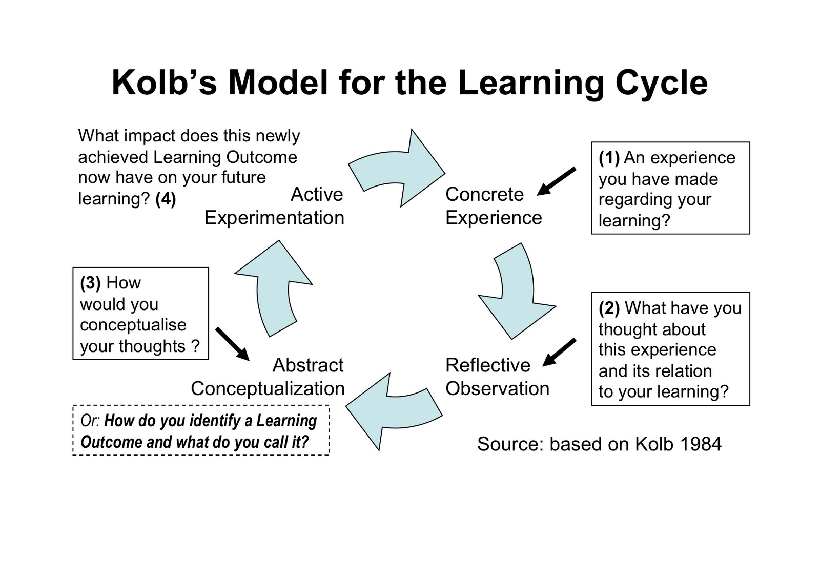 (Anon., n.d.)
The almost last classes it was about analytical critical thinking. Definitevelly my favour one from this course. That does not means the rest I did not like it. But this one, was a special one for me. It was like our lecturer teached us how to make a dissection to everuthing, how to pull things apart and look at them in details, how to synthesise, how to question “why”, to interpret and evaluate things, do not biasing, to distingnish facts from opinions, to be sceptical in a good way, and finally to conclude in our own way and argue. I also realized by learning, how much being an analytical person, makes you more employable. It is a type of intellectual discipline that emphasizes the logical syntesis of information to produce informed though and action. And it is also a transferable skill.

FEELINGS
From the beginning, I felt lost in all these information and I thought I will not be able to understand, keep it and fix it in my mind, use it. I thought my connection with learning, it is lost forever, because of the age, language… But very soon I will discover that my brain is not blocked, in the mather fact became not only unblocked, became even courious again, ready to make sinapses again, and in short time, I realize how much I have been missing school, learning, because made me feel alive again. In one class we had learned about the ability to recognize the emotions in other people and inside of you.
I have learned about reliable and not reliable sources, how to filter information, how to select what is good and what is not good, and I start to explain why I have been cautious about a lot of things, why I prefer to listen, read and make my own opinion about everything, and I discover that means to have analythical critical thinking skill. This class was one of my favour also in this course.
I found out also, not with pleasure, that sometimes I have been also a procrastinaiting person, and of course, I start to think about how to control and eliminate this behaviour from my personality. Because I am a very talkactive person, I have start to learm how to say only important things, how to speak when I really have something to say, to listen when is necessary, and trying to transform this behaviour in a positive skill.
I have learned to structure a good paragraph. Now I have a better idea how to define my thoughts, and not only to define, also to argue. About the skills, now I am thinking always why is good to have it and what if you do not have it, how I can develop, which is a more deeper thinking that before.
In one class, unforgetable one, our lecturer teached us about Analytical Critical thinking, about how to pull things apart and look at them in details, how to synthesize things, to question “why”, to interpret, to evaluate, everything without biasing, being cautious, distingnishing facts from opinions, like a good judge which should have critical skill, and put a conclusion, our own, based on facts and proves. It is a type of intellectual discipline that emphasizes the logical synthesis of information to produce informed though and action. Definitively, my favour class from all this course. And the lecturer was magical.

EVALUATION

It was a very good course, and the lecturers, Anita Nan and Sylvia Hoffman, I felt about more than just two teachers, I felt like two very close persons, on the same wave with me. I felt like I knew both from long time, and we just met again. It was my favour course from all, a bid part because of the lecturers.

ANALYSIS

Borton reflective circle (Borton, 1970), explain us how to reflect based on three questions:
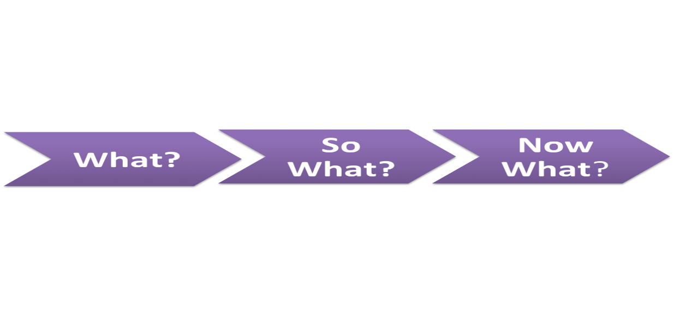

(Anon., n.d.)
We learned about some models of reflection and reflective writing like: Borton’s model (1970), based on “what, so what, now what” kind of questions, and based on ourself changed which is very hard today.
Kolb’s cycle (1984) which is very experimental in education;
Hatton and Smith (1995), with critical reflection,
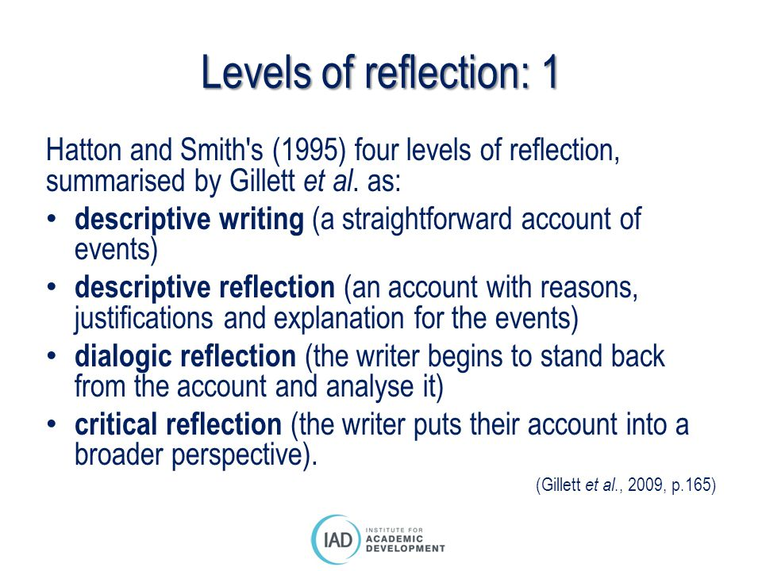
(Anon., n.d.)
Brookfield’s, with stages assumption analysis, contextual awerness, imaginative speculation and reflective scepticism.
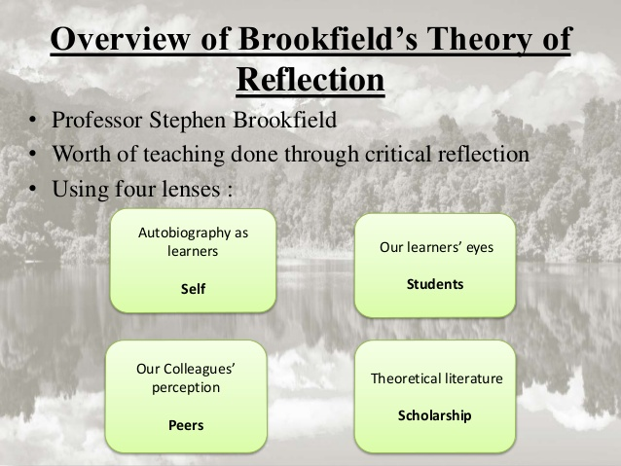 (Anon., n.d.)

CONCLUSION

This course, helped me to discover information that clearified to me things about myself in a deep way. Things like how to communicate with others, how to make myself clear when I have an opinion, how to assume my opinions based on facts, based on real informations not to others opinion. How to manage my time, how to transform all these informations in skills, which I think it is the most important thing. Knowing something it is not enough, without to transform it in skill, which is the most usefull. I also learned a lot of ways to improve the skills that I have it, by boost my brain power, playing brain games, reading books, which I always loved to do, learning new things every single day, transform that in habbit, not only for became a more employability person, also for being a health brain person, updated to the reality in each moment.

ACTION PLAN

Because I just re discover the pleasure to learn in an academical environment, I intend to keep doing this as long as is possible. I intend to finish university, to continue with a master degree, and maybe a doctorate degree.

REFERENCES
Anon., n.d. [Online]
Available at: https://www.bing.com/images/search?view=detailV2&ccid=9sLG6j1j&id=5E0C5AB53BCF060A26A9D596E4634B1648AF79EE&thid=OIP.9sLG6j1jCk_mzayR4R0kNAHaGE&mediaurl=http%3a%2f%2fwww.sdduonline.leeds.ac.uk%2freflection%2fwp-content%2fuploads%2fsites%2f3%2f2013%2f07%2fB
[Accessed 22 April 2018].
Anon., n.d. [Online]
Available at: https://www.bing.com/images/search?view=detailV2&ccid=rp5mfuWP&id=C3ED5F59758307B64E0D761E5EB54186DE1800DA&thid=OIP.rp5mfuWPQp3M451UbiEt_AHaFO&mediaurl=http%3a%2f%2f3.bp.blogspot.com%2f-UE3OL4LeXT0%2fThQAFm4m9YI%2fAAAAAAAAAAY%2fYaM8Am39REQ%2fs1600%2fKolb%
[Accessed 26th April 2018].
Anon., n.d. [Online]
Available at: https://www.bing.com/images/search?view=detailV2&ccid=MkN3YXMX&id=BE96AD0977B7FB664DE927D6D607094DCF502006&thid=OIP.MkN3YXMX-wbkZcc9R-Y79gHaFj&mediaurl=http%3a%2f%2fslideplayer.com%2f1381928%2f8%2fimages%2f16%2fLevels%2bof%2breflection%253A%2b1%2bHatton%2
[Accessed 30th April 2018].
Anon., n.d. [Online]
Available at: https://www.bing.com/images/search?view=detailV2&ccid=gMuBJI4z&id=F177774774F040B8883E7C2A8F73F2BDA53F7561&thid=OIP.gMuBJI4zFZFWKB3A0MAzPQHaFj&mediaurl=http%3a%2f%2fimage.slidesharecdn.com%2fbrookfieldstheoryofreflectionfinal-1-150409094728-conversion-gat
[Accessed 30th April 2018].
Borton, 1970. [Online].

