
Skills for the Workplace
Module Assignment Submission
Student Name: | Carrie-Ann Elizabeth Moore
Student Number: | 1811709
Module No: | BMSK6003
Module Title: | Leading and Implementing Workplace Change

Statement of Confirmation of Authenticity
By the act of making this submission, the student declares that this is the work of the student named above. The work has not, in whole or in part, been knowingly presented elsewhere for assessment, or where assessment has been built on a previous assessment, this has been identified. Where materials have been used from other sources it has been properly acknowledged. If this statement is untrue, the student acknowledges that an assessment offence has been committed.
Attention is drawn to the plagiarism and unfair practice policies of both the University and of ILM.
Permission for ILM to use this script
ILM uses learners’ submissions – on an anonymous basis – for assessment standardisation. By submitting, both the centre and the learner agree that ILM may use this script on condition that identifying information is removed. However, if you are unwilling to allow ILM to use this script, please refuse by ticking the box: X

Table of Contents
Introduction 4
Critically analyse the relationship between environmental change and organisational capability 4
What is Change Management and why is it important? 4
Change Management models 5
What forces drive change? 7
Macro (wider) environment (External Factors) and Micro (organisational) environment (Internal Factors) 8
External Factors 8
Internal Factors 9
Impact on workplace culture, workplace capability and their relationship to change 10
Conclusion 11
How can organisational stakeholders be effectively led through workplace change? 11
What are stakeholders? 12
Stakeholder analysis 12
Conclusion 12
Explore contemporary issues and their impact on business management 13
Why do Change processes fail? 13
Change Reluctancy and how to overcome the resistance 14
How to celebrate milestones and successfully implemented change processes 16
Conclusion 17
References 18
Appendices 23
Appendix 1 Kotter’s Model 23
Appendix 2 Lewin’s Model 23
Appendix 3 Senge’s Model 24
Appendix 4 Shapiro’s Model 24
Appendix 5 Porter’s Five Forces 25
Appendix 6 PESTEL Analysis 25
Appendix 7 SWOT Analysis 26
Appendix 8 Positive Feedback Loop 27
Appendix 9 Negative Feedback Loop 28
Appendix 10 Power-Interest Matrix 28

Introduction
This report will critically analyse the relationship between environmental change and organisational capability by discussing how internal and external factors drive change. The report will investigate the impact change has on workplace culture and capability and how change relates to both, workplace culture and capability and will be discoursing different change models and analyse how change management is affected through leadership. Further, the report will discuss stakeholder analysis and how Kotter’s eight step change process aids with change management. Finally, the report will review the effects of change reluctancy and how they can be overcome. As the student works as a project manager on a change project within the Ministry of Defence, she will include a workplace change example to highlight the impact change reluctancy can have on business performance if not carefully managed.

Critically analyse the relationship between environmental change and organisational capability
In this section, the report will start by explaining what change management is and then move on to a selection of different change management models. The report will further discourse the macro- and micro-environments that drive change and move on to the impact this has on workplace culture and capability.

What is Change Management and why is it important?
‘The Effective Change Manager’s Handbook’ describes Change management as an ‘emergent profession’ due to the ever-increasing demand to create changes to organisations. With change projects having failed often in the past, a need for professional change managers was created, who could lead organisations through small and major changes whilst controlling the reluctancy many employees have toward change (Smith et al, 2014). This statement is supported by Gleeson (2017) who argues that change processes fail in up to 70% of instances. But why is change of such importance? A business inevitably will need to change for different reasons, internal and external factors, to remain competitive. Failing to change and adapt to challenges and opportunities swiftly may lead to business failure. This argument is supported by the example of the Blockbuster business failure. In 2000 the founder of Netflix proposed a partnership with Blockbuster but was ‘laughed out of the room’. The business’ failure to adapt to the changing needs of its users ultimately led to the inability to compete with online streaming services and made the business obsolete (Satell, 2014).

Change Management models
There are four models the report will investigate further by disseminating a workplace change scenario.
Kotter’s eight-step model, which describes a map based on frequent mistakes businesses have made when attempting to introduce change to the workplace. (Appendix 1; Laig et al, 2021)
Lewin’s three-step model, which describes how the group mentality is broken down to effectively enable change to happen. (Appendix 2; Hussain, 2018)
Senge’s systems thinking model, which bases its foundation on learning to enable major organisational changes. (Appendix 3; Chow, 2014)
Shapiro’s Tipping Point model, which focuses on when and how effectively a business should make changes, rather than whether it should make a change. (Appendix 4; Shapiro, 2018)
The student works within the Ministry of Defence and as such the current illegal war in Ukraine has had a sudden impact on day-to-day business. It has become apparent that there must be a higher focus on recruitment and retention within the Army, contrary to previous years, in which the Army was being reduced (Allison, 2022). Using Kotter’s eight steps to organisational change, the report will analyse how the change can be created, seeking similarities and differences between the other mentioned models. Kotter’s model approaches change by using common mistakes businesses have previously made during a change project and offers solutions on how to avoid them (Kotter, 1995), in this case the drastic reduction of the Army previously.
1 Creating a sense of urgency – As the Ministry of Defence is a government organisation, the government and those involved in the change must see the changes as essential. According to Kotter, at least 75% of them, to start the change process.
2 Creating a guiding alliance – the persons in charge of the organisational change must be effective leaders, driven by a common goal. In this scenario it includes being able to manage the media effectively, as the country (it’s citizens, businesses, etcetera) is a stakeholder
3 Creating a vision and strategy – The vision and strategy should be SMART (Specific, Measurable, Achievable, Relevant and Timed). If this is not the case, the change will face reluctance. In this case it could be Specific – Recruitment and retention to stabilise; Measurable – 75000 Full-time serving personnel; Achievable – Use of recruitment campaign strategies that have worked/ failed in the past; Relevant – To counter the change in threat and make the Army sustainable; Timely – Over the next three years
4 Communicating the vision of change – The change must be communicated in a clear and concise manner to all stakeholders. In this case, the media must be worked with effectively as well as internal communications must be delivered to a high standard
5 Empowerment of employees– The workforce should feel like they are making a difference through the change. As this change is a big undertaking, it very much falls in with point four to communicate why and how this change will create a difference
6 Creating short-term wins – this will increase morale and satisfaction that the change is worthwhile. Setting milestones for achieving specific recruitment/ retention rates.
7 Consolidation of gains and production of further change – Instead of reverting to the pre-change phase, Kotter suggests to ‘press on’ and deliver further change instead of becoming complacent. As government organisations face constant change depending on factors such as who formed the government, threat levels within the country and internationally, it becomes difficult to not revert to pre-change in this instance, however, learning lessons and understanding continued need for an adequately staffed Army will support the case.
8 Embedding changes into the organisational culture – It is important that changes are aligned with the organisational culture to be successful. The organisational culture in this instance has a much wider impact than solely the Ministry of Defence. Changes in government may mean the organisational culture changes by some degree.
Lewin’s model is based on three stages (Smith et al, 2014):
1 Unfreezing: the breaking down of habits and ways of thinking
2 Change: unclear and confusing time during which old ways being disputed, but a clear way forward is not yet distinguished
3 Refreezing: Establishing of the new habits and ways of thinking
In comparison to Kotter’s model, Lewin appears to have a similar approach by creating a sense of urgency, need to change and understanding of the change in the first block. Having the second block ‘Change’ seems to rely on the leadership effectively communicating and ‘selling’ the change, so all stakeholders can see how it will affect and benefit the organisation. Finally, establishing the changes is in harmony with Kotter’s eighth step.
Peter Senge’s model involves three key areas (Senge et al, 1991) -
1 Change initiation: a general lack of support and uncertainty, fear that there is not enough time.
2 Sustaining the transformation: worry about the future including fear of loss of job, learning something new, how to measure the success of the change and adapting workplace culture.
3 Redesigning and rethinking the change: meaningful strategy and vision to enable new habits to settle effectively and the creation of assurance and governance of the change.
Senge’s model, like Lewin’s model, is based on a change project without looking at experience. This is contrary to Kotter’s model, which effectively encourages the use of ‘lessons learnt’ from previous projects.
Finally, Shapiro’s Tipping Point model (Shapiro, 2012) is based on two parts
1 Stakeholder attitudes/ emotions
2 Seven Levers of Change
Shapiro highlights the importance of the emotional response to change from stakeholders and in the example used, could prove very effective in mitigating the risk of resistance by the public. Shapiro’s model is set apart from the other above models by using the emotional aspects of stakeholders to create enthusiasm for the change rather than obligation.
In conclusion, the student believes that the given example would benefit from Kotter’s model on how to navigate change, adding elements of the Tipping Point model, especially in terms of stakeholder communications.

What forces drive change?
According to Porter (CGMA, 2013) there are five forces that drive change within a business (Appendix 5; Greenfield, 2021). These forces assess the strength and competitiveness of an organisation within their respective industry.
- Supplier power: How competitive is the market? Can the supplier increase their prices without losing their competitive edge? Does the supplier hold a monopoly, or can the supplier easily be replaced?
- Buyer power: Can the buyer decrease the prices by switching to a supplier costing less? Is there a big supply market or is the supplier unique with their service/ product?
- Competitive rivalry: Number of competitors within the market. If all competitors offer the same or similar services/ products, the market attractiveness will be reduced.
- Threat of substitution: Are substitutes of a service or product available? If they are cheaper and a like-for-like, market attractiveness and the power of the suppliers may be impacted.
- Threat of new entry: If a new competitor joins the market, this could lead to a decline in profit for other competitors to an economical rate, unless barriers such as for example patents are held.
Porter’s theory is supported by Sun Tzu’s book ‘The Art of War’ (translated by Giles, 1910). Whilst Sun Tzu specifically theorises about military strategizing and the leading through change, Porter’s theory resembles Sun Tzu’s in many ways. From creating continuity by making the organisation sustainable, fitting into the ‘market’ creating and proposing a value of service/ product or having trade-off’s (rejections) within a market (using the Blockbuster example, not changing the organisation to fit in with the changing needs of the consumer, will inevitably result in failure). The only major difference the student could find was that Sun Tzu suggests a deeper understanding of goals versus continuity is required, compared to Porter’s strategy. This conclusion is supported by the organisation Science of Strategy (Gagliardi, 2021).

Macro (wider) environment (External Factors) and Micro (organisational) environment (Internal Factors)
Change is driven by many factors, which can be divided into external and internal elements. The report will further investigate both.

External Factors
(Appendix 6 PESTEL Analysis)
External Factors include the wider environment surrounding an organisation. Political factors include taxes, laws, and political stability – a continuously changing government will create instability and uncertainty, as seen in UK politics with five Prime Ministers in six years (Langfitt, 2022) the recent mini budget of the UK government, which will see, for example, the scrapping of a planned cooperation tax increases (Jordan, 2022). Economic factors, such as economic growth, Interest Rates, Unemployment, Inflation and Exchange Rates can create imbalances as seen across the globe with the current Cost of living Crisis (IRC, 2022). Social Factors include Demographics, Lifestyles and Tastes and Trends – an example of this can be found in the Coca Cola Company, who created ‘New Coke’ and albeit market research showed it would be accepted, the business misjudged that the ‘Old Coke’ and its design was part of a lifestyle and trend choice with a huge emotional connection to its consumers (Traqline, 2022). Technological Factors, such as Information Communication Technology (ICT), Research and Development, Automation and E-commerce are also important to analyse. American Express found that automation alone has an array of advantages to businesses including improvement of operational efficiency, cost savings, customer personalisation online, increased safety and finally less work (Bawden-Davis, 2020). Environmental Factors include Climate Change, Weather, Recycling and Pollution. An example of the effect of Climate Change and Weather-related issues to a business could be extreme weathers resulting in floods, hurricanes, or draughts (Rahman, 2021). And finally, Legal Factors such as Imitations, Price Wars and Product differentiation may also affect a business. An example for this includes the competition of a business (who else offers the same or a similar product/ service?) and costs to procure materials (market changes), as Ulen suggests (2010).

Internal Factors
(Appendix 7 SWOT Analysis)
The microenvironment is considered everything internally, within an organisation that may affect change. Ulen discourses that this entails elements of flexibility of the leadership within an organisation and how the business is structured. The student would agree with this statement, understanding from her workplace that many decisions take a long time to go through the CoC (Chain of Command) before change can happen, making it often difficult to act and react to a sudden alteration to ‘business as usual’. An example to support the students claim is Kotterer’s explanation of hierarchical structures within an organisation and how it affects their ability to act and react to changes in a timely manner (Smith et al, 2014). If a business follows the ‘traditional family tree hierarchy’, any change movements will have to find their way to the top and then be communicated back to the bottom. Contrary, a business that consists of ‘autonomous and self-directed teams’, which are able to make decisions without the ‘top-heavy’ input, are more likely to act and react to sudden changes and implement strategies without running the increased danger of ‘running out of energy’ before transformation has occurred.

Impact on workplace culture, workplace capability and their relationship to change
The impact of change on workplace culture is important when trying to predict the success or failure chances of said transformation. Peter Senge discoursed this topic in detail and is widely known for his theories on the ‘learning organisation’ (Senge et all, 1993). In his book the ‘Fifth Discipline’ Senge discourses ‘systems thinking’, how certain processes limit organisational growth and how proposed changes may be implemented successfully (Smith et al, 2014).
Senge differentiates between a positive feedback loop (self-reinforcing process) and a negative feedback loop (limiting process) and argues that by viewing different loops (positive and negative), reinforcing circles can be strengthened and risks of change failure could be limited by mitigating or eliminating limiting processes.
An example of a positive feedback loop in the student’s workplace (Appendix 8 Positive Feedback Loop)
The leadership has noted a gap in how civil servants and military personnel work together, due to both groups keeping to themselves. A process to mitigate this risk is developed, named Operation Teamwork, and used to create familiarity and understanding of the value of each member of staff. The desired outcome is to increase working relationships/ create a collaborative working environment in which members act as part of a team, rather than their respective group. The loop will continue until this is achieved, but once it is engrained into how the organisation and the members of staff work, it could make a significant and sustainable culture change.
When investigating this workplace example, the student found there to be strong links to Tuckman’s Model of Team development, which also is part of a change process in terms of developing a group of people (civil servants and military staff) into becoming a team that can efficiently and effectively work by collaborating and using their skills and potential collectively (high performance) (Stein, 2022).
An example of a negative feedback loop in the student’s workplace (Appendix 9 Negative Feedback Loop)
The leadership has noted a gap in workload and completion. Employees have trouble completing the high work volumes given, as everything is labelled urgent and a lack of time and priority management results in deadlines not being adhered to. Staff are encouraged to re-evaluate time allocated for different tasks and use the Eisenhauer Matrix (Eisenhauer, 2023) at their and their managers discretion rather than adhere to ‘urgent’ email labelling by another department.
This feedback loop, albeit being negative as the workload is not changing, can be managed through risk mitigation in terms of putting procedures in place to help employees manage their time and the urgency/ importance of individual tasks better. The loop will continue with an acceptable amount of risk of work not being completed.
Both feedback loops are connected to the internal and external forces previously discussed. For example, the number of changes within the government in 2022 have affected the workload of all staff because each government sets different priorities. The illegal war in Ukraine further impacted this and created threats to security but also affected how much money the organisation receives for projects/ which projects must be prioritised. The internal threat of decreased teamwork also has an impact on the emotional, mental wellbeing of employees, leading to them not being able to perform their job to the highest standard.

Conclusion
In conclusion, the student has been able to establish how internal and external factors can affect any organisational change process positively and negatively through a PESTEL and SWOT analysis. Understanding and differentiating between different levels of risk is crucial to determine what is an acceptable risk, what can be influenced to ensure a positive outcome of the change desired and what risk is out of the organisations/ change managers hand (for example force majeure). Acceptance of the need for change by an organisation is crucial and Porter’s five forces that drive change further enhance the imperativeness of understanding the difference between micro and macro factors that may demand a company to change.
By using change management models such as the four examples discoursed above (Kotter, Lewin, Senge and Shapiro) an organisation can be led through change in a structured and success-orientated way, with a focus on key areas such as change requirement, path to follow to implement the change, desired outcome, and people. The latter being investigated further in the next paragraph around stakeholders.

How can organisational stakeholders be effectively led through workplace change?
People management is one of the most important aspects during organisational change processes (Indeed, 2021) and failure to involve affected stakeholders may have dire consequences for any desired change, risking for the transformation to be unsuccessful.

What are stakeholders?
Cambridge Dictionary defines a stakeholder as someone involved in an organisation and as such has responsibilities towards it and as such interest in its success (Cambridge Dictionary, 2023). This definition is supported and expanded by Oxford Bibliographies which defines stakeholders as ‘groups or individuals with an interest in the actions and outcomes of an organisation and upon whom the organisation relies on to achieve its own objectives’ (Harrison, 2021).

Stakeholder analysis
At the beginning of a change project, it is important to identify all key stakeholders involved and what their expectations and needs are. The importance of this derives from the fact that a stakeholder’s needs and expectations may not be in unison with the proposed change and potential risks must be managed accordingly (Hoory et al, 2022).
Generally, stakeholders are mapped into four categories
- Monitor stakeholder. These stakeholders usually have a low interest in the detail of change and low power.
- Keep stakeholder informed. These stakeholders usually have low power but a high interest in the change.
- Keep stakeholder satisfied. These stakeholders have a low interest in the change process but hold high power.
- Manage stakeholder closely. The stakeholders have a high interest and high power in the change process and must be updated frequently and managed closely.
Once all stakeholders have been correctly identified and grouped, communications about the transformation progress can be targeted in an effective and meaningful way.
The report has analysed the student’s current change project stakeholder list (Appendix 10) and understands that different stakeholders have different needs in terms of frequency and detail of communication.

Conclusion
Concluding this section, the student believes knowing your stakeholders within any change process is imperative to understand how, when and what to communicate to the individual groups. Having a carefully mapped out stakeholder analysis will provide an opportunity to make communication meaningful and effective, which in return will keep parties interested and engaged where necessary. Information overflow or providing not enough information can be avoided this way, lowering the risk of resistance, and creating a sense of identification with the change and belonging to the organisation.

Explore contemporary issues and their impact on business management
In this paragraph, the student will explore what causes an organisational change process to fail. She will cover the topic of change reluctancy in-depth and offer solutions to overcome such hesitancy using relevant research to back up her findings. Finally, she will highlight the importance of celebrating successfully implementing changes within an organisation and ways of doing this.

Why do Change processes fail?
According to Harvard DCE, there are seven main reasons why change processes fail within an organisation (Emerson, 2022).
- The strategy is incomplete or poorly defined. Whilst the ‘what’ requires changing and ‘why’ it requires changing are important, it is equally significant to determine ‘how’ the change is going to happen. This argument is supported by Kotter’s 8 Step to Change model, discoursed earlier in the assignment. Failed US business K-Mart is an example of this, failing to make its mark by lacking strategy to set itself apart from competitors like Walmart and Target (KeepSolid, 2021).
- The strategy is to rigid or inflexible. If a change strategy is too planned through, allowing no room for alteration, adaptation to sudden climate changes (for example a force majeure like a pandemic or sudden market changes) will become difficult to manage and incorporate. K-Mart can be again used as example, as they failed to adapt to their competitors (KeepSolid, 2021).
- Lack of communication. The student was told at the beginning of her project management career that ‘no project ever failed because the communication is too good’ by her mentor. Emerson supports this statement advising that many change projects do well in initial communications about the vision and strategy for change, however after this first engagement, the communication often becomes less consistent and relevant, leading to stakeholders losing interest and reverting to the status quo. Within her current project, she noticed a lack of communication based on the Chain of Command not passing on updates, which caused confusion and upset with staff.
- Disconnect between Strategy and Culture. If a change process conflicts directly with existing organisational culture, the proposed transformation is more likely to fail. This is supported by Deshler (2017) who specifies that this disconnect can lead to a loss of sense of mission, confusion of staff and damage image of an organisation.
- Unrealistic expectation setting. This point is very much connected to a too rigid and inflexible strategy. If the expectation of the change is to happen too fast, too much and too forced, it is inevitable that the transformation cannot be adapted to sudden external or internal changes. The student’s current work project is based on changing the Army Welfare, something that has not been changed in many years. Any change will happen with a transitioning period to avoid leaving staff behind in their understanding.
- Failure to identify and address change reluctancy. According to Emerson’s article, change resistance is the most common reason why change processes ultimately fail. The student will discourse change reluctancy in more detail below. As per point four, the student identified a lack of communication which resulted in reluctancy due to employees not understanding the proposed changes.
- Not creating and celebrating milestones. It is imperative that milestones are set within a change process and celebrated upon achievement to keep up moral and create a positive environment, showing stakeholders the progress made. The student will discourse this topic in more detail below.

Change Reluctancy and how to overcome the resistance
Most change processes will face some form of resistance from stakeholders, and it is important to identify and understand this risk at its earliest stage to ensure it can be mitigated and managed appropriately.
According to the Harvard Business Review, there are ten main reasons for stakeholders to be reluctant to change (Kanter, 2012).
- Losing control. When a change process is proposed, some stakeholders may feel they are losing control or autonomy in some way. This can be mitigated by actively involving stakeholders to participate in the change, provide options and give ownership in terms of planning the change. It will create a sense of belonging and desire to achieve a successful outcome.
- Too much uncertainty. Change process that are not adequately planned out will face resistance by its stakeholders. A clear strategy is required, mapping out the process of the proposed change in a concise and clear manner, including individual steps, milestones, and timelines.
- Lack of communication. If a change process is not properly communicated, stakeholders will feel surprised and left in the dark which causes reluctancy to the transformation. A way of mitigating the risk is by using available communication tools to keep stakeholders up to date on progress made and milestones achieved. Encouraging involvement and excitement for the impending change is important to minimise the risk of resistance.
- Too much change. Whilst every change process involves amending the way of doing something to a new way, changing for the sake of change can be detrimental to the organisation. The saying ‘don’t fix, what isn’t broken’ is true to most cases and will save an organisation from facing reluctancy by stakeholders to any unnecessary changes.
- Losing face. Change within an organisation is always led by changing internal or external factors that make the current process less viable. This carries the risk of stakeholders involved in the previous strategic direction feeling unvalued or at fault. It is important to ensure past success are reflected on and celebrated and an emphasis is given that the change is not a reflection on the stakeholders worth but a result of changing forces.
- Concerns about competency. Stakeholders may be faced with the worry whether they are able to work as well after the change as they did before. This concern of competency is often seen when an organisation changes IT systems and is intertwined with employees having to learn a new way of conducting their job role, which can lead to reluctance. A way to overcome this reluctance to change is by being eased into the change, ensuring enough training and guidance is offered and supporting employees to build confidence in their ability and any new system.
- Increased workload. Any change process requires additional work to the usual day-to-day business and as such staff involved in the change can easily become overwhelmed, especially if they take the additional workload on without reducing their usual workstreams. It is important to ease the pressure of stakeholders involved in the change process and possibly even create extra perks to reward their additional efforts to avoid resistance.
- Effect of change on others. Change in one part of the organisation may not directly impact another part, however, it is still important to identify and manage all stakeholders closely. Some will require less involvement than others, but good communication will avoid revolts in other areas of the business that may, albeit less drastic, feel the change.
- Resentments from the past. Past conflicts, failed change processes and unaddressed concerns can lead to reluctancy to buy into a transformation process. It is recommended to ensure relevant issues and worries are addressed prior to conducting the change.
- Real threats. Not all change is painless and in the age of automating processes, chances are that a transformation can result in job loss/ redundancy, cut hours or switching job roles. This will face resistance and this risk cannot be fully eliminated. The leadership is encouraged to conduct such transformation processes with honesty, transparency and on a fast and fair basis. Letting this change go on for longer than required, will cause resentment and resistance, and create a culture in which employees may feel robbed of their dignity.
These points are supported by Prosci, a Change Management Specialist Firm, which discourses the best practices to overcome change reluctancy include doing change right the first time, with 47% of resistance having been avoidable if processes had been implemented correctly from the beginning; expecting resistance to change, because it is a human psychological reaction to be reluctant to change; mange change reluctance, meaning an organisation should not only be reactive to resistance but actively seek out, understand and manage reluctancy (Prosci, 2022).

How to celebrate milestones and successfully implemented change processes
As the student mentioned above, a risk for any change process to fail can be due to not celebrating successes. Whether it is successfully achieving a milestone in the project life cycle or upon completing the implementation of the desired change – it is important to praise the successes and those involved in making it happen.
Forbes Online discoursed this topic and came up with several ways to celebrate successes, which the student will further investigate and compare to her own workplace’s practices.
- Shoutouts via internal messaging system. The student’s workplace does not currently celebrate successes through shoutouts on internal messaging systems but does praise individuals and teams for their hard work and dedication at staff meetings. The culture of praise giving in person is very deeply ingrained within her organisation.
- Logging everything along the way. The student agrees with this practice and within her organisation, it is very important to understand ‘lessons learnt’ (they may be good or bad) for future or similar projects.
- Embedding empathy and appreciation into the organisations culture (from the top down). The student’s workplace is very ‘rank-heavy’, meaning, junior staff often will not get the chance to present their findings or make speeches to the more senior staff, this can lead to them feeling under-valued. The student believes, whilst point one does give credit to employees who performed exceptionally, it will not go further than up to two levels above them before a more senior staff member takes the credit for work done.
- Encouraging peer-to-peer recognition. Like the previous point, the student does not believe her organisation is using this way of celebrating success to its full potential.
- Encouraging leaders to be creative in celebrating wins. The student’s workplace has an incentive for civil servants to be recognised for their hard work by being presented with in-year and end of year rewards in form of bonuses and gift cards. This however is not available to uniformed personnel (military staff), which at times causes disputes and resentment.
- Making it practice recognising two employees each month. This is not a practice which is done within the student’s organisation. Members of staff are praised at weekly meetings but there is no ‘Employee of the Month’-scheme. The student further does not believe this to be relevant to her organisation, due to every employee working on one or more different projects at any given time and measuring/ comparing efforts does not seem beneficial.
- Monthly company-wide celebrations. The student’s organisation has a monthly ‘All-Staff-Dial-In’ in which key successes and concerns are addressed. This does not include the work of individuals or teams but rather departmental successes.
- Building a ‘give an oar’ program. As per point five, the student’s workplace has a reward scheme available, and any employee can recommend a colleague to receive a bonus via an online portal.
- Spotlighting accomplishments on social media. Whilst this may be suitable for other organisations, the student’s organisation is dealing with national and international security and as such any publications must go through an array of internal signoffs before being published to the public. Successes are celebrated in official statements but will not include names of all those involved.
The company Sodexo wrote an article on their website agreeing with the above ways to celebrate milestones and successes, emphasising on the importance of knowing one’s audience to keep it personal and further advises to not leave the celebrations to the last minute but to celebrate in a timely manner, involving the entire team (Sodexo,2022).

Conclusion
In conclusion being reluctant to change and resisting any modifications to what one is used to, seems to be normal human behaviour. Be it fearing the unknown, fear of redundancy or not understanding a new process are only a few points the student has highlighted as factors for someone to be opposed to an impending transformation. It is of immense importance that those anti-factors are acknowledged and mitigated at an early stage of the change process to avoid failure due to this. By highlighting the importance of celebrating successes for accomplished milestones and achieving implementation of the desired change, the student understands individuals, teams and the organisation feel a sense of belonging and pride.

References
Allison, G., (2022), Britain reconsidering cuts to the size of the Army. Available at: https://ukdefencejournal.org.uk/britain-reconsidering-cuts-to-the-size-of-the-army/ [Accessed 16 January 2023].

Association of International Certified Professional Accountants (2013) Porter’s Five Forces of Competitive Position Analysis. Available at: https://www.cgma.org/resources/tools/essential-tools/porters-five-forces.html [Accessed 4 September 2022).

Bawden-Davis, J., (2020), 5 Ways Automation Will Change the Business Landscape. Available at: https://www.americanexpress.com/en-us/business/trends-and-insights/articles/5-ways-automation-will-change-the-business-landscape/ [Accessed 21 January 2023].

BBC Bitesize, (2023), Business Management PESTEL. Available at: https://www.bbc.co.uk/bitesize/guides/zgfrpbk/revision/1 [Accessed 20 January 2023].

Cambridge Dictionary, (2023), Definition of ‘Stakeholder’. Available at: https://dictionary.cambridge.org/dictionary/english/stakeholder [Accessed 12 December 2022].

Chow, A., (2014), Leading Change and the Challenges of Managing a Learning Organisation in Hong Kong. Available at: https://www.researchgate.net/figure/The-five-disciplines-of-Senges-learning-organisation-model-Adapted-from-Senge-1990_fig2_276182032 [Accessed 16 January 2023].

Deshler, R., (2017), The Dangers of a Misalignment Between Culture and Strategy. Available at: https://www.amanet.org/articles/misalignment-culture-strategy/ [Accessed 21 January 2023].

EISENHOWER (2022), The Eisenhower Matrix. Available at: https://www.eisenhower.me/eisenhower-matrix/ [Accessed 12 December 2022].

Emerson, M., (2022), 7 Reasons Why Change Management Strategies Fail and How to Avoid Them. Available at: https://professional.dce.harvard.edu/blog/7-reasons-why-change-management-strategies-fail-and-how-to-avoid-them/ [Accessed 15 December 2022].

Forbes Human Resources Council, (2021), 12 Smart Strategies For Celebrating Your Team’s Wins Together. Available at: https://www.forbes.com/sites/forbeshumanresourcescouncil/2021/03/16/12-smart-strategies-for-celebrating-your-teams-wins-together/?sh=60bc000c16e7 [Accessed 20 December 2022].

Greenfield, A., (2021), Welcome to Leading Successful Change. Available at: https://youtu.be/WDpKBwqvQLc [Accessed 20 January 2023].

Harrison, S., (2019), Stakeholders. Available at: https://www.oxfordbibliographies.com/display/document/obo-9780199846740/obo-9780199846740-0096.xml [Accessed 12 December 2022].

Hoory, L., et al, (2022), What is a Stakeholder Analysis? Everything you need to know. Available at: https://www.forbes.com/advisor/business/what-is-stakeholder-analysis/ [Accessed 16 December 2022].

Hughes, M., (2011), Do 70 per cent of all organizational change initiatives really fail? Journal of Change Management, 11 (4), p. 451 – 464. doi: 10.1080/14697017.2011.630506 [Accessed 4 September 2022).

Hussain, S., et al, (2018), Kurt Lewin's change model: A critical review of the role of leadership and employee involvement in organizational change. Available at: https://www.sciencedirect.com/science/article/pii/S2444569X16300087 [Accessed 16 January 2023].

ICT, (2022), What the Cost-of-Living Crisis looks like around the World. Available at: https://www.rescue.org/uk/article/what-cost-living-crisis-looks-around-world [Accessed 20 January 2023].

Indeed Editorial Team (2021, Updated 2022), The Importance of Managing a Team Through Change (Plus Tips). Available at: https://uk.indeed.com/career-advice/career-development/managing-a-team-through-change [Accessed 12 December 2022].

Kanter, M., (2012), Ten Reasons People Resist Change. Available at: https://hbr.org/2012/09/ten-reasons-people-resist-chang [Accessed 16 December 2022].

KeepSolid, (2021), Don’t Repeat These Mistakes! 3 Companies That Failed Due to Poor Strategy. Available at: https://www.keepsolid.com/goals/blog/companies-that-failed-due-to-poor-strategy-examples [Accessed 21 January 2023].

Lagfitt, F., 2022, The U.K. will have 5 Prime Ministers in just 6 years. What’s gone wrong?. Available at: https://www.gpb.org/news/2022/10/20/the-uk-will-have-5-prime-ministers-in-just-6-years-whats-gone-wrong [Accessed 20 January 2023].

Laig, R., Abocejo, F., (2021), Change Management Process in a Mining Company: Kotter’s 8-Step Change Model. Available at: https://jomeino.com/sites/default/files/paper_attachment/Change%20Management%20Project%20in%20a%20Mining%20Company.pdf [Accessed 16 January 2023].

Prosci, (2022), 5 Tips for Managing Resistance to Change. Available at: https://www.prosci.com/resources/articles/tips-for-managing-resistance-to-change [Accessed 21 January 2023].

Satell, G., (2014), A Look Back At Why Blockbuster Really Failed And Why It Didn't Have To. Available at https://www.forbes.com/sites/gregsatell/2014/09/05/a-look-back-at-why-blockbuster-really-failed-and-why-it-didnt-have-to/ [Accessed 01 January 2023].

Senge, P., (2006), The Fifth Discipline – The Art And Practice Of The Learning Organization. Available at: http://www.seeing-everything-in-a-new-way.com/uploads/2/8/5/1/28516163/peter-senge-the-fifth-discipline.pdf [Accessed 12 December 2022].

Shapiro, A., (2018), APPLYING LESSONS FROM PUBLIC HEALTH TO ORGANIZATIONAL CHANGE. Available at: https://thesystemsthinker.com/applying-lessons-from-public-health-to-organizational-change/ [Accessed 20 January 2023].

Smith, R. et al, (2014), The Effective Change Manager’s Handbook – Essential guidance to the change management body of knowledge, APMG International, p. 17pp, 36-42, 45-47, Ch 1. 40-41 ISBN: 978-0-7494-7307-5

Sodexo, (2022), Top Tips for celebrating Milestones with your remote workers. Available at: https://www.sodexoengage.com/blog/rewards-recognition/top-tips-for-celebrating-milestones-with-remote-workers [Accessed 21 January 2023].

Stein, J., (2022), Using the Stages of Team Development. Available at: https://hr.mit.edu/learning-topics/teams/articles/stages-development [Accessed 13 December 2022].

TraQline, (2022), Top 5 Examples of Market Research Failure. Available at: https://www.traqline.com/newsroom/blog/top-5-examples-market-research-failure/ [Accessed 21 January 2023].

Tzu, S. (Translated by Giles, M.), (2000), The Art of War. Available at: https://sites.ualberta.ca/~enoch/Readings/The_Art_Of_War.pdf [Accessed 4 September 2022).

Ulen, T., (2010), Responding to change: internal and external factors in organizational success. Available at: https://www.proquest.com/docview/213640903?accountid=130472&parentSessionId=wjliUEHZKCVL83aYrFZ1ZyUjl71qAQQCcO2lT2MyOAY%3D&pq-origsite=primo [Accessed 7 September 2022).

Zurich, (2021), Here’s how climate change will impact businesses everywhere – and what can be done. Available at: https://www.zurich.com/en/knowledge/topics/climate-change/how-climate-change-will-impact-business-everywhere [Accessed 21 January 2023].

Appendices

Appendix 1 Kotter’s Model
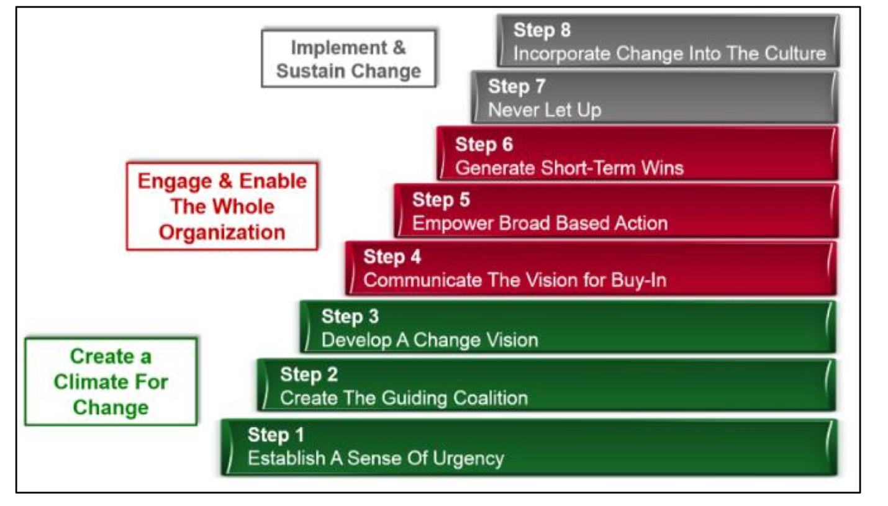

Appendix 2 Lewin’s Model
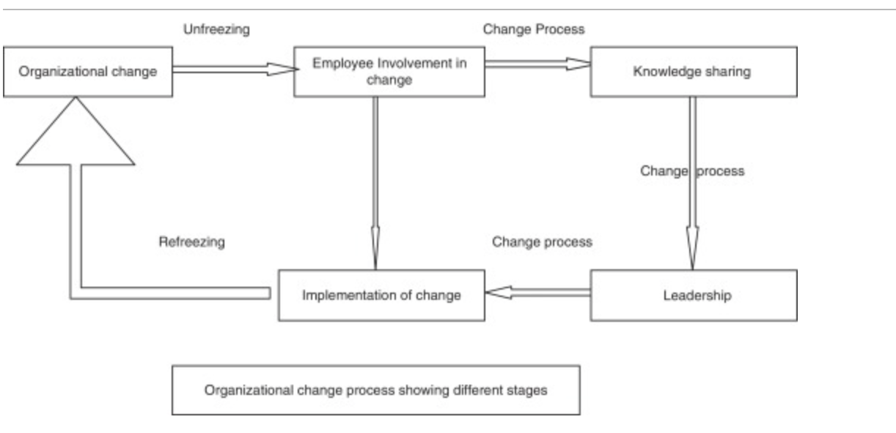

Appendix 3 Senge’s Model
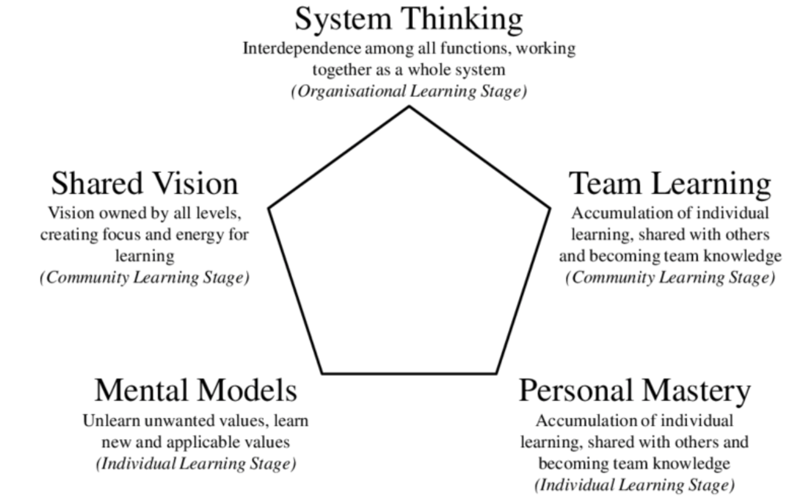

Appendix 4 Shapiro’s Model
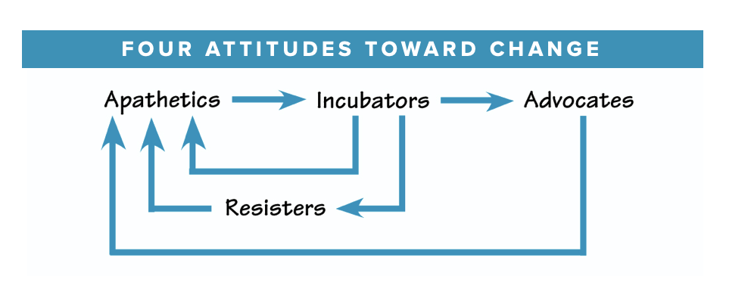

Appendix 5 Porter’s Five Forces
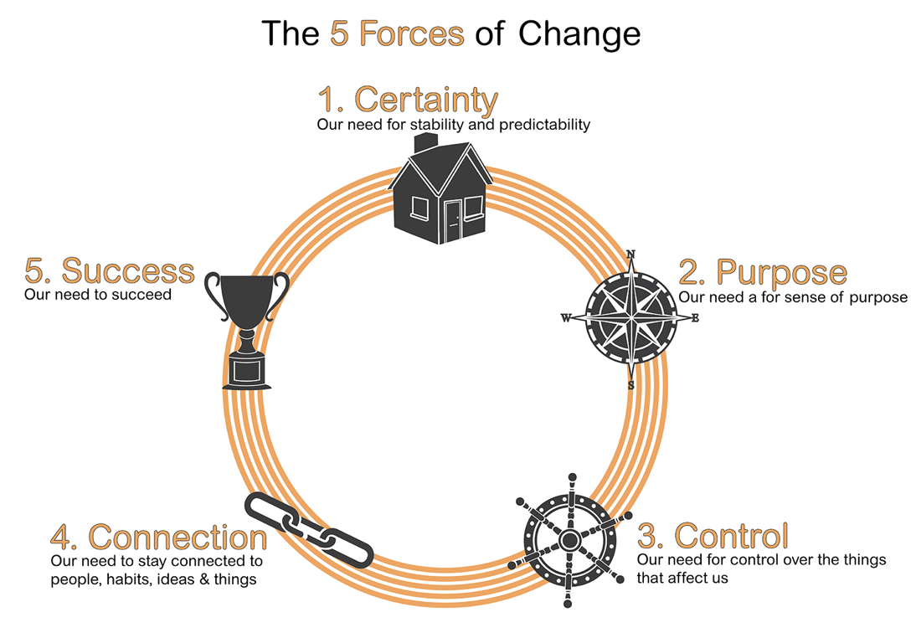

Appendix 6 PESTEL Analysis
Political | Economical | Social | Technological | Environmental | Legal
Tax | Economic Growth | Demographics | Information Communication Technology (ICT) | Climate Change | Imitations
Laws | Interest Rates | Lifestyles | Research and Development | Weather | Price Wars
Political Stability | Unemployment | Tastes and Trends | Automation | Recycling | Product differentiation
 | Inflation |  | E-Commerce | Pollution
 | Exchange Rates

Appendix 7 SWOT Analysis
Strengths | Weaknesses | Opportunities | Threats
Security (Government organisation) | Government Changes bring uncertainty | Work with other (friendly) defence organisations across the globe to share knowledge | War/ Conflicts
Pacts and Alliances | Bureaucracy | Pacts and Alliances | Climate Change
 | Hierarchy

Appendix 8 Positive Feedback Loop

Influences
Influences
Influences
Influences
Operation Teamwork-days to tackle issues and create familiarity
(Desired Outcome/ Perceived gap) Good and efficient working relationship between both services
Civil Servants feeling excluded and overlooked, military and civil service personnel stay in their respective groups rather than collaborating
Civil servants and military personnel don’t work collaboratively together

Appendix 9 Negative Feedback Loop
Influences
Influences
Influences
Influences
Staff encouraged to re-evaluate their tasks and allocated time for completion
Reduced risk of important tasks not being completed. Workload has not changed, this is a continuous loop
Lack of time management and priority management
Employees struggle to complete the high work volumes

Appendix 10 Power-Interest Matrix
High
Manage Closely
Unit Welfare Officers

Keep Satisfied
4* General
Government

High
Low
Interest
Power
Monitor
Service Personnel
Dependants
Keep Informed
Commanding Officers
Other staff directly and indirectly affected

