Iyesha Thomas
1714914@student.uwtsd.ac.uk
BMSW2002-Yohan Mendis
BA (Hons) Management and Leadership – Skills for the Workplace
Developing Relationships and Workplace Achievement
BMSW5002 Developing Relationships and Workplace Achievement
Component 2- Report

Contents
Introduction 2
What are development vehicles? 2
How do they work? 2
Fig.2 (Vrooms expectancy theory) 3
Fig.3 (Herzberg theory model) 5
Fig.4 (Kirkpatrick training analysis model) 6
Fig.5 Example of a Ward 360 feedback model 7
Fig.(6) 11
References: 12

Introduction

The aim of this report is to take three development vehicles which are used within a workplace and critically evaluate them, the three models are; motivation, feedback and rewards system, and organisational learning, in order to show how they can be used to develop their staff and in doing so meet the needs of their employees. I will then demonstrate examples of companies that use these vehicles, in order to critically asses the benefits gained by the company and the employee. I will then create a development plan, that will have six examples based on the needs and expectations of an individual within the work environment.

What are development vehicles?

Development vehicles are incentives given to employees in order to sustain them within a company, they are devised to help employees experience work gratification.
Incentives:
Defined in the Cambridge Dictionary (2019), as : “something that encourages a person to do something”
The definition is quite broad but when used within a workplace, the word incentive is used to address added bonuses that can be made on top of the usual wage or benefits provided by company or establishment.

How do they work?

The reasoning behind work incentives is that based on the theory that performance incentives boost motivation amongst employees and employers. Therefore, they are so broadly used, from the education system to the corporate world (Hur and Nordgren, 2016).
In order to know what type of incentives to apply to the workforce, you must first find out what it is that motivates them.
“Motivation is the force that energizes, directs and sustains behaviours. High performance is achieved by well-motivated people who are prepared to exercise discretionary effort” UWTSD,2019
There are many ways in which people can be motivated and by attaching incentives to them we are able to create a more productive and efficient employee. There are two types of motivation, intrinsic and extrinsic, intrinsic motivation is described as behaviours that are initiated out elation, such as hobbies and other individual joyous interest. Extrinsic is that of the contrary, they are behaviours that are emitted in order to achieve provisional results (Deci and Ryan, 2002).
Both intrinsic and extrinsic motivators can be used by employers when seeking to create both more effective and productive staff, meeting both their needs as a company and that of their staff. Through the use of these motivators, many motivational theorists created their own concepts which they believed to be realistic, on how best to manage staff, there is the Maslow Hierarchy of needs theory, in which he believed that needs were listed in 5 stages, ranked in importance; Biological and physical needs, safety, belonging, self-esteem and finally self-actualization, so once the basic needs of a person were met (food, shelter, air, warmth), they would proceed to the next stage, safety and so forth (Highgatecounselling.org.uk, 2013). Then there is the Lawler and Porter theory, they incorporated Vroom’s expectancy theory (Fig.1), in order to formulate their expectancy template(Fig.2), they concluded that a person’s motivation comes from the incentive that they are expected the get once the job is complete(Lawler and Porter, 1967).

Fig.2 (Vrooms expectancy theory)
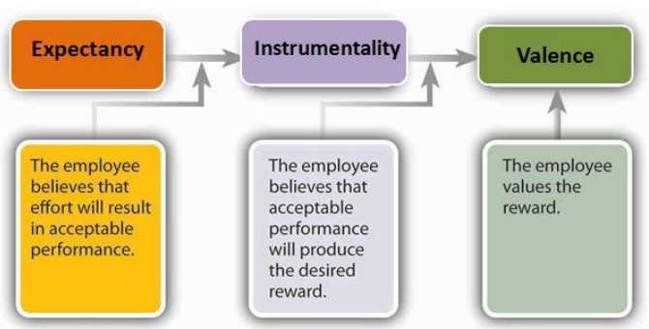
(Researchgate 2019).

Fig.3 (Lowler and Porter Theoretical Model,1968)

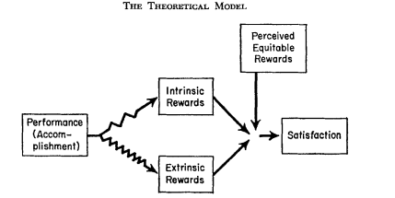

These are examples of process-based theories, these are theories which look at the way in which people are motivated via steps used to achieve the goal.
If we use Frederick Herzberg’s two-factor motivational theory, which applies both motivators, and apply it, we can take the concept he believed in and use it to investigate how employers are using incentives as a way to benefit not only their employees but their company as well.
Herzberg who was a very well know motivational theorist, devised a model based on the motivational factors he believed that most peoples could relate to, his theory was content based, this is when you look at the question: why? we as humans are motivated, these motivators could be put into two groups, motivation factors and hygiene factors.
Motivational factor, these are the factors used to motivate staff to produce better, be more productive and hit higher targets at work for example, career development, incentive, recognition and responsibilities, they all help create job satisfaction.
Hygiene factors, are the factors that are in place ensure the staff are happy, they are not necessarily there to motivate better work but are there to ensure staff have their basic needs met, so do not need to slack on work, for instance, job security, fair wages, good working conditions and personal life, without these factors staff will experience job dissatisfaction and can become de-motivated (Alshmemri, Shahwan-Akl and Maude, 2017).

Fig.3 (Herzberg theory model)
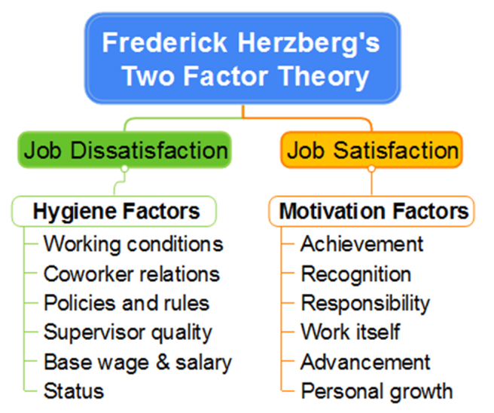
Herzberg’s two Factor Theory (Bigplate, 2019).

By incorporating a theory such as Herzberg’s in the workplace, employers can use motivational theories to create development vehicles. Such as organisational learning and the feedback and reward system both motivation factor (extrinsic), which feed into motivation from the hygiene (intrinsic) factors as well as the motivation factors.
Within organisations it is important to continue the development of your staff, by engaging them in learning opportunities, you are not only bettering the individual but also creating more efficient and independent workers.
Workers now more than ever need to be able to acclimatise and increase their ability in order to remain and fit in with the ever-evolving industries of today (Jackson, 2017). In order to fulfil this need, employers can use a learning needs model to see where it is that their employees could use improvement and/or training to enhance their career.
By doing a learning needs analysis on the organisation and its individuals, companies can see what kind of training will provide mutual benefits to both parties. Firstly, you must identify what kind of training is needed and if the employee and company will benefit from it, a needs assessment must be fulfilled. This is to determine where there is a gap or lack of knowledge or training for a specific job role lay and to find out how to close it.
Once this has been determined and the correct training has been initiated, the employers must then determine whether the training sufficed. One such model designed to determine this is the learning and development model by Kirkpatrick (2017), a model designed to be used after training to observe 4 key things, firstly (reaction), to evaluate how staff receiving training reacted to the training; are they happy? Did they enjoy the experience? Second (learning), is to examine the staff, to see whether they grasp the concept of the training provided; do they show more knowledge of the role, are they incorporating newly taught skills? Thirdly to watch the actions of the staff (behaviours), are they applying what it is that they have learnt within the workplace, is there a change in their behaviours or attitude? And finally (result), to conclude whether or not the training had a constructive impact on not only the employee, but the organisation as well (Kurt, 2016).

Fig.4 (Kirkpatrick training analysis model)


(Kurt, 2016. Educational Technology)
Organisational training can be delivered in many ways, depending on the individuals needs and that of the company, some examples are: Continuing professional development, which can be mandatory or done voluntarily at some companies, it is aimed at keeping staff members up to date with new tech and skill expansion opportunities. Personal development plans used withing the workplace to further develop their employees, this is a plan of action designated to an individual with personal work targets and career/personal elevating aspects. Companies also initiate team building and internal or external conferences, all designed to further expand the knowledge and skill set of their staff (Evans-Brian and Neugebauer, 2019).
Feedback and rewards
The feedback and rewards system play once again not into just the hands of the employee, but again the organisation too, if handled in the correct manner. An example of a successful feedback model used within industries is Wards’s 360 feedback appraisal system (Fig.5), this is also known as the multi-rater feedback, the purpose is to allow those that you work with, yourself and customers to evaluate you performance both negative and positive. The idea is that you perform a self-critic, then using this as a base, compare it to the data collected from your colleagues and customers, you can use this both within the workplace and outside the work environment (360, 2019).

Fig.5 Example of a Ward 360 feedback model

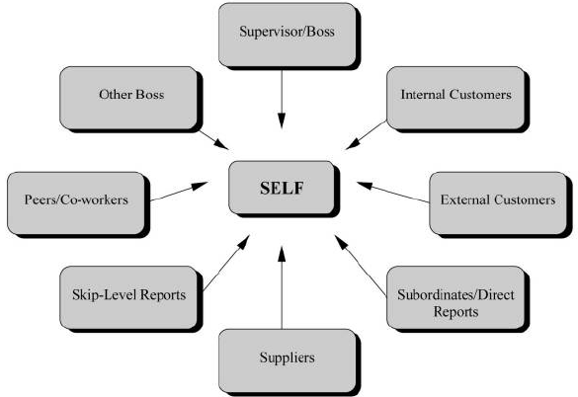
(Researchgate,2019)

A reward system on the other hand is a structure set up within the company by the company, it is there to reward specific performances to further motivate staff on or individuals therein. Usually they are not in conjunction with the regular pay and work benefits, however, can come in the form of monetary bonuses and if not then they incur extra charges to the company giving the rewards. They can be set up in order to push staff in a certain work direction, boost the current business approach or even have an ulterior motive such as to help implement a new rewards strategy. The rewards can come in numerous forms such as, company shares, monetary bonuses or even recognition resulting in better job opportunities. It is important that the company has a strategy in order to convey such a scheme, HR are usually the instigators behind the system (inc, 2019).
It is important to note that different companies apply altering rewards for their staff, as not all companies have the same goals and therefor, must motivate their staff according to their own policies and procedure.

Tesco is a multi-million-pound organisation, who cover everything from groceries to car insurance and mobile phone contracts. The understand the importance of using motivational vehicles to keep their staff happy and continue to flourish and hit goals (Tesco, 2019.)
When applying for a job at Tesco, you are able to read testimonies from their staff members, who express their “work-life balance” and advancement opportunities (Rashi, Tesco employee, 2019). They boast of learning opportunities on the job and model an easily maintained work and home life stability, both targeting their basic needs as well as job security needs.
Tesco embody the needs of their staff members, taking care of not only their intrinsic wants such as fair wages, health benefits, flexible hours, good team leadership and communal bonding, encourage in their “Tea points” system, were staff can take breaks and have free beverages whilst being encouraged to interact with each other (Tesaco,2019), but also their extrinsic desires in the form of career development, learning opportunities, bonuses, company benefits, recognition and employee investments.
There are ample opportunities to develop your career are available to Tesco employees, they offer both apprenticeship and internships, they also qualify both to earn the Tesco bonuses subject to their role and targets, Tesco say they do this to ensure that all their staff feel comfortable, that by having apprenticeship they are training the staff of their companies future, retaining these apprentices and interns is vital to Tesco, so they instil incentives to keep them happy and motivated.
My role as waitress saw a slightly different take on the motivational vehicles used by Tesco, yet they had similar lasting results and used the same principles of, organisational learning, motivation and a feedback and rewards system.
At Le Truc Bistro, formerly an independent French restaurant, HR did not introduce the motivational methods, instead it was deduced by the manager and general manager, they put in place staff motivational vehicles based on their experiences in the restaurant business.
So rather than having learning vehicles that enabled us to predict possible skill development, they applied impromptu staff training based on the need of the company, for example, a course in mixology was offered to any member of staff that was willing to participate, the qualification meant that you would be able to understand practice the art of mixology, which is the study of mixing drinks, you are able to understand the chemistry required when creating flavours through this you can create a professional career(The Spruce Eats, 2019), however, the training was pulled as they would save more money by hiring someone to fulfil the role. Another example of an impromptus learning opportunity was the alcohol license application, this was introduced when the need for a holder came upon the company, the required all staff to do the training onsite and then take the test at a testing site. Once the qualification was awarded staff who passed where given a pay bonus if they were the only member onsite holding a licence at the time. The added bonus of licence was that it enabled you, upon leaving Le Truc, to apply for hire paid jobs and bar supervisor jobs.
Flexible hours and a communal environment were also encouraged withing Le Trcu, staff members where encouraged to interact during breaks and keep in contact outside of work hours, creating a family withing the company. This created a positive work environment and enabled staff to feel secure withing themselves and their job role.
As an independent business Le Truc did not offer pensions or many opportunities to advance withing their company, but they did provide chance to develop your skills. They also used incentives as a way to motivate staff, usually in the form of a game or challenge, for example, “whoever sells the most steaks gets £20 at the end of the shift” or the £5 game, where a £5 note is moved from the last staff member to sell a bottle of wine, to the next staff member who sells it, whoever has the £5 at the end of the night get to keep it. These incentives not only motivated staff but created sport out of everyday tasks, changing the narrative of the services given, these incentives also enabled the company to hit targets simultaneously as relaxing the staff. The company uses these strategies in order to get staff to work harder and smarter.
Basing the conclusion on the Tesco organisation example and that of the Le Truc restaurant, companies can gain just as much as their staff can from using motivational vehicles. The motivational vehicles mentioned, allow a staff member to continuously improve themselves, whilst contributing more efforts to the company. The security of having their the basic needs meet along with the reassurance that they can progress as employees, means that companies are able to obtain and keep good employees, using a combination of motivational vehicles that include targeting and securing both hygiene and motivational factors, creating job satisfaction, more knowledgeable and empowered staff and higher staff retention.

Personal development plans are a tool used both by employees and employers to measure the success of an individual, they allow the user to set SMART goals with specific time frames, ensuring that the plan is easily followed an exam[le of a personal development plan can be seen below Fig.(6).
SMART objectives or goals are:
Specific, the goal or intention cannot be vague, if we are aiming to create a portfolio and distribute it, then that is not specific, just distributing the portfolio is not a clear enough instruction to be taken, its success can not be measured as there are too many variable, but to say “I will hand deliver it to 10 art galleries within Birmingham” is specific.
Measurable,goals are easier to obtain if you can measure them, by being able to set a time limit on the task for completion, this way you know that the task has been completed and not been left idle, leaving task without a date of expectancy can lead to procrastination.
Achievable and Realistic these two components both relate to how likely you are to success, they highlight how obtainable the goal is, taking in to account the resources, time and data available to you, but also measuring how credible the task will be, for instance, if you are a shop floor worker and plan to move up to management within the company, firstly is there a measure in place for this to happen within the company? Are there steps in between required in order to make the jump?
And finally, Time-sensitive, are your timeframes set, it is easy to say that you will finish a task next month. But this is not time sensitive, you are allowing to many opportunities to delay. Tasks and goals should have a specific timeframe, example,” within the next 14 working day” this allows you to see when the task must be completed in order to move on to the next goal (Morgan, 2017).

Fig.(6)
Specific | Measurable | Achievable | Realistic | Timely
Develop managerial knowledge and jargon | I will have read the handbooks available at work regarding management. | Resources are available at work via e-learning and textbook based. | There is ample time on my breaks and added knowledge and help from colleges. | I have until the 21st of February 2020, this is when I must apply for the training.
Hit more targets at work and hit them on time. | I will take the time allocated to complete task, rather than allotting my own time measures. | I will request specific deadlines from management for individual pieces. | By arranging them in time specific order (most urgent first) I can achieve this goal. | Staff evaluation meeting on the 18th of March 2020.
Sign up to the Managerial training | Ii can apply for the training as I am eligible due to my time working here. | This application is made in work, obtained from HR. | The training works alongside my regular work, I can achieve it on-site. | Training applications open on the 21st February 2020 and close on the 25th of February 2020
Acquire more industry awareness | Create a LinkedIn, this will allow me to interact with other trainees and evaluate other companies | LinkedIn is a website, accessible via phone app, computers and other android devices, I can access and create/update this regularly | The app makes it easy to manage, alerts will notify me so as I do not miss anything. | I will be a trainee as of the 27th of March 2020, this is when I will start my profile, I will update it when required for as long as the app is valuable.
Apply for manager position (within company if available) | I will be a manger withing the company I currently work for or have moved to be manager within another. | By updating my CV after training to be and obtaining managerial status, then distributing it to companies. | Uploading CV’s can be done online, I can get job matches and attend interview for desired companies. | I will be a manger by the 20th of July 2020, this will give me the opportunity to ably for managerial positions.
Start my studies for university. | I will become a part time student alongside working. | With the new job I will be able to finance my studies. | Enrolling onto the university course will start my study journey. | My course starts on the 7th of September 2020.

(Personal Development Plan example)
References:

Alshmemri, M., Shahwan-Akl, L. and Maude, P. (2017). Herzberg’s Two-Factor Theory. [online] Lifesciencesite.com. Available at: http://www.lifesciencesite.com/lsj/life140517/03_32120lsj140517_12_16.pdf [Accessed 1 Dec. 2019].

The Spruce Eats. (2019). Are You a Mixologist or Bartender? Well, That's a Good Question. [online] Available at: https://www.thespruceeats.com/what-is-mixology-759941 [Accessed 6 Dec. 2019].

Armstrong, M. (2014). Armstrong's Handbook of Human Resource Management Practice 13th Edition. [online] Www-dawsonera-com.ezproxy.uwtsd.ac.uk. Available at: https://www-dawsonera-com.ezproxy.uwtsd.ac.uk/readonline/9780749469658 [Accessed 2 Dec. 2019].

Biggerplate.com. (2019). Frederick Herzberg's Two Factor Theory. [online] Available at: https://www.biggerplate.com/mindmaps/ubbWTg1P/frederick-herzberg-39-s-two-factor-theory [Accessed 1 Dec. 2019].

Biggerplate.com. (2019). Frederick Herzberg's Two Factor Theory. [online] Available at: https://www.biggerplate.com/mindmaps/ubbWTg1P/frederick-herzberg-39-s-two-factor-theory [Accessed 1 Dec. 2019].

Deci, E. and Ryan, R. (2002). Handbook of Self-determination Research. [online] Google Books. Available at: https://books.google.co.uk/books?hl=en&lr=&id=DcAe2b7L-RgC&oi=fnd&pg=PA37&dq=extrinsic+motivation+examples&ots=drBO0KZ22k&sig=t1taGiGRP68KESMY7AnK428Y3vg#v=onepage&q=extrinsic%20motivation%20examples&f=false [Accessed 25 Nov. 2019].

Highgatecounselling.org.uk. (2013). CT2 Paper 1 – Maslow Hierarchy of Needs. [online] Available at: http://highgatecounselling.org.uk/members/certificate/CT2%20Paper%201.pdf [Accessed 1 Dec. 2019].

Hur, J. and Nordgren, L. (2016). [online] Web-a-ebscohost-com.ezproxy.uwtsd.ac.uk. Available at: https://web-a-ebscohost-com.ezproxy.uwtsd.ac.uk/ehost/pdfviewer/pdfviewer?vid=1&sid=dcca3e9e-116b-4add-8150-a43620bb1f95%40sdc-v-sessmgr02 [Accessed 2 Dec. 2019].

https://dictionary.cambridge.org/dictionary/english/incentive

Inc.com. (n.d.). Employee Reward and Recognition Systems. [online] Available at: https://www.inc.com/encyclopedia/employee-reward-and-recognition-systems.html [Accessed 2 Dec. 2019].

Kurt, S. (2016). Kirkpatrick Model: Four Levels of Learning Evaluation - Educational Technology. [online] Educational Technology. Available at: https://educationaltechnology.net/kirkpatrick-model-four-levels-learning-evaluation/ [Accessed 2 Dec. 2019].

Lawler I11, E. and Porter, L. (1967). The Effect of Performance on Job Satisfaction. [online] S3.amazonaws.com. Available at: https://s3.amazonaws.com/academia.edu.documents/50985106/j.1468-232x.1967.tb01060.x20161220-21641-xbnq3y.pdf?response-content-disposition=inline%3B%20filename%3DThe_effect_of_performance_on_job_satisfa.pdf&X-Amz-Algorithm=AWS4-HMAC-SHA256&X-Amz-Credential=AKIAIWOWYYGZ2Y53UL3A%2F20191204%2Fus-east-1%2Fs3%2Faws4_request&X-Amz-Date=20191204T195526Z&X-Amz-Expires=3600&X-Amz-SignedHeaders=host&X-Amz-Signature=5bed0e58c7fc7e81375881a3ba6299bff9931f4f6b76d7a0af273b4752a70408 [Accessed 1 Dec. 2019].

Managementstudyguide.com. (2019). Motivation Incentives - Incentives to motivate employees. [online] Available at: https://www.managementstudyguide.com/motivation_incentives.htm [Accessed 3 Dec. 2019].

Maund, A. (2018). BA in leadership and management. 1st ed. [Los Angeles]: SAGE, p.Brian, M. The meaning and Importance of Managing Across Cultures. Pg.315.

Maund, A. (2018). BA in leadership and management. [Los Angeles]: SAGE, p.539, Jackson D. A . Using Work-Integrated Learning to Enhance Career Planning Among Business Undergraduates.

Maund, A., Schriek, M. and Tinkler, P. (2017). Certificate in higher education. 1st ed. London: Sage, pp.Neugebauer, J and Evans-Brian, J. Chapter 5, Workplace learning and development. pg.349-354.

Morgan, P. (2017). Business student's guide to study and employability. 1st ed. Los Angeles: SAGE, pp.33-40.

Researchgate (2019). Potential raters in multi-source appraisal systems. [online] Researchgate.net. Available at: https://www.researchgate.net/figure/Potential-raters-in-multi-source-appraisal-systems_fig1_235315887 [Accessed 2 Dec. 2019].

Researchgate, (2019). Vroom's Expectancy Theory. [online] Available at: https://www.researchgate.net/figure/Vrooms-Expectancy-Theory-Expectancy-Expectancy-is-the-belief-ones-effort-E-will_fig53_323695129 [Accessed 4 Dec. 2019].

Tesco (2019). Apprenticeships | Tesco Apprenticeships & Graduates. [online] Tesco-programmes.com. Available at: https://www.tesco-programmes.com/apprenticeships/ [Accessed 6 Dec. 2019].

Tesco (2019). Benefits | Tesco Careers. [online] Tesco-careers.com. Available at: https://www.tesco-careers.com/explore-our-world/benefits/ [Accessed 6 Dec. 2019].

Tesco (2019). Sajid Rashid | Tesco Careers. [online] Tesco-careers.com. Available at: https://www.tesco-careers.com/explore-our-world/sajid-rashid/ [Accessed 2 Dec. 2019].

Tesco (2019). Stories | Tesco Careers. [online] Tesco-careers.com. Available at: https://www.tesco-careers.com/explore-our-world/stories/ [Accessed 6 Dec. 2019].

Youtube.com. (2019). Motivation Theory: Herzberg (Two-Factor Theory). [online] Available at: https://www.youtube.com/watch?v=f-qbGAvR4EU [Accessed 3 Dec. 2019].

360, A. (2019). FREE 360 degree Feedback Review Evaluation Development - Appraisal360. [online] Appraisal360. Available at: https://www.appraisal360.co.uk/ [Accessed 4 Dec. 2019].

