Sanxingdui Reimagined: Merging Ancient Culture with Cyberpunk Art

Name: Xuanjing Zhu
Email: 1915468@student.uwtsd.ac.uk
Course Title: M7X02024 Confirmative Praxis

Contents

Abstract 3
1.Introduction 3
2.Literature review 5
3.Practical work 10
4.Discussion 15
5.Conclusion 19
Reference 20
Words:4601

Abstract

This project aims to combine the Sanxingdui site with cyberpunk art, integrating the ancient Shu civilization with future elements to create a unique visual and cultural experience. Through the phenomenological way to study and analyze the patterns of the excavated relics of Sanxingdui and combined with the case studies way to collect the literature related to Sanxingdui culture for screening and analysis, to guide and improve the project design for this research. It is hoped that this design will not only safeguard and preserve traditional culture but also spark the interest of the younger generation in traditional Chinese culture. The audience can experience the dialogue and collision between ancient civilization and future technology, stimulating interest in history and imagination for the future. Through forms such as information visualization posters, viewers are able to gain a deeper understanding of history and culture, promote cultural diversity and inclusiveness, and at the same time reflect on the relationship between ancient civilization and modern technology. Ultimately, the goal is to create a design project that integrates traditional culture with emerging digital age technologies in a symbiotic way.

1. Introduction

Looking at and understanding science from an aesthetic perspective, people have long found that science contains forms of beauty. In the last century, with the help of computer calculations of iterative equations, folding, scaling, flipping, and other operations can be carried out efficiently, resulting in the formation of three-dimensional fractal art that is rich in aesthetic significance. These ever-changing shapes are full of decorative flavor and breathtaking. As Yang (2015) said, ‘It is a great beauty.’ People have not only found the beauty from visual presentation to spiritual perception in science but also further applied science to artistic creation, closely integrating modern technology, breaking through the boundaries of traditional art, and creating brand-new art forms. The intermingling of science and art has promoted the development of art. Under this trend, modern artists are more and more inclined to combine traditional culture with modern science as a way to promote traditional culture and make innovative development while preserving traditional culture.

The purpose of this paper is to bridge the past and present by using the cultural relics unearthed at Sanxingdui as the subject of study and employing the popular medium of cyberpunk art as the means of expression. We aim to integrate and develop traditional culture alongside the crafts of the new era of science and technology. As the great French writer Flaubert said, ‘The further we go, the more art has to be scientific, and at the same time, science has to be artistic.’ Scientific and technological innovation has infused traditional culture with new vitality, preserved its treasures through digital means, enabled virtual historiography, and facilitated historical and cultural exchanges and learning.

This paper will use the Sanxingdui excavated artifacts as a foundation for creative design. By combining these designs with a modern cyberpunk style, we aim to showcase the charm of history and culture. The project seeks to merge traditional culture with contemporary crafts in the design of Sanxingdui cultural relics, thereby using futuristic elements as a platform to inherit the traditional culture of ancient Shu. In doing so, the project aims to innovate ways of protecting traditional culture and spark the interest of younger generations in their cultural heritage.

This paper will explore the symbiosis between the heraldic symbols in the bronze art of Sanxingdui and the technology of the digital age, aiming to revitalize the fields of art and history. Using phenomenological theory, this study will qualitatively analyze the research question and establish a theoretical basis for the research direction. In light of the current trend of merging traditional culture with modern style, the author has chosen to integrate the appearance of Sanxingdui artifacts with a modern cyberpunk sci-fi aesthetic. Additionally, through case studies, the author will examine a large body of literature on cyberpunk, the culture of Sanxingdui artifacts, and history education, providing a solid theoretical framework for the design.

The author adopts a practice-led research approach to combine the artistic elements of ancient Shu civilization with the cyberpunk art style, which serves as a guide for the design process. Based on the solid theoretical framework established by the case studies, the authors used the sci-fi futuristic style as the keynote to design cyberpunk-style artworks for the artifacts excavated from the Sanxingdui culture. This approach not only highlights the unique artistic elements of the ancient Shu civilization but also injects fresh energy into the traditional culture by incorporating modern cyberpunk aesthetics.

2. Literature review

Through preliminary research and review of related literature, it has been found that current studies on Sanxingdui cultural relics primarily focus on aspects such as modeling, history, and aesthetics. The development and design of the relics themselves are often limited to museum exhibits, with fewer studies addressing the visualization of cultural relics' information, as well as design integration and innovation. Therefore, this paper will focus on the innovative design applications of traditional culture, Sanxingdui culture, and the cyberpunk style. It will also analyze relevant theories from these three aspects to provide a theoretical reference for this research.

With the advent of the digital age, how to incorporate traditional cultural elements in modern design has become a hot topic. Designers and artists have demonstrated cross-generational design thinking by incorporating traditional culture into modern design. This approach not only promotes cultural diversity and heritage but also infuses modern design with new creativity (2022). Bai Lian (2024) highlights that innovative design can be achieved by reinterpreting traditional symbols and elements, thereby imbuing them with new meanings and functions. Visualization techniques for heritage information have also gradually become the focus of culturally innovative design. Into the 1990s, the digitization of cultural heritage, supported by 3D and virtual reality technologies, can effectively protect cultural artifacts while providing immersive experiences to help people better understand and experience traditional culture (2020). This approach not only enhances people's understanding of cultural heritage but also provides visual material and inspiration for cultural and creative product design.

Phenomenological methodology is to intuitively recognize the characteristics and features presented by things themselves and to observe the deeper meanings and essences behind the phenomena through their surface appearances. The Sanxingdui site, located in Guanghan City, Sichuan Province, China, is one of the most important discoveries of China's ancient civilization, as well as a typical representative of Shu culture (1987). Studies have shown that the Sanxingdui culture is known for its unique and mysterious bronzes and gold masks, whose motifs and patterns usually reflect the cultural, religious, and artistic aspects of the society at that time. According to Liu Shaohui (2004), the motif pattern avoids the fragmented and disorderly rhythm, and rhyme is a borrowed language that transforms the auditory sense into visual elements. The unique iconographic features of the Sanxingdui artifacts, with their exaggerated facial features and complex geometric shapes, reinterpret ancient symbols through a modern artistic lens, thus linking past cultural expressions with contemporary creative practices.
Under the guidance of phenomenological methodology, this study will explore in depth the visual features of Sanxingdui artifacts, such as shapes, lines, and colors, in order to reveal the cultural meaning and symbolism behind them. Phenomenology emphasizes understanding the nature of things through direct visual experience, which is of great theoretical significance in analyzing the mysterious symbols in the Sanxingdui artifacts. For example, exaggerated facial features and complex geometric shapes may not only be a choice of artistic expression but may also reflect the ancient Shu people's unique understanding of cosmology and religious beliefs. These features can be reinterpreted in a modern way through the surrealist representation of the cyberpunk style, thereby creating a new visual experience. This experience not only contributes to the preservation of traditional culture but also stimulates interest in and reflection on ancient culture.
Gombrich states in The Sense of Order: ‘All motifs were originally thought of as symbols, although their meaning has been lost in the course of historical development.’ The design patterns in bronze artifacts serve as the most visual representation of the religion, nature, and society of their time within the spiritual world. These patterns reflected the reverence people had for nature. Hegel, in his book Aesthetics, asserts: ‘The elements of beauty can be divided into two kinds: one is internal, i.e., content; the other is external, i.e., the meaning and characteristics given by the content.’ In fact, the patterns on bronze artifacts, as a form of decoration, express people’s attitudes toward the objective world and their level of artistic cognition. These elements reflect the mysterious and solemn atmosphere that was created by the worship of natural deities during that period.

According to the famous semiotician Cahill (1953),'Symbolic thinking is the most representative feature of human life’. Symbols convey the messages they contain and can be experienced through touch or visual stimulation. From a methodological perspective, while previous interpretations of the connotations of bronze motifs have been exploratory and enlightening, they often fail to adequately explain the logical relationship between the actual formal structure, stylistic variations, and belief connotations of these motifs (Lin Sinaifu, 2019). In the excavated cultural relics, only certain decorations are present on the bronzes, and there is no specific textual interpretation available. As a result, many interpretations of the connotations of Sanxingdui patterns remain speculative and conjectural, making it difficult to confirm their accuracy.

Perhaps due to a lack of tradition in style analysis, domestic academic research on Sanxingdui bronze patterns has focused primarily on archaeological art typologies, classifying patterns according to geometric designs, animal and plant motifs, composite patterns, ideograms, etc. This approach has created an academic blind spot regarding the structural relationships between different patterns. Questions remain about the visual isomorphism between them and the underlying reasons for these patterns. According to Ran Honglin (2023), although no written texts have been found at Sanxingdui, many bronze vessels with engraved symbols have been discovered at the site. The limited number of incised symbols and the absence of a coherent system for interpreting them have made it challenging to connect and translate them into meaningful text. However, this paper argues that these symbols possess mnemonic attributes and represent a unique form of record-keeping.

Cyberpunk, as an art style that emerged in the 1980s, combines the terms 'cyber' and 'punk' to represent paradoxical cultures characterized by contradiction and conflict (2002). It is often used to critique and reflect on the future of a highly mechanized civilization. By integrating cyberpunk aesthetics with traditional cultural elements, a new visual experience can be created. This design approach not only offers a striking visual impact but also reinterprets cultural symbols to critique and reflect on modern society. Cyberpunk style is undeniably at the forefront of contemporary visual expression, characterized by its distinctive use of contrasting colors that highlight the inherent contradiction of 'high-tech, low-life'. Designers utilize the symbolism of colors to convey specific intentions, with their symbolic content influenced by the history, geography, religion, institutions, customs, and habits of various ethnic groups. The symbolic meanings can vary significantly between different ethnic groups and historical periods (2017).

Although much of the research on Sanxingdui culture has focused on its historical background and plastic arts, relatively few studies have combined it with the cyberpunk style, and the authors' combination of the two has great potential and room for innovation. The mysterious symbols and peculiar modeling in Sanxingdui culture are somehow similar to the futuristic sense of cyberpunk, both of which have surreal visual characteristics and deep cultural connotations (2023). By combining the ancient symbols of Sanxingdui with the futuristic elements of cyberpunk, a cultural experience that transcends time and space can be created. This fusion is not only visually striking but also offers a fresh perspective on the modernization of traditional culture.

Although existing studies have discussed the artistic value of Sanxingdui culture and the application of cyberpunk style to a certain extent, there are still relatively few studies on the combination of the two. To fill this research gap, this paper will explore the innovative combination of Sanxingdui culture and cyberpunk style by using information visualization techniques under the theoretical framework of phenomenology and semiotics. Phenomenology will aid in understanding and interpreting the visual features of Sanxingdui artifacts, while semiotic analysis will be used to decipher the cultural symbols and their implied meanings within the artifacts. Through these methods, this paper aims to create designs that blend historical significance with modern sensibilities, offering new perspectives for the contemporary preservation and innovation of cultural heritage.

3. Practical work

The aim of this design project is to explore the artistic expression of combining ancient Sanxingdui culture with modern cyberpunk style through the use of information visualization. Through this attempt, the authors hope to create a visual work that is both historical and futuristic in its technological sense. The Sanxingdui culture is known for its unique bronze masks and mysterious style, while the cyberpunk style is characterized by high technology and an anti-utopian atmosphere. The combination of the two can present a visual work that is both mysterious and futuristic, as well as bring new artistic inspiration and cultural expression.

The Sanxingdui culture, which originated in the ancient Shu region of China, is known for its unique bronze artifacts, gold masks, and symbolic totems, which demonstrate the mystical atmosphere of ancient rituals and religious beliefs. The cyberpunk style, on the other hand, originates from the literature and film works of the 1980s, featuring a dark style with bright neon colors, depicting a highly technological but socially divided world of the future. Combining these two styles creates a visually conflicting yet harmonious artistic effect that expresses visions of future technology and homage to ancient cultures. Guided by the methodology of phenomenology and semiotics, the project interprets the cultural symbols of Sanxingdui through direct visual experience and symbolic thinking, combining them with the technological symbols in the cyberpunk style to create a new design work.
The number of bronze objects and art forms excavated at Sanxingdui is extraordinarily rare in the field of archaeology (2001). The Sanxingdui culture is primarily distinguished by its mysterious bronze masks and symbolic totemic symbols. These artifacts not only reflect the religious beliefs and social structure of the ancient Shu ancestors but also convey their unique understanding of nature and the universe. The bizarre shapes of the Sanxingdui bronzes, along with the patterns and symbols engraved on the idols and artifacts, offer a glimpse into the extraordinary creativity of the ancestors, who revered gods and shamans. The decorations attached to the bronze statues and artifacts of Sanxingdui highlight the divine beauty of animal patterns, the abstract beauty of geometric symbols, and the diverse representations used to communicate with the gods and goddesses of heaven and earth. These artistic patterns, with their aesthetic value, unite the spirit of the ancient Shu culture with the view of religious myths.

The Sanxingdui bronze motifs can be categorized into three main types: animal motifs, geometric motifs, and human face patterns (2022). These motifs reflect the spiritual support and cultural beliefs of the ancient Shu ancestors and represent a combination of their crystallized wisdom, creativity, and imagination. Animal motifs include animal face patterns, dragon motifs, and bird motifs. The animal face pattern, also known as the Taotie pattern, was first documented in the Lv's commentaries of history (2010) as ‘Zhou Ding with Taotie.’ This motif represents a mythical beast imagined by people, embodying their fervent worship of nature gods. Bird motifs reflect the spiritual needs of the people during the Sanxingdui period (2017). The cloud and thunder patterns are among the most classic and widely used on bronzes, often serving as decorative elements to enrich the artifacts. The sun pattern is frequently found on the bases of Sanxingdui bronze figures. The prominence given to the eyes in the carvings, akin to the sun, suggests that both the sun and the eyes held significant importance for the ancient Shu ancestors.
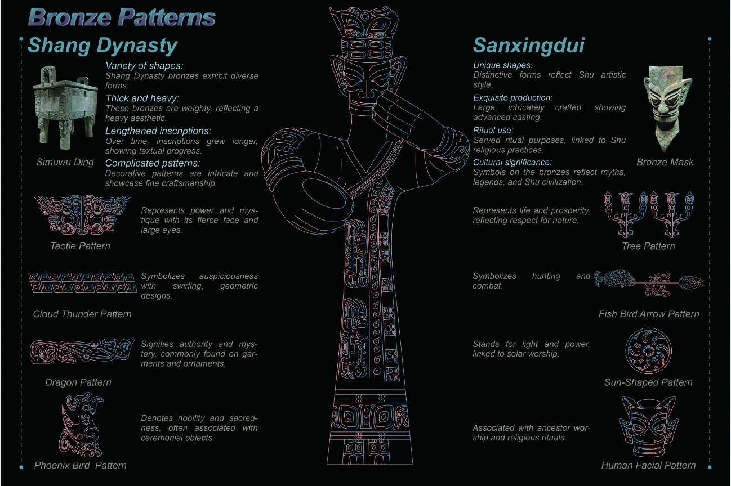
Fig.1 Process
The visual characteristics of the cyberpunk style represent a modern imagination of the future world based on current technological levels. In the cyberpunk worldview, information technology is highly advanced, and people live in a society saturated with information. The streets are illuminated by brilliant neon lights, creating striking and unusual lighting effects. The author chose cyberpunk’s classic, highly saturated color scheme and circuit patterns, integrating these elements into Sanxingdui symbols to convey both historical depth and a futuristic visual language. High purity is a key feature of cyberpunk colors. Primary colors like red, yellow, and blue are noted for their high purity. The use of these high-purity colors, both in large areas and in small details, not only emphasizes a sense of technology but also highlights the contrast between wealth and poverty within this environment, reflecting the rapid pace of technological advancement (2022).
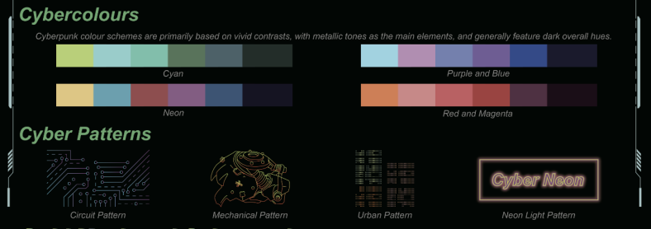
Fig.2 Process
The conceptual development of this project is rooted in the visual and symbolic characteristics of both Sanxingdui culture and the cyberpunk style. The authors use Sanxingdui's bronze masks and symbolic totems as the primary visual elements, integrating them with cyberpunk’s highly saturated color scheme and circuit textures. By merging ancient symbols with a sense of futuristic technology, the authors aim to create a visual experience that intertwines time and space, allowing viewers to experience both the mystery of ancient culture and the impact of future technology.

The author uses Adobe Illustrator for drawing and applies information visualization techniques to showcase the fusion of Sanxingdui culture symbols and cyberpunk style. The project consists of three main works: The first work introduces the history and culture of Sanxingdui, analyzing the pattern of the Sanxingdui Bronze Tall Man. This design features the pattern presented with lines, using a contrast of highly saturated blue and pink colors to evoke the cyberpunk aesthetic.

The second work focuses on the cyberpunk art style, using the gold mask as the central element of the poster. It retains the external shape of the gold mask while adding a neon light effect inside, symbolizing high-tech elements and resonating with the cyberpunk theme. A star pattern is included inside the eyes to enhance the sense of futuristic technology.

The third work features the information visualization of the fusion design between the Bronze Tree and cyberpunk technology. The Bronze Divine Tree, a significant treasure of Sanxingdui, is depicted with its three layers of branches representing the shamanic universe of heaven, man, and earth. Each layer of branches extends in three directions, symbolizing the world’s quadrants, and features a huge dragon descending from the heavens, connecting heaven and earth. These elements reflect the region's unique religious culture. The author integrates cyberpunk’s circuit patterns with the Bronze Tree to create a new design that combines traditional cultural heritage with futuristic technology, achieving a harmonious visual effect.
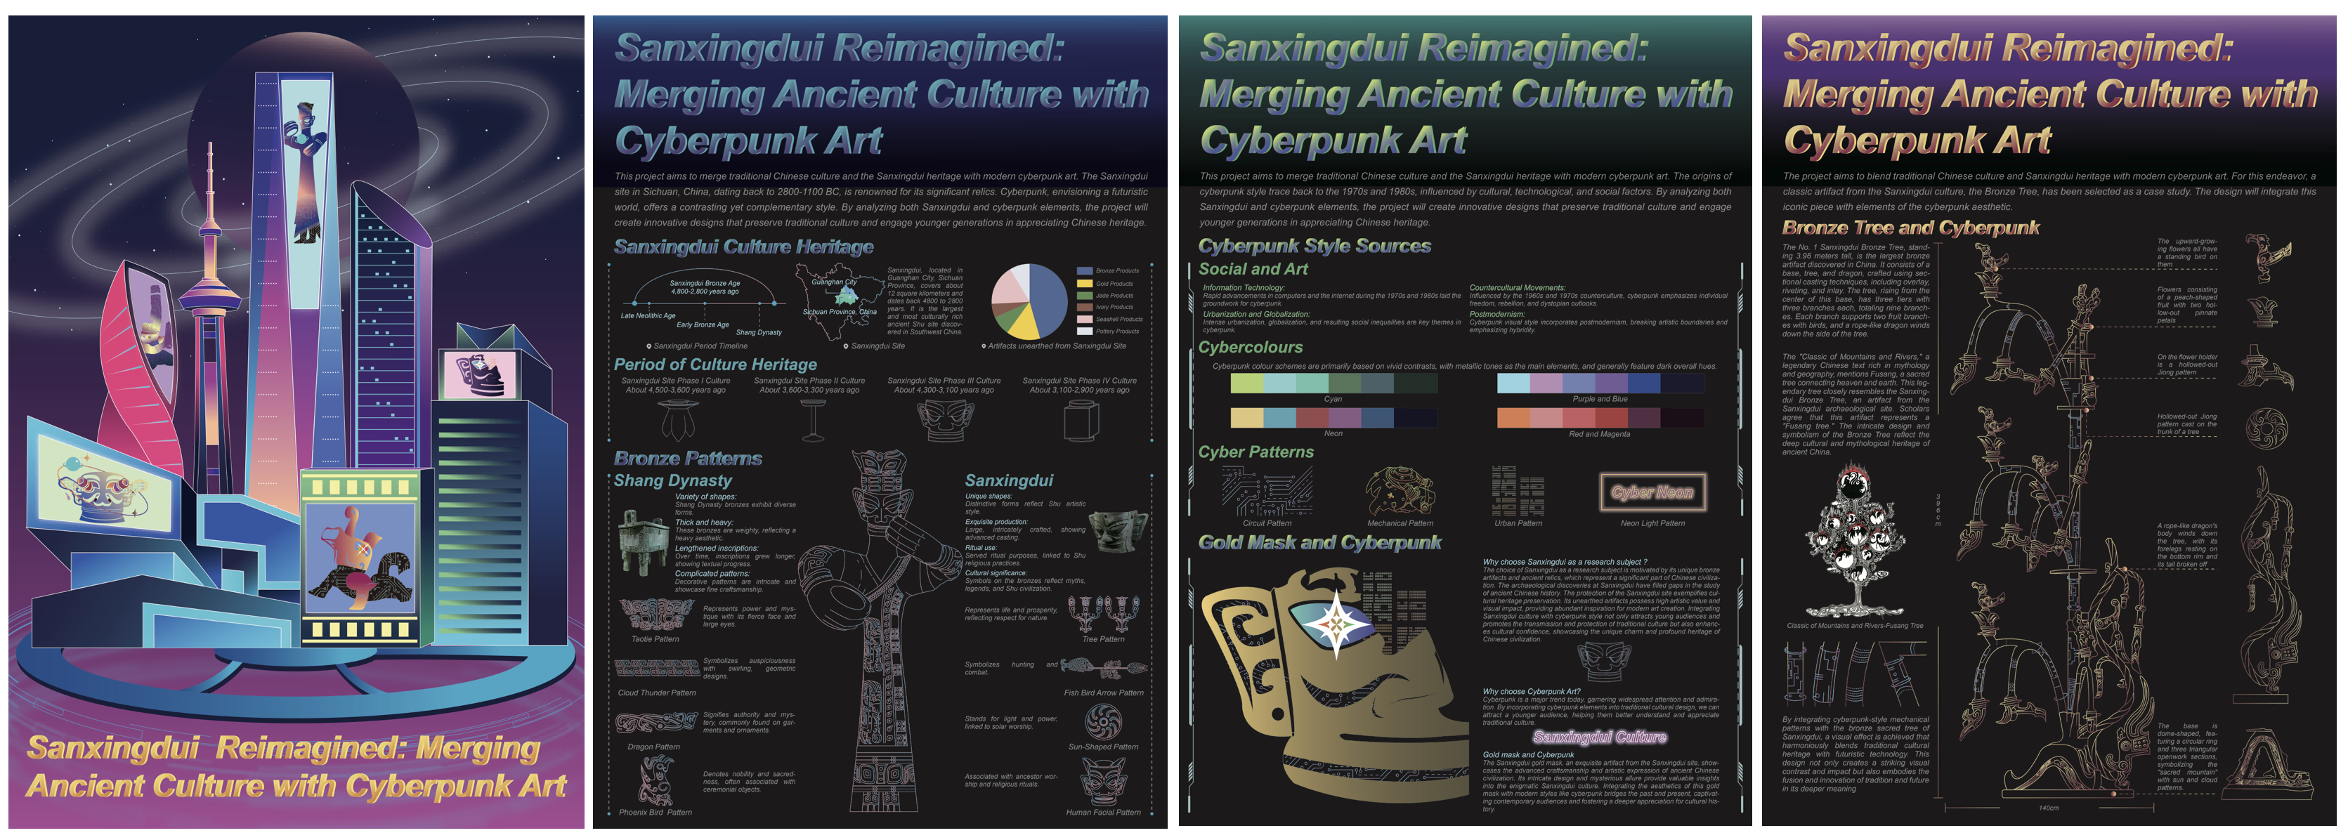
Fig.3 Process
This main poster extracts the representative artifacts of Sanxingdui, refines their appearance, and combines them with cyberpunk-style elements and colors to bring them to life. Due to the fusion design, the author reimagines these artifacts within a futuristic space universe. The representative artifacts from Sanxingdui are depicted as traveling to this future realm, eager to join and integrate into this new world by incorporating cyberpunk elements. Two of the masks have fully integrated, showcasing vibrant cyberpunk-style colors. The remaining three masks are only partially fused, with parts of their designs still reflecting a black circuit board style.
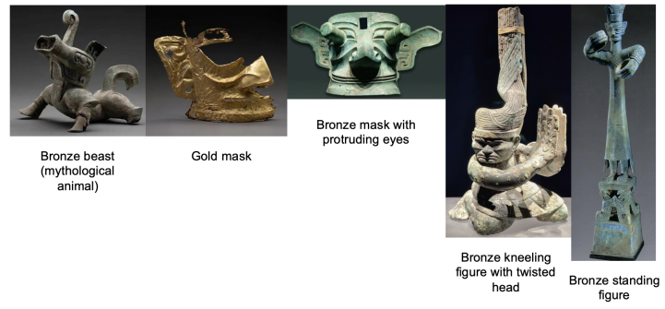
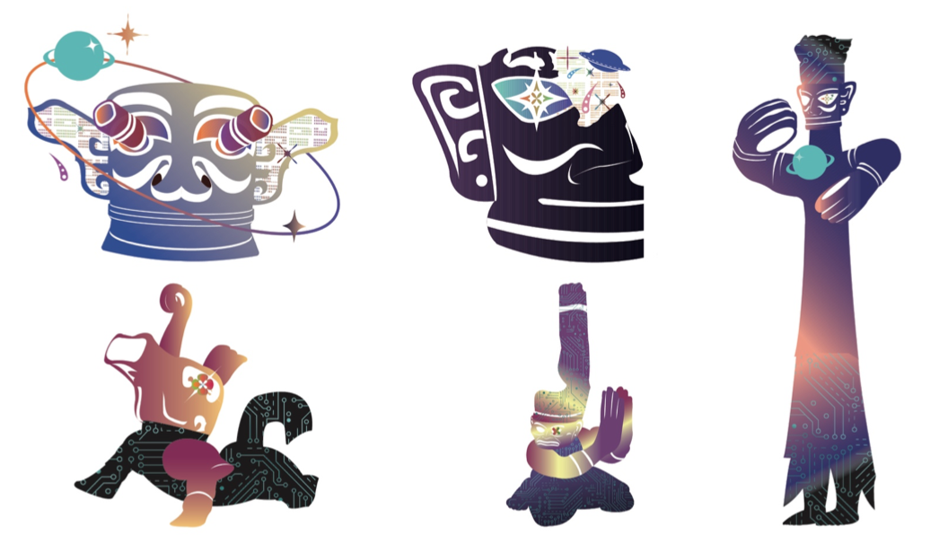
Fig.4 Process
During the creative process, the author extensively reviewed literature related to the Sanxingdui artifacts to ensure the design's accuracy and historical authenticity. At the same time, the authors combined the visual characteristics of the cyberpunk style and continuously adjusted and improved the composition, color, and use of symbols of the work through multiple sketches and the application of digital tools. The entire creative process emphasizes the dialogue between tradition and modernity, history and the future, aiming to find a balance between the two to create a unique artistic expression.
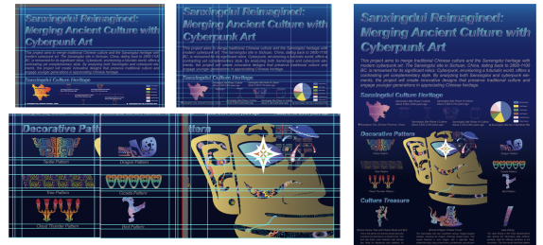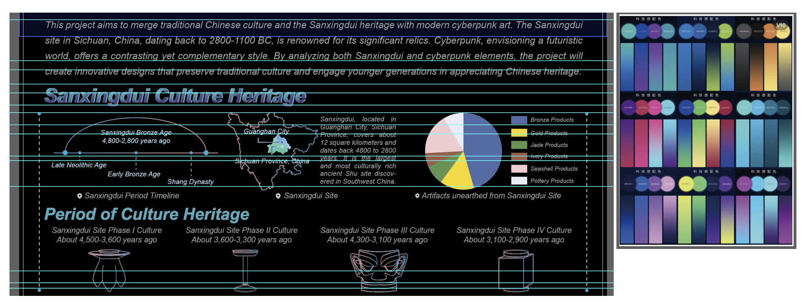
Fig.5 Process
In this project, the authors delved into the possibilities between traditional culture and modern art through their attempt to combine the Sanxingdui culture with the cyberpunk style. During the creative process, the author faced the challenge of how to balance the two styles, especially in the use of symbols and color schemes. This process taught the author the skill of extracting elements from historical artifacts and blending them with modern design language. Although the cyberpunk style has followed some programmatic trends in recent years, the authors aim to disrupt this trend by incorporating traditional culture. Their goal is to revive interest in and attention to ancient cultural symbols. This is not only a tribute to traditional culture but also a way to promote modern design innovation.

4. Discussion

Based on a phenomenological research methodology, this design project illustrates how ancient Sanxingdui culture can be merged with modern cyberpunk aesthetics to create a novel visual language, as demonstrated through qualitative case studies. Literature research provided the theoretical foundation for the project, including in-depth analyses of Sanxingdui cultural semiotics, cyberpunk visual language, and the reinterpretation of these symbols in a contemporary context. Through this research, the project identifies the commonalities between Sanxingdui culture and the cyberpunk genre in terms of semiotics and cultural expression. As stated by Hairong Zheng (2010), ‘Pattern motifs are a visual image in themselves, but when they enter into the experience of activity to relate to the human mind, they possess an endless world of meaning.’ This finding suggests that the combination of cross-cultural symbols and styles can create a new aesthetic experience that has both historical depth and looks to future technology, achieving both theoretical and practical validation.

The project is driven by practice-led research, where practical work integrates Sanxingdui culture with cyberpunk style in a visual exploration. Reporting enhances the visual narrative by providing deep cultural and historical context through theoretical analyses and contextual research. The project employs an iterative design process, applying theoretical insights from semiotics and cultural symbolism directly to the creation of art. This organic relationship is evident in every aspect of the project, from the initial conceptual development to the final visual presentation, which is supported by literature reviews and theoretical research, as well as the validation and expansion of these theories. The results of the literature review and theoretical research were incorporated at each stage of creation, strengthening the theoretical foundation of the artwork and using practical work to test and extend the theory. By applying semiotic theory to practical design, the project continues to validate and enrich theoretical assumptions. The combination of the enigmatic shapes and symbols of Sanxingdui bronzes with the high-tech symbolic language of cyberpunk not only creates a new visual form of expression but also illustrates the dialogue between two different worldviews on a cultural level.

This project explores the fusion of Sanxingdui culture and cyberpunk style through illustration and information visualization, offering a fresh perspective in the field of art research. Tang Xilan (2020) proposed that bronze ornamentation encompasses not only art but also the aesthetic psychology of its time, providing new insights for art research. Through visual creation, this project not only enhances the audience’s understanding of ancient culture but also stimulates reflection on the relationship between technology and humanity in the future. The project showcases a high degree of originality and creativity in concept, aesthetics, and execution. By integrating symbols from Sanxingdui culture with cyberpunk-style colors and visual language, it creates a novel form of visual expression. This innovative approach, bridging different eras and cultures, revitalizes ancient cultural symbols and infuses new meaning into the cyberpunk style. The use of highly saturated colors and circuit patterns effectively conveys the theme and meaning of the work, demonstrating the author’s unique perspective and creative prowess. This form of creative expression advances academic research, particularly in cross-cultural studies and visual arts. The project's creativity is evident in the recombination of symbols from various times, cultural backgrounds, and artistic styles, resulting in a new narrative and aesthetic experience.

In terms of methodology, this project employs a phenomenological research framework to investigate how to reconstruct the meaning of cultural symbols in modern art creation through a deep understanding of these symbols. Adopting case studies in qualitative research to analyze the typical symbols of Sanxingdui culture, Bagley (1999) states, ‘The Sanxingdui finds have forced scholars to rethink their understanding of early Chinese civilization and its development, especially regarding the diversity and complexity of Bronze Age cultures.’ The cyberpunk style, on the other hand, represents a return to the sublime aesthetic, where technology transcends its role as a mere tool and becomes a medium for a new experiential realm, blending high-tech and low-life elements (Bukatman). During the creative process, the authors employed modern digital design tools such as Adobe Illustrator and conducted multiple design iterations to ensure the final work effectively communicated the project's themes and concepts. Additionally, a semiotic analysis was performed to deconstruct the symbols used in the creation. Saussure notes, ‘A linguistic sign is not a link between a thing and a name, but between a concept and a sound pattern.’ The historical and cultural context of these symbols was analyzed to understand their potential significance in a contemporary context.

This project establishes a foundation for further exploration of integrating ancient cultural symbols with modern visual styles. Future research could expand to include the fusion of other traditional cultures with contemporary aesthetics, examining how different cultural symbols interact across various artistic mediums. As cyberpunk aesthetics are disseminated through various platforms, they evolve to better suit different environments and application needs. In today's society, cyberpunk aesthetics are increasingly anticipated and gaining more attention (2007).
Such explorations can offer a deeper understanding of how traditional cultural heritage adapts and thrives in a rapidly evolving technological landscape. Future innovations might also include the introduction of VR and AR technologies to provide a more immersive cultural experience. In the field of education, modern interpretations of visual symbols can enhance viewers' understanding and appreciation of ancient cultures. In design, new inspirations and directions can emerge for graphic and interactive design, bridging the gap between the past and the future, as well as between tradition and innovation through art.

5. Conclusion
By innovatively combining Sanxingdui culture and cyberpunk style, this design project successfully creates a visual language that is both historically deep and futuristic. Through information visualization, several sets of posters were designed, each showcasing a fusion of key features from Sanxingdui culture and cyberpunk aesthetics. These designs incorporate elements such as bronze masks, deity shapes, and symbolic totems, blending them with the highly saturated colors and circuitry textures characteristic of cyberpunk. This visual expression across time and space not only creates a strong visual impact effect but also triggers the audience to think deeply about the relationship between modern technology and ancient wisdom. Through this secondary creation, the design work successfully brings history and culture back to the modern audience while promoting the artistic value and historical significance of Sanxingdui culture.

The main goal of this project is to explore the commonalities between Sanxingdui culture and cyberpunk style through the creative fusion of ancient cultural symbols and modern visual aesthetics, presenting these unique artistic values through information visualization. Adobe Illustrator was used to integrate both elements into the posters. These posters are not only visually striking but also rich in cultural depth and heritage, showcasing the author's profound understanding of both ancient and contemporary cultures.

The completion of the project demonstrates the feasibility of integrating diverse cultural elements in art design and illustrates how such integration can create new aesthetic experiences and cultural significance. Given the enigmatic nature of Sanxingdui culture, a more comprehensive understanding requires further study. This project has only explored a portion of Sanxingdui artifacts and cyberpunk art; future research should delve deeper into the cultural essence of Sanxingdui artifacts to provide a more refined theoretical reference for their development.

By combining Sanxingdui culture with cyberpunk style, this design project creates a new visual expression that demonstrates the reinterpretation of ancient cultural symbols in a modern technological context. Although the design project successfully achieved the goal of exploring the fusion of tradition and modernity, there is still room for further research and improvement.
The scope of the project's cultural research can be expanded beyond data visualization to include advanced technologies such as VR and AR. These technologies could enable the audience to experience the fusion of ancient culture and future technology in a more immersive manner, enhancing interactivity and participation while further promoting traditional culture.
In conclusion, this design project not only offers a fresh perspective on the modern application of ancient cultural symbols but also infuses new cultural connotations into the cyberpunk style. Future art research should continue to deepen the dialogue between culture and technology, exploring innovative possibilities in contemporary art and design.

Reference

[1]Sichuan Provincial Cultural Relics Management Committee, Sichuan Provincial Museum, Guanghan County Cultural Center. "Guanghan Sanxingdui Site" , Archaeological Journal [J]. 1987-04-15.
[2]Cavallaro D . Cyberpunk and Cyberculture: Science Fiction and the Work of William Gibson[J]. The Library Quarterly, 2002, pp.19-20.
[3]Li Yang. Inheritance and development of traditional culture: a new path for design education reform in China[J]. 2022.
[4]Lian B, Din S C, Li W. Inheriting history and culture: The significance of auspicious animal brick carving in modern cultural and creative design[J]. Herança, 2024, 7(3 In press).
[5]Pan Zhigeng, Yuan Qingshu, Chen Shengnan, et al. Research and progress on digital display and interactive technology of cultural heritage[J]. Journal of Zhejiang University (Science Edition), 2020, 47(3).
[6]Yu Sen. Graphic Design Visual Symbol Communication[M]. Changchun: Jilin Fine Arts Publishing House, 2017.08.59.
[7]Liu Shaocong, The Kingdom in the Mist [M] Sichuan: Sichuan Publishing Group Bashu Publishing House, 2004
[8]Qian Ma, “Aesthetic Analysis of the Decorative Art of Chinese Bronze Ware”, Journal of Xuzhou Education College, 2005.
[9]Ming Han, “Bronze Culture Researeh —The Analysis of Texture”, Master's Thesis of Wuhan University of Technology, 2005.
[10]Gombrich: A Psychological Study of the Decorative Arts in the Sense of Order, translated by Yang Siliang and Xu Yiwei, Zhejiang Photography Press, 1987, p. 376.
[11]Zheng Hairong, The Symbolic Evolution of Traditional Patterns [J] Art and Design (Theory), 2010, (06): 25-27.
[12]Chen, Xu. (2023). Cyberpunk and cultural symbolism: A futuristic reimagining of ancient artifacts. Design Futures, 12(2), 201-218.
[13]Fan Xiaoping. The tourism value of Sanxingdui ruins and its protection and utilization positioning[J]. Chinese Culture Forum, 2001, (04): 26-29.
[14]Xu Qianqian. Research on the application of animal patterns on Shang and Zhou bronze wares in cultural and creative product design[D]. Lanzhou University, 2021.
[15]Wei Si. Study on the Aesthetic Connotation of Sanxingdui Bronze Ornaments[J]. Creative Design Source, 2022(03):43-47.
[16]Fan Linlin. Comparative study of the decorative art of bronze wares in Yinxu and Sanxingdui[D]. Sichuan Conservatory of Music, 2017.
[17]Mu Ying. Blade Runner 2049: An Exploration of the Color Aesthetics of Cyberpunk Movies[J]. Art and Society, 2022, 1(1): 46-48.
[18]Hu Ge. William Gibson, Cyberpunk Fiction and the Posthuman World[J]. Occupational Space, 2007, 3(10S): 65-65.
[19]Lv Buwei. Lv’s Commentaries of histort. Foreign Language Press,2010.
[20]Sasha Myerson. Global cyberpunk: Reclaiming utopia in Japanese cyberpunk film[J]. Science Fiction Film and Television,2020,13(3).
[21]Cavallaro D . Cyberpunk and Cyberculture: Science Fiction and the Work of William Gibson[J]. The Library Quarterly, 2002.
[22]Ernst Cassirer. Philosophy of Symbolic Form[M]. Jilin Publishing Group Co., Ltd., 2017-7-1.
[23]Liu Xing. The origin and concept of cyber and related words[J]. Command Information Systems and Technology, 2010, 1(0.
[24]Balsom, Erika, A Cinema In the Gallery, A Cinema In Ruins. Oxford University Press on behalf of Screen, 2009.
[25]Hanying Wu. The Aesthetic Characteristics of Sanxingdui Bronze Ornamentation - Taking Bird Ornamentation as an Example[J]. Art and Design,2022,5(7).
[26]Lai. Archaeological museums and tourism in China: a case study of the Sanxingdui Museum[J]. Museum Management and Curatorship,2015,30(1).
[27]Ming Guanghao. Aesthetic characteristics of Sanxingdui bronze ware[D]. East China Normal University, 2010.
[28]Chen Xiandan. Research on Sanxingdui bronze wares in Guanghan[J]. Sichuan Cultural Relics, 1990, (06): 22-30+81.
[29] Yin Hong. Spirit, Form and Meaning[D]. China Academy of Art, 2017.
[30]Jia Siying. Explore Innovative Ideas for Visual Communication Design[J].International Jo urnal of Computational and EngineeringVolume 6, Issue 3. 2021.
[31]Amots Dafni. On the Typology and the Worship Status of Sacred Trees with a Special Reference to the Middle East[J]. Journal of Ethnobiology and Ethnomedicine,2006,2(01):1-14
[32]Carole M.Cusack. The Sacred Tree: Ancient and Medieval Manifestations
[M]. Cambridge Scholars Publishing,2011.

