Supporting Materials

Emily Combe – 2306560

Video Link -

These were the main wicked problems we came up with as a group, which were climate change and poverty.

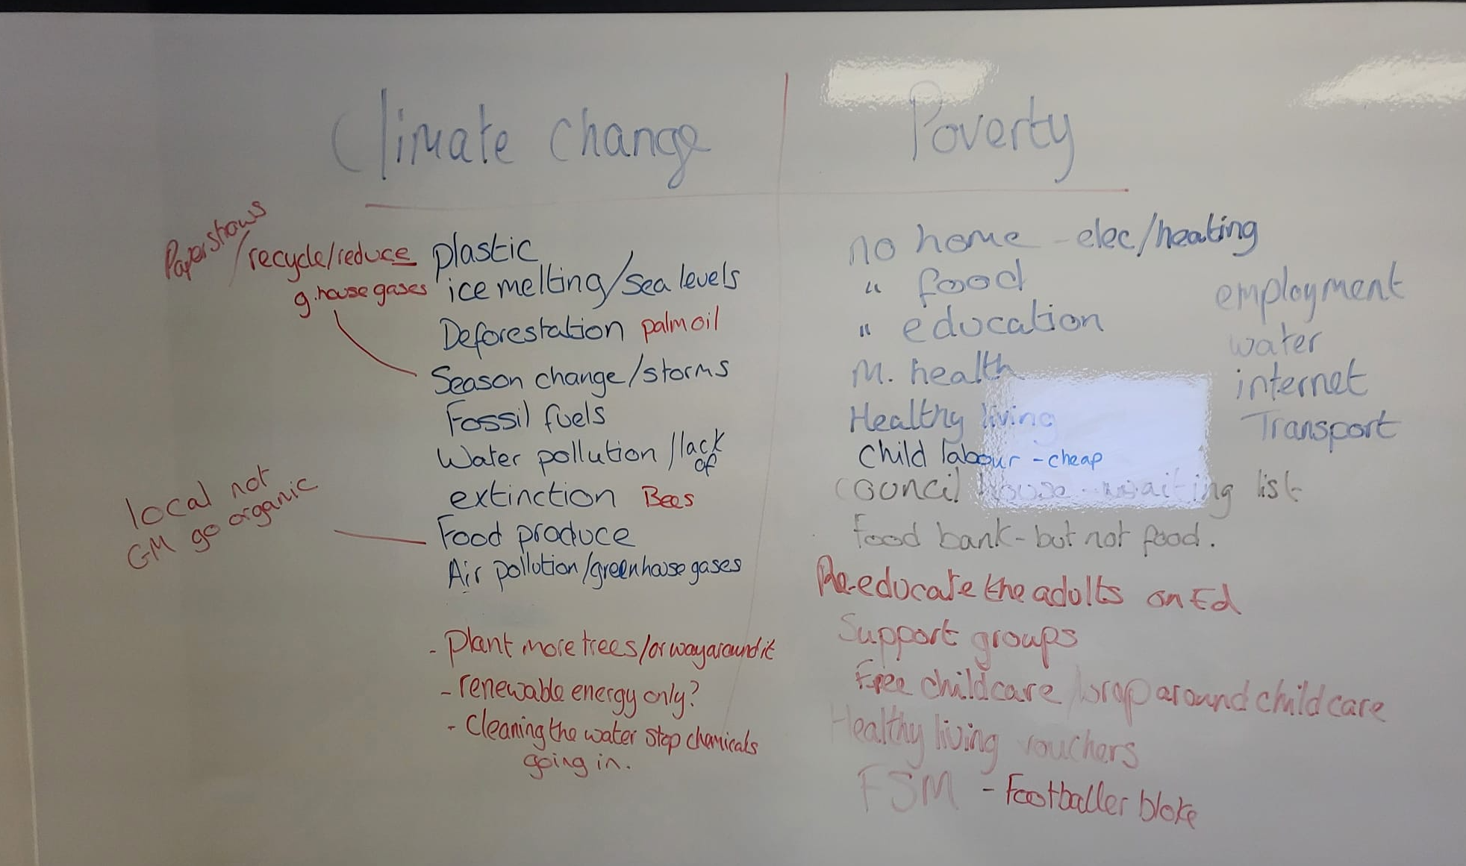

We decided to go with climate change and began looking into the problems it presented and how they could be tackled. A few of the topics linked to climate change that were discussed: rising sea levels, Fast fashion and deforestation.

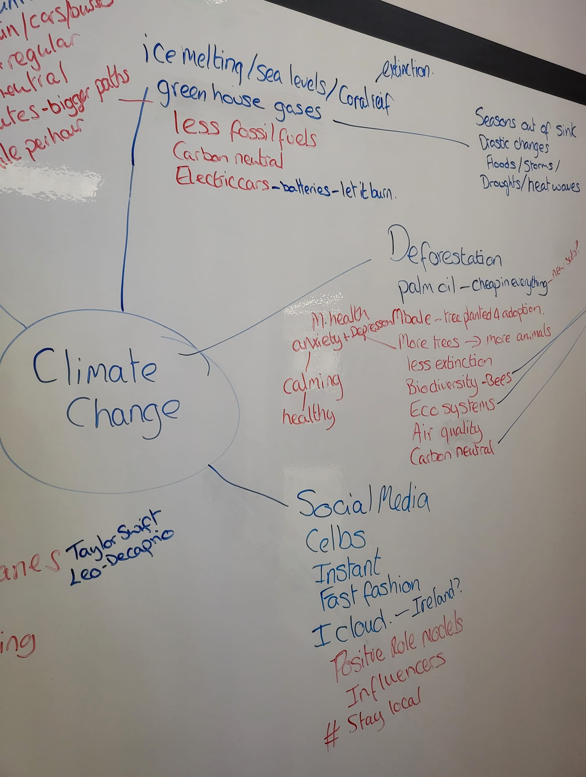
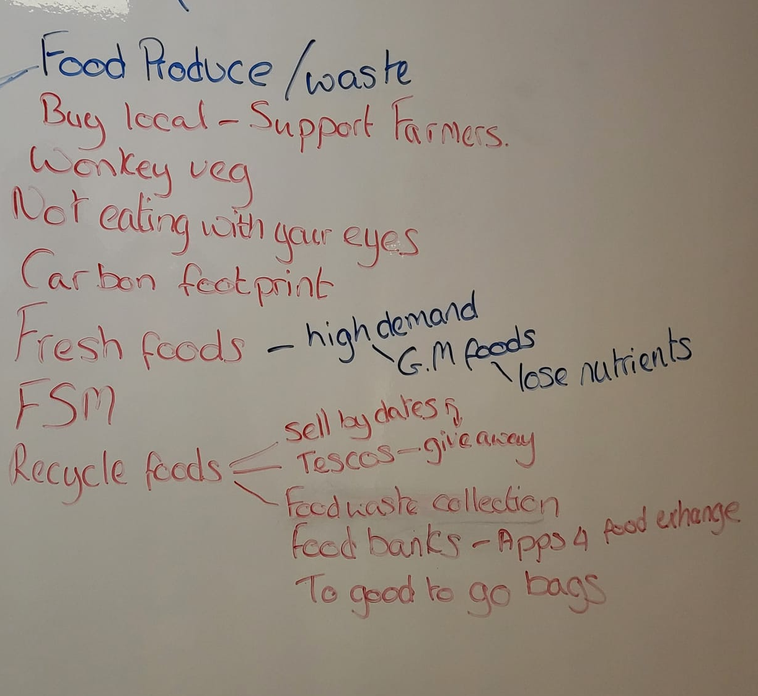

After going away and researching, after a group discussion we decided upon the chosen idea of Deforestation that is being caused due to palm oil production. Our idea for tackling this was to find and use a sustainable alternative (Clean Food Group) within Wales.

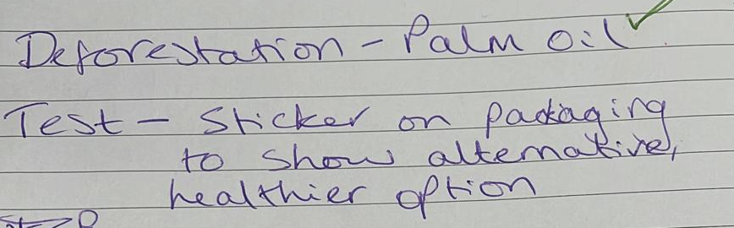

We then all went away and found further research on this topic. Once we had investigated the chosen idea and gathered more information. We discussed that the product (Clean Food Group) could be promoted through a logo to show consumers it is a healthy and sustainable alternative. We said that this could be achieved by working in partnership with schools, involving the pupils in designing the logo. We as a group then decided what everyone’s role was going to be for the video.

Personal Reference list for group video:

Ames. C (2022) The 15 Most Environmentally Friendly & Sustainable Companies. Available at: https://growensemble.com/environmentally-friendly-companies/ (Accessed: 15 March 2024).

Clean Food Group (2023) UK food-tech business Clean Food Group announces additional £2.3m funding to scale operations in advance of Series A. Available at: https://cleanfood.group/news/uk-food-tech-business-clean-food-group-announces-additional-23m-funding-to-scale-operations-in-advance-of-series-a (Accessed: 17 March 2024).

Clean Food Group (2024) News. [image] Available at: https://cleanfood.group/news (Accessed:17 March 2024).

Food Labels (Quality, Origin, and Sustainability): The Experience of Czech Producers (2021) Sustainability, vol. 13, no. 1, pp. 318. DOI:10.3390/su13010318

Footprint (2022) Palm oil alternative secures funding boost. Available at: https://www.foodservicefootprint.com/palm-oil-alternative-secures-funding-boost/ (Accessed 17 March 2024).

Getting Smart (2018) 3 Ways To Model Collaboration and Partnership in Schools and Classrooms. [image]. Available at: https://www.gettingsmart.com/2018/02/26/3-ways-to-model-collaboration-and-partnership-in-schools-and-classrooms/ (Accessed: 18 March 2024).

Stickler, B. (2018) Analyzing 7 Logo Designs from Companies that Went Green. Available at: https://blueandgreentomorrow.com/features/analyzing-7-logo-designs-from-companies-that-went-green/ (Accessed: 17 March 2024).

Sustainability For All (2019) What is sustainability? [image]. Available at: https://www.activesustainability.com/sustainable-development/what-is-sustainability/?_adin=02021864894 (Accessed: 17 March 2024).

Welsh Government (2023) Wellbeing of Wales. Available at: https://www.gov.wales/wellbeing-wales-2023-globally-responsible-wales-html#:~:text=In%202021%2C%20it%20was%20estimated,increase%20of%207%25%20from%202020 (Accessed: 17 March 2024).

WWF (n.d) Our work with schools. Available at: https://www.wwf.org.uk/get-involved/schools (Accessed: 17 March 2024).

Video Slides

Slide 1:
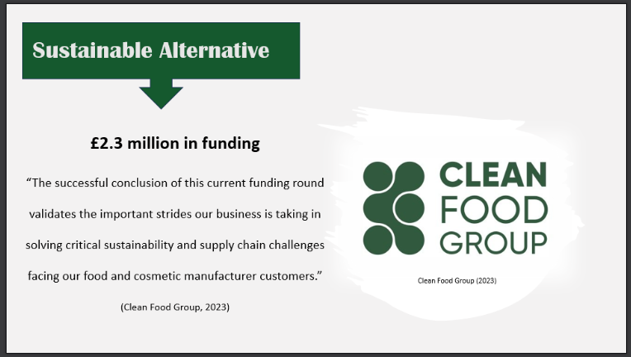

Slide 2:
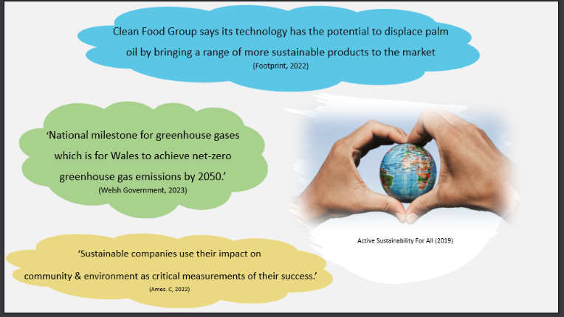

Slide 3:
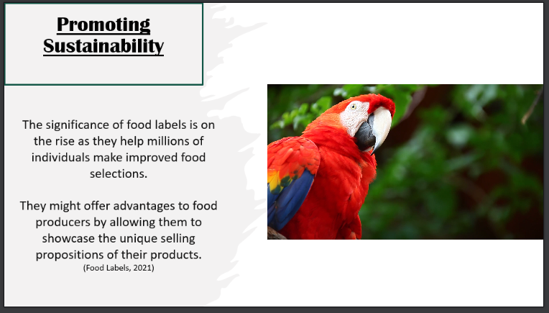

Slide 4:
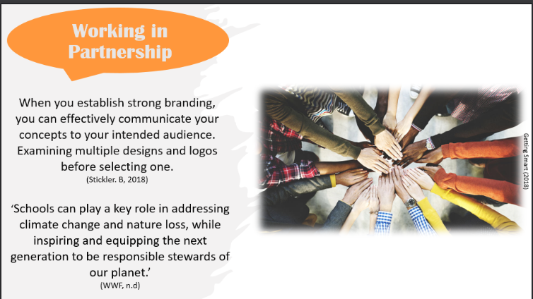

Script For Video:
A sustainable alternative. With the funding Clean Food Group have received, they continue to take important strides in tackling critical sustainability within our food and cosmetic industries. Our idea as a group is for Wales to use this product as a sustainable alternative to palm oil. Promoted by creating a logo for products by working in partnership with schools.
Footprint (2022) states that Clean Food Group technology could eradicate palm oil use and bring with it a range of sustainable products. Welsh Government state in their report that there is an aim for Wales to achieve net-zero greenhouse gas emissions by 2050, by promoting and using this product this aim could be achieved. As Ames 2022 says Sustainable companies see their impact on the community and environment as crucial to measuring their success.
Next let’s talk about logo’s. Our idea of creating a logo for placement on products to show it is a sustainable alternative, is backed up by Food Labels 2021. There is a high importance for labels on packaging, as it is helping individuals to make improved choices for themselves and the environment alongside offering advantages to companies to promote their unique selling position.
Having multiple designs and logos before choosing one is key to strong branding. Our idea is to work in partnership with schools, through a competition for pupils to design a logo that will be used to promote Clean Food Group products. As WWF state schools can play a key role in addressing climate change while equipping the next generation to be responsible stewards for our planet. Our idea is to teach pupils the importance of tackling deforestation due to palm oil. Whilst promoting a healthier and sustainable alternative.

