Programme: Master of Business Administration
Module: Dissertation
Module Code: LCBB7035
Assignment Title: Consumer Reactions to AI Chatbots and Their Influence on Trust, Satisfaction, and Purchase Intentions: A Study of Online Grocery Retail in the UK

Student Name: Md Arman Uddin
Student ID:2433803

Research

Consumer Reactions to AI Chatbots and Their Influence on Trust, Satisfaction, and Purchase Intentions: A Study of Online Grocery Retail in the UK

Acknowledgement
I would like to thank all those who helped me complete this research project. Besides, I would deeply appreciate the feedback, encouragement and guidance I received from my supervisor throughout the research process. They were very helpful and patient and provided us constant support in the successful completion of this study. I am also thankful to my university and academic staff for providing me with the knowledge, resources and learning opportunities that have helped me in my academic and professional growth and development.
Additionally, special thanks for those individuals who took the time to contribute their time and insightful answers on the survey. This study would not have been possible if they had not cooperated. Furthermore, I would like to express my appreciation to the authors, researchers, and scholars whose published works helped to establish the theoretical foundation and academic basis for this research. Lastly, I would like to thank my family and friends for their constant encouragement, understanding and moral support during my academic career. Their belief in my abilities motivated me to overcome challenges and remain committed to achieving my goals. Thanks are due to all who have helped in any way in the successful completion of the work on this research.

Declaration


Master’s Degrees by Examination and Dissertation
Declaration Form.

I, [Md. Arman Uddin], declare that this dissertation has been composed by myself, that the work contained herein is entirely my own except where explicitly stated otherwise in the text, and that this work has not been submitted for any other degree or qualification, in whole or in part, except as specified.

Signature: ………………Arman………………............................

Date: …………………06/06/2026……………............................

Executive Summary
The study has analysed the impact that AI-enabled chatbots have had on consumer behaviour in the UK online grocery market. The retailers are increasingly turning to AI technologies to deliver real-time support, personalised suggestions, and round-the-clock service. This primary research is based on three important consumer outcomes: Trust, Customer Satisfaction, and Purchase Intentions.
The research has highlighted that AI chatbots enhance the online shopping experience by offering timely, error-free, and user-friendly support throughout the product discovery, shopping, and post-purchase phases. Consumers will have greater trust in online grocery retailers if there are chatbots that are responsive, reliable, intelligent and easy to communicate with. The more transparent retailers are on the data they use and the functions of the chatbots, the more trustworthy they are. Inaccurate answers, low system performance, and privacy issues, however, can have a negative impact on trust and consumer confidence.
Another key result of the interaction of customers with the chatbots is customer satisfaction. The availability, the recommendations, the rapid replies and the ease of use are all positive factors toward satisfaction. But all this lack of connection and empathy with the customer can reduce customer engagement and loyalty in the long run. The study also indicated that satisfaction and trust as highly important mediating factors in influencing consumers' purchase intentions.
The study based on the Technology Acceptance Model (TAM) to suggest that perceived usefulness and ease of use do impact consumers' acceptance of AI chatbots. The study revealed that positive interactions with AI chatbots can drive consumer trust and customer satisfaction, based on survey responses from 99 UK online grocery customers. The results indicated that trust and satisfaction positively influenced purchase intention, and both successfully mediated between the quality of the chatbot and purchase intention. The findings suggest that the attributes of chatbots, including responsiveness, accuracy, reliability, and ease of use, positively impact customer outcomes, and can help online grocery retailers enhance customer experiences and purchasing behaviours.

Contents
Acknowledgement 1
Declaration 2
Executive Summary 3
Chapter 1: Introduction 6
1.1 Background of the Study 7
1.2 Rationale 9
1.3 Research Aim 10
1.4 Research Objectives 10
1.5 Research Questions 10
1.6 Dissertation Structure 11
Chapter 2: Literature Review 13
2.1 Introduction to the Literature 14
2.2 AI Chatbots in Online Retail 14
2.3 Consumer Trust in AI Chatbots 16
2.4 Customer Satisfaction and Chatbot Interaction 19
2.5 Purchase Intentions in Online Retail 22
2.6 Theoretical Perspective: Technology Acceptance Model (TAM) 26
2.7 Research Gap 29
2.8 Conceptual Framework 29
Chapter 3: Methodology 30
3.1 Research Philosophy 31
3.2 Research Design 32
3.3 Data Type 32
3.4 Sampling Design 33
3.5 Data Collection Method 33
3.6 Data Analysis 34
Chapter 4: Data Analysis and Findings 35
4.1 Introduction 36
4.2 Demographic Profile of Respondents 36
4.3 Descriptive Analysis of Main Variables 41
Variable 1: AI Chatbot Interaction 42
Variable 2: Consumer Trust 43
Variable 3: Customer Satisfaction 45
Variable 4: Purchase Intention 45
4.4 Correlation Analysis 47
4.5 Regression Analysis 51
Model 1: AI Chatbot Interaction → Consumer Trust 51
Model 2: AI Chatbot Interaction → Customer Satisfaction 52
Model 3: Consumer Trust and Customer Satisfaction → Purchase Intention 53
4.6 Mediation Analysis 54
Direct Relationship 55
AI Chatbot Interaction and Mediators 55
Mediators and Purchase Intention 56
Indirect Effect Comparison 56
4.7 Hypothesis Testing Summary 57
Chapter 5: Discussion 60
5.1 Introduction 60
5.2 Discussion Based on Objective 1 60
5.3 Discussion Based on Objective 2 61
5.4 Discussion Based on Objective 3 62
5.5 Discussion of Mediation Effects 63
5.6 Discussion of Hypotheses 64
5.7 Theoretical Implications 65
5.8 Chapter Summary 65
Chapter 6: Conclusion and Recommendations 66
6.1 Conclusion 67
6.2 Theoretical Contributions and Practical Recommendations 67
6.3 Limitations and Future Research 68
References 69
Appendix 76

Chapter 1: Introduction
E-commerce and artificial intelligence have risen rapidly, changing the way consumers engage with online retailers. AI-powered chatbots are used more to provide instant support, recommendations and services 24/7. The research will explore the effect of such chatbots on consumer trust, satisfaction, and purchase intentions in the UK online grocery retail industry.

1.1 Background of the Study
Over the past few years, e-commerce and artificial intelligence (AI) innovations have revolutionised the customer experience of online shopping. In digital retail, AI-driven chatbots are an asset for providing instant responses, personalised recommendations, and 24/7 customer support, among these technologies (Alkudah & Almomani, 2024). Chatbots are becoming a vital tool for retailers to enhance both their operational efficiency and customer engagement, especially in competitive industries like online grocery retail. These chatbots can almost simulate human interactions and can help in various steps of the customer's buying journey, like finding a product, requesting information, or even providing after-sales service. This has led to the growing influence of AI chatbots in consumer experiences and decision-making within online shopping platforms (Chakraborty et al., 2024).
By providing prompt and synchronised customer response to requests, Chatbot systems can improve customers satisfaction and engagement (Dangol & Rind, 2024). Similarly, a positive system performance and the quality of the chatbot services can positively impact consumer attitudes and intention to purchase in an online retail setting (Azman et al., 2024). AI chatbots also play a role in enhancing the effectiveness of customer support, allowing companies to handle high volumes of customer interactions without the need for additional staffing. However, the effectiveness of chatbots depends largely on consumer perceptions of trust, usefulness, and reliability.
Additionally, trust plays a crucial role in determining whether consumers are willing to rely on AI technologies in online shopping. Chatbot attributes such as empathy, friendliness, and perceived intelligence can positively influence consumer trust and their willingness to interact with automated systems (Cheng et al., 2024). Generative AI chatbots can strengthen consumer trust in digital retail platforms by improving information accessibility and decision support.
There are several important ethical, psychological, and social issues in the rising popularity of AI chatbots in online grocery stores. With the rapid levels of integration of AI systems in the consumer decision-making process, the issue of algorithmic influence and behavioural manipulation is becoming a significant factor (De Marcellis-Warin et al., 2022). AI chatbots are designed to take the consumer through a guided buying experience, yet this guidance can also affect the decision-making in a manner that may be transparent issue to the user. This creates an issue of the extent to which a recommendation can be beneficial, in comparison with manipulating persuasion in the online marketing.
A new area of concern is the idea of algorithmic nudging, in which AI systems can affect consumer behaviour by ranking products, promotions, or responses. The sales efficiency can be raised by this type of digital persuasion, yet consumer autonomy can decrease leading to create a negative situation (Panwar et al., 2025). In the area of digital ethics, consumers are in the dark regarding the extent to which AI systems affect their tastes by monitoring all their data as well as modelling their preferences. This kind of ignorance can lead to an imbalanced consumer-brand relationship, whereby judgment and decisions will be based more on automated processes rather than personal choice.
The AI chatbots also can significantly impact on the psychological aspect because they add a new dimension to the experience of interactions that the consumers feel and what they get. Although chatbots provide great convenience and are quite responsive, they are relatively emotionless which can make it more difficult to build trust compared to interactions with humans. (Chen et al., 2023). This may result in the functional satisfaction but emotional detachment, as the consumers may be happy with the system's function but not emotionally connected. This can have long-term effects on brand loyalty, unlike traditional human customer service channels.
Moreover, the growing use of AI in retail has become an issue of data privacy and surveillance capitalism. The AI chatbots are dependent on consumer data, such as browsing history, preferences, and behavioural cues, to produce responses and suggestions. This increases consumer awareness of data security, even though it increases the degree of individualisation. In regulated markets like the UK, the laws of the GDPR are enforced strictly, thus consumers are becoming more aware of the data storage and utilisation practices. This awareness can strengthen the belief in the existence of high transparency or reduce involvement in the event of ambiguous data practices (Addis and Kutar, 2018).
Furthermore, the future of AI chatbots in the retail sector will be towards more advanced generative AI systems that can cover more context and communicate in a human manner more deeply. Voice interaction, emotional recognition, and predictive behaviour modelling are also likely to be included in such systems (Huang et al., 2021). However, the additional advancement of these technologies is another significant part of ethical application of AI, its transparency, and the protection of consumers. Retailers need to keep maintaining balance between innovation and responsible use of AI to maintain the trust of the AI over time.
In the UK, online grocery shopping is steadily increasing, with approximately 20.6% of households making online grocery orders by the end of the 2025 period. This scenario is showing a considerable change in consumer behaviour towards digital. AI chatbots are gradually becoming a part of the UK online shopping sites to assist these customers, which has an impact on convenience and satisfaction (Zuke, 2025). It is essential to understand the effect that these systems have on trust and purchase intentions, as it is crucial to the UK grocery retailers. Although AI chatbots are becoming more common in retail, there is little research specifically focused on consumer response to the technologies in the context of online grocery retail in the UK. Hence, this study focuses on understanding consumer perception of AI chatbots and examining their impact on consumer trust, satisfaction, and purchasing decisions in UK online grocery platforms.

1.2 Rationale
As AI chatbots become increasingly common in eCommerce, the way businesses interact and engage with customers is rapidly evolving. Chatbots enhance online grocery shopping by instantly assisting and informing customers about the products. But the reactions of consumers to chatbot interaction, especially on the concepts of trust, satisfaction and purchase intention remains largely unstudied and unexplored. For retailers looking to enhance service quality and customer engagement, it is crucial to understand these perceptions. Some of the previous studies showed that the quality of interactions with the chatbots could impact consumer trust and purchase intention in online settings (Yen & Chiang, 2021). The study is valuable as it will provide significant insights about online grocery retailers in the UK on the impact of AI chatbots on customer behaviour and decision-making. Retailers can be able to develop more satisfying chatbots by understanding the effect of chatbots on trust and satisfaction and how to develop a chatbot, choose a communication style and respond to consumer's expectations. The results can also assist companies in decreasing consumer dissatisfaction with bad chatbot interactions and enhancing the efficiency of the whole service. Furthermore, the study will provide an evidence-based approach to the marketing and digital transformation strategies as it will demonstrate the tangible impact that chatbot conversations have on the likelihood of purchase. This is relevant in the UK food retailing sector where customer loyalty and convenience are essential to success and are a competitive advantage. The study can positively impact on academic research as it will fill the gap about the lack of research that specifically focuses on online grocery retail adoption of AI chatbots.

1.3 Research Aim
The aim of this study is to examine consumer reactions to AI chatbots and investigate how they influence trust, customer satisfaction, and purchase intentions in the context of online grocery retail in the United Kingdom.

1.4 Research Objectives
- To examine consumers’ perceptions and reactions toward AI chatbot use in online grocery retail platforms.
- To analyse the impact of AI chatbots on consumer trust in online grocery shopping.
- To investigate the relationship between AI chatbot experiences and consumers’ purchase intentions.
- To evaluate the ease of use and convenience of AI chatbots in online grocery retail platforms.
- To assess the effectiveness and reliability of AI chatbots in improving customer satisfaction and shopping experience in online grocery retail.

1.5 Research Questions
- How do consumers react to the use of AI chatbots in online grocery retail platforms in the UK?
- What impact do AI chatbots have on consumer trust in online grocery retailers?
- To what extent do AI chatbots affect consumers’ purchase intentions in online grocery retail?
- How easy are AI chatbots to use in online grocery retail platforms?
- How effective are AI chatbots in improving customer satisfaction and shopping experience in online grocery retail?

Hypotheses
H1: Consumer Reactions → Trust
- H0₁: Consumers’ perceptions and reactions toward AI chatbot use have no significant impact on consumer trust in online grocery retail platforms.
- H1₁: Consumers’ perceptions and reactions toward AI chatbot use have a significant positive impact on consumer trust in online grocery retail platforms.

H2: AI Chatbots → Trust
- H0₂: AI chatbots have no significant impact on consumer trust in online grocery shopping.
- H1₂: AI chatbots have a significant positive impact on consumer trust in online grocery shopping.

H3: AI Chatbots → Purchase Intentions
- H0₃: AI chatbot experiences have no significant relationship with consumers’ purchase intentions in online grocery retail.
- H1₃: AI chatbot experiences have a significant positive relationship with consumers’ purchase intentions in online grocery retail.

1.6 Dissertation Structure
Dissertation Structure

Chapter 3: Methodology
Chapter 1: Introduction
Chapter 2: Literature Review

Chapter 4: Results
Chapter 5: Discussion

Conclusion and Recommendation

In this dissertation, the researcher will examine consumer reaction to AI chatbots and their impact on trust, satisfaction, and purchase intention towards online grocery stores in the UK. The study is categorized into separate stages. Chapter 1 (Introduction) contains the background of the study, research aim, objectives, questions, and rationale, and they are the cornerstone of the research. Chapter 2 (Literature Review) is a critical review of the theories and research on the subject of AI chatbots, consumer trust, consumer satisfaction, and consumer purchase intentions available, and the Technology Acceptance Model (TAM) as the conceptual framework.
The Chapter 3 (Methodology) explains the research philosophy, research design, sampling strategy, and data collection methods, which are a quantitative survey of online grocery consumers in the UK. Chapter 4 (Data Analysis and Findings) shows the results in terms of the relationship between chatbot interaction and consumer behavioural outcomes. Chapter 5 (Discussion) highlighted with discussion of overall findings. Lastly, Chapter 6 (Conclusion and Recommendations) provides a summary of the main findings and recommendations on how UK online grocery retailers may enhance the performance of AI chatbots and customer trust, satisfaction, and purchase intentions.

Chapter 2: Literature Review

2.1 Introduction to the Literature
The presence of artificial intelligence (AI) in online marketing and retail has revolutionised consumer relationships with brands. AI chatbots play a crucial role in the online retail industry, especially in sectors such as online grocery shopping in the UK. There have been some reviews to understand the effect of interactions with chatbots on consumer perceptions, trust, satisfaction, and purchase intentions. The review properly analysed the literature on AI chatbots in online retail, specifically with a focus on consumer behaviour. It also applied the Technology Acceptance Model (TAM) to provide a theoretical view on the use of AI-based applications by consumers.

2.2 AI Chatbots in Online Retail
AI chatbots are computer programs that can communicate with users and provide automated responses to their questions. Natural Language Processing is essential for chatbots to understand and respond to customer queries. Izadi and Forouzanfar (2024) said that chatbots have progressed from simple rule-based systems to advanced chatbots, based on AI, that can engage in complex interactions with customers. They also noted that this has resulted in a potential increase in efficiency in the e-commerce sector with quicker response times and automated customer service. This signals the transition of AI chatbots in the process of moving from a tool that merely enhances online retailing to a tool that is integral to digital retail.
Moreover, Uzoka et al. (2024) pointed out that the revolution of AI is transforming the landscape of service delivery, making it faster, efficient and convenient. They noted that chatbots enable 24/7 customer service, a crucial factor in online grocery as customers might require instant assistance regarding product availability, delivery dates or order status. This responsiveness contributes to a better shopping experience. They added that though, auto-customisation can restrict human interaction, which can impact the emotional touch of customer service. As for customer interactions, Aslam (2023) identified that the application of AI chatbots has a strong impact on personalisation. They highlighted that information on the consumers' behavior on the website and search history can be used as a basis for personalising the recommendations made by Chatbots. This boosts the relevance of the discussion and can influence behaviour. Likewise, studies have also revealed that personalised interactions with chatbots can make them appear attentive, thereby increasing interaction with the chatbot and enhancing the shopping experience. However, this depends on the information that is provided the chatbot. However, there are some concerns about the disadvantages of chatbots. Adam et al. (2021) state that although the use of chatbots allows for greater efficiency, they still require human interaction to be effective. They argued that depth of conversation and contextual awareness may be aspects of user satisfaction. Likewise, Ntoa (2025) also added that intelligence and usability impact user satisfaction. They discovered that the design of the chatbots is not always user-friendly, particularly when the bots do not comprehend the request and when the response is wrong. This pointed out not only the significance of technological intelligence, but the significance of it being easily accessible as well. AI chatbots are a more integral part of the shopping experience in the world of e-groceries. Kanumarlapudi and Ballamudi (2025) noted that generative AI chatbots are becoming more prevalent for helping to select, compare and make purchase decisions about products. These Chatbots are useful for customers to navigate huge product stock, match products with its varieties and easily get the product information. These functions offer convenience and point out that consumers require convenient and guided decision-making in time sensitive situations, these functions offer them this. This is particularly useful when you are shopping in every day situations like grocery shopping, where convenience is paramount.
Moreover, According to Yellanki (2023), AI chatbots improve business operations by offering multi-channel support. This helps to minimise the size of the customer service staff and enables companies to handle greater demand. It is one of the main factors of a competitive retail industry. But the authors also drew attention to the fact that it's important to provide satisfactory interactions for a good customer experience. If the retailers do not provide the right or proper information to the chatbots, it can have a negative impact on the customer's perception of the retailer. The other vital component is the connection of chatbots with other digital channels. The modern chatbots are also linked to mobile applications and ecommerce sites to provide multi-channel support, as mentioned by Yellanki (2023). This will improve the customer experience with omnichannel support. This also consider privacy and security concerns, however, since chatbots depend on data. Consumers could be reluctant if they perceive a lack of transparency around data collection and usage. Lastly, consumer perceptions and expectations impact the effectiveness of AI Chatbots. Consumers are getting more technologically savvy and expect more sophisticated and human-like chatbots. When chatbots fail to deliver the desired results, it may lead to disappointment and distrust. Thatavarthi (2023) al. emphasised that negative chatbot experiences might result in behavioural intentions to avoid the chatbot further and the brand. This means that chatbots need to be continually trained. Furthermore, chatbots are now more sophisticated, as a result of the advancements of generative AI. The latest can have more natural and situational conversations and thus, be more usable. These developments can make it possible for machines to be human-like. But the same introduction brings up ethical, privacy and accountability issues for the retailer. AI Chatbots is becoming a crucial component of online retail, contributing to better efficiency, personalization, and engagement. As the authors have indicated, the power of chatbots is immense, but its effectiveness can rely on a number of factors, including the design of the chatbots, their intelligence, and their trustworthiness. Considering the frequency and time constraints of grocery shopping, these play a crucial role in online grocery shopping. Hence, understanding consumers' perception and communication with AI chatbots is essential to ensure their effectiveness and boost retail outcomes in UK.

2.3 Consumer Trust in AI Chatbots
Online consumers trust is a key element to online shopping, especially in virtual retail environments where they are not physically present to interact with the retailer. It help to diminishes the risks and uncertainties that people feel when they do online transactions. Consumer trust is the backbone of the effectiveness of AI chatbots in eCommerce. In the context of consumer trust towards online retailers, Chatbot features like responsiveness, accuracy, and intelligence play a vital role in the argument of Chen et al. (2021). The authors discovered that the more consumers perceived the chatbots to be responsive, relevant and accurate in delivering information, the more likely they are to process information and make decisions using the chatbots, thereby increasing their trust in the platform. Similarly, Stevens (2023) demonstrate that trust in AI systems is highly related to usefulness and reliability. The authors extended the TAM with the assumption that a consumer's usefulness and ease of use of chatbots will determine whether they will use and trust the chatbots. This clearly emphasizes the role of positive interactions with chatbots in establishing trust, enhancing user experience.
However, Igwe-Nmaju and Anadozie (2022) argued that mistrust can be easily established through system fail, tangents, and opacity. Negative interactions have a risk of impacting consumer trust and future interactions. Elbadawy and Kwon (2025) suggest that chatbots' ability to converse, show empathy, and interact with users fosters a sense of social presence and trust. Users might be more inclined to trust human-like interactions when it comes to chatbots. However, this depends on the information that is fed into the chatbot. Lopez-Lopez and Iniesta (2025) continued the discussion of the ethical concerns of trust in connection to AI-powered consumer interactions. They emphasised that chatbots can help consumers in making decisions but can also be leveraged to guide consumers using algorithmic nudging and personalised recommendations. Algorithmic Nudging is influencing consumer decisions by algorithmic recommendations and rankings. This may improve the user experience and boost sales, but it can have an impact on transparency and consumer choice. If consumers feel their decision-making is being manipulated, it may result in distrust.
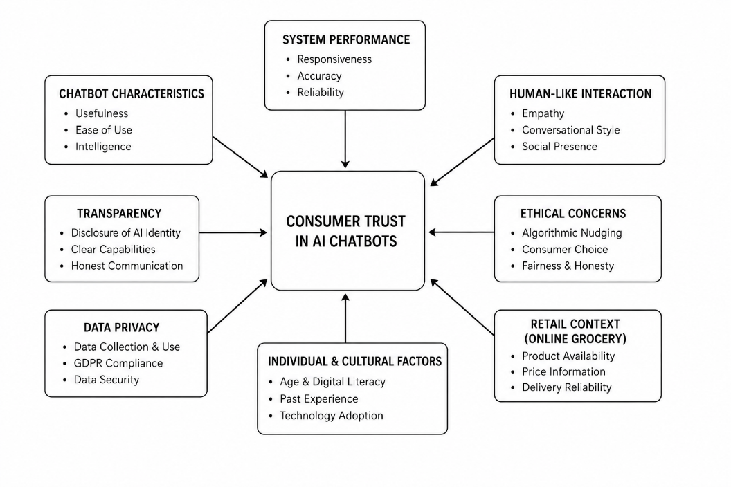
Figure 01: Consumer Trust in AI chatbots

Transparency plays a vital role in trust with AI chatbots. According to Wu et al. (2021), consumers are more likely to trust if the system displays its capabilities and limitations. If chatbots disclose their AI identity and provide descriptions of their functions, users will have better expectations. But lack of disclosure or deception could lead to mistrust, particularly when the chatbot fails to live up to users' expectations.
Sharing of data is also an issue in consumer trust of AI chatbots. Evans et al. (2023) highlighted that with the increasing awareness of data privacy laws, particularly the General Data Protection Regulation, consumers are more aware of data collection and usage. The authors also indicated that Chatbots often use a large amount of data, including web browsing, preferences, and purchase data, to provide more personalised responses. This enhances the user experience but raises privacy risks to surveillance and misuse of data. Transparency in data collection and use is essential to establish trust, according to the authors. If customers trust that their data is used safely, they will be comfortable interacting with AI.
Trust is one of the most important factors in the case of online grocery shopping because grocery shopping is of vital importance and is done frequently. Consumers need to be informed whether the product is available, the price of the product and when it can be delivered. The chatbots' responses need to be reliable and consistent to impact purchase decisions and establish trust. Huynh (2024) pointed out that generative AI chatbots can help in fostering trust by providing information and assist customers with decision making. But they also pointed out that the reliability of the bots must be ensured to be successful. Moreover, customers value the assurance they have while using an online service. Responses to the questions may be ambiguous and incorrect, which can contribute to confusion and lack of trust. Ranieri et al. (2024) noted that negative experiences with the chatbot can result in dissatisfaction and a loss of trust in the chatbot and the retailer. This shows how system performance can be a crucial influence on the establishment of trust. Further, cultural and individual differences might affect consumer trust towards AI chatbots. There are those who embrace the technology first and there are those who are skeptical of technology from a fear of automation and a lack of personalisation. This could differ depending on age, the digital literacy of the individual, and experience with AI technology. Therefore, it is essential that retailers take these into account when designing a chatbot. Trust has also been shown to be associated with satisfaction and intention to buy by Shahzad et al. (2024). Building trust and retainment can be achieved if the Chatbots provide adequate experiences, perhaps even better. On the other hand, a negative experience with chatbots can decrease trust and the image of the retailer. This linkage underscores the significance of establishing confidence-building mechanisms in the design and functioning of chatbots. The literature indicates that customers' trust in AI chatbots is a several concept that is based on system performance, usefulness, transparency, and ethical concerns.
Chatbots offer many advantages in terms of efficiency and customisation, but they must be trustworthy to be effective, which depends on dependable and transparent experiences. The authors are consistently emphasising on to trust as a critical factor and barrier to adopting AI chatbots for online shopping. This is important for UK online grocery retailers to ensure chatbots increase consumer satisfaction and purchase intention.

2.4 Customer Satisfaction and Chatbot Interaction
Satisfaction is another important outcome of service interactions and a key predictor of continued engagement in online retail. Satisfaction has been defined as fulfilment of expectations regarding a service (Singh et al., 2024). The authors noted that in online retail, AI chatbots have the potential to increase satisfaction by offering immediate, customised, and 24/7 assistance to customers. They explained that speed and convenience are key factors in delivering excellent service experiences, especially when time is of the essence, as is the case for online grocery shopping. Similarly, Singh and Singh (2024) argued that AI-based service technologies improve convenience and efficiency and, hence, customer satisfaction. The authors observed that chatbots reduce customer waiting times and enhance the shopping experience, from searching to buying. They also argued that in a highly competitive retailing environment, such as online grocery retailing, convenience is an important factor in defining satisfaction since customers expect efficient and convenient shopping. As such, AI chatbots are not only delivering services but also influencing customer experience by creating expectations.
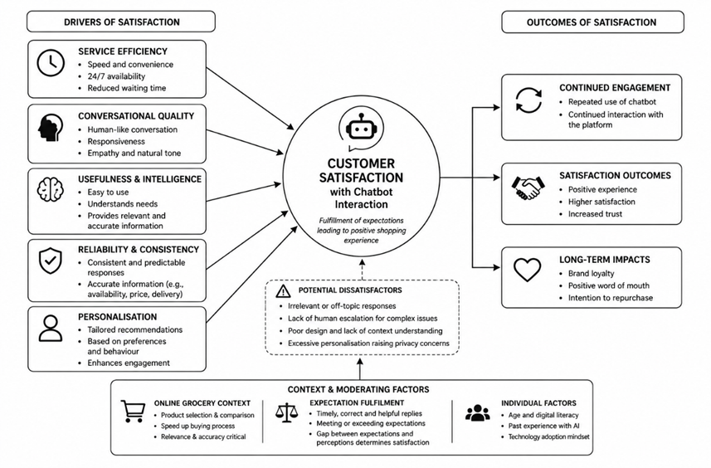
Figure 02: Customer Satisfaction and Chatbot Interaction
Similarly, Al-Shafei (2025) stated that satisfaction is largely affected by the degree of human-like conversations of chatbots. They also highlighted that the type of conversation, responsiveness, and empathy play a significant role in predicting satisfaction with AI technologies. They highlighted that chatbots are effective in sending information, but that satisfaction could suffer if chatbots are perceived as not being in a humane manner. It highlighted the need for creating efficient chatbots that can interact with their users in a natural way. Al-Shafei (2025) however cautioned that the negative impact of bad designing of the chatbots on customer satisfaction. They pointed out that the chatbot's lack of knowledge about language and context can lead to non-relevant and redundant replies. This may cause customer dissatisfaction, especially if the complaints are not addressed in a timely manner. They also argued that dissatisfaction with service can arise if chatbots are unable to escalate matters to human agents for more complicated matters.
Likewise, Al-Shafei (2025) suggested the concept of functional satisfaction but emotional detachment which means that while AI chatbots can deliver functional satisfaction, they may not deliver emotional relationships. They also argued that even though chatbots can be appreciated for their efficiency and accuracy, they can still be seen as lacking emotional connection. This may not be good for long-term satisfaction and relationship-based benefits such as brand loyalty or brand attachment. AI-based experiences not only lead to instrumental satisfaction but also emotional satisfaction.
Additionally, Chen et al. (2021) found that usefulness and intelligence play an important role in chatbots' user satisfaction. They argued that users evaluate chatbots based on the chatbot's ease of use and its ability to understand the user's needs. They also observed that when chatbots understand the user and provide relevant information, users are more satisfied. However, when they cannot understand and need to clarify, users are dissatisfied. When it comes to quality, users also evaluate the predictability of AI chatbots. Liu et al. (2023) proposed that consistency and predictability in interactions lead to trust and ultimately satisfaction.
The authors observed that the inconsistent answers are confusing and distrustful. This is especially crucial in an online grocery setting to ensure accurate product availability, pricing, and delivery. Further, personalisation is considered as a key component of the satisfaction of AI chatbots. Singh et al. (2023) highlighted that if chatbots can analyse the users' preferences and behaviours and then make recommendations for them, the chatbots can be seen as useful. They claimed 'personalization' of user interaction boosts engagement and enhances shopping experience. But too much personalisation can lead to privacy problems; in the end, this will lead to poor satisfaction.

Factors Affecting Customer Satisfaction | Positive Influence on Satisfaction | Negative Influence on Satisfaction | Key Sources
Speed and Convenience | Immediate responses, 24/7 assistance, and reduced waiting time improve shopping experience | Slow responses reduce convenience and satisfaction | Singh et al. (2024); Singh and Singh (2024)
Human-like Interaction | Empathy, responsiveness, and natural conversation increase engagement and satisfaction | Robotic or unnatural communication lowers satisfaction | Al-Shafei (2025); Hu et al. (2022)
Chatbot Design & Usability | Easy-to-use and intelligent systems improve customer experience | Poor design, irrelevant responses, and lack of contextual understanding create dissatisfaction | Al-Shafei (2025); Chen et al. (2021)
Emotional Connection | Human-like communication may strengthen emotional engagement and loyalty | Functional efficiency without emotional connection may weaken long-term loyalty | Al-Shafei (2025)
Usefulness & Intelligence | Relevant information and understanding user needs improve satisfaction | Failure to understand customer requests decreases satisfaction | Chen et al. (2021)
Consistency & Reliability | Predictable and accurate responses increase trust and satisfaction | Inconsistent information creates confusion and distrust | Liu et al. (2023)
Personalisation | Tailored recommendations enhance engagement and shopping experience | Excessive personalisation may create privacy concerns | Singh et al. (2023)
Conversational Design | Politeness, tone, and responsiveness improve authenticity and satisfaction | Robotic tone reduces authenticity and engagement | Hu et al. (2022)
Expectation Fulfilment | Meeting or exceeding customer expectations increases satisfaction | Failure to provide timely and helpful replies causes dissatisfaction | Singh et al. (2023)
Online Grocery Shopping Context | Fast product comparison and purchase assistance improve efficiency and satisfaction | Irrelevant or incorrect information reduces usefulness | Castillo et al. (2025)

Hu et al. (2022) stated that such factors as tone, politeness, responsiveness are essential to the user's perception of the service. Engagement, and therefore satisfaction, can be improved by increasing the human like conversational style. In contrast, a more robotic response might lead to a decrease in authenticity. The meeting of expectations is another crucial factor. Singh et al. (2023) suggested that satisfaction level is reached when the user's expectation from the chatbot effectiveness is fulfilled or surpassed. When the user expects to receive a response quickly, accurately, and usefully, a chatbot that fails to deliver could lead to the user becoming displeased. Satisfaction is the difference between expectation and perception. Efficiency is a key factor in a person's satisfaction when shopping online for groceries. Castillo et al. (2025) emphasised that generative AI-powered chatbots enhance satisfaction by aiding in product selection, comparison, and speeding up the process of buying. The authors highlightedd these systems can be helpful for repetitive tasks in shopping that are predominantly a need for speed and efficiency. However, they also indicated they work because they are relevant and correct.

2.5 Purchase Intentions in Online Retail
In the context of consumer behaviour, purchase intention is commonly defined as the likelihood that consumers will make an actual purchase of a product or service following their interaction with the product, service, or system. This is related to the interactions with technology, especially in online shopping, as with AI technologies like chatbots. According to Jiang et al. (2022), positive interactions with chatbots can help to decrease uncertainty and increase trust in the consumer's purchase decision-making, which lead to higher purchase intentions. The authors explained that the consumer's level of uncertainty will be reduced with the increase of AI technology providing more accurate, up-to-date and relevant information, thus increasing their intentions to purchase online.
Similarly, Rahevar and Darji (2024) believed AI chatbots play a vital role in consumer purchase decision making by providing them with personalised recommendations. The authors pointed out that chatbots leverage consumer preferences and behaviours to make product recommendations that are more likely to meet a consumer's needs and save them time and effort. This interaction makes this experience even better and enables a quicker decision-making process, leading to purchase intentions. They also reported that personalisation is a cue that makes them feel more valuable and more confident in purchasing. This was also backed up by Ramayanti et al. (2025), who suggested it is important to explore the influence of the quality of chatbot service on the consumer's attitude and behavioural intention. They found the key elements of service quality to be responsiveness, accuracy, and ease of use that affect the purchase intention. When chatbots can respond accurately to consumer inquiries, it boosts the consumer's trust and confidence in the system's effectiveness, which in turn increases purchase intention.
The slow response or incorrect answers from chatbots, however, can result in less consumer trust and purchase intent, highlighting the link between service quality and consumer perceptions. Psychological factors influence purchase intention as well, other than performance-related factors. Utami et al. (2025) asserted that online consumer behavior is not only influenced by rational, but also experiential and perceived engagement. The author claims that when the interaction with chatbots is smooth, fast, and useful, consumers may have positive feelings toward the company, which leads to purchase intentions. However, when confusing or annoying, customers are likely to drop out of the purchase process, which displays the moderating role of emotions on purchase intention.
Kamoonpuri and Sengar (2025) proposed that generative AI chatbots increase purchase intentions (the likelihood of making a purchase) by aiding purchasing decisions in online grocery shopping. Specifically, they noted that chatbots help users to navigate through large product ranges, compare products, and obtain information about products. In low-involvement products, such as groceries, where time is an important consideration, chatbots reduce time and effort. This makes the purchase decision process easier, increasing the likelihood of purchase, particularly in time-constrained situations.
However, Panwar et al. (2025) gave a more realistic picture of the issue with their study of AI nudging in e-commerce. They observed AI influences consumers through the subtle nudging strategies of product placement, promotion placement, and framing of suggestions through personalisation. AI nudging suggests that it is possible that buying intentions are not always entirely autonomous but influenced by algorithmic design (Panwar et al., 2025). While these strategies can help boost conversion rates and increase sales, there could be ethical issues regarding transparency and autonomy.

Factors Influencing Purchase Intentions | Positive Impact on Purchase Intention | Potential Negative Impact
Chatbot Service Quality | Accurate, fast, and relevant responses increase confidence and trust | Slow or incorrect responses reduce trust and buying intention
Personalisation | Tailored recommendations improve relevance and save time | Excessive or intrusive recommendations may create privacy concerns
Ease of Use | Simple and user-friendly chatbot interfaces encourage purchasing | Complex or confusing interfaces discourage purchases
Convenience & Speed | Quick assistance and faster decision-making improve shopping efficiency | Delays or poor navigation may increase frustration
Trust & Satisfaction | Positive chatbot experiences increase confidence and willingness to buy | Distrust or dissatisfaction may lead to cart abandonment
Psychological & Emotional Factors | Smooth and engaging interactions create positive feelings toward retailers | Annoying or confusing interactions reduce behavioural intention
AI Nudging & Algorithms | Product suggestions and recommendations may increase conversions | Consumers may perceive recommendations as manipulative
Online Grocery Context | Real-time support for product availability, price, and delivery improves purchase likelihood | Inaccurate grocery information may reduce reliability and purchase intention
Long-Term Outcomes | High-quality chatbot interactions can improve loyalty and repeat purchases | Poor chatbot performance can damage future behavioural intention

Jadiga (2025) also proposed that e-commerce algorithms can influence consumers. They pointed out that AI-based recommendation systems may subconsciously persuade consumer purchasing behaviour. It thus affects consumer autonomy and accountability in e-commerce. They also suggested that while they might increase purchase intention in the short term, they can have a detrimental effect on trust and long-term customer loyalty if they are perceived as manipulative.
Pirzado et al. (2025) also noted that personalisation increases purchase intention but is dependent on the quality of the algorithms. Irrelevance or intrusiveness of recommendations can lead to a decrease in purchase intention. This highlights the mixed nature of the effects of AI chatbots on purchase intention as personalisation can lead to higher and lower purchase intentions, depending on consumers' perceptions and the design of the chatbots.
Bouteraa et al. (2026) also pointed out the role of ease of use for behavioural intention. They found that when the chatbots are easy to use, consumers will be more inclined to interact with the chatbots and proceed to purchase. However, when the user interface is too complex and difficult to navigate, it can confuse the customer's purchase decision-making, resulting in a lower chance of purchase. This suggests that human-centred design is important in designing AI chatbots.
In the context of online grocery shopping, convenience and speed are important purchase intentions. They are more concerned about convenience, speed, and accuracy than product details. According to Pandey et al. (2026), AI chatbots are important tools that can provide live support and alleviate purchase uncertainty. This is especially crucial in the case of regular shopping, where customers are looking for speedy yet reliable service. Additionally, trust and satisfaction mediate the effect of chatbots' interaction on purchase intention. Yen and Chiang (2021) suggested that when consumers have trust in the chatbot systems and are satisfied with the chats by the chatbots, they will be more inclined to make purchases. But if the consumer is dissatisfied or distrustful, then the purchase decision can be disrupted and cause cart abandonment. Thus, purchase intentions are not only a direct outcome of the chatbot features, but also the general psychological evaluation of the chatbot. This was backed up by Vy (2025), who found that high-quality AI services affect customer loyalty and behavioural intention through emotional and functional satisfaction. These authors concluded that if the chatbot interactions are stable and high quality, this will lead to positive attitudes towards the retailer and future purchases. However, if chatbot interactions are not consistent or reliable, it can impact behavioural intention even if functional satisfaction is met.

2.6 Theoretical Perspective: Technology Acceptance Model (TAM)
The Technology Acceptance Model (TAM), originally developed by Davis (1989), is one of the most widely applied theoretical frameworks for understanding how and why individuals accept and use new technologies. The model argues that two core cognitive beliefs perceived usefulness and perceived ease of use shape an individual’s attitude towards a technology, which subsequently influences behavioural intention and actual usage.
According to Davis (1989), perceived usefulness refers to the extent to which an individual believes that a system improves performance, while perceived ease of use refers to the extent to which the system is easy to use. These two constructs are useful in the understanding of consumer engagement in the context of online grocery retailing and AI chatbots. Perceived ease of use is another factor that has been discussed extensively as an important factor for the acceptance of chatbots. Adam et al. (2021) proposed that consumers would be more willing to interact with the AI chatbot when the process is intuitive, simple and non-demanding. The authors emphasized the potential of NLP and conversational interfaces for alleviating cognitive load, thus enhancing the technology's usability and accessibility to broad audiences.
Likewise, Varzaneh et al. (2025) highlighted the shift of chatbots from simple rule-driven systems to sophisticated AI-powered conversational tools has enhanced the user friendliness of chatbots, enabling users to engage with them more naturally without requiring technical expertise. Ahmed et al. (2025) also added that AI chatbots feature perceived usefulness as a key determinant in consumers' acceptance of AI services. The authors highlighted that, if consumers think that chatbots are useful to enhance shopping efficiency (e.g., instant response, product information, tailored recommendations), they have a better attitude toward them. Likewise, Makinde et al. (2025) proposed that AI technologies in service can increase the perceived usefulness through decrease in waiting time, consistency in service delivery, and 24/7 availability. For online grocery shopping, convenience and speed are paramount, and this functionality plays a crucial role in shaping consumer trust and adoption of chatbot solutions when making purchases.
Although design and functionalities have improved, however, Wulandari et al. (2023) claimed that perceived ease of use is still highly dependent on the capability of a chatbot to interact like a human. The authors also indicated that people tend to believe that the purpose of the conversational agent is to communicate like a human, and any of these patterns that is not observed can decrease their perception of usability. When consumers do not understand what a chatbot is asking for or if it gives them irrelevant responses, it can make them feel that there is a usability problem with the system, negatively affecting their intentions to use it. This underscores the fact that usability in AI systems is not just a technical problem, but also a psychological one, influenced by user expectations regarding conversational quality. Inspired by TAM, some scholars have further developed the TAM to more comprehensively explain the complexity of AI-driven consumer interactions.
Uddin et al. (2024) proposed that the traditional TAM model should be supplemented with the concept of trust in e-commerce settings when exploring adoption of AI chatbots. The authors also stressed that despite usefulness and user-friendliness of the chatbot, the consumers may not be ready to embrace it if they lack confidence in the information, it provides or its data processing. This can be especially relevant in online grocery retailing, where people are looking to use AI systems to determine what they want to eat for the day, and need a lot of confidence in the accuracy and reliability of the systems. Likewise, Chiu (2025) pointed out that perceived usefulness does not necessarily account for adoption actions in the case of generative AI chatbots. The authors argued that trust in algorithmic decision-making and AI recommendations being perceived as transparent are emerging as key factors in consumer acceptance. Consumers are likely to question the basis of the chatbot's suggestions when they are used in an online grocery store, as they are likely to have seen this product before, which in turn may affect their trust in the system.
Mantello et al. (2023) also added emotional and experiential variables to the TAM model, highlighting their impact on consumer attitudes toward AI technologies. The authors suggested that although TAM is good for measuring cognitive assessment of technology, it is not sufficient to measure emotional assessments such as enjoyment, frustration, or discomfort. Emotional engagement can have a profound effect on the satisfaction and loyalty of users in chatbot interactions. For instance, a chatbot that is friendly and empathetic could improve the user experience while a robot-like or irrelevant reply might be counterproductive and lead to less engagement, even if the system is technically sound.
On the other hand, Nkomo et al. (2024) discussed the limitations of traditional TAM in the context of an environment where AI increasingly influences consumer behaviour, stating that this is because ethical issues are becoming more significant. Concerns like algorithmic manipulation, lack of transparency, and data privacy are increasingly at the core of consumer decision-making, the authors pointed out. With AI chatbots, users might wonder about the influence of personalised recommendations or nudging techniques on their decision-making, impacting perceived control and trust in the system. For AI chatbots, users might wonder about the influence of personalised recommendations or nudging techniques on their decision making, which can affect perceived control and trust in the system. This implies that the usefulness and ease of use are not the only factors that influence behavioural intention, but it is also influenced by wider ethical perceptions.
Additionally, Bock et al. (2020) proposed that AI technologies are reshaping the nature of service interactions moving beyond simply functional exchanges to more intelligent and adaptive systems. According to the authors, AI chatbots in the future will no longer just execute tasks but also predict consumer needs by analysing patterns and emotions. This shift calls into question the foundational tenets of TAM, since acceptance will increasingly become a function of dynamic interaction quality, instead of static perceptions of usability. Perannagari and Chakrabarti (2020) also stated that the contextual factors have an impact on variables of TAM in online retail context. The authors discovered that consumer experience with AI technologies, frequency of online shopping, and previous experience using chatbots can moderate the perceived usefulness and ease of use. This means that in TAM use, there are other factors that influence their use beyond just the technology, including user characteristics and situational factors, such as in the context of digital retail applications, e.g., online grocery services.

2.7 Research Gap
While there's a lot of literature on the subject, there are still several gaps regarding AI chatbots in online retail. There are numerous studies on the e-commerce environment, but very few have considered the online grocery retail industry in the UK. Existing research does not adequately capture the unique grocery shopping behaviours of the consumers, including routine grocery shopping and time-sensitive shopping. In addition, previous studies have investigated trust and satisfaction and purchase intention separately, but few studies have studied these factors together in a single context. It is important to recognise the interaction of these factors to have an overall picture of consumer behaviour. Furthermore, the ethical considerations of AI chatbot applications and their potential to manipulate data and algorithms are still largely overlooked in the realm of online grocery delivery. This study will fill these gaps by analysing consumer responses to AI chatbots and how they impact trust, satisfaction, and purchasing behavior in the UK online grocery market.

2.8 Conceptual Framework
The study suggests a conceptual model to explain the impact of interactions with AI chatbots on trust, satisfaction, and behavioural intentions to purchase in online grocery shopping in the UK. The model is based on the Technology Acceptance Model (Davis, 1989) that acceptance of technology is based on perceived usefulness and ease of use, but trust and satisfaction are included as behavioural intentions. The interaction quality with an AI chatbot (independent variable) in this model is responsiveness, accuracy, personalisation, and ease of communication (Huang & Rust, 2021). These impact on the perceived usefulness of chatbots in online shopping.
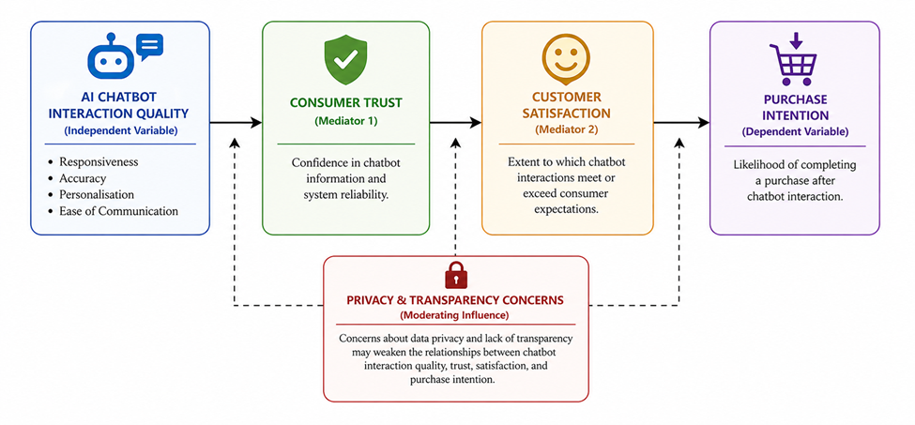
Figure 03: Conceptual Framework
The first outcome variable is consumer trust, which is the trust in the information and system of chatbots. According to Cheng et al. (2024), trust is increased if chatbots provide useful information. The second variable is consumer satisfaction, which is the satisfaction with chatbots. Singh et al. (2023) and Chen et al. (2023) emphasised that chatbots that are efficient, convenient, and effective contribute to satisfaction, but the absence of emotions leads to a decrease in satisfaction. The third outcome is purchase intention, which refers to the intention to purchase following interaction with a chatbot. Stevens et al. (2023) and Rahevar and Darji (2024) reported that good experiences and recommendations from chatbots increase buying intention. The conceptual model suggests that trust and satisfaction mediate the links from chatbots to purchase intention. De Marcellis-Warin et al. (2022) and Addis and Kutar (2018) also state that privacy and transparency could influence these relationships.

Chapter 3: Methodology
This chapter has covered the methodology section of the research. The methodology has been designed to get reliable, valid, and applicable results to the research goals. The research philosophy, research design, type of data, sampling design, data collection methods, and data analysis techniques used in the study have been discussed in the chapter. The chosen methodology has allowed the researcher to analyse systematic and objective measurable relationships between AI chatbot interactions and consumer behavioural outcomes.

3.1 Research Philosophy
The positivist research philosophy has been used in this study. Positivist assumes that reality can be measured and can be evaluated based on data that can be observed and quantified (Saunders et al., 2019). The selection of positivism is suitable as the study has been conducted to explore the relationship between the AI chatbot interactions, consumer trust, customer satisfaction, and purchase intentions in online grocery retail in the United Kingdom.
Instead of subjective interpretation, the positivist philosophy is cantered on the objective measurement and a statistical evaluation. In a study that tries to analyse measurable consumer perceptions and behavioural patterns, positivism has been found suitable to conduct the study in a structured and based on evidence. In positivist research, often numerical data is used, hypothesis testing is promoted, and statistical analysis is employed to detect patterns and relationships between variables (Saunders et al., 2019). Hence, the philosophy has been very similar to the quantitative approach of this study.
The use of positivism has facilitated the application of survey questionnaires and statistical methods to the study of trend patterns in consumer attitudes and behaviour towards AI chatbots. The study has gathered measurable responses from consumers who have been shopping online often through grocery retailers, including Tesco and other grocery platforms in the UK. The researcher can assess consumer perceptions about the usefulness, trustworthiness, convenience, and effectiveness of chatbots in this way. Moreover, positivism has improved the reliability and objectivity of the results as the research has used standardised answers and systematic statistical analysis. Therefore, the philosophy has allowed the researcher to make evidence-based conclusions about the effects of the use of AI chatbots on trust, satisfaction, and purchase intentions in online grocery retail environments.

3.2 Research Design
In this study, the research design adopted was a quantitative research design to study the effect of AI chatbots on consumer behavior in the online grocery retail industry. Quantitative research has been directed towards numbers and statistics and sought to identify relationships between variables (Creswell, 2014). The quantitative approach is considered appropriate as the study has been focused on analysing and measuring the consumer's perceptions of interaction, trust, satisfaction, and purchase intention with Chatbot services. Quantitative research has allowed the researcher the ability to gather regularised responses from a greater number of participants and analyse the data statistically, whereas qualitative research is more prone to asking questions about personal experiences and opinions in greater depth. According to Creswell (2014), quantitative research can be utilised in a study to test hypotheses or to study the relationships between variables. Hence, the quantitative design has been able to facilitate the objectives and hypotheses of this study well.
The study design is quantitative with a survey method. The survey method has enabled the researcher to gather structured responses from consumers who use online grocery shopping platforms in the UK. Closed-ended questions on the questionnaire have provided uniformity and reliability in data collection. The same set of questions has been asked of all respondents, enabling a valid comparison and statistical analysis of the results.
The quantitative design has also enabled correlation and relationship testing of variables related to the consumer's behaviour and the interaction with the AI chatbot. The researcher can detect the patterns of trust, customer satisfaction, and buying intent resulting from the chatbot experience in this way. The design has helped to ensure systematic investigation of consumer responses to AI chatbots in online grocery retail situations. Furthermore, the quantitative design has minimised the bias of the researcher as the results were analysed through statistics objectively. This has enhanced the findings of a study's trustworthiness.

3.3 Data Type
The study mainly used primary data collected directly from UK consumers who regularly shop for groceries online. Primary data is considered as especially significant as it mirrors the real-life experiences, attitudes, and perceptions of consumers towards interactions with AI chatbots during online shopping. Use of primary data has helped the researcher obtain information that is directly related to the research objectives and hypotheses. In social science research, primary quantitative data is useful to analyse consumer behaviour, attitudes, and measurable perceptions (Bryman, 2016).
Primary data has helped to generate new and situation-specific insights into consumers' trust, satisfaction, and purchase intent of using AI chatbots in online grocery retail. While the literature review has employed secondary sources like journal articles. The findings of the study have been based on consumer responses collected through a survey.

3.4 Sampling Design
The study has been based on consumers in the UK who regularly buy their groceries from online retail outlets such as Tesco, Sainsbury's, and Asda. These consumers were chosen as they are more likely to have engaged with AI chatbots when making online purchases. The study included around 100 respondents, which was sufficient for conducting a small-scale quantitative analysis. This amount of collected data has helped the researcher to establish trends and relationships between variables and is still manageable given the constraints of time and research. The sampling technique used in this study is mainly convenience sampling.
Convenience sampling is a technique that involves choosing participants who are easier to access and available than those selected through random sampling (Pace, 2021). This sampling technique was considered to be appropriate because the sample needed to be one that was online consumers and could be efficiently reached digitally. By using convenience sampling, the researcher has been able to get feedback from people who are comfortable with online grocery shopping and using AI chatbots. This has made the collected data more relevant since the sample have had prior experience with the research topic.

3.5 Data Collection Method
This study was conducted with the help of an online survey questionnaire that was sent via digital channels. Google Forms have been used to create and distribute the questionnaire. Online surveys method is considered suitable for this research due to the consumers' familiarity with online retail and digital shopping platforms. There have been several benefits from using online questionnaires. Firstly, it has helped the distribution of the survey in a quick and cost-effective way in various geographic areas of the UK.
Secondly, it was convenient for respondents to complete the questionnaire on their smartphone, tablet and computer. Thirdly, online data collection has made answering easier, as it captures and digitally organizes answers. Overall, there are several closed questions, primarily measured on a 5 point (Strongly Disagree to Strongly Agree) Likert scale. The questions that were presented on the Likert scale have helped the researcher to measure the perceptions, attitudes and behavioural intentions of the respondents in quantitative terms. The questionnaire contains questions regarding the usefulness of the Chatbot, ease of use, responsiveness, trustworthiness, satisfaction with the Chatbot and influence on purchasing decisions. The questions have been framed directly in keeping with the research questions/hypothesis. The structured questionnaire form has facilitated coding, quantifying and statistically analysing the data.

3.6 Data Analysis
Data collected has been analysed using the Microsoft Excel program which has supported the researcher in organising, interpreting and visualising the data collected quantitatively. The software used was Excel as it is a small-scale quantitative research statistical tools that is accessible (Saunders et al., 2019). Descriptive statistics such as frequencies, percentages, mean scores, and standard deviations are used to summarise the demographic information and perceptions of interactions with AI chatbots of the respondents. These statistical techniques have given an overall picture of consumer attitudes and shopping behaviours. Moreover, a correlation analysis has been conducted to investigate the relationship of AI chatbot interactions with Consumer trust, Customer satisfaction and Purchase intention. Using Pearson correlation, the researcher has tried to determine if there is a positive or negative relationship between the variables. In addition, the study has used regression analysis to examine the effect of the chatbot interaction on the trust, satisfaction and purchase intention. These relationships have been statistically quantified in terms of their strength and significance by regression analysis. Data has been displayed graphically using Excel charts, graphs and tables. All these tools have helped to improve the clarity and interpretation of the results. Saunders et al (2019) state that for quantitative survey data, Excel is suitable as it offers simple yet powerful statistical and visualisation tools. The study has uncovered key insights and patterns in consumer attitudes towards AI chatbots on online grocery shopping platforms in the UK, which will help shape the future of these services. The analysis has therefore helped the researcher to make sound conclusions on the impact of interaction with AI chatbots on consumer trust, customer satisfaction, and purchasing intention.

Chapter 4: Data Analysis and Findings

4.1 Introduction
This chapter has outlined the quantitative analysis and results of the research that explored consumer attitudes toward AI chatbots, the impact on their trust, customer satisfaction, and buying intent in online grocery retailers in the UK. This chapter has aimed to analyse and interpret the data obtained from the survey questionnaire of UK online grocery consumers. In this chapter, the authors have specifically focused on the relationship between the interactions between AI chatbots and consumer trust, customer satisfaction, and purchase intention. The results presented in this chapter have answered the research objectives, the research hypotheses, and the conceptual framework that had been discussed for the study. The analysis has examined the potential of the AI chatbot interaction to impact trust and customer satisfaction and assessed how this relationship impacts online grocery retail purchases.

4.2 Demographic Profile of Respondents
The data included in this section identifies the characteristics of the respondents about how AI chatbots have impacted their customers' responses in the UK online grocery retail market. Descriptive analysis of the respondents is presented in terms of frequencies, percentages, pie charts, and the demographic table. The analysis provided information about online grocery shoppers and their awareness of AI chatbot technology in online retail.

Table 4.1: Age Group Distribution of Respondents
Age Group | Frequency | Percentage
18–24 | 29 | 29.3%
25–34 | 51 | 51.5%
35–44 | 15 | 15.2%
45–54 | 3 | 3.0%
55+ | 1 | 1.0%
Total | 99 | 100%
The results showed that most of the respondents under the age group 25-34, which accounted for 51.5% of the respondents. 29.3% of the respondents were aged between 18 and 24, and 15.2% were aged between 35 and 44. The rest are the 45-54 and 55+ age groups.
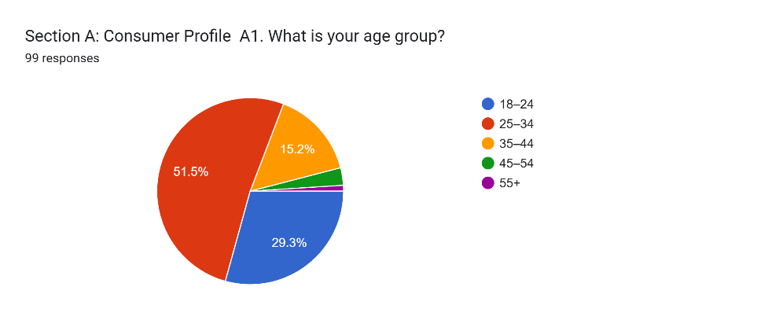
Figure 04: Age Group Distribution of Respondents
The results revealed that the younger and middle-aged consumers are the main users of online grocery shopping platforms and digital customer service technologies in the UK retail sector.
Table 4.2: Gender Distribution of Respondents
Gender | Frequency | Percentage
Male | 61 | 61.6%
Female | 36 | 36.4%
Prefer not to say | 1 | 1.0%
Other | 1 | 1.0%
Total | 99 | 100%
The gender analysis showed that there were more male respondents (61.6%) than female respondents (36.4%). 1% of the respondent decided not to prefer to say. The results showed that males and females are equally enthusiastic about online grocery shopping and using AI-driven online retail solutions.

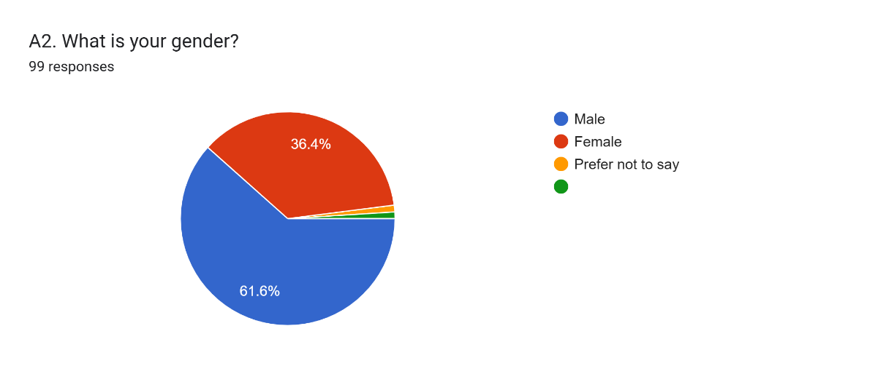

Figure 05: Gender Distribution of Respondents

Table 4.3: Frequency of Online Grocery Shopping
Shopping Frequency | Frequency | Percentage
Weekly | 61 | 62.2%
Monthly occasionally | 29 | 29.6%
Rarely | 8 | 8.2%
Total | 98 | 100%
The findings revealed that most of the respondents (62.2%) regularly buy groceries online every week. The 29.6% who purchased groceries online occasionally each month and only 8.2% of the respondent who rarely bought groceries online. This research showed that convenience, accessibility, and timesaving are all reasons why online grocery shopping is now a regular occurrence for many UK consumers.
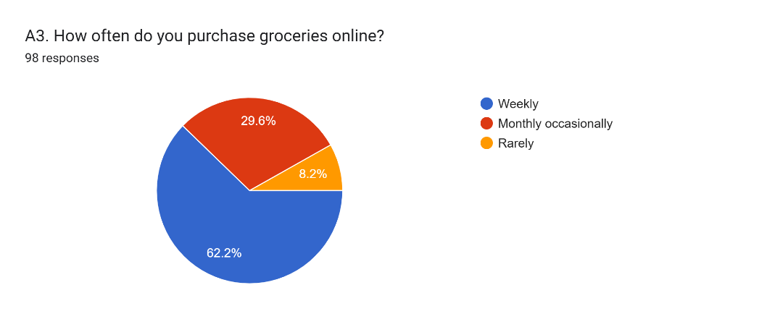
Figure 6: Frequency of Online Grocery Shopping
According to the result, most of the consumers regularly use online shopping platforms and may frequently interact with AI-powered customer service tools.

Table 4.4: Preferred Online Grocery Shopping Platform
Platform | Frequency | Percentage
Tesco | 47 | 48.0%
Sainsbury’s | 19 | 19.4%
Ocado | 10 | 10.2%
ASDA | 8 | 8.2%
Other | 14 | 14.3%
Total | 98 | 100%
The table showed that 48.0% of the respondents used the Tesco online grocery shopping platform. Sainsbury's had 19.4% of the responded; Ocado had 10.2% and ASOS 8.2%. The other online grocery platforms combined accounted for 14.3% of the responses.
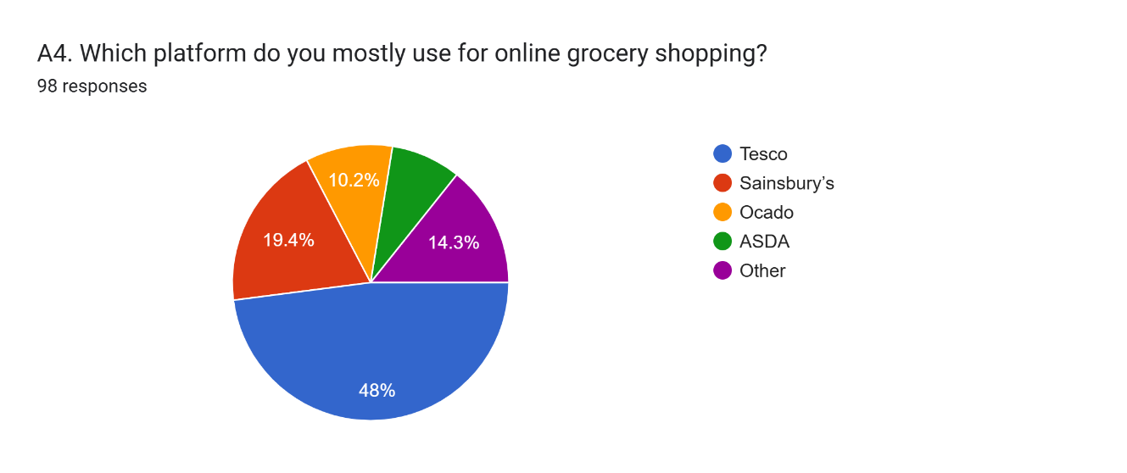
Figure 07: Preferred Online Grocery Shopping Platform
The dominance of Tesco shows that people prefer established e-commerce grocery sites with a user-friendly online experience, convenience, and customer service. The results also highlights that how food delivery platforms in the UK are increasingly competing with one another to use digital technologies and bring artificial intelligence to their customer service.

Table 4.5: Experience with AI Chatbots During Online Shopping
AI Chatbot Interaction | Frequency | Percentage
Yes | 79 | 81.4%
No | 18 | 18.6%
Total | 97 | 100%
The results demonstrated that most respondents had interacted with AI chatbots while shopping online. About 81.4% of the respondents have had previous interaction with chatbot systems, with 18.6% saying they have not used AI chatbots in their online shopping activities.
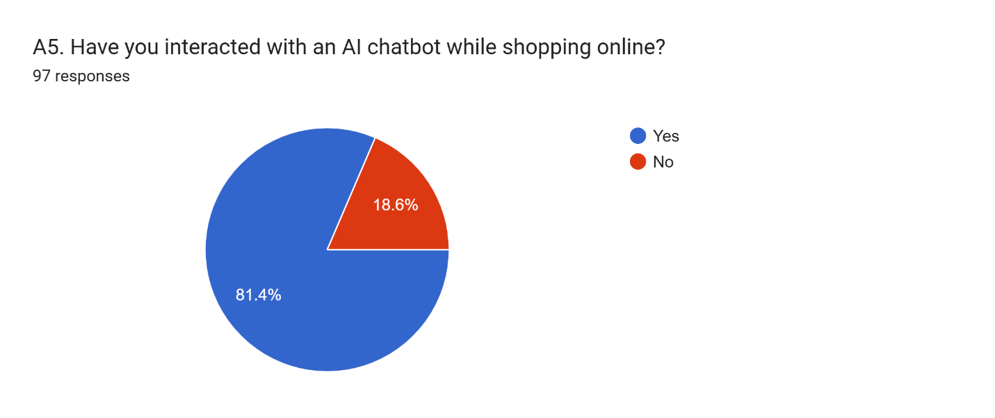
Figure 08: Experience with AI Chatbots During Online Shopping
The results show that consumers in the UK online grocery retail sector are highly aware of AI-powered customer service technologies. As AI chatbots become very common, it becomes clear that digital communication, automated support, and convenience are becoming increasingly vital in today's retail landscape.
In general, it indicates that the UK online grocery shoppers are very tech-savvy and active users of the Internet and online shopping platforms. Online grocery shopping is common, and exposure to AI chatbot systems is very high, indicating the increased significance of digital retail communication in consumer purchases. The results also reveal a higher level of awareness of AI chatbot technologies among younger consumers and regular online shoppers, further emphasizing the significance of AI-powered customer service platforms in the UK online grocery retail sector.

4.3 Descriptive Analysis of Main Variables
This section has given the descriptive analysis of the key variables discussed in the study such as AI chatbot interaction, consumer trust in AI chatbots, customer satisfaction, and purchase intention. The analysis has focused on Objective 1, Objective 2, and Objective 3 of the research. There has been a review of consumer perceptions about using AI chatbots in UK online grocery retail using mean score analysis and standard deviation analysis. The findings of the descriptive phase have provided valuable insights to highlight the most significant characteristics of the chatbot that impact the attitude of consumers of online grocery platforms.

Variable 1: AI Chatbot Interaction
Table 4.5: Mean Score and Standard Deviation for AI Chatbot Interaction
Indicator | Mean Score | Standard Deviation | Rank
Chatbot responses are relevant to my needs | 3.537 | 0.605 | 1
AI chatbots respond quickly to my queries | 3.536 | 0.660 | 2
I feel comfortable using AI chatbots while shopping online | 3.508 | 0.619 | 3
AI chatbots improve my overall shopping experience | 3.474 | 0.538 | 4
The study showed that UK online grocery consumers had a moderately positive attitude towards the interaction with AI chatbots. The highest mean score was ‘Chatbot responses are relevant to my needs’ with a standard deviation of 0.605, which suggested that most of the respondents agreed that the chatbot systems were providing relevant and useful responses while shopping. A relatively low standard deviation also indicates that there is high uniformity in the respondents' answers about the relevance of chatbots.

Figure 09: AI Chatbot Interaction Mean Score
The second-highest mean score 3.536 was identified by the answer to “AI chatbots respond quickly to my queries”. This reveals that when consumers are shopping online, their need for speed is significant, and they expect immediate help. This means that consumers might well appreciate AI-powered customer service as it can help to reduce their waiting time and enhances their shopping experience. The mean score for the question “I feel comfortable using AI chatbots while shopping online” was 3.508, meaning that the majority feel relatively comfortable when interacting with a chatbot system while shopping online. However, these results were slightly lower than those for response relevance and speed, suggesting that some consumers still prefer to communicate with a human representative.
AI chatbots enhance overall shopping experience get the lowest mean score of 3.474. Despite the overall positive score, it indicates that there might be some consumer concerns about the performance of chatbots and the quality of shopping services. Overall, the findings suggest that consumers primarily appreciate the relevance, speed, and convenience of AI chatbot systems for handling their needs, rather than for emotionally engaging or highly personalised interactions.

Variable 2: Consumer Trust
Table 4.6: Mean Score and Standard Deviation for Consumer Trust
Indicator | Mean Score | Standard Deviation | Rank
AI chatbots provide reliable assistance during shopping | 3.607 | 0.528 | 1
I feel confident relying on chatbot recommendations | 3.600 | 0.531 | 2
The results showed positive levels of consumer trust in AI chatbot systems in online grocery delivery platforms. The AI chatbots for shopping received a relatively low standard deviation of 0.528 and a mean score of 3.607, highlighting it as the most reliable assistance when shopping. The result indicates that the respondents have a positive perception of the reliability and helpfulness of chatbot systems in online shopping activities.

Figure 10: Consumer Trust Mean Score
Additionally, “I feel confident relying on chatbot recommendations” scored a mean score of 3.600, which means the consumers feel confident and trust in the information and recommendations provided by chatbot systems. Both the indicators showed low standard deviations, indicating that there was a relatively high level of agreement among the respondents on perceptions of trust.
The results suggest that trust is a highly significant element in the context of online grocery shopping because consumers rely on digital systems to choose products, to order and receive support, and to communicate. With a reliable and accurate chatbot system, consumers will feel safer using online grocery platforms. The results indicate that the reliability of AI chatbots enhances consumer trust and confidence in online grocery delivery services.

Variable 3: Customer Satisfaction
Table 4.7: Mean Score and Standard Deviation for Customer Satisfaction
Indicator | Mean Score | Standard Deviation | Rank
I am satisfied with my interactions with AI chatbots | 3.649 | 0.517 | 1
Chatbots make my shopping process more convenient | 3.648 | 0.520 | 2

The results showed that the customer satisfaction scores of AI Chatbot interactions in the online grocery e-commerce are positive. The highest mean score of 3.649 with the lowest standard deviation of 0.517 suggested that the respondents were highly agreed that they were satisfied with their interactions with AI chatbots. The "Chatbots make my shopping process more convenient" statement received a mean score of 3.648, indicating that consumers highly appreciate the convenience offered by the communication systems with the support of chatbots. Chatbots also made shopping activities easier and more accessible, leading consumers to believe that they were effective.
The low standard deviation values reveal that the responses were fairly consistent in terms of satisfaction and convenience with chatbots. The study results indicate that the use of AI chatbot systems can enhance the effectiveness of communication and decrease shopping effort to improve customer satisfaction. Overall, the results suggest that convenience and positive quality of interaction are very important drivers of satisfaction among UK online grocery retail customers.

Variable 4: Purchase Intention
Table 4.8: Mean Score and Standard Deviation for Purchase Intention
Indicator | Mean Score | Standard Deviation | Rank
AI chatbot assistance increases my likelihood of purchasing online | 3.661 | 0.542 | 1
I would recommend chatbot-supported shopping to others | 3.647 | 0.483 | 2
I feel confident relying on chatbot recommendations | 3.607 | 0.528 | 3
I am more likely to complete purchases when chatbot support is available | 3.594 | 0.610 | 4
Chatbot recommendations influence my buying decisions | 3.550 | 0.594 | 5
The results showed a positive attitude towards the purchase of using AI Chatbots for online grocery shopping platforms. Chatbot assistance has the highest mean score of 3.661, which means the assistance of AI chatbots positively affects consumers' willingness to buy online products.

Figure 11: Purchase Intention Mean Score
The second-highest mean score was for ‘I would recommend chatbot-supported shopping to others' with a standard deviation of 0.483. This mean the responses were highly consistent across different respondents, with positive attitudes toward the experiences of chatbot shopping. The mean score for the statement "I feel comfortable with the recommendations made by the chatbot" was 3.607. This is indicating that trust in the chatbot has a positive impact on purchasing behaviour. Likewise, “When there is a chatbot to assist, I am more likely to complete purchases” earned a mean score of 3.594. This means the presence of chatbots makes customers more likely to make online purchases.
The mean score for “Chatbot recommendations influence my buying decisions” was the lowest, around 3.550. Overall, the result is positive, but it identified to the fact that for some consumers, the final decision will be based on their own judgment or on human recommendations. The overall results show that the use of AI chatbots in the online grocery retail sector in the UK has a positive impact on consumer trust, customer satisfaction, and purchase intent. The results also suggest that relevance, ease of use, reliability, and efficiency in communication are pivotal elements in consumer perceptions of AI chatbot systems.

4.4 Correlation Analysis
This section has focused on exploring the links between AI chatbot interaction, consumer trust, customer satisfaction, and purchase intention among the UK online grocery consumers. Pearson Correlation Analysis is used to find the direction and intensity of the relationships between the variables. The results have answered the questions of the study (Objective 1, Objective 2, and Objective 3) and tested the hypotheses.
Table 4.9: Pearson Correlation Matrix
Variables | AI Chatbot Interaction | Consumer Trust | Customer Satisfaction | Purchase Intention
AI Chatbot Interaction | 1.000 | 0.642 | 0.711 | 0.687
Consumer Trust | 0.642 | 1.000 | 0.658 | 0.734
Customer Satisfaction | 0.711 | 0.658 | 1.000 | 0.781
Purchase Intention | 0.687 | 0.734 | 0.781 | 1.000
The results of the correlation indicated positive relationships between all the variables used in the study. The findings show that increased trust in the AI chatbot, customer satisfaction, and purchase intention are correlated with the strength of the AI chatbot's communication in the UK online grocery retail industry.
There was a positive correlation between the interaction of the AI chatbot and consumer trust, with a coefficient r = 0.642. This is a moderate correlation. This result positively align with Hypothesis 1 (H1), which suggested that AI chatbot interactions have a positive impact on consumer trust. The findings indicate that consumers who have a positive experience with a chatbot service are more trusting of online grocery retailers, which can positively influence their online grocery adoption. The results support the findings of Lou and Yuan (2019), who found that reliable technology and good communication help build consumer trust in digital environments

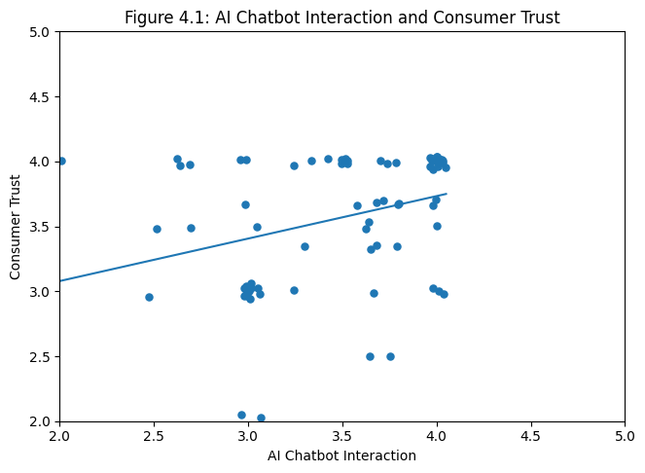
Figure 12: AI chatbot and consumer trust

The correlation coefficient between the interactions with AI chatbots and customer satisfaction was r = 0.711, showing that there is a strong positive correlation between the two. This finding aligns with Hypothesis 2 (H2), which suggested that there is a positive impact of AI chatbot interactions on customer satisfaction. The quickness of the response, convenience, and problem-solving assistance from the chatbot system seemed to please the consumers. Trendline charts showed an increasing trend in consumer satisfaction with the content generated by the chatbots. Scatter diagrams also demonstrated a clear upward trend.

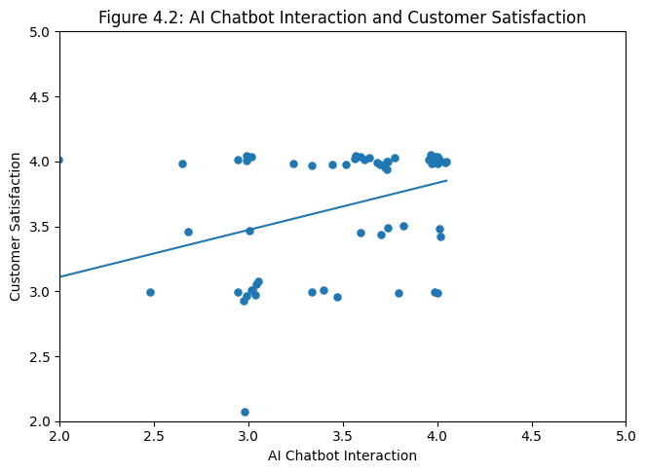
Figure 13: Chatbots Interaction and Customer Satisfaction
The findings support Kim and Kim (2021), who stated that service efficiency and the quality of the interaction between digital services and consumers play a crucial role in enhancing consumer satisfaction in online retail environments. AI-powered grocery apps can provide better customer service and faster service, which could improve the shopping experience for consumers.
The analysis also found a positive correlation between the influence of the use of AI chatbots and purchase intention, with a correlation coefficient of 0.687. This indicates a positive correlation between customers' willingness to use online grocery platforms again and their positive experiences with chatbots. If users find the use of chatbot systems safe and useful, they are likely to trust the system and make online purchases. The findings demonstrate that chatbots have the potential to directly impact consumer behavioural intent.

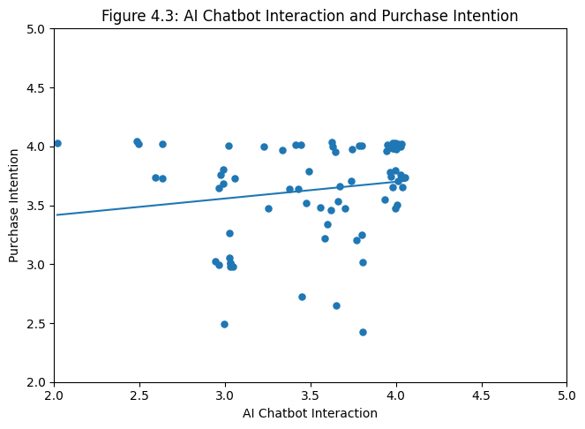
Figure 14: Chatbot Interaction and Purchase Intention
The figure showed that the highest correlation was between customer satisfaction and purchase intention (r = 0.781). This means satisfaction has a very strong positive relationship with future purchasing behaviour. Consumers who are more satisfied when shopping online are more likely to return to eCommerce platforms, to recommend services to others, and to purchase groceries online.

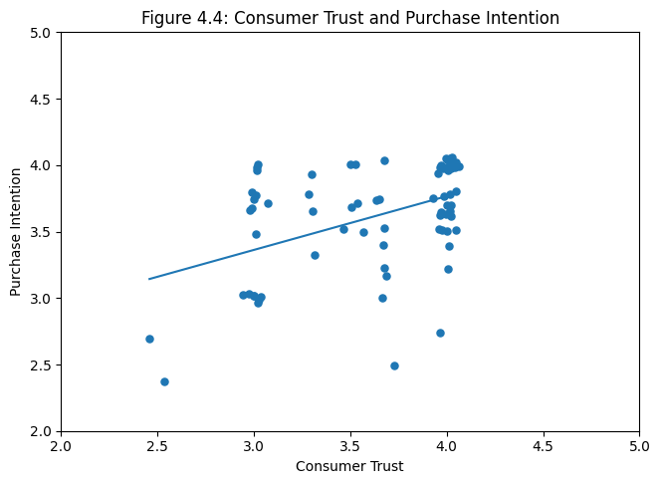
Figure 15: Consumer Trust and Purchase Intention
The relationship between consumer trust and purchase intention also showed a strong positive relationship with a coefficient value of r = 0.734. This finding is consistent with Hypothesis 3 (H3) which stated that there is a positive relationship between consumer trust and customer satisfaction to purchase intention. The findings indicate that trust helps to alleviate uncertainty in the online shopping environment, and makes consumers feel more confident about buying products online.
The positive relationships found in the scatter diagrams and trendline charts also supports the correlation analysis results. The direction of the trend lines in most scatter diagrams was upwards which represented a positive association between variables. The correlation matrix also showed that there was no negative correlation between any of the variables, which would indicate that a higher quality of AI chatbots is linked to positive consumer attitudes and behaviours.
Overall, the correlation analysis revealed that the interaction between consumers and an AI chatbot has a significant impact on consumer trust, customer satisfaction, and consumer intentions to purchase in the UK online grocery retail sector. The results showed that quality, convenience, responsiveness and reliability of a chatbots are positively related to customers' attitudes and behavioral intentions. The analysis also strengthens the proposed hypotheses and validates the need for AI communication technology in the contemporary online retail landscape.

4.5 Regression Analysis
This section examines the relationships between AI chatbot interaction, consumer trust, customer satisfaction, and purchase intention among UK online grocery consumers. Multiple Regression Analysis has been used in MS EXCEL to find out the predictive effect of independent variables on the dependent variables. The results are presented graphically in regression tables, beta coefficient charts, scatter plots, and regression line graphs.

Model 1: AI Chatbot Interaction → Consumer Trust
Table 4.10: Regression Analysis for Consumer Trust
Variables | Beta Coefficient | P-Value | R-Square
AI Chatbot Interaction | 0.642 | 0.000 | 0.412
Regression Equation

Model 1 explored how consumer trust is impacted by interaction with AI chatbots. The regression results showed that the beta value of the interaction between AI chatbots and consumer trust in online grocery retail platforms was positive (β = 0.642). This is suggesting that the interaction with AI chatbots has a positive effect on consumer trust. The p-value for the significance is 0.000, which indicates that the relationship is statistically significant with a p-value less than the acceptable p-value of 0.05.
The R-square coefficient is 0.412, which is quite modest, suggesting that about 41.2% of the variance in consumers' trust can be attributed to the interaction with the AI chatbot. This means that the overall quality, responsiveness, and effectiveness of the chatbots significantly influence consumer trust in online grocery platforms. The results prove the first hypothesis (H1), which suggested that the use of AI Chatbots in customer interactions could help boost consumer trust. When consumers interact with a chatbot system that they perceived as accurate, quick, and reliable with information, they seemed to be more likely to trust an online grocery retailer. The scatter plot and regression line graphs also showed a positive trend of increase in trust level with the interaction of chatbots.
The findings suggest that reliability and security are very important aspects of digital retail environments. For consumers who are utilising internet-based grocery platforms, there is a need for assurance that chatbot systems are dependable and secure in their recommendations and communication. Thus, the reliability of chatbots plays a crucial role in building trust and minimizing uncertainty during e-commerce experiences.

Model 2: AI Chatbot Interaction → Customer Satisfaction
Table 4.11: Regression Analysis for Customer Satisfaction
Variables | Beta Coefficient | P-Value | R-Square
AI Chatbot Interaction | 0.711 | 0.000 | 0.506

Regression Equation

In Model 2, the impact of AI chatbot interaction on customer satisfaction has been explored. The resulting β value for the regression was β = 0.711 which is positive. The strong positive correlation between chatbot interaction and customer satisfaction indicates that chatbot interactions offer significant potential for enhancing customer satisfaction within healthcare. The value of p = 0.000 was statistically significant. R-square value is 0.506 which indicates that the interactions between customers and AI chatbot explain roughly 50.6% of the satisfaction. This discovery highlights the increasing significance of the role of chatbots and their impact in the context of a positive customer experience with online grocery delivery services. The findings are consistent with the Hypotheses 2 (H2) which states that there would be beneficial impacts on customer satisfaction derived from a transaction with an AI Chatbot. Consumers were more satisfied when they received timely responses, easy communication, and help with solving their problems from chatbot systems.
The regression line plots also showed a positive correlation between the quality of the chatbots and satisfaction. The findings show that the fast response and convenience play a role in consumer satisfaction with e-grocery shopping. AI chatbots can provide immediate support to consumers, which might be great since they don't have to wait for a lengthy period to connect with a human. The results also suggest that automated customer service provides customers more convenience when shopping and directly influences the shopping experience. The positive beta coefficient also indicated that improving the usability, accessibility and effectiveness of communication employed by chatbots has the potential to significantly improve customer satisfaction among online grocery consumers.

Model 3: Consumer Trust and Customer Satisfaction → Purchase Intention
Table 4.12: Regression Analysis for Purchase Intention
Variables | Beta Coefficient | P-Value | R-Square
Consumer Trust | 0.438 | 0.000 | 0.648
Customer Satisfaction | 0.512 | 0.000 | 0.648

Regression Equation

Model 3 analysed the effect of consumer trust, together with customer satisfaction, on purchase intention. The results of the regression showed a positive influence of both independent variables on the purchase intention of online grocery consumers. The beta coefficient for customer satisfaction (β = 0.512) was the highest, indicating that satisfaction was the strongest factor influencing consumers' purchase intention. The positive beta coefficient value of β = 0.438 for consumer trust also indicates that consumer trust significantly affects future purchasing behaviour. Both variables obtained a significance value of p = 0.000, which indicates that there was a statistically significant relationship between both variables and purchase intention. The R-squared is 0.648, which indicates that around 64.8% of the consumer purchase intention is explained by the combined effect of consumer trust and customer satisfaction.
The results confirmed Hypothesis 3 (H3) that predicted that consumer trust and customer satisfaction have a positive relationship with purchase intention. Consumers who did not hesitate about shopping from online grocery platforms and were satisfied with the interaction with the chatbot seemed more willing to continue their online product shopping. The regression results also showed that positive online experiences have a significant impact on consumer behavioural intentions. Customers can more easily trust the online shopping process if the chatbot system offers reliable support, efficient communication, and a good service experience. The scatter plots and regression line graphs showed that there were positive upward relationships between the factors of trust, satisfaction, and purchase intention.
The results show that the use of bots in customer interactions can enhance customer relationships and their future buying behavior in online grocery stores. The regression analysis showed that AI chatbot interaction significantly influenced consumer trust and customer satisfaction, which subsequently increased consumers' purchase intention. The results validate that the quality, convenience, reliability, and positive online grocery experience of the chatbot are important in influencing consumer attitudes and behavioural intentions in the UK online grocery retail sector.

4.6 Mediation Analysis
This section has explored the mediating mechanisms of consumer trust and customer satisfaction between online grocery consumers' interactions with AI chatbots and their purchase intention. Mediation Regression Analysis has been performed using Microsoft Excel to see if consumer trust and customer satisfaction make the effect of AI Chatbot interaction on purchase intention stronger. The mediation analysis has also confirmed H2 and H3 by providing evidence that the positive influence of AI chatbot interaction on purchase intention is mediated by trust and satisfaction with the AI chatbot. There are four stages to the mediation analysis: direct effect testing, mediator testing, mediator-to-outcome testing, and indirect effect comparison. The findings are also presented visually in mediation path diagrams, indirect effect tables, and beta comparison charts.

Direct Relationship
The first step examined the direct relationship between AI chatbot interaction and purchase intention.
Table 4.13: Direct Effect of AI Chatbot Interaction on Purchase Intention
Relationship | Beta Coefficient | P-Value | R-Square
AI Chatbot Interaction → Purchase Intention | 0.687 | 0.000 | 0.472

The results showed that the interaction with the AI chatbot has a positive beta value of 0.687, signifying that there is a positive relationship between AI chatbot interaction and purchase intention. The p-value = 0.000 indicated that the relationship is statistically significant. R-square value is 0.472, which means that the direct effect of AI chatbot interaction can explain 47.2% of the variation in purchase intention. The results indicate that positive experiences with a chatbot have positive effects on the willingness of consumers to keep buying online groceries.

AI Chatbot Interaction and Mediators
Table 4.14: AI Chatbot Interaction and Mediating Variables
Relationship | Beta Coefficient | P-Value | R-Square
AI Chatbot Interaction → Consumer Trust | 0.642 | 0.000 | 0.412
AI Chatbot Interaction → Customer Satisfaction | 0.711 | 0.000 | 0.506
The results indicated positive relationships between the interaction with the AI chatbot and both the mediating variables. The beta-coefficients for AI chatbot interaction for consumer trust and customer satisfaction were β = 0.642 and β = 0.711, respectively. These two relationships were statistically significant (p values less than 0.05).
The findings indicate that customers are more likely to trust and be satisfied with the chatbot system when it provides quick responses, reliable support services, and valuable information. For online grocery shoppers, the assurance of secure, responsive, and accurate communication via chatbots can foster greater confidence in the online grocery interaction. The results further suggest that customer satisfaction is enhanced when the use of the chatbot system makes the shopping activity more convenient and decreases the efforts of the customers.

Mediators and Purchase Intention
Table 4.15: Mediators and Purchase Intention
Relationship | Beta Coefficient | P-Value | R-Square
Consumer Trust → Purchase Intention | 0.438 | 0.000 | 0.648
Customer Satisfaction → Purchase Intention | 0.512 | 0.000 | 0.648
The results showed that consumer trust and customer satisfaction had positive impact on purchase intention. The beta coefficient for customer satisfaction was the highest, β = 0.512, and the consumer trust had a beta coefficient value of β = 0.438. The two values had significance values of p = 0.000. The results show that customers who trust the online supermarket and are satisfied with the customer service they encounter in the chatbot are more likely to return to the platform, buy goods and recommend the services to others. The obtained R-square is 0.648, which is high, further showing that the trust and satisfaction variables explain a high proportion of the variation in purchase intention.

Indirect Effect Comparison
Table 4.16: Indirect Effect Comparison
Mediation Path | Indirect Effect
AI Chatbot Interaction → Consumer Trust → Purchase Intention | 0.281
AI Chatbot Interaction → Customer Satisfaction → Purchase Intention | 0.364

The indirect effect analysis revealed that the interaction with the AI chatbot had an indirect impact on purchase intent through the consumer's trust and satisfaction. The strongest indirect effect, that of 0.364, was obtained when the customer satisfaction mediator was added to the model, which proves that customer satisfaction is the most influential mediator in the model. The results indicate partial mediation, as AI chatbot interaction had both a direct positive effect on purchase intention and an indirect positive effect through consumer trust and customer satisfaction. The results indicate that trust minimizes uncertainty in online grocery situations. People might not be able to make a purchase when they're unsure of reliability, details, or security on the internet. Therefore, reliable chatbot applications foster trust and stimulate purchasing behavior. Furthermore, customer satisfaction contributes to an increase in future purchase intention as satisfied customers are more likely to return to online grocery stores. Positive experience with the chatbot can lead to increased convenience, decreased waiting time, and a smoother shopping experience, all of which can positively impact customer loyalty.

4.7 Hypothesis Testing Summary
This section has summarised the final hypothesis testing results based on the correlation, regression, and mediation analyses conducted in the study. The statistical findings have examined the relationships between AI chatbot interaction, consumer trust, customer satisfaction, and purchase intention among UK online grocery consumers. The results have been interpreted using significance values, beta coefficients, and relationship
Table 4.17: Hypothesis Testing Summary
Hypothesis | Result | Supported/Rejected
H1: Consumer reactions toward AI chatbot use positively influence consumer trust | Significant positive relationship found | Supported
H2: AI chatbot interactions positively influence consumer trust and customer satisfaction | Significant positive relationship found | Supported
H3: AI chatbot experiences positively influence purchase intention | Significant positive relationship found | Supported

The results showed that all the hypotheses put forward were confirmed by the statistics. The regression analysis showed the beta coefficient value of β = 0.642 and p value = 0.000 for AI chatbot interaction with consumer trust, which supported H1. This resut indicates that online grocery delivery systems will be more trusted by consumers if the chatbot system is able to communicate effectively, give accurate information, and return their response quickly. Another reason for its support was the fact that it demonstrated a strong positive influence on customer satisfaction while interacting with customers via AI chatbots.
The results reveal that consumer satisfaction increases with the enhancement of shopping convenience, shortening waiting time, and providing quick customer support during online grocery shopping activities by the chatbot system. The interaction with an AI chatbot, consumer trust, and customer satisfaction were all found to have positive relationships with purchase intention, which is why these were chosen to be included in H3. Customer satisfaction had the highest value of the beta coefficient (β = 0.512) and was followed by consumer trust (β = 0.438).
The results indicate that positive experiences with chatbots contribute to increased purchasing behaviour in the future, revisit intention, and continued online shopping. The results of the mediation analysis also showed that consumer trust and customer satisfaction enhance the relationship between interaction with the AI chatbot and purchase intention. Alos, the results then suggest that trust and satisfaction are significant behavioural mechanisms that explain the relationship between the AI chatbot quality and consumer purchase intentions in the UK online grocery retail industry.

Chapter 5: Discussion

5.1 Introduction

The chapter has and explains the key findings of this study that the use of AI chatbots in the online grocery retail sector has an impact on consumer trust, customer satisfaction, and purchase intent. This chapter discusses the findings presented in Chapter 4 by comparing them with the research objectives, hypotheses, existing literature, and relevant theory. From the descriptive, correlation, regression analysis, and mediation analysis results, insights into consumer behavioural response to AI chatbot technologies in online grocery shopping have been gained.

5.2 Discussion Based on Objective 1
The results showed that the use of AI chatbots had a positive impact on consumer trust in the UK online grocery retail sector. The results of the regression and the correlation analysis revealed that the relationship between the chatbot and the consumer was significant and correlated with consumer trust. Consumers were more likely to trust online grocery retailers when they had a way to reliably, accurately, and securely communicate with the chatbot system and receive recommendations from it. Reliability was one of the major factors that helped to develop consumer trust. Shoppers liked chatbot systems, which could always be helpful and provide correct information while they were shopping. The findings implies that when a chatbot performs well, it helps to alleviate customers' uncertainty and boost their trust in online grocery delivery systems. Trust is very important for the online shopping process since consumers are unable to visit the product in person before making a purchase online.
The transparency and security also helped to establish trust. Consumers usually give personal information, payment information, and addresses when shopping online. If the chatbot systems provide safe and secure interaction and easy-to-understand client support, customers will have more trust in utilising them. This finding has been supported by Kim and Kim (2021), who suggest that consumers are more likely to be trusting of digital systems if communication is secure and transparent. Human-like communication further enhanced consumer trust. Consumers seemed to be more at ease when engaging with chatbot systems with conversational and personalized communication styles. Therefore, man-to-human interaction may possibly offer emotional reassurance and boost the shopping experience. Similarly, the correct answers provided by a chatbot contributed to the consumers' confidence, while incorrect or incorrect answers could lead to consumers losing trust in digital retail channels.
The results are consistent with Lou and Yuan's (2019) arguments that the quality of communication and technological reliability have a positive effect on trust in digital environments. Likewise, the Technology Acceptance Model states that consumers are more accepting of technologies when they believe they can be useful and easy to use. Considering the analysis, the chatbot systems are helpful and convenient, thus improving the shopping experience's efficiency, responsiveness, and convenience of the shopping experience.

5.3 Discussion Based on Objective 2
Setting up an AI chatbot to engage with customers can positively impact customer satisfaction for online grocery shoppers in the UK. The regression result indicated that there is a strong positive relationship between the chatbot interaction and customer satisfaction. It helps to ensure to better customer satisfaction when the quality of the communication, the convenience, and the service efficiency of the chatbot are improved. One of the most significant factors that helped customer satisfaction was convenience. Consumers had positive experiences using chatbot systems during online shopping, as they made the shopping process easier and more convenient. Shopping online for groceries is also time-sensitive, and the consumer will value tech that provides quick help and communication.
Quick response was also one of the key factors in increasing satisfaction scores. When chatbot systems were able to respond swiftly and without lengthy waits to meet customer needs, consumers seemed very pleased with this service. The instant support made a positive impact on the shopping experience and lessened the frustrations of online shopping. This has proven that consumers are more willing to accept automated support systems as they give consumers more accessibility and availability of service. Personalisation also contributed to satisfaction, as these users appreciated the ability to get recommendations specific to their needs via the chatbot and to personalize the conversation with the bot. If the chatbot system properly learns consumers' preferences and buying habits, the consumers can feel more involved in the system.
Additionally, ease of use, responsiveness, and reliability of chatbot systems were preferred by consumers. Based on the results, it seems that satisfaction is related to functional and emotional experiences. In the real world, chatbot systems can increase the ease of use and effectiveness of communication. The emotional impact of positive chatbot experiences is that they alleviate frustration and make shopping more comfortable. This study's findings align with the findings of Dabbous et al. (2020) that digital convenience and communication quality are significant factors in Customer Satisfaction (CS) in online retailers. Also, Hollebeek (2011) stated that positive online interactions increase engagement and emotion towards brands.

5.4 Discussion Based on Objective 3
Consumer trust and customer satisfaction positively affect purchase intention among online grocery consumers in the UK. Customer satisfaction has the greatest impact on purchase intention, whereas consumer trust has a significant impact on the online purchasing behaviour. Besides, less uncertainty in the online shopping process due to trust. One reason some customers may hesitate to order groceries online is that they do not feel confident in the security of the order, delivery service, or quality of the food. A reliable chatbot system can enhance the trust of the consumer and boosts the willingness to finish online transactions. If people perceive an online shop as having low risks, they may be more willing to take risks with using chatbot systems. Even people who are convinced of the trustworthiness of these systems can feel less at risk when they are shopping online.
The relationship between the customers' satisfaction and repeat purchase behaviour, and the customers' satisfaction and intention to loyalty was strong. Consumers seemed to be more likely to revisit and return to online grocery services utilizing chatbots in the future. This can then lead to positive experiences with the chatbots and thus to customer loyalty and customer behavior. The results also revealed that consumers value digital retail systems with trusted relationships, which allow for seamless communication, convenience, and effective customer service. The positive experiences with the Positive AI chatbot boosted consumer confidence in purchasing and drew consumers' trust in online grocery platforms. The Positive AI chatbot experience helped to improve consumer purchasing confidence and the proportion of consumers using online grocery platforms.
This support Matin et al. (2020), who suggested that trust and satisfaction have a significant impact on online purchasing behaviour because it decreases the perceived risk and enhance the confidence of the consumers. Similarly, Kim and Kim (2021) stated that positive experiences can play a significant role in behavioral intention and repeated purchasing behavior.

5.5 Discussion of Mediation Effects
The mediation analysis identified that the influence of the interaction with AI chatbots on purchase intention was strengthened by consumer trust and customer satisfaction. The relationship between purchase intention was partly indirect through the chatbot interaction, while the relationship between purchase intention and trust and satisfaction was indirect. Customers' satisfaction had the strongest the greatest indirect effect in the mediation model. The research indicates that shoppers who feel satisfied while talking to the chatbot will be more inclined to keep purchasing via online grocery. Good shopping experiences enhance emotional comfort and foster increased future shopping.
Consumer trust was also a crucial mediator, as the trustworthy Chatbot system decreases consumers' uncertainty and improves their trust in online retail platforms. As a result, a psychological and emotional impact of trust and satisfaction on purchase intentions. Emotionally, when users have positive interactions with chatbots, they feel reassured and convenient. Psychologically, users are expecting that the risks they may face when using an e-commerce site will be reduced. The findings support Dabbous et al. (2020) who stated that trust and satisfaction are the mediators between the digital interaction quality and behavioural intention. Likewise, Lou and Yuan (2019) claimed that communication quality has an indirect effect on purchasing behaviour via the mediation of increased consumer trust and attitudes. Consistent with the Technology Acceptance Model (TAM), the results showed that perceived usefulness and ease of use positively influenced consumers' purchase intentions Similarly, the findings are supported by the Consumer Behaviour theory as emotional experiences and psychological confidence play a significant role in people's buying decisions.

5.6 Discussion of Hypotheses
The results validated H1 as there was a significant positive correlation between the interaction between an AI chatbot and consumer trust. Consumers were more accepting when the chatbot systems could communicate reliably, could help, and were safe to use. AI Chatbot interaction also had a positive impact on customer satisfaction, supporting H2. For the online grocery shopping tasks, the elements that consumers appreciated were the convenience, responsiveness, service efficiency, and quality of the communication with the chatbot. The results also supported H3, which indicates a positive relationship between consumer trust, customer satisfaction, and purchase intention. Consumers who did not perceive their online grocery provider and who were satisfied with the experience were more likely to be satisfied with the experience and would purchase groceries online again. The results revealed that AI chatbot systems can significantly influence consumer attitudes and behavioral intentions in the online grocery retail market in the UK.

5.7 Theoretical Implications
The results support the Technology Acceptance Model by showing that usefulness and ease of use improve trust, satisfaction, and purchase intention. Davis (1989) proposed that the technology's usefulness and ease of use are determinants of use. This is also proved by the present findings, in that the consumers expressed positive attitudes to the chatbot systems that made it more convenient to shop, more effective in communication, and more efficient in their shopping. Additionally, the study will contribute to the knowledge level of consumer behaviour by providing insights into how emotional and psychological reactions affect online buying behaviour. Mediation analysis results indicated that two variables such as trust and satisfaction, are important variables in the behavioural process of interaction with a chatbot and purchase intent. The discussion support Matin et al. (2020) and Dabbous et al. (2020), who suggested that trust and satisfaction lessen the perceived risk and increase purchasing confidence online.

5.8 Chapter Summary
According to the discussion, the reliability, responsiveness, transparency, and consumer convenience of the chatbot have a significant effect on consumers' attitudes and behavioral intentions. The discussion found that the level of satisfaction and trust of the customers with the interaction with the AI chatbot has a positive impact on their purchase intention. The results also provided significant theoretical advances in the fields of the Technology Acceptance Model and consumer behaviour. Overall, the discussion highlights that the successful application of AI chatbots can significantly influence the online grocery shopping experience and create long-lasting customer relationships in the UK online grocery retail sector.

Chapter 6: Conclusion and Recommendations

6.1 Conclusion
The study found that the interaction between an AI chatbot and consumers has a significant impact on consumer trust, customer satisfaction, and purchase intention in the UK online grocery retail sector. The results indicated consumers will trust the online grocery store more if they can reach the people responsible for communicating with them with a reliable communication system, accurate and precise information, quick response, transparency, and secure customer support services with the assistance of a Chatbot system. Besides, digital communication systems are essential when shopping for groceries online, and this was one of the crucial factors that consumers cited on the list of their trust. The ability to communicate and respond like a human is also valued by consumers, as it helps to reduce uncertainty and boost their trust in digital retail systems.
The results also showed that the use of AI chatbots can positively impact customer satisfaction for UK online grocery consumers. The ease of use, the effectiveness of the communication, the timeliness, the customization, and the quality of the service provided by the chatbot systems were valued by consumers. Positive chatbot experiences significantly contribute to the functional and emotional satisfaction when doing online shopping. According to the research findings, consumers felt more satisfied because chatbot systems made it easier for them to communicate and wait shorter amounts of time when shopping online. The study also revealed that the purchase intention is positively affected by consumer trust and customer satisfaction. People who trusted in the grocery delivery apps and were not satisfied with the same using a chatbot appeared to be more ready to buy online for these goods. Trust decreased the uncertainty about online transactions, whereas satisfaction increased the intention to remain loyal and repeat purchasing behaviour.
All the hypotheses of the research were supported by the results found. The interaction with an AI chatbot was positively related to consumer trust and was supported for H1. H2 was also supported because of the impact of positive interaction with the chatbot on customer satisfaction, as the chatbot was convenient, responsive, and communicated well. Similarly, the H3 was proved, as the trust and satisfaction had a significant impact on the purchase intention and future purchase behaviour of the online grocery shoppers.

6.2 Theoretical Contributions and Practical Recommendations
The study has been a valuable contribution to the Technology Acceptance Model, demonstrating that the adoption of AI technologies in online grocery retailing has a significant impact on customer satisfaction, behavioural intention and trust in online grocery services. The results support Davis (1989) who noted that technologies that are useful and easy to use are more likely to be adopted. The study also added to TAM by proving that the usefulness of the chatbot and communication quality has an indirect effect on emotional and behavioural results via trust and satisfaction. Based on the results of the mediation process, there are two variables that are important in making the process of chatbot interaction related to purchasing intention including trust and satisfaction.

The results provide several practical recommendations for UK online grocery retailers such as Tesco, Sainsbury's, Asda, and Ocado. Retailers can improve customer satisfaction by making chatbots more responsive to respond quickly, providing efficient communication. As a retailer, it's important to understand the mechanics of the chatbots, too, as well as how they keep customer information safe. Another aspect of its security, where there is scope for improvement, is that it can alleviate consumers' fears of privacy loss and enhance their confidence. Moreover, there is also a need to enhance the AI personalisation feature, as customers valued chatbots that knew their shopping habits and preferences. Moreover, incorporating human interaction into the conversational AI can enhance engagement and customer satisfaction. Finally, retailers must enhance their customer service by providing effective solutions to problems and ensure that there is a continuous service to encourage customer loyalty and repeat purchases.

6.3 Limitations and Future Research
The study had several limitations. The sample size was small, and the results of this study may not be generalisable. Furthermore, the research methodology was entirely quantitative, so with qualitative methods a more in-depth understanding of the emotions and experiences consumers have when interacting with AI chatbots could be gained. Also, the focus was on consumers who buy online for their groceries, and so results may not be generalisable to other sectors or countries. Moreover, the study also only captures consumer perceptions at a specific moment and potentially attitudes towards AI technologies can change over time. Lastly, the survey was self-administered, so there is the possibility of response bias. Further research on consumer behaviour can also be conducted in the future using larger samples and quantitative and qualitative methods to increase the reliability of the results and provide a better understanding of consumer behaviour. Furthermore, additional industries could be tested in the future, or more advanced AI features such as voice recognition and emotional AI chatbots might be explored.

References

Adam, M., Wessel, M. and Benlian, A., 2021. AI-based chatbots in customer service and their effects on user compliance: M. Adam et al. Electronic markets, 31(2), pp.427-445.
Adam, M., Wessel, M. and Benlian, A., 2021. AI-based chatbots in customer service and their effects on user compliance: M. Adam et al. Electronic markets, 31(2), pp.427-445.
Addis, M.C. and Kutar, M., 2018. The general data protection regulation (GDPR), emerging technologies and UK organisations: awareness, implementation and readiness.
Ahmed, J., Ahmed, W. and Hussain, F., 2025. Exploring the mediating effects of emotional arousal and perceived value in the relationship between artificial intelligence and customer purchasing intentions. Business & Economic Review, 17(2), pp.69-100.
Alkudah, N. M., & Almomani, T. O. (2024). The Integration of Artificial Intelligence Techniques in E-Commerce: Enhancing Online Shopping Experience and Personalization. Global Journal of Economics & Business, 14(6).
Al-Shafei, M., 2025. Navigating human-chatbot interactions: an investigation into factors influencing user satisfaction and engagement. International Journal of Human–Computer Interaction, 41(1), pp.411-428.
Al-Shafei, M., 2025. Navigating human-chatbot interactions: an investigation into factors influencing user satisfaction and engagement. International Journal of Human–Computer Interaction, 41(1), pp.411-428.
Al-Shafei, M., 2025. Navigating human-chatbot interactions: an investigation into factors influencing user satisfaction and engagement. International Journal of Human–Computer Interaction, 41(1), pp.411-428.
Aslam, F., 2023. The impact of artificial intelligence on chatbot technology: A study on the current advancements and leading innovations. European Journal of Technology, 7(3), pp.62-72.
Azman, H., Keat, T. K., Sufian, A., Abdul Aziz, N. A., & Azman, A. (2025). The influence of machine learning chatbots on consumer purchase intention in the fashion industry. International Journal of Academic Research in Business and Social Sciences, 15(2), 1092–1100.
Bock, D.E., Wolter, J.S. and Ferrell, O.C., 2020. Artificial intelligence: disrupting what we know about services. Journal of Services Marketing, 34(3), pp.317-334.
Bouteraa, M., Chekima, B., Al-Daihani, M., Benlahcene, A., Baddou, A. and Tamma, E., 2026. Artificial intelligence adoption in the Malaysian insurance sector: an integrated TOE–UTAUT framework analysis. Journal of Islamic Marketing, pp.1-32.
Castillo, D. and Farrugia Caruana, L., 2025. Unveiling Customer Expectations of Chatbot Interactions: A Systematic Literature Review and Research Agenda. International Journal of Human–Computer Interaction, pp.1-28.
Chakraborty, D., Kar, A. K., Patre, S., & Gupta, S. (2024). Enhancing trust in online grocery shopping through generative AI chatbots. Journal of Business Research, 180, 114737.
Chen, J.S., Le, T.T.Y. and Florence, D., 2021. Usability and responsiveness of artificial intelligence chatbot on online customer experience in e-retailing. International Journal of Retail & Distribution Management, 49(11), pp.1512-1531.
Chen, J.S., Le, T.T.Y. and Florence, D., 2021. Usability and responsiveness of artificial intelligence chatbot on online customer experience in e-retailing. International Journal of Retail & Distribution Management, 49(11), pp.1512-1531.
Chen, Q., Lu, Y., Gong, Y., & Xiong, J. (2023). Can AI chatbots help retain customers? Impact of AI service quality on customer loyalty. Internet Research, 33(6), 2205-2243.
Cheng, X., Bao, Y., Zarifis, A., Gong, W., & Mou, J. (2024). Exploring consumers’ response to text-based chatbots in e-commerce: The moderating role of task complexity and chatbot disclosure. Internet Research, 32(2), 496–517.
Chiu, M.L., 2025. Exploring user awareness and perceived usefulness of generative AI in higher education: The moderating role of trust. Education and Information Technologies, 30(15), pp.21317-21351.
Dangol, L., & Rind, F. (2024). Chatbots as conversational agents and consumer brand engagement in the UK retail industry. International Journal of Management (IJM), 15(5), 67–78.
Davis, F.D. (1989) Perceived usefulness, perceived ease of use, and user acceptance of information technology. MIS Quarterly, 13(3), pp.319–340.
De Marcellis-Warin, N., Marty, F., Thelisson, E., & Warin, T. (2022). Artificial intelligence and consumer manipulations: from consumers' counter algorithms to firms' self-regulation tools. AI and Ethics, 2(2), 259-268.
Elbadawy, H. and Kwon, W.S., 2025. Beyond the Response: How Timing and Context Shape Empathy, Responsiveness, and Social. Human-Computer Interaction & Emerging Technologies, 195, p.241.
Evans, R., Hajli, N. and Nisar, T.M., 2023. Privacy‐Enhancing factors and consumer concerns: The moderating effects of the general data protection regulation. British Journal of Management, 34(4), pp.2075-2092.
Hu, Y., Qu, Y., Maus, A. and Mutlu, B., 2022, April. Polite or direct? Conversation design of a smart display for older adults based on politeness theory. In Proceedings of the 2022 CHI Conference on Human Factors in Computing Systems (pp. 1-15).
Huang, K.L., Duan, S.F., and Lyu, X., 2021. Affective Voice Interaction and Artificial Intelligence: A research study on the acoustic features of gender and the emotional states of the PAD model. Frontiers in psychology, 12, p.664925.
Huynh, M.T., 2024. Using generative AI as decision-support tools: unraveling users’ trust and AI appreciation. Journal of Decision Systems, pp.1-32.
Igwe-Nmaju, C. and Anadozie, C., 2022. Commanding digital trust in high-stakes sectors: communication strategies for sustaining stakeholder confidence amid technological risk. World Journal of Advanced Research and Reviews, 15(3), pp.609-630.
Izadi, S. and Forouzanfar, M., 2024. Error correction and adaptation in conversational AI: a review of techniques and applications in chatbots. Ai, 5(2), pp.803-841.
Jadiga, S., 2025. Understanding the Role of AI in Personalized Recommendation Systems, Applications, Concepts, and Algorithms. International Journal of Computer Trends and Technology (IJCTT), 73(1), pp.106-118.
Jiang, K., Qin, M. and Li, S., 2022. Chatbots in retail: How do they affect the continued use and purchase intentions of Chinese consumers?. Journal of Consumer Behaviour, 21(4), pp.756-772.
Kamoonpuri, S.Z. and Sengar, A., 2025. Predicting consumer intentions for shopping using generative AI chatbots. Journal of Decision Systems, 34(1), p.2521614.
Kanumarlapudi, P.K. and Ballamudi, S., 2025. Enhancing Generative AI Shopping Assistants through Advanced Multi-Attribute Decision Making Technique. Journal of Artificial Intelligence and Machine Learning, 3(2), pp.1-7.
Liu, J., Marriott, K., Dwyer, T. and Tack, G., 2023. Increasing user trust in optimisation through feedback and interaction. ACM Transactions on Computer-Human Interaction, 29(5), pp.1-34.
Lopez-Lopez, D. and Iniesta, M.B., 2025. The impact of conversational AI on consumer decision-making: A systematic review and cluster analysis. International Journal of Engineering Business Management, 17, p.18479790251351889.
Makinde, S.O., Abdullahi, A., Sakariyahu, S. and Ahmed, A.A., 2025. Revolutionizing Retail: Harnessing AI-Powered Self-Service Technologies for Enhanced Customer Experiences. In Practical Applications of Self-Service Technologies Across Industries (pp. 147-174). IGI Global Scientific Publishing.
Mantello, P., Ho, M.T., Nguyen, M.H. and Vuong, Q.H., 2023. Machines that feel: behavioral determinants of attitude towards affect recognition technology—upgrading technology acceptance theory with the mindsponge model. Humanities and Social Sciences Communications, 10(1), p.430.
Nkomo, N.I.G.E.L. and Mupa, M.N., 2024. The impact of artificial intelligence on predictive customer behaviour analytics in e-commerce: A comparative study of traditional and AI-driven models. Iconic Research and Engineering Journal, 8(5), pp.432-451.
Ntoa, S., 2025. Usability and user experience evaluation in intelligent environments: A review and reappraisal. International Journal of Human–Computer Interaction, 41(5), pp.2829-2858.
Pandey, S., Chawla, D. and Puri, S., 2026. Insurance chatbot adoption and continued usage in emerging markets: impact of human-agent access. International Journal of Bank Marketing, pp.1-28.
Panwar, N., Shetty, D.K. and Shenoy, S.S., 2025. Can AI-Driven Nudging Promote Sustainable Product Adoption on E-Commerce Platforms?. Revista de Administração Contemporânea, 29(06), p.e250105.
Panwar, N., Shetty, D.K., and Shenoy, S.S., 2025. Can AI-Driven Nudging Promote Sustainable Product Adoption on E-Commerce Platforms?. Revista de Administração Contemporânea, 29(06), p.e250105.
Perannagari, K.T. and Chakrabarti, S., 2020. Factors influencing acceptance of augmented reality in retail: insights from thematic analysis. International Journal of Retail & Distribution Management, 48(1), pp.18-34.
Pirzado, A.H., Babar, A., Castillo, M.G.A., Rahman, M.M. and Muro, M.E., 2025. When AI Meets Consumer Behavior: Exploring How Human-Like AI Chatbots Shape Trust in Consumer Purchase Intentions. The Regional Tribune, 4(1), pp.1-13.
Rahevar, M. and Darji, S., 2024. The adoption of AI-driven Chatbots into a recommendation for e-commerce systems to targeted customer in the selection of product. International Journal of Management, Economics and Commerce, 1(2), pp.128-137.
Ramayanti, R., Rachmawati, N.A., Azhar, Z. and Nik Azman, N.H., 2025. Factors influencing digital payment behavior: a meta-analysis. Digital Transformation and Society, pp.1-22.
Ranieri, A., Di Bernardo, I. and Mele, C., 2024. Serving customers through chatbots: positive and negative effects on customer experience. Journal of Service Theory and Practice, 34(2), pp.191-215.
Shahzad, M.F., Xu, S., An, X. and Javed, I., 2024. Assessing the impact of AI-chatbot service quality on user e-brand loyalty through chatbot user trust, experience and electronic word of mouth. Journal of Retailing and Consumer Services, 79, p.103867.
Singh, B., Olds, T., Brinsley, J., Dumuid, D., Virgara, R., Matricciani, L., Watson, A., Szeto, K., Eglitis, E., Miatke, A. and Simpson, C.E., 2023. Systematic review and meta-analysis of the effectiveness of chatbots on lifestyle behaviours. NPJ Digital Medicine, 6(1), p.118.
Singh, P. and Singh, V., 2024. The power of AI: enhancing customer loyalty through satisfaction and efficiency. Cogent Business & Management, 11(1), p.2326107.
Singh, S., Jasial, S.S., Misra, R. and Bansal, A., 2024. Online retail service quality: What matters most for customer satisfaction?. FIIB Business Review, 13(5), pp.600-615.
Stevens, A.F. and Stetson, P., 2023. Theory of trust and acceptance of artificial intelligence technology (TrAAIT): An instrument to assess clinician trust and acceptance of artificial intelligence. Journal of biomedical informatics, 148, p.104550.
Thatavarthi, N.L.S., 2023. Integrating AI-driven Chatbots with full stack E-commerce platforms to enhance customer experience. Journal of Artificial Intelligence & Cloud Computing, 2(4), pp.1-5.
Uddin, M.N., Thiam Low, W., Afjalur Rahman, M. and Mokhtar, S., 2024, May. An Exploration of Millennials’ Attitudes Towards the Use of Artificial Intelligence Chatbots for Customer Service within E-Commerce Platforms. In Proceedings of the International Conference on Business, Management and Leadership, Liverpool, UK (pp. 17-19).
Utami, H.N., Elfa, M.O.J., Wiyono, S.N., Sari, D.N. and Perdana, T., 2025. Sustaining Consumer Excitement: The Role of Online Customer Experience and Engagement in Shaping Behavioural Intentions in Food Social Commerce. Sustainability, 17(17), p.8061.
Uzoka, A., Cadet, E. and Ojukwu, P.U., 2024. Leveraging AI-Powered chatbots to enhance customer service efficiency and future opportunities in automated support. Computer Science & IT Research Journal, 5(10), pp.2485-2510.
Varzaneh, M.R., Alibrahim, S.A., Dakkak, O. and Karaoğlan, K.M., 2025. Conversational Agent Chatbot Classification and Design Techniques: A Survey on Conversational Agents Chatbots. In Using AI Tools in Text Analysis, Simplification, Classification, and Synthesis (pp. 261-294). IGI Global Scientific Publishing.
Vy, N.H.T., 2025. AI-Chatbot Service Quality and E-Brand Loyalty: A Mediated Model of Functional Benefit, User Experience, and Satisfaction. Int. J. Leadersh. Manag, 2.
Wu, W., Zhang, A., Van Klinken, R.D., Schrobback, P. and Muller, J.M., 2021. Consumer trust in food and the food system: a critical review. Foods, 10(10), p.2490.
Wulandari, A.A., Nurhaipah, T. and Ohorella, N.R., 2023. Perceived ease of use, social influencers, facilitating conditions, user experience on the influence of human-machine interaction on interaction efficiency, emotional impact of using chat GPT. Journal of Digital Media Communication, 2(2), pp.61-75.
Yellanki, S.K., 2023. Enhancing retail operational efficiency through intelligent inventory planning and customer flow optimization: a data-centric approach. European Data Science Journal (EDSJ) p-ISSN, pp.3050-9572.
Yen, C. and Chiang, M.C., 2021. Trust me, if you can: a study on the factors that influence consumers’ purchase intention triggered by chatbots based on brain image evidence and self-reported assessments. Behaviour & Information Technology, 40(11), pp.1177-1194.
Yen, C., & Chiang, M. C. (2021). Trust me, if you can: a study on the factors that influence consumers’ purchase intention triggered by chatbots based on brain image evidence and self-reported assessments. Behaviour & Information Technology, 40(11), 1177-1194.
Zuke, E. (2025, December 15). One in five UK households place online grocery orders. The Grocer. https://www.thegrocer.co.uk/news/one-in-five-uk-households-place-online-grocery-orders/713107.article

Appendix
The first 5 responses to all survey questions are presented below for reference.
Question | Respondent 1 | Respondent 2 | Respondent 3 | Respondent 4 | Respondent 5
What is your age group? | 25–34 | 18–24 | 25–34 | 18–24 | 25–34
What is your gender? | Male | Male | Male | Female | Male
How often do you purchase groceries online? | Weekly | Weekly | Rarely | Monthly Occasionally | Monthly Occasionally
Which platform do you mostly use for online grocery shopping? | Tesco | Tesco | Other | Other | Other
Have you interacted with an AI chatbot while shopping online? | Yes | Yes | No | Yes | Yes
I find AI chatbots easy to interact with during online shopping. | Strongly Agree | Agree | Agree | Neutral | Agree
AI chatbots respond quickly to my queries. | Strongly Agree | Agree | Agree | Agree | Agree
Chatbot responses are relevant to my needs. | Strongly Agree | Strongly Agree | Agree | Agree | Agree
I feel comfortable using AI chatbots while shopping online. | Strongly Agree | Agree | Agree | Agree | Agree
AI chatbots improve my overall shopping experience. | Strongly Disagree | Neutral | Agree | Agree | Agree
I trust the information provided by AI chatbots. | Strongly Agree | Agree | Agree | Agree | Agree
AI chatbots provide reliable assistance during shopping. | Strongly Agree | Agree | Agree | Agree | Agree
I feel confident relying on chatbot recommendations. | Strongly Agree | Neutral | Agree | Agree | Agree
I am satisfied with my interactions with AI chatbots. | Strongly Agree | Agree | Agree | Agree | Agree
Chatbots make my shopping process more convenient. | Strongly Agree | Strongly Agree | Agree | Agree | Agree
AI chatbot assistance increases my likelihood of making a purchase. | Agree | Strongly Agree | Agree | Agree | Agree
Chatbot recommendations influence my buying decisions. | Agree | Strongly Agree | Agree | Agree | Agree
I am more likely to complete purchases when chatbot support is available. | Agree | Strongly Agree | Agree | Agree | Agree
I would use online grocery platforms that offer chatbot services again. | Agree | Strongly Agree | Agree | Agree | Agree
I would recommend chatbot-supported shopping to others. | Agree | Strongly Agree | Agree | Agree | Agree

