Formative tasks/assessments of the personal language lessons

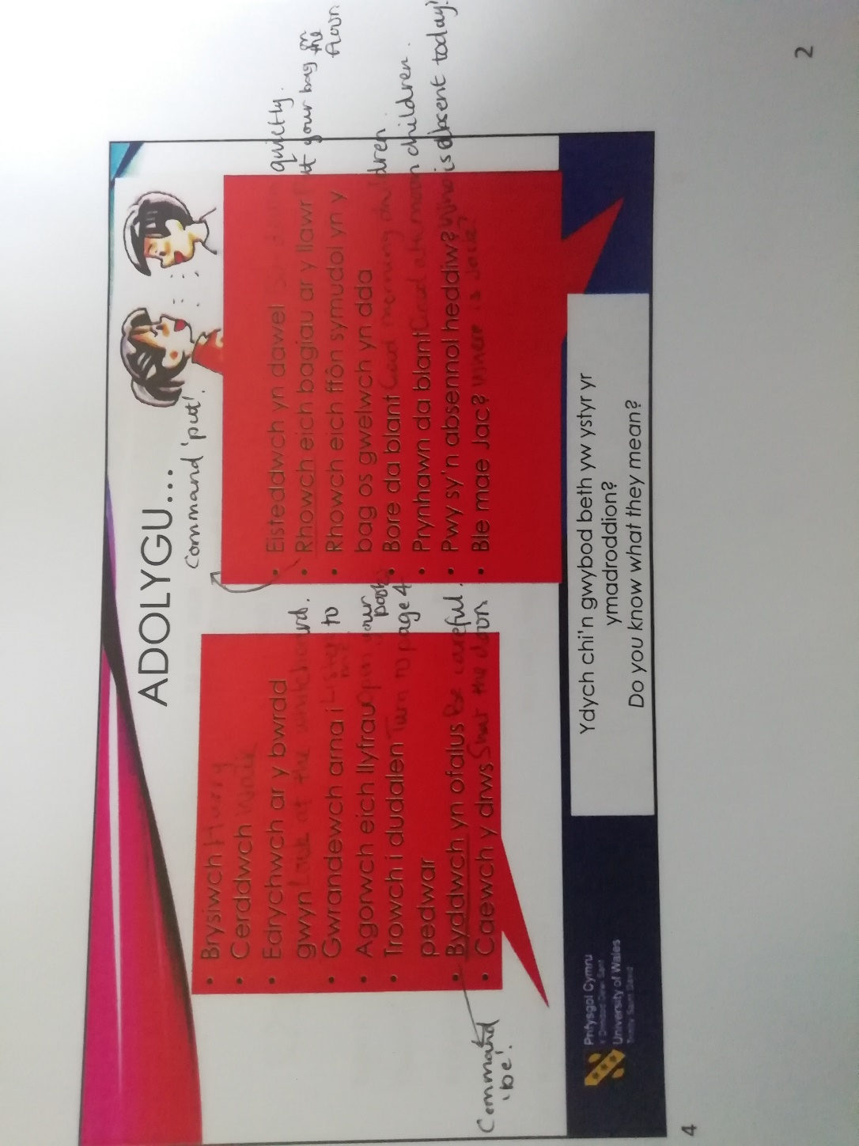
The following images are of formative tasks I completed during Welsh language lectures at University of Wales Trinity Saint David. These demonstrate that I have engaged with formative tasks to assess my personal Welsh language skills. In doing so I could identify what I understood and which areas I required further learning to improve my understanding. I completed tasks which covered general Welsh language and vocabulary relevant to the classroom, so I was able to take sentences and vocabulary I had learnt forward into my teaching practice. This allowed me to develop my personal Welsh language skills, and in turn supported me in providing learning experiences which developed pupils’ Welsh language skills.


