PSYCHOLOGY IN HEALTH AND SOCIAL CARE (BMHP4003, LCHS4006_LON)
Lecturer: Diya Ganguly
Student: Raluca Roman 2113735

Assets.ltkcontent.com (accessed 8th August 2022)

Introduction
Reflection is defined as the examination of one’s own conscious thoughts and feelings. Reflection and self-reflection are often used by psychologist in their therapy and the process relies mostly on observations done over the mental state of the patient. Also, as part of reflection, in a spiritual context, it may refer to the introspection of one’s soul.
Reflection is important is therapy as is a process of exploring and examining ourselves. The way we see life, our perspective about life and how the experiences we have been through, while becoming adults has impacted our personality and the way we interact with others.
Boud would describe reflection as referring to ‘those intellectual and affective activities that individuals engage into explore their experience, which leads to new understanding and appreciation’. (Magdeleine D.N. Lew and Henk G. Schmidt 2011)
In this report I will reflect upon Erik Erikson’s psychosocial theory and its applicability in now days and how it impacts our development from birth to old age.
The key idea in Erikson’s theory is that everyone faces a conflict at each stage of the theory. In order to move to the next stage and be successful, the individual needs to overcome the conflict. The most important stage in his theory is infancy, trust vs mistrust, if the child has a good quality of care in infancy, he will develop trust into the world and feel secure that his needs would be satisfied always. (S. Ramkumar 2022)

Erik Erikson’s psychosocial theory

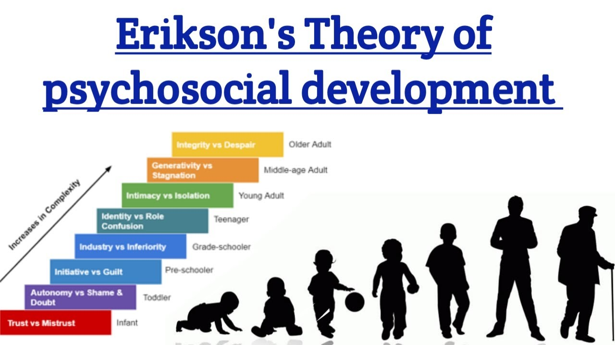
Photo 1 www.youtube.com (Accessed 8th August 2022)
Erik Erikson was a German American psychologist and psychoanalyst; he is known for his theory on psychosocial development of human beings. He was Freud’s disciple, and they had a very close relationship, Freud was like a father to him, as he never met his father. He developed his psychosocial theory inspired by Freud’s psychosexual theory.
Compared to Freud’s psychosexual theory, Erikson’s theory marked a shift form focusing on childhood events to describing the impact of social experience across the whole lifespan.
Erikson supported the fact that personality develops in a predetermined order through the 8 stages of psychosocial development. Each stage represents a crisis that must be overcome, the outcome could be a positive or negative and it will have a great impact on personality development.

According to the theory a successful completion of each stage will result in a healthy personality and the individual develops strengths that will help pass the next stages successfully as well.
Failure to complete one stage can reduce the ability to complete next stages as well and could cause an unhealthy personality and sense of self. However, these stages can be completed successfully later in life.
1. Infancy conflict between trust and mistrust. This stage begins at birth and last until 18 months of age. During this period if the infant receives constant care and stability, also he can rely on his caregiver to support all his needs. The infant will develop a sense of trust in the new environment, he will be able to feel secure even threatened.
On the other hand, if his needs are not met the child can develop sense mistrust, insecurity and anxiety. The infant will not trust the world around him.
2. Toddler stage autonomy vs shame and doubt from 18 months to 3years old. Children at this stage are more focused to develop a sense of personal control over their physical skills and to seek independence. If they are supported during this stage children will become more independent, and their self-esteem will increase.
If they are being always criticised and overly controlled, they will become to feel inadequate and not capable to survive. They can become overly dependent on others; they will have no self-esteem. The aim must be ‘self-control without the loss of self-esteem’ (Gross, 1992)
3. Preschool stage initiative vs guilt between 3-5 years old. This stage develops during school years when the child begins to assert control and power over their environment by planning activities, discovering role plays and developing through `them. If the child is discouraged or overcriticized he could develop a sense of guilt. Too much guilt can make the child slow to interact and even inhibit their creativity.
4. School age industry vs inferiority. At this stage children start school; their focus is to make friends and create a peer group. The child will seek the approval and acceptance of his group. He will be coping with new leaning and social demands.

When they successfully pass this stage they will have a sense of competence, failure can result in feeling inferior.
5.Teenager stage identity vs role confusion. During this stage adolescence search for their inner self through exploring and experimenting different situations and people around them. Erikson considered this stage as a crisis period as children are heading into adulthood and they must decide what path they want to follow and what to do with their life. They also become sexually active and start exploring, developing deep feelings and living deception in love.
6. Young adult intimacy vs isolation. During this period, we explore relationships and allow us to become more intimate with others. We explore relationships that lead toward long term commitments. Passing this stage successfully can result in happy relationships and the sense of safety and belonging. Success in this stage will lead to true feeling of love.
7-8. Generativity vs stagnation and ego integrity vs despair. These final stages of the theory, generativity refers to the need of experienced individuals to create or nurture things that will outlive them. They feel that doing so will create positive changes in others life. The final stage begins around 65 years old and during this time we contemplate our accomplishments and can develop integrity if we see ourselves as leading a successful life. If we regret not achieving our goals this could lead to feelings of bitterness and despair

Birth order theory- Alfred Adler

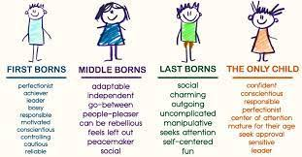Photo2 crowe-associates.co.uk/psychotherapy/birth-order/ (accessed 8th August 2022)

Alfred Adler was born just outside Vienna in 1870, he was an ophthalmologist at the beginning of his medical career but later he switched to general practice. His work was also influenced by Freud, they have met in 1907 in Vienna and developed a working relationship.
Unlike Freud, Adler believed that the social behaviour and community aspects of a person’s life were as important as inner thoughts and emotions. His birth order theory describes how the order you were born in your family determines and shapes your thoughts and behaviour. The theory applies to the first born, middle child, youngest child and only child.
Only child: being an only child means that they get all the attention from the adults around him. Interacting mostly with adults could make him more mature than children that have siblings. They enjoy being the centre of the attention, but they can be very confident and mature for their age.
First child: as the first born was an only child, they can exhibit the characteristics of an only child. They may have problems when they get siblings as jealousy comes on and they can feel neglected.
Second born and middle children: they begin their lives by sharing the attention of their parents with the older sibling, they could look to their older sibling as a model. Adler believed that second child will be better adjusted in life.
When a younger child appears and they become a middle child, this event can cause significant changes in the child's behaviour, as now they must share the attention of their parents with and older and younger sibling.
From being the youngest child, having most of the parents' attention they woke up being middle child that must share with other two siblings.
Youngest child: the last child cannot be dethroned by another sibling and being the baby of the family, they might get more attention from their parents as the older siblings become more independent.
Death of a sibling: when this unfortunate and devastating event happens, it can affect the way the surviving children develop after this event. Some children may adapt to their life after the event, but others feel that they cannot live up to the pristine image of the deceased sibling.

Critically evaluate the application of psychological principles affecting behaviour change in health and social care settings
Education: has a huge impact on human behaviour and the purpose of education is to organise a human being and make him fit for the social and physical environment of the world. All the studies have revealed that individuals that are more educated live in areas where the crime rate is lower, and they are more likely to live a happy and fulfilling life.
Emotions: body language relates to the emotional statues of an individual. Our body language tells a different story about us sometimes. Even if we try to hide our emotions, the way our body reacts without even noticing talk more about ourselves.
Conflict management: I am an individual that will try to avoid conflict as much as possible and I think it’s connected to the way I was raised as I am afraid to hurt anyone if I bring up things that could cause them discomfort and I keep them for myself. This type of approach is causing me discomfort and I need to learn how to deal with it.
Will or self-control: it is important to have self-control over our minds and to keep us away from bad actions and bad environment. Establish a goal for ourselves and work hard to reach it. A part of a social worker jobs is to help enhancing the power of will to our service users and support them to reach their goals.
Resilience: is the process of negotiating, managing and adapting to significant sources of trauma and learning how to live and deal with all your emotions. (Windle, Gill 2012)
Being resilient will help staff working in health and social care to manage stressful situations, protect themselves from getting mentally drained and improve their wellbeing. As an example of being resilient was the Covid 19 pandemic where all health care workers were asked to work long hours and to be exposed to a deadly virus, with huge cost for some of them.

Conclusion
Psychology module has brought some questions in my adult life, questions that I have never thought about before. Question about the way I interact in society and whey, questions about why I feel sometimes as I am cold towards my children, even though I love them deeply, they are my whole life. My behaviour at work I have learnt that it’s being influenced by the way I was raised, I had to put everybody's feelings before mine, and make sure I don’t disappoint my parents and behave as they would like me too. I was always hiding things from them and trying to sort my problems on my own.
As I said during the PP presentation, I believe that Erikson’s theory is the most accessible and the easiest to ‘digest’ as a new starter in psychologic theories. I was also intrigued by Freud’s psychosocial theory, and I have tried to read more about it.
Adler theory about birth order influencing your personality it applies very much to me, as an older child, I find many of the characteristics from the first born in my personality. I have looked about characteristics of my children in relation to Adler’s theory and most of them apply to my children as well.
As an end to this report, I would like to thank you for bringing this subject to us, it made me question lots of things but I the same time I found answers.

References
Bee, H.L. (1992). The developing child. London: HarperCollins
Erikson, E. N. (1950). Childhood and society. New York: Norton
Erikson, E. N. (1963). Youth: Change and history. New York: Norton
Gross, R.D., & Humphreys, P. (1992). Psychology: the science of mind and behaviour. London: Hodder & Stoughton
Jason Anderson, Reflection, ELT Journal, volume 74, issue4, October 2020, pages 480-483
Magdeleine D.N., Henk G. Schmidt, Self-reflection and academic performance: is there a relationship? 2011, 16(4): 529-545
PA Atkinson, Camilia R Martin, Jean Rankin, Journal of psychiatric and mental health nursing 16(2) 137-145, 2009
Suchitra Ramkumar, Erik Erikson’s theory of development: A teacher’s observations, Journal of the Krishnamurti schools 2022
Windle, Gill. The contribution of resilience to healthy ageing, Perspective in public health, vol 132, 159-160, 2012
https://assets.ltkcontent.com/images/44558/using-psychology_c7b15a2f06.jpg
https://www.youtube.com/watch?v=V1DMVa1IXcc
https://www.crowe-associates.co.uk/psychotherapy/birth-order/
https://www.betterhelp.com

