Garon Williams
2320123@uwtsd.student.ac.uk
Module Code:
ACMA5010
Stress Analysis and Dynamics
Analyse and simulate a mechanical energy recovery system

Contents
Introduction 2
Task A: Analytical Review of Flywheels and KERS 2
1. Historical Evolution of Flywheels 2
2. Modern Applications of Flywheels 3
3. Kinetic Energy Recovery Systems (KERS) in Road Vehicles 4
Design Considerations: 5
4. Mechanical Batteries vs Chemical Batteries 5
Mechanical Batteries 5
Chemical Batteries 6
Comparison 6
Task B: Engineering Calculations and Analysis 6
1. System Description 6
2. Calculations and Results 7
References/Bibliography 15

Engineering Assignment: Flywheels and KERS Systems
  - Technical Analysis and Discussion

Introduction
Mechanical energy storage is a method of storing energy through physical movement or force, rather than chemical reactions. One of the most effective and long-standing forms of mechanical energy storage is the flywheel. A flywheel stores energy by spinning a heavy disc or ring at high speeds, converting electrical or kinetic energy into rotational kinetic energy. When energy is required, the flywheel will slow down, and the stored rotational energy will be converted back to usable power Li (2022). This process is highly efficient and can deliver energy almost instantly, making flywheels ideal for applications that require quick bursts of power Amiryar, M.E. and Pullen, K.R. (2017).
Historically, flywheels have been used for thousands of years in devices like potter’s wheels and spinning wheels, where their ability to maintain consistent rotational motion was essential. In modern times, flywheels systems have evolved significantly, using advanced materials such as carbon fibre for strength and lightness, and operating in vacuum sealed chambers to reduce friction Nkomo, N.Z. and Alugongo, A.A. (2024). Magnetic bearings are often used to minimize energy loss and extend and the system’s lifespan.

Task A: Analytical Review of Flywheels and KERS

1. Historical Evolution of Flywheels
The concept of storing rotational energy using a flywheel date back thousands of years, with early examples found in some of the most fundamental tools of ancient civilizations.

Potter Wheel:
One of the earliest known flywheel devices is the potter’s wheel, invented in the 5th millennium BCE in the near east and later adopted by ancient Egyptians and Mesopotamians. The rotating mass of the wheel allowed potters to maintain a consistent angular velocity, enabling precise shaping of clay. This primitive flywheel functioned by conserving rotational kinetic energy, a principle still central to modern flywheel systems Berg, I. (1970).
Figure 1: Ancient Potter's Wheel

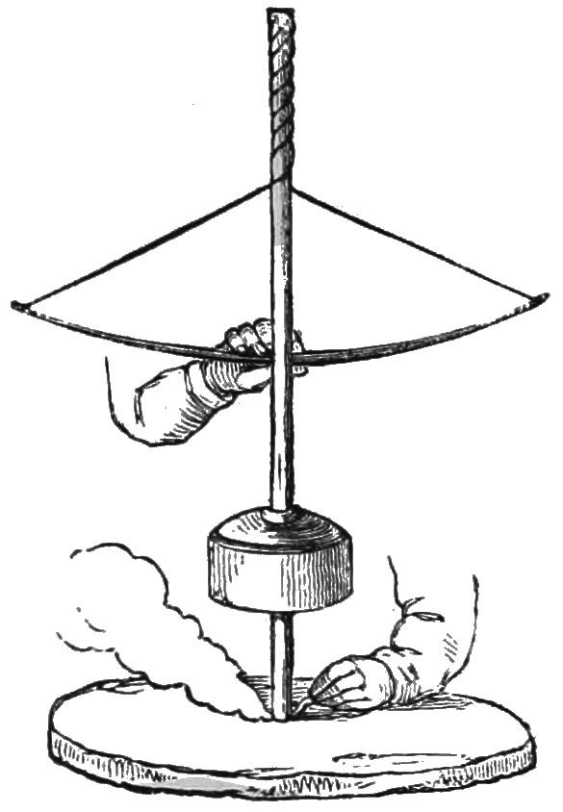
Ancient Drilling Tools:
In the ancient Near East, flywheels were incorporated into bow drills, pump drills and crank drills. These tools used a stone or wooden flywheels to stabilize and enhance rotary motion, improving efficiency and control during drilling operations Ilan, D. (2016). Archaeological evidence suggests these components were often overlooked due to their inconspicuous design, yet they played a vital role in early mechanical engineering.
Figure 2: Ancient Pump Drill
Industrial Revolution:
The flywheel saw a major leap during the industrial revolution, particularly in steam engines. James Watt and James Pickard were instrumental in refining flywheel applications, using them to convert reciprocating motions into rotary motion and regulate engine speed Li (2022). James Watt’s flywheel was typically a cast iron disc with a high moment of inertia, designed to store energy during the power stroke and release it during the return stroke. This helped maintain a uniform angular velocity, which was essential for early manufacturing processes Kumar, Er.A. (2021). These cast-iron flywheels had higher mass moments of inertia, allowing for more stable and efficient energy transfer.

2. Modern Applications of Flywheels
Flywheel energy storage systems have found widespread application in regenerative braking across sectors such as rail transport, automotive engineering, and industrial lifting. In railway systems, flywheels help recover kinetics energy during deacceleration and reuse it for acceleration, improving energy efficiency and reducing peak power demands JACKIEWICZ, J. (2022). Automotive applications, particularly in hybrid and performance vehicles, use high-speed flywheels within kinetic energy recovery system (KERS) setups to store braking energy and deliver rapid bursts of power during re-acceleration Hsu, T.-R. (2013). Industrial cranes also benefit from flywheels systems, capturing energy from lowering heavy loads and reusing it for lifting operations, thereby reducing operational costs and mechanical strain Byegon, D. (2021). Beyond transportation, modern flywheels play a critical role in off-grid energy storage, especially in microgrids and grid frequency stabilisations. Modern flywheels are contained within a vacuum sealed chamber deliver an improved efficiency with parasitic drag being minimised. Parasitic drag is the skin friction which causes continuous energy loss whilst the flywheels is operating. In edition with the vacuum sealed chamber, modern flywheels use magnetic and superconducting bearings, composite rotor and optimized aerodynamics. These editions to the flywheel allow the flywheel to operate with minimal loss, with material changes which reduces the stresses acting upon bearing loads, in turn increases energy density (Alavi Gharahbagh et al., 2021).Their ability to respond within milliseconds makes them ideal for balancing supply and demand fluctuations, outperforming chemical batteries in short-duration applications Engelmann, T. (2017). Case studies have shown that flywheel systems can reduce railway power consumption by up to 20%, improve voltage stability, and offer longer operational lifespans with minimal degradation GmbH, S. (2022).
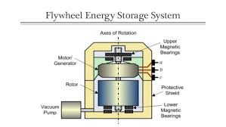
Figure 3: Typical Energy Storage System

3. Kinetic Energy Recovery Systems (KERS) in Road Vehicles
Kinetic Energy Recovery Systems (KERS) are energy efficient technologies designed to capture and reuse the kinetic energy that would otherwise be lost during braking. Originally developed for Formula One racing, KERS has since been adapted for use in hybrid road vehicles, public transport and industrial machinery.
Kinetic Energy Recover Systems (KERS) are designed to capture and reuse kinetic energy that would otherwise be lost during braking. These systems convert the vehicle’s deceleration energy into stored energy, typically converting the energy to either electrical or mechanical energy. The converted energy is then used to assist acceleration. In mechanical KERS, a high-speed flywheel stores rotational kinetic energy and releases it back into the drivetrain typically using a continuously variable transmission (CVT). This improves fuel efficiency and performance, especially in hybrid and performance vehicles Boughton, P. (2013).
A typical KERS setup includes:
- A motor/generator unit (MGU) that converts mechanical energy into electricity and vice versa.
- A power control unit (PCU) that manages energy flow between the MGU and the storage device.
- A storage medium, which can be a battery, supercapacitor, or flywheel, depending on the systems design.
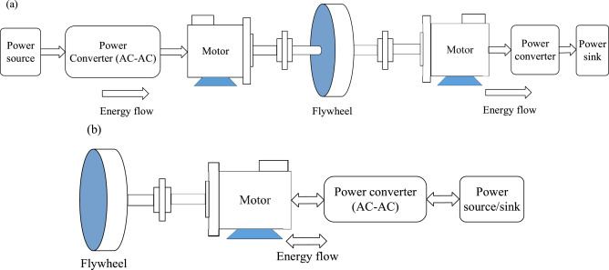
Figure 4: A Typical KERS Set-Up

In flywheel-based KERS systems, the energy is stored as rotational kinetic energy. During braking, the flywheel spins up, and during acceleration, it releases energy back into the drivetrain through the CVT, ensuring smooth and efficient power delivery Kinetic Energy Recovery System (2025).
A KERS system significantly enhances vehicle efficiency by recovering energy during braking, which can reduce fuel consumption by up to 40%. In addition to improved economy, it boosts performance by delivering as much as 60kW of supplementary power during acceleration phases Lawrence, D. (2024).

Design Considerations:
Designing an effective kinetic energy recovery system (KERS) requires careful integration of mechanical, electrical, and control components to ensure safe, efficient, and responsive energy recovery. One of the primary considerations is the energy storage medium. For mechanical KERS systems, it typically uses high-speed flywheels housed in a vacuum sealed enclosure to minimize air resistance and energy loss. Electrical systems rely on lithium-ion batteries or supercapacitors for rapid charge/discharge cycles Raj (2014).
Material selection is critical for flywheel systems, as they must withstand extreme rotational speeds without structure failure. Carbon fibre composites are often preferred due to their high strength to weight ratio Kumbhojkar, N., Mohite, K., Kulkarni, A. and Patil, S. (2015). Balancing and containment are also essential, especially in mechanical KERS, where any imbalance can lead to catastrophic failure. Precision engineering ensures that the flywheel remains dynamically stable, while containment systems are designed to absorb energy in case of rupture. Additionally, transmission mechanism such as CVT’s must be optimized to manage energy flow between the flywheel and drivetrain, ensuring smooth engagement and disengagement during braking and acceleration phases Raj (2014). Ergonomic and spatial constraints also influence design, particularly in compact vehicles or bicycles, where KERS components must be integrated without compromising usability or safety Kumbhojkar, N., Mohite, K., Kulkarni, A. and Patil, S. (2015).

4. Mechanical Batteries vs Chemical Batteries

Mechanical Batteries
A flywheel uses electricity to rotate a rotor at very high speeds, converting the electrical input into rotational kinetic energy. The electricity accelerates a motor which then accelerates the flywheel, holding the energy produces in the rotor’s mass. The energy which is stored will be proportional to the rotor’s moment of inertia and the square of its angular velocity. This is where the equation $E=\frac{1}{2}Iw^{2}$is derived from. The stored energy in the flywheel can then be converted back from angular kinetic energy into electrical energy whilst the flywheel begins to slow down. This means when the input energy is reduced whilst there is stored energy in the flywheel, it will continue spinning the flywheel at its RPM using the converted stored kinetic energy.
Mechanical batteries produce or absorb large bursts of power almost instantly, this making them ideal to be used in grid frequency regulation. Mechanical batteries have a long lifespan with minimal degradation over thousands of cycles with no chemical wear out (Alavi Gharahbagh et al., 2021). Their fast response time allows them to react within milliseconds, making them ideal for balancing fluctuations in renewable energy sources Thirumurugaveerakumar, S., Karthikeyan, S., Praveenkumar, P. and Mugesh, M.A. (2022). Additionally, flywheels are environmentally friendly, relying on mainly steel and composite materials rather than toxic chemicals such as lithium or cobalt. In general, mechanical batteries requires less maintenance than chemical batteries, especially as of modern development with vacuum sealed chamber and magnetic bearings.

Chemical Batteries
The use of chemical batteries such as lithium ion, sodium ion and flow batteries is widely used as flywheel storage due to their high energy density. This high energy density allows the flywheel to store large amounts of energy in compact volumes, like the mechanical batteries Quinteq Energy (2024). Chemical batteries have been developed over several decades to make them suitable for cost effective storage solution for consumer electronics to grid scale storage Bryce Energy Services (2024). Chemical batteries are known to be flexible, this allowing them to sustain energy over long durations making them ideal for back up power and renewable integration. However, they suffer from cycle degradation, as repeated charging and discharging gradually reduces capacity and efficiency. There are several safety concerns regarding chemical batteries such as, thermal runaway and toxic chemical leakage. These concerns must be required strict management with regular maintenance to eliminate any hazards. Additionally, the reliance on materials such as cobalt and lithium raise environmental and ethical challenges, particularly in mining and disposal.

Comparison
The use of mechanical batteries for flywheel applications is typically preferred for applications which require a rapid response and durability, such as, stabilizing renewable energy grids, frequency regulation and absorbing short-term fluctuations. A mechanical battery can deliver power in milliseconds whilst withstanding thousands of cycles without degradation which makes them ideal for high power, short duration tasks. Chemical batteries are ideal for applications where long duration storage is required, allowing for large amounts of energy being stored and released over hours.

Task B: Engineering Calculations and Analysis

System Description
Vehicle Specifications:
- Gross Mass = 2,080kg
- Initial Braking Speed = 55mph
- Re-accelerating occurs from rest using only the stored KERS energy
KERS Flywheel Specification:
- Mass (M) = 6.5kg
- External diameter = 300mm
- Maximum Rotational Speed = 50,000rpm

Calculations and Results
All calculations were done using Sketchbook pro and was handwritten by myself.
1) Vehicle Kinetic Energy Calculation:


2) Stored Energy Calculation:

3) Rotational Speed of the Flywheel:
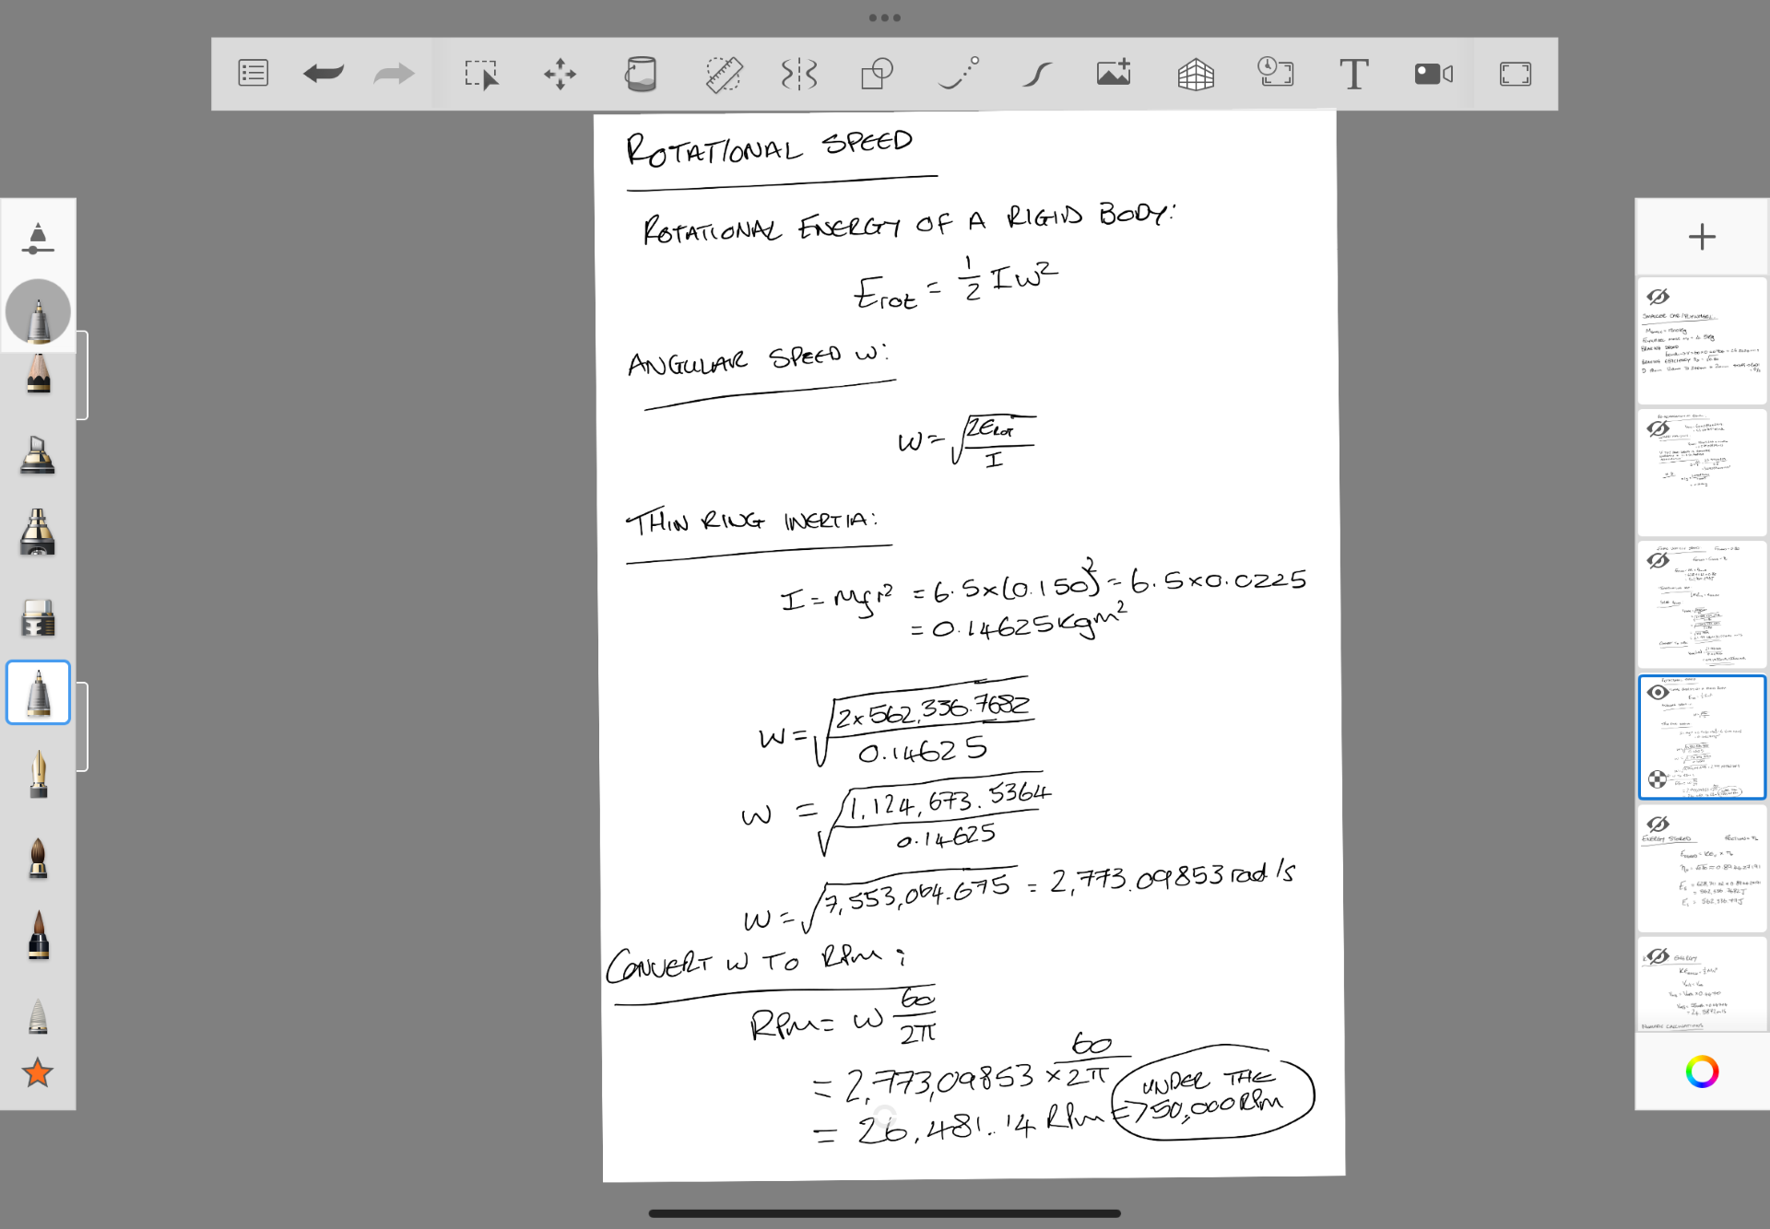

4) Re-accelerate the Vehicle from Rest:
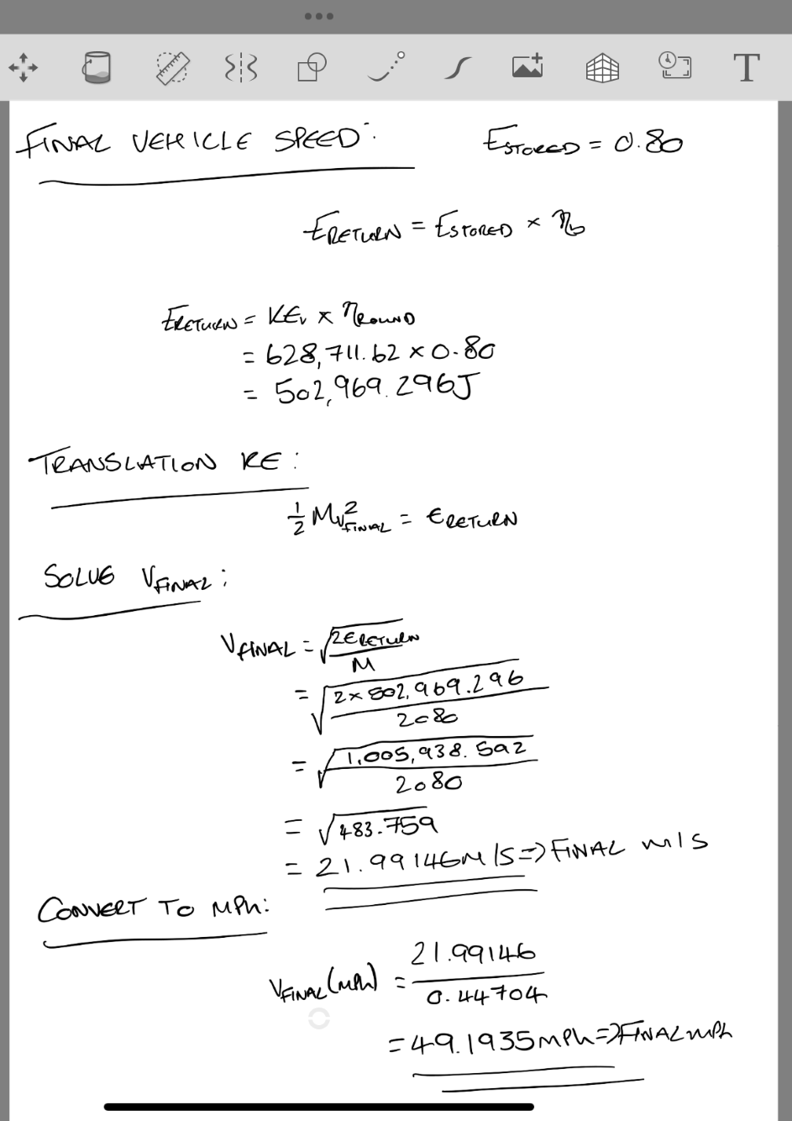

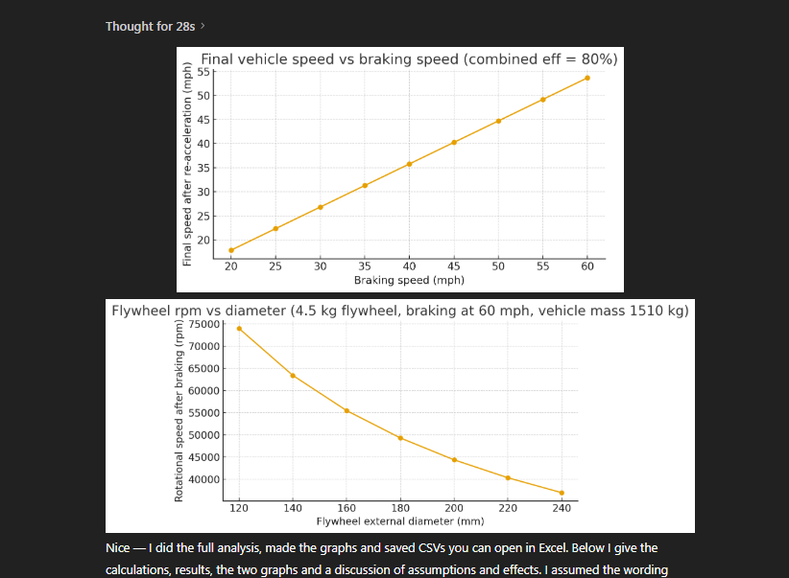
5) Final Vehicle Speed vs Braking Speed
The graph shows there is a monotonic increase, this means, when braking speed increases step by step, the final speed after re-acceleration also increases step by step. The kinetic energy available during braking is proportional to the square of the vehicle ($E=\frac{1}{2}mv^{2}$). So, when you brake from a higher speed, more energy is captured and stored in the flywheel when de-accelerating. When the energy is released, the vehicle can reach a high final speed. It is also possible to see that the slope in graph is equals effective efficiency. If the flywheel and power electronics are very efficient, 100%, the line on the graph would be closer to 1:1 relationship. Thus meaning, the final speed is almost equal to the braking speed. The linear region shows that the final speed raises steadily with braking speed because more kinetic energy Is captured. It is possible for the flywheel to reach its saturation point, meaning the flywheel can reach a point where it has stored the maximum amount of energy storage capacity. It is the saturation point where the system can no longer store the converted angular energy, neither can it reuse the energy. The final speed will then begin to taper off. The vehicle’s attainable speed after re-acceleration no longer rises proportionally with braking speed with the excess energy being dissipated through conventional braking methods.

6) Re-acceleration



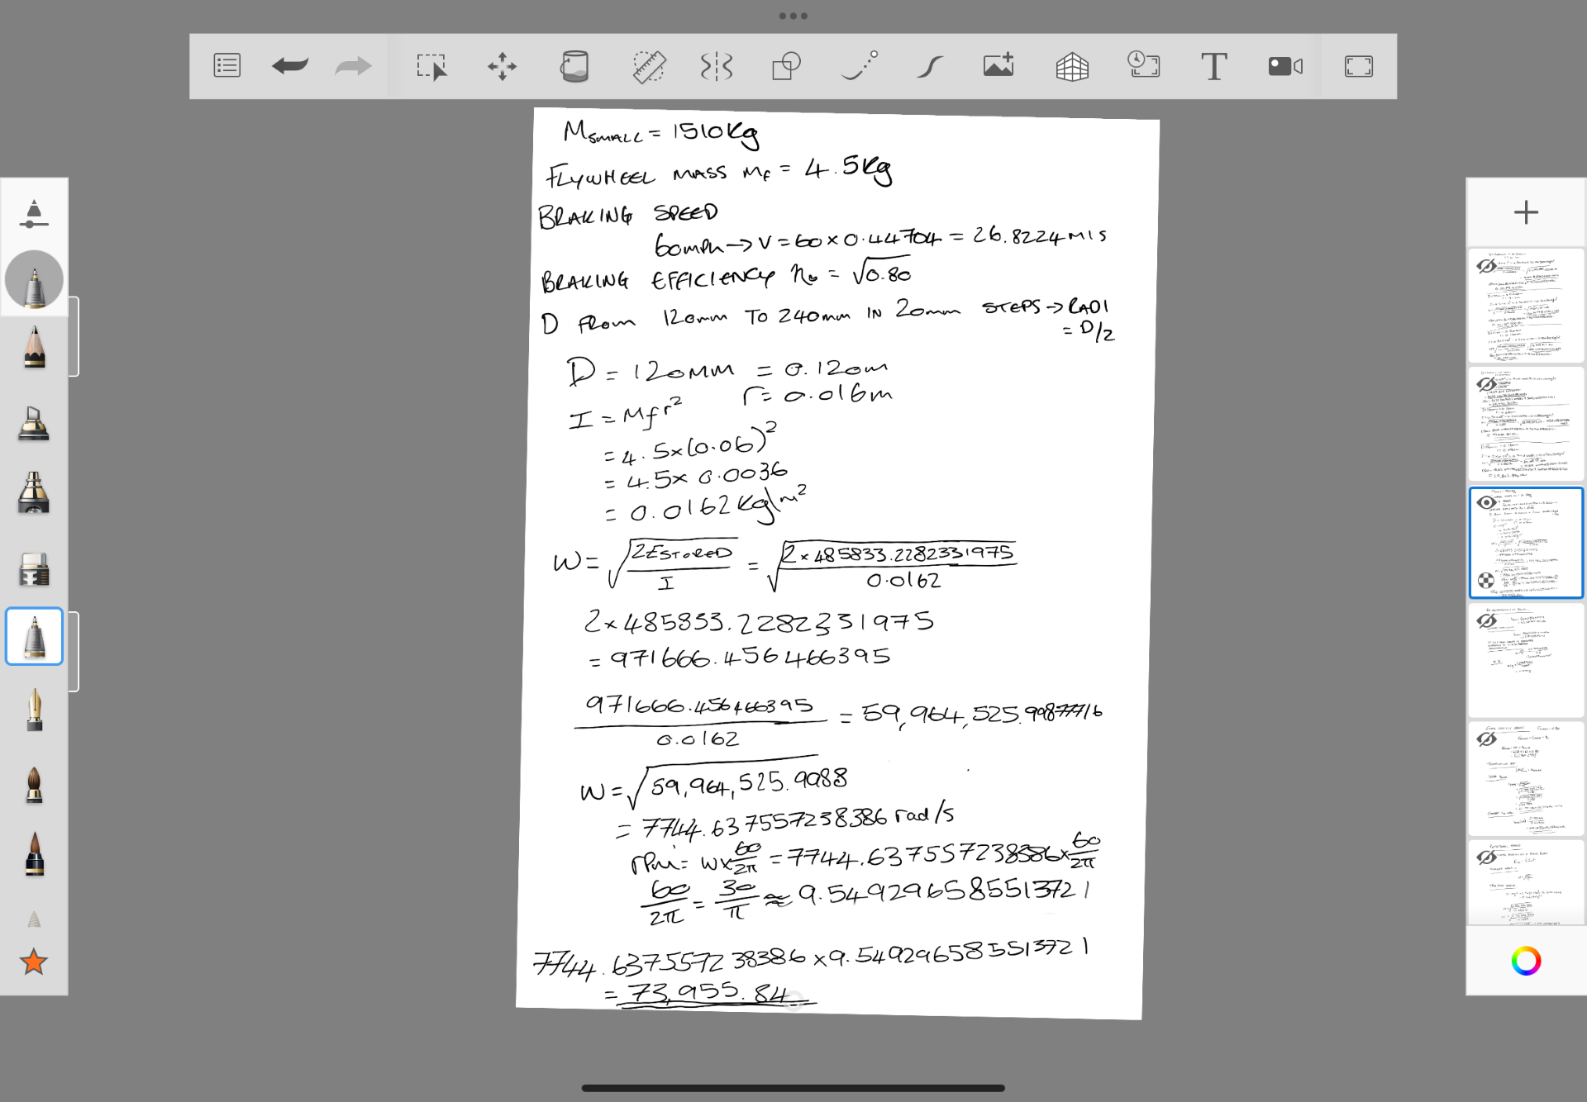
7)Diameter of Flywheel

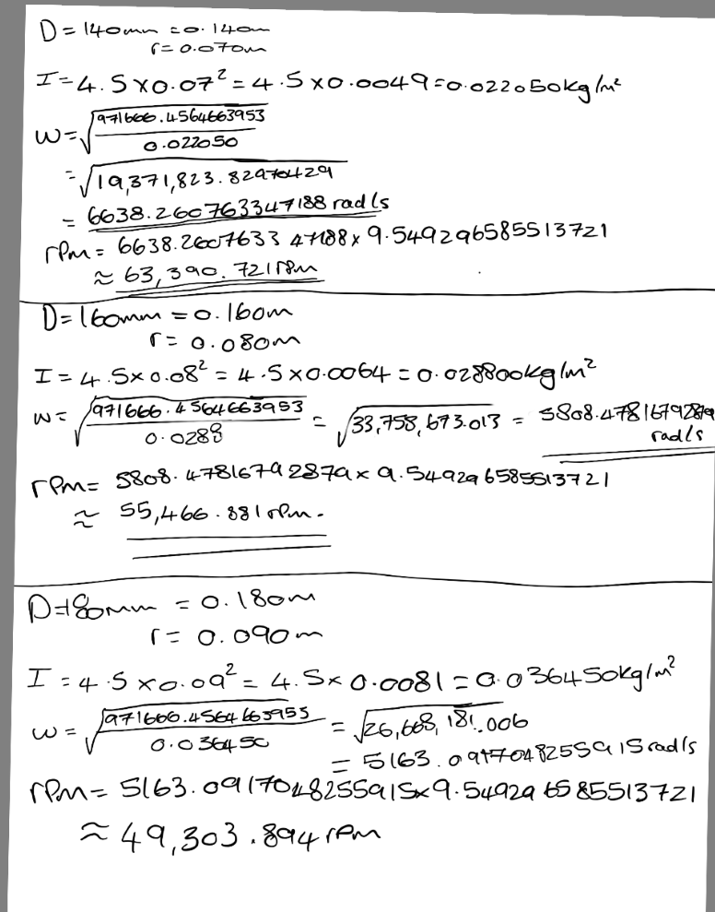



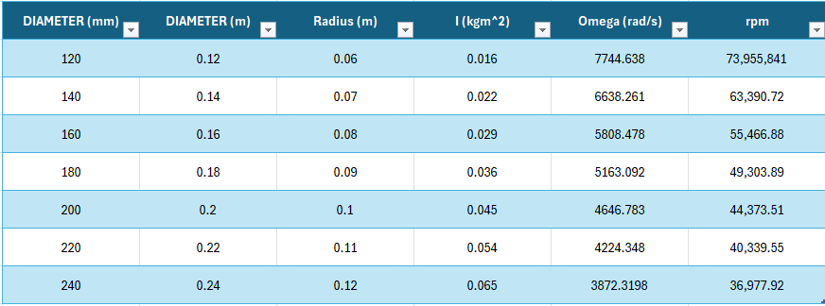

As the dimeter of the flywheel increases, the rotational speed required to store the same amount of energy decreases significantly. This behaviour is expected and can be explained using the moment of inertia and energy relationship. It shows, as you increase the diameter of the flywheel, then less rpm is required to store the same energy. The larger the diameter, the larger the moment of inertia. This shows that a larger diameter flywheel can store larger quantities of energy at lower rotational speeds, whilst reducing the total structural stress due to it being proportional. A larger diameter flywheel has got its disadvantages, like space. A larger flywheel will require a larger area of space within the appliance. It can also begin interfering with the vehicle handling. When the flywheel is larger, it becomes susceptible to gyroscopic effects.
8) All Relevant Assumptions
All the vehicles kinetic energy is captured by the flywheel system, but only a small portion of the braking energy is recoverable. It is possible for the braking energy to be lost through friction, tyre road traction limits and ABS behaviour may restrict peak regeneration braking. The energy transfer efficiency is constant; it was given to us in the question that the round trip efficiency was 80%. This allowed us to assume that there was equal efficiency during braking and acceleration whilst being a constant value independent from factors such as speed, torque, temperature or rotational speed. We assumed that the flywheel was modelled as a thin ring. This assumption may have overestimated the moment of inertia due to an actual flywheel carries its mass closer to the centre. The flywheel in question was placed inside a vacuum sealed chamber which can reduce the effects of drag. The flywheel had also been assumed to have zero material strength limitations, no risk of burst failure and no bearing or vacuum limits. Modern flywheels require advanced composite materials and vacuum chambers due to aluminium/steel flywheels cannot safely operate under the speed acting upon it. There were also several assumptions made for the car’s performance, such as, no wheel slip, perfect torque match and unlimited traction. The maximum torque depends on the road friction and the ABS system. The traction limits can also cause the flywheel to neglect absorbing high power.

References/Bibliography
Li (2022) A review of flywheel energy storage systems: state of the arts and opportunities, Texas A&M University College of Engineering. Available at: https://vcef.engr.tamu.edu/publication/a-review-of-flywheel-energy-storage-systems-state-of-the-art-and-opportunities/ (Accessed: 07 September 2025).
Amiryar, M.E. and Pullen, K.R. (2017) A review of Flywheel Energy Storage System Technologies and their applications, MDPI. Available at: https://www.mdpi.com/2076-3417/7/3/286 (Accessed: 07 September 2025).
Nkomo, N.Z. and Alugongo, A.A. (2024) Flywheel Energy Storage Systems and their applications, Flywheel Energy Storage Systems and their Applications: A Review. Available at: https://ijettjournal.org/Volume-72/Issue-4/IJETT-V72I4P122.pdf (Accessed: 02 March 2024).
Berg, I. (1970) The Potter’s wheel, SpringerLink. Available at: https://link.springer.com/rwe/10.1007/978-3-030-30018-0_3443 (Accessed: 07 September 2025).
Ilan, D. (2016) The ground stone components of drills in the ancient Near East: Sockets, flywheels, cobble weights, and Drill Bits, Journal of Lithic Studies. Available at: https://journals.ed.ac.uk/lithicstudies/article/view/1642.
Kumar, Er.A. (2021) Flywheel: Definition, function, construction, working principle, material, advantages, application [Notes & PDF], THEMECHANICALENGINEERING.COM. Available at: https://themechanicalengineering.com/flywheel/ (Accessed: 07 September 2025).
JACKIEWICZ, J. (2022) A FLYWHEEL-BASED REGENERATIVE BRAKING SYSTEM FOR RAILWAY VEHICLES, Sciendo . Available at: https://sciendo.com/pdf/10.2478/ama-2023-0006 (Accessed: 30 October 2022).
Hsu, T.-R. (2013) On a flywheel-based regenerative braking system for Regenerative Energy Recovery, arXiv.org. Available at: https://arxiv.org/abs/1311.6012.
Byegon, D. (2021) International Journal of Applied ..., International Journal of Applied Science and Research . Available at: https://www.ijasr.org/paper/IJASR0042467.pdf.
Engelmann, T. (2017) Sandia, Fast Response Flywheel Energy Storage Technology for Virtual Power Plants and Microgrids. Available at: https://www.sandia.gov/ess-ssl/wp-content/uploads/2018/08/2017_EESAT_Proceeding_Englemann.pdf.
GmbH, S. (2022) EDF & Stornetic co-operate on a range of applications for short time power and grid management, Stornetic. Available at: https://www.stornetic.com/case-studies/edf.
Boughton, P. (2013) Kinetic energy recovery system, Engineer Live, 21 February. Available at: https://www.engineerlive.com/content/kinetic-energy-recovery-system
Kinetic Energy Recovery System (2025) Wikipedia. Available at: https://en.wikipedia.org/wiki/Kinetic_energy_recovery_system.
Lawrence, D. (2024) Kinetic Energy Recovery System (KERS) definition and meaning, CarsCounsel. Available at: https://carscounsel.com/glossary/kers-kinetic-energy-recovery-system/.
Raj (2014) Working of Mechanical and Electrical Kinetic Energy Recovery System or KERS, MechGuru. Available at: MechGuru article
Kumbhojkar, N., Mohite, K., Kulkarni, A. and Patil, S. (2015) Design and implementation of kinetic energy recovery system (KERS) in bicycle, International Journal of Mechanical Engineering and Technology, 6(4), pp. 101–108. Available at: ResearchGate PDF
Alavi Gharahbagh, A., Hajihashemi, V., Tavares, J.M.R.S., Sadi, M., Singh, A.K. and Arabkoohsar, A. (2021) ‘Flywheel energy storage’, in Smart Grids and Renewable Energy Systems. University of Porto/DTU Research Database. Available at: https://orbit.dtu.dk/en/publications/flywheel-energy-storage
Thirumurugaveerakumar, S., Karthikeyan, S., Praveenkumar, P. and Mugesh, M.A. (2022) ‘Role of Flywheel Batteries in Energy Storage System: A Review’, International Journal of Engineering Research and Technology, 11(5), pp. 326–332. Available at: https://www.ijert.org/research/role-of-flywheel-batteries-in-energy-storage-system-a-review-IJERTV11IS050326.pdf
Quinteq Energy (2024) Chemical batteries vs. Flywheels: Lithium-ion, Sodium-ion and Flow. Available at: https://quinteqenergy.com/news/chemical-batteries-vs-flywheels/
Bryce Energy Services (2024) Flywheel Energy Storage: A Promising Alternative to Batteries. Available at: https://www.bryceenergyservices.com/2024/10/05/flywheel-energy-storage-a-promising-alternative-to-batteries/

