Edward sharp

Swansea Mumbles raod development
Fundamentals of Construction Technology ACBA4022

Contents Page
- Site Details
- Historical Appraisal
- Geological Appraisal
Bedrock Geology
- Mudstone and Siltstone
- Sandstone
Superficial Deposits
- Blown Sand
Site Stability and Ground Condition
- Groundwater and Drainage
- Foundation Consideration
- Environmental Risks

- Environmental Appraisal
Potential Contamination Sources:
- Historical Gas Works Contamination
- Current Site Contamination
- Potential Contamination from Future Construction
- Other Contamination Sources
Flora and Fauna Risks:
- Flora Risks
- Fauna Risks

- Archaeology Appraisal
- Conceptual Ground Model
- Site Summary

Desk Study
- Site Details
The study's location is the current site of the Tesco superstore and carpark in Swansea Marina, 51.61686500333942, -3.943901029958926.
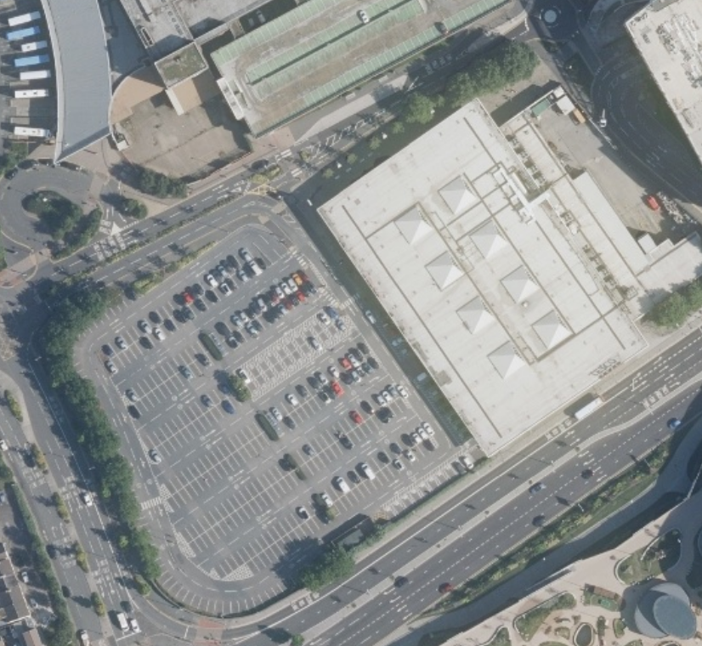
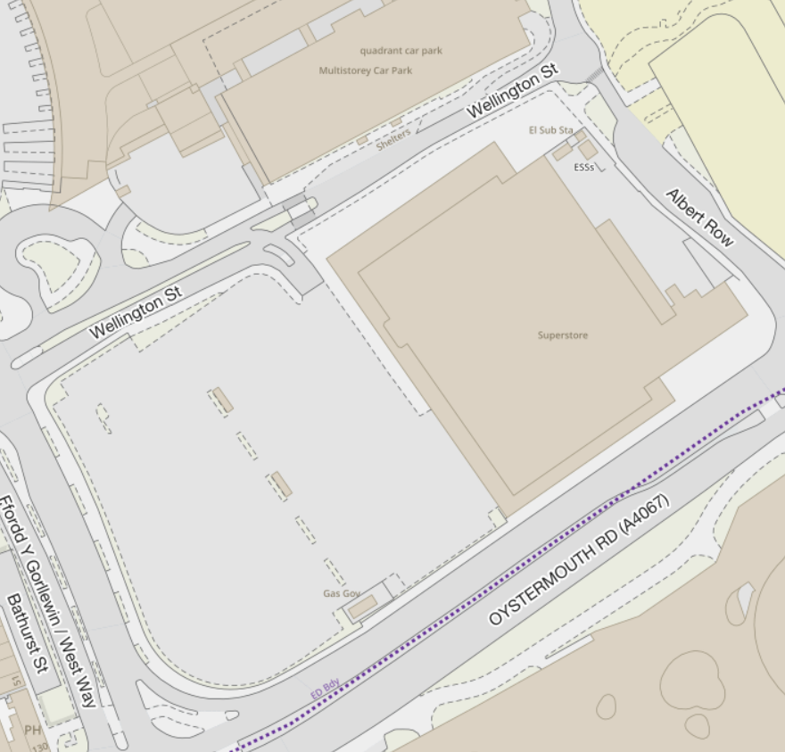
(Photos Taken from APU Welsh Government Aerial Photography – DataMapWales)
In the image above you can see the boundary lines for the superstore and its car park, there is a main entrance on the north side of the car park and access behind the superstore with a road going all the way around the site. The new proposed site use is the City and County of Swansea’s joint agreement with Jarvis Hotels to create a new five-storey hotel, bar, restaurant and conference centre where the current store and car park are to be demolished and relocated nearby to the old Debenhams building in the quadrant centre.

- Historical Appraisal
Previous to the £13.5 million pound superstore that was built in 2000 there was a gas works. Production of gas at the site dates back to 1841, when the site began burning coal to make gas, was from a company called Swansea Gas Light. In 1922, the site stopped producing gas and was used for gas distribution instead until 1949 when it was then used as a gas operations centre. (Wales Online, May 2020)
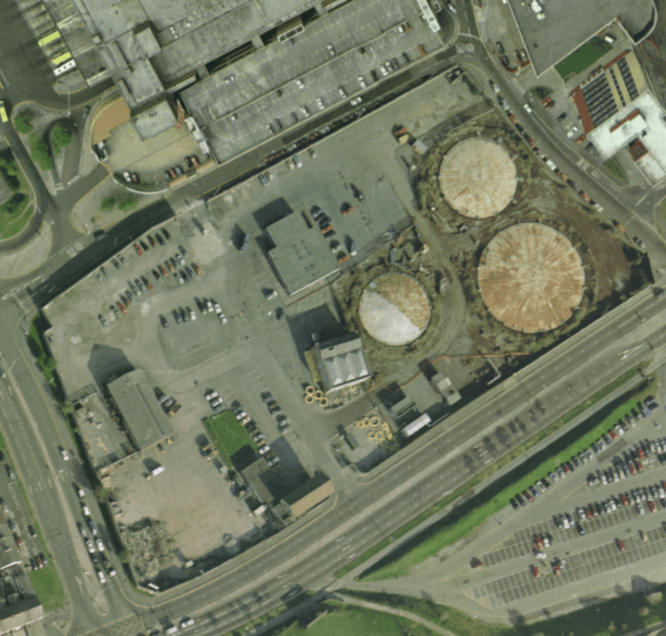
(DataMapWales)
This aerial image shows the site in 1992 where it just stopped producing gas and became a distributer instead.

- Geological Appraisal
This geological appraisal provides an overview of the subsurface conditions at the Tesco Superstore site in Swansea Marina, based on the site’s bedrock geology and superficial deposits. The appraisal considers potential construction challenges and the suitability of the site for development, with a focus on foundation design, drainage, and geotechnical risks.
Information from (BGS Geology Viewer)

Bedrock Geology
The underlying bedrock at the site belongs to the South Wales Middle Coal Measures Formation, which was deposited during the Carboniferous period approximately 318 to 309.5 million years ago. This formation consists of a combination of mudstone, siltstone, and sandstone, which are characteristic of sedimentary rocks formed in swampy, riverine, and deltaic environments.
- Mudstone and Siltstone: These fine-grained rocks typically form in low-energy, depositional environments such as floodplains or shallow lakes. While they are often soft and easily eroded, they can also exhibit poor drainage properties, leading to potential waterlogging and reduced bearing capacity in areas where these formations are near the surface. In the context of construction, these layers would require careful assessment of their strength and stability.
- Sandstone: Coarser-grained sandstone layers indicate higher-energy environments such as rivers or deltas. Sandstone generally provides better structural stability compared to mudstone and siltstone due to its greater strength and permeability. However, if sandstone layers are present at significant depths, they may not impact the surface-level engineering significantly but could be a key consideration for deep foundations.
Superficial Deposits
The superficial deposits at the site primarily consist of blown sand, which is a Quaternary-period deposit formed over the past 2.588 million years. Blown sand is typically loose, unconsolidated, and can vary in composition and thickness.
- Blown Sand: This is a type of wind-deposited sediment, often found in coastal or estuarine environments. While it can provide a stable surface for low-load structures, its loose, granular nature can pose challenges for construction, particularly in terms of bearing capacity and settlement. In areas where the blown sand layer is thick, further ground improvement techniques such as compaction or stabilization may be necessary to ensure a firm foundation. Additionally, if the sand is dry and poorly consolidated, it may be prone to shifting or erosion, especially in response to high winds or heavy rainfall.
Site Stability and Ground Conditions
Given the combination of sedimentary bedrock (mudstone, siltstone, and sandstone) and superficial blown sand deposits, several geotechnical factors should be considered for the site’s development:
- Groundwater and Drainage: The presence of mudstone and siltstone may result in poor drainage characteristics in certain areas, especially in low-lying zones near the water's edge. These fine-grained materials tend to retain water, which could lead to increased groundwater levels or potential issues with surface water drainage. Effective drainage systems will be required to mitigate these concerns, particularly as the site is located near Swansea Bay. Additionally, blown sand deposits are generally more permeable and may allow for quicker drainage, though this could lead to variable groundwater behaviour across the site.
- Foundation Considerations: The soft nature of mudstone and siltstone may lead to concerns regarding settlement or soil instability. These materials typically have lower load-bearing capacities than coarser-grained rocks. Shallow foundations may not be appropriate in areas where these deposits dominate. Therefore, deep foundations, such as piling, would likely be required to reach more stable material, either within the deeper layers of sandstone or below the blown sand, depending on the depth and thickness of the superficial deposits.
  - The blown sand deposits will also require attention in foundation design, as loose sands can shift under loading or vibration. Proper compaction or stabilization techniques (such as grouting or the use of reinforced foundations) may be needed to prevent potential shifting or settlement of the sand layer.
- Environmental Risks: There may be risks of subsidence or compaction due to the varying soil characteristics across the site. It’s essential to assess whether there are any previous mine workings or historical activities that could have affected the ground structure, particularly given the proximity to the South Wales Coal Measures, a region with a history of coal mining. A thorough subsurface survey would help assess if any residual mining activities might impact ground stability.
Conclusion
The Tesco Superstore site in Swansea Marina, located within the South Wales Middle Coal Measures Formation, presents a complex mix of geological challenges and opportunities. The presence of mudstone, siltstone, and sandstone in the bedrock, combined with superficial deposits of loose-blown sand, suggests that the site will require careful consideration in terms of foundation design, drainage, and potential soil stabilization.
A detailed geotechnical site investigation will be crucial to assess the specific subsurface conditions further and ensure that the development is structurally stable and environmentally sustainable. With appropriate engineering solutions, such as deep foundations and effective drainage systems, the site can be developed to accommodate the Tesco Superstore while mitigating potential geotechnical risks.

- Environmental Appraisal
Potential Contamination Sources:
- Historical Gas Works Contamination
A former gas works site could pose several contamination risks due to the chemicals and byproducts associated with gas production during its operational period. Common contaminants found at such sites include:
- Coal Tar and Oil: Historically, gas works produced coal gas by heating coal, which resulted in the formation of coal tar and other hydrocarbons. These compounds can be hazardous to human health and the environment and may have contaminated the soil and groundwater in the area.
- Polycyclic Aromatic Hydrocarbons (PAHs): PAHs are organic compounds found in coal tar and can be toxic, carcinogenic, and persistent in the environment. They can be present in the soil and groundwater at former gas works sites.
- Heavy Metals: Gas works may have involved the use of various metals, including arsenic, lead, cadmium, and zinc, which could have leached into the soil and groundwater, especially if the site wasn’t properly remediated after decommissioning.
- Volatile Organic Compounds (VOCs): VOCs, which include substances like benzene, toluene, and xylene, may be present in areas where gas was produced. These compounds are harmful to human health and can contaminate both soil and groundwater.
- Cyanides: Gas works also historically used processes that involved cyanide compounds, which could have polluted the soil and groundwater, especially in older facilities that were poorly regulated.

- Current Site Contamination
Even after the gas works were decommissioned, the site may still contain residual contamination, including:
- Petroleum Hydrocarbons: These can come from fuel spills or leaks, especially from vehicle operations in the car park or old underground storage tanks.
- Asbestos: If the original gas works facility included insulation or building materials containing asbestos, there may be a risk of asbestos-containing materials (ACMs) still being present in the building fabric or underground.
- Chemical Spills: Previous or current activities on the site, such as maintenance work, could have resulted in chemical spills or improper disposal, which may have impacted the soil.

- Potential Contamination from Future Construction
When building a new five-storey hotel, several potential contamination risks may arise from both the existing contamination and the construction process itself:
- Soil Disturbance: Excavation and soil disturbance during construction can release or spread contaminants, especially if they are located near the surface. Soil or groundwater contaminated with hydrocarbons, metals, or PAHs could be mobilized during the works.
- Dust and Air Pollution: During construction, activities such as demolition, excavation, and transportation of soil could generate dust containing hazardous substances like asbestos, heavy metals, or VOCs. Airborne dust particles can pose a risk to workers and local communities.
- Groundwater Contamination: Construction activities that alter the landscape, such as deep excavation or piling, could disturb contaminated groundwater or potentially allow for further migration of pollutants. Special care must be taken to monitor and control groundwater flow during the construction phase.
- Waste Management: Construction waste, including materials such as concrete, metals, and demolished building materials, must be properly managed to avoid contamination of the surrounding environment. Improper disposal of hazardous waste could lead to localized contamination.

- Other Contamination Sources
Nearby Polluting Sources: In addition to the historical use of the site, nearby industrial, commercial, or transport activities could also contribute to contamination risks. For example, local roads or maritime traffic could result in air, soil, or water pollution from vehicle emissions or marine fuel.
Flora and Fauna Risks:
- Flora Risks
Contamination can affect the local flora and fauna within the area, here are some of the risks:
- Contaminated Soil: If the soil is contaminated with hydrocarbons, metals, or other toxic substances it can harm local vegetation on the site and in nearby areas. Plants may absorb contaminants from the soil which could disrupt ecosystems and reduce biodiversity.
- Invasive Species: The construction of work may inadvertently encourage the spread of unwanted invasive species, especially if the topsoil or disturbed materials are moved and introduced from other locations.

- Fauna Risks
Contamination can also affect the animal life within the area, here are some risks to fauna:
- Toxic Contaminants: Wildlife could be harmed by direct exposure to the toxic substances in the soil or water, especially if they rely on the site for habitat or food. Insects may consume contaminated plants which are then consumed by higher organisms such as birds leading to toxins being passed on.
- Habitat Disruption: Construction activities would disrupt the local habitats, noise, vibration and the presence of humans and construction can drive away wildlife from there habitats.
- Protected Species: Within the immediate area of the site there are some protected species such as birds, the disturbance from the site may cause issues to these species. These species would need to be addressed by regulatory authorities.
- Pollution Impact on Aquatic Life: As the site is situated in Swansea Marina it is close to the sea, there could be a risk of contamination affecting aquatic wildlife. Heavy metals, oils, or chemicals leaching into the water systems could cause this.

- Archaeology Appraisal
There is potential of locating archaeology beneath the site as just 350m away is Swansea Castle remains. It is a grade 2 listed structure. It is possible that remains of medieval or post-medieval structures associated with the castle could be located under the site. This could include remains of earlier phases of the castle that were either demolished or repurposed.
The site also holds potential for the preservation of archaeological remains, which may include evidence of Roman or pre-Roman settlements, such as roads and buildings extending into the area. Considering the site’s historical commercial activity, it is also plausible that industrial archaeological features from the Victorian or Edwardian periods, such as structural foundations or material artifacts, may be present. The site's location near Swansea Marina additionally raises the possibility of preserved waterfront infrastructure, including quays and wharves, indicative of the region's maritime heritage. Finally, there exists a potential for the discovery of buried cemetery remains, particularly from the medieval or post-medieval periods, necessitating further investigation to evaluate their presence and archaeological significance.

- Conceptual Ground Model
The Tesco Superstore site at Swansea Marina has a lot of ground-related issues and contamination risks. The ground here is tricky with soft mudstone, siltstone, and loose blown sand, which could cause settling and make the soil unstable. This might affect the building's strength and underground utilities, so they'll need deep foundations and stabilizing techniques. Some areas might get swampy too because of bad drainage, making it even harder to plan foundations.
There's also old pollution from gas works, such as coal tar, heavy metals, and cyanides. That’s bad for people, plants, and the water around Swansea Marina. During construction, digging could release harmful contaminants into the air, which could be bad for workers and folks nearby. It could also harm the local plants and animals, and the water that fish live in. Also, these contaminants could corrode structures and buried utilities, so builders will need special methods.
Building work might also kick up dust and stir up polluted groundwater, spreading the contaminants around even more. That's why they've got to focus on things like stabilizing the soil, handling waste right, and keeping an eye on pollution to keep everyone safe and protect the environment and the buildings as they develop.

- Site Summary
The proposed development site is currently occupied by the Tesco superstore and car park in Swansea Marina. The City and County of Swansea plans to demolish the superstore and car park, relocating them to the old Debenhams building. The new development will include a five-storey hotel, bar, restaurant, and conference centre, as part of a partnership with Jarvis Hotels.
Historically, the site was a gas works, operational from 1841 to 1922, and later used for gas distribution until 1949. Prior to the construction of the superstore in 2000, it had a long industrial history.
The geological appraisal of the site reveals key factors for construction. The bedrock is part of the South Wales Middle Coal Measures Formation, containing mudstone, siltstone, and sandstone from the Carboniferous period. These materials pose challenges, with mudstone and siltstone being soft, poorly draining, and prone to erosion, affecting foundation stability. Sandstone is stronger but could be deep enough to have limited impact at the surface.
Superficial deposits primarily consist of blown sand, which is loose and unconsolidated. This can complicate foundation design due to its low bearing capacity and potential for shifting, particularly in coastal conditions. Groundwater drainage issues may arise due to poor drainage in mudstone and siltstone layers, especially near the water's edge.
Construction considerations will require deep foundations, such as piling, to reach stable materials below the surface. Ground improvement methods like compaction or stabilization of the blown sand layer may also be necessary to ensure site stability and prevent subsidence or settlement. These geotechnical risks and environmental factors must be addressed to ensure successful development.

References
  - APU Welsh Government Aerial Photography – DataMapWales
  - Wales Online, May 2020
  - BGS Geology Viewer
  - https://www.environment.nsw.gov.au/resources/clm/gasworks05237.pdf

