PROJECT INITIATION DOCUMENT
Project management and research methods
Runa Bibi
2018

Table of Contents

1 Background 2
2 Project Definition 2
2.1 Purpose 2
2.2 Objectives 2
2.3 Scope 3
2.4 Deliverables 3
2.5 Constraints 3
2.6 Assumptions 4
2.7 Stakeholders 4
3 Business Case 4
3.1 Benefits 4
3.2 Options 5
3.3 Cost and Timescale 5
3.4 Cost/benefit Analysis 5
4 Risk Analysis 5
4.1 Risk Identification 5
4.2 Risk Prevention and Management 5
4.3 Risk Monitoring 6
5 Roles and Responsibilities 6
5.1 Project Organisation Structure 6
5.2 Team Authority and Members and Roles 7
6 Initial Project Plan 7
6.1 Assignments 7
6.2 Schedule 7
6.3 Resources 9
6.4 Project Control 9
6.5 Quality Control 9
7 References 10

Background

The basis of this project began with help during disaster recovery. One of the most important aspects of this is missing persons. A huge priority for people during disasters is making sure their family members and friends are safe. Therefore, as a team we decided to plan and create a lost/found person database corresponding with a mobile app.

Project Definition

Purpose

In 2017, over 95.6 million people were affected by 335 natural disasters with notably 1,102 people being reported missing or dead in a landslide in Sierra Leone and 884 in India after Cyclone Sochi [1]. Both of these disasters share a high number of missing people. The purpose of our project is to provide people with a way to search for anyone who is missing during a national disaster and find their location. It will allow people who are missing to log their details and provide their whereabouts so they can be found. The end product will be an app which will allow search queries and updates on whether a missing person has been found and their status.

Objectives

The following are what we wish to achieve by the end of the project and how we will measure its success:
- A lost/found database with functionality including: adding records, amending records and searching for records
- A mobile app which allows people to search for missing persons and for anyone missing to record their location
- Successful usability testing for expected functions
- User documentation that helps user to use the app

Scope

This project will only be as big as a one-person software hardware project as normally done for a university assignment. This means that we are constrained to a small team and a short timescale, which is why a demo will be important at the expected date. It also means we will be unable to provide technical support after the app has been completed. The app will be able to be used globally. It will be designed to be user-friendly and comply with usability guidelines [2].

Deliverables

The expected outputs for the project are:

Output | By date
Database design | 18-10-2018
Software design | 25-10-2018
User interface design | 01-11-2018
Database development | 30-11-2018
Presentation with demo | 18-01-2018
Software development | 18-02-2018
User interface development | 19-03-2018
Documentation | 08-04-2018

Constraints

As this project is being undertaken as a team, one constraint may be one or more team members being unable to attend when we plan to meet. This could slow down the completion of the project. As we need a certain lab to carry out our work, we may not find it free when we need it to be, so we may need to reschedule or find another lab to do it. A further constraint is that we have no budget provided so we can only use the software and hardware that is available to us.

Assumptions

Some assumptions we can make about the project are:
- All team members will work to the best of their ability
- All team members will have enough time to complete the project
- The software will work readily
- The hardware will be available and work
- The lab will be available to work in
- We will meet the deadlines of our project plan

Stakeholders

Within the project team | Outside the project team, but within the same organization | Outside both the project team and the organization
Runa (me) | Sue Maw (sponsor) | Family members of team
Josh |  | Clients i.e. users of the app
Gabor |  | Government

Business Case

Benefits

The reason we are carrying out this project is to provide worried family members a way to find out where their missing family members are. One benefit of the project is that there will be a platform available for people to log missing persons without the need to go through the media, so they can get an answer quicker. Any missing person who cannot find a way to contact family can log their location, so they can be found. We will ultimately know if this has been successful if there are fewer missing people reported by the end of a disaster as more of them will have been found.

Options

Some other options which were explored when this project was being designed were:
- A resource for a water and food supply
- An app to locate the nearest disaster recovery centre
- Stock control for supplies

Cost and Timescale

As this project is being undertaken for university there will be no budget provided so any resources used will be whatever is available. The team will also only be me, Josh and Gabor and we will be the only workforce involved.

Cost/benefit Analysis

As there will be no money spent essentially the project’s return will be based on how successful the testing of the app goes.

Risk Analysis

Risk Identification

- Team member(s) being absent during scheduled meet up times
- Not completing tasks by deadline
- Loss of data
- Software/hardware being unavailable or not working
- Database, Software and UI design including wrong functions
- Late changes to requirements

Risk Prevention and Management

Some of these risks can be managed and prevented:

- Set up an online collaborative source so that any member who cannot attend can be caught up on what has been done and share input
- Find a critical path of our project plan so we can determine which tasks to give priority to
- Make a backup plan for all data i.e. online backup and backup hardware
- Download programs on personal laptop so they can be used if software not on university computers
- Prototyping the software and making a demo of the database should ensure we meet all requirements without unnecessary functions
- Develop the database, software and UI in increments so it can be monitored

Risk Monitoring

We will monitor these risks by:
- Keeping track of project progress in increments
- Schedule when to back up data

Roles and Responsibilities

Project Organisation Structure

As we have chosen not to elect a project manager we will work democratically and report to each other. Any decisions will be voted on based on majority.

Team Authority and Members and Roles

The team sponsor is Sue Maw and she will have the ultimate authority of the project’s progress. As a team, we decided not to have a project manager. As we all have a web background we will share our knowledge on all parts of the design and development process.

Initial Project Plan

Assignments

The following are major tasks which are planned for the duration of the project:

- PID
- Database design
- Software design
- User interface design
- Database development
- Presentation with demo
- Software development
- User interface development
- Testing
- Documentation

Schedule

Below is an expected timeline for the project and a Gantt chart which shows this.
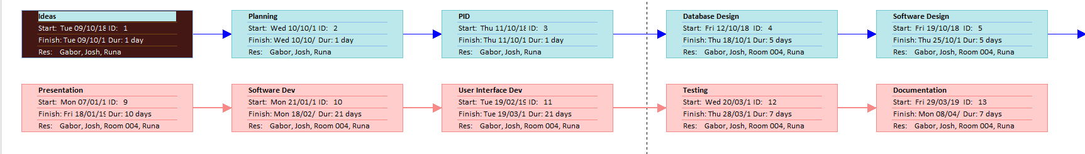
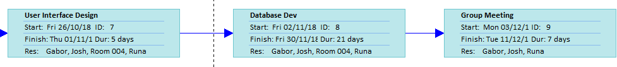
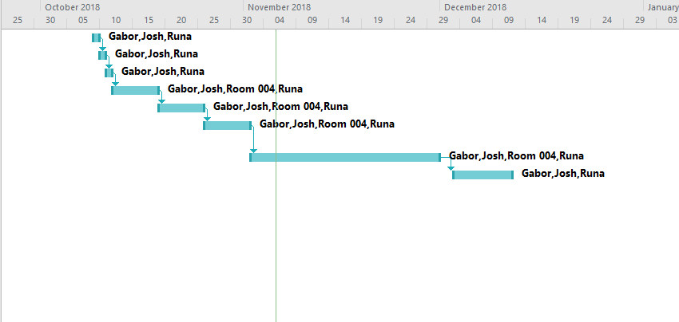
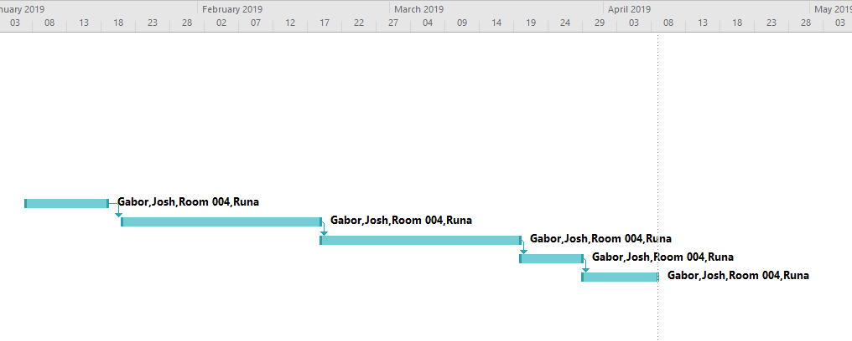
We have also determined a critical path for the project. These tasks will be given the highest priority to ensure the project’s success.
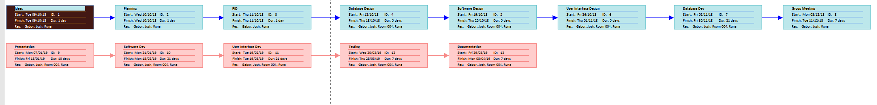

Resources

We have planned the following tasks and time needed for each and will not need further support staff. We will need the lab 004 as specified in the project plan and the software i.e. SQL server and hardware i.e. desktop computer within.

Tasks | Days needed
Planning | 1 day
PID | 1 day
Database design | 5 days
Software design | 5 days
User interface design | 5 days
Database development | 21 days
Group meetings | 7 days
Presentation with demo | 7 days
Software development | 10 days
User interface development | 21 days
Testing | 7 days
Documentation | 7 days

Project Control

Progress will be monitored and communicated at weekly meetings and more frequently when needed i.e. before the presentation when the demo will need to be presented so we can practice presenting.

Quality Control

In order to evaluate and monitor the quality of the deliverables, we will confer with Sue at certain intervals during design and development and carry out internal and user testing to ensure we are meeting requirements.

References

[1] | Centre for Research on the Epidemiology of Disasters, “Natural Disasters 2017,” reliefweb, Belgium, 2018.
[2] | W3C, “Accessibility, Usability, and Inclusion: Related Aspects of a Web for All,” [Online]. Available: https://www.w3.org/WAI/intro/usable. [Accessed 06 November 2018].

