

Assessment 1 – Reading Task Template
PART 1: Upload your photo of your A3 in-class notes here:
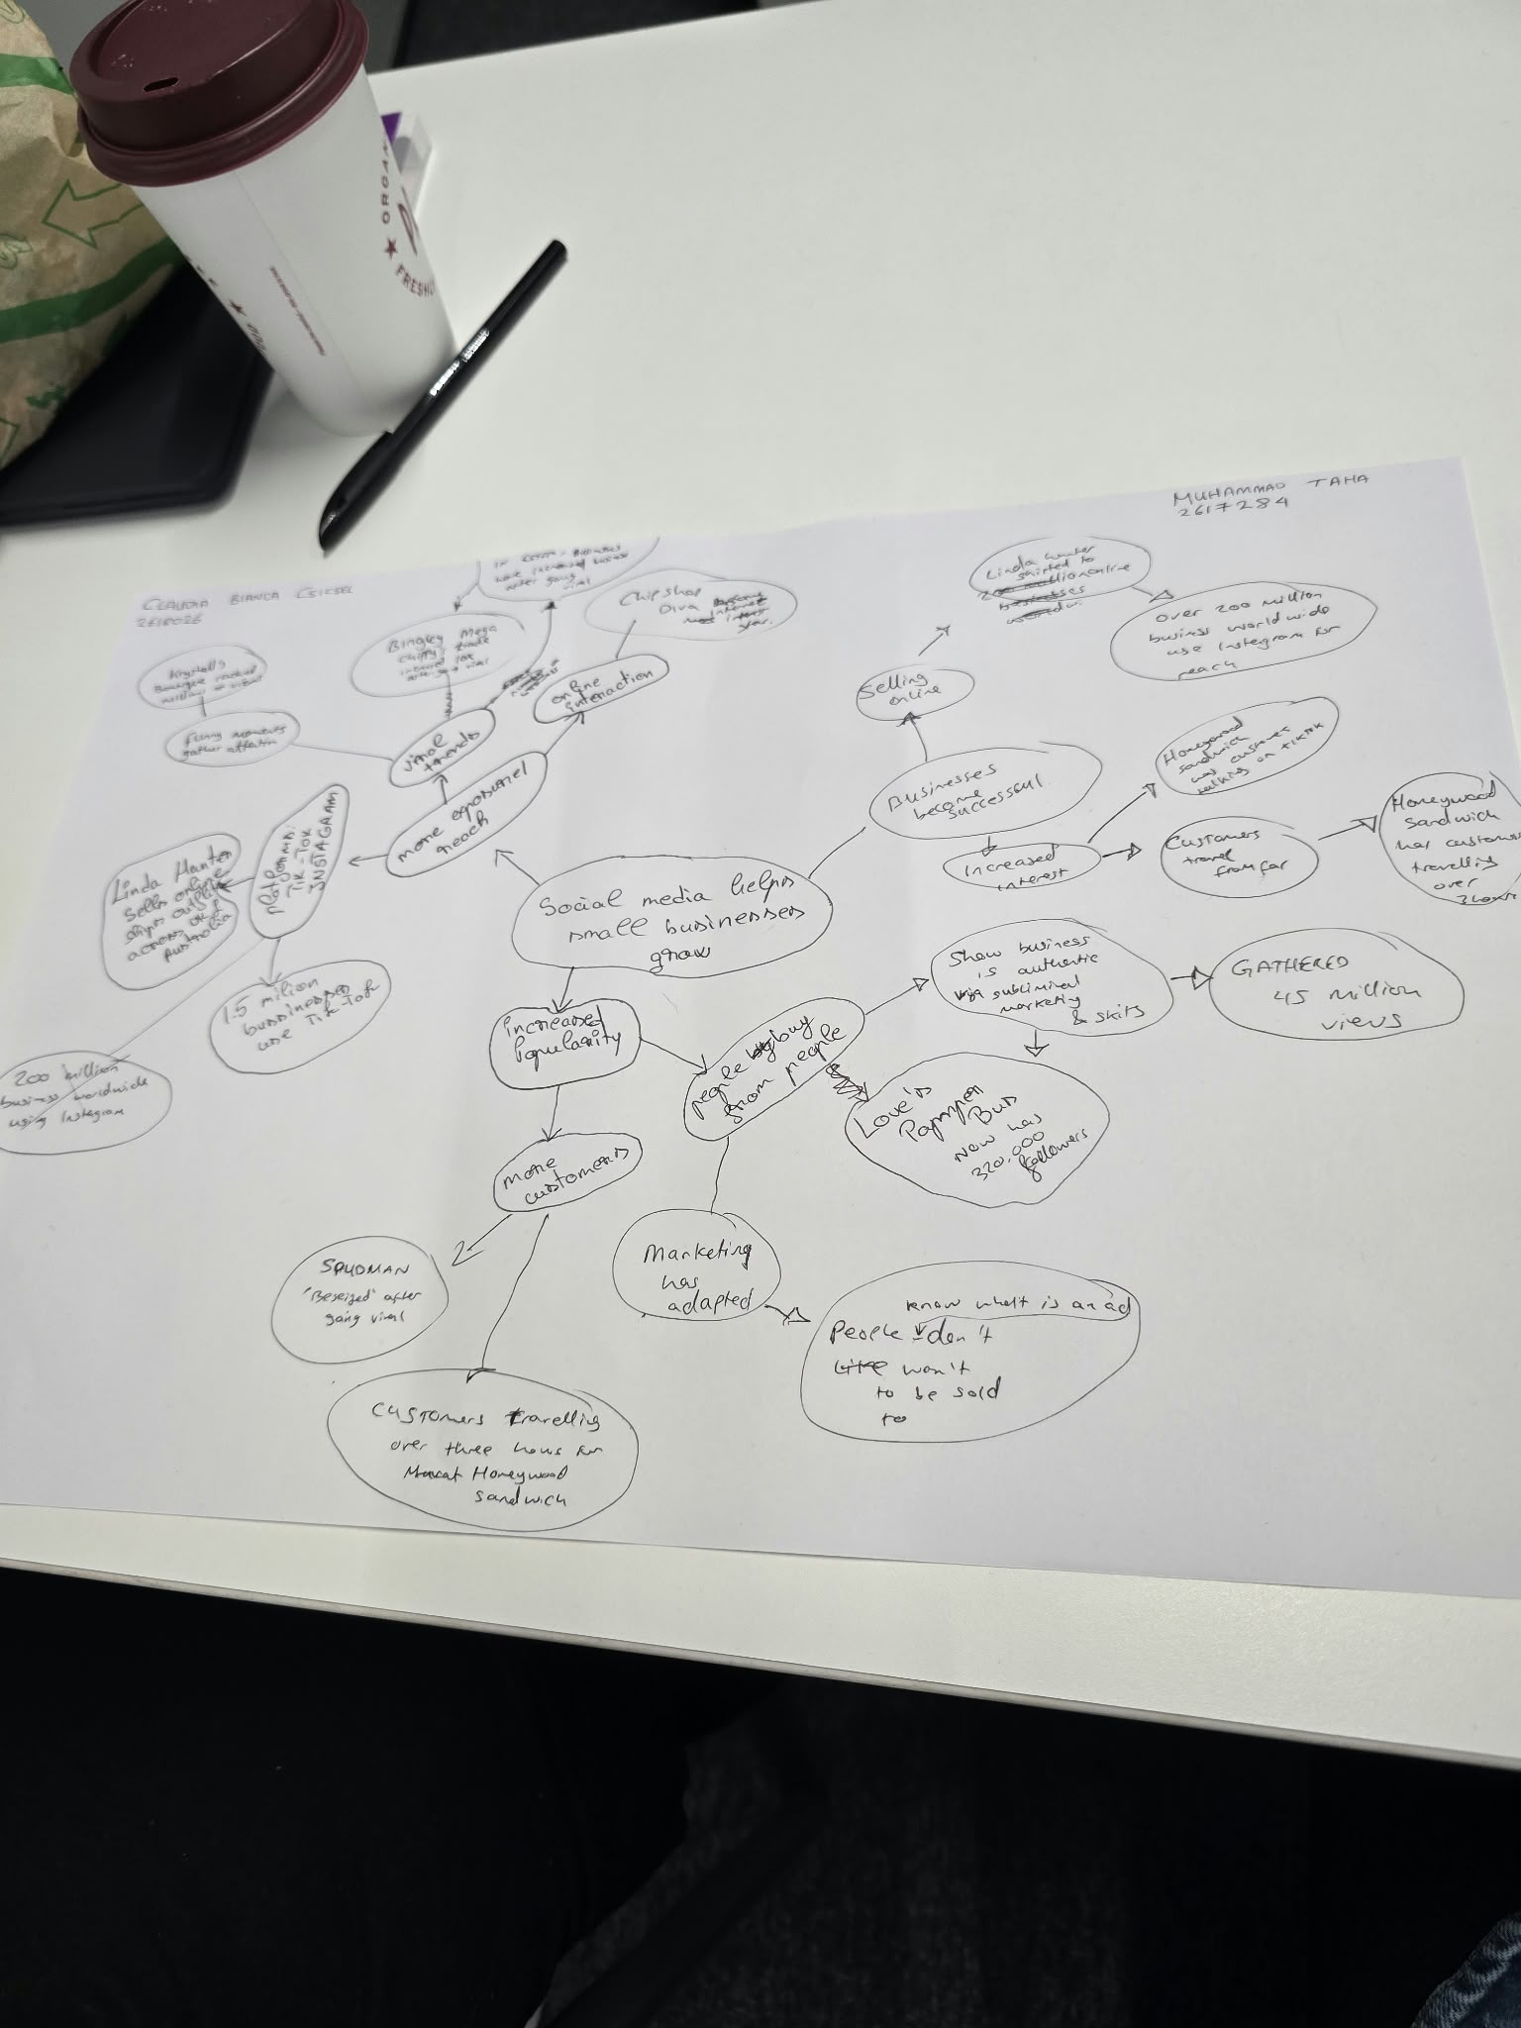

PART 2:
- Answer every question below in 1-3 full sentences.
- Use your own words. Do not use generative AI to answer these questions.
- Include a specific detail from the text when asked.
REMINDER
- The main idea is the overall message of the whole text.
- A key point helps to explain the main idea.
- A specific detail or example from the text shows that the key point is true.

- What is the main idea of the whole text?

It may be possible to use social media to help small companies grow. It can make them more easily purchasable by new buyers and allow them to sell further than their local town. Fun clips and customers' posts can also convert views into actual sales (BBC News, 2026), the passage states.

- What is one key point that supports the main idea, and which specific example from the text shows this?
One thing to take note is that social media can urge individuals to travel to a shop. In the text, the duration required for the customers to walk to Honywood Sandwich Shop to eat the chicken burger came to about 3 hours. They did this after people shared footage of the burger which attracted tourists from outside the local vicinity (BBC News, 2026).

- What is a different key point that supports the main idea, and which specific example from the text shows this?
Another important aspect is the fact that social media can influence the way a business sells and can help you to promote your companies to other nations. Linda Hunter changed the direction of market trading to online sales for boutique “Lindy Loo”. Following this change, the shop began distributing clothes throughout the UK and even as far afield as Australia (BBC News, 2026).
- Which part of the text do you think is most important, and why?
believe it's the final part that is the most important. It deals with genuine and relatable marketing. It cites marketing professional Faye Martin's recommendation that individuals respond to personally involved relationships and material that is interesting. That is one crucial aspect to clarify and understand why the business narratives were effective and how video impacts purchasing behaviours (BBC News, 2026).

Reflection:
- What did you find difficult in this task (including in-class components), and why was it difficult?
It was difficult not to get the overall message and business stories mixed up during the making of the class mind map. There were lots of companies, platforms and names in this article. Hence, it seemed to be very tempting to remember just the interesting facts. However, the task lacked some more connections to the main idea.

- What helped you with this difficulty, and how did it help you?

I put the main idea in the centre of the mind map. Next, I created some branches to add additional points. I think that's how I could see how each story fits because of that layout. I also reviewed the article and got verification on the given details with respect to each business. So that I can select evidence to support two different key points.

Reference
BBC News (2026) If you post it, they will come: The businesses turning likes into livelihoods. Adapted article supplied for LCLM4001 Assessment 1. Original report by Elliot Deady, published 19 October 2025.

