Name: Miroslava Tosheva
ID: 1907385

Topic: Brazil

Lecturer’s name: Dr Rexon Nting

Module: International Business Communications

Module № LCBB6001

Executive summary
A United Kingdom (UK) based company intends to strengthen its market position in Brazil. Cultural disparities and communication barriers can create challenges for the business expansion process. That is why the senior management of this company has hired an international business communications consultant responsible for identifying the cultural differences and cultural sensitivity. Hofstede's cultural dimension has highlighted cultural disparities between Brazil and the UK in power distance, individualism, masculinity, uncertainty avoidance, and long-term orientation dimension. This British firm needs to follow the polycentric approach while expanding its business in Brazil. In order to manage the cross-border business, this British company needs to imply the proposed cross-border communication strategy.

Table of Contents

Introduction: 4
Business environment in Brazil: 4
International and intercultural communication: 7
Hofstede's cultural dimensions: 8
Intercultural communication by Samovar: 11
Cultural sensitivity: 12
Communication barriers: 13
Communication strategy and recommendations: 14
Conclusion: 14
References: 16

Introduction:
Compared to a few decades ago, contemporary business entities are experiencing stiff competition from close competitors. In order to exploit every emerging opportunity, the management of a business entity needs to take advantage of globalisation, industrialisation, and the advent of technology. A UK-based business entity intends to strengthen its market position in the international market. Expanding its business operations in emerging markets like Brazil might be a successful move for this company. However, cultural differences and communication barriers can create challenges for the business expansion process. That is why the senior management of this company has hired an international business communications consultant responsible for identifying the cultural differences and cultural sensitivity. Based on that, the international business communications consultant needs to develop an appropriate strategy so that this UK-based company can make successful business expansion in Brazil.

Business environment in Brazil:
The most influential country in South America is Brazil. One of the most promising economic powers and one of the biggest democracies of this world is Brazil. Before expanding its business operation in Brazil, the UK-based company needs to assess the business environment within the country. This can be achieved by using PESTLE analysis in the following paragraph.
Political factors | - The political stability of Brazil can impact the business operations of the British company. The political stability index score of Brazil is 2 (TheGlobalEconomy.com, 2022).  - The role of the government in maintaining strict law and order might impact the business of the British company. In the rule of law index, the score of Brazil is -0.18 (TheGlobalEconomy.com 2022).  - In the government effectiveness dimension, the score of Brazil is -0.45 (TheGlobalEconomy.com, 2022).
  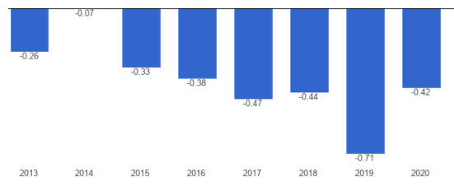
  Index1: The score of Brazil political stability index
  Source: (TheGlobalEconomy.com 2022).
  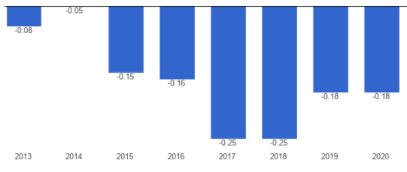
  Index 2: The score of Brazil in the rule of law index.
  Source: (TheGlobalEconomy.com, 2022).
Economic factors | - Brazil's economic stability might play a pivotal role in the organisational success of the British company.  - GDP: $1.445 trillion (Data.worldbank.org, 2022).  - GNI per capita income: $7,850  - Inflation rate: 10.54 %  - GDP growth rate: 5.23 %
  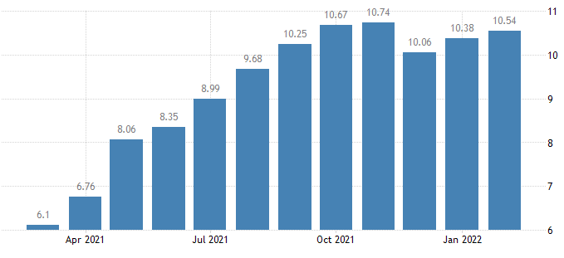
  Index 3: Inflation rate of Brazil.
  Source: (Tradingeconomics.com, 2022).
  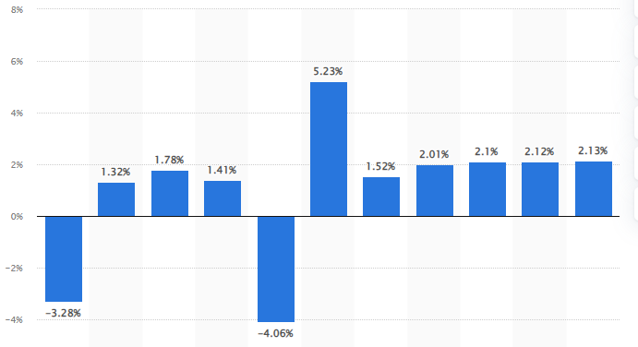
  Index 4: GDP growth rate of Brazil.
  Source: (O'Neill, 2021).
Social factors | - Cultural differences between the UK and Brazil might impact the business of the British company.  - The presence of corruption in society can create challenges for the British company. In the corruption perception index, the score of Brazil is 38 (TheGlobalEconomy.com, 2022).
  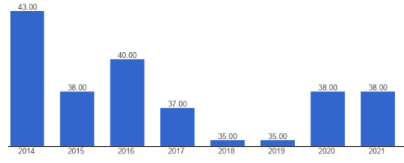
  Index 5: The score of Brazil in the corruption perception index.
  Source: (TheGlobalEconomy.com, 2022).
Technological factors | - In the recent years, Brazil has experienced a technological boom.  - The availability of advanced technology and infrastructure in Brazil might be useful for the British company.  - Fifty per cent of Brazilian citizens can be categorised as enthusiastic social media users (BBC.co.uk, 2022).  - Brazil is the largest market in Latin Market for ICT (BBC.co.uk, 2022).
Environmental factors | - To avoid legal challenges, the British company needs to follow the environmental regulations set by the Brazilian government (Hochstetler, 2018)  - This country faces environmental challenges due to deforestation, pollution, severe oil spills, and illegitimate wildlife trade (Andrade et al., 2018)
Legal factors | - Apart from specific sectors such as postal service, transport, nuclear energy, financial institution segment, this country encourages FDI, which might be useful for the British company (Ilo.org, 2021).  - The British company needs to follow the laws, regulations, and standards set by the Brazilian government (Ilo.org, 2021).

International and intercultural communication:
Before entering Brazil, the management of the British company should identify the cultural differences between the UK and Brazil. Cultural differences and the attitude of local people towards FDI might impact the business operations of the British company (Minkov et al., 2018). By using Hofstede's cultural dimensions framework, the international business communications consultant needs to identify the cultural differences between the UK and Brazil.

Hofstede's cultural dimensions:
Hofstede's cultural dimensions theory, created by Geert Hofstede, is a useful framework for identifying cultural differences across countries (Abdelrahim, 2021). The implementation of Hofstede’s theory can be very effective in developing a cross-communication strategy. In the following paragraph, the cultural differences between Brazil and the UK will be identified by using the Hofstede’s framework.
Power distance dimension: This dimension indicates how society members of a country expect and accept the inequal power distribution in an organisation or a country. The attitude of the society members towards inequalities and unequal power distribution (Minkov et al., 2018). The score of Brazil in this dimension is sixty-nine (Hofstede-insights.com, 2022). A high score in this dimension reflects that society members of this country expect and accept inequality. Brazilian people respect hierarchy and take care, and show respect to older people.
In this dimension, the score of the UK is 35, which highlights that British people are interested in minimising the inequalities among society members (Hofstede-insights.com, 2022). The sense of fair play drives the British people to treat other society members equally.
Individualism dimension: This dimension highlights the degree to which society members maintain interdependence among themselves. Society members of an individualist society take care of themselves (Beugelsdijk and Welzel, 2018). In a collectivist society, members of the society take care of the group in return for loyalty. The score of Brazil in this dimension is 38, which indicates that Brazilian people belong to a collectivist society (Hofstede-insights.com, 2022). The preferred communication style in this country is context-rich. Before starting the meeting, participants make general conversations to understand each other.
In this dimension, the score of the UK is eighty-nine (Hofstede-insights.com, 2022). A high score in this dimension indicates that British people are highly individualist. They prefer to take care of themselves and their immediate relatives. While mentoring their child, British parents teach their children about their unique purpose in this world. In this dimension, there are differences between British culture and Brazilian culture.
Masculinity dimension: This dimension indicates the motivators that inspire the society members to demonstrate their best performance. Society members are motivated by accomplishments, success, competition, money in a masculine society. In a feminine society, people are motivated by work-life balance and quality of life. The score of Brazil in this dimension is forty-nine (Hofstede-insights.com, 2022). This means that it would be difficult to define the Brazilian people's characteristics in this dimension.
The score of the UK in this dimension is sixty-six, which highlights that British people are motivated by success and achievements (Hofstede-insights.com, 2022). While communicating with the British people, it is important to remember that what is said is not always what is meant. In this dimension, there are differences between British culture and Brazilian culture.
Uncertainty avoidance dimension: This dimension highlights the degree to which people are threatened by uncertain situations and how they use their beliefs and institutions to avoid these situations. This dimension highlights how society members deal with the fact that the future cannot be predicted (Zainuddin et al., 2018). In this dimension, the score of Brazil is seventy-six (Hofstede-insights.com, 2022). Brazilian people reliance on rules, bureaucracy, and laws are crucial for developing Brazil as a better place for the members of the society. Brazilian people are passionate and demonstrative by nature and their body language represents their emotions.
The score of the UK in the uncertainty avoidance dimension is thirty-five, which indicates that the British people stay calm in uncertain situations (Hofstede-insights.com, 2022). While setting up the strategic plan, British employees are clear about the end objective. However, the process to accomplish the end goal is flexible.
Long-term orientation dimension: This dimension highlights how people connect their past while dealing with present and future challenges. Members of a normative society prefer to follow time-honoured traditions while addressing societal changes (Rojo et al., 2020). Members of a pragmatic society are driven by thrift and efforts to prepare themselves for the future. The score of Brazil in this dimension is forty-four (Hofstede-insights.com, 2022). The intermediate score of Brazil in this dimension makes it difficult to understand Brazil's culture in this specific dimension.
The score of the UK in this dimension is fifty-one (Hofstede-insights.com, 2022). The intermediate score of this country in the long-term orientation dimension does not highlight explicitly the British people's culture in this dimension.
Indulgence: This dimension highlights how society members try to control their impulses and desires. Members from an indulgent society have weak control over impulses and leisure. Members of a restraint society have strong control over impulse and leisure (Gallego-Álvarez and Pucheta-Martínez, 2021). In this dimension, the score of Brazil is fifty-nine, which highlights that Brazilian people have weak control over their impulse and leisure time (Hofstede-insights.com, 2022). They are interested in living their life with fun and joy and they have a positive attitude and demonstrate optimism. Brazilian people prioritise their leisure time.
The score of the UK in the indulgence dimension is sixty-nine, which highlights the society of this country is indulgent by nature (Hofstede-insights.com, 2022). People have weak control over their impulses and desires. They have a positive attitude towards leisure time. They want to spend time and money according to their wish. So, it can be said that the utilisation of Hofstede's cultural dimension is useful to define the cultural differences between Brazil and the UK.
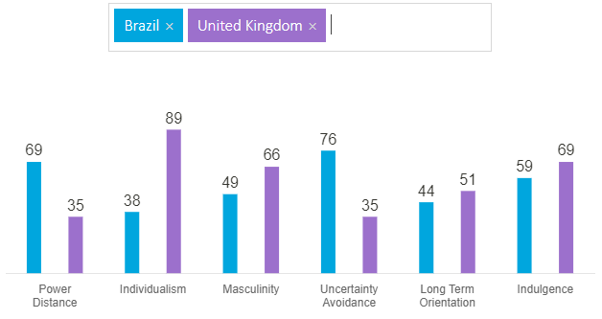
Index 6: Cultural differences between the UK and Brazil.
Source: (Hofstede-insights.com, 2022).

Intercultural communication by Samovar:
Intercultural communication happens between members from different cultural backgrounds. The objective of intercultural communication is to negotiate the shared meaning to influence how the other behaves. According to Samovar’s theory, intercultural communication between people from different cultural backgrounds can change the communication event (Eko and Putranto, 2019). In the case of Brazil and the UK, the cultural differences between these two countries can impact the communication procedure. The cultural differences between these two countries can create misinterpretations during the intercultural communication.

Cultural sensitivity:
With the advent of technology, communication, and transformation, people from different countries communicate and do business with each other. In the 21st century, the rapid growth of cross-border business has changed the way international business entities communicate with their target audience and foreign partners. The significance of the cultural sensitivity has increased drastically. In order to define cultural sensitivity, it can be said that being aware that cultural differences exist can impact behaviour, learning, and attitude (Szkudlarek et al., 2020). In order to achieve successful business expansion, the management of the British company needs to understand that cultural differences and similarities exist. For example, the communication style in the UK is more-pointed and direct. On the other hand, the communication style in Brazil is emotional and very expressive.
The management of the British company needs to assess various factors of the consumer culture such as social learning, subcultures, education, language, religion, and political philosophy. Hofstede's cultural dimensions analysis has highlighted the cultural disparities between Brazil and the UK in power distance, individualism, uncertainty avoidance, masculinity, and long-term orientation dimensions. Based on the cultural differences and similarities, the management of the British organisation needs to identify which would be the most applicable business cultural approach from the different types of cultures such as ethnocentric, polycentric, and geocentric cultures (Guang and Tian, 2018). As there are cultural differences between the UK and Brazil, it can be recommended that the British company needs to follow the polycentric culture while operating its business in Brazil.

Communication barriers:
The management of the British company needs to identify the communication barriers while planning the cross-border business operations. The cultural differences between the UK and Brazil can create communication barriers. In order to develop an effective cross-border communication process, the management of the British organisation needs to identify the communication barriers (Ramlan et al., 2018). In the following paragraph, the current study will identify the potential communication barriers.
- Interpersonal barriers: There are several factors such as perception and perceptual selection procedure, verbal and non-verbal communication, channel selection, that can create interpersonal barriers (Guldmann and Huulgaard, 2020). For example, the communication system in the UK is more direct. On the other hand, the communication style of Brazil is more emotional and passionate.
- Organisational barriers: There are different factors such as technical and ingroup language, time pressure, organisation structure requirement, status differences, lack of formal communication channels, and physical distractions, that can impact the cross-border business operations of the British company (Guldmann and Huulgaard, 2020).
- Psychological barriers: It is very likely that the manager responsible for leading the business expansion in Brazil to face challenges and act against natural preferences (Gu, Wang, and Wang, 2019). Because of these challenges, employees from Brazil might feel unauthentic and incompetent. The British manager might provide direct feedback to the Brazilian employees. However, the communication style of Brazilian people is not that direct as in UK. Brazilian people are more emotional and passionate. So, the psychological barrier might create challenges.
- Language barriers: The common language of Brazil is Portuguese. The common language of the UK is English. If the Brazilian employees are not fluent in English, which might create social distance between employees. It might impact operational efficiency and team performance (Ramlan et al., 2018). The non-English native speakers might feel that the career growth opportunities for them are not the same as English-native speakers.
- Barriers due to conflicting values: Societal values are influenced by culture. As there are differences between the Brazilian culture and the culture of the UK, it can be stated that the societal values of the British manager will not be the same as the societal value of the Brazilian employees. The differences between British and Brazilian people's attitudes towards the organisation and the business process might vary.

Communication strategy and recommendations:
The international business communications consultant is responsible for developing an appropriate communication strategy that will allow this British company to manage its cross-border business operation. That is why it is very important that management of the British organisation to implement an effective cross-border communication strategy.
- Customer care and support: To deal with the Brazilian customers appropriately, the UK-based company needs to utilise a robust customer support process. The customer service agent employed by the organisation will try to connect with the target audience at a personal level.
- Prioritise technical side: The UK-based company needs to focus on the technical side. It will allow this organisation to manage its cross-border business operations and communication. By using advanced technology, the communication practices used within the organisation with the Brazilian employees and customers should be modified to achieve high efficiency.
- Optimisation of the communication style: While addressing or communicating with the Brazilian employees, the British employees needs to understand the culture, traditions, societal values, attitude of the Brazilian people. Based on that, British managers need to optimise their communication style. As this organisation will follow the polycentric cultural approach, thus, it can be said that the company needs to optimise its communication style.
- Utilise the right platform: The British company needs to utilise the right channel and platforms to connect with the Brazilian customers and employees.

Conclusion:
As a conclusion of the report it can be concluded that the British organisation can expand its business in Brazil successfully. The business environment in this country might be useful for this company to gain competitive advantages. However, Hofstede's cultural dimensions has highlighted cultural differences between Brazil and the UK in power distance, individualism, masculinity, uncertainty avoidance, and long-term orientation dimension. The British company needs to follow the polycentric approach while expanding its business in Brazil. While formulating the cross-border communication strategy, the international business communications consultant needs to assess the cultural sensitivity. In order to manage the cross-border business operations, the British company needs to imply the proposed cross-border communication strategy.

References:
(Abdelrahim, Y., 2021) ‘Hofstede's Cultural Dimensions Theory: Can Researchers Add More Cultural Dimensions?’, In International Conference on Human Interaction and Emerging Technologies (pp. 468-482). Springer, Cham.
Andrade, L. et al. (2018) Narratives of Environmental Challenges in Brazil and India: Losing Nature. Rowman & Littlefield.
BBC.co.uk (2022) Brazil country profile. [online]. Available at: https://www.bbc.co.uk/news/world-latin-america-18909529/ (Accessed: 23rd March 2022).
Beugelsdijk, S. and Welzel, C. (2018) ‘Dimensions and dynamics of national culture: Synthesizing Hofstede with Inglehart’, Journal of cross-cultural psychology, 49(10), pp. 1469-1505.
Data.worldbank.org (2022) Brazil | Data. [online]. Available at: https://data.worldbank.org/country/BR/ |(Accessed: 23rd March 2022).
Eko, B. S. and Putranto, H. (2019) ‘The role of intercultural competence and local wisdom in building intercultural and inter-religious tolerance’, Journal of Intercultural Communication Research, 48(4), pp. 341-369.
Gallego-Álvarez, I. and Pucheta-Martínez, M. C. (2021) ‘Hofstede's cultural dimensions and R&D intensity as an innovation strategy: a view from different institutional contexts’, Eurasian Business Review, 11(2), pp. 191-220.
Gu, F. F., Wang, J. J. and Wang, D. T. (2019) ‘The role of sales representatives in cross-cultural business-to-business relationships’, Industrial Marketing Management, 78, pp. 227-238.
Guang, T. and Tian, K. (2018) ‘Cross-Cultural Business Communication: An Anthropological Approach Toward Diminishing Geographic Borders’, In Handbook of Research on Cross-Cultural Business Education (pp. 183-198). IGI Global.
Guldmann, E. and Huulgaard, R. D. (2020) ‘Barriers to circular business model innovation: A multiple-case study’, Journal of Cleaner Production, 243, p. 118-160.
Hochstetler, K. (2018) ‘Environmental impact assessment: evidence-based policymaking in Brazil’, Contemporary Social Science, 13(1), pp. 100-111.
Hofstede-insights.com (2022) Country Comparison - Hofstede Insights. [online]. Available at: https://www.hofstede-insights.com/country-comparison/brazil,the-uk/ (Accessed: 23rd March 2022).
Ilo.org (2021) Brazil - Structure and organization of the Labour Inspection. [online]. Available at: https://www.ilo.org/labadmin/info/WCMS_114935/lang--en/index.htm/ (Accessed: 24th March 2022).
Minkov, M. et al. (2018) ‘A reconsideration of Hofstede's fifth dimension: New flexibility versus monumentalism data from 54 countries’, Cross-Cultural Research, 52(3), pp. 309-333.
O'Neill, A. (2021) Brazil - Gross domestic product (GDP) growth rate 2026 | Statista. [online]. Available at: https://www.statista.com/statistics/263615/gross-domestic-product-gdp-growth-rate-in-brazil/ (Accessed: 23rd March 2022).
Ramlan, S. et al. (2018) ‘The impact of language barrier and communication style in organizational culture on expatriate’s working performance’, Management Science Letters, 8(6), pp. 659-666.
Rojo, J., Everett, B., Ramjan, L.M., Hunt, L. and Salamonson, Y. (2020) ‘Hofstede's cultural dimensions as the explanatory framework for performance issues during clinical placement: A mixed-methods study’, Nurse education today, 94, p. 104-581.
Szkudlarek, B., Osland, J.S., Nardon, L. and Zander, L. (2020) ‘Communication and culture in international business–Moving the field forward’, Journal of World Business, 55(6), p. 101-126.
TheGlobalEconomy.com (2022) Brazil Corruption perceptions - Transparency International - data, chart | TheGlobalEconomy.com. [online]. Available at: https://www.theglobaleconomy.com/Brazil/transparency_corruption/ (Accessed: 23rd March 2022).
TheGlobalEconomy.com (2022) Brazil Government effectiveness - data, chart | TheGlobalEconomy.com. [online]. Available at: https://www.theglobaleconomy.com/Brazil/wb_government_effectiveness/ (Accessed: 23rd March 2022).
TheGlobalEconomy.com (2022) Brazil Political stability - data, chart | TheGlobalEconomy.com. [online]. Available at: https://www.theglobaleconomy.com/Brazil/wb_political_stability/ (Accessed: 23rd March 2022).
TheGlobalEconomy.com (2022) Brazil Rule of law - data, chart | TheGlobalEconomy.com. [online]. Available at: https://www.theglobaleconomy.com/Brazil/wb_ruleoflaw/ (Accessed: 23rd March 2022).
Tradingeconomics.com (2022) Brazil Inflation Rate - February 2022 Data - 1980-2021 Historical - March Forecast. [online]. Available at: https://tradingeconomics.com/brazil/inflation-cpi/ (Accessed: 23rd March 2022).
Zainuddin, M., Yasin, I.M., Arif, I. and Abdul Hamid, A.B. (2018) ‘Alternative Cross-Cultural Theories: Why Still Hofstede?’. In Proceedings of International Conference on Economics, Management and Social Study (pp. 4-6).

