

LEVEL 6

SEMESTER 1

MODULE CODE: BMOE6003
Landscape and Sustainable Recreation
aSSESSMENT TYPE: assignment
Assessment: 2

COMPONENT WEIGHTING: 50%

WORD COUNT: 2,500 WORDS

MODULE TUTOR: Anthony Burns

Reflective Fieldwork Journal
As part of this module there will be a number of virtual/physical site visits as fieldwork. As you visit each site you will need to keep detailed notes relating to the following issues:

• Landscape Character
• Landscape Quality
• Designations
• Use
• Access
• Future Potential

You should choose two sites of your choice from those visited (whether virtual or physical) and the notes you took should subsequently form the basis of a reflective and critical account of the landscape at each location, including relevant academic and policy related literature also providing suggestions for sustainable approaches to recreational development at each site. Maps, sketches and photographic evidence should be used as appropriate.

SUBMISSION DETAILS:

Submit by Turnitin on or before 22nd January Friday 2021
Feedback to be returned to student: on or before19th February 2021

School of Sport, Health & Outdoor Education

Assessment Feedback Sheet

Student No./Name: Madeleine Barnes-Watson
Module: Landscape and Sustainable Recreation
Module Code: BMOE6003

Personal Evaluation – to support your academic progress please complete the section below BEFORE submitting your work.
What do you consider to be the best aspects of this work?
Which aspects do you consider could have been improved in this piece of work?
What have you found most satisfying whilst undertaking this submission?
ASSESSMENT CRITERIA | Learning  Outcomes |  | GRADE
ASSESSMENT CRITERIA |  |  | Poor  < 20% | Weak  20-29% | Unsatisfactory  30-39% |  | Satisfactory  40 – 49% | Good  50 – 59% | Very Good  60 – 69% | Excellent  70 – 84% |  | Exceptional  85– 100% | %
Your discussion of the nature of landscape within the context of the fieldwork locations | 1 |  |  |  |  |  |  |  |  |  |  |  | 20%
Your critical evaluation of external and internal influences that affect the perception, interpretation and use of landscape at the fieldwork sites. | 2 |  |  |  |  |  |  |  |  |  |  |  | 20%
Your critical discussion of the relationship between landscape and recreation and your suggestion of sustainable approaches to the interpretation and use of landscape for recreation. | 3 |  |  |  |  |  |  |  |  |  |  |  | 40%
Your identification and use of relevant academic and other material to help inform and develop your argument | 1,2,3 |  |  |  |  |  |  |  |  |  |  |  | 20%
It is expected that students will present work that is proof read, correctly referenced and adheres to the Assessment Checklist. Therefore a range of 0 – 10 marks will be deducted for non-completion of any of the points on the checklist below.
TUTOR COMMENTS:

Submission date:  via Turnitin |  | Return date:  (at least within 4 weeks) |  |  |  | Tutor: |  |  |  |  | Mark:

Assignment Checklist

- Please complete the Personal Evaluation section of the Assessment Feedback sheet, add your name and details, and paste the whole of this assignment document into the front of your assignment

- Submission is a single word file, clearly labelled with your name and module code
- Font style - Times New Roman, size -12 for text and 14 for headings
- Ink colour – black only
- Line spacing – 1.5 line spacing and 2cm- 2.5cm page margins
- Quotations more than three lines to be indented 1 line spacing
- One line space between paragraphs, paragraphs must be left aligned
- Pagination (your assignment should have page numbers)
- All tables and figures are internally referenced and have a title
- Word count checked and written at end of text (before references and any appendix)
- Assignment is within 10% of the word limit (excluding references and any appendices)
- All references in the text are included in the reference list
- Correct referencing following the Harvard style, as described in the Palgrave study skills book ‘Cite them Right’.
- Correct spelling using UK English
- Correct use of punctuation
- Grammar and syntax correct- double check anything that has a green line under it
- I have read my assignment out loud to myself and it makes sense and is easy to read
- Somebody else has read my work and it makes sense to him or her!
- I have checked and I have not plagiarised
Failure to follow these guidelines will cost you marks!
In this essay I aim to critically explore the landscape characteristics of two fieldwork locations. Landscape character is created the physical components come together and can be defined as "a distinct, recognisable and consistent pattern of elements in the landscape that makes one landscape different from another".

The first fieldwork location I aim to explore is Cheddar Gorge, Somerset, which is the Mendip Hills most prominent feature. Cheddar Gorge is one of England's most iconic and spectacular landscapes (National Trust, 2021).

Aerial View of Cheddar Gorge and Cheddar Town. 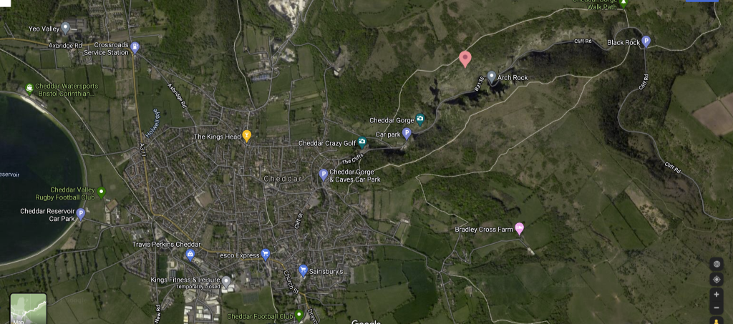(Google Maps, 2021).

The nature of the Mendip Hills landscape consists of cavernous Carboniferous Limestone, form a gently rolling plateau surface at 800 to 850 ft. (245–260 m.) (Ford and Stanton, 1968). The complex geological history has created a region with an exceptional range of geology and geomorphology within a comparatively small area (Farrant, 2020). This geodiversity has attracted the attention of numerous geologists, geomorphologists, and naturalists over the past few centuries, making the region a classic area for study. For this reason, the Mendips host many Sites of Special Scientific Interest (SSSIs) and has been designated an Area of Outstanding Natural Beauty (AONB) (Farrant, 2020).

Researching the nature of Cheddar Gorge landscape and its geology, it is found that the Gorge is formed from an anticline (A ridge of stratified rock raised by folding), and erosion caused the gorge. The anticline is a result of a thick sequence of Upper Palaeozoic sandstones and limestones were folded and thrusted into a series of en-echelon periclines that were denuded during the Triassic (Farrant, 2020). 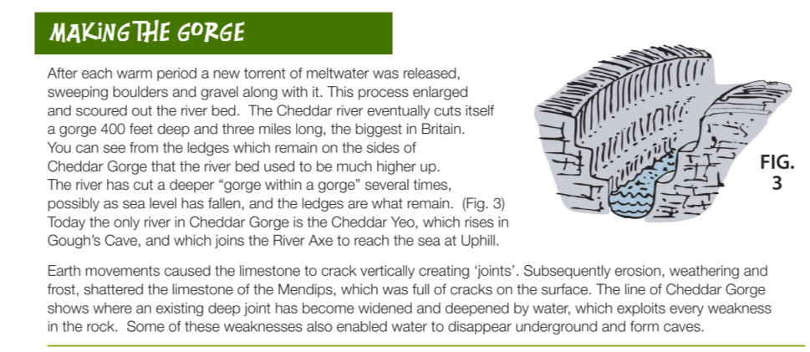Available at: Cheddar Gorge 2015 A4 Education Fact Sheet - How Land Was Formed.indd (uwtsd.ac.uk) (Accessed 27th January 2021).

The landscape character and perception of an area, especially Cheddar Gorge can be affected by multiple influences, external and internal. Such as the atmosphere, mood, history, life experience, topography and culture. Also, having visual geographical feature makes the landscape more interesting. To show the landscape of Cheddar Gorge, I have included a YouTube video showing aerial footage of Cheddar Gorge by drone. Cheddar Gorge by Drone April 2015 - YouTube.
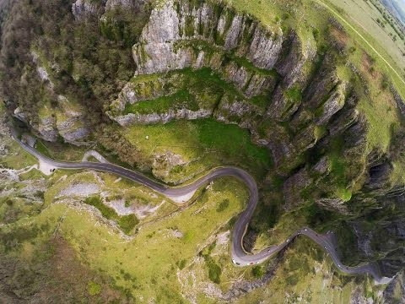
Within Cheddar Gorge are multiple cave systems. The most famous one is Gough Cave which also is an SSSI. I Have included a link to a virtual tour of Goughs Cave in Cheddar to best show the nature and character of the landscape. Gough's Cave - Cheddar Gorge - Somerset - Virtual Tour - February 2020 | kittikoko - YouTube.
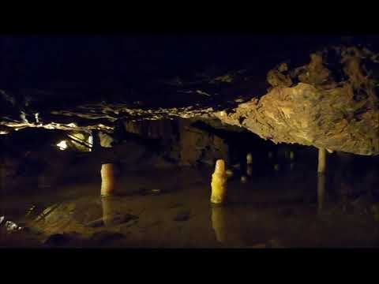

The caves at Cheddar Gorge, especially Goughs Cave fired the imagination of JRR Tolkien, and using his perception of the landscape he created The Lord of The Rings trilogy (Burns, 2020). No one can look unmoved on that stupendous pile of rocks which overwhelms the beholder with its sublime majesty, Balch (1947) described the overwhelming internal influence the gorge has on its visitors.

A huge influence on the perception, interpretation and use of the landscape at Cheddar Gorge is the finding of Britain's oldest complete human skeleton, Cheddar Man, estimated to be 9,000 years old, in 1903. Also, one of the most extensive Magdalenian human bone assemblages comes from Gough's Cave resulting in 1880s, the site was developed as a show cave and emptied of sediment, at times with minimal archaeological supervision (Bello et al, 2015). This has resulted in the site becoming a Scheduled Ancient Monument.

The owners of Cheddar Gorge insist on a seasonal access restriction to most of the cliffs during the summer months – when the highest numbers of tourists are encountered. As a result, climbing is currently only allowed from 1st October until 15th March. The cliffs on the north side of the gorge are owned by the National Trust (Keating, 2006). They are on open access land as designated by The Countryside and Rights of Way Act 2000, and restrictions for public safety have been reviewed and agreed between the BMC and the National Trust (Keating, 2006). According to the National Trust (2021), access to the Gorge involves steep paths, the cliffs may be difficult to access for those with limited mobility and the current information point is wheelchair friendly.

The second fieldwork site I have chosen to explore is Merthyr Tydfil. The Municipal Borough of Merthyr Tydfil was created in 1905, with eight electoral wards, with the council taking over the roles of Merthyr Tydfil Urban District Council. Most of the Merthyr Tydfil area is what Cloquell-Ballester et al (2021) describe as permanent industrial character.

Landmark Map of Merthyr Tydfil District Council.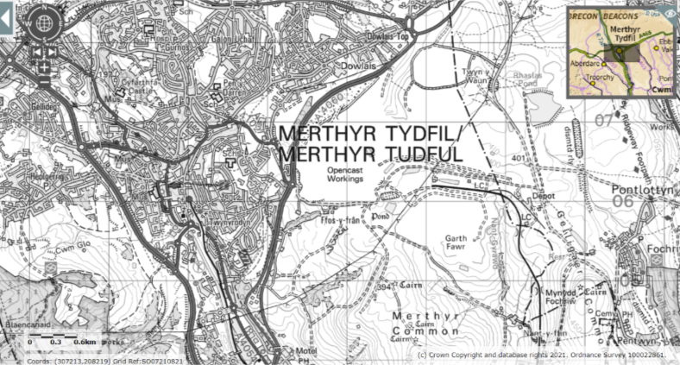(Magic, 2021).

Aerial View of Merthyr Tydfil area.
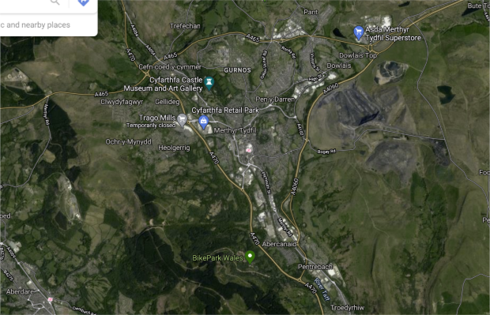(Google Maps, 2021).

Merthyr Tydfil is one of the most historically fascinating and beautiful regions of Wales it is ideally placed between Brecon Beacons National Park and Cardiff. Historically, Merthyr Tydfil was severely industrialised. In the 1800s, Merthyr Tydfil's’ landscape was filled with giant furnaces and smog from the factories. Below is a link to short film focusing on French and German travellers to the industrial town of Merthyr Tydfil in the mid-nineteenth century and their descriptions of the town. This shows some historical perspectives of the Merthyr Area. Land of Forges and fire: Merthyr Tydfil in the 1800s - YouTube
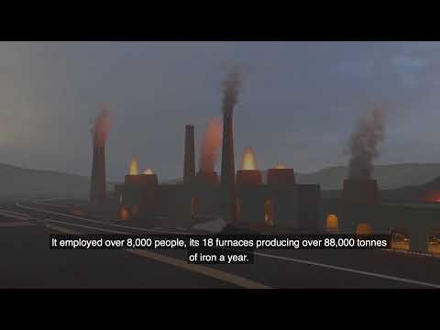
By understanding the history of Merthyr Tydfil, people can see and understand the complex cultural-ecological changes that have occurred over the centuries (Stewart, 2008). Though most of the scars have disappeared and the valleys have become green once more, that period of heroic industry and associated human endeavour can still be traced through the reminders left in the landscape (Visit Merthyr, 2019).

Cyfarthfa Ironworks, Merthyr Tydfil.
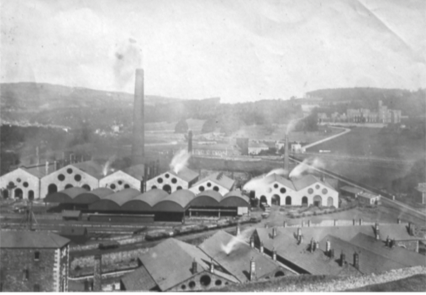
(CADW, 2015)
Combined natural and urban landscape at Merthyr Tydfil.
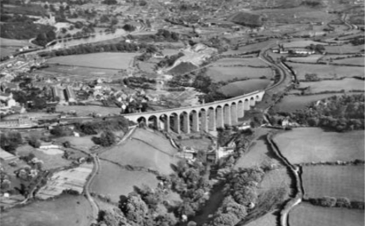
The rural context of industrial and urban development is clearly shown in this early aerial photograph (CADW, 2015). However, agricultural landscape now survives only in fragments in the area around Merthyr Tydfil. The agricultural landscape until urban development began to impose itself in the late nineteenth century to the north, around Cyfarthfa Castle and Penydarren House, where a landscape of fields and plantations with scattered houses and farms was retained by the two ironworks’ estates and is recorded on the first edition Ordnance Survey map of 1875 (CADW, 2015).

Landscapes evolve to become complex entities that are always synthetic: it is not a natural feature, but a synthetic space, a human-made system of spaces superimposed on the face of the land (Menatti and Casado da Rocha, 2016). Because that system is made by the community and for the community, landscape is not fixed once and for all; it is always subject to sudden or unpredictable changes (Menatti and Casado da Rocha, 2016). Merthyr Tydfil's landscape has evolved and been used in a variety of ways. Mines may be viewed negatively by those expecting what they perceive to be an unspoilt environment, the Foss-Y-Fran Open Cast Mine in Merthyr Tydfil. (Sinnett and Sardo, 2020). However, there is a large positive economic value of mines, especially for the local population where work is scarce. An example of this is Foss-y-Fran Open Caste mine with the revenues from which will redevelop the current former industrial workings into residential and recreational use.

Foss-y-Fran Open Caste mine in Merthyr Tydfil
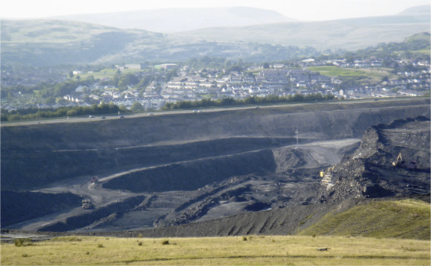
Available at: open cast mining merthyr - Bing images (Accessed 27th January 2021).
The varying perceptions of mining and the importance of a natural landscape has led to conflict within Merthyr Tydfil.

Protesters at Foss-y-Fran Mine.
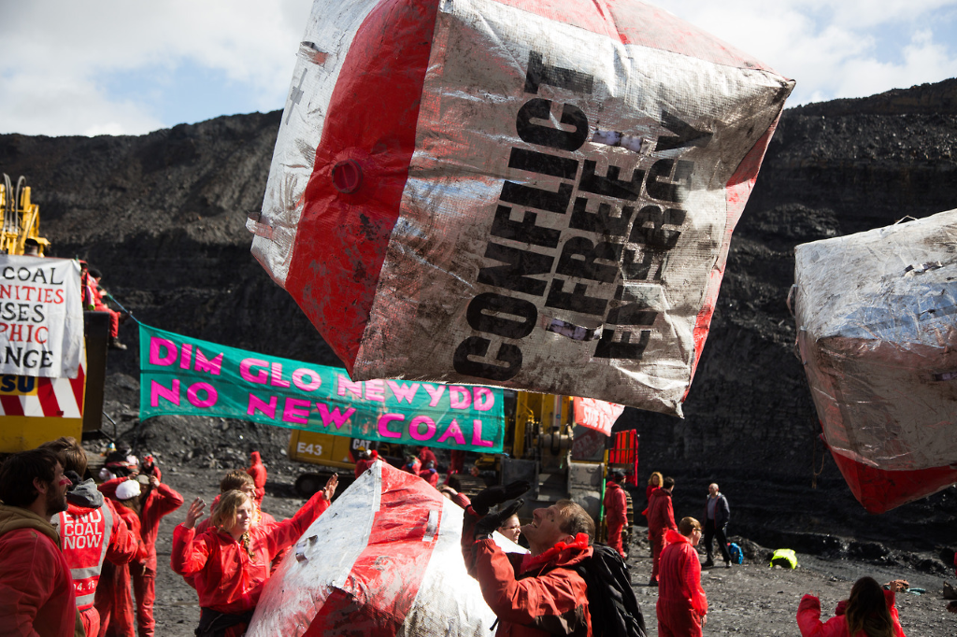
Available at:begejstring • empathyasatoolforchange: Shutting down a coal... (tumblr.com) (Accessed 29th January 2021).

In early May 2016 hundreds of activists prevented the open cast coal mine Ffos-y-Fran near Merthyr Tydfil in Wales from operating. Research shows that local preservationists felt the mines should be left alone to preserve the cultural heritage of the landscape, whereas nature enthusiasts, environmentalists and landscape lovers placed different emphasis on restoring the sites for nature conservation, to improve water quality or the visual appearance of the mines (Sinnett and Sardo, 2020). The research suggests that the views of local people in towns like Merthyr Tydfil are varied; they value their mining heritage in diverse ways and opinion is split on the most effective way to manage these sites especially where there is a need to revegetate or remediate the site (Sinnett and Sardo, 2020). The varying interpretation would lead to a variety of sustainable practices and land use.

Below is a YouTube video Merthyr Tydfil Council has created, showing the available recreational activities. Discover Merthyr Tydfil - YouTube
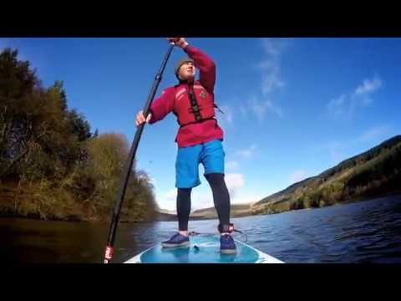
Below is a map of Merthyr Tydfil showing a scan for catchment area for accessible greenspace.
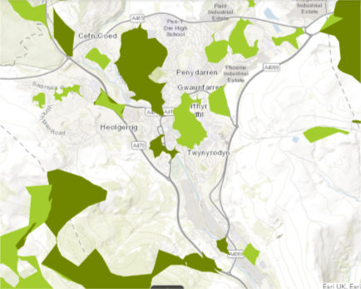
(Natural Resource Wales, 2021).

This map shows that in the Merthyr Tydfil District that considerable amounts of the landscape have been urbanized beyond regeneration. It is a landscape with a large urban population and an intense sense of community. People's relations with places are frequently saturated with emotions. For places, it is possible to have feelings and bonds like those that are established between people and equally ambivalent (González, 2005) especially if the entire community is close and have similar histories. The Merthyr Tydfil Open space strategy has been created to provide a long-term framework to protect and develop a network of high-quality open spaces that deliver a range of social, economic and environmental benefits (Jones, 2016).

Below is a photograph of the plans to sustainably develop the grounds of Cyfarthfa Castle to increase green space, therefore allowing outdoor recreation.

Architect's image of the Cyfarthfa development.
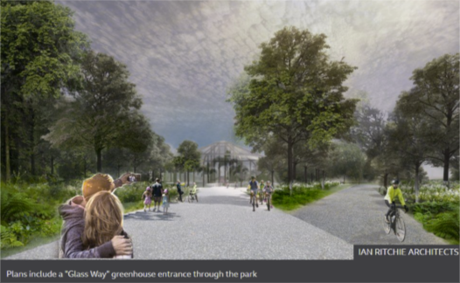
(BBC, 2021).

The report sets out a three-part plan for the castle and a "Greater Cyfarthfa Park" that will "celebrate Merthyr Tydfil's unique history, celebrate and heal the natural environment to provide a beautiful setting for recreation, education and scientific advance and create an engine of creativity that can embrace the whole community", therefore resulting in a very sustainable development linking the landscape with recreation (BBC, 2021). Also, Stewart (2008) suggests that it is ‘essential that outdoor environmental educators carefully consider the ways in which outdoor experiences introduce participants to particular ‘stories’ of the land, whose land it is or has been, and how it has changed overtime’.

The Cyfarthfa development would deliver memorable interpretative experiences to visitors that help raise sensitivity to host countries' (in this case, Merthyr Tydfil) political, environmental, and social climates. Gambassi (2017) suggests that landscape becomes objective when it becomes the bearer of the cultural identity of a land and of its people such as the case in South Wales, were welsh history and language influence the perception of landscape character.

Tourism and landscape are interdependent concepts (De Aranzabal, Schmitz, & Pineda, 2009). The aim is to critically discuss the relationship between landscape and recreation and suggest sustainable approaches. Also, understanding sustainable tourism through a focus on outdoor adventure tourism activities, helps preserve the landscape for future generations (Hanna et al. 2019).

Diagram of Sustainability.
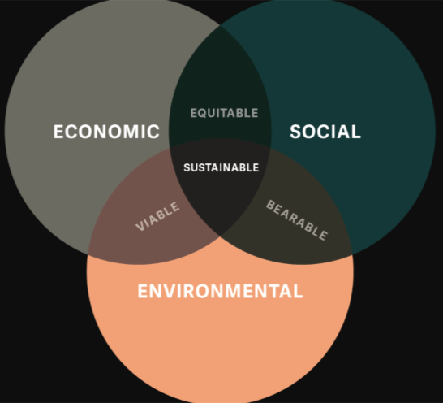
(Gerardot, 2016).

“Sustainability principles refer to the environmental, economic and socio-cultural aspects of tourism development. A suitable balance must be established between these three dimensions to guarantee its long-term sustainability”. Hall (1992, quoted in Hanna et al, 2019) argues that, environmental degradation occurs giving little chance for the environment to recover, having implications for sustainable tourism. Relatedly, Wager (1964, quoted in Hanna et al, 2019) suggested, “when too many people use the same area, some traditional wildland values are lost”. Hanna et al (2019) suggest that we should be overly cautious about discouraging outdoor adventure tourism due to the perception that its environmentally “destructive” and demonstrated that it might prove fruitful to promote and encourage such activities for the psychological wellbeing and environmental attitude effects.

There is a firm link between a population's positive perspective on landscape and their efforts towards sustainability (Musacchio, 2009). Sustainable recreation can be found using ecotourism. The International Ecotourism Society defines Ecotourism as "responsible travel to natural areas that conserves the environment, sustains the well-being of the local people, and involves interpretation and education" (The International Ecotourism Society, 2015). This can also be interpreted as responsible travel anywhere, such as an urban landscape like parts of Merthyr Tydfil and Cheddar town. Urban characterization is a tool that can help use historic character to create sustainable and distinctive places for the future (CADW, 2015). It seeks to inform and support positive planning, regeneration and conservation programs, help improve the quality of planning advice, and contribute to local interpretation and education strategies (CADW, 2015).

To sustainably approach recreation in a variety of landscapes, people should aim to minimize negative physical, social, behavioral, and psychological impacts. Build environmental and cultural awareness, and respect. Additionally, provide positive experiences for both visitors and hosts, especially in areas like Cheddar Gorge where the local economy relies heavily on tourism.

Outdoor environmental education experiences offer a significant opportunity to engage both physically with a landscape and cognitively with those who have played a role in shaping a place (Stewart, 2008). By using outdoor adventure education to teach people about how the environment and outdoor recreation connect, people will use pro-environmental behaviour while out on activities.

One of the most prominent sustainable practices to the landscape and recreation is the Leave No Trace (LNT) principle. However, LNT has been criticised for ignoring the more significant impact equipment purchase, travel, and modern lifestyles has on sustainability (Loynes, 2018). Furthermore, Loynes (2018) finds the LNT concept to be unrealistic and unhelpful in Europe, where most landscapes have experienced the impact of humans for millennia, unlike America. Inspired by European approaches of human-nature relations, and at a time of need for significant environmental changes, Loynes (2018) suggests that educational programs should seek to connect people with nature and encourage people to "leave more trace" or to "consider their trace" instead.

In areas like Merthyr Tydfil and Cheddar Gorge, where there is a diverse range of landscape perceptions, understanding the diversity of values and uses associated with natural areas is critical for long-term, sustainable planning for the local landscape (Biedenweg et al. 2019). An example of this can be seen in Merthyr Tydfill with the development of Bike Park Wales and Rock UK Summit centre. Below is a video showing the activities available at Rock UK summit, the video also shows the relationship between manufactured and natural landscapes and recreational activities. Rock UK Summit Centre - YouTube
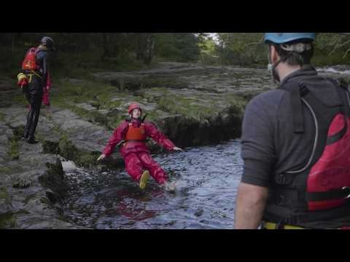
Word count: 2,361

References

Balch, H.E. (1947) Mendip: Cheddar, Its Gorge and Caves, 2nd edn. Great Britain: Butterworth-Heinemann. Available at: Mendip: Cheddar, Its Gorge and Caves - H. E. Balch - Google Books (Accessed 29th January 2021).

BBC (2021) Cyfarthfa Castle: £50m plans for renovation of Merthyr Tydfil site, Available at: Cyfarthfa Castle: £50m plans for renovation of Merthyr Tydfil site - BBC News (Accessed 27th January 2021).

Biedenweg, K. Williams, K. Cerveny, L. & Styers, D. (2019) ‘Is recreation a landscape value?: Exploring underlying values in landscape values mapping,’ Landscape and Urban Planning, 185, pp. 24-27. DOI: https://doi.org/10.1016/j.landurbplan.2018.12.005.

Burns, A. (2020) ‘Introduction to Cheddar Gorge and the activities’, Landscape and Sustainable Recreation (BMOE6003), Available at: BMOE6003: Introduction to Cheddar Gorge and the activities (uwtsd.ac.uk) (Accessed 26th January 2021).

CADW (2015) ‘Merthyr Tydfil: Understanding Urban Character’, Welsh Government. Available at: Merthyr Tydfil- Understanding Urban Character_1.pdf (uwtsd.ac.uk) (Accessed 28th January 2021).

Cloquell-Ballester, V. A. del Carmen Torres-Sibille, A. Cloquell-Ballester, V. A. Santamarina-Siurana M. C. (2012) ‘Human alteration of the rural landscape: Variations in visual perception,’ Environmental Impact Assessment Review, 32(1), pp. 50–60. DOI: https://doi.org/10.1016/j.eiar.2011.03.002.

De Aranzabal, I. Schmitz, M.F. & Pineda, F.D. (2009) ‘Integrating Landscape Analysis and Planning: A Multi-Scale Approach for Oriented Management of Tourist Recreation,’ Environmental Management, 44, 938. DOI: https://doi.org/10.1007/s00267-009-9371-z.

Farrant A.R. (2020) ‘The Mendip Hills—A Landscape Shaped by Exhumation and Karstification. In: Goudie A., Migoń P. ‘(eds) Landscapes and Landforms of England and Wales. World Geomorphological Landscapes. Springer, Cham. DOI: https://doi.org/10.1007/978-3-030-38957-4_16.

Ford, D.C. and Stanton, W.I. (1968) ‘The geomorphology of the south-central Mendip Hills,’ Proceedings of the Geologists 'Association, 79(4), pp. 401-427. DOI: https://doi.org/10.1016/S0016-7878(68)80012-4.

Gambassi, R. (2017) ‘Reading a Landscape’, Architecture and Engineering, 2(1), pp. 3-23. DOI: https://doi.org/10.23968/2500-0055-2017-2-1-3-23.
Gerardot, M. (2016) ‘The Business Case for Sustainability,’ UpandUp, 29th February. Available at: The Business Case for Sustainability - Up&Up Agency (upandup.agency) (Accessed 27th January 2021).

González, B. M. (2005) ‘Topophilia and Topophobia : The Home as an Evocative Place of Contradictory Emotions’, Space and Culture, 8(2), pp. 193-213, DOI: 10.1177/1206331204273984.

Google Maps (2021) Available at: Google Maps (Accessed 25th January 2021).

Hanna, P. Wijesinghe, S. Paliatsos, I. Walker, C. Adams M. & Kimbu, A. (2019) ‘Active engagement with nature: outdoor adventure tourism, sustainability and wellbeing,’ Journal of Sustainable Tourism, 27(9), pp. 1355-1373, DOI: 10.1080/09669582.2019.1621883.

Jones, J. (2016) ‘Merthyr Tydfil Open Space Strategy,’ Merthyr Tydfil County Borough Council. Available at: sd47-merthyr-tydfil-open-space-strategy-june-2016.pdf (uwtsd.ac.uk) (Accessed 28th January 2021).

Jones, J. (2016) Merthyr Tydfil Open Space Strategy,’ Merthyr Tydfil County Borough Council, Available at: sd47-merthyr-tydfil-open-space-strategy-june-2016.pdf (uwtsd.ac.uk) (Accessed 25th January 2021).

Keating, G. (2006) ‘Access Q&A: Cheddar Gorge’, BMC, 8th March. Available at: Access Q&A: Cheddar Gorge (thebmc.co.uk) (Accessed 27th January 2021).

Knowles, N. L. (2019) ‘Targeting sustainable outcomes with adventure tourism: A political ecology approach,’ Annals of Tourism Research, 79, 102809. DOI: https://doi.org/10.1016/j.annals.2019.102809.

Loynes, C. (2018) ‘Leave More Trace,’ Journal of Outdoor Recreation, Education, and Leadership, 10(3), pp. 179–186. DOI: https://doi.org/10.18666/JOREL-2018-V10-I3-8444.
Magic (2021) INTERACTIVE MAPPING AT YOUR FINGERTIPS, Available at: Magic Map Application (defra.gov.uk) (Accessed 27th January 2021).

Menatti, L. and Casado da Rocha, A. (2016) ‘Landscape and health: Connecting psychology, aesthetics and philosophy through the concept of affordance’, 7, DOI: https://doi.org/10.3389/fpsyg.2016.00571.

Musacchio, L.R. (2009) ‘The scientific basis for the design of landscape sustainability: A conceptual framework for translational landscape research and practice of designed landscapes and the six Es of landscape sustainability’, Landscape Ecology, 24(8), pp.993–1013. DOI: https://doi-org.ezproxy.uwtsd.ac.uk/10.1007/s10980-009-9396-y.

National Trust (2021) Cheddar Gorge Overview, Available at: Cheddar Gorge | National Trust (Accessed 27th January 2021).

Natural Resource Wales (2021) ‘Landscape,’ Wales environmental information (beta).
Available at: Natural Resources Wales / Wales environmental information (beta) (Accessed 28th January 2021).

Sinnett, D. E. & Sardo, A. M. (2020) ‘Former metal mining landscapes in England and Wales: Five perspectives from local residents,’ Landscape and Urban Planning, 193, 103685. DOI: https://doi.org/10.1016/j.landurbplan.2019.103685.

Stewart, A. (2008) ‘Whose place, whose history? Outdoor environmental education pedagogy as ‘reading’ the landscape,’ Journal of Adventure Education & Outdoor Learning, 8(2), pp. 79-98. DOI: https://doi.org/10.1080/14729670801906125.

The International Ecotourism Society (2015) TIES Announces Ecotourism Principles Revision, Available at: TIES Announces Ecotourism Principles Revision - The International Ecotourism Society (Accessed 27th January 2021).

Visit Merthyr (2019) Culture and Heritage. Available at: Culture & Heritage | visitmerthyr.co.uk (28th January 2021).

