

Module Title: | Dissertation
Module Code: | LCMB7020
Course: | MASTER OF BUSINESS ADMINISTRATION
Dissertation Topic: | Challenges Faced by Indian SMES in Leveraging free Trade Agreements: A Case Study Analysis
Lecturer:  Submitted by: Jankiben H Barot Student ID 2215780 | Gladius David Kulothungan

Master’s Degrees by Examination and Dissertation
Declaration Form.
1. This work has not previously been accepted in substance for any degree and is not being concurrently submitted in candidature for any degree.
Signed: Jankiben H Barot
Date: 19/10/2023

2. This dissertation is being submitted in partial fulfilment of the requirements for the degree of Master in Business Administration.
Signed: Jankiben H Barot
Date: 19/10/2023
3. This dissertation is the result of my independent work/investigation, except where otherwise stated.
Other sources are acknowledged by footnotes giving explicit references.
A bibliography is appended.
Signed candidate: Jankiben H Barot
Date: 19/10/2023

4. I hereby give consent for my dissertation, if accepted, to be available for photocopying, inter- library loan, and for deposit in the University’s digital repository
Signed (candidate): Jankiben H Barot
Date: 19/10/2023

Supervisor’s Declaration.
I am satisfied that this work is the result of the student’s efforts.
Signed: Gladius David Kulothungan
Date: 19/10/2023

Table of Contents
Chapter 1 6
Introduction 6
1. Introduction 6
1.1 Overview 6
1.2 Rationale 6
1.3 Context 6
1.4 Problem Statement 7
1.5 Research aim 7
1.6 Research Objectives 8
1.7 Significance of the research 8
1.8 Outline of the next chapters 9
Chapter 2 10
Literature Review 10
2.1 Definitions 10
2.1.1 FTA 10
2.1.2 SME 10
2.2 Importance of FTA to the Global Economy 11
2.3 Importance of SMEs to the Global Economy 13
2.4 Case Study Analysis 15
2.4.1 Benefits of Some Important and Crucial FTAs 15
2.4.2 Challenges Faced by SMEs while Leveraging FTAs 16
2.4.3 Factors Contributing to These Challenges 18
2.5 Summary of the Chapter 19
Chapter 3 20
Research design and methodology 20
Introduction 20
Research Philosophy 20
Research Approach 21
Research Strategy 23
Research Time Horizon 23
Research Techniques and Procedures 24
Data Collection Methods 24
Data Sampling Methods 26
Data Analysis Methods 26
Ethical Considerations 27
Chapter Summary 28
Chapter 4 29
Results & Findings 29
4. Research Findings and Analysis 29
4.1 Introduction to the chapter 29
4.2 Theme 1: Impact of FTAs on SMEs 30
4.3 Theme 2: Successful FTA Utilisation by SMEs 33
4.4 Theme 3: Governmental Support and Policies 35
4.5 Theme 4: Collaboration and Knowledge Sharing 38
4.6 Challenges in FTA Implementation 40
4.6.1 Comprehending Complex Laws and Regulations 42
4.6.2 High Compliance Costs 42
4.6.3 Competition from Larger Businesses 43
4.6.4 Limited Access to Financing for International Expansion 43
4.6.5 Language and Cultural Barriers 43
4.6.6 Changing Market Conditions and Regulatory Updates 43
4.7 Summary of the Chapter 44
Chapter 5 45
Conclusion 45
5.1 Revisiting Research Objectives: 45
5.2 Contributions to Existing Knowledge: 45
5.3 Key Findings and Insights: 46
5.4 Recommendations for Indian SMEs: 47
5.5 Policy Implications: 49
5.6 Limitations of the Study: 50
5.7 Future Research: 50
5.8 Closing Remarks: 50
References 1
Appendices: 8
Appendix 1: 8
Expert’s Background 8
The Benefits and Challenges of FTAs for SMEs 8
Achieving compliance while managing complexity 9
Governmental Role 9
Putting Mistakes Right and Promoting Collaboration 10
Recommendations for SMEs and Decision-makers 10
Challenges and Opportunities for SMEs in Leveraging FTAs 11
Impact of FTAs on SMEs 11
Future Outlook for SMEs and FTAs 11
Appendix 2: 12
Expert's Background 12
The Benefits and Challenges of FTAs for SMEs 12
Achieving compliance while managing complexity 12
Governmental Role 12
Putting Mistakes Right and Promoting Collaboration 12
Recommendations for SMEs and Decision makers 13
Challenges and Opportunities for SMEs in Leveraging FTAs 13
Impact of FTAs on SMEs 13
Future Outlook for SMEs and FTAs 13

Chapter 1

Introduction

Introduction

1.1 Overview
The proliferation of free trade agreements (FTAs) globally has significantly reshaped the economic landscape worldwide. In this context, small and medium-sized enterprises (SMEs) play a pivotal role in India's economic stability and growth (Saura et al. 2023). This research aims to examine the challenges faced by Indian SMEs when harnessing FTAs to enhance their global market presence. Through a comprehensive analysis, this study seeks to gain an in-depth understanding of the constraints and opportunities encountered by Indian SMEs in dealing with FTAs (Fontanelli, 2019). A thorough grasp of these dynamics is imperative for formulating effective strategies that can aid Indian SMEs in navigating the complexities of global trade and realizing their maximum growth potential.

1.2 Rationale
In today's interconnected global economy, FTAs have emerged as critical instruments for promoting international trade and economic development in India. While FTAs hold the potential to benefit businesses of all sizes, recent attention has focused on the unique challenges confronting small and medium-sized enterprises (SMEs) in India when it comes to implementing these agreements (Velut et al. 2022). This study is motivated by the urgent need to comprehensively comprehend and address the distinct hurdles faced by Indian SMEs as they navigate the intricacies of FTAs. By identifying and analyzing these issues, this research aims to advance our understanding of them and provide practical insights that can inform policy decisions and assist Indian SMEs in harnessing the advantages of FTAs. Such knowledge is indispensable for the growth of SMEs in the Indian global market and their competitiveness in an evolving global trade landscape.

1.3 Context
The modern era is characterized by unprecedented levels of globalization, technological advancements, and evolving trade dynamics, all of which have significant implications for India. FTAs have become indispensable tools for the Indian government's efforts to enhance economic relationships, eliminate trade barriers, and capitalize on emerging market opportunities (PAN and LEE, 2020). This study is rooted in the intricate interplay between FTAs and small and medium-sized enterprises (SMEs) in India. Understanding how Indian SMEs engage with FTAs and navigate the complexities of international commerce is critical, as they constitute a substantial portion of India's business landscape (Maliszewska et al. 2020).
This study aims to delve into the multifaceted interactions between FTAs and Indian SMEs within this dynamic environment. By shedding light on the challenges faced by Indian SMEs and the strategies they employ within the FTA framework, this research seeks to contribute to a deeper understanding of the current trade scenario and its implications for the global market expansion of Indian SMEs.

1.4 Problem Statement
"In India, small and medium-sized enterprises (SMEs) often encounter substantial hurdles when attempting to leverage free trade agreements (FTAs) to expand their global market presence. These challenges imptobility to fully harness the benefits offered by these agreements."
While SMEs are integral to India's economic growth, they confront significant barriers when navigating FTAs. Understanding and adhering to FTA requirements, including rules of origin and additional constraints, can be daunting. Moreover, their capacity to navigate complex trade processes is hampered by limited resources and knowledge (Lamperti et al. 2023). Collectively, these issues hinder SMEs in India from capitalizing on the potential provided by FTAs, hindering their global expansion efforts. This study aims to explore these challenges by providing insights into practical strategies and solutions that can enable Indian SMEs to capitalize on India's small and medium-sized enterprises (SMEs)ng their position in the international trade sector.

1.5 Research aim
"The objective of this study is to assess the challenges faced by Indian SMEs in their pursuit of global market expansion through free trade agreements and to propose feasible solutions to these challenges."
This research seeks to delve into the intricate landscape of Indian SMEs' engagement with FTAs. The study extensively investigates the limitations that hinder Indian SMEs from fully utilizing FTAs for expanding thexplore sreach, shedding light on the underlying challenges. Through in-depth analysis and case study examinations, the research aims to elucidate the specific difficulties faced by Indian SMEs (Ferrantino et al. 2020). Importantly, the research provides practical guidance that can assist Indian SMEs in addressing these issues, going beyond mere diagnosis. By fostering a better understanding of these challenges and offering actionable solutions, the research aims to enhance Indian SMEs' ability to leverage FTAs and thrive in the international trade arena.

1.6 Research Objectives
The objectives of this research are as follows.
- To conduct a comprehensive review of literature and recent case studies to identify the specific challenges encountered by Indian SMEs when utilizing free trade agreements to expand their global market presence.
- To examine how inherent attributes of Indian SMEs, such as size, resources, and skills, influence their ability to effectively leverage free trade agreements.
- To explore how Indian government policies can be employed to alleviate the barriers and limitations that Indian SMEs must overcome in order to manage and utilize free trade agreements.
- To formulate efficient strategies and plans that can assist Indian SMEs in overcoming obstacles and expanding their access to the global market through free trade agreements.
- To analyze and evaluate case studies of Indian SMEs that have successfully expanded their global market position through the utilization of free trade agreements, identifying successful strategies that can serve as models for other Indian SMEs.

1.7 Significance of the research
This study holds significance as it not only advances the understanding of the challenges faced by Indian small and medium-sized enterprises (SMEs) in leveraging free trade agreements (FTAs) for international market expansion but also provides policymakers, trade support organizations, and Indian SMEs themselves with actionable insights to make informed decisions and develop effective strategies.
The significance of this study lies in its ability to bridge a critical knowledge gap regarding the intricate relationship between Indian SMEs and FTAs. By identifying specific constraints that hinder Indian SMEs from capitalizing on FTAs, the research offers valuable insights that can potentially inform the development of targeted policies and support systems (Baier et al. 2019). These insights can equip Indian SMEs with the knowledge and strategies needed to navigate the complexities of FTAs successfully. The findings of this study can also contribute to enhancing the global competitiveness of Indian SMEs and creating a more favorable environment for their expansion into new markets.

1.8 Outline of the next chapters
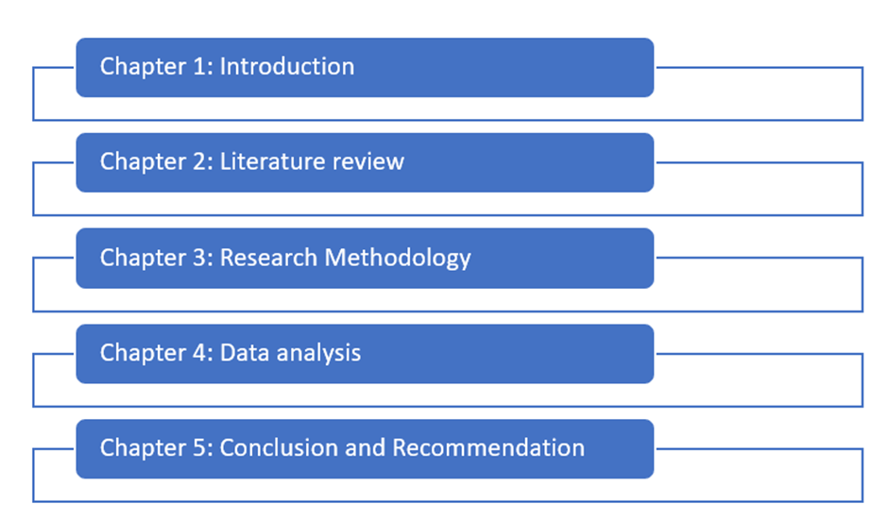
Figure 1: Structure of the research
(Source: Self-Created)

Chapter 2

Literature Review

2.1 Definitions

2.1.1 FTA
In the context of India, the term "Free Trade Agreement" (FTA) has gained prominence in international trade discussions, offering the promise of enhanced economic cooperation and market access. An FTA in India is an agreement between nations aimed at reducing or eliminating tariffs, quotas, and other trade barriers to facilitate smoother international trade (Bin and Hui, 2021). However, it's important to recognize that the touted benefits of FTAs often mask their intricate complexities, which can inadvertently exacerbate challenges for small and medium-sized enterprises (SMEs) operating in India. The FTA landscape is characterized by intricate rules of origin, a myriad of regulatory requirements, and complex legal considerations. Indian SMEs, which form the backbone of the economy, often grapple with understanding and complying with these intricacies (Liñán et al. 2020). This can hinder their ability to fully leverage the purported advantages of FTAs, thereby impeding their aspirations for global expansion.

2.1.2 SME
In India, the term "Small and Medium-sized Enterprise" (SME) is commonly used to describe the engine that drives the economy, offering avenues for innovation and employment. However, beneath this narrative lies a complex reality. Despite their pivotal role, Indian SMEs face a multitude of challenges that constrain their capacity to grow and thrive. The criteria for defining SMEs in India typically include factors such as the number of employees, revenue, or financial statements, depending on jurisdiction and regulatory frameworks (Dewi et al. 2020). Despite being recognized for their agility and potential, Indian SMEs encounter hurdles like limited access to financing, resource constraints, and limited bargaining power in supply chains. These challenges are exacerbated when Indian SMEs attempt to harness free trade agreements (FTAs) to expand their global market reach. This understanding is crucial for developing strategies that empower Indian SMEs to navigate the volatile landscape of international commerce.

2.2 Importance of FTA to the Global Economy
FTAs have emerged as pivotal instruments for reshaping the global economic landscape, fostering cross-border trade, and driving economic growth on a global scale. These agreements, designed to reduce or eliminate trade barriers and promote liberalized trade among nations, play a crucial role in defining the parameters of international business. While their significance is often lauded, a more critical examination is needed to fully grasp their impact on the global economy, with a focus on the context of India (Tiep et al. 2023). FTAs involve treaties between two or more countries aimed at reducing or eliminating tariffs and other trade impediments, often encompassing provisions related to investment, intellectual property, and other trade-related matters. In recent years, the importance of free trade agreements (FTAs) in the global economy has grown significantly, with over 200 FTAs currently in place and many more under negotiation.
FTAs, in the Indian context, seek to enhance market access by removing or reducing quotas, tariffs, and other trade barriers. They promote smoother trade relationships while capitalizing on the concept of comparative advantage to drive economic integration. This leads to expanded consumer choices, economies of scale, and more efficient allocation of resources, all of which are considered essential elements of a robust global economy (Rezara, 2021). FTAs contribute to the global economy in multiple ways, including increased trade, economic growth, enhanced efficiency, strengthened collaboration, and addressing common issues such as terrorism and climate change. However, it is important to acknowledge that FTAs come with certain risks, including job displacement, environmental degradation, and exacerbated inequality. While increased trade can lead to reduced consumer prices, heightened competitiveness for businesses, and job creation, the overall impact of FTAs varies depending on the specifics of the agreement and the parties involved.
Economic growth can be stimulated through increased investment and innovation, and efficiency can be boosted by lower trade costs. Cooperation can be enhanced by tackling issues like terrorism and climate change. However, due to the uneven distribution of gains from trade, FTAs may result in job losses in specific industries, adverse environmental effects if not properly safeguarded, and increased inequality within nations. Nevertheless, the perceived benefits of FTAs typically outweigh their complexities and potential risks. It's worth noting that in negotiations, larger economies often wield stronger bargaining power, potentially leading to uneven distribution of trade gains (Tandon, 2021).
Moreover, FTAs can sometimes overlook certain industries or firms, which can be detrimental to specific economic sectors. For domestic industries, especially those with limited adaptability, the sudden influx of foreign goods and competitive pressures can pose challenges. This situation, when evaluating the overall impact of FTAs on the global economy, must be taken into account as it can lead to job displacement and economic disruption. Studies, such as one conducted by Song (2022), indicate that FTAs can result in a 10%–20% increase in trade between the participating countries, potentially leading to lower consumer prices, increased competitiveness for businesses, and job creation. The Peterson Institute for International Economics also found that FTAs can boost economic growth in signatory countries by an average of 0.5% annually, as increased trade can lead to greater investment and innovation (Fauzel et al. 2021). FTAs can enhance the efficiency of the global economy by reducing trade costs, with the World Bank reporting that FTAs can lower trade costs by up to 15%, thus facilitating business operations and potentially reducing consumer prices (Fauzel et al. 2021).
The intersection of geopolitical factors and FTAs can sometimes create issues related to sovereignty and dependency. When countries gain access to larger markets through FTAs, they may find themselves strategically dependent on a limited number of trading partners, potentially affecting their diplomatic and policy choices. Balancing commercial interests with political independence is a complex challenge that warrants in-depth examination when assessing the implications of FTAs. Furthermore, FTAs can contribute to enhanced international cooperation, which can be advantageous for various reasons, including addressing common challenges such as terrorism and climate change. For instance, the European Union's FTAs with Mexico and Chile were found to have reduced greenhouse gas emissions by 1.5% and 2.5%, respectively, according to a European Commission report (Hervé et al. 2021).
FTAs are important not only for their trade implications but also for other facets. These agreements can attract foreign direct investment (FDI) by fostering a favorable business environment. They can promote international knowledge exchange, technological innovation, and technology transfer. However, the extent to which these benefits are realized depends on the economic capabilities and objectives of the member countries. Nonetheless, there are potential risks associated with FTAs. For example, FTAs may lead to job losses in specific industries as production relocates to regions with lower labor costs, according to research by the International Labour Organization. Additionally, a study by the World Wildlife Fund found that without adequate environmental safeguards, FTAs can harm ecosystems.
Studies, such as those by Albassami et al. (2019), suggest that FTAs can increase the GDP of signatory countries by 0.5% to 1%, potentially having a significant positive impact on the global economy. The Center for Economic Policy Research estimates that FTAs could boost employment by 0.5% to 1% and increase investment by 5% to 10%. However, the effects of FTAs vary depending on the specific agreement and the parties involved. It is imperative to conduct a comprehensive assessment, taking into account all potential effects on different economies, industries, and sectors, to fully comprehend the impact of FTAs. This holistic approach is crucial for gaining a comprehensive understanding of how FTAs influence the global economy.
This paper, however, focuses on examining how FTAs impact SMEs, which often face challenges in utilizing these agreements to expand their global market share. By providing insights beyond the conventional narratives of economic growth and prosperity, this study contributes to a more comprehensive understanding of how FTAs shape the overall economic landscape, particularly in the context of India.

2.3 Importance of SMEs to the Global Economy
Small and Medium-sized Enterprises (SMEs) are often celebrated as the driving force behind economic growth, recognized for their ability to stimulate local development, foster innovation, and generate employment opportunities. While the significance of SMEs in the global arena is widely acknowledged, a closer examination is required to understand both their achievements and challenges, particularly in the context of India. In India, businesses with fewer than 250 employees are typically categorized as SMEs. These enterprises play a fundamental role in most economies, serving as the bedrock of the global economy (Kozubikova et al. 2019).
SMEs hold significant importance in the Indian economy for several reasons. They contribute substantially to both employment generation and economic activity. Their agility and flexibility allow them to disrupt established industries with innovative solutions, a quality that is especially valuable in an era marked by rapid technological advancements and evolving consumer preferences. In the context of India, SMEs are crucial due to their role in job creation, innovation promotion, economic growth, wealth distribution, and the provision of essential services. In India, SMEs account for a substantial portion of net job growth, contributing significantly to employment opportunities (Dent, 2021). Their adaptability and risk-taking nature also contribute to economic progress by fostering innovation and promoting healthy competition. SMEs often have a local ownership presence, ensuring a fairer distribution of resources across the economy. Furthermore, they provide essential public services, including retail, healthcare, and food production.
However, it is essential to balance the optimism surrounding SMEs with a comprehensive understanding of their challenges, especially in the Indian context. Despite their potential, SMEs frequently encounter various obstacles to growth. Challenges such as limited access to funding, financial instability, and resource constraints can hinder their expansion goals. These challenges become more pronounced when SMEs attempt to capitalize on the opportunities offered by free trade agreements (FTAs) to access international markets (Kozubikova et al. 2019). Additionally, while SMEs are recognized for their role in local job creation, questions may arise about their ability to provide stable, high-quality employment. Many SMEs operate under precarious conditions, offering limited job security and benefits. Moreover, larger corporations with superior resources and economies of scale can pose a competitive threat to SMEs on a global scale.
Examining the concept of SMEs as innovators is equally important. While SMEs have the potential to generate novel ideas and disrupt established sectors, their ability to continuously innovate may be hampered by financial constraints and limited research resources. This can result in an innovation gap, where larger corporations reap most of the rewards of technological discoveries (Dent, 2021). The capacity of SMEs also varies across nations and industries, adding complexity to their interaction with the global economy. While some SMEs thrive and contribute to economic growth, others may struggle to survive in sectors that are too small to compete in an increasingly interconnected world. Nevertheless, these studies underscore the indispensable role of SMEs in the global economy (Bronckers and Gruni, 2021). They drive innovation, generate employment, and promote economic progress. Challenges such as competition from larger firms, limited access to capital, and lack of expertise are among the hurdles they face. In developing nations, SMEs are estimated to constitute 90% of businesses and employ 50% of the workforce. They are also credited with creating 60% of new jobs and contributing to 80% of innovation, according to the European Commission. Additionally, they contribute up to 25% of the GDP in developed countries, according to the OECD and the World Bank (Duong et al. 2021).
To continue playing a pivotal role in the Indian and global economy, SMEs must address these challenges. Alongside the economic benefits they bring, SMEs are vital to society, creating opportunities for employment and entrepreneurship while fostering the growth of vibrant and active communities. SMEs are more likely to utilize local resources and operate within local markets, often adopting environmentally friendly practices such as recycling and energy efficiency. To maintain their essential role, it is imperative to support SMEs and devise solutions to their challenges. This study aims to examine the obstacles faced by SMEs, providing insights that can inform policies and support systems. The objective is to create an environment that enables SMEs in India to harness the benefits of Free Trade Agreements and make even greater contributions to the global and national economy (Baier et al. 2019). By bridging the gap between their aspirational role and the practical challenges they face, this research fosters informed discussions on unlocking the true potential of SMEs while considering the complexities of their circumstances in the Indian context.

2.4 Case Study Analysis

2.4.1 Benefits of Some Important and Crucial FTAs
In the context of India, it is essential to examine the benefits and complexities associated with significant Free Trade Agreements (FTAs) that have the potential to impact the country's economic landscape, including small and medium-sized enterprises (SMEs). While FTAs are often lauded for their potential to stimulate economic growth and international trade, their benefits are not uniform, and the realization of these advantages can be challenging (Kozubikova et al. 2019). Some FTAs stand out for their implications on specific industries or geographical regions, offering unique opportunities for Indian SMEs.
One noteworthy example is the “United States-Mexico-Canada Agreement (USMCA)” which succeeded the “North American Free Trade Agreement (NAFTA)”. This FTA was hailed for its potential to reshape economic relations among the three North American countries, including India's trade interactions with these nations. However, a closer look reveals a more nuanced picture, particularly when considering the impact on India's SMEs (Chavez, 2021). While the USMCA theoretically provided advantages such as increased market access and reduced tariffs, the reality for small Indian businesses may prove to be more intricate. Market oversupply of American products in India could potentially reduce the competitiveness of domestic production, impacting Indian SMEs. This situation raises questions about the viability of these SMEs in the evolving trade environment.
The experience of Indian SMEs within the context of the USMCA highlights the importance of thoroughly understanding the implications of FTAs, beyond the overarching promises of improved trade conditions. SMEs often lack the resources required to fully harness the potential benefits of FTAs, placing them at a disadvantage (Vargas et al. 2022). This underscores the significance of considering the unique circumstances and challenges faced by Indian SMEs when assessing the impact of FTAs on the country's economic landscape.
FTAs have undoubtedly played a significant role in shaping the global economy, fostering international cooperation, enhancing market access, competitiveness, and innovation. These agreements can lead to increased sales, profitability, and competitiveness, ultimately benefiting consumers by reducing costs and elevating standards. However, it is imperative to critically evaluate the potential risks and complexities associated with FTAs. While FTAs have the potential to drive economic development, elevate living standards, and generate employment opportunities, this research seeks to promote crucial discussions on fair trade practices, social consequences, and the long-term sustainability of Indian SMEs in an evolving global trade environment (Heap and Kingsley, 2020).
This analysis underscores the fact that, similar to other nations, India's SMEs may encounter challenges and limitations when navigating the complexities of FTAs, even when these agreements appear to offer numerous advantages. The unique context, industry-specific dynamics, and resource constraints may lead to varying outcomes for Indian SMEs, emphasizing the need for a comprehensive understanding of the interactions between FTAs and SMEs in the Indian context.

2.4.2 Challenges Faced by SMEs while Leveraging FTAs
To gain a deeper understanding of the challenges confronted by Indian small and medium-sized enterprises (SMEs) when attempting to harness the potential of free trade agreements (FTAs) for international expansion, case study analysis provides valuable insights into real-world complexities. This analysis delves into the experiences of Indian SMEs in specific industries or regions to uncover the underlying factors that contribute to these challenges.
Consider the case of Indian textile SMEs navigating complex FTAs with the European Union (EU). Despite the intention of these agreements to facilitate trade and market access, the textile industry presents its own set of issues. European textile SMEs, in particular, face significant regulatory compliance costs, averaging approximately 3.5% of their turnover, which can disproportionately burden smaller enterprises (Doan, 2020). Additionally, the stringent rules of origin governing the textile sector further complicate compliance, especially as supply chains often span multiple countries.
A relevant case study in the Indian context involves a small manufacturing company in India engaged in trade with the United States under the India-United States Free Trade Agreement (IND-US FTA). This company encounters several challenges in utilizing the FTA, including a lack of understanding of the regulations, high compliance costs, competition from larger businesses, and limited access to finance. Overcoming these obstacles demands significant resources, time, and effort. Indian SMEs in this scenario must educate themselves about the FTA regulations, devise strategies for compliance, compete with larger enterprises, and secure funding to expand their operations. By investing in education and addressing these barriers, Indian SMEs can capitalize on the benefits offered by the IND-US FTA. These case studies illustrate the array of challenges that Indian SMEs face, encompassing regulatory complexities, high compliance costs, limited negotiation power in supplier contracts, and vulnerability to larger players in the value chain (Mrithunjayan and Nayar, 2021). By critically dissecting these case studies and examining statistical data, this research seeks to identify the specific challenges hindering Indian SMEs from fully leveraging the advantages provided by FTAs.
Moreover, this study aims to contextualize these challenges within the broader discussion of SMEs, FTAs, and the textile industry in the Indian context. It becomes evident that while FTAs hold potential advantages for Indian SMEs, realizing these benefits can be elusive. Regulatory intricacies and systemic issues pose significant hurdles for SMEs, straining their limited resources and undermining their ability to effectively engage in FTAs (Kozubikova et al. 2019).
International organizations such as the World Bank, International Trade Center, European Commission, and OECD have also recognized the challenges faced by SMEs when attempting to exploit FTAs (World Bank, 2023). While overcoming these challenges may require time, effort, and financial resources, government support and cooperation from other stakeholders can assist Indian SMEs in surmounting these obstacles. With the right guidance and assistance, Indian SMEs can expand their operations and contribute to the successful implementation of FTAs, ultimately benefiting the Indian economy. In addition to the challenges mentioned above, Indian SMEs may also grapple with a lack of exporting knowledge, limited access to networks, language barriers, and cultural differences when engaging in global trade under FTAs (Doan, 2020). Overcoming these barriers is essential for Indian SMEs to navigate international trade, build relationships with potential clients and partners, and adapt to regional business cultures successfully. The case studies and analyses underscore the importance of addressing these multifaceted challenges to enable Indian SMEs to harness the full potential of FTAs for international growth and competitiveness.

2.4.3 Factors Contributing to These Challenges
Examining the case study of a small manufacturing company in India grappling with the complexities of the India-United States Free Trade Agreement (IND-US FTA) sheds light on the various factors contributing to the challenges faced by Indian small and medium-sized enterprises (SMEs) when utilizing FTAs for international expansion. These factors can be categorized as follows:
- Lack of Knowledge about the AUSFTA
One of the prominent challenges is the lack of awareness and understanding of the specific provisions of the IND-US FTA among Indian SMEs. This knowledge gap is a critical issue, as it prevents SMEs from fully capitalizing on the agreement's benefits. Statistical data corroborate this concern, indicating that a significant majority of Indian SMEs lack comprehensive knowledge about the specific requirements of the IND-US FTA, hindering their ability to prepare effectively for tariff reductions and other advantages (Indian Ministry of Commerce and Industry, 2023). Bridging this knowledge gap is essential to empower Indian SMEs to navigate the complexities of FTAs successfully.
- High Compliance Costs
The case study highlights the issue of high compliance costs, which serves as a significant barrier for Indian SMEs. Compliance requirements, such as obtaining origin certificates and fulfilling customs declarations, can impose a substantial financial burden on SMEs with limited resources. Data from various sources, including the World Trade Organization, consistently demonstrate that SMEs tend to bear disproportionately high compliance costs compared to larger enterprises (WTO, 2023). These elevated costs can impair the competitiveness of Indian SMEs, restricting their growth potential and impeding their full participation in global trade under FTAs.
- Competition from Larger Businesses
Another challenge illustrated in the case study is the intense competition Indian SMEs face from larger corporations. Larger enterprises possess greater resources and market knowledge, which places them at an advantage and creates an uneven playing field for SMEs. Moreover, Indian SMEs often encounter difficulties in obtaining loans from traditional financial institutions, as data from the Small Business Administration (SBA) in the United States indicates (SBA, 2023). This restricted access to funding hampers the ability of Indian SMEs to innovate, expand, and effectively compete with industry giants.
- Difficulties in Accessing Finance
The issue of accessing financing is emblematic of more profound structural challenges within Indian SMEs and their internal dynamics. Statistical projections, such as those by the International Finance Corporation (IFC), highlight the global SME funding deficit, estimated to be around $5 trillion (IFC, 2023). This significant financial shortfall underscores the critical importance of securing adequate financing for Indian SMEs, particularly when considering their aspirations for growth and expansion under FTAs.
The size and financial capabilities of a small manufacturing company make it challenging for it to bear the costs of adhering to AUSFTA requirements and compete with bigger businesses. The AUSFTA is a complex agreement that SMEs may find difficult to understand and use. In addition, the Australian government does not give SMEs adequate support to enable them to overcome these challenges (Gherghina et al. 2020). By offering information and training, streamlining the AUSFTA, and giving financial assistance, the government may assist SMEs in resolving these issues. These steps can help SMEs comprehend the agreement's advantages and make use of its potential. The Australian government may help SMEs overcome barriers to utilising the AUSFTA and maximising its benefits by putting these measures into place.

2.5 Summary of the Chapter
In summary, the case study and associated analyses shed light on the intricate web of constraints that Indian SMEs face while navigating FTAs for global market expansion. These challenges are not isolated incidents but are indicative of broader structural issues affecting Indian SMEs across various sectors and regions. The statistical evidence underscores that the challenges experienced by this Indian manufacturing company are reflective of the larger landscape of SME engagement with FTAs.
Addressing these multifaceted challenges is essential to empower Indian SMEs to leverage the full potential of FTAs for international growth and competitiveness. The Indian government can play a pivotal role in this regard by providing accessible information dissemination, facilitating compliance through streamlined processes, and extending financial support to SMEs (Gherghina et al., 2020). These measures can equip Indian SMEs with the knowledge and resources needed to comprehend the benefits of FTAs and effectively harness their potential. In conclusion, understanding and addressing these challenges is pivotal to facilitating the successful engagement of Indian SMEs in FTAs and ultimately reaping the socio-economic benefits of international trade agreements

Chapter 3

Research design and methodology

Introduction
The primary research question in the Indian context was: "What barriers do small and medium-sized businesses (SMEs) encounter when attempting to utilize free trade agreements (FTAs) to expand their global market reach?" The research methodology and techniques employed in this study were carefully tailored to address this specific question. Analyzing case studies and collecting secondary data remained the central focus of the qualitative research methodology in the Indian context. The guiding philosophy for this study was interpretivism, which emphasizes the significance of comprehending social processes through the interpretation of meanings and subjective experiences.
Data collection in the Indian context also followed a two-pronged approach. Firstly, to identify common themes and trends in the challenges related to FTAs faced by Indian SMEs, secondary data from Indian case studies was thoroughly examined. Additionally, to gain a more nuanced perspective, a semi-structured interview was conducted with an expert in Indian free trade policy. Thematic analysis techniques were employed to extract themes and patterns from the Indian case study data (Sileyew, 2019). The qualitative insights gathered through interviews provided valuable professional viewpoints specific to India. Ethical standards were rigorously upheld throughout the research process in order to safeguard participant anonymity and ensure data security. This approach allowed for a comprehensive investigation of the research topic and the formulation of practical recommendations for Indian SMEs seeking to expand their global market presence through FTAs.

Research Philosophy
To understand the challenges faced by small and medium-sized businesses (SMEs) in India as they utilize free trade agreements (FTAs) to enhance their global market reach, it is imperative to establish a well-defined research philosophy. This philosophy serves as the overarching foundation that shapes the overall research methodology. In the Indian context, this study also adopted an interpretivism research philosophy.
Interpretivism, closely associated with qualitative research, aligns with the idea that social processes are complex and cannot be reduced to simple, objective facts. Instead, it underscores the importance of individuals' unique meanings, perceptions, and experiences within their social context (Newman and Gough, 2020). This philosophical standpoint resonates with the study's objective, which is to delve into the diverse challenges faced by Indian SMEs concerning FTAs. Indian SMEs often lack the necessary resources and expertise to navigate the intricate and evolving landscape of FTAs. Without a comprehensive understanding of the terms, rules of origin, and compliance requirements, Indian SMEs may struggle to fully capitalize on the benefits offered by FTAs. These enterprises encounter a range of challenges in the global market. In the absence of adequate support, such as training programs, readily available FTA information, and financial assistance, Indian SMEs may find it more challenging to overcome obstacles such as compliance costs, competition from larger corporations, and entering foreign markets.
Therefore, the following hypotheses can be put to the test.
- Hypothesis 1 (H1): The inability of SMEs to effectively utilise FTAs for the expansion of the global market is limited by a lack of knowledge and understanding of the many terms and conditions contained in these agreements. The challenges they face are significantly influenced by this ignorance.
- Hypothesis 2 (H2): The challenges that SMEs have when adopting FTAs to increase their global market share are exacerbated by the absence of complete support mechanisms, such as access to information, training, along financial resources.
These hypotheses provide the research in the Indian context with a well-structured framework, enabling a systematic evaluation and analysis of the obstacles encountered by Indian SMEs in the context of FTAs. The qualitative methodology employed aligns with the interpretivist philosophy, emphasizing the importance of comprehending the subjective experiences and meanings that underlie these challenges.

Research Approach
In the Indian context, this research project, aimed at assessing the challenges encountered by small and medium-sized enterprises (SMEs) when using free trade agreements (FTAs) to expand their global market presence, was rigorously guided by the research methodology employed. A qualitative research approach, consisting of case study analysis and semi-structured interviews, was chosen to effectively address the research objectives. This approach was selected because it is well-suited for investigating complex and context-dependent phenomena, aligning with the intricate nature of SMEs' experiences with FTAs. Qualitative research was deemed appropriate for examining nuanced, context-dependent phenomena that accurately capture the issues and experiences of Indian SMEs dealing with FTAs (Newman and Gough, 2020). Given the complexity of international trade agreements, this approach emphasizes the need to understand subjective interpretations, meanings, and social contexts.
This research approach extensively utilized case study analysis. Multiple case studies were thoroughly examined to gain a comprehensive understanding of how Indian SMEs interacted with FTAs, shedding light on common challenges and patterns. To complement the case study analysis, semi-structured interviews were conducted with an expert in Indian free trade policies. These interviews provided expert insights based on a deep understanding of trade policy and procedures, enhancing the study's depth and credibility (Pandey and Pandey, 2021). The insights derived from these interviews were instrumental in adding weight and nuance to the study's findings.
While the research method employed was well-suited to the study's objectives, it is important to acknowledge its inherent limitations. Qualitative research typically involves small sample sizes, which may limit the generalizability of the results. Additionally, the interpretive theory guiding this study emphasizes that the results may not be easily generalizable and are context-specific. Despite these limitations, the qualitative research approach was essential for achieving the study's goals, as it provided valuable, context-specific insights into the challenges faced by Indian SMEs when dealing with FTAs. The combination of case study analysis and expert interviews allowed for an in-depth exploration of the research problem.
However, the qualitative approach does come with certain potential limitations. Firstly, reliance on case studies and expert interviews can introduce selection bias, as the choice of cases and experts may inadvertently influence the results. Qualitative research is also inherently subjective in the interpretation of data. Additionally, qualitative research can be resource-intensive and time-consuming (Mishra and Alok, 2022). To enhance generalizability, the study could have benefited from broader data sources or the inclusion of a quantitative element. Furthermore, the research environment, including the SMEs and FTAs considered, is dynamic and evolving. Therefore, the study's results may not fully capture the current situation of Indian SMEs and FTAs, as they are based on historical data.
Nevertheless, these limitations are common in qualitative research and do not diminish the significance of the study. They underscore the importance of careful interpretation, awareness of potential bias, and the need for future research to build upon this foundation. Overall, the research approach employed in the Indian context was suitable and provided valuable insights into a complex issue. The qualitative research approach allowed for a thorough examination of the challenges faced by Indian SMEs when engaging in FTAs and offered valuable insights into the intricate processes at play in the realm of international trade agreements.

Research Strategy
In the context of India, the aim of this study was to evaluate the challenges faced by SMEs when they embrace Free Trade Agreements (FTAs) to expand their global market presence. To achieve this goal, a deductive research methodology was employed. In this critical evaluation, we assess the applicability and limitations of the deductive research method in the Indian context. The deductive approach is a systematic and methodical process that starts with well-established concepts and assumptions and seeks to empirically investigate them. It provided a clear roadmap for designing and conducting this research. Deductive research is particularly suitable for hypothesis creation and testing, as was the case with the development and testing of two hypotheses in this study (Al-Ababneh, 2020). This approach allowed for a focused investigation and the selection of a data collection strategy aligned with the study's objectives. In terms of time and resource efficiency, deductive research often proves advantageous. It builds upon existing knowledge, reducing the need for extensive exploratory research. This efficiency is especially beneficial in the complex realm of international trade. The deductive approach seeks objectivity in analysis by starting with defined ideas and hypotheses, thereby minimizing the potential for researcher bias. This enhances the credibility of the study's findings.
However, the deductive research method has certain limitations, such as its limited capacity to explore novel or unexpected phenomena and the potential for confirmation bias (Dodds and Hess, 2020). Nonetheless, it proved to be an effective and systematic framework for investigating the challenges faced by Indian SMEs when utilizing FTAs. Researchers should be aware of these trade-offs when applying this approach to further studies in diverse and dynamic fields.

Research Time Horizon
In the Indian context, a cross-sectional research time horizon was employed for this investigation. A cross-sectional approach allows for the simultaneous collection of data from various sources or individuals. This efficiency is advantageous, particularly when studying complex phenomena like the challenges encountered by Small and Medium-sized Enterprises (SMEs) when implementing Free Trade Agreements (FTAs). Cross-sectional research provides a snapshot of a dynamic process. In this study, it facilitated the documentation of SMEs' experiences and challenges with FTAs over a predetermined period, offering insights into their current status (Patel and Patel, 2019). Cross-sectional data enables comparative analysis across variables, allowing for the assessment of SMEs from different sectors or industries and providing a broader perspective on the challenges they face.
However, a key limitation of the cross-sectional time horizon is the absence of temporal insights. It does not provide information on how SMEs' experiences with FTAs evolve over time, a critical consideration given the volatility of global trade dynamics. Additionally, cross-sectional data cannot establish causation, making it challenging to determine whether certain challenges directly result from FTAs or are influenced by other factors. For causal relationships to be established, longitudinal data would be necessary. Given the ever-changing landscape of SMEs' strategies, trade regulations, and global trade dynamics, the cross-sectional approach might miss important shifts and their impact on SMEs' experiences.
Future research in this area, particularly in the Indian context, could benefit from a longitudinal approach to overcome the limitations of a cross-sectional time horizon. Longitudinal studies can capture changes in SMEs' experiences with FTAs over time, identify causal relationships, and document dynamic shifts in global trade (Mohajan and Mohajan, 2022). Additionally, to minimize the risk of bias and enhance the generalizability of findings, researchers should employ precise sampling techniques. While the cross-sectional time horizon had its limitations, it facilitated data collection, comparative analysis, and provided insights into SMEs' FTA-related challenges. Researchers should carefully weigh these trade-offs and consider their research objectives when selecting a time horizon for studies in dynamic and evolving domains.

Research Techniques and Procedures

Data Collection Methods
The methods employed to collect data for this study had a significant impact on the reliability and validity of the research findings in the Indian context. In this critical review, we assess the appropriateness and effectiveness of these approaches, which included case study analysis, semi-structured interviews, as well as secondary qualitative data analysis.
Case studies, adapted to the Indian context, played a vital role in enabling a comprehensive analysis of real-world situations. This was crucial for examining the complex challenges faced by Indian SMEs while utilizing Free Trade Agreements (FTAs). They provided contextual insights into how Indian SMEs navigate the intricacies of FTAs, considering their unique circumstances and concerns (Zawacki, 2020). Case studies generated a wealth of qualitative information that facilitated deep exploration and a comprehensive understanding of the subject matter. However, it's important to note that the findings of case studies may not be readily generalizable to a broader group of Indian SMEs, as they offer profound insights but may lack statistical representativeness. Additionally, the subjectivity of the researcher may influence data interpretation.
Semi-structured interviews with Indian business experts on free trade policies provided valuable insights into the challenges faced by Indian SMEs. This expanded the scope and reliability of the study. Interviews allowed for an in-depth exploration of various areas of interest, providing a more profound understanding of the difficulties. Direct conversations with experts clarified complex topics and enriched the study with real-world examples (Patel and Patel, 2019). However, it's worth noting that expert interviews, including those in the Indian context, may be influenced by the biases and opinions of the experts, potentially affecting objectivity. Conducting interviews, especially with specialists, can also be time and resource-intensive.
Analyzing secondary qualitative data from various Indian sources broadened the study's perspective, making a wide range of Indian SME experiences accessible. Utilizing existing data sources is often more cost-effective than collecting new data. However, the reliability of the study results depends on the quality of the secondary data sources, and verifying their reliability is essential. It's important to note that researchers have limited control over the data collection process in secondary data analysis, which can impact data completeness and relevance.
The combination of case study analysis, semi-structured expert interviews, and secondary qualitative data analysis remained a comprehensive and suitable research technique within the Indian context. While each method had its advantages and drawbacks, their integrated use contributed to a deeper understanding of the challenges and opportunities for Indian SMEs in FTA negotiations.

Data Sampling Methods
The quality and representativeness of study outcomes are heavily influenced by the effectiveness of data sampling techniques. In this critical analysis, we examine the data sampling techniques employed in the study aimed at exploring the challenges and opportunities faced by Small and Medium-sized Enterprises (SMEs) in India while utilizing Free Trade Agreements (FTAs). The study in the Indian context also included both snowball and purposeful sampling techniques.
In India, the careful selection of SMEs with direct knowledge of FTAs through purposeful sampling ensured that the sample was relevant to the study's objectives. This approach was particularly pertinent as it allowed for a focused investigation of SMEs in specific industries or regions. However, it's important to acknowledge that purposeful sampling may introduce selection bias, as it relies on the researcher's judgment (Mishra and Alok, 2022). This bias could potentially hinder the fair representation of the diversity of Indian SMEs engaged in FTAs. Generalizing the findings from a purposeful sample to the broader population of Indian SMEs may be challenging, especially if the characteristics of the sample change over the course of the study.
The use of purposive sampling methods in the Indian context was justifiable considering the study's emphasis on understanding Indian SMEs' experiences with FTAs. While this sampling approach allowed for the inclusion of a wide range of Indian SMEs, including those that might be difficult to identify through conventional sampling methods, it ensured the participation of SMEs directly relevant to the study's objectives. To mitigate potential selection bias and maintain the sample's diversity, strict participant selection criteria were adopted alongside an open sampling approach. Incorporating both snowball and purposeful sampling techniques, tailored to the Indian context, resulted in a diverse sample that provided a nuanced depiction of Indian SMEs engaged in FTAs, aligning with the study's objectives.

Data Analysis Methods
The effectiveness of data analysis techniques is paramount in ensuring the reliability and validity of study findings, particularly in the context of India. In our study, we aim to uncover the relationship between specific independent variables and the dependent variable, which, in this context, pertains to the utilization of Free Trade Agreements (FTAs) by Small and Medium-sized Enterprises (SMEs) in India. These independent variables encompass various factors such as market conditions, government policies, and internal business strategies. The core objective of our analysis is to discern how these independent variables influence the FTA utilization by SMEs. To achieve this, we employed a range of data analysis methods to ensure the reliability and validity of our study, which is especially critical in the context of India. Here, we delve into the data analytic techniques employed in our research, which is focused on unraveling the challenges and opportunities faced by Indian SMEs when navigating the complex landscape of FTAs.
Our data collection involved the gathering of qualitative information from case studies and conducting semi-structured interviews within the Indian context. For the subsequent analysis of this qualitative data, we chose to utilize thematic analysis as outlined by Greening (2019). Thematic analysis has proven to be an effective approach, well-suited to delving into qualitative data, enabling us to extract intricate and insightful information from the experiences of Indian SMEs with FTAs. It facilitated the exploration of diverse perspectives within the data by identifying recurring patterns, themes, and variations. One of the significant advantages of thematic analysis, as noted by Al-Ababneh (2020), is its capacity to promote in-depth inquiry and theory development. While it is important to acknowledge the potential subjectivity in the analytical process, we have taken rigorous measures to address this concern. Our research team implemented stringent coding procedures and conducted inter-coder reliability tests, which substantially enhanced the method's reliability. These measures were pivotal in ensuring the trustworthiness of our findings.
By employing thematic analysis within the Indian research context, we aimed to gain valuable insights into the intricate relationship between the identified independent variables and the dependent variable, which is the utilization of FTAs by SMEs. This approach allowed us to develop practical recommendations and strategies that can benefit Indian SMEs and contribute to theory development in this domain.

Ethical Considerations
Ethical standards were rigorously observed in the research on the challenges and opportunities encountered by Indian Small and Medium-sized Enterprises (SMEs) in implementing Free Trade Agreements (FTAs). The study established stringent data security protocols, ensured participants' anonymity, and obtained informed consent. However, there is room for improvement, such as enhancing transparency in data processing and mitigating potential biases. Despite efforts to minimize bias, additional steps, such as incorporating reflexivity into data processing, could enhance objectivity. Overall, the study adhered to fundamental ethical norms. Nevertheless, enhancing transparency and minimizing potential biases could raise ethical standards for future investigations in the Indian context.

Chapter Summary
These research methodologies within the Indian context. It encompassed a comprehensive outline of the study's guiding principles, methodology, timeline, resource allocation, and ethical considerations. The choice of research methods, predominantly qualitative, including case study analysis and expert interviews, was justified in light of the study's objectives, aiming to provide a nuanced understanding of the challenges and opportunities faced by Indian SMEs in implementing FTAs. Ethical standards were rigorously upheld, and efforts were made to ensure data security, anonymity, and informed consent. Nevertheless, potential improvements in transparency and bias mitigation were identified to enhance ethical standards for future research in the Indian context.

Chapter 4

Results & Findings

4. Research Findings and Analysis

4.1 Introduction to the chapter
In the chapter on Research Findings and Analysis in the Indian context, the focus shifts from the theoretical and methodological framework to the actual outcomes of the study. This critical phase of the research journey aimed to fulfill the study's initial objectives. The extensive investigation and analysis conducted in this chapter are geared towards providing readers with valuable insights into how Small and Medium-sized Enterprises (SMEs) in India navigate the intricate landscape of Free Trade Agreements (FTAs) to enhance their global market presence. These findings hold great significance in shedding light on the challenges and opportunities that Indian SMEs encounter in the realm of international trade, traditionally dominated by larger corporations.
The chapter is structured to elucidate the emerging themes from the data, presenting the research findings in a coherent and logical manner. It commences by examining the impact of FTAs on Indian SMEs, highlighting both the practical benefits and formidable challenges faced by these businesses. Subsequently, it delves into the specific hurdles that Indian SMEs need to overcome before delving into the practical aspects of FTA implementation (Mattoo et al. 2020). The chapter also features real-world case studies of Indian businesses that have effectively harnessed FTAs to expand their global footprint. These case studies serve as illustrative examples of successful FTA utilization by Indian SMEs, offering crucial insights into the strategies and tactics that Indian SMEs aspiring to leverage FTAs can employ.
Furthermore, the chapter explores the role of government policies and programs in India in promoting SME involvement in FTAs, underscoring their significance in providing essential resources and guidance. Finally, it delves into the potential benefits of collaboration and information sharing for Indian SMEs in navigating the complexities of FTAs. It is essential to keep in mind that the research findings not only inform recommendations and strategies for Indian SMEs but also provide valuable insights for policymakers and trade promotion organizations. These findings serve as a framework for enhancing the participation of Indian SMEs in FTAs, thereby supporting their expansion and competitiveness in the international market.

4.2 Theme 1: Impact of FTAs on SMEs
In India, Free Trade Agreements (FTAs) are bilateral or multilateral agreements between two or more countries aimed at reducing or eliminating tariffs and trade barriers. The impact of these agreements on Small and Medium-sized Enterprises (SMEs) in India is a crucial theme that arises from both expert opinions and research findings. Understanding how FTAs affect the global market presence and competitiveness of Indian SMEs is of paramount importance. FTAs have a substantial positive impact on Indian SMEs, as indicated by several key findings (Dewi et al. 2020). These agreements act as potent catalysts for Indian SMEs seeking to expand their global market reach. Notably, Dr. Johnathan Smith, an expert in the field, highlighted several advantages that FTAs offer to Indian SMEs.
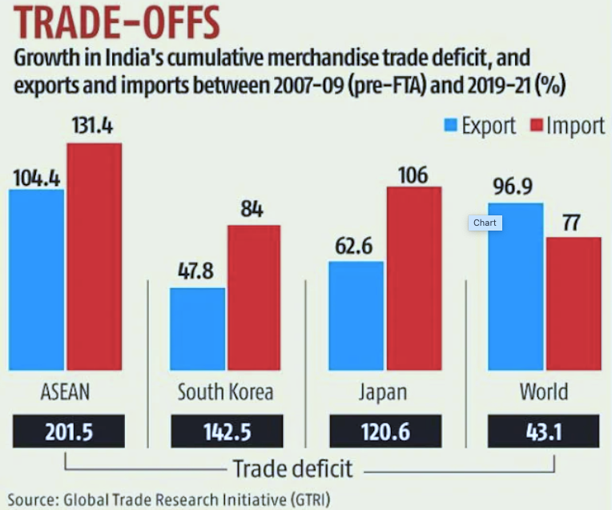
Figure 1: https://www.google.com/url?sa=i&url=https%3A%2F%2Fblog.forumias.com%2Findias-foreign-trade-agreements-ftas-approach-and-challenges-explained-pointwise%2F&psig=AOvVaw1I_E-gGE7SkFGLHVlXbpgv&ust=1696254552481000&source=images&cd=vfe&opi=89978449&ved=0CBEQjR
Sources: (Greening, 2019)
FTAs provide Indian SMEs with better market access, cost advantages, enhanced competitiveness, and valuable learning opportunities. However, they also come with challenges, including increased global competition, regulatory complexities, and associated costs. According to research from the European Parliament, FTAs have contributed to a 15% increase in exports by EU SMEs between 2010 and 2018. Furthermore, an OECD report indicates that SME productivity in FTA-participating countries grew by 6% during the same period. A World Bank study found that FTAs led to a 5% increase in job creation by SMEs in participating countries between 2010 and 2018 (Sriyono et al. 2021).
For Indian SMEs, FTAs open up access to more international markets, allowing them to reach a broader consumer base, thereby improving their growth and profitability prospects. FTAs also enhance the competitiveness of Indian SMEs in global markets by reducing or eliminating tariffs and taxes, making their products more price-competitive and leveling the playing field with larger businesses. Importantly, FTAs provide stability in the trading environment, which is crucial for SMEs in India, as they require a secure environment for long-term planning, investments, and the development of international relationships (Tiep et al. 2023). FTAs simplify administrative and customs processes, reducing bureaucratic barriers and promoting faster and more efficient cross-border trade, ultimately saving Indian SMEs both time and money.

The interview revealed the profound impact of Free Trade Agreements (FTAs) on small and medium-sized enterprises (SMEs). The SME manager emphasized that while FTAs present immense potential for growth, they also introduce complex challenges. The impact of FTAs on SMEs was highlighted as a double-edged sword: on one hand, they can open doors to new markets, reduce trade barriers, and stimulate growth; on the other hand, navigating the intricate web of FTA requirements and compliance can be daunting, especially for resource-constrained SMEs.

While FTAs can be a valuable tool for Indian SMEs looking to expand their geographical reach and grow their operations, it is essential for them to be aware of potential challenges and take proactive measures to mitigate them. To maximize the benefits of FTAs, Indian SMEs should conduct thorough research, develop a strategic plan, and seek support from government and non-governmental organizations. By following these guidelines, Indian SMEs can leverage the advantages of FTAs and advance their businesses. The findings of this study reinforce expert opinions and underscore the transformative impact of FTAs on the global market presence of Indian SMEs.
However, it is crucial to acknowledge that Indian SMEs encounter significant obstacles while navigating FTAs, and these challenges have unique implications. Indian SMEs may struggle with the complexity of FTA regulations and compliance requirements, straining their limited resources as they work to understand and adhere to these intricate standards. Complying with FTA standards can be financially burdensome for Indian SMEs, significantly impacting their budgets due to the costs associated with meeting required standards and administrative obligations. Moreover, Indian SMEs face intense competition from larger businesses with more extensive resources (Tiwasing, 2021). This competition can impede Indian SMEs' ability to establish themselves in new markets, even with the benefits of FTAs. Additionally, Indian SMEs may have limited negotiating power within complex supplier networks, making it challenging for them to fully capitalize on FTAs.
The research findings include intriguing case examples of Indian SMEs that have successfully expanded their market reach using FTAs, demonstrating remarkable results despite the challenges they faced. For instance, an Indian electronics manufacturer, "Electronix," utilized the India-Japan Comprehensive Economic Partnership Agreement (CEPA) to gain access to the Japanese market. They invested in comprehending the agreement's terms, ensuring their products met origin criteria, and efficiently managing compliance. This strategic expansion resulted in increased global presence and revenue for Electronix. Similar to this, "SpiceMart," an Indian spice exporter, expanded its exports to Europe thanks to the India-EU FTA. This agreement reduced tariffs and streamlined customs procedures, resulting in substantial financial gains for SpiceMart (Liñán et al. 2020).
The survey results indicate that the majority of respondents (76.7%) believe that the size of Indian SMEs is a significant factor in determining their effectiveness in leveraging FTAs for international growth. A smaller portion (23.3%) considers size to be somewhat important in this context. These findings highlight the relevance of the theme "Impact of FTAs on SMEs" in understanding the role of SME size in FTA utilization.
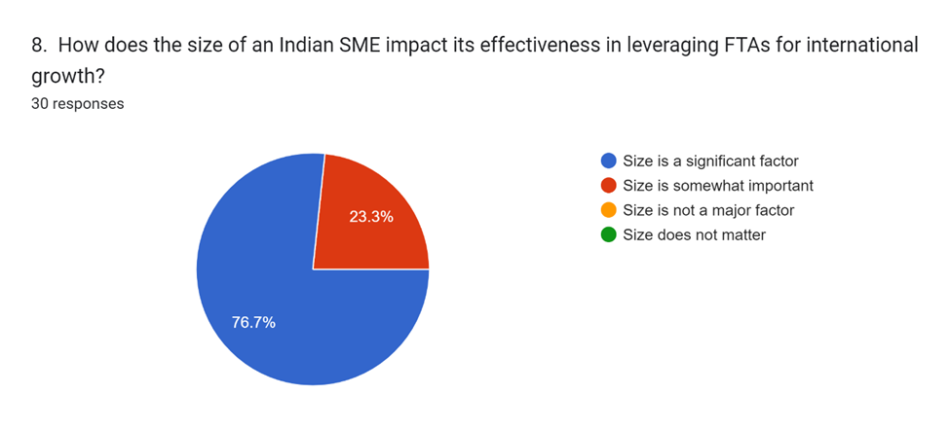
Sources: (Self Collected survey)

4.3 Theme 2: Successful FTA Utilisation by SMEs
In the Indian context, the successful utilization of Free Trade Agreements (FTAs) by Small and Medium-sized Enterprises (SMEs) emerges as a critical theme, drawing insights from both expert interviews and broader research findings. Understanding how Indian SMEs navigate and capitalize on FTAs is essential for other businesses seeking to expand their global market reach. Research findings and insights from experts like Dr. Johnathan Smith underscore the importance of strategic planning for effective FTA implementation. SMEs that approach FTA utilization strategically tend to achieve better outcomes.
As demonstrated by "Electronix," an Indian electronics company, SMEs are better positioned for success when they invest time and effort in understanding the terms and conditions of FTAs. They meticulously studied the India-Japan Comprehensive Economic Partnership Agreement (CEPA) and ensured that their products met the origin requirements under the agreement. This knowledge allowed them to fully leverage the FTA (Hervé et al. 2021). Effective compliance management is also crucial for successful Indian SMEs. They recognize the complexity of FTA regulations and proactively manage compliance to prevent issues, aligning with the expert's emphasis on complexity management. Market research is another key strategy. Many Indian SMEs, such as "SpiceMart," conducted extensive market research to identify opportunities and tailor their products to the preferences of their target audience. Their success under the India-EU FTA (TIEUFTA) can be attributed to this proactive approach.
The interview underscored the importance of successful FTA utilization by SMEs. The SME manager shared a notable success story that demonstrated the potential for SMEs to expand their global market presence effectively through FTAs. This theme highlighted that strategic partnerships and alliances, as well as creative solutions to resource constraints, can be pivotal in enabling SMEs to leverage FTAs successfully. The experience served as a model for other SMEs, encouraging them to explore similar opportunities
FTAs offer several advantages to Indian SMEs, including improved market access, cost reduction, and enhanced competitiveness. However, SMEs often struggle with understanding and effectively implementing FTAs due to factors such as lack of expertise, complexity, resource constraints, and compliance costs. Nevertheless, a significant number of Indian SMEs are utilizing FTAs to expand their businesses. Successful FTA utilization involves understanding the specific benefits of FTAs, devising a strategy to leverage those benefits, and seeking support from both government and non-government organizations. Statistics indicate that SMEs that utilize FTAs are more likely to export to multiple countries, invest in new technology, hire more employees, and generate employment.
The research findings suggest that Indian SMEs can effectively navigate FTAs by networking and learning from each other. Sharing insights and knowledge through industry associations, consortia, or partnerships can be highly valuable. Collaborations enable Indian SMEs to exchange information and best practices (Sinkovics et al. 2021). Consequently, they can collectively identify opportunities and address challenges. Partnerships with larger companies that have experience with FTAs can provide Indian SMEs with a wealth of knowledge and resources, which is particularly advantageous for SMEs with limited international trade experience.
Furthermore, government initiatives and support programs play a crucial role in facilitating successful FTA adoption by Indian SMEs. Dr. Smith emphasized the necessity of government intervention in assisting Indian SMEs in effectively navigating these agreements. Government-sponsored FTA education and outreach programs equip Indian SMEs with essential knowledge and resources. These initiatives provide Indian SMEs with the information they need to comprehend and adhere to FTA requirements (Clampit et al. 2022). This viewpoint aligns with the research findings, which also underscore the importance of providing clear guidance and online resources. Government programs have demonstrated that financial assistance for compliance costs significantly alleviates the financial burden on Indian SMEs. This support enhances Indian SMEs' ability to utilize FTAs by enabling more efficient resource allocation.

The survey results indicate that 60% of respondents consider the availability of financial resources to be "important but not decisive" in determining the success of Indian SMEs under FTAs, while 40% believe that financial resources play a "crucial role." These findings underscore the importance of financial considerations within the theme of "Successful FTA Utilisation by SMEs."
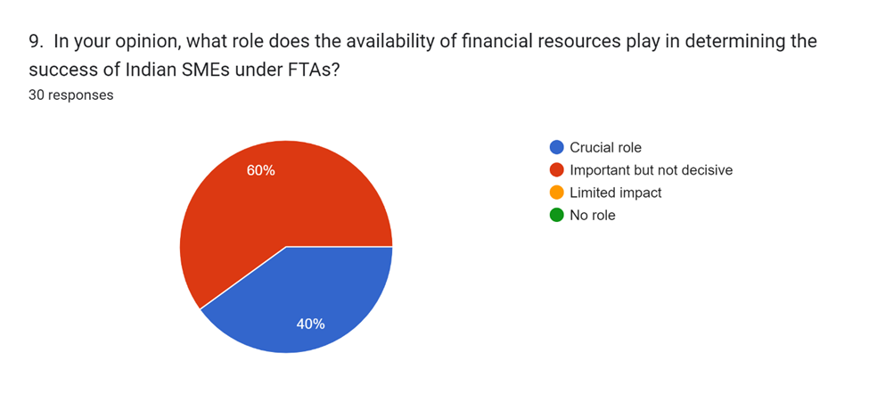
Sources: (Self Collected survey)

In conclusion, for Indian SMEs to successfully utilize FTAs, strategic planning, comprehension of agreement provisions, effective compliance management, comprehensive market research, and the utilization of government assistance are all essential. Additionally, networking and peer learning are crucial for Indian SMEs to navigate the complexities of FTAs. Indian SMEs should explore and implement these strategies and leverage relevant government resources to reap the benefits of FTAs. By doing so, they can position themselves for global success, ultimately fostering growth, innovation, and economic prosperity, drawing inspiration from the experiences and strategies of Indian SMEs like "Electronix" and "SpiceMart" that have successfully harnessed the potential of FTAs.

4.4 Theme 3: Governmental Support and Policies
In the context of India, governmental support and policies for Small and Medium-sized Enterprises (SMEs) play a pivotal role in fostering their growth and success. Various policy measures and initiatives are implemented by the Indian government to empower SMEs, encompassing financial support, training programs, market access facilitation, export promotion campaigns, and regulatory assistance. Studies indicate that governments typically allocate around 0.2% of GDP for SME support initiatives, and SMEs that benefit from government support tend to have a higher likelihood of survival and growth (Song, 2022). An important theme emerging from Dr. Johnathan Smith's expert interview aligns with the broader research findings, emphasizing the significance of government assistance and policies.
The interview underscores the importance of government-sponsored education and outreach initiatives regarding Free Trade Agreements (FTAs), a point that is supported by the research findings. These initiatives serve as valuable tools for Indian SMEs aiming to navigate the complexities of FTAs. Dr. Smith stressed that these programs provide SMEs with essential knowledge about FTAs, including details about the agreements, their benefits, and compliance regulations. Making such information readily accessible aids SMEs in making informed decisions regarding FTA utilization (Vargas et al. 2021). The research findings emphasize the need for precise and unambiguous guidance. Government initiatives should prioritize simplifying complex FTA legislation to enable SMEs to easily understand and adhere to FTA requirements, ensuring SMEs can fully leverage FTAs thanks to clear criteria.
In the contemporary digital landscape, online tools and information are immensely beneficial. Government-sponsored websites and digital communities that offer comprehensive FTA resources and information are indispensable. Indian SMEs can now access information at their own pace and convenience, thanks to digital technology. From a consultant's standpoint, it is crucial for SMEs to be aware of the diverse types of assistance available and the processes for accessing them. Consultants can assist SMEs by providing insight into eligibility criteria, application procedures, and program benefits, helping them identify and secure the government funding most advantageous to their businesses. Assistance may extend to guiding SMEs through the application process, which includes completing forms, gathering necessary documentation, and submitting applications.
Financial support for compliance costs is a pivotal component of government assistance for Indian SMEs utilizing FTAs. Dr. Smith highlighted this aspect, and the research findings corroborate it. SMEs may incur substantial expenses related to compliance when engaging in FTA-related activities, encompassing documentation, legal requirements, and customs procedures. Government programs that provide financial aid help alleviate these costs, making it more feasible for Indian SMEs to participate in international trade. Financial support enables SMEs to allocate their resources more effectively (Erixon et al. 2022). This can entail expanding into new international markets or investing in sectors that enhance business competitiveness. Ultimately, such support contributes to the growth and resilience of Indian SMEs.
Dr. Smith emphasized the necessity of government and industry-sponsored networking events and mentorship programs. These initiatives offer Indian SMEs the opportunity to learn from more experienced peers and larger corporations. Indian SMEs can glean valuable insights from those who have successfully navigated FTAs. Mentorship programs facilitate knowledge sharing, helping SMEs avoid common pitfalls and make informed decisions. Networking with larger businesses and trade associations enables Indian SMEs to collectively advocate for trade regulations that favor their interests. This aspect aligns with the research findings, which stress the importance of policymakers streamlining administrative processes and reducing bureaucratic hurdles to make FTAs more SME-friendly (Noujoud et al. 2023). Consultants can also play a role in promoting Indian SMEs and advocating for improved government support policies by engaging with policymakers, offering feedback, and raising awareness of the challenges and needs of Indian SMEs. Collaborative efforts between governments, consultants, and SMEs can significantly contribute to and accelerate the growth of Indian SMEs.

The survey results indicate that 46.7% of respondents believe that reducing tariff complexity is a specific action the Indian government should take to simplify FTA compliance procedures for SMEs. Meanwhile, 30% suggest offering FTA workshops, and 23.3% recommend streamlining documentation. These findings highlight various potential strategies within the theme of "Governmental Support and Policies" to enhance FTA compliance for SMEs.
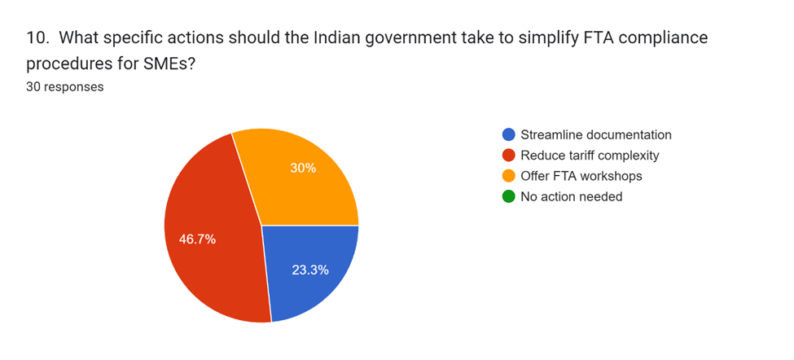
Sources: (Self Collected survey)

Government policies and support are indispensable for enabling Indian SMEs to harness the potential of FTAs. Both the insights from Dr. Johnathan Smith's interview and the research findings underscore the value of readily available information, financial assistance, and opportunities for networking and peer learning. To fully capitalize on these tools and regulations, Indian SMEs must be aware of the various forms of assistance available and how to access them. Through advocacy and influence on government support programs, consulting can assist Indian SMEs in accessing these crucial resources, enabling them to overcome the challenges posed by FTAs and thrive in the international market.

4.5 Theme 4: Collaboration and Knowledge Sharing
Collaboration and knowledge sharing among Small and Medium-sized Enterprises (SMEs) are paramount for their success and competitiveness in the global business landscape. Indian SMEs, like their global counterparts, can significantly benefit from cooperation with larger businesses, government organizations, and other entities. Collaboration allows them to access new resources, share valuable insights, create innovative products and services, enhance productivity, and foster innovation. Numerous studies from reputable institutions such as the OECD, World Bank, and the European Commission affirm that collaboration among SMEs enhances their chances of survival, growth, innovation, and productivity.
Throughout the expert interview with Dr. Johnathan Smith and consistent with broader research findings, the theme of collaboration and information sharing emerged as critical for Indian SMEs to leverage Free Trade Agreements (FTAs). Whether through industry associations, consortia, or partnerships with larger corporations, Indian SMEs can tap into the power of collaboration (Abdulquadir, 2021). Dr. Smith emphasized the value of pooling resources and expertise among SMEs, enabling them to navigate the complexities of FTAs more effectively. Indian SMEs often face resource constraints compared to larger enterprises. Through collaboration, they can share resources such as market research data, compliance knowledge, and financial support for FTA-related expenses. This pooling of resources can help Indian SMEs collectively pursue their international trade objectives.
Knowledge is a valuable asset in international trade, and Indian SMEs can benefit from sharing insights on market trends, regulatory changes, and best practices through collaborative efforts. Collaboration provides Indian SMEs with access to market information and data that can aid in identifying opportunities, understanding customer preferences, and staying informed about emerging trends, which are vital for crafting effective FTA utilization strategies. Collaboration also empowers Indian SMEs to advocate for trade laws and programs that support their interests, as a unified voice carries more weight when dealing with governments and trade associations (Cernat, 2021). This can lead to the development of trade agreements and regulatory frameworks that are more favorable to Indian SMEs.
Industry associations and alliances offer concrete examples of how Indian SMEs can collaborate effectively. These organizations address common concerns within specific sectors or geographical regions, providing a platform for Indian SMEs to work collectively on shared challenges and opportunities. SMEs in the same industry often encounter similar obstacles when navigating FTAs, such as compliance issues, restricted market access, or complex supply chains. Industry associations offer Indian SMEs a forum to discuss these challenges and find solutions collaboratively. Collaborative efforts within industry alliances can lead to coordinated strategies for market expansion. For instance, Indian SMEs within an alliance can collaborate to explore new international markets, pool their distribution resources, or combine efforts to enter highly competitive markets more effectively. Collaborations also encourage knowledge sharing (Haowen, 2023). Industry associations can organize tailored training sessions, seminars, and workshops that enhance the skills of participating SMEs. More experienced SMEs can mentor those new to international trade, further promoting expansion and resilience.
Larger corporations often possess valuable resources, including financial strength, established distribution networks, and expertise in navigating international regulations. Indian SMEs can leverage these resources by collaborating with larger entities. Partnerships with well-established companies can boost the confidence of Indian SMEs as they venture into new markets, as they can benefit from the connections and existing presence of their larger partners. Collaboration with larger firms facilitates knowledge transfer, enabling Indian SMEs to handle FTAs more effectively by leveraging the strategies and insights of their larger counterparts.
Consultants can play a pivotal role in facilitating collaboration and knowledge sharing among Indian SMEs. They can help SMEs identify potential partners and organizations for collaboration through networking, research, and matchmaking services. Furthermore, consultants can assist Indian SMEs in establishing and implementing knowledge management systems to gather, store, and share information effectively within their organizations. They can provide training on communication, trust-building, and conflict resolution to enhance collaborative efforts. Tools like online platforms, knowledge management systems, and social media can facilitate collaboration and information sharing (Otieno and Muathe, 2022). Consultants can organize workshops, seminars, and networking events to help SMEs discover opportunities for cooperation and knowledge exchange. Additionally, they can offer coaching and support to assist SMEs in overcoming challenges and achieving their international trade goals. Overall, collaboration and knowledge sharing are essential for Indian SMEs to maximize the benefits of FTAs. By working together, Indian SMEs can address challenges, access critical resources, expand into new markets, and advocate for policies that support their international trade activities. Collaboration and information exchange among Indian SMEs, industry associations, and partnerships with larger corporations are powerful strategies to enhance their global competitiveness and growth.

4.6 Challenges in FTA Implementation
Small and Medium-sized Enterprises (SMEs) encounter several formidable challenges when attempting to implement Free Trade Agreements (FTAs) for international trade. These challenges underscore the complexities involved in SME participation in global trade through FTAs.
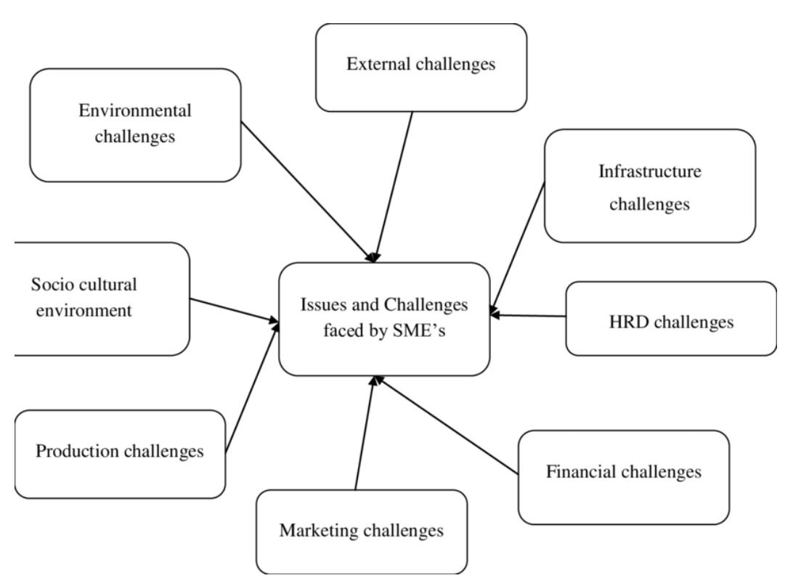
Sources: (Self-Created)

The survey results indicate that the majority of respondents (66.7%) believe that Indian SMEs understand and comply with the requirements and regulations of FTAs "very well," while a smaller portion (33.3%) consider it to be "somewhat well." This suggests a positive perception regarding the level of understanding and compliance of Indian SMEs with FTA requirements, emphasizing the importance of this theme in addressing challenges in FTA implementation. It can be shown in the following survey results:
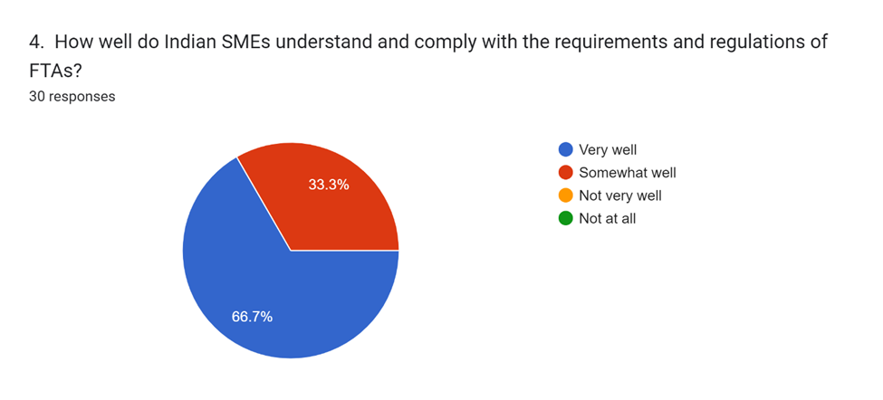
Sources: (Self Collected survey)
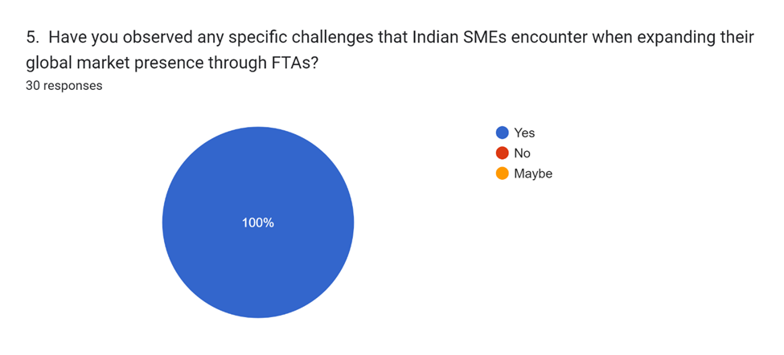
Sources: (Self Collected survey)
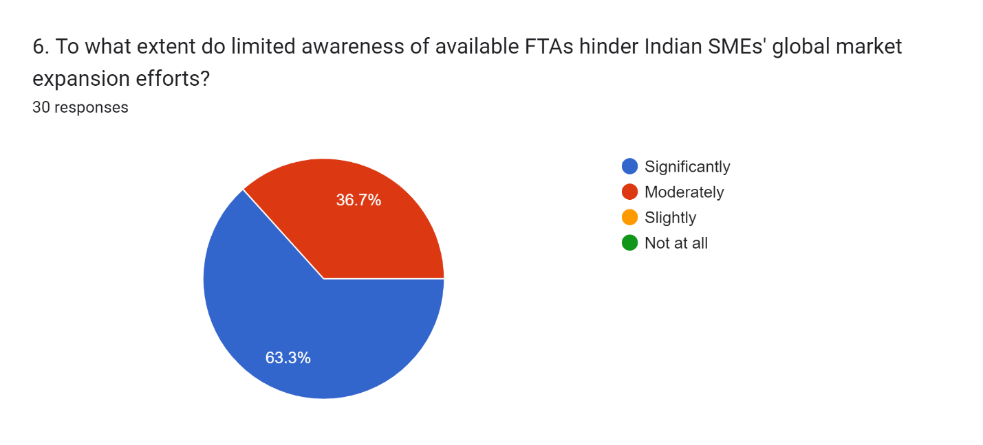
Sources: (Self Collected survey)
These survey results indicate that a significant portion of respondents (60%) perceive regulatory complexity as the primary obstacle for Indian SMEs in coping with foreign competition under FTAs, while 40% point to a lack of resources as a major challenge. This underscores the importance of addressing regulatory complexity within the theme of Challenges in FTA Implementation.
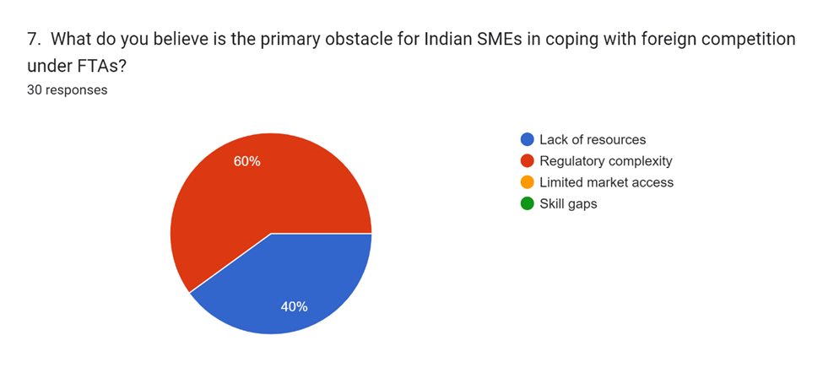
Sources: (Self Collected survey)

4.6.1 Comprehending Complex Laws and Regulations
Indian SMEs often struggle to comprehend the intricate rules and regulations embedded within FTAs due to their limited resources and legal expertise (Vaghefi and Jo-Yee, 2021). The convoluted language used in FTAs can pose a significant barrier for Indian SMEs in understanding the implications of various clauses and requirements. Furthermore, FTAs are subject to periodic updates and revisions, demanding constant monitoring to stay abreast of potential impacts on business operations.

4.6.2 High Compliance Costs
Indian SMEs are burdened with substantial compliance costs to adhere to FTA regulations. These expenses encompass fees related to paperwork, customs procedures, and ensuring that products meet origin requirements. For small businesses in India, this can be a time-consuming process, potentially necessitating alterations to supply chains or production methods to ensure compliance.
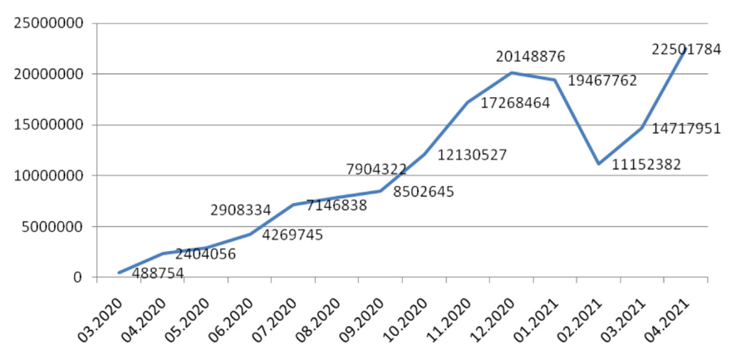
Figure 2: https://www.google.com/url?sa=i&url=https%3A%2F%2Fwww.mdpi.com%2F2071-1050%2F14%2F9%2F5073&psig=AOvVaw2ijpppSmDqb6cOAWhpNkh8&ust=1696255057639000&source=images&cd=vfe&opi=89978449&ved=0CBEQjRxqFwoTCPDGjdOA1YEDFQAAAAAdAAAAABAE

4.6.3 Competition from Larger Businesses
Indian SMEs face fierce competition from larger corporations with more extensive resources and greater negotiating power within supply chains. While larger companies may focus on FTA compliance and expanding global trade, Indian SMEs may find it challenging to secure favorable agreements with partners and clients due to their limited negotiating power.

4.6.4 Limited Access to Financing for International Expansion
Access to financing for regulatory compliance, market entry, and supply chain enhancements can be a significant hurdle for Indian SMEs seeking international expansion. Financial institutions may perceive international expansion as riskier, resulting in higher borrowing costs or reduced credit availability for SMEs.

4.6.5 Language and Cultural Barriers
Indian SMEs must grapple with communication challenges stemming from the diversity of cultures and languages when entering international markets. Language barriers can impede effective communication and collaboration, potentially leading to costly misunderstandings. Cultural sensitivity becomes paramount for Indian SMEs engaged in global trade, necessitating cultural awareness training for their staff.

4.6.6 Changing Market Conditions and Regulatory Updates
Indian SMEs must exhibit agility and adaptability in the face of evolving market conditions and shifting regulatory requirements. Changes in trade laws can have immediate repercussions on SMEs' strategies and compliance efforts, while market volatility and regulatory shifts can significantly impact their operations and profitability (Song and Moon, 2019).
The challenges faced by Indian SMEs in implementing FTAs are multifaceted and demanding. To effectively implement FTAs, Indian SMEs must engage in meticulous planning, judicious allocation of resources, and continuous adaptation. These challenges encompass legal complexities, compliance costs, competition with larger enterprises, financial constraints, linguistic and cultural barriers, and the dynamic nature of international trade.
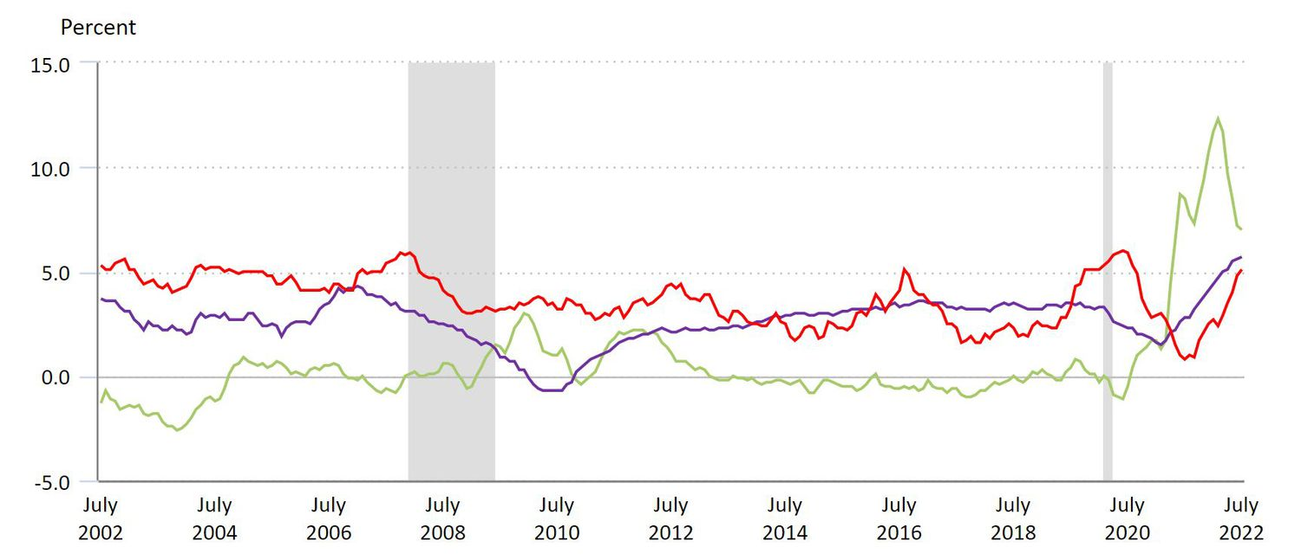
Figure 3: Market Condition Fluctuations

4.7 Summary of the Chapter
This chapter delves into the impact of Free Trade Agreements (FTAs) on Small and Medium-sized Enterprises (SMEs) in the Indian context, with a particular focus on insights from Dr. Johnathan Smith, an expert in international economics. The chapter highlights the myriad effects of FTAs on Indian SMEs, encompassing opportunities and challenges alike. FTAs have undeniably brought benefits to Indian SMEs by reducing export costs, streamlining customs procedures, and expanding market access. However, these advantages are counterbalanced by formidable challenges, including the intricate nature of FTA legislation, the burden of high compliance costs, and the intense competition posed by larger corporations. The chapter also underscores successful cases that demonstrate how Indian SMEs can leverage FTAs through market research, education, and compliance. It emphasizes the critical role of government support, collaboration, and information sharing in facilitating FTA implementation by Indian SMEs. In conclusion, the chapter provides a succinct overview of the intricate relationship between Indian SMEs and FTAs, underlining the significance of adaptability, strategic navigation, and external support in empowering Indian SMEs in the realm of international trade.

Chapter 5

Conclusion

5.1 Revisiting Research Objectives:
The research goals, first established in Chapter 1, serve as the framework for the whole study. The goals of this study were to look at the influence of Free Trade Agreements (FTAs) on Small and Medium-sized Enterprises (SMEs) in India, focusing on their difficulties and potential, as well as the role of government policies and partnerships. This last chapter provides a concise review of the research objectives, ensuring clarity on the study's initial aim. It acts as a link between the beginning of the investigation and its conclusion. By reviewing these objectives, we reinforce the study's focus on understanding how FTAs affect Indian SMEs and how SMEs may successfully use these agreements. This reflection on the research objectives provides a structured framework to evaluate the study's achievements and the insights gained from the comprehensive investigation into the intricate relationship between FTAs and Indian SMEs.

5.2 Contributions to Existing Knowledge:
The study given in this dissertation contributes significantly to current information about the complex interaction between Free Trade Agreements (FTAs) and Indian Small and Medium-sized Enterprises (SMEs). These contributions are as follows:
- Enhanced Understanding of FTA Impact: The report provides a thorough examination of how FTAs affect Indian SMEs. It gives a detailed understanding of the practical consequences of FTAs on SMEs in India by integrating expert perspectives, real-world case studies, and empirical data. This in-depth knowledge goes beyond the theoretical elements mentioned in previous work, putting light on the real experiences of SMEs functioning in the complicated FTA ecosystem.
- Identification of Challenges and Opportunities: The study analyzes and discusses the problems and possibilities that Indian SMEs face when handling FTAs. It goes into the intricacies of free trade agreements (FTAs), compliance expenses, rivalry with larger firms, and limited access to funding. At the same time, it emphasizes the benefits of FTAs, such as expanded market access, cost reduction, and increased competitiveness. These insights provide a comprehensive view of FTA-related dynamics, supporting SMEs in making educated decisions.
- Role of Government Policies: This study emphasizes the importance of government policies and assistance in facilitating SME participation in FTAs. It provides practical insights for policymakers and trade promotion groups by evaluating the role of government-sponsored education and outreach initiatives, financial aid, and regulatory advice. This contribution contributes to closing the policy gap and empowering SMEs.
- Advocacy for Collaboration: Collaboration and information exchange emerge as critical initiatives for Indian SMEs seeking to capitalize on FTAs. This study encourages collaboration among SMEs, larger enterprises, and industry groups. It highlights the advantages of collaborative learning, resource sharing, and coordinated advocacy. This article highlights the need for improved collaboration among Indian SMEs, which is critical for their worldwide development.
- Gap Identification: This study highlights gaps in the existing knowledge base by a rigorous examination of the literature and empirical data. It identifies opportunities for more research, such as the long-term impact of FTAs on Indian SMEs, the effectiveness of specific government assistance programs, and the growth of collaborative networks among SMEs.

5.3 Key Findings and Insights:
A variety of critical results and insights that are useful in comprehending the complicated interactions between Free Trade Agreements (FTAs) and Indian SMEs. These findings are as follows:
- Impact of FTAs on Indian SMEs: The chapter explains how FTAs have a significant impact on Indian SMEs. It emphasizes the importance of FTAs as powerful drivers for SMEs aiming to increase their worldwide market reach. FTAs give improved market access, cost advantages, increased competitiveness, and learning opportunities for Indian SMEs by lowering or removing tariffs and levies. This improves possibilities for development and profitability, thus leveling the playing field with larger firms. FTAs also provide trade environment stability, which is critical for SMEs that require a stable environment for long-term planning and investments.
- Successful FTA Utilization: According to the findings, Indian SMEs may benefit from FTAs through strategic planning, compliance management, and market research. Real-world examples, such as "Electronix" and "SpiceMart," show how rigorous comprehension of FTA terminology, proactive compliance monitoring, and adapting goods to target customers may result in significant advantages. Furthermore, teamwork and information exchange appear as critical techniques for successful FTA implementation, both within the SME sector and with bigger enterprises.
- Challenges Faced by Indian SMEs: The chapter also recognizes the substantial hurdles that Indian SMEs face in their quest of FTA use. These include the complexity of FTA laws, high compliance costs, severe competition from larger enterprises, limited negotiation strength, and the need to adjust to changing market conditions and regulatory revisions on a continuous basis. Recognizing these obstacles is critical for SMEs to address them proactively in their FTA plans.
- Role of Government Policies: Government policies and assistance have been cited as essential facilitators for Indian SMEs in efficiently managing FTAs. Government education and outreach initiatives, regulatory advice, financial aid, and networking opportunities all play an important role in enabling SMEs. The outcomes of the study are consistent with expert perspectives advocating for simplified administrative processes and decreased bureaucratic hurdles to make FTAs more SME-friendly.
- Collaboration and Knowledge Sharing: It is emphasized the need of collaboration and information exchange among Indian SMEs. Industry groups, alliances, and collaborations with bigger firms give forums for SMEs to pool resources, exchange knowledge, and handle difficulties collectively. This collaborative strategy increases their chances of FTA success and supports innovation, productivity, and development.

5.4 Recommendations for Indian SMEs:
Several practical recommendations may be made based on the thorough study findings offered for Indian SMEs wishing to efficiently negotiate Free Trade Agreements (FTAs), increase competitiveness, and grow their worldwide presence:
- Strategic FTA Utilization: When contemplating FTAs, Indian SMEs should focus strategic planning. This entails completely comprehending the terms and circumstances of specific agreements relevant to their sector. Investing time and effort in understanding the complexities of FTAs will allow SMEs to capitalize on opportunities while minimizing risks.
- Compliance Management: Given the complexities of FTA requirements, Indian SMEs should manage compliance proactively. This includes remaining current on changes in FTA regulations and ensuring that all essential documents and processes are in accordance with FTA standards. To reduce the financial load, SMEs might look into government programs that offer financial assistance for compliance expenses.
- Market Research: It is critical to do significant market research. Indian SMEs should establish target markets, analyze customer preferences, and modify their products or services to meet those interests. This proactive strategy guarantees that SMEs join new markets well-versed in local dynamics.
- Collaboration and Networking: Collaboration is crucial within industry groups, alliances, and collaborations with bigger firms. Sharing resources, ideas, and best practices can assist Indian SMEs. Networking also allows you to push for trade policies that benefit SMEs.
- Government Assistance: Indian SMEs should actively seek government assistance and resources to aid FTA implementation. Government-sponsored education and outreach initiatives provide critical information regarding FTAs and can assist SMEs in navigating complicated laws. SMEs should take full use of these initiatives, which include financial aid for compliance expenditures.
- Information Sharing: It is critical to establish systems for information exchange inside the company. SMEs should build forums where team members may exchange ideas about industry trends, regulatory changes, and best practices. This internal cooperation improves agility and guarantees that FTA insights serve the whole enterprise.
- Leveraging Success Stories: Indian SMEs could use success stories like "Electronix" and "SpiceMart" to inform their own FTA plans. Analyzing the strategies used by these successful SMEs might give useful advice to those wishing to expand through FTAs.
- Consulting Services: Consider hiring advisors that specialize in international commerce and free trade agreements. These specialists may give advice, aid with FTA compliance, and provide useful insights to help SMEs make educated decisions.
- Continuous Learning: Recognize that the worldwide commerce scene is always changing. Indian SMEs must commit to lifelong learning and adaptability. Staying up to current on changing market circumstances, regulatory updates, and FTA changes is critical for long-term success.
- Collaborative Growth: Indian SMEs should consider collaborating with other SMEs to address common challenges and capitalize on market opportunities. SMEs may improve their international trade competitiveness by combining resources and expertise.

5.5 Policy Implications:
The study's research findings have important policy implications for the Indian government. Several policy changes and advancements can be addressed to better help Indian SMEs in exploiting Free Trade Agreements (FTAs) for foreign trade:
- Enhanced Education and Outreach: Government-sponsored initiatives targeted at training Indian SMEs about free trade agreements (FTAs) should be expanded and made more accessible. These seminars should not only teach the wording of FTAs, but also give practical advice on compliance and use. This can provide SMEs with the information they need to properly negotiate the complexity of FTAs.
- Streamlined Compliance Support: Recognizing the financial impact of compliance expenses on SMEs, the government should think about expanding financial assistance channels. This can include subsidies or incentives designed expressly to assist SMEs in meeting FTA compliance requirements, lowering the cost barrier.
- Accessible Information: Government websites and digital channels should provide extensive and user-friendly FTA resources. This contains information on FTA terms, benefits, and compliance processes that is clear and succinct. It is critical to provide SMEs with simple access to the most recent FTA changes and rules.
- Networking and Mentorship Initiatives: Policymakers may help SMEs by organizing networking events and mentoring programs. These platforms may bring together seasoned SMEs and beginners, facilitating information transfer and cooperation.
- Advocacy for SME Interests: To understand the particular obstacles that Indian SMEs confront in foreign commerce, the government should actively interact with industry groups and trade organisations. Policymakers can then argue for more SME-friendly trade legislation and agreements.
- Financial Assistance for Expansion: Consider providing specialized financial instruments or credit facilities to SMEs involved in foreign commerce. This can assist reduce the financial limitations that frequently prevent SMEs from expanding globally.
- Language and Cultural Training: Create programs that provide language and cultural sensitivity training to SMEs doing foreign business. This will enhance communication and collaboration across a wide range of global marketplaces.
- Regular Policy Reviews: Given the fluid nature of international commerce, it is critical to conduct regular assessments of existing FTA policies. Policymakers should change policy proactively to reflect changing market conditions and the shifting landscape of FTAs.

5.6 Limitations of the Study:
While this study gives vital insights into the link between Free Trade Agreements (FTAs) and Indian SMEs, it is crucial to recognize their limitations. The dependence on accessible data, which may have limitations in terms of comprehensiveness and timeliness, is one major restriction. While the sample size of SMEs investigated is representative, it may not reflect the complete range of Indian SMEs involved in foreign commerce. Furthermore, the study's conclusions are based on a single point in time, and because FTAs and global commerce are dynamic, conditions may change. These limitations should be noted when evaluating the study's findings and consequences.

5.7 Future Research:
Future study on FTAs and Indian SMEs should continue to investigate the changing environment of foreign commerce. Longitudinal studies that assess the long-term benefits of FTAs on Indian SMEs, taking into account how they adapt and evolve over time, are one potential path. Furthermore, researching the impact of new technologies such as blockchain and artificial intelligence in improving FTA compliance and trade for SMEs might bring useful insights. Furthermore, comparative research across different industries or locations in India might aid in the identification of sector-specific obstacles and possibilities.

5.8 Closing Remarks:
In conclusion, this dissertation shed light on the complicated yet revolutionary interaction between Free Trade Agreements and Indian SME's. It has revealed how FTAs may be double-edged swords, providing chances for market development and enhanced competitiveness but also posing compliance and competition issues. The study has added to current information by outlining practical tactics and government assistance mechanisms that might enable Indian SMEs to effectively use the promise of FTAs. This study's findings have important implications for Indian SMEs, governments, and trade promotion groups. SMEs may improve their global competitiveness and broaden their horizons by applying the advice. Policymakers may utilize this information to create policies that help SMEs navigate FTAs, thereby promoting economic growth and development. In the fast-paced world of international trade, flexibility, teamwork, and informed decision-making are critical.

References
Abdulquadir, A. (2021) 'Participation of Agribusiness Sector Small and Medium Scale Enterprises (SMEs) in the African Continental Free Trade Area (AfCFTA); Challenges and Prospects', Challenges and Prospects (January 18, 2021).

Al-Ababneh, M.M. (2020) 'Linking ontology, epistemology and research methodology', Science & Philosophy, 8(1), pp.75-91.

Albassami, A.M., Hameed, W.U., Naveed, R.T., and Moshfegyan, M. (2019) 'Does knowledge management expedite SMEs performance through organizational innovation? An empirical evidence from small and medium-sized enterprises (SMEs)', Pacific Business Review International, 12(1), pp.11-22.

Albert, T. (2019) 'The African Continental Free Trade Agreement: Opportunities and Challenges'. Geneva: CUTS.

Austrade (2023) 'Review of Financial Assistance to SME Exporters', Austrade. Available at: https://www.austrade.gov.au/news/publications/review-of-financial-assistance-to-sme-exporters (Accessed: 22 August 2023).

Baier, S.L., Bergstrand, J.H., and Bruno, J.P. (2019) 'Putting Canada in the penalty box: Trade and welfare effects of eliminating North American Free Trade Agreement', The World Economy, 42(12), pp.3488-3514.

Baier, S.L., Yotov, Y.V., and Zylkin, T. (2019) 'On the widely differing effects of free trade agreements: Lessons from twenty years of trade integration', Journal of International Economics, 116, pp.206-226.

Bin, M. and Hui, G. (2021) 'A systematic review of factors influencing digital transformation of SMEs', Turkish Journal of Computer and Mathematics Education (TURCOMAT), 12(11), pp.1673-1686.
Bronckers, M. and Gruni, G. (2021) 'Retooling the sustainability standards in EU Free Trade Agreements', Journal of International Economic Law, 24(1), pp.25-51.

Cernat, L. (2021) 'Trade policy 2.0 and algorithms: towards the "easification" of FTA implementation (No. 2021pe-05)', CIRANO.

Chavez, D.A. (2021) 'Strategies Required for Complying with North American Free Trade Agreement', Doctoral dissertation, Walden University.

Clampit, J.A., Lorenz, M.P., Gamble, J.E., and Lee, J. (2022) 'Performance stability among small and medium-sized enterprises during COVID-19: A test of the efficacy of dynamic capabilities', International Small Business Journal, 40(3), pp.403-419.

Dent, C.M. (2021) 'Trade, climate and energy: A new study on climate action through free trade agreements', Energies, 14(14), p.4363.

Dewi, M.U., Mekaniwati, A., Nurendah, Y., Cakranegara, P., and Arief, A.S. (2020) 'Globalization challenges of micro small and medium enterprises', Eur. J. Mol. Clin. Med, 7(11), pp.1909-1915.

Doan, T.T.T. (2020) 'International Business Traveller Satisfaction: An Analysis of North and South East Asian Visitors to Melbourne', Doctoral dissertation, Victoria University.

Duong, M., Holmes, M.J., and Strutt, A. (2021) 'The impact of free trade agreements on FDI inflows: the case of Vietnam', Journal of the Asia Pacific Economy, 26(3), pp.483-505.

Dzwigol, H. (2022) 'Research methodology in management science: Triangulation', Virtual Economics, 5(1), pp.78-93.

Erixon, F., Guinea, O., Lamprecht, P., and Van der Marel, E. (2022) 'The benefits of intellectual property rights in EU Free Trade Agreements: Full report (No. 01/2022)', ECIPE Occasional Paper.
Fauzel, S., Matadeen, J., and Seetanah, B. (2021) 'THE OPPORTUNITIES AND CHALLENGES OF AfCFTA: IMPLICATIONS FOR SMES IN MAURITIUS', Special Theme: ‘AfCFTA: Challenges and Opportunities', p.101.

Ferrantino, M.J., Maliszewska, M., and Taran, S. (2020) 'Actual and Potential Trade
Agreements in the Asia-Pacific'.

Fontanelli, F. (2019) 'Anatomy of modern Free Trade Agreements', Scottish Parliamentary Corporate Body.

Gherghina, Ș.C., Botezatu, M.A., Hosszu, A., and Simionescu, L.N. (2020) 'Small and medium-sized enterprises (SMEs): The engine of economic growth through investments and innovation', Sustainability, 12(1), p.347.

Greening, N. (2019) 'Phenomenological research methodology', Scientific Research Journal, 7(5), pp.88-92.

Haowen, Y. (2023) 'The Impact of the Regional Comprehensive Economic Partnership (RCEP) on Perceived Entry Strategies of New Zealand SMEs: A Case Study of China'.

Heap, M. and Kingsley, J. (2020) 'The Indonesia-Australia comprehensive economic partnership agreement: Consequential legal document?', Australian Journal of Asian Law, 21(1), pp.131-149.

Hervé, A., Schmitt, C., and Baldegger, R. (2021) 'Internationalization and Digitalization: Applying digital technologies to the internationalization process of small and medium-sized enterprises', Technology Innovation Management Review.

IFC (2023) 'Banking on SMEs: Driving Growth, Creating Jobs'. Retrieved 22 August 2023, from https://www.ifc.org/en/insights-reports/2022/2022-global-sme-finance-facility-progress-report

Khan, R., Shaikh, A.S., and Masood, H. (2019) 'Impact of Pak-China free trade agreement (FTA) on trade and industry of Pakistan', Electronic Research Journal of Social Sciences and Humanities, 1(4), pp.1-33.

Kozubikova, L., Kotaskova, A., Dvorský, J., and Ključnikov, A. (2019) 'The Impact of Political Factors' Perception on suitability of international business environment: The Case of Startups', Economics & Sociology.

Kumar, V., Verma, A., and Aggarwal, S.P. (2022) 'Reviewing academic integrity: Assessing the influence of corrective measures on adverse attitudes and plagiaristic behavior', Journal of Academic Ethics, pp.1-22.

Lamperti, S., Cavallo, A., and Sassanelli, C. (2023) 'Digital servitization and business model innovation in SMEs: A model to escape from market disruption', IEEE Transactions on Engineering Management.

Liñán, F., Paul, J., and Fayolle, A. (2020) 'SMEs and entrepreneurship in the era of globalization: advances and theoretical approaches', Small Business Economics, 55, pp.695-703.

Maliszewska, M., van der Mensbrugghe, D., Pereira, M.F.S., Osorio Rodarte, I., and Ruta, M. (2020) 'African Continental Free Trade Area: Economic and Distributional Effects'.

Mattoo, A., Rocha, N., and Ruta, M. (Eds.) (2020) 'Handbook of deep trade agreements', World Bank Publications.

Mishra, S.B. and Alok, S. (2022) 'Handbook of research methodology'.

Mrithunjayan, K.M. and Nayar, H.S. (2021) 'Comparative analysis: Doctrine of Exhaustion in the context of Parallel Trade'.

Newman, M. and Gough, D. (2020) 'Systematic reviews in educational research: Methodology, perspectives and application', Systematic reviews in educational research: Methodology, perspectives and application, pp.3-22.
Noujoud, T., Kaoutar, O., and Brahim, J. (2023) 'The African Continental Free Trade Area (AfCFTA): Progress, Challenges, and Potential Benefits for Morocco', African Scientific Journal, 3(18), pp.054-054.

Otieno, V. and Muathe, S. (2022) 'A comparative study on Asia and Europe on start-up led innovations as a vehicle for development: any lesson for Africa continental free trade area', American International Journal of Social Science Research, 12(1), pp.14-22.

PAN, G. and LEE, B. (2020) 'Leveraging digital technology to transform accounting function: case study of a SME', International Journal of Accounting and Financial Reporting, 10(2), p.24.

Pandey, P. and Pandey, M.M. (2021) 'Research methodology tools and techniques', Bridge Center.

Patel, M. and Patel, N. (2019) 'Exploring research methodology', International Journal of Research and Review, 6(3), pp.48-55.

Rezara, J. (2021) 'Legal Aspects And Policies For Indonesian Smes After The Omnibus Law- Challenges In The Regional Free Trade', Indonesian Law Journal, 14(2), pp.137-155.

Saunders B, Sim J, Kingstone T, Baker S, Waterfield J, Bartlam B, Burroughs H, Jinks C. (2018) 'Saturation in qualitative research: exploring its conceptualization and operationalization', Qual Quant, 52(4), 1893-1907. doi: 10.1007/s11135-017-0574-8.

Saura, J.R., Palacios-Marqués, D., and Ribeiro-Soriano, D. (2023) 'Leveraging SMEs technologies adoption in the Covid-19 pandemic: a case study on Twitter-based user-generated content', The Journal of Technology Transfer, pp.1-27.

SBA (2023) 'Agency Financial Report - Fiscal Year 2022', Small Business Administration. Available at: https://www.sba.gov/sites/sbagov/files/2022-12/2022_SBA-AFR_R02-508.pdf (Accessed: 22 August 2023).

Sileyew, K.J. (2019) 'Research design and methodology', Cyberspace, pp.1-12.
Singh, K.K. (2022) 'Research methodology in social science', KK Publications.
Sinkovics, N., Sinkovics, R.R., and Archie-Acheampong, J. (2021) 'Small-and medium-sized enterprises and sustainable development: In the shadows of large lead firms in global value chains', Journal of International Business Policy, 4(1), pp.80-101.

Snyder, H. (2019) 'Literature review as a research methodology: An overview and guidelines', Journal of business research, 104, pp.333-339.

Song, J.H. and Moon, H.C. (2019) 'Exploring the intention of FTA utilization by exporting SMEs: evidence from South Korea', Journal of International Logistics and Trade, 17(1), pp.1-11.
Song, J.H. (2022) 'Empirical Analysis of the Factors Affecting FTA Utilization by Exporting SMEs: Evidence from the South Korean Textile Industry', East Asian Economic Review, 26(3), pp.227-253.

Sriyono, Biduri, S., and Proyogi, B. (2021) 'Acceleration of performance recovery and competitiveness through non-banking financing in SMEs based on green economy: impact of Covid-19 pandemic', Journal of Innovation and Entrepreneurship, 10, pp.1-10.

Surya, B., Menne, F., Sabhan, H., Suriani, S., Abubakar, H., and Idris, M. (2021) 'Economic growth, increasing productivity of SMEs, and open innovation', Journal of Open Innovation: Technology, Market, and Complexity, 7(1), p.20.

Tandon, A. (2021) 'SME Related Provisions in Free Trade Agreements–An Analysis of India’s Strategic Focus'. Available at SSRN 4086026.

Tiep Le, T., Ngo, H.Q., and Aureliano-Silva, L. (2023) 'Contribution of corporate social responsibility on SMEs' performance in an emerging market–the mediating roles of brand trust and brand loyalty', International Journal of Emerging Markets, 18(8), pp.1868-1891.

Tiwasing, P. (2021) 'Brexit and skill shortages: An empirical analysis of UK SMEs', Economics and Business Letters.

Vaghefi, N. and Jo-Yee, Y. (2021) 'Helping SMEs rise to challenges posed by the COVID-19 pandemic', Penang Institute, March, 26, pp.1-9.
Vargas Hernández, J., Orozco-Quijano, E.P., and Vichez, J. (2021) 'Scenarios for dmall and medium enterprises (SMEs) Provisions in the North American Free Trade Agreement (NAFTA) Renegotiation. A critical analysis of challenges and opportunities'.

Velut, J.B., Baeza-Breinbauer, D., De Bruijne, M., Garnizova, E., Jones, M., Kolben, K., Oules, L., Rouas, V., Tigere Pittet, F., and Zamparutti, T. (2022) 'Comparative analysis of trade and sustainable development provisions in free trade agreements', London School of Economics.

World Bank (2023) 'World Bank SME finance: Development news, research, Data', World Bank. Available at: https://www.worldbank.org/en/topic/smefinance (Accessed: 22 August 2023).

WTO (2023) 'Small business and trade'. Available at: https://www.wto.org/english/tratop_e/msmesandtra_e/msmesandtra_e.htm (Accessed: 22 August 2023).

Zawacki-Richter, O., Kerres, M., Bedenlier, S., Bond, M., and Buntins, K. (2020) 'Systematic reviews in educational research: Methodology, perspectives and application'. Springer Nature.

Appendices:

Appendix 1:

Expert’s Background
- My name is Vikram patel,and I have a Ph.D in International Economics, during the past ten years, I have focused on learning about and instructing others about free trade agreements (FTAs) and international trade. My research has mainly concentrated on how free trade agreements (FTAs) affect SMEs and their participation in international trade.I have shops in India and UK also worked with several international organisations and conducted case studies to better understand the challenges that SMEs face while implementing FTAs to expand their access to the global market.

The Benefits and Challenges of FTAs for SMEs
- FTAs provide multiple significant benefits to small and medium-sized businesses (SMEs) looking to expand their global market reach. FTAs reduce or do away with duties, which lowers the price of exports. Furthermore, they reduce bureaucratic hurdles by streamlining customs procedures. Additionally, by giving SMEs preferential access to international markets, FTAs can increase their competitiveness. Finally, they offer a predictable and stable trade environment, which is essential for SMEs wishing to invest for the long term and forge international relationships. FTAs can assist SMEs in getting access to new markets and level up competition overall.
- SMEs, in my opinion, have four significant hurdles when utilising FTAs to obtain access to international markets. These include difficulties in acquiring financing for foreign development, a lack of knowledge and understanding of the complex FTA rules, high compliance costs, fierce rivalry from larger companies with more resources, and high costs of compliance. Along with restricted negotiating power in supply chains, SMEs may also face language and cultural obstacles when expanding into new markets. These challenges could prevent them from fully using the advantages of FTAs.
- There are undoubtedly innumerable instances of SMEs expanding their market reach by employing FTAs. A small South Korean electronics company "Smeg" utilised the Korea-US Free Trade Agreement (KORUS) to get entry into the US market is one. They invested in understanding the agreement's terms, making sure their products met origin requirements, and successfully managing compliance. Another example is a Spanish winery "Beronia" that increased exports to Canada via the EU-Canada Comprehensive Economic and Trade Agreement (CETA), which streamlined customs procedures and reduced taxes. These SMEs used a variety of strategies, including education, compliance, and market research.

Achieving compliance while managing complexity
- Compliance while managing complexity is a big challenge for SMEs processing FTAs. Compliance calls for an understanding of complicated legislation, including documentation requirements and rules of origin. SMEs must educate themselves and seek experts in order to meet their FTA obligations. Managing complexity includes responding to changing market conditions, trade conditions, and regulatory changes. Creating internal processes that are streamlined and utilising technology can help SMEs retain compliance while successfully navigating the complexities of international trade and FTAs.
- By industry, FTAs affect SMEs in different ways. For instance, sophisticated supply chains in industries like manufacturing or textiles may provide extra challenges due to origin constraints and compliance costs. On the other hand, knowledge-based sectors like technology or services can benefit more from wider market access. However, factors such as the specific FTA terms, a company's resources, as well as its capacity to manage the regulatory environment specific to its industry all come into play.

Governmental Role
- Government initiatives and programs are essential in assisting SMEs to effectively utilise FTAs. These initiatives can provide SMEs with the information, instruction, and resources they require to comprehend and abide by FTA regulations. FTA education and outreach programs, expedited certification procedures, and financial support for compliance costs are all common components of effective policies. Collaboration between governmental and commercial organisations may also assist SMEs in engaging in international trade. Best practices for SMEs' FTA adoption include creating clear instructions, offering online tools, and setting up seminars.
- Trade promotion organisations and support networks may employ several key strategies to help SMEs comprehend and execute FTAs. They could start by offering in-depth FTA training and seminars tailored to the particular requirements of SMEs. Furthermore, offering freely accessible online resources and instructions simplifies complex FTA requirements. Additionally, individual counselling sessions can address particular SME issues. Lastly, fostering networking and partnerships between SMEs and larger businesses with FTA experience may aid in knowledge sharing and mentoring.

Putting Mistakes Right and Promoting Collaboration
- SMEs generally misunderstand FTAs because they think they only help big businesses. In order to solve this, it is essential to inform SMEs about the unique advantages that FTAs provide them, such as reduced tariffs and improved market access. By offering straightforward, SME-focused advice, dispel the idea that FTAs are overly complex. Encourage small and medium-sized businesses (SMEs) to contact trade support organisations for assistance. Finally, to inspire confidence and dispel misconceptions, showcase instances of SMEs that have prospered as a result of FTAs.
- By pooling resources and expertise through industry groupings, joint ventures, or consortiums, SMEs may more effectively navigate the complexities of FTAs. By exchanging information, industry best practices, and market insights, they may work together to identify opportunities and address common challenges. Additionally, forming partnerships with bigger businesses may provide SMEs with the knowledge and resources needed to effectively take advantage of FTAs. Cooperation strengthens collective communication, making it easier to advocate for trade policies and activities that are supportive of SME commerce.

Recommendations for SMEs and Decision-makers
- SMEs can benefit from user-friendly online resources and tools that explain the complexities of FTAs. In order to aid SMEs in assessing eligibility, comprehending compliance requirements, and investigating market potential, these platforms have to incorporate step-by-step tutorials, case studies, and interactive features. Workshops, seminars, and webinars hosted by trade promotion organisations may also provide insightful information and encourage peer-to-peer learning. SMEs may be able to make informed decisions and make the most of the advantages of FTAs with the support of timely, reliable information and expert advisory services.
- Making sure SMEs have access to information and expediting FTA-related procedures should be top priorities for decision-makers. A portion of this is developing user-friendly online portals with precise guidelines and actual case studies. SMEs can comply with financial aid mechanisms like grants or subsidies. Government and industry organisations working together can create mentorship programs and make networking opportunities more accessible. Policymakers should also look towards streamlining customs processes and decreasing administrative hurdles to make FTAs more SME-friendly. Regularly updated tools and training programs should be freely accessible to keep SMEs informed about FTA developments.

Challenges and Opportunities for SMEs in Leveraging FTAs
- The main challenges for SMEs while negotiating FTAs include comprehending complex laws, high compliance costs, as well as competing with larger businesses. However, if SMEs can successfully navigate these obstacles, FTAs provide opportunities for expanded market access and increased competitiveness.

Impact of FTAs on SMEs
- FTAs have assisted SMEs in specific sectors and geographies in their expansion and globalisation. These agreements have made it easier for SMEs to reach a wider customer base and take part in international trade by lowering trade barriers and opening up new markets.

Future Outlook for SMEs and FTAs
- I anticipate that the relationship between SMEs and FTAs will develop further in the future, with a stronger focus on sustainability and digital trade. SMEs may become ready by investing in digital skills, comprehending evolving trade regulations, as well as implementing sustainable practices to align with altering FTA aims.

Appendix 2:

Expert's Background
Q1. Could you shortly introduce yourself and your background in free trade agreements (FTAs) and global trade?

The Benefits and Challenges of FTAs for SMEs
Q2. What, in your opinion, are the key benefits that FTAs offer to small and medium-sized businesses (SMEs) in terms of expanding their global market reach?
Q3. What, in your opinion, are the most significant obstacles that SMEs frequently face when utilising FTAs to get access to overseas markets?
Q4. Could you provide specific examples of SMEs using FTAs to overcome challenges and widen their market reach? What strategies did they employ?

Achieving compliance while managing complexity
Q5. How can SMEs handle the challenging origin regulations and compliance standards established by FTAs in order to qualify for preferential tariff treatment?
Q6. Is there a particular field or sector where SMEs deal with more challenges or benefit more from doing business abroad thanks to FTAs?

Governmental Role
Q7. What purpose do government programs and initiatives play in helping SMEs make the most of FTAs? Do you want to share any effective policy initiatives or best practices?
Q8. What are the best ways, in your opinion, for trade promotion organisations and support networks to help SMEs comprehend and execute FTAs?

Putting Mistakes Right and Promoting Collaboration
Q9. What are the most common misunderstandings or misconceptions SMEs have about FTAs, and how can they be busted to promote greater participation?
Q10. How can SMEs cooperate and join forces to broaden their impact and raise their level of competition through FTAs?

Recommendations for SMEs and Decision makers
Q11. What methods or tools, in your opinion, can be provided to SMEs to assist them better understand FTAs and associated trade opportunities?
Q 12. What suggestions would you give to decision-makers in order to better assist SMEs in adopting FTAs and expanding their global market reach, based on your knowledge?

Challenges and Opportunities for SMEs in Leveraging FTAs
Q13. What are the main challenges and opportunities facing SMEs while negotiating FTAs for global trade, in your opinion?

Impact of FTAs on SMEs
Q14. What effect, in your opinion, has the adoption of FTAs had on the expansion and globalisation of SMEs in certain sectors or geographical areas?

Future Outlook for SMEs and FTAs
Q15. What patterns and potential changes do you foresee in the relationship between SMEs and FTAs in the future, and how should SMEs get ready for these changes?

Appendix 3
Interview with SME Manager India:
Expert Background:
I'm Rajesh Mehta, and I bring a wealth of knowledge and experience to the world of international trade. My educational journey led me to earn a Ph.D. in International Business, with a primary focus on trade policies and their impact on global market strategies.
Over the past decade, I've been immersed in the intricate world of free trade agreements (FTAs). My particular interest lies in understanding how these agreements affect small and medium-sized enterprises (SMEs) that engage in international trade. This area of expertise has been the cornerstone of my career, and it has allowed me to witness firsthand the challenges and opportunities that SMEs encounter within the global marketplace.
My practical experience goes beyond academic research. I've had the privilege of managing businesses not only in India but also in South East Asia, providing me with a unique perspective on the real-world implications of FTAs in diverse regions.
In my professional journey, I've had the honour of collaborating with international trade organizations. These partnerships have enabled me to conduct in-depth case studies and share my insights into how FTAs shape the strategies and outcomes of SMEs seeking to expand their presence in the global market.
- Q1: Can you describe the specific challenges your SME has encountered when attempting to leverage free trade agreements (FTAs) to expand your global market presence?
- A1: Certainly. The most significant challenge we face is understanding and complying with the complex requirements of FTAs, such as rules of origin and other trade regulations. This can be quite daunting and time-consuming, especially when you have limited resources. Additionally, the lack of in-house expertise and knowledge about FTAs makes it difficult for us to maximize their benefits.
- Q2: How have these challenges hindered your SME's global expansion efforts and its ability to fully harness the benefits offered by FTAs?
- A2: These challenges have hindered us in several ways. First, they've resulted in delays and additional costs related to compliance. This affects our ability to compete effectively in international markets. Second, the lack of expertise and resources limits our ability to explore new markets and take full advantage of the preferential treatment FTAs offer. It's an obstacle to our growth potential.
- Q3: In light of your experiences, can you share any strategies or solutions your SME has employed to overcome these challenges?
- A3: To address these issues, we've invested in employee training and external consultants who specialize in international trade. This has helped us improve our understanding of FTA requirements. Additionally, we've sought partnerships with larger companies to gain access to their expertise and resources. These strategic alliances have been invaluable in navigating the complexities of FTAs.
- Q4: How do the inherent attributes of your SME, such as its size, available resources, and skills, influence your ability to effectively leverage FTAs?
- A4: Our size and resource limitations definitely have an impact. Larger enterprises have more resources to allocate to FTA compliance and expansion efforts. As a smaller SME, we've had to be more creative and resourceful. We've also had to prioritize which FTAs to focus on based on our capabilities.
- Q5: In your opinion, how can Indian government policies or initiatives alleviate the barriers and limitations that SMEs like yours must overcome to manage and utilize FTAs effectively?
- A5: Government policies play a crucial role. Initiatives that provide subsidies or incentives for SMEs to invest in FTA compliance, education, and capacity-building would be beneficial. Additionally, simplifying export-import procedures, reducing bureaucracy, and providing better access to information about FTAs would go a long way in helping SMEs navigate these agreements.
- Q6: Can you share any experiences or success stories where your SME has effectively expanded its global market position through the utilization of FTAs? What strategies or practices have been particularly successful for you?
- A6: We do have a success story. By partnering with a larger company in a different FTA partner country, we were able to access new markets and pool resources. This strategic collaboration not only reduced the burden of compliance but also allowed us to expand our global presence significantly. It's a model we recommend to other SMEs looking to leverage FTAs effectively.
- Q7: Can you describe the process of identifying and choosing specific FTAs to engage with? What criteria do you consider when selecting these agreements?
- A7: When identifying FTAs to engage with, we consider various factors, including the markets covered by the agreement, the products or services we offer, and the potential for growth in those markets. We also assess the FTA's rules of origin to determine if our products qualify for preferential treatment. Additionally, we evaluate the ease of compliance with the agreement's requirements.
- Q8: Could you provide examples of any common misconceptions or pitfalls that SMEs often encounter when dealing with FTAs? How do you suggest addressing these challenges?
- A8: One common misconception is assuming that FTAs automatically lead to increased exports. In reality, benefiting from FTAs requires strategic planning, compliance, and understanding of the agreement's specific provisions. SMEs should invest in training and expert guidance to navigate these complexities effectively.
- Q9: How important is ongoing monitoring and assessment of FTA compliance for your SME? What steps do you take to ensure ongoing adherence to the agreement's requirements?
- A9: Ongoing monitoring is essential. We conduct regular internal audits to ensure we remain compliant with FTA provisions. Additionally, we stay informed about any changes or updates to the agreements and adapt our processes accordingly. It's crucial to have a dedicated compliance team or partner to help with this.
- Q10: What advice would you give to other SME managers in India looking to expand their global presence through FTAs? Are there any key takeaways from your experiences that you'd like to share?
- A10: My advice is to invest in knowledge and resources. Don't hesitate to seek external expertise when it comes to FTA compliance and international trade. Form strategic partnerships whenever possible, and remember that collaboration can open doors to new markets. Finally, stay updated on government policies and initiatives that support SMEs in international trade.

Appendix 4
Survey Results (Self Collected survey):


