Introduction
In this report on lean thinking, I will focus on data from a recent project implemented by Automotive Distribution Centre Ltd trading as FAI (ADC) and explore the problems that have arisen. I will also examine how lean thinking can be applied to address these challenges and support the company’s objectives. As one of the UK’s leading suppliers of aftermarket automotive components, ADC is currently expanding, with additional warehouse space both in the UK and in Europe to better meet customer demands and gain a competitive edge within the industry.
Every workplace should apply lean thinking to improve efficiency and quality of work. According to Yu, D. and Ye, T. (2023) the lean thinking philosophy can encourage companies and supply chain to apply the 5 principles which are defining value, mapping the value stream, creating flow, using a pull system and pursuing perfection, to gain a competitive edge.
Gaining an understanding of our customers’ needs and values post Brexit, along with the need to have product closer to customers and to avoid additional custom fees, led to ADC expanding into Europe in March 2024. Based on sales data gathered over a five-year period, this informed our decision to choose Poland as the EU Hub location.

The purpose of this report is to define how lean principles can be applied, specifically to eliminate the non-value-added processes which we are currently facing.

The 9 Wastes
From the 9 possible wastes we will investigate both Transportation and Inventory as both are currently causing us issues relating to our EU Hub.
Transportation – Our companies aim is to handle the items as little as possible because each time the product is touched, we lose profit. As shown in the flow chart below; goods arriving from suppliers (China / Taiwan), quality checks, items being put into stock, items being picked / packed into orders, orders being shipped to our EU Hub in Poland, goods being received and put into stock in Poland, and finally, the goods are picked & packed again before being shipped to our customers.
Table 1.1 – ‘Flow chart Hub movements’
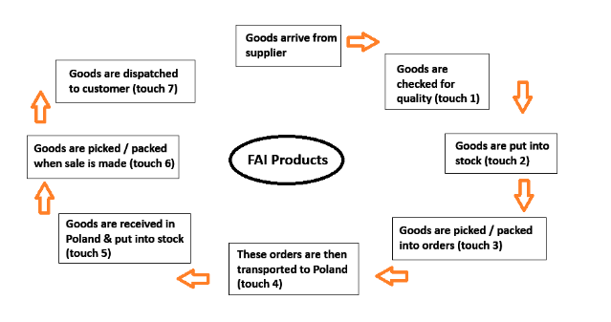
Inventory (time) - The process explained above applies to parts for which we cannot arrange a direct drop from the supplier to the hub in Poland. These parts typically move slower and, therefore, do not meet the minimum order quantity threshold for direct delivery from factory. As a result, these parts are moved from our UK warehouse to Poland in ‘EU Hub’ shipments. The additional workload involved in raising the necessary paperwork, along with the transport and customs fees incurred when moving goods into the UK, out of UK, and into Poland, increases the overall costs. This combined with the material costs results in a higher product cost once the parts arrive at the Poland Hub. If we do not manage our order levels to Poland properly, we risk repeating this process, which incurs further costs and devalues the parts at each stage.

Wastes being investigated.
Our biggest current waste and inefficiency is the transfer of goods from UK Hub to Poland Hub which ADC action once a month, spending a total of €26K on freight since March 2024. An investigation into the EU Hub movements reveals that ADC is including top movers, suggesting that our stock level management is not accurate. This excess movement of goods is costing the company both time and money and slowing down our processes. As shown in table 1.1 goods are touched up to seven times before reaching the customer.
Additionally, ADC has identified a bottleneck upon arrival of goods from UK into Poland. The daily performance KPI target is 160 lines, and the average number of lines in the EU Hub movement is 400, with an average 7900 parts taking 2.5 days to process. In contrast, a direct delivery from the supplier for top movers involves 20 lines and 60,000 parts, which is processed almost immediately and made available for sale the following day.

Quantification of the data
Looking at the 7,200 parts we currently stock in Poland Hub, we have gathered data that showing that, from our export sales of €16,404,014 over 11 months (March 2024 – January 2025), our top 250 parts account for 68% of the total sales value. When examining these top 250 parts more closely, we found that an additional €2,566,967 in value was transferred through EU Hub movements to replenish stock. Additionally, a further €2,064,247 in sales was generated from direct shipments from the UK to customer due to shortage in Poland Hub.

The potential lost sales, combined with current backorder report showing €260K in back orders for the top 250 parts, indicate that our current purchasing and inventory framework is not working. This is leading to a repetition of the transport and inventory inefficiencies previously identified.

Proposed improvements
The current purchasing process can be summarised as a Push System, but an investigation reveals that it is not being executed as effectively as it could be. The holding stock levels are based on sales history, but do not account for opportunity sales or future demand. With three months of holding stock, ADC and customers benefit from a more stable supply. However, this approach carries the risk of overstocking and high inventory costs, particularly for slow movers.
By collaborating with the purchasing department, the proposal based on this report is to continue using a Push System for the top 250 parts but transition them to a “Just in Case” (JIC) model with six months of holding stock. This will ensure that maximum stock is available in Poland to facilitate the rapid turnover of fast movers, providing stability in the supply chain. For the middle-tier, which represents 30% of sales, we propose a Hybrid Push-Pull system. This will allow ADC to meet demand variability while minimising the risk of unnecessary stock holdings. Finally, the remaining 2% of slow-moving and low-value parts should transition to a Pull System, where parts are only replenished when demand is triggered. The implementation of these purchasing strategies is expected to reduce waste associated with transport and inventory time.

Conclusion
The importance of lean thinking within any company is significant, particularly in reducing waste. If ADC applies principles such as Kaizen and value stream mapping to projects both before implementation and through continuous improvements once projects are in place, it will strengthen the lean thinking culture of constant learning and adapting. Lean thinking isn’t without its challenges, organisations must adapt and overcome resistance to change. Phrases like “We’ve always done it this way” or “It has always worked, so there’s no need to change” are common obstacles. Despite this, the long-term benefits such as increased efficiency and stronger relationships with both internal teams and customers, make it essential for ADC to adopt.
Adopting lean thinking will be key to the long-term success of the EU Hub project and any future initiatives as ADC grows. Fostering a culture of continuous improvement and engaging employees at all levels, will not only eliminate waste but also create lasting value. The challenge of pursuing perfection should always remain a priority at ADC. When this mindset is integrated throughout the company, it will lead to improved processes and greater flexibility in responding to market changes. Lean thinking is a long-term commitment that requires ongoing attention and adaptation. By embracing these principles ADC will be better equipped to face challenges and involves employees in continuous improvements across the entire organization.
In conclusion, lean thinking is a strategic approach that will enable ADC to maintain a competitive edge in the automotive sector. By pursuing operational excellence through lean thinking ADC will enhance internal processes, improve profitability and pave the way for future expansion. As the company scales and evolves, a commitment to lean and Six Sigma methodologies will remain vital in navigating the complexities of the industry and achieving long-term success.

Referencing
Imai, M., 1986. Kaizen: The key to Japan’s competitive success. Kaizen Institute Ltd.
Yu, D. and Ye, T. (2023) ‘Tracing the lean thinking in supply chain management: a comprehensive main path analysis’, International journal of lean six sigma, 14(2), pp. 483–513. Available at: https://doi.org/10.1108/IJLSS-06-2022-0135

