ASSESSMENT 1:
Business and Web Management

MODULE | Business and Web Management (ACCA5019_LON)
STUDENT NAME | Pedro Gaetjens Molongua
STUDENT NUMBER | 2327143
LECTURER | Md Sadeque Imam Shaikh


INDEX
INTRODUCTION 3
EDUNEXT WEBSITE REDESIGN (THE PROBLEM/SOLUTION) 3
RESPONSIVE DESIGN IMPLEMENTATION (ANALYSIS) 5
Implications for UX/UI 5
Mobile Optimization and Engagement 5
E-commerce Sales and Course Enrolment 6
Justification through Rättel and Krug 6
Summary Table 6
IMPLEMENTATION SECTION 7
Mood Board 7
My Mood Board 7
Visual Justification 8
Wireframes 8
Home Page 9
Courses Page 10
About Us Page 11
Contact Page 12
Enrol Page 13
EduNext website Prototype 14
CONCLUSION 14
REFERENCES 15

INTRODUCTION
The purpose of this assessment is to present and justify a comprehensive redesign proposal for the EduNext online education platform. EduNext has experienced declining user engagement and enrolment due to usability challenges, outdated aesthetics, and limited responsiveness across devices. The proposed redesign addresses these challenges through a user-centred, accessibility-focused, and brand-cohesive approach, grounded in established UI/UX principles and responsive design best practices.
I will outline the critical analysis of EduNext’s current digital presence, identifying major usability constraints and proposing solutions to enhance navigation, accessibility, and personalization. Informed by key theories in user experience (Norman, [1]; Nielsen, [2]), visual design principles (Lidwell et al., [3]), and responsive web design frameworks, the study emphasizes the importance of aligning business objectives with user needs.
Following this introduction, the report is organized into several sections. The first analyses EduNext’s existing design issues and proposes evidence-based improvements. The next section explores the implications of responsive design for e-commerce success and user engagement. The implementation section then documents the practical design outputs (mood board, wireframes, and interactive prototype) along with their theoretical justification. Finally, the conclusion reflects on the project outcomes, demonstrating how the design process advances EduNext’s strategic goal of delivering an intuitive, inclusive, and high-quality digital learning experience.

EDUNEXT WEBSITE REDESIGN (THE PROBLEM/SOLUTION)
EduNext’s existing online platform currently presents several usability and engagement limitations that impact its ability to attract and retain learners. The interface lacks clarity in navigation, the visual style feels outdated, and the platform does not adapt effectively across different devices. Additionally, the enrolment process is lengthy and unintuitive, and course presentation (both imagery and text) does not effectively communicate value or motivation. These issues collectively reduce user trust, increase cognitive effort as Krug cited in [4].
The redesign I propose in this report addresses these challenges by applying evidence-based UI/UX and branding principles derived from both user feedback and contemporary design theory:
- Clarifying Visual Identity: The new colour palette integrates warm tones (optimism, creativity) with deep navy (trust, reliability), anchored by the neutral off-white shade #f2f0ef to create a clean and calming interface background. This aligns with Norman’s concept of Visceral Emotional Design, where first impressions strongly influence user engagement and decision-making [5]. This approach emphasizes the brand's persona by immediately conveying a sense of humanity and positive feeling to gain audience connection discussed by Walter in [5]. The smoother tonal contrasts and softer visual atmosphere help establish an inviting, personable brand identity, improving emotional connection from the first interaction.
- Improved Navigation: The wireframes apply Gestalt principles of proximity, similarity, and continuity to simplify how users progress from broad learning categories (such as business skills, technology, and personal growth) to individual courses [6]. Reducing visual clutter and grouping related elements lowers cognitive load, producing a more intuitive behavioural user experience [4].
- Responsive, Mobile-Friendly Layout: The redesigned interface follows responsive design guidelines, ensuring consistent usability across desktop, tablet, and mobile screens. Clear hierarchy on every display size supports accessibility and user independence, aligning with the usability principle of not making users think unnecessarily [4].
- Personalized and Motivating Content: Incorporating personalised course suggestions based on browsing history and stated interests encourages deeper user engagement and supports intrinsic motivation. Personalisation also improves exploration efficiency and supports higher retention [7].
- Streamlined Enrolment and Calls to Action: The enrolment journey has been simplified to reduce steps, clarify benefits, and emphasise motivating CTAs. This aligns with usability guidance suggesting that essential actions should be achievable within minimal steps to avoid user abandonment [4].
- Accessible Design: All typography, spacing, and colour combinations have been evaluated against WCAG 2.2 accessibility standards to ensure sufficient contrast and legibility. Johnson’s guidelines on perceptual design inform these adjustments to support all users, including those with visual or cognitive differences [8].
In summary, this redesign strategically aligns EduNext’s visual identity, interaction design, and content structure with its mission to help learners become their “Best Self” as its slogan tries to describe. By applying established design frameworks, the platform becomes more intuitive, motivating, and professional. All these elements together, improve the user trust, engagement, and long-term retention, effectively addressing the platforms initial limitations of low enrolment and low perceived value.

RESPONSIVE DESIGN IMPLEMENTATION (ANALYSIS)
Responsive design is pivotal for maximizing both user experience (UX) and user interface (UI) quality, particularly for mobile optimization and driving course enrolment and e-commerce success on platforms like EduNext. According to Krug’s principle of 'don’t make me think,' design should prioritize user intuition and minimize cognitive effort, allowing visitors to find what they need quickly and efficiently [4]. The study by Parlakkiliç, as referenced and discussed by Rättel, empirically demonstrates these benefits in academic web contexts [9].​

Implications for UX/UI
Responsive design ensures academic websites are accessible and visually harmonious on every device (smartphones, tablets, laptops, desktops) by automatically adjusting layouts, fonts, images, and navigation elements based on screen size and resolution. This approach eliminates the need for separate mobile sites, making updates faster and reducing cost, while supporting consistent, reliable branding and usability.​
The study found that users overwhelmingly prefer responsive sites: 99.2% had smartphones; 91.3% regularly accessed via mobile; daily users (4–5 hours/day) valued ease of use (average rating 3.67/5). “Ease of use” was the dominant usability dimension, echoing Krug’s assertion that clear visual hierarchy, restricted scrolling, touch-friendly controls, and immediate access to essential information reduce user frustration and boost satisfaction [4, 9].​

Mobile Optimization and Engagement
Mobile-first, responsive web design is essential as many users now start their search for courses on handheld devices. Responsive layouts (using fluid grids and flexible images) help maintain visual clarity and effective use of space, promoting longer site visits and faster navigation. This directly impacts course enrolment: if users encounter an intuitive, device-optimized browsing journey, they are less likely to abandon enrolment or leave incomplete applications.​
Empirical results from the Parlakkiliç study found a strong positive correlation between responsive design and usability (r=0.92, p<0.01), with regression analysis showing responsive design explained 91.5% of usability changes and 74.7% of effectiveness. In other words, responsive design is a key driver of user satisfaction, learning effectiveness, and engagement with academic or e-commerce content [9].​

E-commerce Sales and Course Enrolment
Increased usability and satisfaction foster trust, a decisive factor in e-commerce transactions and course registrations. When academic websites and online learning platforms are responsive:​
- Users can easily browse offerings, compare options, and confidently complete payments or registrations on any device.
- Clear calls to action, streamlined checkout/enrolment flows, and accessible support further decrease dropout rates and abandoned carts.
- Course providers benefit from lower support queries and higher completion rates, since students can seamlessly engage with resources everywhere.

Justification through Rättel and Krug
Rättel’s article draws direct connections; simplifying user journeys, supporting screen agnosticism, and minimizing visual/cognitive friction are foundational to modern web usability, especially in a mobile world ravaged by the unpredictability highlighted during the pandemic. Krug’s “don’t make me think” is realized through responsive design, which allows platforms like EduNext to meet the high expectations of modern learners and buyers [4, 9].

Summary Table
Responsive Design Impact | UX/UI Quality | Mobile Optimization | Enrolment/Sales Impact
Device-agnostic layouts & navigation | High | Essential | Increases conversions
Positive correlation with usability (r=0.92) | Proven | Direct | Higher retention
Supports quick updates, brand consistency | Reliable | Flexible | Reduces drop-off
Prioritizes ease of use, intuitive experience | Transformative | Key | Boosts satisfaction
By making EduNext fully responsive, the site increases accessibility, engagement, and course sales, aligning perfectly with best practices and the preferences of modern academic and e-commerce users, as evidenced by both Rättel and Krug.

IMPLEMENTATION SECTION

Mood Board
A mood board is a foundational conceptual tool that curates visual elements such as colour palettes, typography, and imagery to define the intended aesthetic and emotional character of a design [10]. Developed after analysing the target audience and competitors, the mood board ensures that all stakeholders share a unified visual direction before structural work begins, reducing ambiguity and supporting consistent branding [10].

My Mood Board
Therefore, this is the mood board I have created for EduNext:


Visual Justification
The established visual direction strategically addresses the platform’s outdated aesthetics. The palette pairs Deep Indigo (trust/reliability) with Vibrant Orange (action/optimism), creating a dynamic, high-contrast UI that maximizes visual hierarchy and readability. This choice directly aligns with Norman’s Visceral Emotional Design [5], ensuring a modern, professional, and accessible first impression. The chosen typefaces (Roboto, Poppins, Open Sans) and the use of rounded shapes and illustrations reinforce accessibility, motivation, and a user-friendly aesthetic, promoting emotional connection and visual consistency.

Wireframes
I have implemented some structural and navigational improvements for the wireframes (Desktop and Mobile) applying Gestalt principles (proximity, continuity) to simplify the information architecture, reducing cognitive load and visual clutter [4], thereby promoting a more intuitive user experience. My structural solutions include:​
- Centralized Navigation: Core navigational links are clear and grouped, moving users seamlessly from broad categories to specific courses [6]. The mobile views collapse this into a simple, single-column stack, ensuring usability across devices and aligning with the principle of not making the user think unnecessarily [4].​​
- Focused Functionality: The homepage prioritizes engagement (Visceral Design) and broad categories. In contrast, the Courses page focuses on exploration by integrating search and personalized suggestions, ensuring the right tools are available at the right stage of the user journey.
- Responsive Application: The prototype demonstrates the seamless transition between desktop and mobile layouts. This validates the empirical finding that responsive design explains a high percentage of usability changes (r=0.92), offering reliable branding and clear hierarchy on every display size [9].

Home Page

Desktop
https://wireframe.cc/kaU7kG
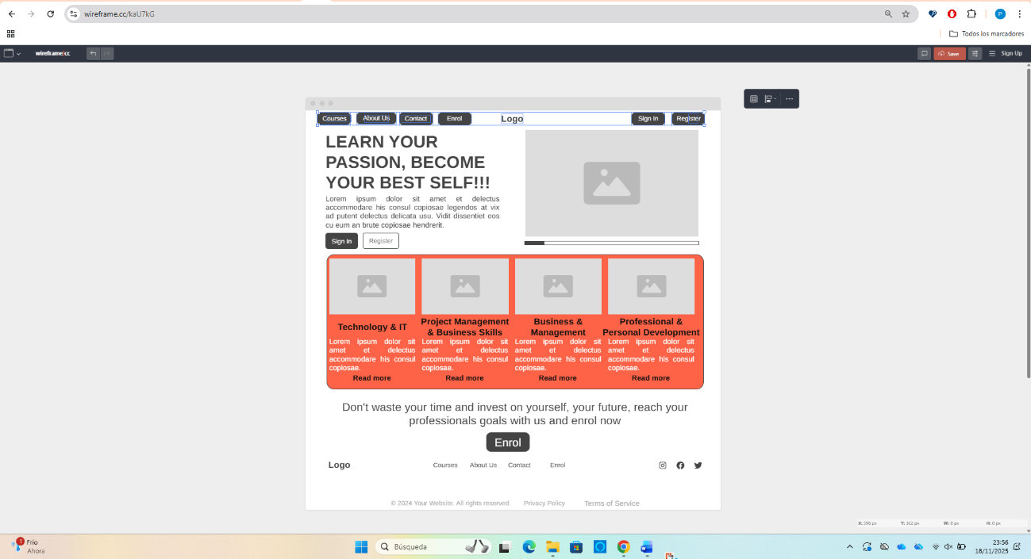

Mobile
https://wireframe.cc/sq21zG 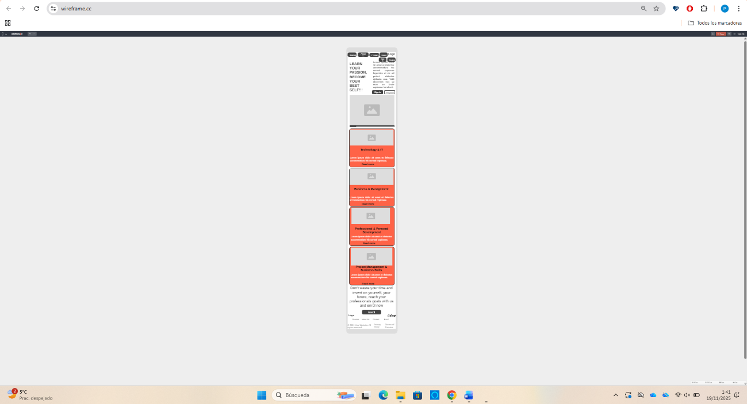

Courses Page

Desktop
https://wireframe.cc/LGBBEi 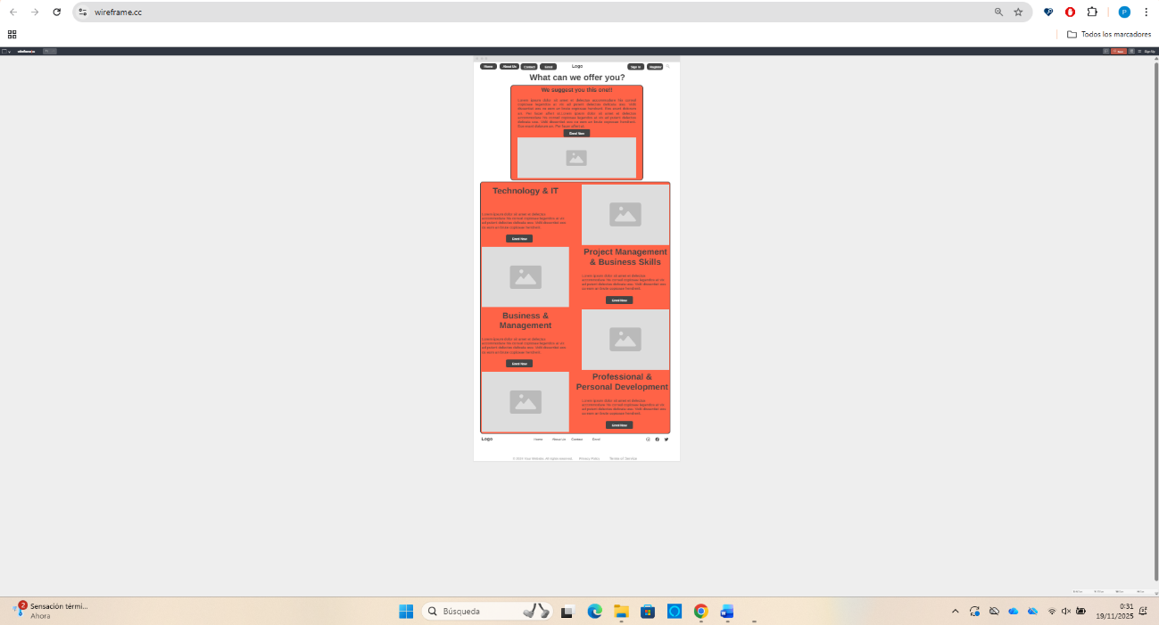

Mobile
https://wireframe.cc/JkSsa8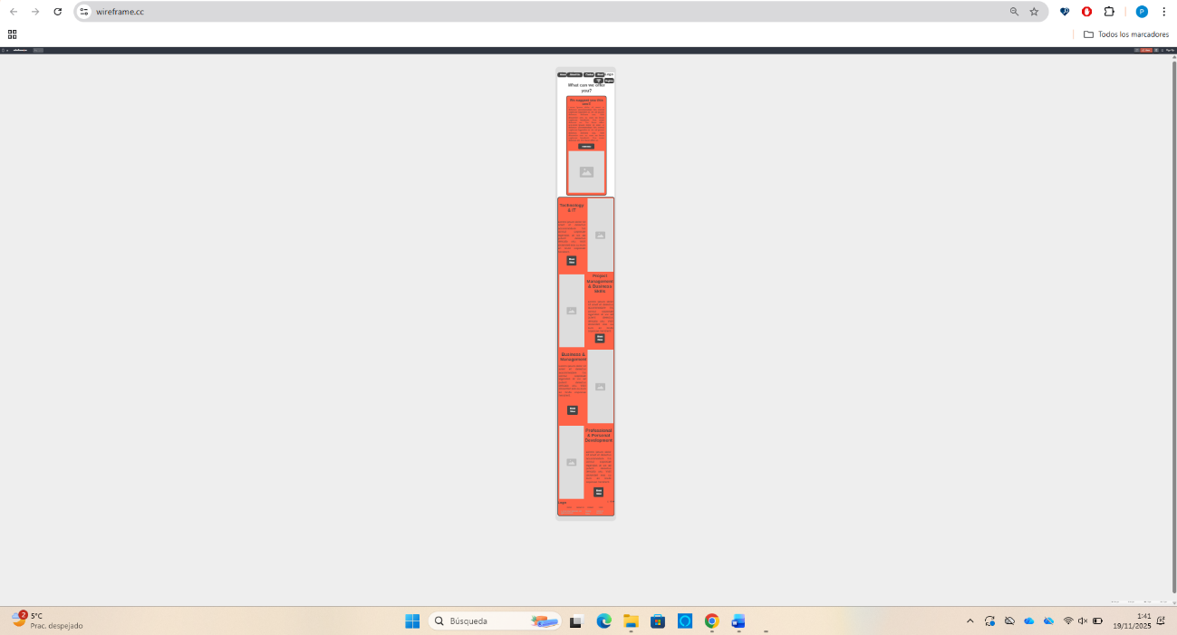

About Us Page

Desktop
https://wireframe.cc/TDeKsj
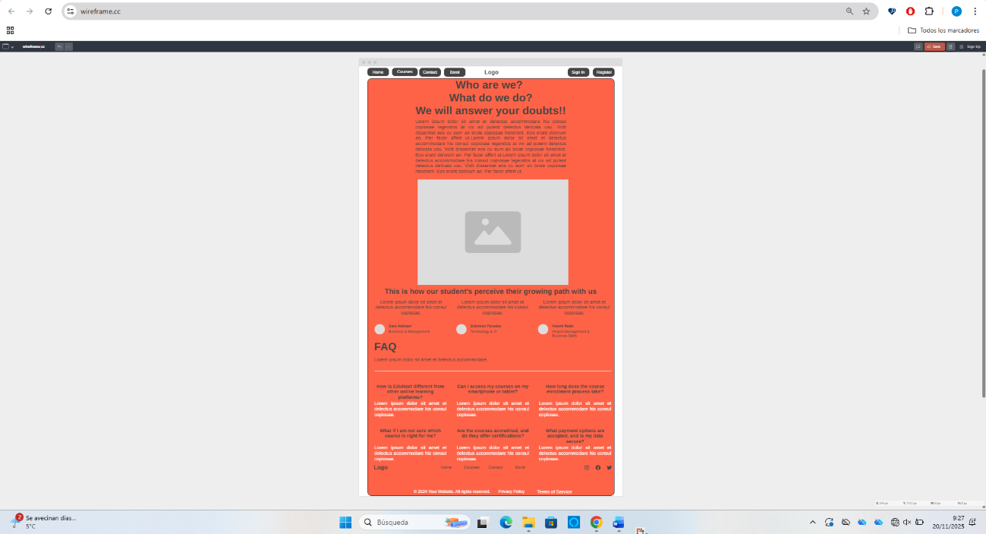

Mobile
https://wireframe.cc/ungLNc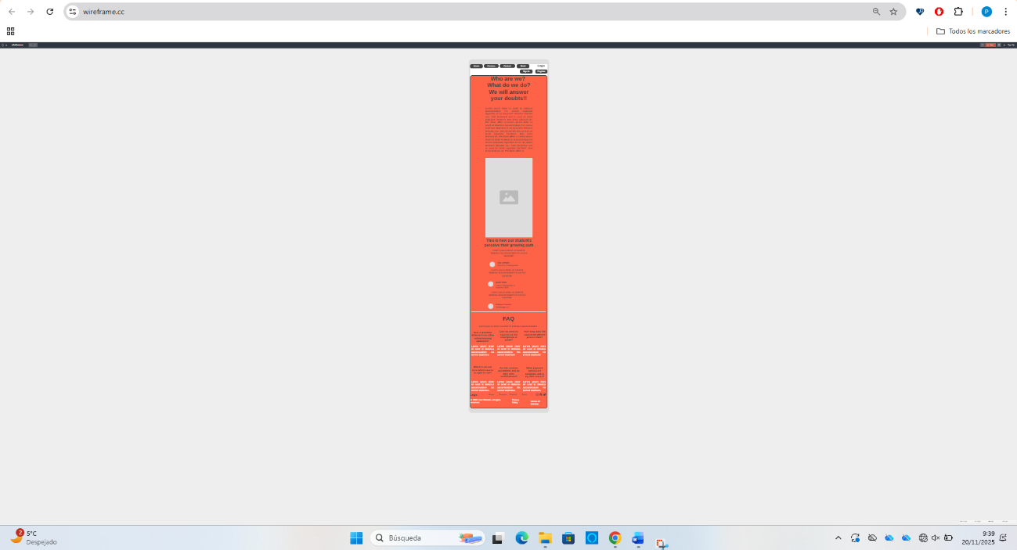

Contact Page

Desktop
https://wireframe.cc/KBhrGO
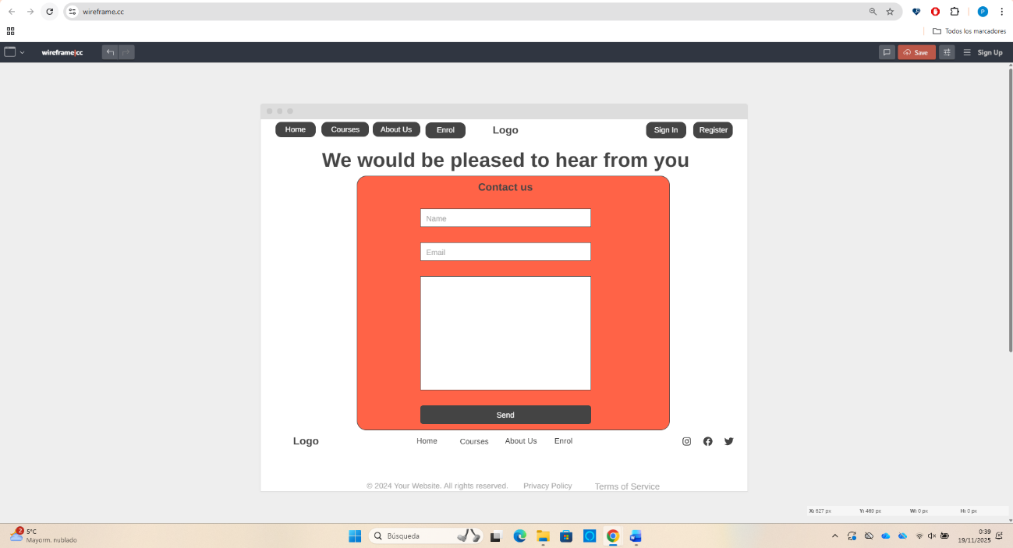

Mobile
https://wireframe.cc/kXLFr4
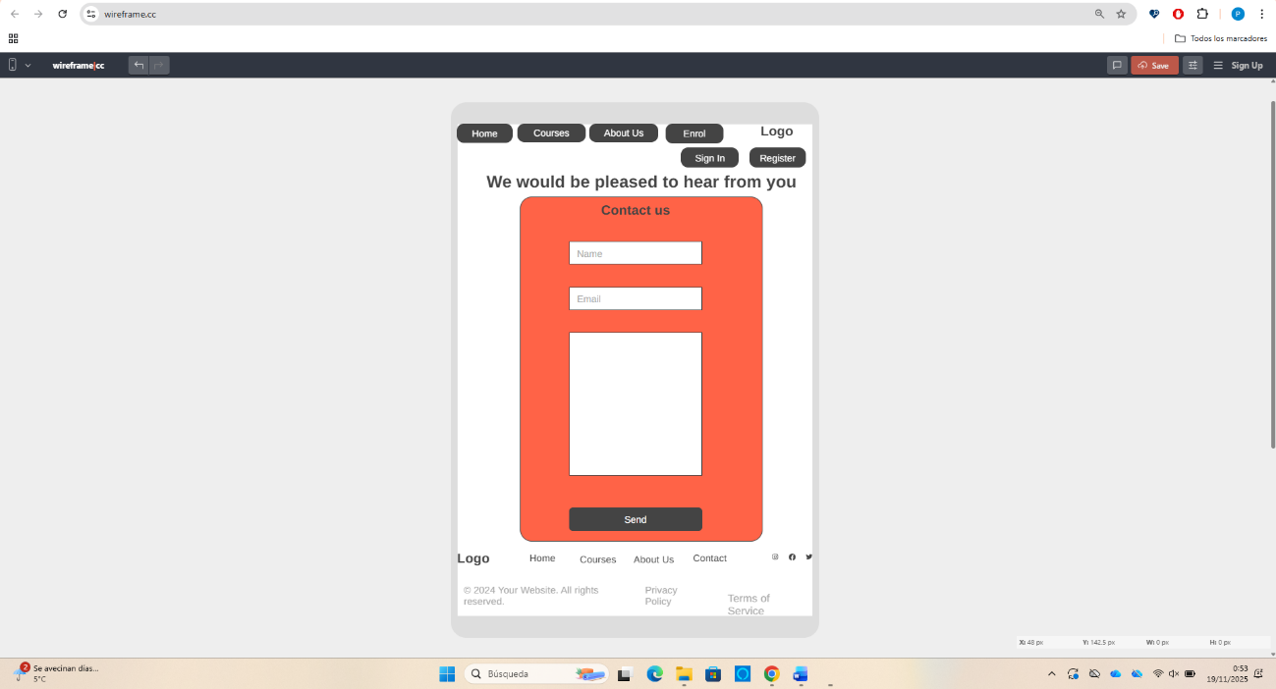

Enrol Page

Desktop
https://wireframe.cc/IhpG7p
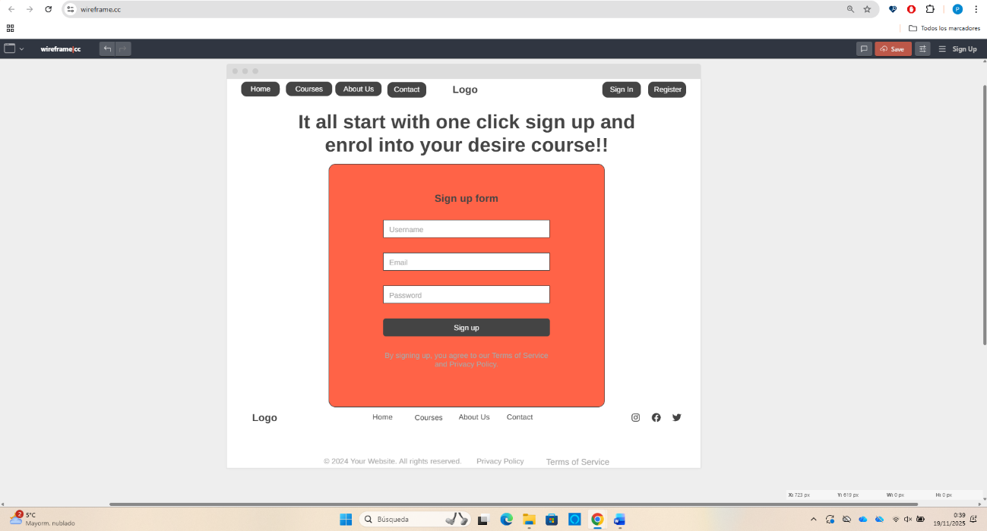

Mobile
https://wireframe.cc/iqxxeU
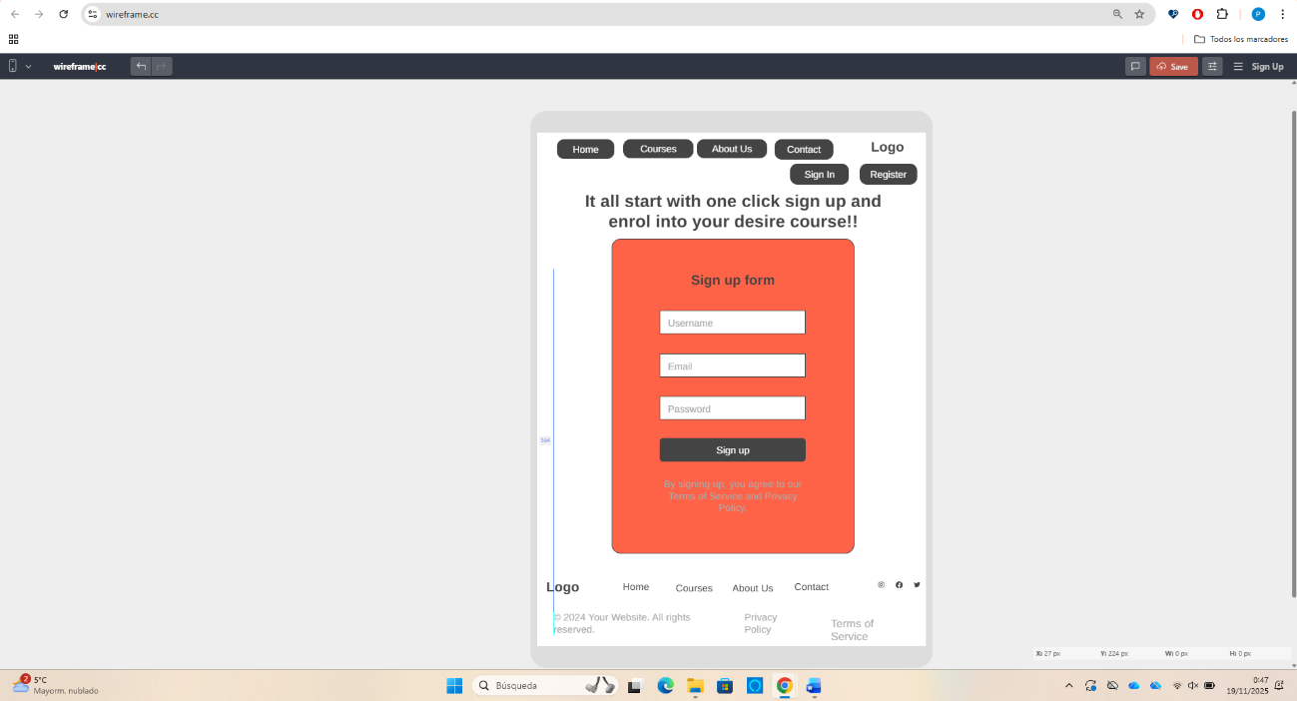

EduNext website Prototype
To be capable of create a functional prototype I have used Figma as my tool for EduNext website. Therefore, the prototype focuses heavily on the streamlined enrolment journey, which was previously a point of high abandonment:
- Simplified Enrolment: The Enrol page (Desktop and Mobile) is reduced to the minimal necessary steps (a single sign-up form). This design choice adheres to usability guidance that essential actions must be achieved within minimal steps [4]. The Vibrant Orange accent colour is used exclusively to highlight the final Sign Up button, maximizing focus and encouraging conversions.​
- Motivating Content: The homepage incorporates large, clear Calls to Action (CTAs) and personalized recommendation areas to encourage deeper user engagement [7] and support intrinsic motivation.​
- Accessibility and Consistency: All interactive elements, including rounded form fields and high-contrast text, reinforce the accessible and approachable aesthetic established in the mood board. All typography, spacing, and colour combinations have been evaluated against WCAG 2.2 standards to ensure sufficient contrast and legibility, informed by guidelines on perceptual design [8].​
The final interactive prototype provides conclusive evidence that the structural and visual redesign successfully addresses all usability constraints and aligns the platform with its strategic business goal of increased engagement and enrolment. With pleasure, I will leave the URL of the online website to visit it:
https://badge-camera-81762659.figma.site/

CONCLUSION
The EduNext website redesign project successfully met its core objective by transforming an outdated platform with usability challenges into an intuitive, brand-cohesive, and fully responsive digital learning experience. The design process applied established UX/UI frameworks, moving logically from defining the aesthetic tone in the Mood Board [10] to creating the structural integrity in the Wireframes. Additionally, the final prototype demonstrates an effective solution grounded in theory:
- Aesthetic Success: The high-contrast palette of Deep Indigo and Vibrant Orange leverages Visceral Emotional Design [5] to improve first impressions and build user trust.
- Functional Success: The use of Gestalt principles [6] simplified navigation, while the commitment to responsive design achieved high usability across all devices [9]. Crucially, the streamlined enrolment journey [4] directly addresses the problem of user abandonment, leading to higher conversion potential.
By applying principles like Krug’s “don’t make me think” [4], the redesign establishes EduNext as a modern, reliable, and engaging platform, thereby advancing its strategic goal of increasing user trust, engagement, and long-term enrolment retention.

REFERENCES

[1] | D. Norman y J. Euchner, «Design for a Better World,» Research-Technology Management, vol. 66, nº 3, pp. 11-18, 2023.
[2] | N. Tuli y A. Mantri, «Usability Principles for Augmented Reality based Kindergarten Applications,» Procedia Computer Science, vol. 172, pp. 679-687, 2020.
[3] | J. J. Garrett, The elements of user experience, マイナビ出版, 2022.
[4] | S. Krug, «Don’t make me think, Revisited,» A Common Sense Approach to Web and Mobile Usability, vol. 3, 2014.
[5] | U. Rättel, «Creating emotions using visual design,» TURKU UNIVERSITY OF APPLIED SCIENCES - Master of Culture and Arts, 2021.
[6] | K. J. Murchie y D. Diomede, «Fundamentals of graphic design—essential tools for effective visual science communication,» FACETS, vol. 5, nº 1, pp. 409-422, 2025/11/03.
[7] | G. Colborne, «Simple and usable web, mobile, and interaction design,» New Riders, 2017.
[8] | J. A. Johnson, «Designing with the mind in mind: The psychological basis for ui design guidelines,» de Proceedings of the 33rd Annual ACM Conference Extended Abstracts on Human Factors in Computing Systems, 2015.
[9] | A. Parlakkiliç, «Evaluating the effects of responsive design on the usability of academic websites in the pandemic,» Education and information technologies, vol. 27, nº 1, pp. 1307-1322, 2022.
[10] | O. Romaniuk y Y. Kovalova, «Web design development concepts,» GS Publishing Services, pp. 30-94, 2025.

