MBA Marketing Management

Table of Contents
1. Introduction 3
2. Company Background 4
3. Communication in Marketing Process 5
3.1. The Shannon-Weaver Model of Communication 5
3.2. Integrated Marketing Communications 6
4. New promotional strategies 7
4.1 Online strategies 7
4.2 Offline strategies 7
5. Brand Equity 7
5.1 Keller’s Brand Equity Model in relation to the company 8
6. Customer Journey Map 9
6.1 Pre-purchase customer journey map 11
6.2. “During the purchase” customer journey map 11
6.3 Post-purchase customer journey map 12
7. Total Engagement Model 12
8. Recommendations 13
9. Conclusion 13
10. References 14
11. Appendices 16
Appendix 1: Shell PLC company logo 16
Appendix 2: Shell PLC revenue report 2021 17
Appendix 3: Kellar’s pyramid 18
Appendix 4: Key Elements of Integrated Marketing 19

Introduction
Shell PLC is a global energy company that is tangled in the investigation, creation, and marketing of oil and gas. The company is also involved in refining, chemicals, and alternative energy sources. As a multinational corporation, Shell PLC has a presence in over 70 countries worldwide. Marketing management is one of the key aspects of Shell PLC's operations. It is responsible for creating and executing marketing strategies that will help the company achieve its goals. Through marketing management, Shell PLC is able to reach its target audience, establish brand recognition, and increase its market share. The marketing management of Shell PLC is responsible for the development and execution of strategic plans that will enable the company to reach its goals. This includes identifying target markets, setting price points, developing promotional campaigns, and creating channels of distribution. The marketing team must also stay abreast of the latest trends in the industry and develop appropriate strategies to capitalize on them.

Figure 1: Shell plc logo
Source: (shell.com, 2022 )
By being mindful of these considerations, Shell PLC can ensure that it is operating in an ethical and socially responsible manner. Shell PLC's marketing management team is responsible for a wide range of activities. These include developing and executing marketing strategies, assessing market conditions, and managing the resources of the company. By doing so, the team is able to drive the company towards its goals and ensure that Shell PLC remains competitive in the energy industry.

2. Company Background
Shell PLC is a global energy company that was founded in 1907 in London, England. It is a part of the Royal Dutch Shell Group and is one of the largest oil and gas companies in the world. The company’s headquarters are located in The Hague, Netherlands, and its main operations are in the United States, United Kingdom, and Australia.
Shell PLC was founded by two Dutch entrepreneurs, Marcus Samuel and his son, Samuel Marcus. The two had previously been trading kerosene in the Far East and wanted to expand into the oil business (Halim, 2019). They founded the Shell Transport and Trading Company in 1897 and the Royal Dutch Petroleum Company in 1890 in order to do so.
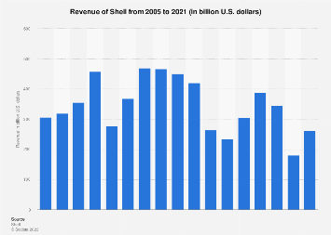
Figure 2: Revenue of Shell from 2010 to 2022
Source: (Aizarani, 2023)

In 1907, the two enterprises merged to form the Royal Dutch Shell Group, which is now known as Shell PLC. The company is involved in a variety of businesses, including oil and gas exploration, production, and marketing, refining, chemicals, and alternative energy sources (Lemken, 2021). It is one of the world’s prominent energy corporations, with operations in more than 70 countries.
Shell PLC is a openly traded company, with shares listed on the London Stock Exchange and Euronext Amsterdam. It is one of the 30 companies that make up the FTSE 100 Index, and it is also a component of the Euro Stoxx 50. The company’s total revenue in 2020 was $327 million.
Shell PLC is committed to providing energy solutions that meet both the needs of the present and the challenges of the future. It is also dedicated to helping build a better future for the communities in which it operates.

3. Communication in Marketing Process
Communication is the process of exchanging information, ideas, and feelings between two or more people. It is a fundamental part of all relationships and is essential for the successful functioning of any organization. It involves a sender, a message, and a receiver, and can be verbal, non-verbal, written, or digital (Krizanova, 2019). Effective communication is essential for the successful completion of any task, as it allows people to exchange ideas, build relationships, and make decisions. It is a critical part of the marketing process, as it helps to create a connection between the company and its target audience.

3.1. The Shannon-Weaver Model of Communication
The Shannon-Weaver Model of Communication is a linear model of communication that was developed by mathematician Claude Shannon and philosopher Warren Weaver in 1949. The model consists of five components: sender, message, channel, receiver, and feedback. The model explains the process of communication and how it is affected by noise or interference. It can be verbal, non-verbal, written, or digital (Daiva Labanauskaitė & Stašys, 2020). The channel is the standard through which the message is sent, such as a telephone call, email, or text message.

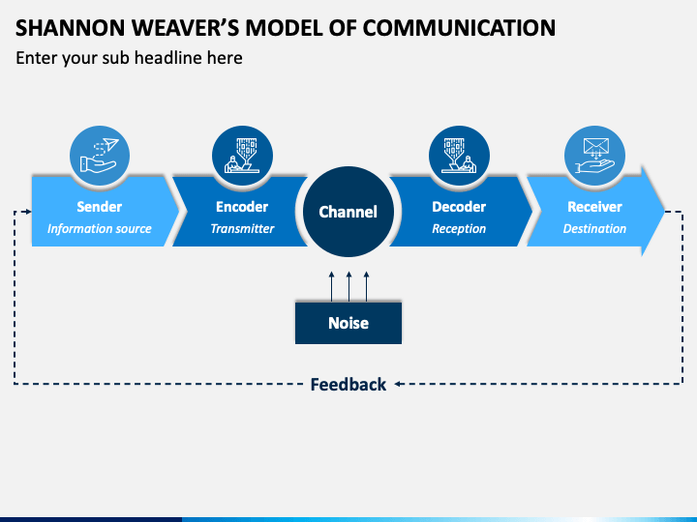
Figure 3: Shannon and Weaver Model of Communication
Source: (Kuznar, 2020)
This model of communication is useful for understanding how messages are transmitted and received. It can be used to identify potential problems that may arise when communicating, such as noise or interference, and how to overcome them. It can also be used to assess the effectiveness of communication strategies and determine how to improve them (Saura, 2021). The Shannon-Weaver Model of Communication is an important tool for understanding the communication process and improving the effectiveness of messages (Kuznar, 2020). It can be used to help develop effective strategies for marketing and other business processes.

3.2. Integrated Marketing Communications
Integrated Marketing Communications (IMC) is a marketing strategy that uses various communication channels to promote a product or service. It is a holistic approach to marketing that uses multiple channels to deliver a unified message. It is based on the idea that a consistent message will have a greater impact on the target audience.
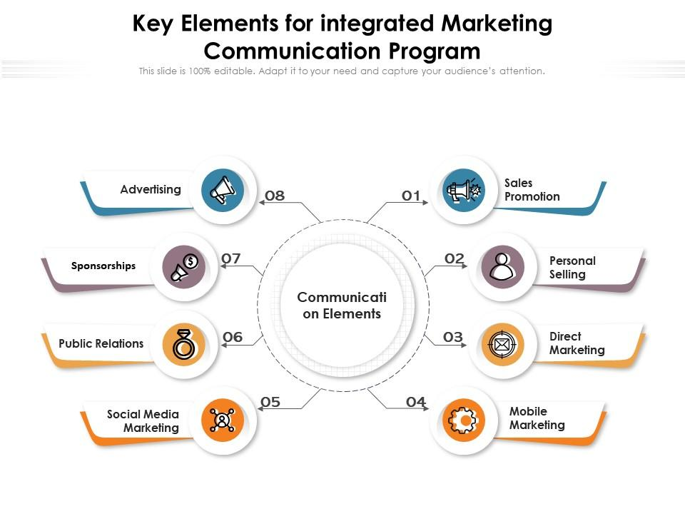
Figure 4: Key Elements for integrated Marketing Communication Programme
Source: (slideteam.net, 2021)

IMC involves the coordination of various marketing activities, such as advertising, public relations, direct marketing, digital marketing, sales promotion, and social media. By using multiple channels to reach customers, the company can create a unified message that will be more effective in reaching its target audience. IMC is a powerful tool for increasing brand awareness and establishing relationships with customers. It can also be used to drive conversions and sales.

4. New promotional strategies

4.1 Online strategies
Shell PLC can use a variety of online marketing approaches to raise consciousness of its brand. These strategies include creating content such as blog posts, videos, and social media posts; running targeted advertising campaigns; and developing a presence on social media platforms such as Twitter, Facebook, and Instagram. The company can also use influencer marketing to reach a wider audience. By partnering with influential people in the industry, Shell PLC can reach a larger audience, build relationships with potential customers, and increase brand recognition. The company can also use search engine optimization (SEO) to increase its visibility online.

4.2 Offline strategies
Shell PLC can use a variety of offline marketing plans to raise awareness of its brand. These strategies include running traditional advertising campaigns in print, radio, and television; participating in trade shows and exhibitions; and sponsoring events. The company can also use direct mail marketing to reach potential customers. By sending promotional materials such as brochures, flyers, and postcards to potential customers, the company can increase brand recognition and drive sales. the company can use public relations to generate positive publicity.

5. Brand Equity
Branding is the process of making a exclusive personality for a company or product. It involves creating a name, logo, slogan, and other elements that will help the company or product stand out from its competitors. Branding is an important part of any marketing strategy, as it helps to establish a strong connection between the company and its target audience. Brand equity is the value that a company or product has in the eyes of its customers. It is based on the perception of the company or product and its ability to deliver on its promises. Brand equity is an significant factor in the success of a company or product, as it can help to attract new customers and retain existing ones. Brand equity is created through a amalgamation of factors, including the quality of the product or service, the reputation of the company, and the level of customer loyalty. It is also affected by the company’s marketing efforts, as well as its ability to differentiate itself from the competition.

5.1 Keller’s Brand Equity Model in relation to the company
Keller’s Brand Equity Model is a basis for accepting how customers perceive a brand. The model comprises of four components: brand salience, brand performance, brand imagery, and brand judgment. Brand salience is the customer’s awareness of the brand. It is based on the customer’s ability to recall the brand and recognize it when they encounter it. Brand performance is the customer’s assessment of the brand in terms of quality, reliability, and other factors. Shell PLC has a strong brand identity and is well-known in the energy industry (Uford, 2021). Its brand salience is high, as customers are aware of the company and recognize its name and logo. The company is also known for its high-quality products and services, and its brand performance is excellent (Ishaq, 2020). Customers also view the company as reliable, trustworthy, and innovative, and its brand imagery is positive. Finally, customers have a high opinion of the company and its brand judgment is strong.
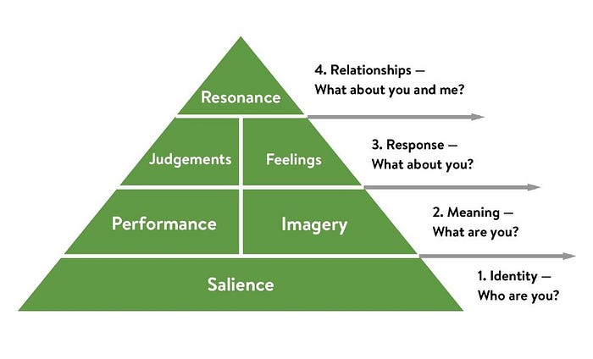
Figure 5: Keller’s Brand Equity Model
Source: (Hawker, 2019)
Advantages of Keller’s Brand Equity Model
Keller’s Brand Equity Model is a useful tool for understanding how customers perceive a brand. It provides a framework for evaluating a brand’s salience, performance, imagery, and judgment and can be used to assess the effectiveness of a brand’s marketing efforts. The model can also be used to identify potential problems with a brand’s identity and to develop strategies for addressing them. By understanding what customers think of the brand, companies can develop strategies to improve the brand’s perception and create a stronger connection with its target audience? The model can also be used to identify opportunities for growth and to develop new strategies for increasing brand awareness.
Disadvantages of Keller’s Brand Equity Model
Keller’s Brand Equity Model is a useful tool for understanding how customers perceive a brand, but it does have some limitations. One of the main disadvantages of the model is that it is based on customer perceptions, which can be difficult to measure accurately. Customers may not always be able to articulate their thoughts and feelings about a brand, so the model may not provide an accurate picture of the brand’s identity. The model does not take into account the influence of external factors on a brand’s identity. Factors such as economic conditions, political events, and social trends can all have an impact on a brand’s identity, but they are not taken into account in the model (Mihaela Simona Moise & Molina, 2019). Keller’s Brand Equity Model is a useful tool for understanding how customers perceive a brand, but it does have some limitations.

6. Customer Journey Map
Shell Plc's customer journey map begins with the awareness stage, where customers become aware of the company through various marketing channels such as advertising and social media. In the consideration stage, customers research more about Shell Plc's products and services before making a purchase decision. The purchase stage involves customers buying Shell Plc's products and services through various channels, including petrol stations and online stores. In the service stage, customers expect a seamless and satisfactory experience, including easy payment options and prompt customer support. The customers become loyal advocates of Shell Plc by repeatedly using its services, recommending it to others, and actively promoting it through various channels.
Strengths:
The customer journey map covers all stages of the customer experience, from awareness to loyalty.
The map provides a framework for tracking and measuring customer satisfaction, loyalty, and advocacy, enabling Shell Plc to identify areas of improvement and optimize its customer experience.
Weaknesses:
The customer journey map is focused on the customer perspective and may not fully capture the internal processes and challenges faced by Shell Plc. The map may oversimplify the complexity of the customer experience, as customers may move back and forth between stages or have different experiences based on their individual preferences and circumstances. It does not explicitly address the role of feedback and customer insights in shaping the customer experience, which could limit Shell Plc's ability to continuously improve its offerings.
The map assumes that all customers follow a linear path from awareness to loyalty, which may not be the case for all customers, particularly those who have previous experience with Shell Plc.
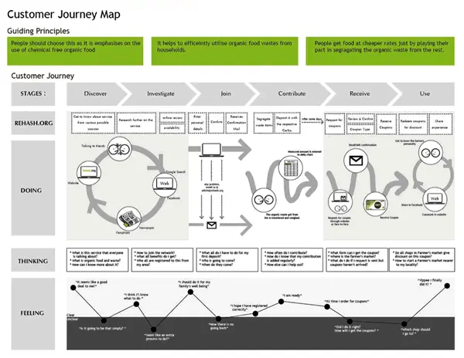
Figure 6: The Customer Journey Map
Source: (DecisionLink, 2022)
They may then visit the company’s website to learn more. From there, they may use the website to explore the company’s products and services, or they may contact customer service directly with questions or concerns. If a customer decides to make a purchase, they will then enter the store or place an online order. Customers may also use the store’s website to check stock availability, read product reviews, and compare prices. After making their purchase, customers may use the store’s website to track their order or contact customer service for assistance.

6.1 Pre-purchase customer journey map
Shell PLC’s pre-purchase customer journey map outlines the various steps that customers may take prior to making a purchase. The consumer journey begins with the customer becoming aware of the company through advertisements or word-of-mouth. The customer then visits the company’s website to learn more. On the website, they can explore the company’s products and services and read customer reviews (Janice Rudkowski & Gunn, 2020).The customer may then use the company’s store sensor to find the adjacent store. They may also use the store’s website to check stock availability, read product reviews, and compare prices. If the customer is satisfied with their research, they may then make a purchase (Modha, 2023). By understanding the pre-purchase customer journey, Shell PLC can identify potential problems in the customer experience and develop strategies to improve it.

6.2. “During the purchase” customer journey map
Shell PLC’s “during the purchase” customer journey map outlines the various steps that customers may take during the purchase process. The customer journey begins with the customer entering the store or placing an online order. In-store, customers may use the store’s website to check stock availability, read product reviews, and compare prices. They may then select the products they wish to purchase and proceed to the checkout. Online, customers may do the same and proceed to the checkout page. At the checkout, customers may use the store’s website to pay for their purchase, or they may contact customer service for assistance. After making their purchase, customers may use the store’s website to track their order or contact customer service for assistance.

6.3 Post-purchase customer journey map
Shell PLC’s post-purchase customer journey map outlines the various steps that customers may take after making a purchase. The customer journey begins with the customer receiving their order and unpacking it. If the customer is satisfied with the product, they may then leave a positive review on the store’s website or social media channels. If the customer has any issues with the product, they may contact customer service for assistance. The customer may then use the store’s website to check for any new promotions or discounts. They may also use the store’s website to track their order or contact customer service for assistance.

7. Total Engagement Model
The Total Engagement Model is a comprehensive approach to marketing that seeks to create a connection between the company and its target audience. It is based on the idea that a company can create a deeper relationship with its customers by engaging them across a variety of channels. The model consists of four steps: awareness, consideration, conversion, and retention. The first step, awareness, involves creating brand recognition and establishing a connection with the customer. The second step, consideration, involves engaging the customer with content and providing them with helpful information. The third step, conversion, involves convincing the customer to purchase the product or service (Henry, 2019). Finally, retention involves creating ongoing relationships with customers and providing them with a positive experience.
Engage and Inform
Convert
Attract
Loyalty
Shell PLC can use the Total Engagement Model to create a deeper relationship with its customers and increase sales. The model provides a comprehensive approach to marketing that can help the company to reach its target audience and create a stronger brand identity. At the awareness stage, Shell PLC can use a variety of online and offline strategies such as traditional advertising, content marketing, and influencer marketing to create brand recognition.

8. Recommendations
Shell PLC can use a variety of strategies to improve its marketing efforts and increase sales. The following recommendations can help the company to reach its target audience and create a stronger brand identity. First, the company should focus on digital marketing. It should create a strong presence on social media platforms such as Twitter, Instagram, and Facebook, and use targeted advertising campaigns to reach potential consumers. The company should also invest in search engine optimization (SEO) to increase its visibility online. Second, the company should use influencer marketing to reach a wider audience.

9. Conclusion
The marketing management of Shell PLC is responsible for developing and executing strategies that will help the company to reach its goals. Through the use of various strategies, such as digital marketing, influencer marketing, and data analytics, the company can reach its target audience and create a stronger brand identity. The company should also focus on customer experience, as this is critical for driving sales and increasing customer loyalty. By understanding the customer journey and using the Total Engagement Model, the company can identify potential problems in the customer experience and develop strategies to improve it.

10. References
Aizarani, J., 2023. Revenue of Shell from 2010 to 2022. [Online]
Available at: https://www.statista.com/statistics/268734/revenue-of-shell/
Daiva Labanauskaitė, M. F. & Stašys, R., 2020. Use of E-marketing tools as communication management in the tourism industry. Tourism Management Perspectives, p. 100652.
DecisionLink, 2022. The Importance of Customer Journey Mapping. [Online]
Available at: https://www.decisionlink.com/blog/the-importance-of-customer-journey-mapping
Halim, K. a. H. S., 2019. Business intelligence for designing restaurant marketing strategy: A case study.. Procedia Computer Science, pp. 615-622.
Hawker, K., 2019. Keller’s Brand Equity Model — What It Is & How to Use It. [Online]
Available at: https://medium.com/@keatonhawker/kellers-brand-equity-model-what-it-is-how-to-use-it-84e42d562299
Henry, L. B. T. a. J. R., 2019. Leading corporate sustainability: T he role of top management team composition for triple bottom line performance. Business Strategy and the Environment, , pp. 173-184.
Ishaq, M. a. D. M. E., 2020. Sustainability countenance in brand equity: A critical review and future research directions. Journal of Brand Management, , pp. 15-34.
Janice Rudkowski, C. H. H. Y. S. S. & Gunn, F., 2020. Here Today, Gone Tomorrow? Mapping and modeling the pop-up retail customer journey. Journal of Retailing and Consumer Services.
Krizanova, A. L. G. G. L. K. J. N. M. a. M. D., 2019. The effectiveness of marketing communication and importance of its evaluation in an online environment.. Sustainability, p. 7016.
Kuznar, L. a. Y. M., 2020. Joint Staff J39, Strategic Multi-layer Assessment Washington, DC United States. The Development of Communication Models, Quick Look. .
Lemken, R. a. S. J., 2021. The use of interest-inventory measurements in marketing education: Improving MBA student team effectiveness.. ournal of Marketing Education, , pp. 75-90.
Mihaela Simona Moise, I. G.-S. M. Š. & Molina, M. E. R., 2019. Influence of environmental practices on brand equity, satisfaction and word of mouth. Journal of Brand Management volume.
Modha, B., 2023. Exploring Customer Journeys in the Context of Dentistry: A Case Study. Dent. J.
Saura, J. R.-S. D. a. P.-M. D., 2021. Setting B2B digital marketing in artificial intelligence-based CRMs: A review and directions for future research.. Industrial Marketing Management,, pp. 161-178.
shell.com, 2022 . www.shell.com. [Online]
Available at: https://www.shell.com/
slideteam.net, 2021. slideteam.net/. [Online]
Available at: https://www.slideteam.net/
Sukhareva, A., 2021. How to Provide Effective Support at Every Stage of Customer Journey Map?. [Online]
Available at: https://www.dashly.io/blog/support-at-cjm-stages/
Uford, I. a. D. H., 2021. Measuring the Sources and Outcomes of Customer Based Brand Equity in a Service Industry.. African Journal of Business & Economic Research.

