
Electrical Power Assignment
By Tommy-Lee Hennegan-Rosser


Table of Contents
Abstract 2
List of figures 4
Table of Figures 4
Total energy and power demands 5
Energy and power costs: 16
Average wind speeds each month in Llanrwst 17
Energy output By Wind Turbine calculations 17
Turbine selections 19
Wind turbine choice pick confirmed: 22
Wind power system 23
23
(Topographic maps. , N.D) 23
Converter: 24
The Battery: 24
Total cost of wind power system: 30
Total cost of maintenance: 30
Electricity Tariffs 31
References 32

List of figures
Figure 1 15
Figure 2 18
Figure 3 19
Figure 4 20
Figure 5 21
Figure 6 22
Figure 7 26
Figure 8 27
Figure 9 28
Figure 10 28

Number of tables

Table 1 5
Table 2 6
Table 3 7
Table 4 8
Table 5 9
Table 6 10
Table 7 11
Table 8 12
Table 9 13
Table 10 14
Table 11 16
Table 12 16

Abstract
The purpose of this report is to demonstrate the ability to design, solve and deal with realistic renewable energy problems. To develop low-cost solutions that are simple to manufacture, assemble and maintain, also to assess the quality of the work in terms of efficiency and reliability.

The problem: The reliance of the European Union and the United Kingdom on Russian natural gas supplies has increased over the last decade. Since the start of the war in Ukraine, Russia decided to suspend the supplies of the natural gas that continental Europe and the UK have been using for years to run factories, generate electricity and generate heat for homes. The price of natural gas is almost 5 times compared to what it was two years ago, this is putting governments worldwide under serious pressure. Rising energy prices are accelerating the cost-of-living crisis, increasing the cost of food, and causing energy poverty; and increasing social unrest. The current global energy crisis and the impacts of environmental/climate change accelerate the transition towards cleaner renewable and cheaper sources than fossil fuels.
This will report will have a lot of critical research performed, which is essential to get the most information needed to successfully perform the task.
In the United Kingdom, there are many small villages that suffer from:
- Poor or insufficient electrical power supply due to technical and environmental problems in connecting these villages with the high voltage grid.
- A current worldwide energy price crisis.
The daily average use of energy demands in these villages is low and varies in the range 8-10 kWh per household. Some of these villages are in regions with high winds that are ideal for use of wind turbines, while other villages have high solar potential that allow use of Photovoltaic generators for generating electricity.
With all the information given in the assignment brief, Task A the local council has ordered a mission to design a small off grid of a Renewable Wind Energy system. Task B requires to design a small off grid Renewable Solar Energy System. The designed electrical power system must provide self-sufficient electrical power based on the natural potential energy recourses available in the geographical site of the village.

Total energy and power demands
Total energy demands for one day:
Table 1
 | Amount of buildings | Average Energy Consumption / Day (kWh) | Total Average Energy Consumption / Day (kWh)
Cottages | 120 | 10 | 1200
School 1 | 1 | 100 | 100
School 2 | 1 | 100 | 100
Police Station | 1 | 120 | 120
Hospital | 1 | 250 | 250
Worship House 1 | 1 | 11.40 | 11.40
Worship House 2 | 1 | 11.40 | 11.40
Sport centre | 1 | 40 | 40
Streets and traffic lights | 80 | 2 | 160
 |  |  | 1992
 |  |  | 1.99 MWh

To calculate the total energy demands for Llanrwst for one day, the table above is a very useful way of doing so. Each building that requires energy is listed in each column with the second column stating the amount of buildings there are, the third column shows the average energy consumption per day (kWh) with the final column stating the total average energy consumption per day for each building (For example, there are 120 cottages that require 10 kWh, therefore the average total energy consumption per day (in kWh) is: (120 * 10 = 1200kWh).
$$Total energy demands for one day=1200+100+100+120+250+11.40+11.40+40+160=1992kWh or 1.99MWh$$

Total Energy demands for a week:
Table 2
 | Amount of buildings | Average Energy Consumption / Week (kWh) | Total Average Energy Consumption / Week (kWh)
Cottages | 120 | 70 | 8400
School 1 | 1 | 700 | 700
School 2 | 1 | 700 | 700
Police Station | 1 | 840 | 840
Hospital | 1 | 1750 | 1750
Worship House 1 | 1 | 80 | 80
Worship House 2 | 1 | 80 | 80
Sport centre | 1 | 280 | 280
Streets and traffic lights | 80 | 14 | 1120
 |  |  | 13950
 |  |  | 13.95 MWh

Using the first table to calculate the total energy demands for a week, we can simply calculate it by understanding that a week is 7 days. Therefore, the daily energy demands can be multiplied by 7 to get the weekly energy demands:
$$Total energy demands for a week:\left(1992\right)\left(7\right)=13950kWh or 13.95MWh$$

Total Energy demands for a month:
Table 3
 | Amount of buildings | Average Energy Consumption / Month (kWh) | Total Average Energy Consumption / Month (kWh)
Cottages | 120 | 280 | 33600
School 1 | 1 | 2800 | 2800
School 2 | 1 | 2800 | 2800
Police Station | 1 | 3360 | 3360
Hospital | 1 | 7000 | 7000
Worship House 1 | 1 | 320 | 320
Worship House 2 | 1 | 320 | 320
Sport centre | 1 | 1120 | 1120
Streets and traffic lights | 80 | 56 | 4480
 |  |  | 55800
 |  |  | 55.8 MWh

Once again, the energy demands for a month can be calculated from the previous table by understanding that there are four weeks in a month. Furthermore, multiplying the weekly energy demands by four should give out the monthly energy demands:
$$Total energy demands for a month:\left(13950\right)\left(4\right)=55800kWh or 55.8MWh$$

Total Energy demands for a year:
Table 4
 | Amount of buildings | Average Energy Consumption / Year (kWh) | Total Average Energy Consumption / Year (kWh)
Cottages | 120 | 3650 | 438000
School 1 | 1 | 36500 | 36500
School 2 | 1 | 36500 | 36500
Police Station | 1 | 43800 | 43800
Hospital | 1 | 91250 | 91250
Worship House 1 | 1 | 4161 | 4161
Worship House 2 | 1 | 4161 | 4161
Sport centre | 1 | 14600 | 14600
Streets and traffic lights | 80 | 730 | 58400
 |  |  | 727372
 |  |  | 727.37 MWh

The energy demands for a year can be calculated in a few ways: Multiplying the monthly energy demands by twelve; multiplying the weekly energy demands by fifty-two, or another way (which we will use in this example because it will ensure more accuracy) will be by multiplying the daily energy demands by 365 days.

Total Energy demands for 10 years:
Table 5
 | Amount of buildings | Average Energy Consumption / 10 years (kWh) | Total Average Energy Consumption / 10 years (kWh)
Cottages | 120 | 36500 | 4380000
School 1 | 1 | 365000 | 365000
School 2 | 1 | 365000 | 365000
Police Station | 1 | 438000 | 438000
Hospital | 1 | 912500 | 912500
Worship House 1 | 1 | 41610 | 41610
Worship House 2 | 1 | 41610 | 41610
Sport centre | 1 | 146000 | 146000
Streets and traffic lights | 80 | 7300 | 584000
 |  |  | 7273720
 |  |  | 7.3 GWh

A total energy demand for 10 years can easily be calculated by multiplying the energy demand for one year by 10.

Power demands for one day:
Table 6
 | Amount of buildings | Average Energy Consumption / Day (kWh) | Total Power consumption / Day (kW)
Cottages | 120 | 10 | 50
School 1 | 1 | 100 | 4.17
School 2 | 1 | 100 | 4.17
Police Station | 1 | 120 | 5
Hospital | 1 | 250 | 10.42
Worship house 1 | 1 | 11.40 | 0.48
Worship house 2 | 1 | 11.40 | 0.48
Sport centre | 1 | 40 | 1.67
Street and traffic lights | 80 | 2 | 6.67
 |  |  | 83.06
 |  |  | 83.06kW

The power demands can be calculated the same way as the energy demands, the only difference is energy demands are in 24 hours of each day. So, the total energy must be divided by 24 to get the total power demands.
$$Power demands for one day: 83.06kW$$

Power demands for a week:
Table 7
 | Amount of buildings | Average Energy Consumption / Day (kWh) | Total Power consumption/ Week (kW)
Cottages | 120 | 10 | 350
School 1 | 1 | 100 | 29.19
School 2 | 1 | 100 | 29.19
Police Station | 1 | 120 | 35
Hospital | 1 | 250 | 72.94
Worship house 1 | 1 | 11.40 | 3.36
Worship house 2 | 1 | 11.40 | 3.36
Sport centre | 1 | 40 | 11.69
Street and traffic lights | 80 | 2 | 46.69
 |  |  | 581.42
 |  |  | 581.42kW

The power demands for a week can be calculated by multiplying the power demands for one day by 7
$$Power demands for a week=83.06×24=581.42kW$$

Power demands for a month:
Table 8
 | Amount of buildings | Average Energy Consumption/ Day (kWh) | Total Power consumption/ Month (kW)
Cottages | 120 | 10 | 1400
School 1 | 1 | 100 | 116.76
School 2 | 1 | 100 | 116.76
Police Station | 1 | 120 | 140
Hospital | 1 | 250 | 291.76
Worship house 1 | 1 | 11.40 | 13.44
Worship house 2 | 1 | 11.40 | 13.44
Sport centre | 1 | 40 | 46.76
Street and traffic lights | 80 | 2 | 186.76
 |  |  | 2325.68
 |  |  | 2.33MW

The power demands for a month can be calculated by multiplying the power demands for a week (581.42kW) by 4:
$$Power demands for a month:581.42×4=2325.68kW or 2.33MW$$

Power demands for a year:
Table 9
 | Amount of buildings | Average Energy Consumption/ Day (kWh) | Total Power consumption/ Year (kW)
Cottages | 120 | 10 | 18250
School 1 | 1 | 100 | 1522.05
School 2 | 1 | 100 | 1522.05
Police Station | 1 | 120 | 1825
Hospital | 1 | 250 | 3803.3
Worship house 1 | 1 | 11.40 | 175.2
Worship house 2 | 1 | 11.40 | 175.2
Sport centre | 1 | 40 | 609.55
Street and traffic lights | 80 | 2 | 2434.55
 |  |  | 30,316.9
 |  |  | 30.3MW

The power demands for a year can be calculated by multiplying the power demands for a day (83.06kW) by 365, this method will ensure the most accurate power demands for a year:
$$Power demands for a year:83.06×365=30316.9kW or 30.3MW$$

Power demands for 10 years:
Table 10
 | Amount of buildings | Average Energy Consumption/ Day | Total Power consumption/ 10 years (kW)
Cottages | 120 | 10 | 182500
School 1 | 1 | 100 | 15220.5
School 2 | 1 | 100 | 15220.5
Police Station | 1 | 120 | 18250
Hospital | 1 | 250 | 38033
Worship house 1 | 1 | 11.40 | 1752
Worship house 2 | 1 | 11.40 | 1752
Sport centre | 1 | 40 | 6095.5
Street and traffic lights | 80 | 2 | 24345.5
 |  |  | 303169
 |  |  | 303.2MW

Finally, to calculate the power demands for 10 years, the power demands for a single year (30316.9kW) by 10:
$$Total power demands for 10 years:30316.9×10=303169$$


Energy and power costs:
Figure 1 (www.casita.com., (N.D) )

The average price of electrical supply by the National Grid of Electrical Power at the end of 2021 (before Ukraine war) is 18.9p/kWh
(www.casita.com., (N.D) )
Power consumption by Llanrwst / Day: 1999 kWh (1.9 MWh)
Cost of Electric energy / Day (£/Day) = (cost/kwh) (kWh/Day)
= (£0.189/kWh) (1999/Day)
= £377.81/Day

Cost of Electric Energy / Year (£/Year) = (cost/day) (365)
= (£377.81) (365)
= £137,900.65 / Year

Cost of Electric Energy / 10 years (£/10 years) = (cost/year) (10)
= (£137,900.65) (10)
= £1,379,009.50 / 10 years
(Average Cost of Electricity per kWh in the UK 2022 to Increase | Casita.com, 2021)

Wind Energy Power System to generate electrical power to the village
Firstly, the average wind speed per year in Llanrwst must be calculated:

Average wind speeds each month in Llanrwst

(kph)
Table 11
Jan | Feb | Mar | Apr | May | Jun | Jul | Aug | Sep | Oct | Nov | Dec
21.5 | 20.0 | 18.3 | 15.5 | 14.6 | 13.7 | 13.8 | 14.5 | 16.2 | 17.9 | 19.3 | 20.6
(weatherspark.com., N.D)
Average wind speeds each month in Llanrwst (converted to m/s)
Table 12
Jan | Feb | Mar | Apr | May | Jun | Jul | Aug | Sep | Oct | Nov | Dec
5.972 | 5.556 | 5.083 | 4.306 | 4.056 | 3.806 | 3.833 | 4.028 | 4.5 | 4.972 | 5.361 | 5.722

Average wind speeds per year in Llanrwst (m/s)
To calculate the average wind speed per year, each wind speed per month must be added together then divided by each month (12):
$$\frac{(5.972 + 5.556 + 5.083 + 4.306 + 4.056 + 3.806 +3.833 + 4.028 + 4.5 + 4.972 + 5.361 + 5.722)}{12}$$
$$Average annual wind speed in Llanrwst = 4.77m/s$$

Energy output By Wind Turbine calculations
The best formula for calculating the power output for a wind turbine in Watts:
$$P=0.5 Cp ρ π R^{2}V^{3}$$
$Cp = coefficient of performance \left(efficiency factor, in percent\right)$ $ρ=air density (kg/m^{3}$) $R=Blade length \left(in metres\right) V=wind speed (\frac{m}{s})$
The average blade length must be found in order to use the formula above, alongside the average wind speed annually in Llanrwst (which is 4.77m/s)
To calculate the number of turbines needed for Llanrwst, the annual power output of a single turbine must be calculated. This is done by finding the power output and then multiplying it by 24 and 365:
Number of turbines needed calculations:
Annual power output of selected turbine = (Power output) (24) (365)
Once the annual power output of selected turbine is calculated, the following formula should be used to calculate the number of turbines needed, which involves dividing the total energy demand in Llanrwst for a year (727372kW) by the annual power output of the selected turbine:
$$Number of turbines needed =\frac{Total Energy Demand for Llanrwst for a year}{Annual power output of selected turbine}$$

Turbine selections
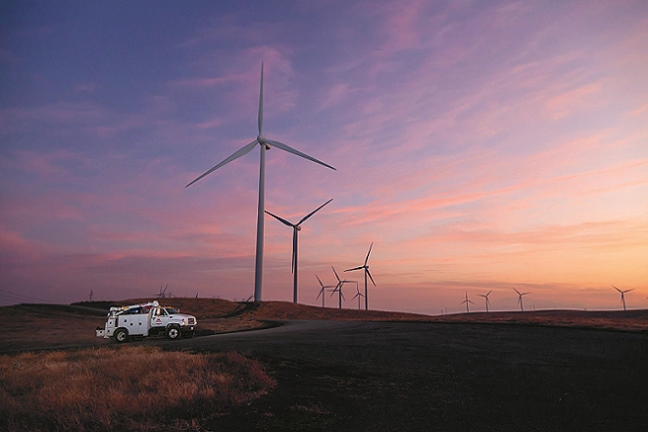
(V110-2.0 MW™ (vestas.com), n.d.)
Figure 2

The affective wind turbine that has been selected is the V110-2.0 MW
Power output of the selected turbine:
2.0MW (2000kW)
Annual power output with a 25% capacity:
$$2×24×365×25\%=4,380MW$$
= 4,380,000 kWh per year
Due to the low wind speed in Llanrwst, an estimated decrease in power output was calculated, more than 30% reduction in average wind speed, this leads to an estimated decrease in annual power output by 81%.
Therefore, the total annual power output after 81% decrease: $4380000×0.19=832,200$ $Number of turbines needed=\frac{727372}{832200}=0.87≈1.00$

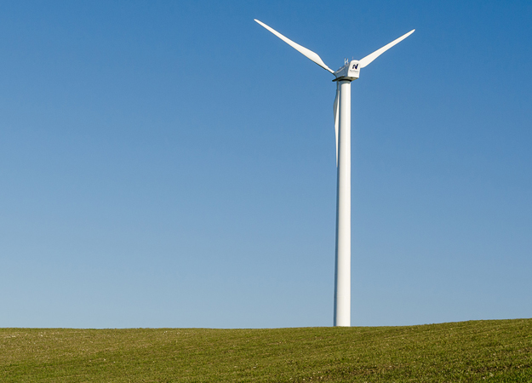
The second wind turbine choice will be: The NPS 100C-24 100kW wind turbine:
Figure 3 (NPS 100C-24 100kW, n.d)


Figure 4 (NPS 100C-24 100kW, n.d)

An average cost of a 100kW sized wind turbine had to be used as the cost of specific wind turbine chosen was not available. The average cost of a wind turbine size of 100kW is around £345,000. This means the only thing left to calculate is the annual total energy output of the wind turbine. (Checkatrade, 2022)

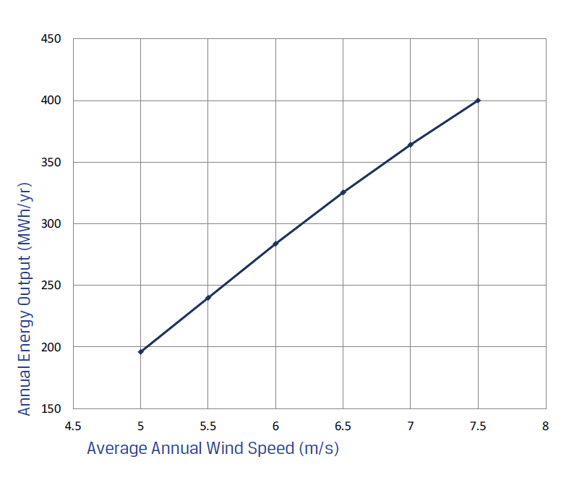
The power curve of the turbine as shown: At 5m/s, the Annual energy output of the wind turbine is roughly 190MWh per year, however the cut-in wind speed is at 3m/s, which means the turbine can still produce a lot of energy from our average weather wind speed in Llanrwst (4.77m/s). An estimated Annual energy power output has to be calculated looking at the graph. The graph is increasing in a straight linear line meaning we can take between the mark of 4.5m/s and 5m/s and estimate the Annual energy power output, which is roughly 175MWh (175000kWh).
Figure 5 (NPS 100C-24 100kW, n.d)

$$Number of turbines needed =\frac{Total Energy Demand for Llanrwst for a year}{Annual power output of selected turbine}$$
$$Number of turbines needed=\frac{727372}{175000}=4.16 turbines≈4 turbines$$
4 turbines was selected instead of 5, although it would be a safer option to have 5 turbines to exceed the energy demands, it is not yet noted that the power curve will have the wind turbines produce more wind energy at a significant rate on some months of each year, this is because the wind turbine energy output increase up to a whopping 200,000 kWh when the months have a windspeed of 5m/s or higher so the energy output expectations should still be met due to this reason.
$$Total cost for wind turbines=£345000×4=£1,380,000$$

(NPS 100C-24 100kW, n.d)

Wind turbine choice pick confirmed:
To conclude, the wind turbine that will be selected due to its efficiency with lower wind speeds will be the NPS 100C-24 100kW turbine, although the V110-2.0MW turbine provides a lot of power/energy output, it will be too expensive to maintain and use due to its large size for an area with low average wind speeds annually.

Wind power system

Figure 6

(Topographic maps. , N.D)

Due to the height above sea level (155m) and the amount of space available, the location was picked for the wind power system in Llanrwst. Not too far from the village as it will not be able to reach the village to supply the renewable energy but having the wind energy power system built in a high ground open space for more efficiency.

Converter:
For a small off grid wind power generation system, the unstable rotational speed of the generator, the electrical energy produced by the turbine becomes unstable. The solution to the problem is to convert the alternating current generated by the wind turbine into direct current, which charges the battery. With the wind turbine being selected, we can now move on to the converter, which is actually given in the wind turbine specification. The converter being used is the: Pulse-width modulated IGBT frequency converter. Luckily it comes with the wind turbines so there is no need to add a cost of a converter into the wind power system. ((NPS 100C-24 100kW, n.d.)
(www.diffen.com., (n.d.))

The Battery:
Daily power consumption in watt hours:
83,060-watt hours/day
Backup Days:
Ideally, battery banks should be able to supply power, even if there is a problem with the wind turbine. The amount of days of backup power wanted, this going to be assumed as 2 days as a preference. ( What is the Difference Between UPS and Battery Backup? , n.d)
Depth of Discharge (DoD):
The longest service life of a battery will be achieved by discharging the batteries as little as possible. Assuming the best possible ‘maximum depth of discharge’. The assumption of this will be 80%. (Battery University. BU-501: Basics about Discharging. , 2010)

Inverter efficiency:
The assumption will be 80%. (This is a standard industry figure for lower quality modified sine waves inverters)
(6.5. Efficiency of Inverters , n.d.)
Battery bank efficiency:
As the batteries being used will be modern low maintenance Lithium-ion batteries, the value will be assumed as 90%
(RAVPower, T, (2023))
Voltage:
Depending on the voltage of the electrical system, batteries may need to be connected together to create a bank at 12, 24 or 48V. Using a higher voltage is a useful way of reducing voltage loss over longer distances or reducing the size of charge controller needed. In order to work out the minimum capacity of the battery or battery bank, the result must be divided from the previous step by the desired voltage. The assumption for this will be 48V.
(www.primaryconnections.org.au, n.d.)

The difference between wiring batteries in series vs parallel:
The main difference in wiring batteries in series vs parallel is the impact on the output voltage and the capacity of the battery system. Batteries wires in series will have their voltages added together. Batteries wired in parallel will have their capacities (in amp-hours) added together. However, the total available energy in both series and parallel will be the same.
Example: wiring two 12-volt batteries with 100Ah capacities in series will output 24 volts with a 200Ah capacity. Therefore, both systems will have a total energy of 240-watt hours (watt-hours = volts X amp-hours).
Furthermore, batteries wired in series and parallel should all have the same voltage and capacity rating. Mixing and matching voltages and capacities can lead to problems that can cause battery damage.
(Batteries in Series vs Parallel: What’s Better? , N.D)

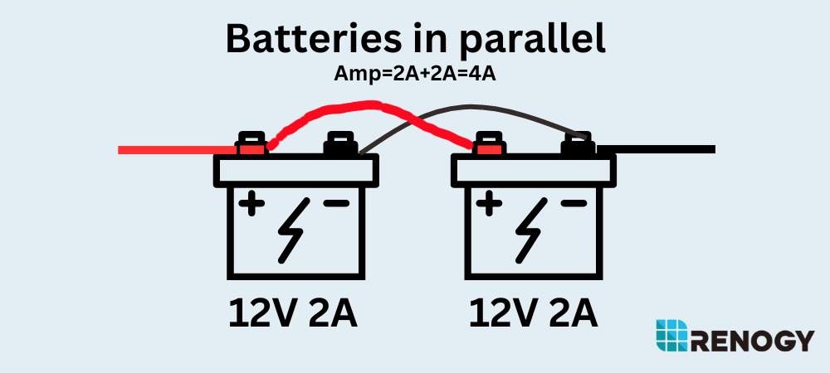
Figure 7 (Renogy, N.D)
The diagram above shows how two batteries in a parallel circuit are connected, batteries in parallel are both connected to their respected connection type, showing that the negative terminals of both batteries are connected together, alongside the positive terminals of both batteries are connected together. In this diagram the batteries are both 2Amp batteries, in parallel they are simply added together to make a total current (2A + 2A) creating a total current of the parallel circuit to 4Amps.
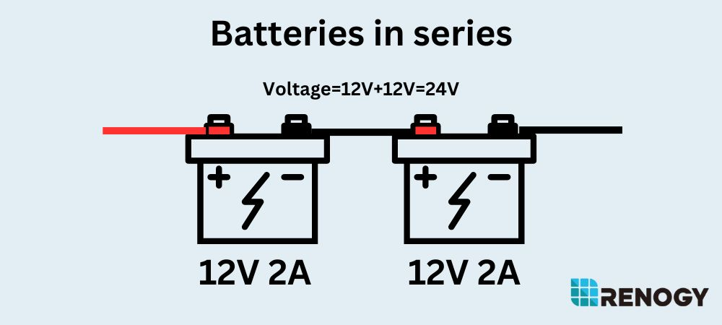
Figure 8 (Renogy, N.D)
This diagram above shows two batteries connected in a series circuit, the main difference between parallel and series battery circuits is compared to the parallel circuit having the batteries connected to their respected connection types, series battery circuits have end-to-end connection with the negative terminal of the first battery being connected to the positive terminal of the second battery. Unlike the parallel circuit allowing the current to be added together, the series circuit allows the voltage to be added together instead. Both batteries have 12Volts, therefore the total voltage of this series circuit is (12V + 12V) = 24Volts.
The battery selected:

Battery specification:
Figure 9 (Lithium-ion battery For Wind Energy Storage - Aokly. [online], n.d.)

Figure 10 (Lithium-ion battery For Wind Energy Storage - Aokly. [online], n.d.)

This ALFP-12200 battery was chosen because it meets the requirements of a good quality wind power system. Its durability and power output are astonishing, with a fantastic number of Amp-hours of 200 and 12.8V and its ability to be compatible with any type of weather Llanrwst faces throughout the year. The only downside is the battery cost could not be possibly found, so an estimated guess of around £1,600. Most wind farms need around 36 batteries so an estimated total cost on batteries was made.
$$Estimated battery costs:\left(1600\right)\left(36\right)=£57,600$$

Total cost of wind power system:
The wind turbines came to a total of: £1,380,000
Converter: (Added in with the wind turbines)
Battery: £57,600
$$Total cost:\left(1,380,000\right)+\left(57,600\right)=£1,437,600$$

Total cost of maintenance:
Now that the cost of the wind power system equipment is calculated, the maintenance cost must now be calculated including the wage of a technician to carry out maintenance tasks to ensure everything remains under high standard. As we identify in the task, the cost of spare parts must be assumed as 3% of the total cost of the wind power system equipment. Furthermore, the average yearly wage of a technician for wind farm maintenance is around £32,250:
( Wind Turbine Technician Salary in United Kingdom , n.d)
Wind turbine spare parts:
$$3\% of £1,380,000=£41,400$$

Battery spare parts:
$$3\% of £57,600=£1,728$$
Total spare parts (including technician salary)
$$\left(£41,400\right)+\left(£1,728\right)+(£32,500)=£75,628$$

Electricity Tariffs
For the tariff, the cost of 10 years of maintenance will have to be calculated. This is then added on to the initial cost of purchasing the equipment, taking into consideration that there is a 0% interest rate on the capital there is no need to add a percentage of each yearly interest rate as there are none.

Calculating the wind farm tariff:
The cost of maintenance for 10 years must be calculated. This is simply done by multiplying every annual maintenance cost by 10 and adding onto the cost of the turbines and batteries.
$$Wind farm tariff=\left(£75,638\right)+\left(£57,600\right)+\left(£1,380,000\right)=£1,513,238$$
The next step is to divide the cost by the number of cottages inside the village. This will give us the value that each person who owns a cottage will have to pay over 10 years to fund the costs of the wind farm setup and the maintenance costs:
$$\frac{£1,513,238}{120}=£12,610.32 per cottage over 10 years$$
$$The yearly tariff for each cottage will be: \frac{£12,610.32}{10}=£1261.03$$

References

www.casita.com. (n.d.). Average Cost of Electricity per kWh in the UK 2022 to Increase | Casita.com. [online] Available at: https://www.casita.com/news/average-cost-of-electricity-per-kwh-in-the-uk-2022-to-increase

www.vestas.com. (n.d.). V150-4.2 MWTM. [online] Available at: https://www.vestas.com/en/products/4-mw-platform/V150-4-2-MW.

‌ Battle Born Batteries. (2021). What’s The Difference Between Wiring Batteries in Series Vs. Parallel? [online] Available at: https://battlebornbatteries.com/batteries-in-series-vs-parallel/.

weatherspark.com. (n.d.). Llanrwst Climate, Weather By Month, Average Temperature (United Kingdom) - Weather Spark. [online] Available at: https://weatherspark.com/y/37920/Average-Weather-in-Llanrwst-United-Kingdom-Year-Round [Accessed 25 Jan. 2024].

Topographic maps. (n.d.). Llanrwst topographic map, elevation, terrain. [online] Available at: https://en-ie.topographic-map.com/map-zw514/Llanrwst/?center=53.05566%2C-3.81809&zoom=11 [Accessed 25 Jan. 2024].

Batteries in Series vs Parallel: What’s Better? | LithiumHub. [online] https://lithiumhub.com /. Available at: https://lithiumhub.com/series-vs-parallel/#:~:text=Connecting%20in%20series%20increases%20voltage.

www.diffen.com. (n.d.). Converter vs Inverter - Difference and Comparison | Diffen. [online] Available at: https://www.diffen.com/difference/Converter_vs_Inverter#:~:text=Converters%20and%20inverters%20are%20electrical.
‌ RAVPower, T. (2023). Understanding Power Bank Specifications: Capacity (mAh), Charging Efficiency, Watt Hours, and More. [online] RAVPower. Available at: https://blog.ravpower.com/2023/09/understanding-power-bank-specifications-capacity-mah-charging-efficiency-watt-hours-and-more/#:~:text=The%20efficiency%20rating%20is%20expressed [Accessed 25 Jan. 2024].

www.primaryconnections.org.au. (n.d.). Primary Connections: Linking science with literacy. [online] Available at: https://www.primaryconnections.org.au/themes/custom/connections/assets/SBR/data/Phy/sub/seriespara/seriespara.htm#:~:text=Batteries%20correctly%20placed%20in%20series.

www.e-education.psu.edu. (n.d.). 6.5. Efficiency of Inverters | EME 812: Utility Solar Power and Concentration. [online] Available at: https://www.e-education.psu.edu/eme812/node/738#:~:text=High%20quality%20sine%20wave%20inverters.

Battery University. (2010). BU-501: Basics about Discharging. [online] Available at: https://batteryuniversity.com/article/bu-501-basics-about-discharging#:~:text=Batteries%20are%20seldom%20fully%20discharged [Accessed 25 Jan. 2024].

www.hcienergy.com. (n.d.). What is the Difference Between UPS and Battery Backup? [online] Available at: https://www.hcienergy.com/blog/what-is-the-difference-between-ups-and-battery-backup#:~:text=Battery%20backup%20is%20applied%20to [Accessed 25 Jan. 2024].

Thunder Said Energy. (n.d.). How is the power of a wind turbine calculated? - Thunder Said. [online] Available at: https://thundersaidenergy.com/downloads/wind-power-impacts-of-larger-turbines/#:~:text=The%20best%20overall%20formula%20for.

www.earthmill.co.uk. (n.d.). NPS 100C-24 100kW | Earthmill | Sustainable Energy Specialists. [online] Available at: https://www.earthmill.co.uk/wind-turbines-for-sale/nps-wind-turbines/nps-100kw-wind-turbine/.

Checkatrade (2022). How Much Does a Wind Turbine Cost in 2020? [online] Checkatrade. Available at: https://www.checkatrade.com/blog/cost-guides/wind-turbine-cost/.

‌ Lithium-ion battery For Wind Energy Storage - Aokly. (n.d.). Lithium-ion battery For Wind Energy Storage - Aokly. [online] Available at: https://www.aokly-battery.com/article/lithium-ion-battery-for-wind-energy-storage.html#:~:text=The%20lithium%2Dion%20battery%20is%20compact%20and%20rechargeable%20with%20greater [Accessed 1 Feb. 2024].

‌ Talent.com. (n.d.). Wind Turbine Technician Salary in United Kingdom - Average Salary. [online] Available at: https://uk.talent.com/salary?job=wind+turbine+technician#:~:text=The%20average%20wind%20turbine%20technician%20salary%20in%20the%20United%20Kingdom [Accessed 1 Feb. 2024].
‌

‌

‌

