Starters + Wine

BUTTERMILK PANCAKES  beacon and sausage + any bottled | 18$
FRENCHS TOASTS  sausage with bacon + any bottled | 19$
WAFFLES BELGIAN  fruit shake with cream+ any bottled | 20$
SMALLER CHOICE | 18$
two eggs, bacon, potato and sausage with bread+ any bottled

SCRAM BAR 20$
Three scrambled eggs with diced chicken-apple sausage, onions, green peppers, and mushrooms, plus your choice of bottled beverage.
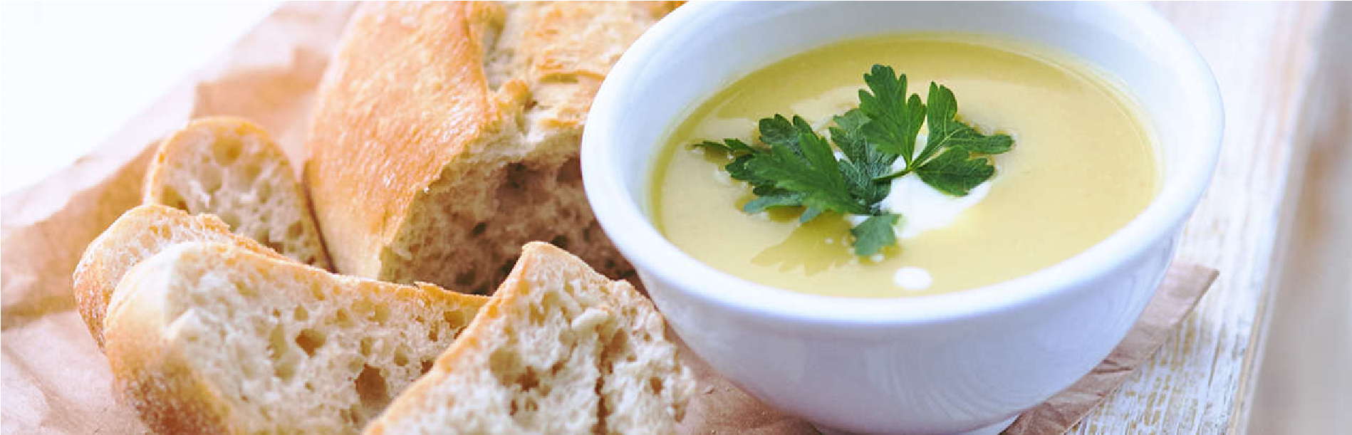

OMLETO MEDITA 16$
STELLA ARTOIS
5
$
(
Belgium
)
AMSTEL LIGHT
6
$
(
Netherlands
)
PACIFICO
$
5
(
)
Mexico
NEWCASTLE
5
$
(
England
)
OLD SPECKLED HEN
6
$
(
England
)
ANCHOR LIBERTY ALE
7
$
ANDERSON VILLA
$
6
REPUBLIC RYE
7
$
CLIPPER CITY RED SKY
6
$
Bottled Imports
Bottled Domestic
served your choice of bottled wine with this dish features roasted red peppers, tomatoes, onions, feta cheese, and more.

BISCS GRAVY 21$
Have two eggs with your choice of country sausage gravy or country veggie gravy and a bottle of your favorite
We are available at JustEat and UberEats
Or you can directly call us at 0987654321

Tequila & Wings

REGULAR 6 PC WINGS, WITH TEQUILA 15$
Six wings (boneless or classic) with up to two sauces, regular fries or veggie sticks, one sauce, and 20 ounces of your choice of beverage.

MID 8 PC WING WITH TEQUILA 18$
Eight wings in your choice of boneless or classic (bone-in) style, along with your choice of regular fries or veggie sticks, one dipping sauce, and a 20 oz. beverage.

BIGGER 10 PC WINGS WITH TEQUILA 20$
Up to two different flavors on ten wings, regular fries or veggie sticks, one dipping sauce, and a 20-ounce soda.

Sandwiches (For Allergens)

TURKEY CURRY 7.75
Wrap of smoked turkey, mozzarella, black olives, and curry mayonnaise on a bed of curried spinach.

CHICKEN SALAD 8.25
PORK PULLED  pork with BBQ sauce | 9.50
SHRIMP WRAP | 8.75
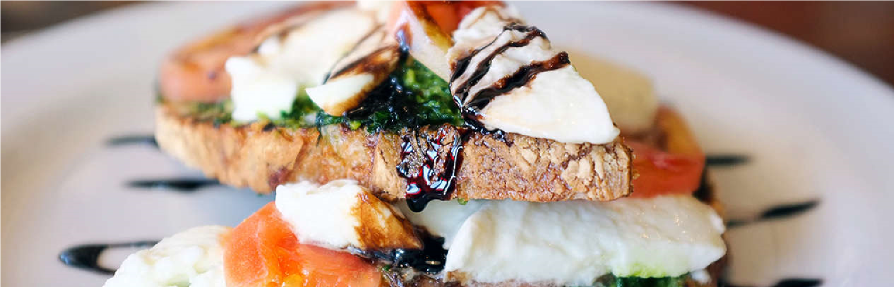
Chicken salad made in-house, served on a croissant with fresh lettuce and tomatoes.
MONDAY
14.75
Quinoa and goat cheese stuffed portobello mushrooms, topped
with roasted red pepper coulis
TUESDAY
19.25
Halibut stuffed with Dungeness crab and served with a wild rice
pilaf and a sauce made from lemons and leeks.
WEDNESDAY
17.25
Chicken à la Tuscany atop angel hair pasta with prosciutto,
Roma tomatoes, roasted garlic, and spinach.
THURSDAY
13.25
House made meatloaf, topped with pepper jack cheese and
onion straws, served with mashed potatoes and mixed
vegetables
FRIDAY
12.25
Beer-battered lingcod, served with french fries and fennel
coleslaw
MONDAY
7.25
Grilled zucchini, red onions and avocado with garlic aioli
TUESDAY
8.25
Hot turkey on sourdough topped with fresh-made gravy
WEDNESDAY
6.75
Lemon dill tuna salad wrap
THURSDAY
7.25
Grilled portobello mushroom and caramelized onion panini
FRIDAY
6.75
Grilled cheddar, Swiss and mozzarella on marble rye
SATURDAY
8.25
Shrimp poblano baguette
SUNDAY
8.25
Roasted chicken and artichoke heart panini
Dinner Specials
Sandwich Specials
On a tortilla infused with sun-dried tomatoes, you'll find shrimp, avocado, greens, salsa, cilantro, and mayo.
Hotel Trinity
Location: Coast in Swansea
South Wales
Facebook: Trinity Foods
WhatsApp: 0987654321
Website: www.trintyhotel.net

We are available at JustEat and UberEats
Or you can directly call us at 0987654321
Please let us know if you want a contactless delivery

VEGI WRAP (For Vegetarians) 6.25
Wrapped in spinach, this dish combines roasted vegetables with curry mayo, fresh greens, tomatoes, and sprouts.

FAJITA 8.75
Garlic herb wrap filled with seasoned beef or chicken, sautéed mushrooms, onions, green peppers, Monterey Jack cheese, lettuce, tomato, salsa, and sour cream.

BUFFALO WRAP 8.75
Wrapped in a spinach-herb tortilla and served with a choice of ranch or bleu cheese dressing, this dish consists of breaded chicken strips tossed in a spicy buffalo sauce.
Terms and Condition:
- All our foods are hyenic and approved by the National Foods Testing and Investigating Firm
- There are no hidden charges for the foods we sell.
- For delivery, you will be charged by the delivery agency, and you must pay their charges.
- For any misconducting delivery service, we will be not liable.
- In case of the latency in delivery we will not take any responsibility.
- If you want a contactless delivery service, we will assist you on that.
- We can change any of our product price at any time.
- Descriptive language provided under each item.
- Our shop might be closed in unwanted situation.
- If you have any query or suggestions, please let us know in social media or via mail.
Helpline: 8907652341
Mail: support.trinty@yahoo.com
References:

- Picture (1) Toast & Cup 2022. https://www.dreamstime.com/royalty-free-stock-photos-toast-cup-coffee-wooden-table-image30764228
- Picture (2) Omleto Medita 2022. https://www.thespruceeats.com/perfect-quick-omlet-tips-995517
- Menu Inspiration. Must Have Menus. 2022. https://www.musthavemenus.com/category/hotel-menu.html?page=2

