Module Title: Problem Solving and Decision Making

Module Code: LCLM 4004

Assessment: Component 2 Report

Student Name: Bilal Aslam

Student Number: 2505193

Lecturer’s Name: CHIJIOKE UBA

Table of Contents

Contents Page Number

Task 1: Overview of Case-study 3

Task 2: Two proposed solutions 3

Task 3b): Evaluation Results and Justifications 4

Task 4b): Risk Analysis Results and Justifications 4

Task 5b): Justifications for the Implementation Plan 5

Task 6b): Justifications for the KPI and SMART objectives 5

Task 7: Key Findings 7

Reference List 5

Appendices

Appendix 1: Task 3a) Grid or PMI Analysis Table……………………………………9

Appendix 2: Task 4a) Risk Analysis Table…………………………………………….10

Appendix 3: Task 5a) Implementation Plan……………………………………………11

Appendix 4: Task 6a) KPI and SMART Table…………………………………………12

Task 1: Case Study Overview

Green Haven Florists is a small independent flower shop, which is based in Norwich, UK and was started in 2016 by Liam and Priya Patel (Chaffey and Ellis-Chadwick, 2019). The company has built a good reputation in offering customized floral arrangements and packaging that is environmentally friendly. Nonetheless, the business has recorded a substantial drop in sales in the stores by 30 percent in the last 12 months. A number of causes have led to this problem, with one of them being a transition to online shopping, an augmented competition with online flower retailers and new competitors in the area, as well as the use of an obsolete web page that restricts online ordering. There has also been a rise in operational costs and costly imported flowers that has had an impact on profitability. In order to be competitive, Green Haven Florists should upgrade its business model and become more online selling and customer oriented (Kotler and Keller, 2016).

Task 2: Two Proposed Solutions
Solution A: Digital Transformation by means of Web site Upgrade.
The initial solution, which is to be suggested, is to enhance the online presence of Green Haven Florists, which can be achieved through the redesign of the company site and the enhancement of the online sales channel. This would include developing a sleek and mobile retailing site with better navigation and online ordering system. Flexible delivery service, same-day delivery service, and flower subscription service to frequent customers should also be provided on the site. Chaffey and Ellis-Chadwick (2019) state that a good e-commerce platform enables companies to access broader markets and enhance customer convenience. Moreover, digitisation can make the smaller companies compete with the bigger online retailers by providing personalised services and meaningful digital experiences (Westerman et al., 2014). A new site would bring more customer experience, online orders, and brand recognition via the use of digital marketing and optimisation of search engines. This is a direct solution to the current weaknesses in Green Haven online presence and would enable the business to seize the increasing number of customers who like buying flowers online.

Solution B: Flower Subscription Service and Community Involvement.

The second solution suggested is the introduction of a flower subscription service with more community involvement. This would enable customers to make weekly or monthly subscriptions of the delivery of flowers to their homes or business. The subscription models may offer predictable and consistent revenue frames and stimulate the long-term relationships with customers (Tzuo and Weisert, 2018). Moreover, the business might encourage the service using social media and collaboration with local organisations, cafes, and event platforms. Customer relationship management strategies highlight the need to establish long term relationship with customers so that it enhances retention and loyalty (Buttle and Maklan, 2019). Green Haven Florists may improve customer loyalty by providing frequent deliveries and custom-designed plans, which would provide the company with steady sales as well. Such a solution would also strengthen the good community reputation and sustainable brand image of the shop.

Task 3b: Results and Justification of the Evaluation

The two offered solutions were analysed with the help of a Grid Analysis methodology according to four criteria, including cost, revenue potential, ease of implementation, and customer demand. Such factors have been chosen due to the fact that they are major strategic considerations of the small enterprises functioning within competitive markets (Johnson, et al; 2017). The greatest weighting was set on revenue potential since the main aim of the business is to increase sales. The findings showed that Solution A, which was the strategy of improving the websites received the highest score. This finding indicates that the digital transformation presents the best chance to expand revenue and market coverage. Solution A was, therefore, chosen as the best solution since it offers competitive benefits in the long term and contributes to the transition into the online purchasing behaviour.

Task 4b: Risk Analysis Results and Justification

The risk analysis revealed that there are three major risks with the new strategy of deploying the new website. The initial risk is the possibility of the financial cost of developing the web site straining the merger resources of the company. The second threat is the lack of customer adoption in case customers do not know about the new online services. The third threat is the possibility of technical challenges in implementation. According to the risk management frameworks, risk identification and mitigation have the potential to enhance successful project outcomes (Hillson and Murray-Webster, 2017). The risks can be minimized by choosing low-cost web development applications, training the staff, and carrying out online marketing campaigns to advertise the new services. On the whole, the risks are not overwhelming and they cannot restrain the advantages of the solution.

Task 5b: Reasons why the Implementation Plan should be implemented

The implementation plan commences with a web site audit and identification of an appropriate web developer. This is necessary to determine the existing weaknesses and define development requirements. The second phase entails the design and development of the new webpage, which has online ordering systems and delivery. Based on the principles of project management, one should be planned and developed before launch to make sure that it functions and is of quality (Kerzner, 2017). The third phase is a digital marketing campaign where the updated site will be launched to market the site and draw customers. Lastly, the performance of websites and customer feedback should be monitored as this is a way to ensure constant improvement. The roles are shared between Liam and Priya according to their management roles, and operations and marketing activities can be effectively coordinated.

Task 6b: Reasons why KPI and SMART Objectives are good

The Key Performance Indicator (KPI) that has been chosen to use in this project is the growth in online sales revenue. This KPI was selected due to the fact that it directly evaluates the performance of the new online sales strategy and the new web site. The performance measurement plays a fundamental role in evaluating the ways to run the business and exclude areas in need of improvement (Parmenter, 2015). This KPI can be supported using the SMART objectives that give clear and measurable objectives. To illustrate this, the company should target online bookings of flowers by 25 percent of its online orders in six months upon the introduction of the new site. Progress will be monitored using Web analytics tool and monthly sales report. Green Haven Florists can measure the effectiveness of the strategy in terms of the improvement of the business through comparison of sales figures before and after the implementation.

Task 7: Key Findings

• The changing consumer behaviour increased online competition, and increasing cost of operation are driving down in-store sales in Green Haven Florists.
Two possible solutions were suggested: 1) to work on the business site and 2) to enter into a flower service with subscriptions.
• The grid analysis showed that further development of the site presents the most opportunities in terms of increased online sales and market coverage.
Risk analysis It was also determined that development costs, customer adoption, and technical challenges are the main risks, but they can be mitigated.
• A digital strategy with well-defined KPIs and SMART goals would help to boost online sales and make the business sustainable in the long term.

Reference List
- Buttle, F. and Maklan, S. (2019) Customer Relationship Management: Concepts and Technologies. 4th ed. London: Routledge. Available via https://ndl.ethernet.edu.et/bitstream/123456789/34623/1/238.Francis%20Buttle.pdf (Accessed on 12th March 2026).
- Chaffey, D. and Ellis-Chadwick, F. (2019) Digital Marketing. 7th ed. Harlow: Pearson.
- Davenport, T. and Westerman, G. (2018) ‘Why companies fail at digital transformation’, Harvard Business Review, 96(2), pp. 70-76.
- Hillson, D. and Murray-Webster, R. (2017) Understanding and Managing Risk Attitude. 2nd ed. London: Routledge.
- Johnson, G., Scholes, K. and Whittington, R. (2017) Exploring Strategy. 11th ed. Harlow: Pearson.
- Kaplan, R. and Norton, D. (2004) Strategy Maps: Converting Intangible Assets into Tangible Outcomes. Boston: Harvard Business School Press.
- Kerzner, H. (2017) Project Management: A Systems Approach to Planning, Scheduling and Controlling. 12th ed. Hoboken: Wiley.
- Kerzner, H. (2017) Project Management: A Systems Approach to Planning, Scheduling and Controlling. 12th ed. Hoboken: Wiley. aVailable via https://www.google.co.uk/books/edition/Project_Management/JRlHEQAAQBAJ?hl=en&gbpv=1&dq=8.%09Kerzner,+H.+(2017)+Project+Management:+A+Systems+Approach+to+Planning,+Scheduling+and+Controlling.+12th+ed.+Hoboken:+Wiley.&pg=PR1&printsec=frontcover (Accessed on 14th March 2026).
- Kotler, P. and Keller, K. (2016) Marketing Management. 15th ed. Harlow: Pearson.
- Mind Tools (2023) Decision Matrix Analysis. Available at: https://www.mindtools.com (Accessed: 20 March 2026).
- Osterwalder, A. and Pigneur, Y. (2010) Business Model Generation. Hoboken: Wiley.
- Parmenter, D. (2015) Key Performance Indicators: Developing, Implementing and Using Winning KPIs. 3rd ed. Hoboken: Wiley.
- Tzuo, T. and Weisert, G. (2018) Subscribed: Why the Subscription Model Will Be Your Company’s Future. New York: Portfolio.
- Westerman, G., Bonnet, D. and McAfee, A. (2014) Leading Digital: Turning Technology into Business Transformation. Boston: Harvard Business Review Press.

Appendices

Appendix 1 – Task 3a

Grid Analysis Table

Appendix 1 – Task 3a

Grid Analysis Table

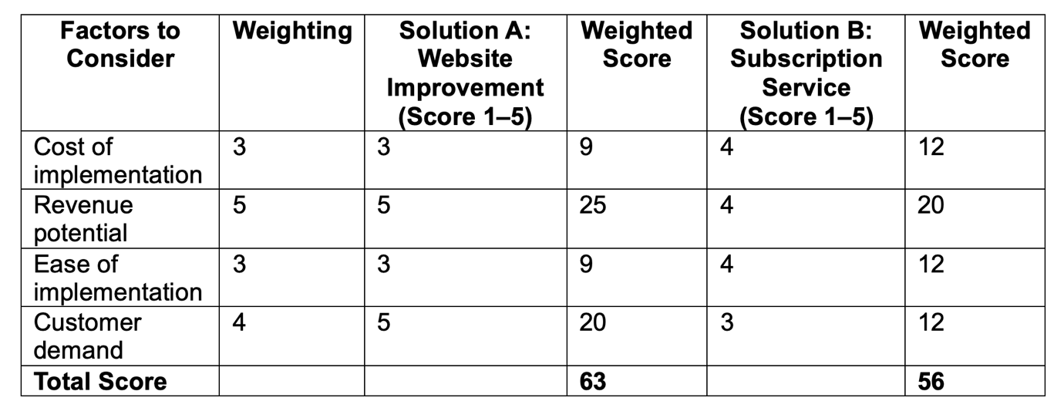
Source Mind Tools (2023) Decision Matrix Analysis. Available at: https://www.mindtools.com

Explanation
The grid analysis is a analytical tool of decision making where various choices are contrasted based on a set of chosen criteria on the basis of weighted scores. Four factors were considered in this analysis namely the cost of implementation, potential of revenue, ease of implementation and demand to the customer. Revenue potential was the most weighted among others as increasing the sales is the primary goal of Green Haven Florists. All the solutions were rated out of 1 to 5 according to their effectiveness in addressing the criterion. The weighted scores were then computed by using the weighting factor and the score. Results indicated that Solution A (website improvement) scored more than Solution B thus demonstrating that it is the best solution towards solving the business problem.

Appendix 2 – Task 4a

Risk Analysis Table

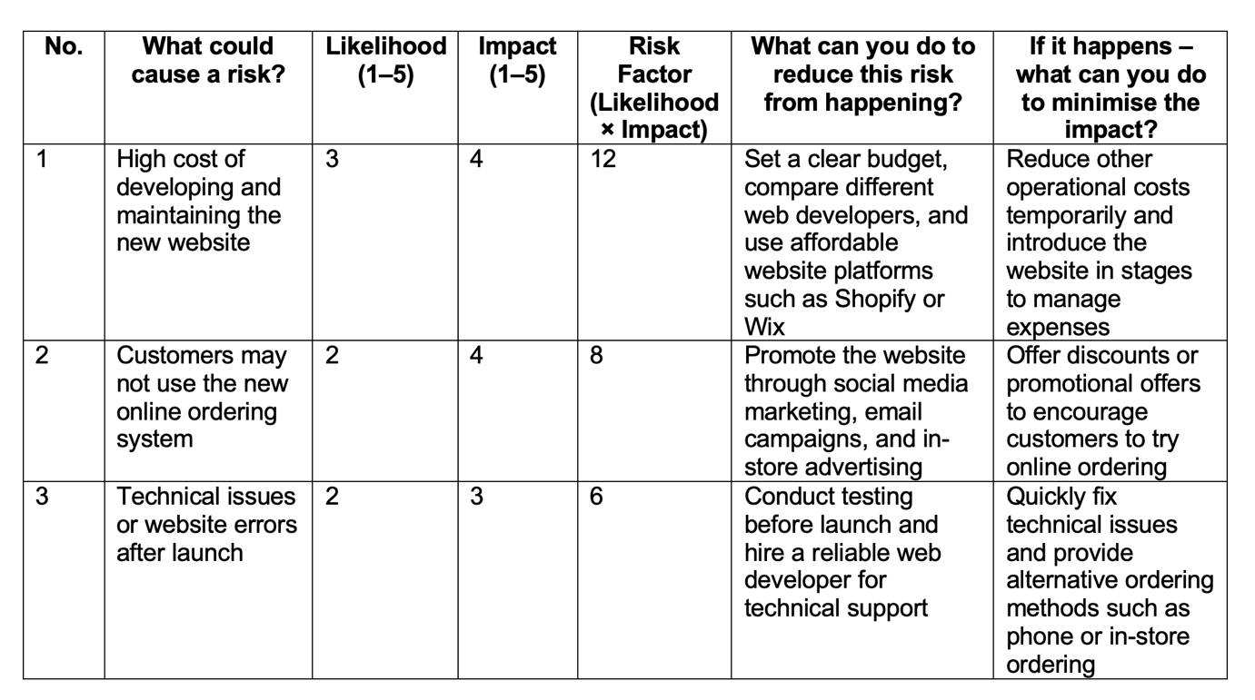
Risk Analysis Table Source (Hillson, D. and Murray-Webster, R. (2017)

Explanation
Risk analysis is a significant instrument applied to define possible threats that can influence the project success. Three significant risks of the site improvement strategy were identified in this analysis: the development costs, the adoption of the site by customers and technical problems. The likelihood and impact scale was applied to each risk (1 to 5) and the total risk factor calculated by multiplying the scores. This approach can be used to prioritise the risks that have to be given more attention. These risks can be considerably minimized by the use of preventative measures, including budgeting, promotion of marketing, and technical testing. In case any risk arises, contingency measures will help to reduce adverse effects on the business activities.

Appendix 3 – Task 5a
Implementation Plan

Name the problem you are solving : Development of a modern e-commerce website to improve online sales and customer accessibility.

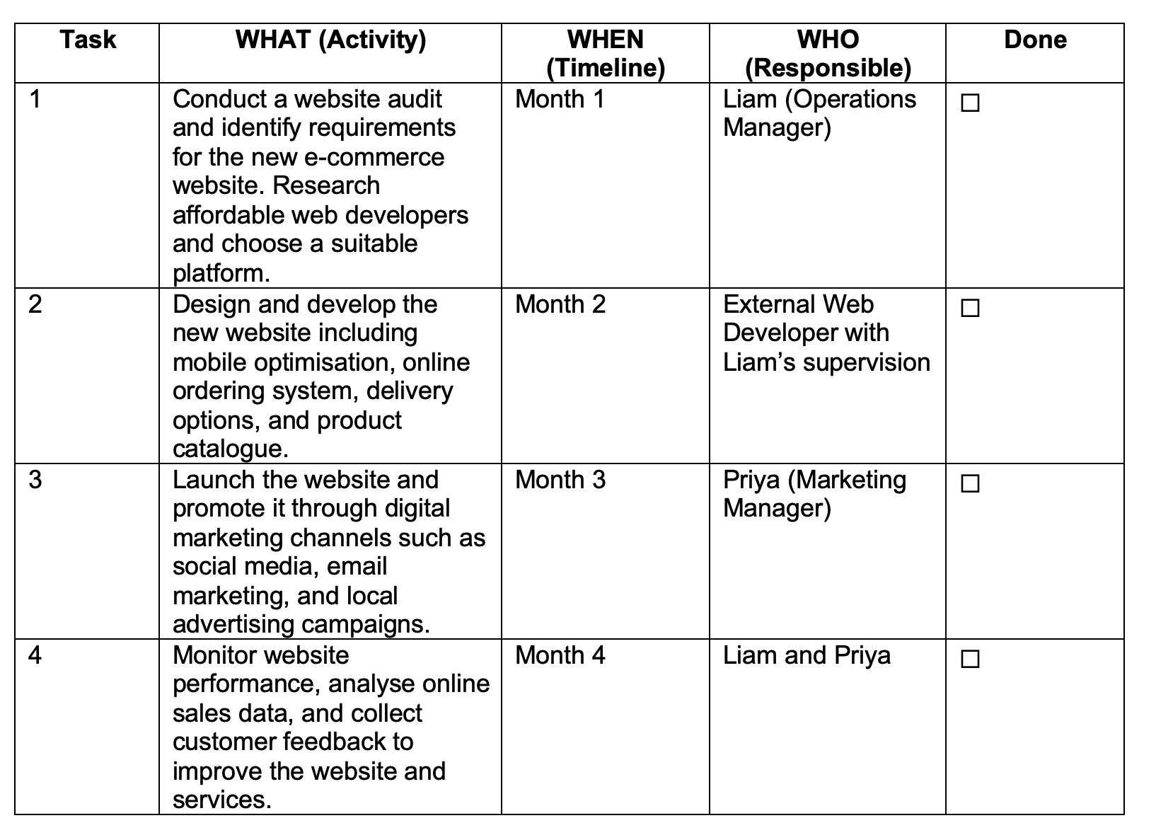
Table : Implementation plan (self-created)
Explanation

Implementation plan is a systematic way of implementing a selected business strategy. The initial step will be to perform an audit of the current websites and determine the most important characteristics that should be featured on the new platform. This measure will make sure that the development of the web site follows customer requirements and objectives of the business. The second phase is concerned with the creation and design of the site, online ordering, delivery services, and mobile adaptability. These are all necessary features that will enhance customer experience and boost online sales.

The third stage entails the opening of the site and advertising the site using online marketing platforms. The use of social media platforms, email marketing campaign as well as local advertisement will help educate new customers and existing customers on the new service. Customer promotion requires effective marketing communication to make customers use the online platform. The last step is to track the performance of the site by using analytics tools and customer response. Through this evaluation process the business is able to determine the areas that it needs to improve and also the strategy is delivering its objectives. This delegation of the duties to Liam and Priya will provide a definite leadership and effective management of the operation and marketing activities.

Appendix 4 – Task 6a

The Key Performance Indicator is:
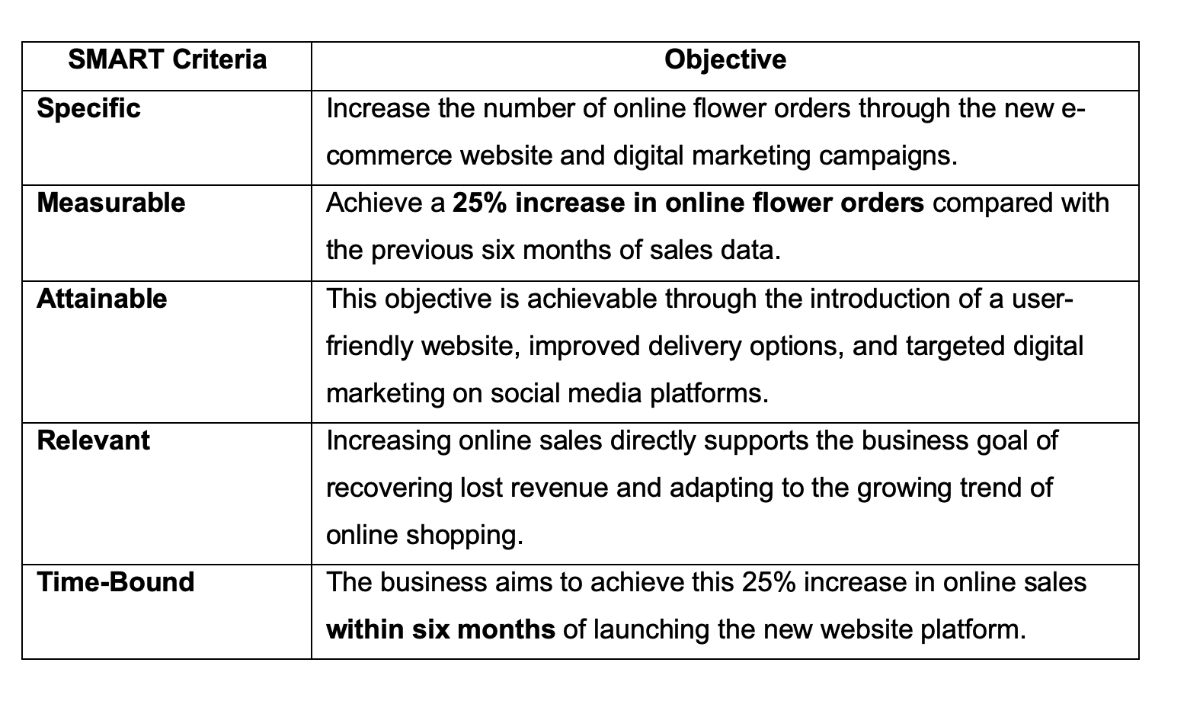
SMART TABLE: (Self-created )

Explanation
Key Performance Indicators (KPIs) are measurable values that help organisations evaluate the success of strategic initiatives. In this case, increasing online sales revenue is an appropriate KPI because it directly measures the effectiveness of the new website and online ordering system. The SMART framework ensures that objectives are clearly defined and achievable. By setting a target of a 25% increase in online orders within six months, Green Haven Florists can monitor progress using website analytics and monthly sales reports. If the target is not achieved, management can adjust marketing strategies or website functionality to improve results and overall business performance.

