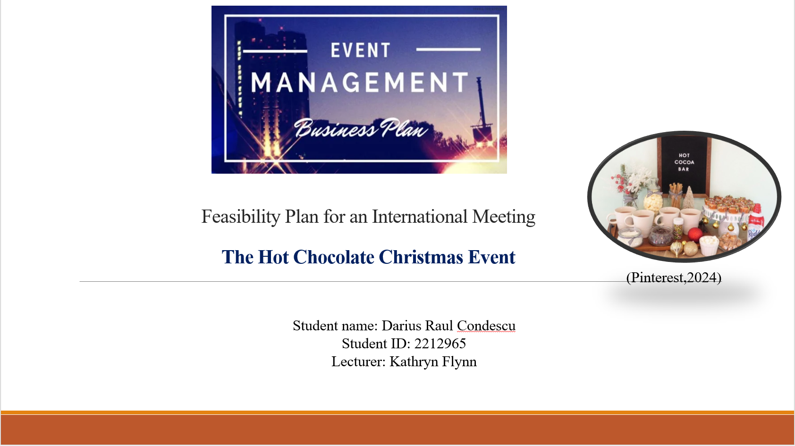

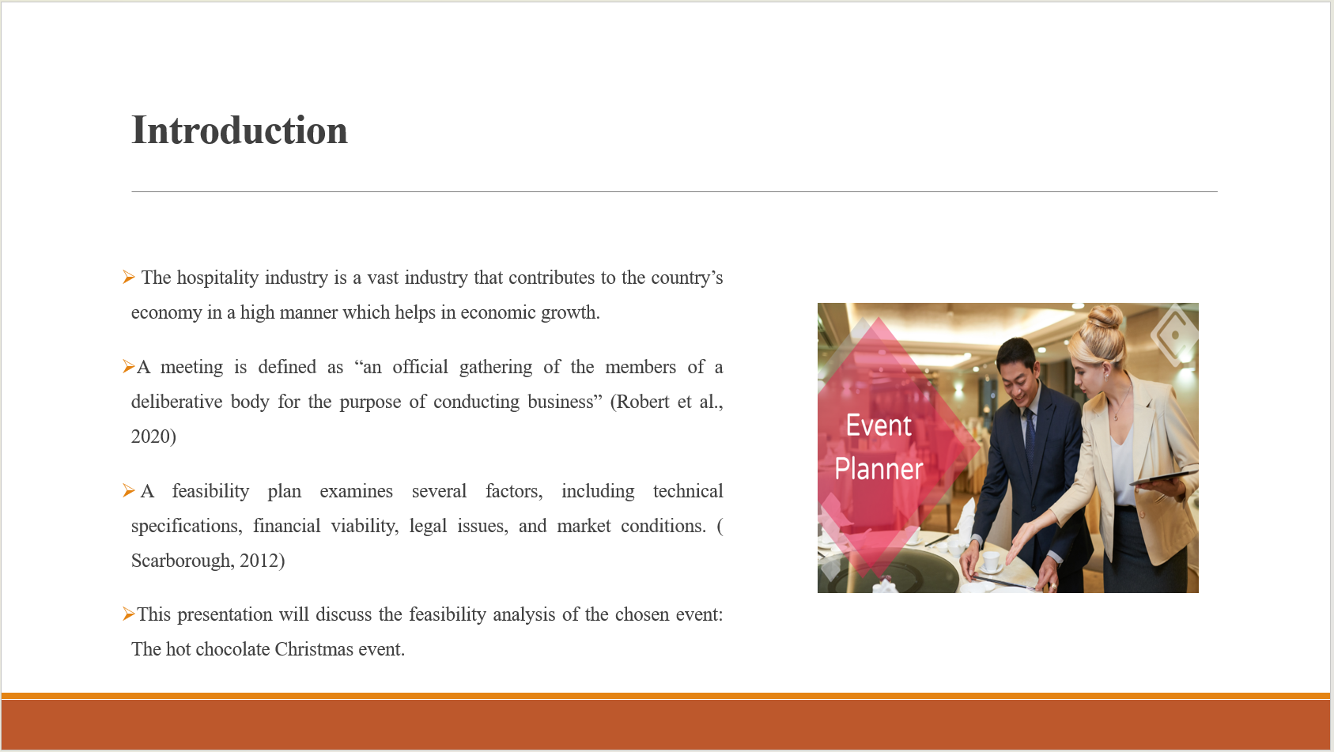

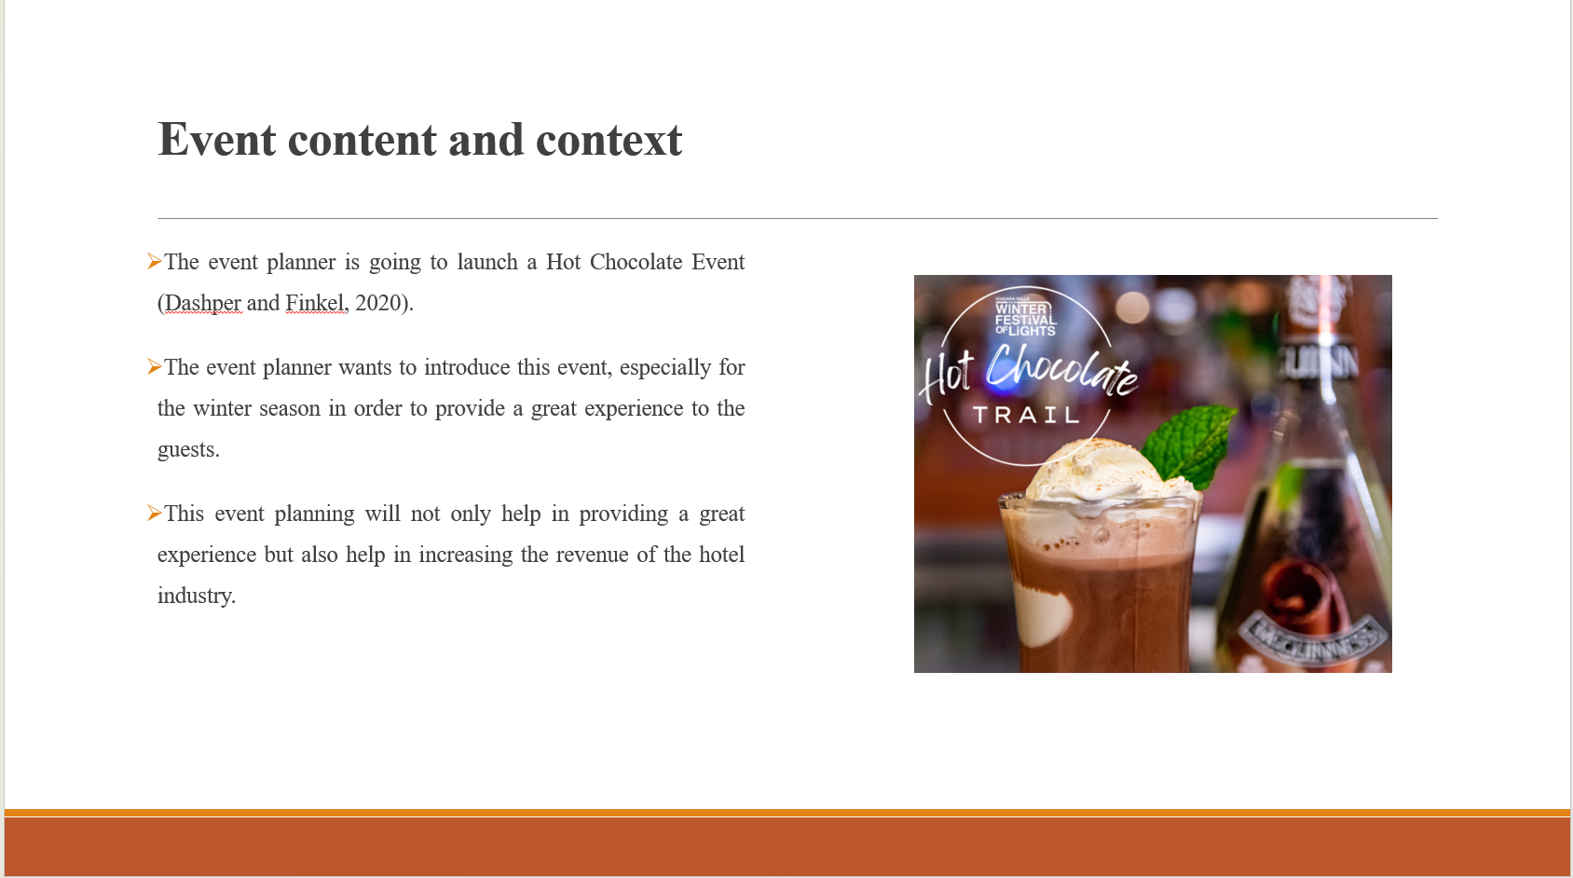
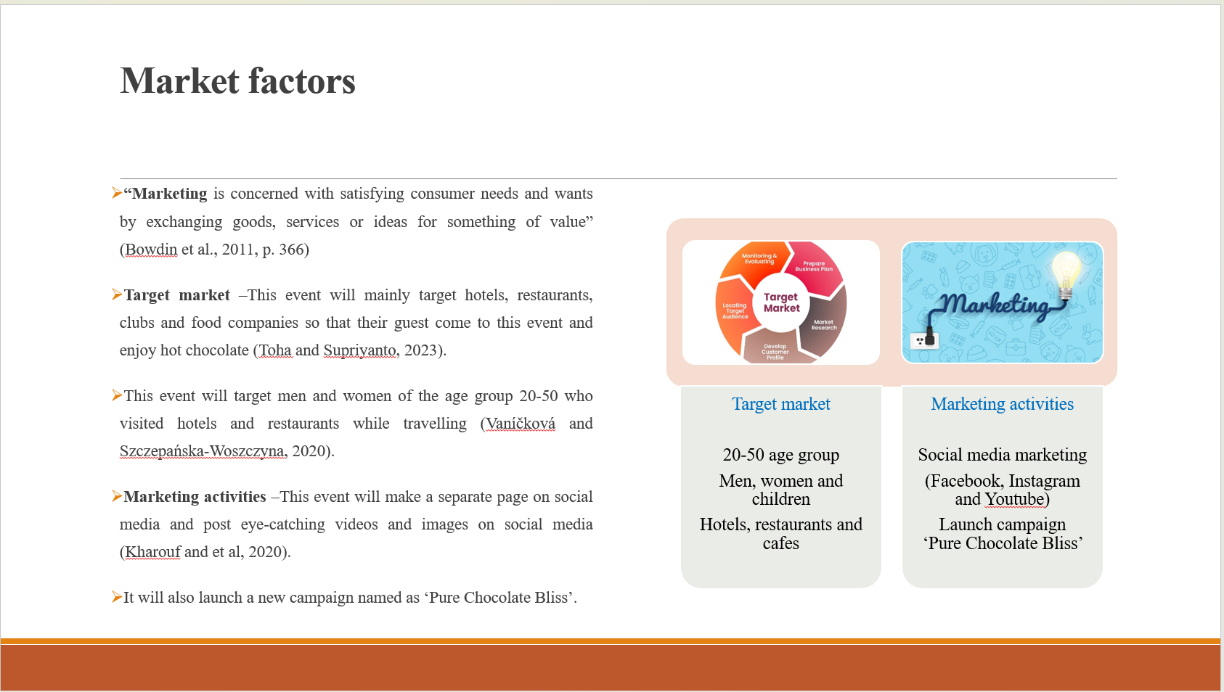
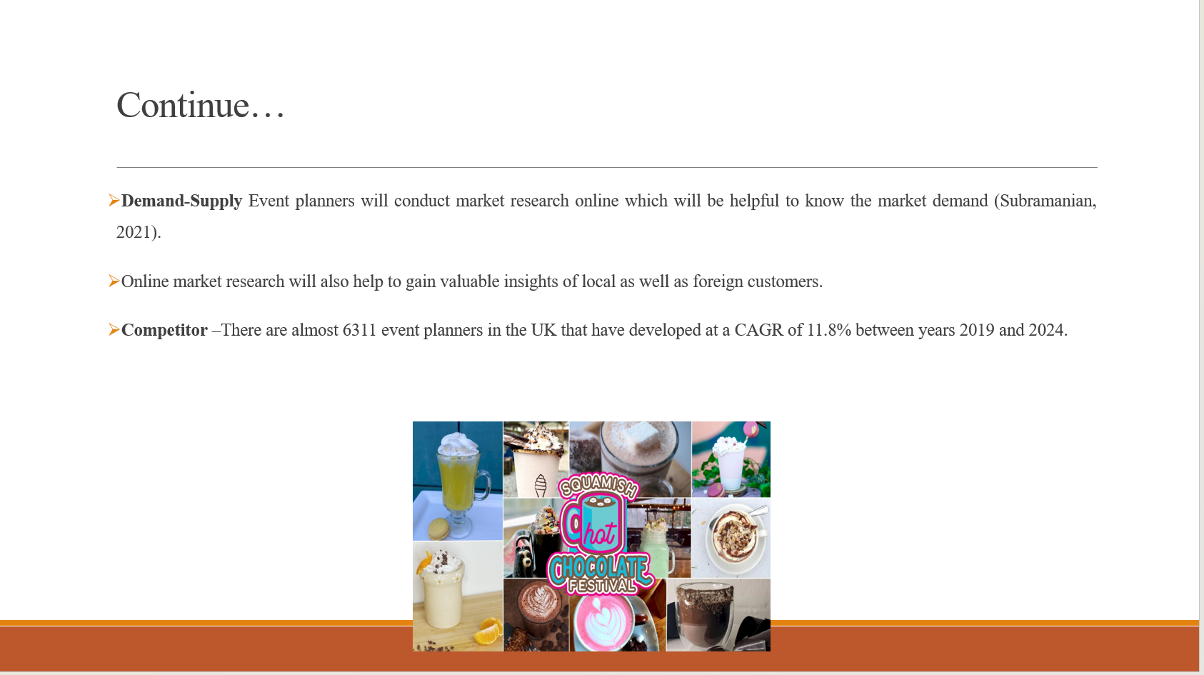
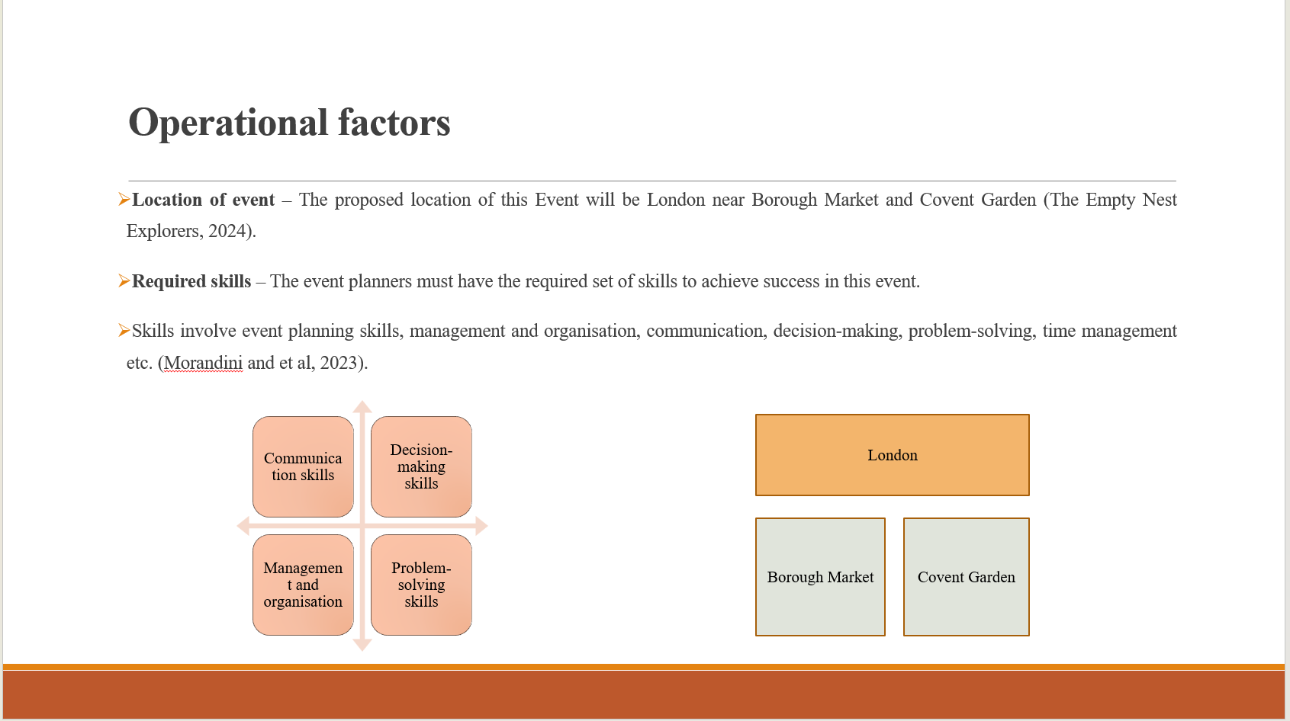
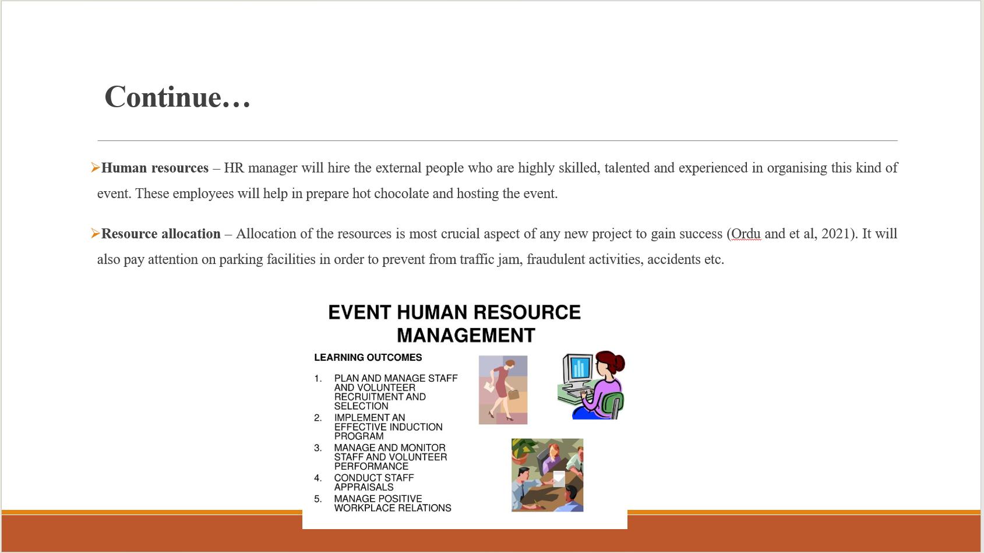
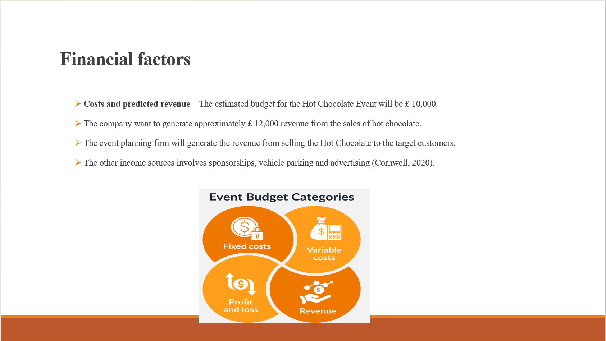
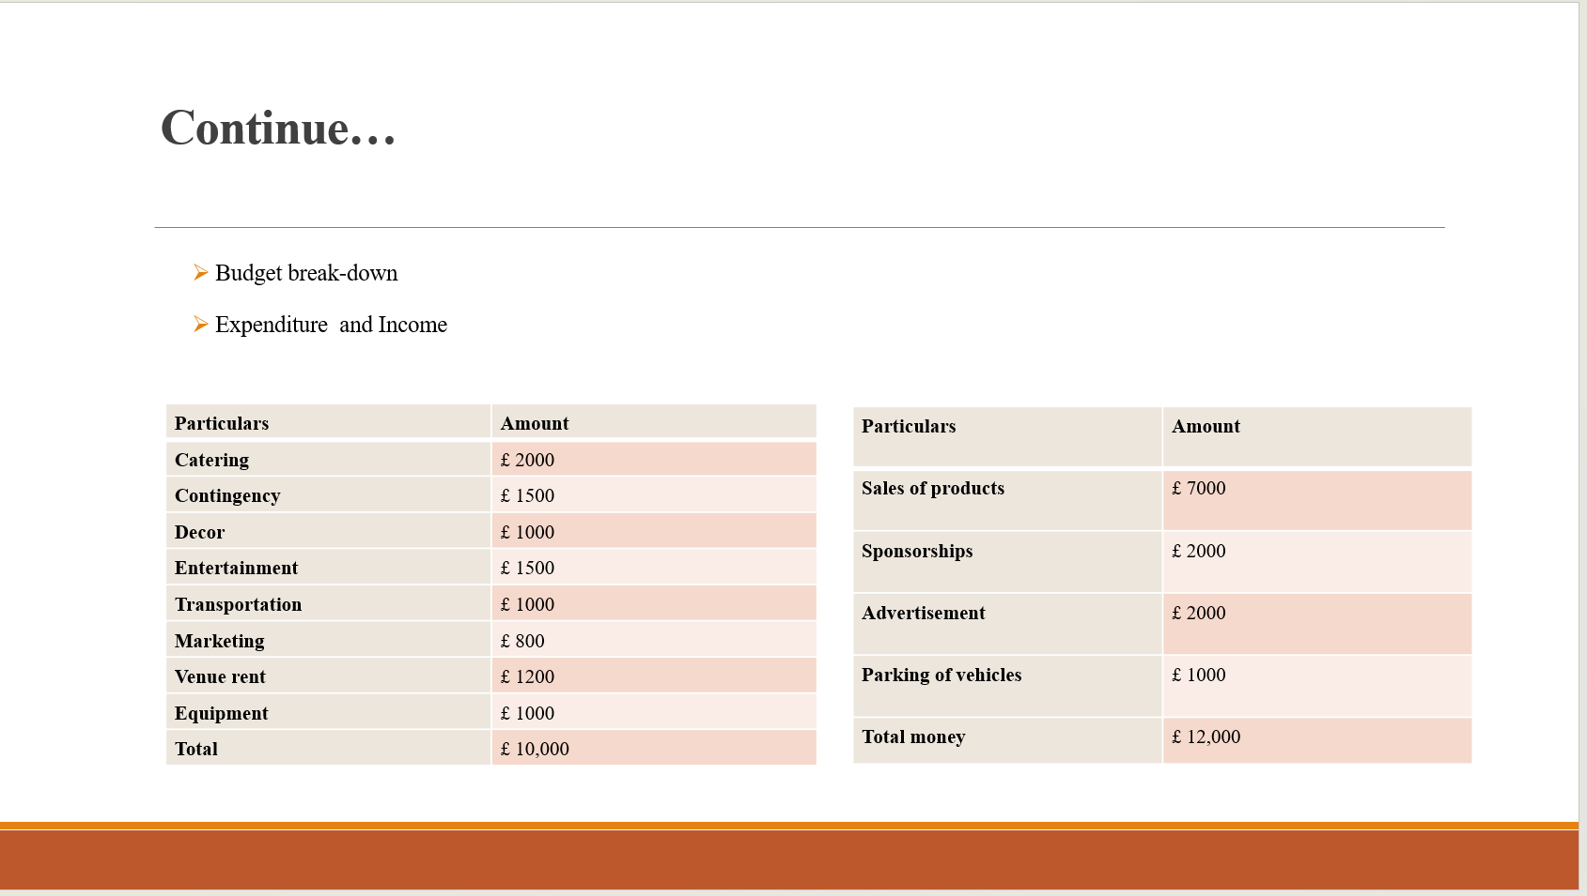
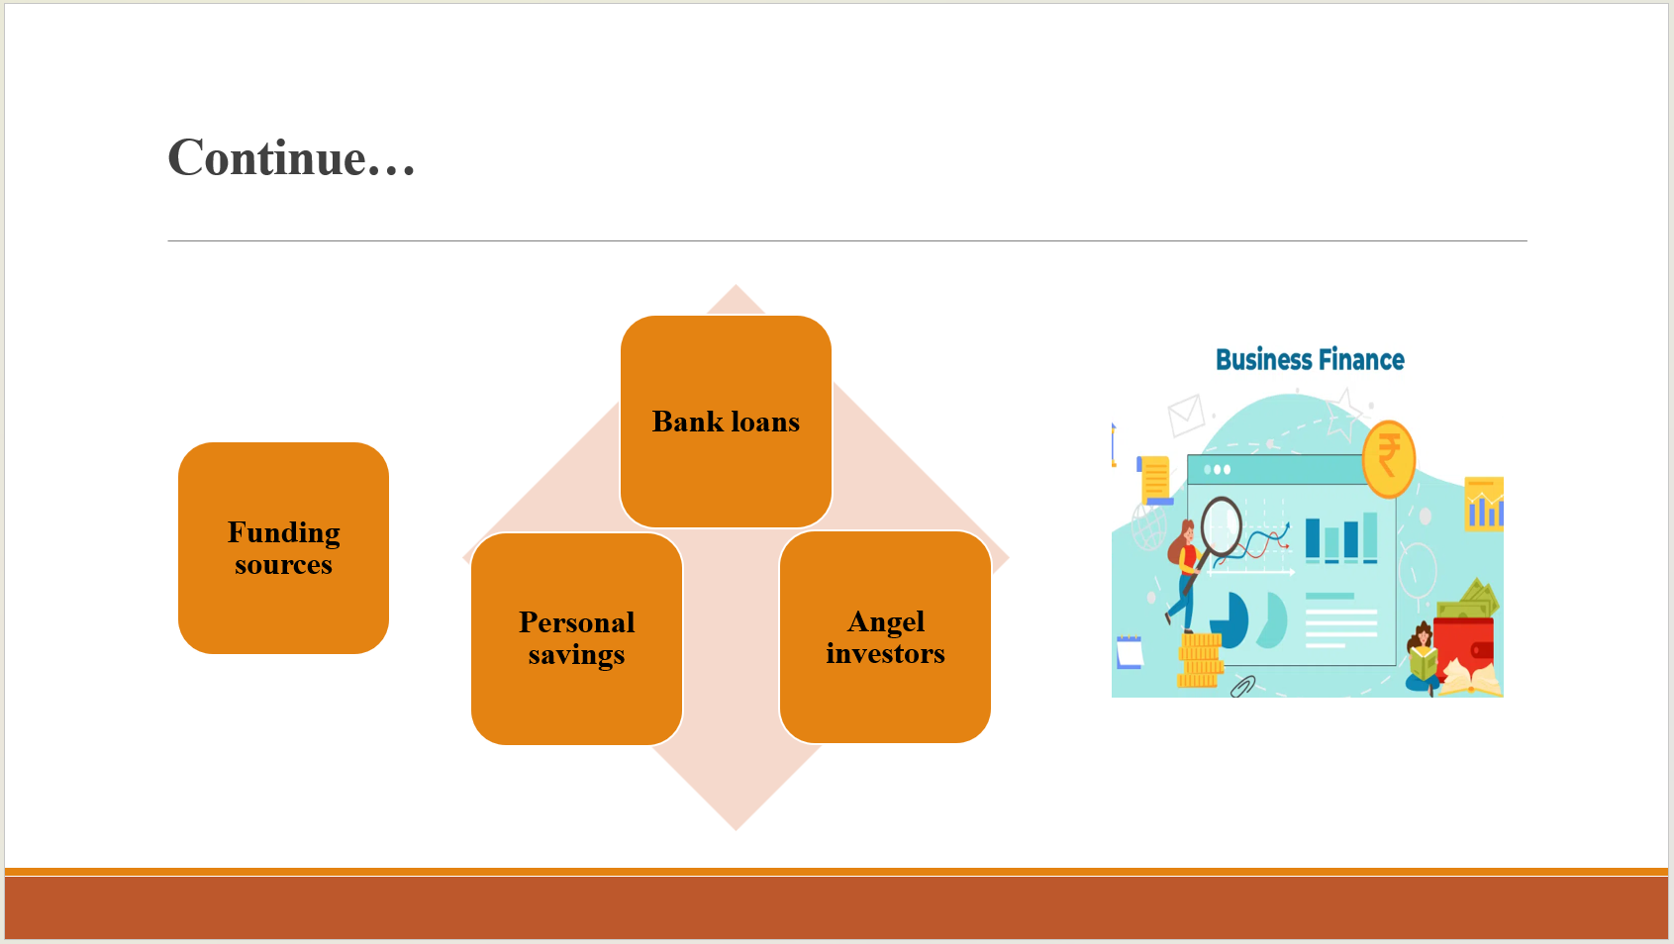
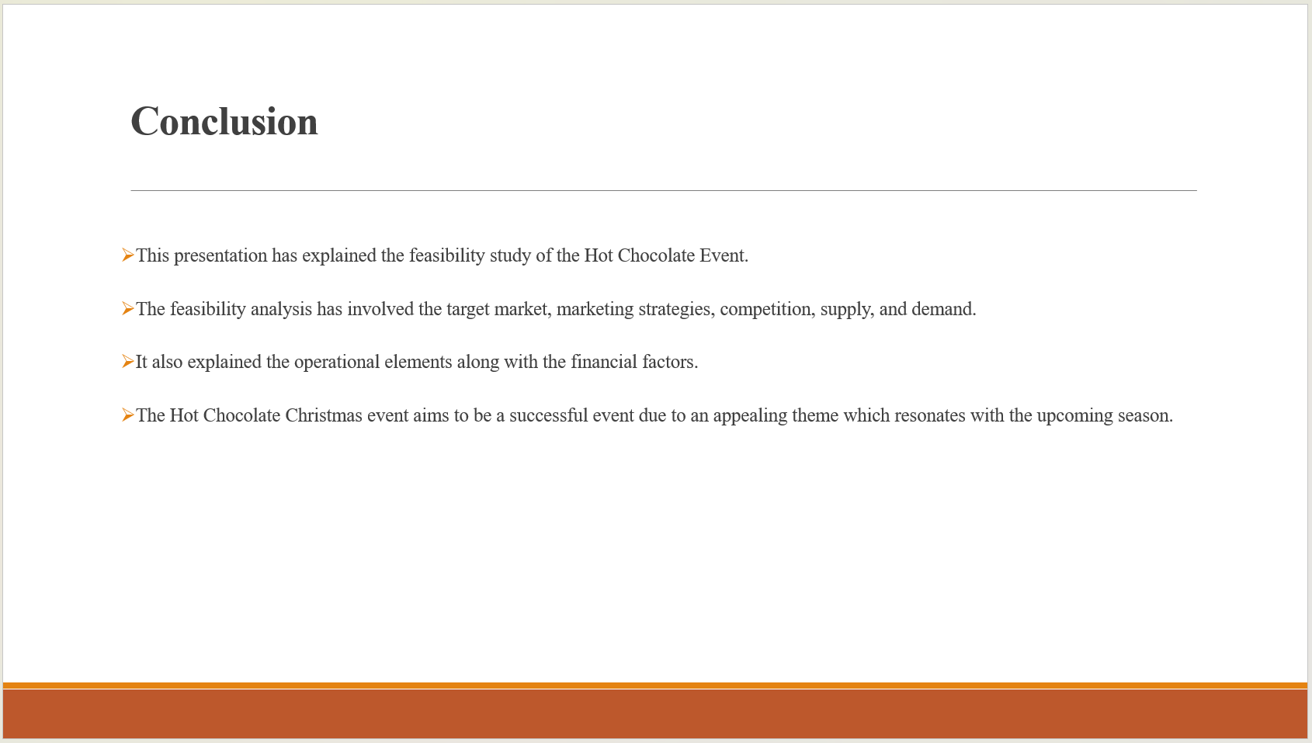

References

- Bowdin, G., Allen, J., O'Toole, W. and Harris, R., 2011. Events Management. 3rd ed. Oxford: Routledge
- Chen, Y. and Volz, U., 2022. Scaling up sustainable investment through blockchain‐based project bonds. Development Policy Review, 40(3).
- Chopra, S., Sodhi, M. and Lücker, F., 2021. Achieving supply chain efficiency and resilience by using multi‐level commons. Decision Sciences, 52(4), pp.817-832.
- Cornwell, T.B., 2020. Sponsorship in marketing: Effective partnerships in sports, arts and events. Routledge.
- Cuskelly, G., and et al, 2021. Volunteer selection at a major sport event: A strategic Human Resource Management approach. Sport Management Review, 24(1), pp.116-133.
- Dashper, K. and Finkel, R., 2020, August. Accessibility, diversity, and inclusion in the UK meetings industry. In Journal of Convention & Event Tourism (Vol. 21, No. 4, pp. 283-307). Routledge.
- Huang, X., and et al, 2023. Angel investment and first impressions. Journal of Financial Economics, 149(2), pp.161-178.
- Joy (2019). DIY Christmas Hot Cocoa Bar Ideas. [online] Joy in the Commonplace. Available at: https://www.joyinthecommonplace.com/diy-christmas-hot-cocoa-bar-ideas/ [Accessed 14 Oct. 2024].
- Kharouf, H., and et al, 2020. Understanding online event experience: The importance of communication, engagement and interaction. Journal of Business Research, 121, pp.735-746.
- Magoutas, B., Apostolou, D. and Mentzas, G., 2020. An Event-Driven Framework for Business Awareness Management. arXiv preprint arXiv:2012.02615.
- Morandini, S., and et al, 2023. The impact of artificial intelligence on workers’ skills: Upskilling and reskilling in organisations. Informing Science, 26, pp.39-68.
- Ordu, M., and et al, 2021. A novel healthcare resource allocation decision support tool: A forecasting-simulation-optimization approach. Journal of the operational research society, 72(3), pp.485-500.
- Robert, H.M., Evans, W.J., Honemann, D.H. and Balch, T.J., 2020. Robert's Rules of Order Newly Revised. 12th ed. Philadelphia: Da Capo Press
- Scarborough, N.M., 2012. Essentials of Entrepreneurship and Small Business Management. 7th ed. Boston: Pearson.
- Serrano, A.S., 2021. The impact of non-performing loans on bank lending in Europe: An empirical analysis. The North American Journal of Economics and Finance, 55, p.101312.
- Subramanian, L., 2021. Effective demand forecasting in health supply chains: emerging trend, enablers, and blockers. Logistics, 5(1), p.12.
- Toha, M. and Supriyanto, S., 2023. Factors Influencing the Consumer Research Process: Market Target, Purchasing Behavior and Market Demand (Literature Review of Consumer Behavior). Danadyaksa: Post Modern Economy Journal, 1(1), pp.1-17.
- Vaníčková, R. and Szczepańska-Woszczyna, K., 2020. Innovation of business and marketing plan of growth strategy and competitive advantage in exhibition industry. Polish Journal of Management Studies, 21(2), pp.425-445.
- Ziakas, V., 2023. Leveraging sport events for tourism development: The event portfolio perspective. Journal of Global Sport Management, 8(1), pp.43-72.

