Creative Venture (M7X01792)
CW2- Report
Rebecca Davies
Student Number: 1703304
Word count: 3727

Executive Summary
This body of work has been an opportunity to reflect on, as well as showcase, the designer I have become, thanks to my years on the surface pattern design course. This report will explore the ambitious ideas that have driven my creative venture, outlining my research methods and how these have fuelled one of my most complex narratives yet. Including my reflection on my own knowledge, of both design and the other elements that have built this narrative.
I also endeavour to convey the challenges of producing this body of work during a pandemic and, although I had perhaps hoped circumstances had been different, how I feel this has prepared me for tackling the world of employment after graduation. I will reflect upon my creative process, from designing to material application, emphasising the strengths and the opportunities of progression and re-evaluation of my outcomes. What I had hoped to achieve and whether or not I feel I have accomplished these goals.

Research Methods
For this body of work, I wanted to approach a floral based print collection, one of the most popular print motif topics, but from a unique, personal perspective. This proposal was driven by the thought experiment assignment, in my first semester, and the emphasis that was placed on considering a topic from every available stand point. It was encouraged to digest and re-interoperate a piece of text, and produce an open ended outcome, through creative experimentation. Which resulted in a variety of outcomes that had a range of direct and ambiguous links to the original text that had inspired them. This provoked me to further research in to the concept of narrative, with the same open minded interest, and the approaches that have already been devised in building a storyline.
Initially, my research was focused on dissecting traditional stories, such as the Grimm’s Fairy Tales (Brockelhurst andDoherty,2010) , and their adaptations. These narratives are what I have grown up with, as they have hugely influenced my creative perspective. They were the first stories with characters that I could relate to, would aspire to. The imagery and ideologies that they portrayed inspired me to be inquisitive and to be open to new ideas and perspectives. This divergent thinking strategy was particularly divisive in interoperating the thought experiment, and has continued to be what I have used to research this collection’s concept.
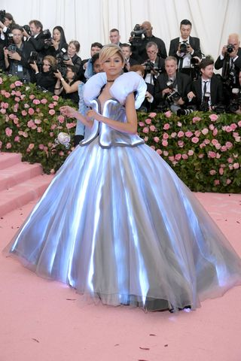
It was interesting to see how some other artist and textile designer that had been influenced by the same stories. Such as the ‘Alice in Wonderland’ C.F.A Voysey toile fabric (Fig 2), the ‘Alice in Wonderland’ inspired photography by Tim Walker (Fig 3) and the Tommy Hilfiger ‘Cinderella’ dress Zendaya wore to the 2019 Met Gala(Fig 1). Each of these design adaptations has obviously been designed for differing audiences. The almost futurisitc take on ‘Cinderella’s’ classic ballgown, by Tommy Hilger, was for the theme of ‘Camp’, and was intended to be an over the top statement garment. The imagery here appears to be purely referencial to the disney depicion of the story, complete with pumpkin carrige clutch bag.
Fig1: Elle, Tommy Hilfiger gown, 2019.
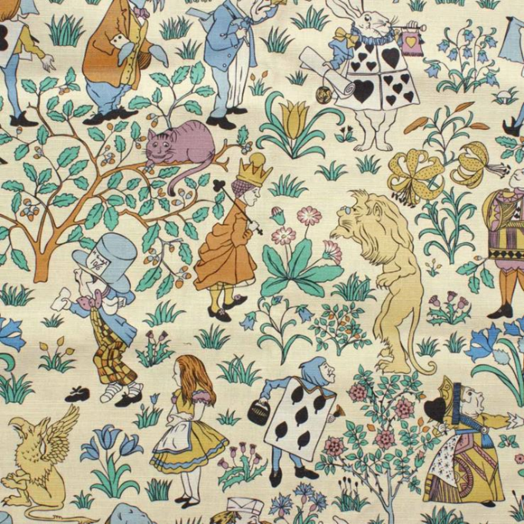
Fig 2: C.F.A Vorsey, V&A, Alice in Wonderland fabric.

Voysey’s traditional illustrations, in textile format, is more akin to the imagery I grew up associating with the story of ‘Alice in Wonderland’; surrealist caricatures of near human characters. A style that I could easily adapt for my own means, to illustrate a chosen story. But it felt too literal, and the primary intention of this research was to discover a less direct means of portraying a narrative structure.
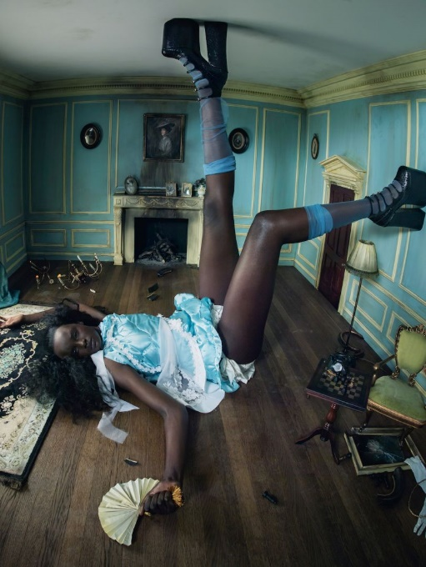
Fig3: Walker, Pirelli Calendar, 2017.
The way that character of ‘Alice’ has been portrayed in Tim Walker’s, shows a stronger, more confident persona. The provocative posing and styling of the model distracts the audience from making such an instant connection between the photography, and the original text. That pause upon first review of the image, is the photos’ most attractive quality in this line of research. It’s that moment of reflection that I aimed to achieve with my designs.
In order to achieve this, there was a need to go deeper into the history of narratives. To strip them back to their basic structures and rebuild these ideas from a whole new perspective. It was found that these stories all hand similar character arcs and frameworks; Princess is a prize to be won by hero, hero must save the day, villain is defeated, with an added smattering of sidekicks and animals along the way. A theory that was confirmed by Vladimir Propp (Film Inquiry, 2015), a Russian theorist who, in 1928, outlined the 7 main character types that could be found in narrative. He stated that every narrative depicts these characters in one way or another, and that he could even narrow it down to the fact that the characters would follow one of 31 potential narrative paths (Film Inquiry, 2015).
The recurring element to this line of enquiry that provoked intrigue was the roles women were usually characterised in. As a weaker element of the story line that requires saving, or is purely a prize to be won. Although, I do feel that we have come a long way in a sense, as there are more female leads in the cinema adaptations these days, the previous portrayals had not been diminished. In order to tackle these female misrepresentations, I abandoned the fairy tales, and delved into Greek mythology, to explore some of the earliest depictions of women in narrative. These women, where they showed strength and resilience, were seen as Goddesses (Bulfinch, 2014). These displays of strength, and each woman’s resilience, is far more relatable than the helplessness women have been portrayed to have in more commercial storylines.
Five female protagonists stood out, for the strength of their personalities and the different kinds of women that they represent. Minerva, is depicted as a highly intellectual woman who often rejected the advances of men(Bulfinch, 2014, p. 14). Medusa has been villainised in many accounts of Greek mythology, and perhaps later her actions were unsavoury. However how she came by her curse was due to the jealousy of another woman a, as her love interest pursued Medusa. Instead of punishing the man, she punished Medusa to never be able to have human contact again (Bulfinch, 2014, p. 17). Galatea was literally created by a man who deemed all women to be below him, and was then expected to love him when he fell in love with her (Bulfinch, 2014, p.17). For context, she was a marble statue. With Persephone and Pomona being softer characters both seeing the beauty in nature and finding joy in simple pleasures. But Persephone’s kidnapping and ties to the underworld emphasises her ability to maintain her gentle nature in the face of adversity (Bulfinch, 2014, p.28). Theoretically, these would be relatable personas to the real women this collection could be worn by. The representation of these personalities in is important, as it encourages a further conversation into mental health and the consideration of human experience. Even renaming the ‘hero’ prints of the collection ‘heroine’ prints to further the narrative of female empowerment; to make the women the hero’s of this moment.
Having formulated a relatively complex idea to drive and underpin the narrative of this body of work, the content of patterns themselves would have to be as equally well considered. It was still intended for the collection’s pattern motifs to be largely drawn from floral forms. This is how the idea of ‘drawing fragrance’ was conceived. As this would mean that the florals would be chosen based on their scent, before considering their appearance. I would illustrate personality driven curations of florals and fragrant ingredients, such as vanilla and coffee bean, based on how they would work together as a scent. Enabling the collection to instead show these heroines stories from a multi-sensory stand point, instead of telling them directly, through figurative illustrations and motifs.
This could allow the customer audience to have a scent based association with the designs, much like the way you may associate a perfume or fragrance with a friend or family member. Knowing this is what the designs have been inspired by, may even influence when someone may want to wear the design. Perhaps for example, on a day that she feels she is making a statement through her intellect, she may feel more inclined to wear the Minerva print. Like have different perfumes for work and for evening wear. A charity named ‘Fifth Sense’ sole focus is on supporting people with smell and taste related disorders. Their research analysis explains how scent is one of our strongest sensory links to memory and emotion, which is something that the perfume industry has used from the beginning (FifthSence.co.uk). They state that “The perfume industry is built around this connection, with perfumers developing fragrances that seek to convey a vast array of emotions and feelings; from desire to power, vitality to relaxation.” (FifthSence.co.uk). Which is the same intention that this collection is being designed from, to convey and encourage an emotional response from the customer. An emotional reference that they could connect to on a deeper level through their own memories and experiences.
In hindsight, Fifth Sense could have been an incredibly relevant charity to have associated with this collection. As they are mostly working with people who have lost their sense of taste and smell completely for various reasons, but most recently they have helping people who have long term side-effects from Covid-19. So, providing a visual representation of scent for these people could be almost therapeutic. Even commissioning and curating personalised designs for members of the charity who have lost their sense of smell, to see if this allows the same memory triggers that smelling the physical fragrance would allow. To provide a new access point for those memories.
For inspiration in how to visually represent these scent, for the ‘drawing fragrance’ portion of my research, I have compared the promotional print designs produced by Michael Angove, for his collaboration with Jo Malone, and the classical painting ‘Primavera’ by Sandro Botticelli . Angove’s art works gave a more literal example of how I could approach designing a pattern that depicts fragrance, as that is exactly what his intentions were; to produce designs illustrating the ingredients found in the various Jo Malone products. Angove’s work was more photographic than is intended for this collection. As he scanned in, or photographed each individual plant specimen, and used Photoshop to piece together the designs. This method of pattern production did allow for his images to be later brought to life, through animation, for the product displays in Jo Malone stores.
Where as ‘Primavera’ is a illustrated narrative of the coming of spring, using various human figures, such as Venus, to tell the story. But what I learned whilst researching this painting was that the over 200 species of florals decorating the floor are accurate to those that wound be found in Tuscany in spring time (Varbeek, Futurist Scents, 2018). Finding this out, was revolutionary to me and completely altered the perspective I have maintained of this painting, for years. As the time taken to individual illustrate each tiny flower on the floor, such small details in the painting, was so easily overlooked because of the figurative story being told in the painting. It’s a small detail like this that feels so much more personal than anything else going on in the painting. You can imagine that he painted those flowers as that is what spring smelled like to him, where he had grown up. It’s a beautiful secret that once you know it you can’t over look it again, and it just adds to the value of that piece of artwork.
Both of these designs had hidden elements and this is what has drawn me in to both. Angove with his hidden mini beasts and Botticelli with his secret sensory tease, both solidified for me this hidden idea of scent being the key characteristic behind each designs’ curation. As I expand upon my career and take my designs forwards, I aim to continue applying this level of consideration and theory to my design narratives. For these hidden elements, act as a kind of inside joke and appear to create a more personal relationship between the designer and their audience. Which seems to be an excellent tool in relating to your audience, and is an interesting way to encourage interaction and conversation with and around your designs.
Building the narrative for this collection has felt a lot more personal, as I have drawn on knowledge from every aspect of my life. From my years of understanding textile design, to my understanding of fragrance from my day job selling perfume, and then expanding this knowledge through further research. As a sales person, selling fragrance, you are expected to have an understanding of the ingredients of each perfume, and how they would compliment there personality of the person wearing it. I never expected to bring this through into my design work, but this body of work has shown that there is no limit to where you may find inspiration. In understanding this, it is evident that continuing to expand my knowledge, whether formally through education or just through hobbies and work, will continue help enrichen the designs that I produce.
In terms of producing patterns, as much as I aimed to produce intriguing floral designs, it was also my intention to focus on interesting pattern structures. Having been in awe of the work produced by, my pattern hero, William Morris I wanted to bite the bullet and commit to hand painted pattern tiles. The rhythm to Morris’ patterns had always baffled me in my first year of study, as I couldn’t wrap my head around the intricate way in which he hid his intersecting lines of repeat. I found that painting half of a tile and reflecting it worked really well for the more structured diamond repeat systems. With chevron design tiles allowing for wider spread, less reflective designs, as shown in William Morris design .Designing in this way allowed the collection to come together a lot quicker, especially as rough designs were produced first. Where I would usually spend long periods of time drawing a few motifs, and trying to get as many designs as I could out of them, for this body of work each design has completely new artwork. Something that would have really intimidated me four years ago. Showing me how much my knowledge of design structure has helped me to feel more confident in producing designs, with a relatively fast turn around. A trait and skill that will no doubt come in to play when I come to work in the pattern and textile industry.
Although I painted these pattern tiles by hand, I put them all into repeat in Photoshop, to be printed digitally. For this reason, it is my opinion that photoshop has been a game changer in design, as it allows for less waste with regards to materials, as well as time. I view Photoshop as a tool to help enhance the quality of the design outcomes. A tool had been described as “[…] something to extend your powers; a piece of technology or intelligence for overcoming the limitations of the body” (McCullough, 1998, p. 59), and I couldn’t agree more. Especially when having to work from home, during lockdowns, the ability to transfer hand-painted and drawn images into digital files has definitely pushed back the boundaries and limitations that could have held back design progression. Where I would paint a single hero tile in a day, if a mistake was made or something needed altering, once seeing it in repeat, being able to just edit this on the computer has enhanced my experience as a young designer. It has grown my confidence in the earlier stages of designing this collection, as well as allowing these designs to come to life, through space mapping, for my final proposition.

The way in which that I have used these methods to produce and designed theses patterns, has given them the potential to be applied across contexts. I would be able to sell these designs to lifestyle and stationary companies, and for interior design use, as the files can be printed onto any substrate. However, for my final body of work, I have been working in a fashion context. I have been set on working in fashion since my second year of study, potentially because my most successful designs at the time, in my own opinion, had been those that I had produced for the body. I was intimidated by the scale of interior design, especially wallpaper, as I did not yet have a confident enough grasp on understanding pattern structures. Although my confidence has grown in my ability to structure a successful pattern, even more so due the research and work I have produced for this collection, fashion presented itself to be the most appropriate context in this instance.
For this series of designs to be physically worn by a person, in particular a woman, would further the poignancy of the stories and intentions that they illustrate. As previously mentioned, the relatable connotations these designs depict allow for a very personal attachment, that would most accurately be captured though dressing in the patterns. Christian Dior states, in the introduction to his book The Little Dictionary of Fashion (Dior, 2008, p.5) that every woman should be “[…] careful to choose the clothes that suit her personality”. Where he was referring the overall aesthetic of a woman’s wardrobe, these textile designs would allow for a woman to quite literally chose clothing that not only suits her personality, but that directly illustrates it.
These patterns have been designed to empower women, to make them feel that they have been seen, no matter their age, race, size or social status. In light of this, it would be intended for these designs to be accessible across the fashion industry, as a pre-season activist collection of designs, that any fashion company, from couture to the high street, would be able to access and adapt them for their needs. This could be through an online pattern sales site such as Patternbank (Patternbank.co.uk) or The Pattern Collective (thepatterncollective.co.uk) , where the collection could be advertised and pitched to a variety of outlets. Not wanting to limit these designs to a particular season, through their colour or set fabric choices and garment shapes, is in the interest of keeping the conversation going about empowering women. Also with the ongoing conversation of fast fashion, and the fleeting trends of the fashion industry, making sure that these designs weren’t married to a singular trend, should prevent them from going out of fashion. Plus, as it’s the designs that tell the story they could be revived and re-worked again and again, and be adapted to relate to future audiences.
There was defiantly more that I had hoped to have executed in this project that I didn’t either due to the timing of when I had the idea, or reservations due to Covid restrictions. But I do not feel that any of these take away from my over all collection, they would simply added to the body of work. It would have been really interesting for me, as a designer, to have explored a wider variety of images application. Whether this be through digital embroidery or laser engraving. The monogram prints that I applied through screen printing , in particular, could have been a stronger component if they had been embroidered. As this would have been a direct link to the French fashion influences that inspired the design. I had also considered sublimated heat transfer print onto reversible sequins, especially for the Medusa print, as the design could turn from colour to grey scale, as if turning to stone. However, there was hesitation due to the environmental implications of the plastic sequins. This is something I could explore in the future however, as there has been research into sequins made from bio-materials (www.bioplasticnews.com), which would allow of this design concept to be executed without harm to the environment.
But the heroine prints of this collection are the strongest designs to have come out of my four years of study. They are a true representation of my design handwriting, in gouache, fine liner and screen printing, and it is reassuring that these are the designs I am going to be presenting to various industry representatives. I do feel that this collection could have had a wider range of co-ordinating patterns, as this would have allowed for a wider range of styling opportunities, in my look book. However, given the strong narrative focus of this collection, it was so important to execute the five main heroine prints to the highest standard possible, as they were the main focus.
I do intend to continue to build on this whole concept, as a side project, and to keep adding to my portfolio. To explore different avenues of discussion and to use to idea of ‘drawing fragrance’ to illustrate them. For there are many under valued and under represented personalities, races and gender related differences that I would be able to build designs for. There is even a possibility brand and head a design label that has the sole focus of producing designs that directly address these narratives, and the people they represent. In the same way that I included the charity Rights of Women in the look book, that is my final proposition, I could work with other charities to raise awareness for their cause. To help raise funds for and educate people about the issues that everyday people face, that may not even be on their radar as a problem to solve, because it’s not a problem they will ever have to face.
In order to approach entering the industry I plan to take advantage of every opportunity available to me. Starting with New Designers, and submitting designs to Liberty and Sanderson. Liberty being the iconic textile print company that it is, would even be one of the top print companies I would aim to be employed by. They take inspiration from history and value the hand drawn and painted quality in design (www.libertylondon.co.uk) , which is exactly how I work and approach design. Sanderson now being the umbrella company for other interior design houses, such as Morris & Co, who also value the hand rendered qualities in design (Sanderson.sandersondesigngroup.com), is one of the top interiors companies I intend to apply, after new designers. I have also secured a portfolio review with both Liberty and Sanderson, which will hopefully boost my confidence in approaching these iconic brands that I would hope to work for.
Although working on building my own brand is an idea I have considered. I believe that doing this would greatly benefit from some initial industry experience. This was confirmed in a talk with Tracey Brown, of Bay & Brown, for The Pattern Cloud (thepatterncloud.co.uk). She answered my questions about the way The Pattern Cloud works and how is best go about getting in touch with an audience, and pricing designs. Her advice has only confirmed for me that gaining industry experience first can only be beneficial.

Bibliography

Books
Bulfinch. T, (2014) Bulfinch’s Mythology, Canterbury Classic; 1st edition.
Brockelhurst ,R and Doherty, G. (2010) Illustrated Grimm’s Fairy Tales, Usborne Publishing ltd
Dior, C. (2008) The Little Dictionary of Fashion., V&A Publishing.
Editions Vault (2019), 265 Vintage Botanical Illustrations, Published by Amazon
McCullough. M, (1998) Abstracting Craft: The Practiced Digital Hand.
Morris. W, (2014) William Morris: Words of Wisdom, National Portrait Gallery Publications.
Morris. W, Wilmer. C, (1993) News from Nowhere and Other Writings, Penguin Books LTD.
Simblet. S, (2020), Botany for Artist, Dorling Kindersley LTD.

Magazines
Ideal Home, February 2021, (Sold as part of a multipack not to be sold separately), Printed in the UK
Homes & Antiques, February 2021, Printed in the UK.
Homes & Garden, February 2021, (Sold as part of a multipack not to be sold separately), Printed in the UK
Living etc, February 2021, (Sold as part of a multipack not to be sold separately), Printed in the UK.
Period Living, march 2021, Printed in the UK.
Period Living, Best of British, Accompanying March 2021, (Sold as part of a multipack not to be sold separately), Printed in the UK,

Websites:
The Pattern Cloud | Take Control of Your Online Textile Business- Date Accessed: 24/05/2012
Sanderson | The Official Home (sandersondesigngroup.com)- Date Accessed: 20/05/2021
Luxury Fabrics | Printed, Pattern & Floral Material | Liberty (libertylondon.com)- Date Accessed: 20/05/2021
About Fifth Sense – Fifth Sense: Date Accessed: 19/05/2021
A Fabric and Wallpaper Shop – The Pattern Collective- Date Accessed: 20/05/2021
Peony Silk Flower Stems for Casual Decorating at Silkflower.com (petals.com) – Date Accessed: 09/02/21
Galatea | Baratta, Pietro | V&A Explore The Collections (vam.ac.uk)- Date Accessed: 09/02/21
Did you know? - Lewis Ginter Botanical Garden- Chaste Tree- Date Accessed: 11/02/2
Collecting violets to make perfume: Which kind to use? (hedgerowrose.com) : Date Accessed- 11/02/21
Viola odorata: Fragrance: The sweetness of violets (cosmeticsbusiness.com): Date Accessed: 11/02/21
Most Fragrant English Roses - David Austin Roses: Date Accessed :11/02/21
Designer invents biodegradable sequins made out of tree cellulose (fastcompany.com) : Date Accessed 06/03/21
Sequins Are Terrible for the Environment. Plant-Based Sequins Are Now Available – Bioplastics News : Date Accessed 06/03/21
Elissa Brunato : Date Accessed- 06/03/21 (Circular socks, an environmentally friendlier means of making socks)
Debate: Propp's Character Conventions In Modern Film (filminquiry.com): Date Accessed: 28/03/21 (Vladimir Propp’s Narrative theory)
Varbeeks, Futurist Scents: Spring is Fragrant and so is Venus – Botticelli’s Primavera Explained by the Sense of Smell – Futurist Scents: Date Accessed: 14/02/21
Zendaya Coleman Wore a Cinderella Tommy Hilfiger Dress to Met Gala 2019 Red Carpet (elle.com): Date accessed: 28/03/21

