How adverse childhood experiences form alternative realities in artists;
A case study of Grayson Perry, Marina Abramovic and Yayoi Kusama.

Submitter in partial fulfillment of the requirements for the degree of BA (Hons) University of Wales Trinity Saint David, 12th December 2018.

Table of contents
- Introduction
- Grayson Perry, introduction
- Marina Abramovic, introduction
- Yayoi Kusama, introduction
- Topic Development
- Grayson Perry, Childhood
- Marina Abramovic, Childhood
- Yayoi Kusama,Childhood
- Grayson Perry, Alternate Reality
- Marina Abramovic, Yayoi Kusama
- Yayoi Kusama,Yayoi Kusama
- Summary
- Bibliography

Word Count: 5002
Lily-Ella Westacott
P150497

List of Illustrations; figure;
- Anonymous. Grayson Perry, Google images, 2016
- Marina Abramović, The Artist is Present, 2010 Performance 3 months. The Museum of Modern Art, New York, NY 2010 © Marina Abramović / Bildupphovsrätt 2016
- Yayoi Kusama. Photo: courtesy the Whitney Museum of American Art, New York.
- Anonymous. Grayson Perry, Google images 2015
- Places of Power, Waterfall 2013, Galerie Krinzinger
- Atlanta , One of the infinity rooms: All the Eternal Love I Have for the Pumpkins

In this essay I discuss three artists who each have their own alternate reality and evaluate how their lives have brought the artists to create them, reiterating the question whether it is our childhoods that make us who we are today. This relates to my practice as an artist as it is other dimensions, fantasies and imaginations that interest me, using performance, sculpture and installation to create temporary identities, using spaces to create new existences and places.

In this essay I’m going to discuss three artists that each have created or live in another form of reality, one a fantasy, another a spiritual reality and the final being a visual reality that stemmed from hallucinations and ill mental health. In this essay I’m going to discuss the correlating elements between the three artists and what each have in common through life experiences that lead them all to discover and create a reality other than the existing one we already know. The first thing I’m going to do is briefly introduce each artist and establish their involvement in another state of existence.

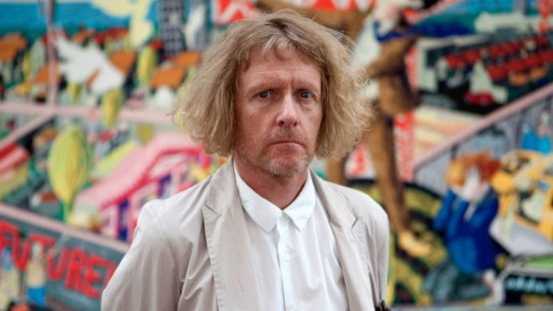
Grayson Perry
Grayson Perry, best known for his colourful cross dressing and work involving the search for identity, is the first artist I’m going to discuss. Perry’s work focuses on the Traditional British fashion, prejudices and fiolables, making a mockery out of and scrutinizing them. Perry’s most known work is his ceramic work, making traditional shaped vases on which he would use the surface as a canvas, smothering with details, whether they be drawings or hand writing, map work or metallic colouring, Perry’s pots would tell a story, illustrating his autobiographical and personal history. It’s in his ceramic work we notice two recurring characters that appear in his designs, one being Clair and the other Alan Measles. It’s these two characters that bring us to the topic of alternate realities. From an early age in life Perry began cross dressing and began wearing his mother’s clothes, it was later in life that he then began to take it further than swirling in front of his mother’s bedroom mirror and started making appearances in public in female clothing, this is where Clair comes to life. The public image of a man in female clothes didn’t shock enough, wearing a dress didn’t provoke people anymore and it was too conventional, Perry was bored of how the public reacted to him and from there on out there were no more plain dresses. The artist began dressing in a much more colourful and flamboyant way, the dresses went from simple to unmissable and outrageously frilly, it was in these dresses that the artist’s alter ego was born, Clair. The second recurring character, Alan Measles, is a little different from Clair but of just as much importance, at the age of five the artist named his teddy, who was not just a teddy at all, Alan Measles was Perry’s best friend, an imaginary friend that came with a well thought through and detailed existence. Coming from his own Fantasy world, Alan Measles was a great comfort to Perry and a greater influence on his life as a child and work later on in life. Although Alan comes from his own world with his own islands, the occurrence of his name was not as fantasy like as his made belief life, the name Alan Measles came about one morning when young Perry was looking out of the window and into the neighbour’s yard, where his next door neighbour, only a few years older than Perry stood, named Alan. It was from behind a window in his bedroom that Perry was observing Alan because he was not allowed outside, funnily enough, Perry was indoors suffering from the measles, and there it was made as his given title, Alan Measles.
Figure 1

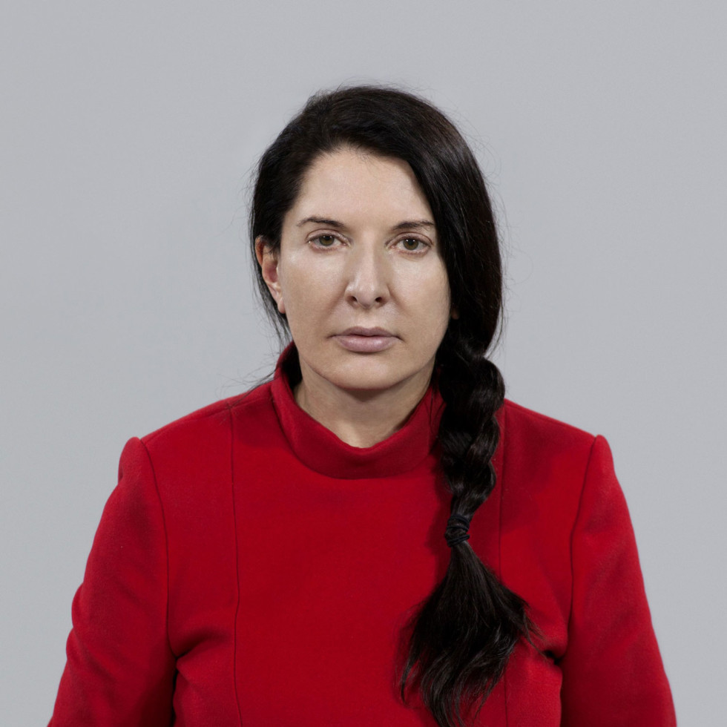
Marina Abramovic
My second artist in discussion, Marina Abramovic, a Serbian performance artist that broke the boundaries of performance art and removed the space between artist and audience, appeared in the 60’s. The main part of Abramovic’s performances were herself, the artist would use her own body as the main media, seeing herself as the object, Abramovic’s performances were a physical test of the body and the mind. The performances would often be violent and the confrontation with injury and blood would test the physical ability of her body and how much it could withstand testing the limits of her mind and where the concentrated consciousness could take her, dedicating her mind to a spiritual existence. Abramovic's performances challenged not only herself but the audience too, not just in the form of making a hard viewing but allowing the audience to be a part of the performance in ways where their actions on the object, the artist, become the performance. ‘They’re like dogs, they can feel immediately that you are afraid, that you are insecure, and that you are not in the right state of mind’. Said by Abramovic, who allows her audience in one performance, ‘Rhythm 0’ to choose from 76 objects, some for pleasure and some for pain, objects such as a glass of water, a rose, a shoe, a coat and then objects such a knife, a razor blade, a hammer and even a pistol with one loaded bullet. Abramovic reads out instructions to the audience explaining to them that she is an object and they are allowed to use any object on her, announcing that all responsibility is her own and even allows for the murder of herself, it was six hours she gave to the audience and six hours she stood allowing the public to do whatever to her. In 2010, ‘The Artist is Present’, a performance where the artist simply sat in her chair for five hundred and twelve hours, eight each day and invited the audience to sit opposite her and exchange a glance with her. “I want to address the public...without moving, motionless, controlling our own breathing and observing this, you experience something completely different. Your mind will start to work in a really different way” says Abramovic in ‘The conversation series, Koenig books.’ This is what I refer to when I say ‘the artists own reality’, Abramovic owns her own place and sense of space within, through a meditative state the artist has the ability to empty the mind and be present in the now and be present elsewhere.
Figure 2

Even as a child Abramovic was not concerned with objects, her childhood was so isolating that she “began to play with the shadows”, Abramovic explains in ‘Marina Abramovic 512 Hours, Serpentine Gallery Koenig book’. “I really discovered an entire world hiding under the blanket...playing with the shadow world, I would create myself”. After this Abramovic began seeing “invisible beings”, she continues to tell us, invisible beings that she would see as flickering lights that would visit her in the dark. Towards the end of the ‘Serpentine Gallery Koenig Book’, Abramovic tells us of an extraordinary experience she had and an important memory she holds. At the time she was living in a “fifth world”, Yugoslavia, nothing there was high tech or advanced, “we didn’t have anything shiny and books were printed on newspaper quality”, she explains. In this memory Abramovic remembers coming home from school and finding a book on her pillow case. The book could not have come from where she was as the cover was “plasticated and very shiny”. Inside this book there were no pages nor any text, just the image of stars and glowing galaxies which also spread over onto the cover. Abramovic was so fascinated by this empty book so full of “milky ways and faraway stars”. Abramovic had no idea how that book had gotten there and she had no idea where it had gone, she had left her room for a few hours and diverted her attention, forgetting about the book and when she had returned the book was nowhere to be seen. When having asked her family if anyone had seen it “nobody knew what I was talking about”, Abramovic stated.
The ‘Marina Abramovic 512 hours, Serpentine Gallery Koenig Book’ ends with the main question Abramovic always had as a child. The question being “not so much the cosmos, but what is behind the cosmos? What is behind everything?” the answer she told herself as a child was that “we are all in the heel of a big fat cosmic lady and we don’t have any kind of control...she can kick us as she wants.” That was Abramovic's first experience with invisible energies.

Yayoi Kusama
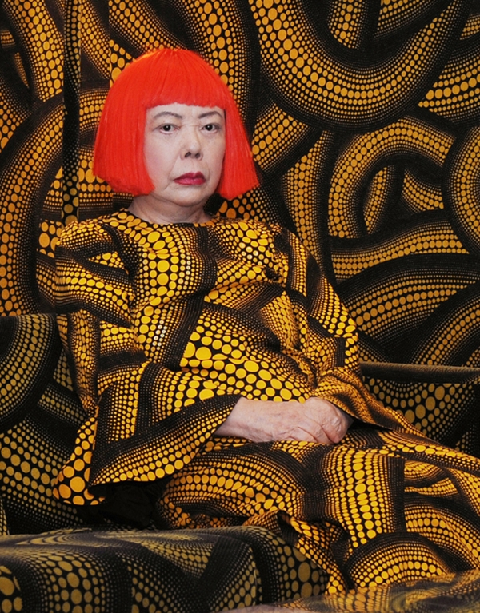
The final artist I’m going to discuss is Yayoi Kusama, born in 1992 in Matsumoto City, Nagano, Yayoi Kusama had a very distinctive style, her bright polka dot infinity rooms and performance pieces created an identity for Kasuma. Recognised often by her infinity nets, Kasuma’s dedication to creating work is like no other, determined to create work of large scale would lead Kasuma to sit for hours, day and night repeating patterns to ensure herself high recognition in the art scene. Kasuma’s life was split into three major divisions, starting life in Japan, leading onto America in the late 1950s, only to return to Japan in 1973, where she now remains. When beginning life in Japan Kasuma was schooled in the traditional way of painting, a Japanese ‘Nihonga painting’, Kusama rejected the traditional ways of paintings and wanted to expand, her work grew into large animated colours and shapes creating microscopic organic forms. It was very clear how Kasumi had come from her traditional Japanese culture by witnessing her newer works which uncover bold and bright concealed worlds.
Figure 3
The second division of her life, Kusama believed ‘the future lay in New York’, the artist wanted to ‘Grab everything that went on in the city an become a star’, Kasumi tells Glenn Scott Wright in an interview. The artist arrived in Seattle in 1957 with her dollars sewn into her dress and note stuffed into the bottom of her shoes, she took only what she could carry and only what she could sell. When in America, the artist used her every minute to create new works, works such as installation, body painting, fashion and film. The artist name was beginning to gain attention and recognition when Kusama would take to the streets of Wall Street and protest the Vietnam War with a signature appearance and public performance. In 1973 Kusama returned to Japan for good, by this time she had succeeded in her goal for greatness and was often said in interviews that Kasuma was considered to be “as famous” as Andy Warhol”. The artists hunger for public happenings had diminished by 1973, at this time Tokyo’s economics had grown rapidly, Kusama’s decision was to return to Japan for good and begin her career as an Art Broker, she began her own business in buying and selling art, having forged gallery links with America, Kusama’s business soon came to an end. In the artist’s earlier stage of life, Kusama suffered with hallucinations that began her signature style of polka dots, Kusama’s existence was consumed by these visions, seeing everything smothered in these dots and colours, which is evidently poured into her work. Kasuma admitted herself into a hospital in 1977 as her hallucinations returned and was suffering from panic attacks, Kasuma now has a permanent residency there and lives happily with a studio across the road, continuing to spend her hours creating works.

Each of the three artists I have talked about all share a very important component in their work, an elsewhere. Each have their own personal space they have created and return to, whether it be a place of the mind, as Abramovic's or a place of fantasy and imagination that was made for a friend, like Perry or a repetitive pattern like Kusama’s to be used as a form of therapy to escape one's mind. Besides their work, as individuals they also share another sad factor, each had experienced troubled childhoods, could their relating childhoods be what lead them to create their own alternate worlds and realities? First I’m going to explain each of their childhoods individually and pinpoint the relating factors between the artists.

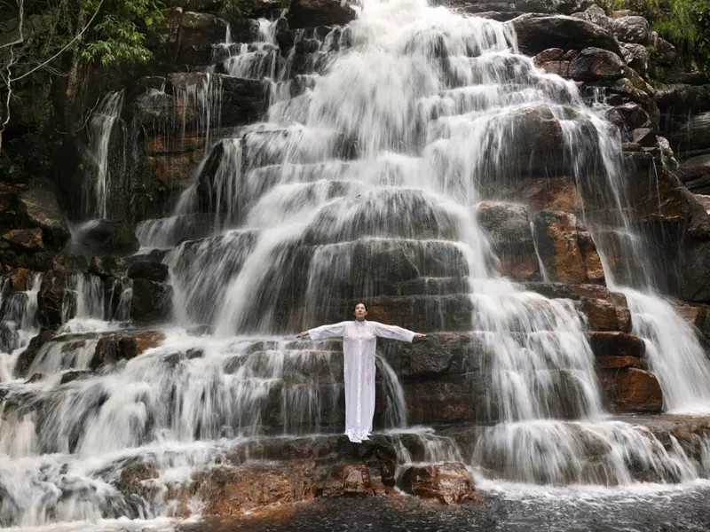
Grayson Perry; Childhood
Grayson Perry didn’t have the best relationship with his parents, and he knows very few truths about them, “I’m unclear of their history…I only have word-of-mouth and fantasy”, Perry tells us in an interview with Wendy Jones in the book ‘Grayson Perry; Portraits of the artist as a young girl’. Perry’s father had the left the family when Grayson was five, leaving them unable to form a father and son relationship, or for that matter, any form of relationship at all. One day in 1964 Perry’s father had driven home after work one day to find his wife, Perry’s mother having an affair with the milkman, having found this out his Father then left and returned to live with his own mother being unable to continue his role in the family home. The abandonment by his father doesn’t leave Perry feeling sour about him and still describes him as a “decent man” and “capable provider”. His father was an Avant photographer and had taken most of the photos of Perry as a child, “all the photographs my father took from that time were burned by my mother or step father when they expelled the memory of my father”, Perry goes on in the ‘portraits of the artist as a young girl’. Having been so young when Perry’s father left had taken a very big toll on him as a child, being only five when his father asked the question “do you want to live with me or your mum?” In ‘The portraits of The Artist as a young Girl’ Perry is extraordinarily open about his life and is very confident in telling us how he felt “I remember not knowing what to say… my sister was three and I was five… we were unable to make a choice…it was too painful to consider” he tells us.
Living through his parents’ divorce for young Perry was difficult as nothing for him was clear to understand until years later, Perry had felt like “nobody was responsible” for them. After Perry’s first Christmas without his father, the milkman soon moved into their home, this was then the last time Perry had ever entered his parent’s bed. In September 1967, Perry’s half-brother was born, he was named Neil and Perry tells us was considered the “golden boy”. Soon after Perry’s father made the decision to no longer contact Perry or his sister. “My dad became a ghost then”. Perry then goes on to tell us how much of an impact this really had on him throughout his life, “when he left, I felt bereft, the rug was pulled out from underneath me”. As far as Perry is aware, he explains to us that “it is the event that has had the largest impact” on him in his life.
Marina Abramovic; Childhood
Like Perry, Marina Abramovic didn’t have much of a relationship with her parents. In the documentary, ‘Marina Abramovic, the artist is present’, Abramovic, in the bonus footage of the documentary the artist talks about her childhood and explains how at the age of sixty she only now understands her mother's ways and reasons. Born in 1946, both parents were highly involved with the communist government. Her mother held the position of an art historian, giving Abramovic an introduction to the art scene and culture.
Abramovic’s father was an elite guard in the War and like Perry’ father, left the family. Abramovic’s mother Danica Abramovic was a tough woman, besides her stern and often violent actions her mother always showed interest in the art her daughter was making and continually supported her. In the bonus footage the artists describes her younger life as a “living hell”. Abramovic’s mother was a stern woman of hardship, her disciplinary rules were very strict and ‘obsessional’, it was because of this that Abramovic found her own spaces of freedom in the Cultural Centre, it was this building in Belgrade that the artist claims to be the most important place in her life, it was also in this space that the artist developed from a conventional painter and began working with performance. Before Abramovic found this “island of freedom”, as she calls it, she was a very unhappy child. The artist’s mother showed no emotion, sympathy or any form of motherly love, when Abramovic one day asked her mother why she had never hugged her, the response was very simple, “I don’t want to spoil you”, her mother would say. “When I was a kid, anybody who wanted to visit me had to wear a mask”, Abramovic says when describing her mother's extensive hygiene obsession. Abramovic's mother would make her wash her hands hundreds of times a day, “when the bathroom was free”, the artist explains, “it meant that me and my brother had to go and wash our hands.” Living with her family meant little communication, the artists father would arrive home late at night, her parents would argue, which Abramovic calls “the devil’s fight”. “We never sit together” the artist tells us, “we would never talk together”. In the bonus footage of the documentary ‘Marina Abramovic, The artist is present’, the artist tells us about the families seasonal yet silent traditions, “we never had a Christmas or new year’s together” Abramovic describes these times as an ‘unpleasant situation’. Having such dry relationships caused the artist to really miss being shown ‘love’ and ‘emotion’. The lack of emotion between Abramovic and her mother was always an issue to her but to her mother this was never considered to be an issue because this was the way her mother was brought up too, leaving her think that this behaviour was totally normal. Abramovic describes her mother as a woman of Heroism, a woman that never showed any response to pain, in the footage Abramovic tells us of when she was born which was an incident that was not acted upon instantly. “She was at a party meeting and her waters broke...she ignored this...finished the party meeting then went to the hospital”. Abramovic never saw need for this ongoing act of heroism in everyday life and believes that this is the cause of an unemotional relationship between her and her mother and her other children too. It was because of this that Abramovic and her brother both suffered as children. When her mother passed away, the stained relationship instantly changed, the age of sixty six Abramovic came to understand her mother and reasoning for life. Abramovic’s mother herself had suffered hardships and although she wasn’t emotionally open she suffered nonetheless. As a child it was the artist’s grandmother who had taken care of her whilst her mother was at work, in the footage of ‘Marina Abramovic, the artist is present’, Marina introduces her mother’s sister and she tells us of her memories of Marina as a child. “Her grandmother would leave her alone whilst she got the groceries”, the beginning of Abramovic’s stillness began here, her grandmother would instruct her not to do anything, telling her “I’ve left you a glass of water...stay here and sit at the table”, it was to all of their astonishment that after hours of leaving young Abramovic unsupervised, that they’d find her in the exact position in which they left her, not even touching the glass of water. Even as a child, Abramovic was sitting for two to three hours, still. Abramovic grandmother was the same as Abramovic’s own, she showed no affection, only concern for education and and when they asked the question of why they were never hugged or kissed the reply was almost the same as Abramovic’s mother, “i do but only when you’re asleep, she’d respond, “because I don't want to spoil you.”
Figure 4
It was this cold childhood that lead Abramovic, as said in an online article about the artist by Maria Popioa, “Turn trauma into power”. Having nothing but one’s self as a child, the artist grew to understand the vitality of solitude, the artists childhood was spent alone with no material objects and this has given Abramovic as a child and as an artist, the complete ability do absolutely nothing other than be with one’s self, this ability is the most evident in any of her works.

Yayoi Kusama; Childhood
“When I was a child I experienced this state of self-obliteration”, Kasuma says in a candid interview with ‘Newness’ a cultural film group, “So I painted the same motif endlessly” the artist goes on, “I found the same pattern on the ceiling, stairs and windows, like they were all over.” When seeing these visions Kasuma would try and touch them, then the hallucinating patterns would follow up her arm. In the short film Kasuma describes these hallucinations as ‘horrible’ experiences. Repetition in Kasuma’s pattern works may have come from an unhappy childhood where the artist would write and draw to warn off and handle anxieties.
Like Abramovic, Kasuma’s childhood was affected by the war, being born into a conservative and wealthy family, Kasuma’s parents owned a seeding farm and like most young Japanese children during the pacific war, was put to work planting crops. Kasuma’s family had strong hopes for her to find a wealthy businessman, marry and settle down, just as her sister had done, assuring herself a high social status in life but of course this is not what the artist wanted for herself.
Abramovic and Perry suffered from bad relationships with their parents, as did Kasuma. Her mother and father were the prime example of an arranged and loveless marriage. Her father was absent often as he spent a lot of his time away from home carrying out numerous affairs. As said in an online article, 'Yayoi Kusama's biography’, by 'The Art Story’, “leaving his angry wife too both physically and mentally abuse his daughter.” A Lot of Kasumi's work references sex and the flaccid form, this may have come from the horrors Kasuma would see as a child, being used as a spy by her mother to observe her father's actions, Kasuma would often whiteness her father's exploits.
French psychoanalysis, Andre Green claims to experience of a 'Dead Mother’, this theory helps to explain Kusama's flawed characteristics. This is a mother whose material joy in her baby is suddenly and catastrophically cut short by her falling into a cataclysmic depression with which the baby then identifies.

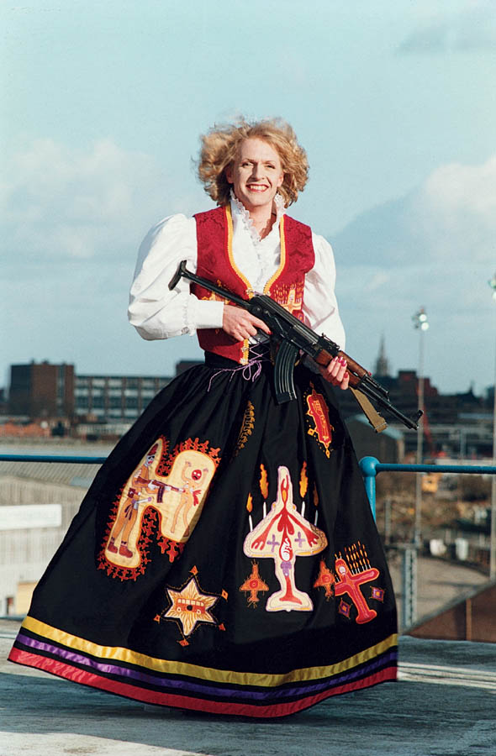
Grayson Perry; Alternate Reality
Perry’s fantasy is one he began making at the age of 5, an imaginary world made up by a troubled young mind with a soft companion. In chapter two; ‘I absolutely couldn’t countenance him losing’ of the book ‘Grayson Perry portraits of the artist as a young girl’, Perry tells us that his ‘imaginary realm’ revolved around the teddy Alan Measles, whom he had received at nine months old. The teddy bear had black beaded eyes on a yellow body that was ten inches tall. When Perry was suffering from measles he and his teddy spent a lot of time in bed together “My teddy and I bonded at that point”, Perry tells us. This was when Perry began conjuring up a world around Measles, Perry seen his teddy as far more than just a teddy, he describes his as the ‘benign dictator’, glamorous, raffish and effortlessly handsome, charming character. It had taken Perry ten years to solidify the rules of his world, by the time he was fifteen his imaginary world consisted of four islands. These four islands were positioned in the Atlantic Ocean, the islands were very much based around existing continents, like Russia, which Perry relates ‘Shark Island’ with, then there’s ‘Round Island’, to the East of Round island was Elfin island, this is in fact the island Alan Measles lived. Perry’s made fantasy was not a simple one, it was well thought through with a well evolving narrative. Along with Alan Measles’ role in this realm. Perry’s world is one example of a child’s beaming imagination, talking to our teddies and building them homes was what young Perry did but to a much more defined detail and external extent. As the first example of fantasy, it is one that is the most relatable and understandable, the second form of fantasy is more from the understanding and accepting adult mind, one of which many relate and many do not.
Figure 5
The second form of fantasy I’m going to talk about is the one of Marina Abramovic.

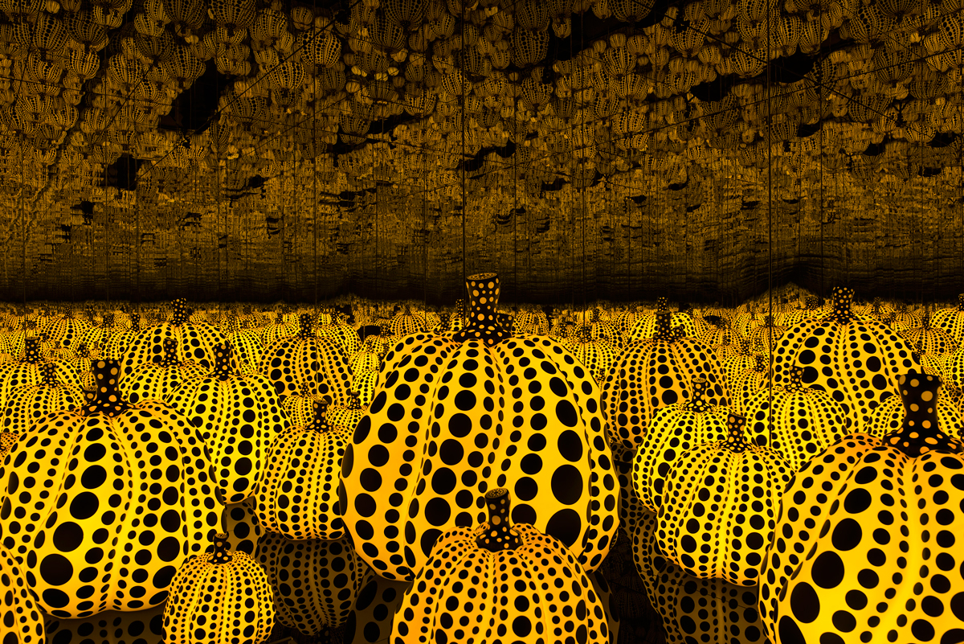
Yayoi Kusama; Alternate Reality
Kusama’s fantasy is one built from personal experiences and visionary, the world’s Kusama creates are physical versions of her mind and what the artist sees, as previously discussed Kasuma suffered from ill mental health and hallucinations, these worlds showing obvious repetitions and coloured polka dots that indicate the hallucinations. The installation rooms are a physical version of Kusama's environmental mind. All the artist’s experiences and visions are personal and private but her worlds are not. The colourful and fantasy like worlds invite people in and allow them to see themselves in Kusama's world, the worlds and reflections allure the public in to participate and create their own scenarios for the multiple worlds. The installation rooms and sculptures created by Kasuma are a way of allowing the artist to share her hallucinogenic ‘world’. Stated in the Artist's personal biography, “I am now determined to create a Kasuma world’ which no one has ever done before or trodden into”. Ultimately the artist’s work is purely about her and entirely her own, the pumpkins above came from her childhood memory, her parent’s seed farm grew pumpkins and they always stood out as comedic to Kasuma, “I love pumpkins”, the artist tells us in an episode of Brilliant Ideas, The Inexhaustible Creations of Yayoi Kusama, "because of their humorous form, warm feeling, and a human-like quality”.
Figure 6

Marina Abramovic; Alternate Reality
Abramovic's 'fantasy’ is different from Kusama's or Perry's, Abramovic's Fantasy is not built from material objects but the exact opposite, the artist dips into the material less world of spirituality, escaping into her own body and mind. The artists practice has taken her on an emotional journey which lead to spiritual healing and powerful hallucinogens such as Ayahuasca, searching for ways to cleanse the mind and body, including indigenous traditions. In the artist's latest exploration Abramovic enters the space of power and entities in search for parallel realities, venturing to Brazil the artist discovers the different sensations places can hold, “a sensation of like some kind of vacuum of time and space”, as she explains in the first diary entry of her Brazil Journal, in the book ‘Marina Abramovic, 512 Hours, published by Serpentine Galleries, Koenig Books’. In this spiritual venture the artist leaves behind her day to day life to discover the true power of her own consciousness. In multiple practices of meditation Abramovic searches her mind for healing, opening her mind to allow the emotions to externalise and rid herself of her pain, physical and mental, such as painful memories of childhood traumas. Abramovic believes there is a place of faith, a place of another dimension where pain does not exist. Abramovic’s current practice about the discovery of a higher energy, a higher consciousness, Abramovic's final diary entry in the ‘Marina Abramovic 512’ books ends with the statement, “my main question as a child was always, not so much about the cosmos but about what was behind the cosmos, what is behind everything?...we are all in the heel of a big fat cosmic lady and she can kick us as she wants...this was my first experience of invisible energies.”

In Summary
After introducing 3 artists I discuss their childhoods, besides the fantasies and realities each have created and share in common, the main correlating element between Perry, Kasuma and Abramovic is their childhood, as we learn each suffered whilst growing up and had unfortunate relationships with their parents. We see that each of the three artists have used art as a form of therapy, using their childhood trauma and emotions to escape and create a type of alternate reality where these painful memories are no longer their main concern. Perry did not enjoy the presence of his stepfather and life with him in it, Perry's work is a prime example of escaping reality, he was a child who loved his toys more than most children of this generation did and he has continued that love for playing, dressing up and creating his own companions throughout his entire career and is why he is the successful, diverse individual and artist that he is today Perry created his own alternate reality, a fantasy world that enabled him to continue without the negativity of his upbringing. Kusama suffered from severe hallucinations and it had led her to become Japan's most known and accomplishing artist. The artist took the visions from her mind and created an identity for herself, allowing her personal experiences space in her artwork is what created such a drive in the artist, Kusama took her trauma as a child through to a woman and created colourful make-believe worlds, if it was not for Kusama's suffering the artist wouldn't have created the magical, other dimensional worlds. Abramovic spent her childhood in solitude and that's the most evident factor in her work now. As a child she had no objects such as toys and it was her own company that grew to be her best. Abramovic's work now is incredibly influenced by her childhood, devoting her practice to using herself as the only material, which as the artist explains, was always done. Abramovic's work has led her to be one of the most recognised performance artists, stirring the public and achieving the reputation of a 'spirit cooker’. Abramovic's work now is a clear indication of her childhood and her pain free reality that the artist seeks now is obviously a place to escape that. Perry, Kasuma and Abramovic are a few of the most known and successful artists of the 21st century. Each have their own identity and their own world of art, their strong and traumatic childhoods allowed them the hard experiences of life and personal growth, reiterating again the much discussed psychological topic of childhood and how it is our childhood that makes us who we are.

BIBLIOGRAPHY

Books

Grayson Perry; portrait of the artist as a young girl, Wendy Jones, Published by Vintage 2007 page 12

Grayson Perry; portrait of the artist as a young girl, Wendy Jones, Published by Vintage 2007 page 13

Grayson Perry; portrait of the artist as a young girl, Wendy Jones, Published by Vintage 2007 page 14

Grayson Perry; portrait of the artist as a young girl, Wendy Jones, Published by Vintage 2007 page 15

Grayson Perry; portrait of the artist as a young girl, Wendy Jones, Published by Vintage 2007 page 16

Grayson Perry; portrait of the artist as a young girl, Wendy Jones, Published by Vintage 2007 page 20

Yayoi Kusama,Tate Publishing 2012, Francis Morris, Introduction, Kasuma 1959, page 10

Yayoi Kusama,Tate Publishing 2012, Francis Morris, Early Years 1957, page 16

Yayoi Kusama,Tate Publishing 2012, Francis Morris, Return To Japan, 1973-1983, page 122

Yayoi Kusama,Tate Publishing 2012, Miduri Yamaura, Rising from totalitarianism, Yayoi Kusama, 1945-1955, page 170

Yayoi Kusama,Tate Publishing 2012, Mignon Mixon, Infinity Politics, page 178

Yayoi Kusama,Tate Publishing 2012, Mignon Nixon - Infinity Politics, page 181

Yayoi Kusama,Tate Publishing 2012, Mignon Nixon - Infinity Politics, page 185

Yayoi Kusama,Tate Publishing 2012, Joe Applin,I'm here but nothing; Yayoi Kusama, Making worlds, page 189

Yayoi Kusama,Tate Publishing 2012, Juliet Mitchel, portraits of the artist as a young flower, page 194

Yayoi Kusama,Tate Publishing 2012, Juliet Mitchell, Portraits of the artist as a young flower, page 194

Yayoi Kusama,Tate Publishing 2012, Juliet Mitchell, Portraits of the artist as a young flower, page 195

Yayoi Kusama,Tate Publishing 2012, Juliet Mitchell, Portraits of the artist as a young flower, page 197

Marina Abramovic 512 Hours, Serpentine Galleries, Published 2014, page 101

Marina Abramovic 512 Hours, Serpentine Galleries, Published 2014, page 109

Marina Abramovic 512 Hours, Serpentine Galleries, Published 20114, page 35

Marina Abramovic 512 Hours, Serpentine Galleries, Published 2014, page 34

Marina Abramovic 512 Hours, Serpentine Galleries, Published 2014, page 19

Marina Abramovic 512 Hours, Serpentine Galleries, Published 2014, page 17

Marina Abramovic 512 Hours, Serpentine Galleries, Published 214, page 15

Marina Abramovic 512 Hours, Serpentine Galleries, Published 214, page 5

Websites - Videos

https://ima.org.au/let-the-healing-begin/

https://anthrosource.onlinelibrary.wiley.com/doi/abs/10.1525/eth.1990.18.3.02a00020

http://blogs.discovermagazine.com/the-extremo-files/2016/03/14/220/#.W7XgmtNKiUk

https://www.brainpickings.org/2015/04/27/getting-there-marina-abramovic-interview/

https://www.youtube.com/watch?v=lRfK21ZE4FA&t=321s

https://www.youtube.com/watch?v=Qor1zzj-WtA&t=37s

https://www.youtube.com/watch?v=ZSz-ZhjDKuU

https://www.youtube.com/watch?v=JQgZsDbrhxA

https://www.youtube.com/watch?v=eQILfMQFPEE&t=17s

https://www.youtube.com/watch?v=ZYZLc79O4AQ&t=32s

https://www.youtube.com/watch?v=reVBAbo5VU8

https://www.youtube.com/watch?v=iT360Glhb9o

https://www.youtube.com/watch?v=_qGvcMBXT0M

https://www.youtube.com/watch?v=JQgZsDbrhxA

https://www.youtube.com/watch?v=lRfK21ZE4FA&t=327s

https://www.youtube.com/watch?v=sJA859mXMLg&t=341s

https://www.youtube.com/watch?v=ASB07-v_ADM&t=4s

https://www.youtube.com/watch?v=PI2JG67b-

https://www.youtube.com/watch?v=rZENw0f5ugY&t=66s

https://www.youtube.com/watch?v=QV8jx5UPCRA&t=5s

https://www.youtube.com/watch?v=OS0Tg0IjCp4&t=2s

https://www.youtube.com/watch?v=AU-Lu1F9TL0&t=15s

https://www.youtube.com/watch?v=O8Mxdk93qPc

https://www.youtube.com/watch?v=17BMY1yKc3A&t=56s

