Transitions for Children in the Early Years

Starting Nursery
2-4 Years

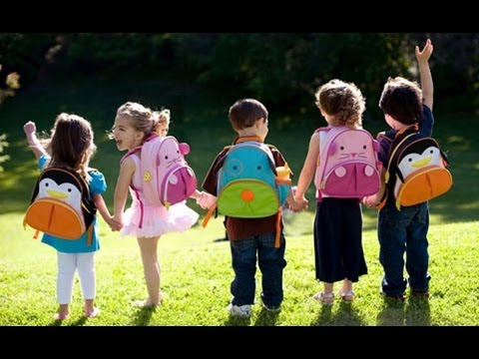

(Source: Play 2 Learn Day Nursey, 2016).
Contents
Introduction 3
What are transitions? 4
Maslow’s Theory 6
Effective Communication 7
Attachment 9
Key Attachment 10
Play 11
Reference List 12
Introduction
This handbook is designed for practitioners and Key Persons in an Early Years setting to promote knowledge and understanding of the importance of effective communication for children’s development during transitions. This handbook looks at children starting Nursery, Playgroups or Preschools and is aimed at children from two to four years. It will look at the transitions children go through and how to ensure children deal with these transitions comfortably. Transitions are changes children go through in their life and it is how we as practitioners deal and make these changes easier for children.
This handbook gives practitioners guidance and information about how to deal with transitions which can be implemented into practice with children transitioning into Nursery.
It looks at the importance of meeting children’s basic needs and the impact it has on the developing child if these needs are implemented. Bowlby’s Theory of Attachment is explained which highlights the effect of having positive relationships with a parent giving children a sense of security and foundation. Ainsworth’s research on different attachment styles has been looked at which practitioners will find relatable in their practice.
Some Nurseries and settings will have a Key Person Approach. It looks at how the Key Person Approach helps children deal with transitions and how it supports their learning and development.
Play has a positive effect on children and this makes transitions more effective. Children love to play so by discovering what their interests are can make interventions more effective with positive outcomes for children. Effective communication is a skill that practitioners need to ensure smooth transitions for children and parents. Good communication with staff members, parents, family and also multi agencies such as Social Workers, Speech and Language Therapists or Health Visitors will ensure smooth transitions for children.
Overall this handbook will help make transitions for children more effective and create positive outcomes for both children and parents. This can help to improve the quality of practise used with transitions and promote effective communication in the setting.

What are Transitions?
Transitions are changes that children go through in their life with each child having to adjust to new experiences and different environments.
Some examples of various kinds of transitions children could go through include:

Every child will deal with transitions differently. When a child leaves home to start Nursery for the first time they can feel anxious and it can be an emotional time not just for the child but the whole family. Having a well-planned out transition ensuring the child’s needs are met appropriately will have a more positive effect on the child and family (Croner-I, 2017).
When a child is about to start Nursery, it is important to work with the parents to ensure a smooth transition. Transitions can be a process over a few weeks but this may be longer or shorter depending on the child’s individual needs (Choo Choos, 2012).
Different interventions that can be planned and prepared include:
- Set up visit mornings or afternoon sessions- In these sessions children can become familiar with where to hang up their coats, where toys and other resources are located and where the toilets are (Fixby, No date). Doing this will enable children to be familiar with their environment and make children feel comfortable starting in the setting enabling them to be more independent and relaxed.
- Transition booklet- A booklet with photos of the Nursey and Key Persons could be sent home. This will enable the child and parents to become more familiar with the setting before the child starts full time. The booklet could also include a section for parents to provide information about the child such as what their favourite toys are, what they like and dislike to eat and what their routine is (Choo Choos, 2012).
- Set up an activity – From the information about the child given by parents an activity could be arranged around the interests of the child. This will distract the child from separation anxiety and make them feel more at home in the setting (Choo Choos, 2012).
- Having a friend- Introducing a friend who is already familiar with the setting will help new children to settle in and feel more comfortable. Play is a big part of connecting with each other and forming relationships which will make transitions easier and more enjoyable (Raising Children, 2017).

Moving to a new House or area
Starting Nursery
Starting in Reception class
Moving into Key Stage 2
New baby in the family
Every Child Matters
The Every Child Matters Policy has been implemented by the Government in England and Wales with its focus on the well-being of children and young people. It states that every child no matter what their individual circumstance or background, should have support throughout their life (Working with kids, 2017).
The Every Child Matters Policy is important to the transitioning child because their main focus is to develop a well-rounded child, who can deal with situations and feel supported and encouraged by practitioners and family members (Allingham, S, 2011).

The Foundation Phase
The Foundation Phase Framework on Personal and Social Development, Well-being and Cultural Diversity also say that:
- Children should be given opportunities to express and communicate different feelings and emotions.
- Children can show interest and develop positive attitudes to new experiences and learning.
- Become independent learners and thinkers.
- Experiment with new learning opportunities and ideas.
- Create a positive environment
- To form friendships and relationships with others and to feel confident to play and work.
- To value friends and family.
- To develop a positive self-image and a sense of belonging within different communities.
- Treat all people from cultural backgrounds with respect (Welsh Government, 2015).
The Foundation Phase promotes these different skills and experiences children need to become effective learners, form positive relationships and have opportunities to learn and explore through all areas of learning.
Through having these experiences children learn about themselves and their relationships with other children, practitioners and family members. Children are encouraged to develop their self-esteem, enabling them to deal with new situations and new environments. Children will develop their self-confidence to make new friends, explore, play and learn. Children are encouraged and supported to become confident, competent independent thinkers and learners. This will enable a smooth positive transition for children to develop confidence within the setting and be able to learn and play comfortably within their setting (Welsh Government, 2015).

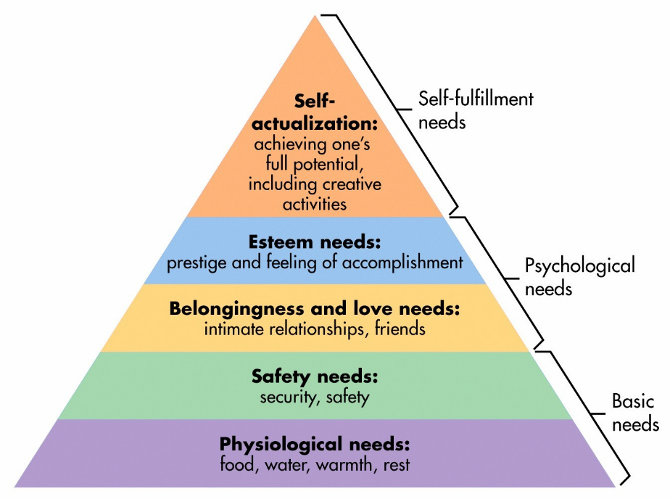
Maslow’s Theory
Maslow’s theory was that if children’s basic needs such as food, water and warmth are not met then children cannot progress on to meet their higher growth needs. His Hierarchy of needs pyramid shows at the bottom the very basic needs of the child and states that if these needs are met then it motivates children to then move up the pyramid to full fill their higher needs (Simple Psychology, 2017). Maslow’s Pyramid consist of five levels which are:

(Source: Simply Psychology, 2017).
By practitioners providing children with their basic needs they can then progress up the pyramid, motivating them to achieve Psychological and Self-fulfilment needs.
If basic needs are not met then this would be seen as Neglect. This would be a child left hungry, dirty, without adequate clothing, not being kept warm with adequate shelter, poor supervision or not having health and medical care (NSPCC, 2017). Children suffering from neglect will not be able to form meaningful relationships resulting in children having low motivation, lack of a feeling accomplishment and positivity.
Practitioners duty when working with children is to ensure children are happy, comfortable and feel safe whilst in the childcare environment. We must work closely with multi agencies as all professionals should work closely together to meet the needs of the children and family (Early Years Careers, 2017). Practitioners and multi-agency professionals are all centred around the child so having effective communication will help the child to progress, learn, develop and be safe efficiently.
Effective Communication
Effective communication is important when working with children to ensure that children feel safe and secure in the setting and that relationships are being built with the children, parents and other professionals. The benefits of home-school partnerships are important for children and young people’s social and emotional wellbeing and learning (Mind Matters, no date). The key people that aid transitions are the practitioners. We as practitioners need to make transitions easier for children. Having effective communication with parents will help practitioners plan and prepare for transition visits.

Communication with parents- Having effective communication with a child’s parents is key to making transitions smoother for children. Parents play an important role in supporting their child through the transition process. Parents and children must be given opportunities to familiarise themselves with the new setting so that they can start to build positive relationships with members of staff (Fixby, no date). Parents know their children best so asking them questions about their child such as:
- likes or dislikes
- Interests
- Hobbies
- Whether they have any friends already in the setting
Asking these questions will help practitioners get to know the child and to plan and prepare activities for when that child arrives in the setting. Settling in visits can be arranged with parents to bring their children in for morning or afternoon sessions. Children will feel more secure having their parents in the setting so they can familiarise themselves with the environment and members of staff.
Practitioners need to be approachable towards the parents and child when they start in the setting. This will build positive and trusting relationships with parents. Practitioners should be:
- Warm and friendly
- Approachable
- Effective classroom/ setting management
- Reliability
- Effective communication skills
- Trust (Mind Matters, No date).

According to Maslow, who was a theorist

Creating a book full of photos of the child during nursery for the parents to see and keep.
Preparing a child and parents for Nursery
Hold a coffee morning for new parents and children who are starting.
Sending home photos of the setting for parents to look at with their child prior to starting nursery.
Regular visits from the parents and child to the setting.
Discussing with parents the setting routine.
Some parents can be nervous about their child starting Nursery for the first time. Therefore, thought must be put into ways to support parents during this transition. Ways include:

(Dukes, C. and Smith, M, 2014).
Organise a ‘settling-in’ period, encouraging parents to attend the setting with the child.
Attachment
In times of transition, children can become quite distressed when leaving their parents or guardians. It is normal for children to feel discomfort and anxiety when first starting Nursery. Children being left with unfamiliar people in a noisy environment can be unsettling and can result in a child feeling reluctant to leave their parents or carers (Early Childhood Australia, 2017).
Bowlby’s Attachment Theory indicates that there is a phycological connection with a Key Person which makes the child feel comforted when stressed or anxious. The theory highlights the importance of a secure and trusting relationship with the parent or guardian promoting the child’s well-being, development and learning. It is said that the quality of attachment has a crucial effect on development (Learning Theories, 2017).
Having a positive relationship with a parent makes a child have a sense of security and foundation, feeling more able to take risks, grow and develop. Those children without that attachment to a parent or guardian were less willing to learn from new experiences and be reluctant to take risks and explore (Psychologist World, 2017).

Ainsworth was also a phycologist who looked at attachments and under took research to explain the individual differences in attachment. She came up with a procedure called the Strange Situation Procedure which investigated the variety of different attachment forms seen between mother and child. Ainsworth identified three main attachment styles which were:
Secure Attachment- These children feel confident that the attachment figure will be there to meet their needs. The attachment figure is used as a safe place and the child feels comfortable to explore the world around them when the attachment figure is in the room. These children seek comfort and attention from the attachment figure when distressed or upset and are easily soothed by them.
Insecure Avoidant- These children do not seek attention from their attachment figure. They are very independent both physically and emotionally and do not want contact when distressed and upset.
Insecure Ambivalent/ Resistant- These children will show clingy and dependant behaviour but will also reject the attachment figure when distracted (Simply Psychology, 2017).
Both Ainsworth and Bowlby’s theories are still relatable today as within settings all children transition differently and we as practitioners will see these different attachment forms take place. Bowlby states the importance of a child having a secure, loving and trusting relationship with parents. This enables children to have more confidence and they are more likely to strive in a learning and loving environment.

Key attachment
In some Nurseries there will be a Key Person Approach put in place within their setting where a practitioner has the responsibility for working with certain children on a daily basis. They have a key role to support individual children and work with them while understanding their needs and development (Dukes, C. and Smith, M, 2014).
Children that transition into Nursery will benefit from having a Key Person. The Key Person has the special responsibility of working with an individual child, giving reassurances so that they feel safe and cared for in the setting. A Key Person can work closely with parents to form a positive relationship ensuring their child is happy and that the practitioner meets their individual needs (Allingham, S, 2011).

A Key Person’s role is to:
- Develop a secure trusting relationship with the child and parents.
- Settles in new children, helping them to become familiar with the setting and supports their arrival and departure each day.
- Meet’s children’s care, learning and development needs.
- Responds to children’s feelings, ideas and deals with behaviour.
- To record observations and be aware of the child’s development (Choo Choos, 2012).

Practitioners can share information with parents about how their child’s day has been and experiences they have had throughout the day. Practitioners can also call parents during the day if there are any concerns about their child settling in. This will reassure parents and promote a trusting relationship which maintains effective communication (Asquith Nurseries and Pre-School’s, 2017).

Play
Play is very important in a child’s life. Children learn through first- hand experiences in their indoor and outdoor environments. Play enhances their learning and development by exploring, experimenting, problem solving, decision making and learning about the world around them (Welsh Government, 2015). According to Play Wales:

Play is so critically important to all children in the development of their physical, social, mental, emotional and creative skills that society should seek every opportunity to support it and create an environment that fosters it.
(Play Wales, 2014: 3).

Children starting Nursery could find the environment over baring with all the noise, colours and all the different resources and toys that are available to them. Play can be a great distraction technique for children. Finding out beforehand what a child likes to play with will help practitioners know what toys or activities to prepare for when the child arrives.
Children’s play is known to reduce stress and anxieties and can distract them from what is going on around them. Play forms positive engagement and promotes relaxed interactions for practitioners or a Key Person that will develop a trusting relationship with the child (App News and Journals Gateway, 2012).
Playing develops social skills and helps build relationships with other children. Children can form relationships and make new friends through play. Children transitioning into Nursery will benefit greatly from having a friend to play with which could make them feel more relaxed in the setting. Children learn not only about themselves but their relationships with other children and adults and are encouraged to develop self-esteem and personal beliefs through play.
The Foundation Phase is a statutory curriculum for all three to seven year olds in Wales and bases learning around play. Children are supported to become confident and independent thinkers and learners (Welsh Government, 2015).
Independency develops from children having confidence, feeling comfortable and relaxed in their environment. According to the Play Policy Wales a child’s free choice of their own play is a critical factor enhancing their learning, development and well-being (Welsh Assembly Government, 2002).
Maria Montessori- The Montessori method is an education that emphasizes individuality and independence in learning (Learning Theories, 2017). Her research indicates that children learn from their own spontaneous actions but within a planned and structured environment. She placed great emphasis on real life objects such as small furniture and crockery which could be seen in a home corner in Nurseries (Featherstone, S and Bayley, R, 2001).
Her theory is still very effective in todays practice as The Foundation Phase framework states that children should be given opportunities to express themselves and experiment with new learning opportunities (Welsh Government, 2015).

Reference List

Allingham, S. (2011). Transitions in the Early Years. London: Practical Pre-School Books, A Division of MA Education Ltd.

App News and Journals Gateway, (2012). ‘The Importance of Play in Promoting Healthy Child Development and Maintaining Strong Parent-Child Bond: Focus on Children in Poverty’. http://pediatrics.aappublications.org/content/129/1/e204 [Accessed date: 26.10.17]

Asquith Nurseries and Pre-School’s, (2017). ‘The ‘Key Person’ approach to nursey childcare’. https://www.asquithnurseries.co.uk/about-us/quality-childcare/learning-and-play/the-key-person-approach/ [Accessed date: 25.10.17]

Choo Choos, (2012). ‘Transitions Matter’. http://www.choochoos.co.uk/wp-content/uploads/2012/11/Transitions-booklet.pdf [Accessed: 29.10.17]

Croner-I, (2017). ‘Managing transitions in Early Years Transitions’. https://app.croneri.co.uk/feature-articles/managing-transitions-early-years-provisions [Accessed date: 17.10.17

Dukes, C. and Smith, M. (2014). ‘Provision and Progress for Two Year Olds’. London: SAGE Publications.

Early Childhood Australia, (2017). ‘Separation Anxiety’. http://www.earlychildhoodaustralia.org.au/parent-resources/separation-anxiety/ [Accessed date: 22.10.17]

Early Years Careers, (2017). ‘Childcare providers working in partnership with Multi Agencies’. http://www.earlyyearscareers.com/eyc/latest-news/childcare-providers-working-in-partnership-with-multi-agencies/ [Accessed date: 22.10.17]

Featherstone, S. and Bayley, R. (2001). Foundations For Independence. Lutterworth: Featherstone Education Ltd.

Fixby, (No date). ‘Kirklees guidance for transitions in the Early Years’. https://fixby.org/kgfl/primary/fixbypri/web/early-years-transition-guidance-booklet-2013.pdf [Accessed date: 22.10.17]

Kids Matter, (no date). ‘Effective Communication between families and early childhood staff’. https://www.kidsmatter.edu.au/early-childhood/about-partnerships/about-communication/effective-communication-between-families-and [Accessed date: 18.10.17]

Learning Theories, (2017). ‘Attachment theories [Bowlby]’. https://www.learning-theories.com/attachment-theory-bowlby.html [Accessed date: 20.10.17]

Learning Theories, (2017). ‘Montessori Method’. https://www.learning-theories.com/montessori-method-montessori.html [Accessed date: 26.10.17]

Mind Matters, (No date). ‘Communicating with parents’. https://www.mindmatters.edu.au/docs/default-source/learning-module-documents/j4497_mm_moduleoverview-3-2-communicatingwithparents_v4.pdf?sfvrsn=0 [Accessed date: 17.10.17]

NSPCC, (2017). ‘Neglect’. https://www.nspcc.org.uk/preventing-abuse/child-abuse-and-neglect/neglect/ [Accessed date: 22.10.17]

Play 2 Learn Day Nursey, (2016). ‘We send every good wish to our children going to BIG school’. http://www.play2learndaynursery.co.uk/2016/07/we-send-every-good-wish-to-our-children-going-to-big-school/ [Accessed date: 26.10.17]

Play Wales, (2014). ‘What is play and why is it important?’ http://www.playwales.org.uk/login/uploaded/documents/INFORMATION%20SHEETS/what%20is%20play%20and%20why%20is%20it%20important.pdf [Accessed date: 26.10.17]

Psychologist World, (2017). ‘Attachment Theory’. https://www.psychologistworld.com/developmental/attachment-theory [Accessed date: 22.10.17]

Raising children, (2017). ‘Supporting your child’s school-age friendships’. http://raisingchildren.net.au/articles/supporting_schoolage_friendships.html [Accessed date: 22.10.17]

Simple Psychology, (2017). ‘Mary Ainsworth’. https://www.simplypsychology.org/mary-ainsworth.html [Accessed date: 22.10.17]

Simply Psychology, (2017). ‘Maslow’s Hierarchy of Needs’. https://www.simplypsychology.org/maslow.html [Accessed date: 22.10.17]

Welsh Assembly Government, (2002). ‘Welsh Assembly Government Play Policy’. http://gov.wales/dcells/publications/policy_strategy_and_planning/early-wales/playpolicy/playpolicye.pdf?lang=en [Accessed date: 26.10.17]

Welsh Government, (2015). ‘Foundation Phase Framework’. http://learning.gov.wales/docs/learningwales/publications/150803-fp-framework-en.pdf [Accessed date: 24.10.17]

Working with kids, (2017). ‘The ‘Every Child Matters’ Policy Explained’. http://www.workingwithkids.co.uk/every-child-matters-policy-explained.html [Accessed date: 24.10.17]

