

Student name: JUMOKE CATHERINE ADEDOYIN
Student ID: 2324739
Module name: EMPOWERING THE OLDER PERSON
Module code: BMHP6027
Lecturer’s name: DR CHRISTOPHER MAFUVA

  handicare-stairlifts.co.uk/ |  | Critical Evaluation of Care, Empowerment and Support Needs of Older People  * Personalised care promotes dignity, independence and wellbeing (NICE, 2023).  * Empowerment enables informed decision-making and greater autonomy (Care Act, 2014).  * Advocacy supports older people with communication or cognitive difficulties (Mental Capacity Act, 2005) |  | 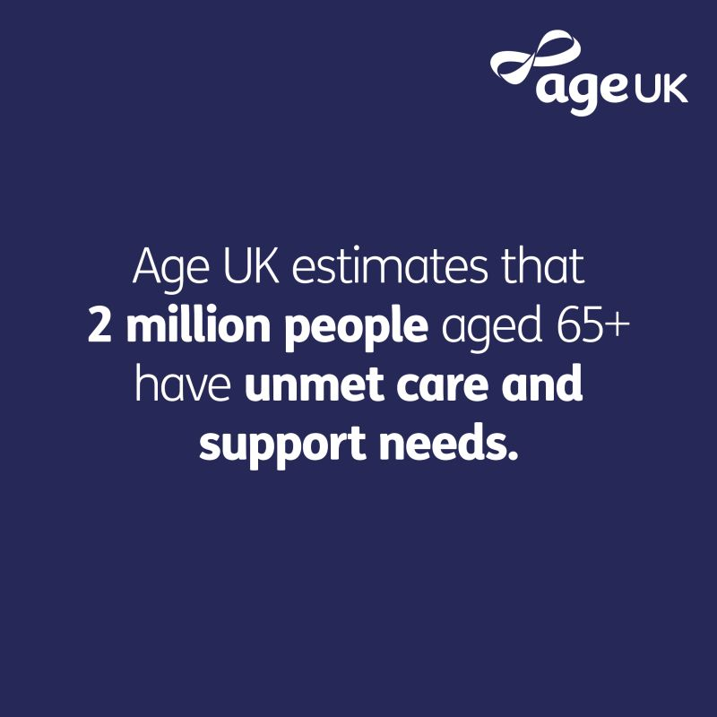  Google-AgeUK
Introduction  The UK has an ageing population, with almost one in five (19%) people in England aged 65 years and over, increasing the demand for person centered health and social care services. Older people require care that promotes independence, dignity and wellbeing while respecting their freedom and choice. This poster critically evaluates the care, empowerment and support needs of older people and examines how local and national services enable autonomy and informed decision-making (Centre for Ageing Better, 2025; DHSC, 2025).  Conclusion.  Promoting independence and functional ability improves quality of life (WHO, 2022).  * Person-centred care empowers older people to make informed choices (NICE, 2023).  * UK legislation supports dignity, autonomy and participation (Care Act, 2014; Mental Capacity Act, 2005).  * Continued investment, workforce development and equitable access are essential to meet the changing needs of an ageing population (The King’s Fund, 2023). |  |  |  | Challenges  - Physical limitations  - Health conditions  - Social / Emotional factors  - Digital divide  Recommendations  Increase funding for adult social care (The King’s Fund, 2023)  * Strengthen person-centred care (NICE, 2023)  * Expand community-based support services (Age UK, 2024)  * Expand reablement and rehabilitation services (NHS England, 2019)

Effectiveness, benefit of approaches and interventions.
Maintains identity and personhood (Kitwood, 1997)
* Addresses physical, social and psychological needs (Maslow, 1943)
* Improves health and wellbeing outcomes
* Limitation: Workforce shortages and funding pressures reduce service effectiveness (The King’s Fund, 2023
Key policies:
* Care Act 2014
* Mental Capacity Act 2005
* NICE Guideline NG32: Older People – Independence and Mental Wellbeing (2023)

References
Age UK (2024) Later Life in the United Kingdom. London: Age UK. (Accessed 30 June 2026)
Alzheimer’s Society (2024) Dementia UK Report. London: Alzheimer’s Society. (Accessed 27 June 2026)
Bunn, F., Goodman, C., Russell, B. et al. (2018) Supporting shared decision-making for older people with multiple long-term conditions. Southampton: NIHR. (Accessed 27 June 2026)
Care Act 2014. London: HMSO. (Accessed 6 July 2026)
Care Quality Commission (2024) State of Health Care and Adult Social Care in England. London: CQC. (Accessed 23 June 2026)
Centre for Ageing Better (2025) The State of Ageing 2025. London: Ageing Better. (Accessed 30 June 2026)
Department of Health and Social Care (2025) Care and Support Statutory Guidance. London: DHSC. (Accessed 6 July 2026)
Kitwood, T. (1997) Dementia Reconsidered: The Person Comes First. Buckingham: Open University Press. (Accessed 27 June 2026)
Mental Capacity Act 2005. London: HMSO. (Accessed 23 June 2026)
NHS England (2019) The NHS Long Term Plan. London: NHS England. (Accessed 30 June 2026)
NICE (2023) Older People: Independence and Mental Wellbeing (NG32). London: National Institute for Health and Care Excellence. (Accessed 6 July 2026)
Office for National Statistics (2024) Ageing of the UK Population. London: ONS. (Accessed 30 June 2026)
Social Care Institute for Excellence (SCIE) (2023) Dignity in Care: Freedom and Choice. London: SCIE. (Accessed 23 June 2026)
The King’s Fund (2023) Social Care in England: Key Issues. London: The King’s Fund. (Accessed 30 June 2026)
World Health Organisation (2022) Decade of Healthy Ageing 2021–2030. Geneva: WHO. (Accessed 2 July 2026)
World Health Organisation (2023) Integrated Care for Older People (ICOPE) Guidance. Geneva: WHO (Accessed 2 July 2026)

