Tracey Hughes
2008698
University Trinity St David’s
ECP4003 research methods 1
Stacey Coleman
Nov 2nd, 2021

Is there an association between gender and preference for working from home?

Table of contents
- Abstract ….....................................................................Page 4
- Introduction …...............................................................Page 5
- Methods …....................................................................Page 6-8
- Discussion …..................................................................Page 8
- References ….................................................................Page 9-10
- Appendices …................................................................Page11-15

Abstract

Covid-19 changed the way we looked at the world of working, and it seems that employees are now wanting the best of both worlds, over 70% of workers still want flexible work options, while over 65% are craving more in-person time. A CEO at Microsoft stated that over the last two yrs. no area has undergone more rapid transformation than the way we work, and All this needs to be done with flexibility in when, where and how people work (Nadella, S) One in five global survey's respondents say they find juggling work/home/ life balance difficult ,54% say they feel overworked, 39% felt exhausted and with more emphasis on working from home workers are now feeling digital exhaustion.(Goodwin,2021). Also as working mums are juggling childcare and domestic duties has Covid 19 undone decades of advancement towards gender Equality. (Savage, 2020).

Introduction

A number of studies have been researched since March 2019 on the impact of working from home. This was a time where the choice was taken out of many workers hands due to Covid 19 and lockdown strategies. One study by The Office of National Statistics (ONS) showed that equal numbers of male and female (86%) cited their reasons for working from home was due to Covid 19. Women spent 64% more of their time on unpaid household work than men and 55% of women spent more time on unpaid childcare, by October 2020 this rose to 99%.
Another report by Heejung Chung in 2018 before the covid 19 pandemic hit did numerous studies on gendered outcomes working from home (WFH) but was limited by qualitive research due to limitations examining the importance of gender and class. In 2020, partnered with Savani, K an additional research paper was aimed at “examining gender gaps in work related outcomes in Covid 19, They hypothesised that it would create a gender gap in work productivity and job satisfaction” ,this was because when couples are WFH and schools were closed, whether due to lockdown or restrictions, women were expected to give more time to housework and childcare, this study was only sampled by opposite sex parents who both had careers and its findings suggested society needs to give additional support to women.
The Work Trend Index Survey was conducted by an independent research team, Edelman Data x intelligence, among 31,092 self-employed or full time employed workers in 31 markets between January12 2021 to January 25, 2021, self-assessed productivity remained the same but the pressure for workers to keep up has increased substantially causing digital exhaustion.
The aim of this study (Coleman, 2020) was without restrictions using a non-experimental design and being a general outlook of preference with working from home (WFH) against being in a place of work using both male and female participants of different ages. Based on previous studies, this study it is hypothesised that more women would rather be back in the workplace where work, childcare and other household duties would be separate, giving them a sense of freedom.

Method

Participants

This study used forty-one undergraduate Psychology students to participate in the study, they were mostly male and female participants and one non-binary. There were twenty-six females and 14 males. The participants ranged in ages from eighteen to fifty-one inclusively. For the purpose of this study only male and female participants were included. (Appendix 1)

Design

A non-parametric design, not based on assumptions or distribution of variables, and was between subjects was constructed was constructed within this questionary where participants were asked of their preference of working from home or preferring their place of work.

Materials

A questionnaire written by the lead researcher (Coleman, 2021) was used to measure the preference of working from home compared to the preference of being at their place of work. The questions were asked in a choice of one or the other and would give the researcher a strong indication of preferences.
An Information sheet was given to all participants detailing key information about the study prior to being presented with a consent form as this allows the participant to make an informed decision about whether they go ahead or not, or use their right to withdraw before the study begins .also a consent form is provided where participants were informed of any ethical facts from the ‘BPS, ethics guidelines for internet mediated research,’ that would have a bearing on the study and making sure data confidentiality was adhered to at all times and unanimity is of the greatest importance as it is commonly reported an ethical concern, and finally, a debrief sheet was given, giving the purpose of the study with the right to withdraw at any time with the lead researchers name and contact details for any further questions or any concerns.

There was not a need to add any additional applications from any other source.

Procedure

Participants of this study were recruited to do this study on an online platform by the lead researcher (Coleman, 2020). Participants were given a link to a questionnaire where they were given a brief description of the study(appendix 1) and a consent form which had to be read fully and asked to read and agree whether they gave consent to participate in the study. This can be seen in (appendix 2) Once this consent was given, a short questionnaire asked a series of demographic questions such as gender and age, following this information, additional questions were asked of their preferences to working from home to being back in the workplace. (Appendix 3)
Once all the relevant data had been completed by the participants, a debrief document was provided giving the aims and purposes of the study and given their right to withdraw from the study should they feel uncomfortable without any penalty inflicted (appendix 4).
Once the participants where comfortable with their answers they were asked to finally submit and were thanked for giving their time to participate in the study.

Results

The results of this study showed that the willingness to work from home was not dependent on gender or age,
This data was calculated using the” chi- square test of independence “and used an independent variable of men /women and a dependent variable of a choice of either working from home or preferring the workplace.” This test works for categorical data (data in categories) but not numerical data such as height or weight “(Chi-Square Test - mathsisfun.com).
After stating our hypothesis, the data was laid out in a table format and then added up within rows and columns and then we calculated the expected table value for each entry, where each row total by each column total and divide the overall total then subtracted expected form the observed, squared it then divided it by the expected.
The table includes information of the observed counts and expected counts, for example our table shows that females and males observed counts were remarkably similar to the expected count see (appendix 5).
When these values were calculated it gave a chi-square of 0.02 which were then used against our degree of freedom which is one.
Chi-squared=0.02
Degrees of Freedom =1
P=0.8875

Discussion
This study showed there was no preference between male and female participants wanting to work from home, in fact most of the female participants would prefer to go back to a work environment.
This totally contradicts a study co-authored by professor’s Taylor, P and Scholarios, D, from Strathclyde business School whose analysis of Covid-19 and working from home survey showed 78% of respondents prefer spending less time at the office, and most females would revert back to being a typical housewife whose place was in the home.
There may have been compound variables that could have altered the results of this study, it must be taken into consideration that all participants were undergraduate students of different ages. It did not use any variables to determine whether any participants had children and how many of these were school aged. This study also only used male /female participants rather than same sex partnerships, seen in literature by Umberson, D (2019) which analyses quantitively dyadic data and promises strategies and methods to advance future research.
Finally, the ratio of men and women were unevenly matched this could be a factor that would alter the results.
In conclusion, the evidence and findings of this study did not account for the diversional range of participants. Further studies on this topic should include a diverse range of participants ranging in ages, ethnicity, and culture and whether the participants did in fact have school aged children which would dramatically alter the outcome of the study (Rothbum, 2009)

References

Chung, H., Van der Lippe, T. (2018). Flexible working, Work-Life balance and Gender Equality: Introduction. Social Indicators Research, 151(2),365-381retrieved from: https://doi.org/10.1007/s11205-0018-2025-x

Coleman, S (2021, October). Is there an association between gender and preference for working from home (No 1). Stacey Coleman.

Goodwin, K. (2021, April 14) The rise of digital burnout. DrKristyGoodwin.com. Retrieved 28 October 2021, from: https://drkristygoodwin.com/the-rise-of-digital-burnout.

Nadella, S. (2021). Work trend index. Microsoft. Retrieved 23 October 2021, from: https://www.microsoft.com/en-us/worklab/work-trend-indexhybrid-work.

Payne, C.A.B.M.S., & Brain, M. (2021, March 10). Coronavirus (COVID-19) and the different effects on men and women in the UK, March 2020 to February 2021 – Office for National Statistics.Www.ons.gov.co.uk. Retrieved 28 October 2021, from https: www.ons.gov.uk/peoplepopulationandcommunity/healthandsocialcare/conditionsanddiseases/articles/coronaviruscovid19thedifferenteffectsonmenandwomenintheukmarch2020tofebruary2021.

Pierce, R. (2000). Maths is fun. Chi square. Retrieved 30 October 2021 from: https://www.mathisfun.com/data/chi-squarecalculator.html

Rothblum, E.D. (2009). An overview of same-sex couples in relationships:a research area still at sea. In D. A .Hope (Ed), contemporary perspectives on lesbian, gay and bisexual identities (pp. 113-139). Springer Science + Business media. Retrieved 23, October 2021 from. https://doi.org/10. 1007/978-0-387-009556-1_5

Savage, M (2020, July 01) How covid-19 is changing women’s lives. BBC News. Retrieved 30 October 2021, from: https://www.bbc.com/worklife/article/20200630-how-covid-19-is-changing-womens-lives.

Taylor, P., & Schoarios, D (2021, March 24) study reveals most employees want to work from home. Strathclyde university. Retrieved 23 October 2021, from: https://www.strath.ac.uk/whystrathclyde/news.study.

Umberson D, Chen MD, House JS, Hopkins K, Slaten E, (1996) The effect of social relationships on psychological well-being: Are men and women really so different? American Sociological Review.1996,61 :837-857:

Appendices

Appendix 1

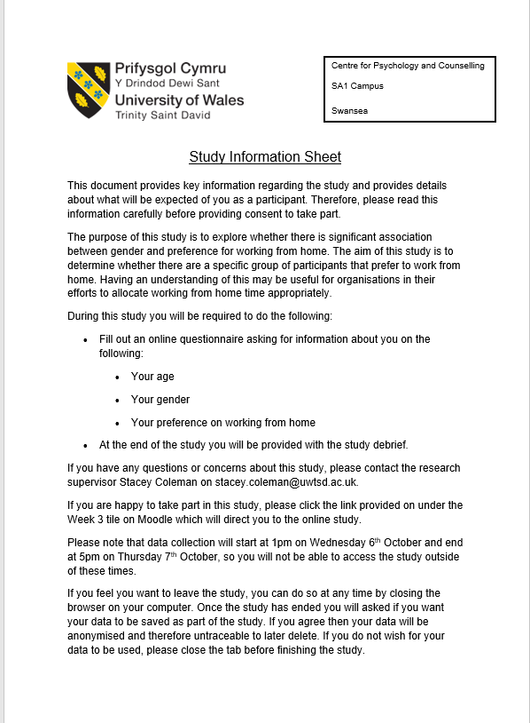

Appendix 2

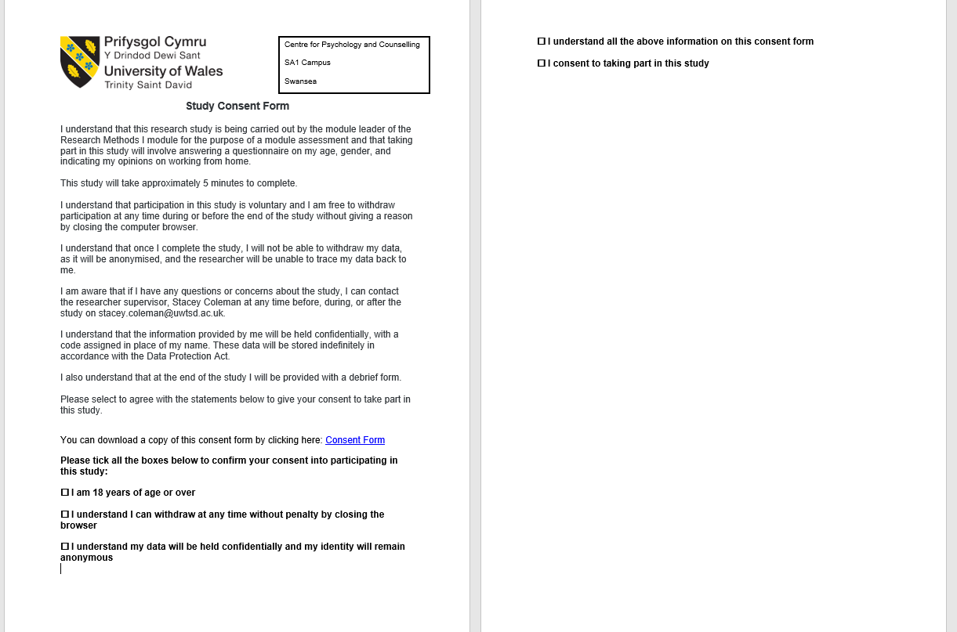

Appendix 3
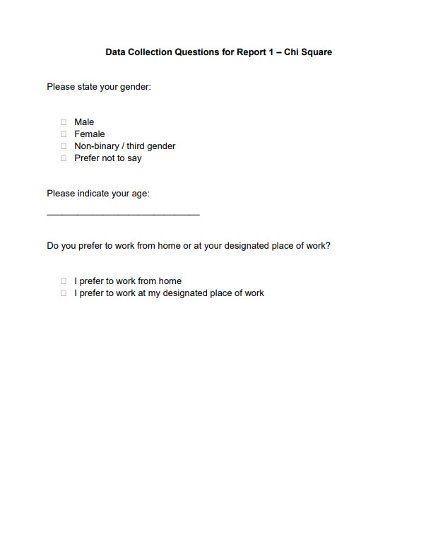

Appendix 4

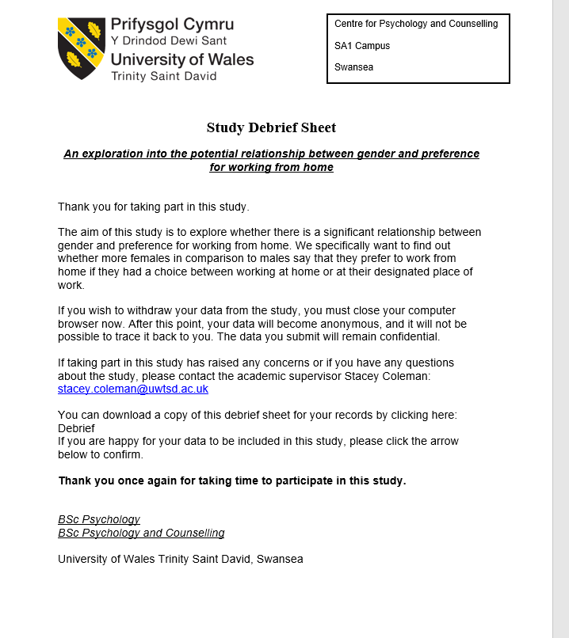

Appendix 5

Chi-squared calculation
 | MALE | FEMALE | TOTALS
WORK | 10 | 18 | 28
HOME | 4 | 8 | 12
TOTALS | 14 | 26 | N=40

Expected Frequencies

A $\frac{14×28}{\begin{aligned}40 \\ \end{aligned}}$ =$\frac{392 }{40}$= 9.8
B $\frac{18×26}{40}$=$\frac{728}{40}$ = 18.2
C $\frac{14×12}{40}$=$\frac{168}{40}$= 4.2
D $\frac{12×26}{40}$=$\frac{312}{40}$= 7.8

OUTCOMES EXPECTED
A | 4 | 4.2
B | 8 | 7.8
C | 10 | 9.8
D | 18 | 18.2

$\frac{(10-9.8)²}{9.8} = \frac{0.04}{9.8}$ = 0.004
$\frac{\left(18-18.2\right)²}{18.2}$ = $\frac{0.04}{18.2}$ = 0.004 Chi-Squared = 0.02
$\frac{(4-4.2)²}{4.2}$ = $\frac{0.04}{4.2}$ = 0.005 Degrees of freedom = 1
$\frac{(8-7.8)²}{7.8}$ = $\frac{0.04}{7.8}$ = 0.004 P = 0.8875

²

Appendices

Appendix 1

Appendix 2



